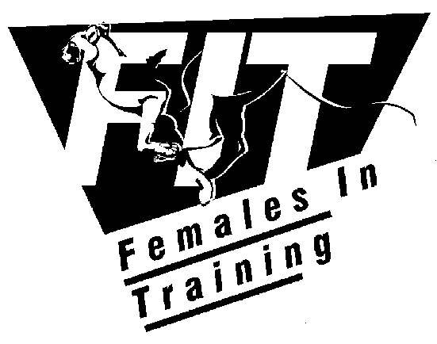


TANDEM BIKE RIDING FOR
VISION IMPAIRED CYCLISTS

A PROJECT OF FIT (FEMALES IN TRAINING) & PEDAL POWER
Would you like to:
- Get out and about, clear your head, get the blood circulating and meet interesting people?
- Feel the sun on your face and wind in your hair as you speed down a long gentle hill?
- Get to cycle through different places in Canberra: lakes, hills, suburbs, parks - on the excellent cycle path network?
- Have a good workout getting to the top of a hill and feel your general fitness increase?
- Spend your time chatting with your tandem buddy and with other cycling friends on a leisurely ride?
- Take things seriously – learn professional tandem riding skills and train for fast paced competition?
- Fulfil your dream to compete in cycling at a national or international level – on a tandem?
- Enjoy coffee, cake, or bacon and eggs at the end of a morning’s ride?
- Lead the way as a trained pilot of a tandem bike with your disabled friend or family member doubling your pedal power?
- Join in cycling weekends away to interesting locations around the region, with good rides, sightseeing and excellent company?
- Attend interesting social events with your cycling friends, including dinners, and talks about inspiring overseas cycling adventures?
- Have opportunities to attend classes to learn more about the mechanics of your bike, looking after yourself as you ride and riding skills?
- Help promote tandem cycling for disabled people by assisting FIT and Pedal Power with organisation and logistics?
About the project
FIT (Females In Training) has offered tandem cycling opportunities to vision impaired people for some years. FIT has a number of high quality racing tandems.
Pedal Power has now come on board to assist FIT to offer tandem cycling to a wider group.
Tandem cycling is available to vision impaired adults and those with other disabilities who would otherwise be unable to cycle. In tandem riding a “pilot” up the front looks out for obstacles, steers, brakes, and changes gears.
There are a number of experienced cyclists trained in tandem riding to assist you – looking for a cycling buddy (a “stoker”) – to provide the extra peddling power.
Trying tandem riding
Regular Come and Try days are held so you can try tandem riding in a safe off-road environment to see if you would like to take it up - even if you have never ridden a bicycle before, or not for some years.
After a little practice, riding a tandem bicycle is as easy as riding a single bicycle and just as much fun.
Meet people and get involved
FIT and Pedal Power have a combined cycling membership of almost 2,000 from Canberra and the local region. The membership includes a wide range of people: mums and dads, young adults, vision impaired people, children, singles, public servants, tradespeople, business people, scientists, retirees, mentally and physically disabled people, and university students.
This means that at any FIT or Pedal Power activity you will find someone interesting to ride with and can make new friends.
It is up to you how often and how far you ride and what kind of activities you would like to join.
Initially tandem riders will join leisurely Saturday morning breakfast rides run by Pedal Power, often starting at Lake Burley Griffin near Civic.
However, over the longer term FIT and Pedal Power may give you opportunities to choose other kinds of activities you would like to do, such as:
- Saturday morning breakfast rides
- weekly training rides – which may lead to competition riding
- cycling skills development courses with trained coaches
- mid week social rides
- longer Sunday road rides
- access to the other triathlon events – swimming and running
- social events
- participation in competition events around the ACT
- cycling weekends away
- bicycle maintenance classes
- volunteering to help organise tandem riding
Pedal Power holds appropriate insurance for those participating in rides if you become a member.
If you are interested in tandem cycling as a:
- Pilot (for experienced cyclists who ride up front),
- Stoker (the rider at the back), or
- volunteer assisting with coordinating tandem riding
please contact:
Rosemary Robinson  FIT Ability Project Officer  Mob: 0416164922  Email: rosemary.mooreoptions@bigpond.com | Lauren Brand  Pedal Power  H) 6258 1160  Email: Lauren.Brand@immi.gov.au
You can discuss with Rosemary and Lauren the kind of activities available for tandem riders, how often you would like to participate, and what assistance or training you would need.

