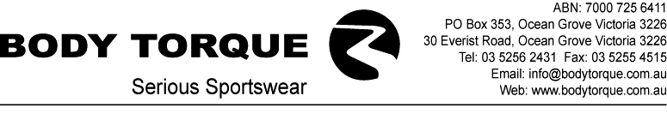

INFORMATION GUIDE

Thanks for your enquiry about our custom made bike gear.
Here at Body Torque we’re so serious about custom-made bike gear that we are leading the pack in design innovation and fabric development.
We have developed this information kit to provide you with as much information as you’ll need to get you started along the track towards your own custom designed bike gear. In fact we call it our ABC of design!

A. Body Torque works on a first in/first out policy. If you have the time we can assist you to design your own gear, if not you might want to choose a design from one of our stock garments. Either option, we will be able to help you every step of the way, but please give yourself and us plenty of time by planning ahead, because we need 4 to 6 weeks to produce your garments from when you confirm your order.

B. When you have all your logos and graphic designs, send them to our Design Department where our design team will produce a mock up for your approval.
We have included a template, which you may photocopy and use to assist in finalising your design.
Please ensure you indicate the quantity and type of garments you require.
Up to this point our service is free however, as our Design Department can allocate only a certain amount of time to each design, we would appreciate it if queries are specific and kept to a minimum. This also assists in making sure the design service we offer to you is of the highest standard.

C. If you require a final detailed quote please contact us at this point however, if you are happy to place your order you should fill out the enclosed credit application and order form, making sure that you provide all the information we require including your store /club/team name, billing and shipping details, contact name, telephone, email and fax number, and all sizes, styles and quantities. A 50% deposit is required and can be paid directly into our bank account or we accept most credit cards.
Please note that production will not commence until we have your signed proof, order confirmation, credit application and deposit and will take 4-6 weeks from receipt. Generally, no further changes can be made from this point.
Garments will be delivered ex factory via Australia Post or by courier. Freight is charged at the most economical option.
All quotes are valid for 30 days and do not include GST, please add 10%.
Please note, upon delivery of your order the remaining payment balance is due and payable.

Once again, thanks for your enquiry. If you need any further information please do not hesitate to contact us.
We look forward to contributing to the success of your project.

Yours sincerely,
The Team at Body Torque.

BTIG-0304

