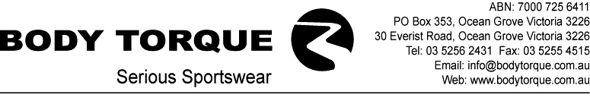

FREQUENTLY ASKED QUESTIONS

Q- What is Plasticol?

A- Plasticol is a plastic based logo that is heat transferred onto fabric. It is not permanent and may wear off and fade over time.

Q- What is Sublimation?

A- Sublimation is the process of using heat to transfer a paper design to white fabric. The ink is forced into the fabric making it permanent as opposed to surface printing of fabric which may wash off and fade.

Q- What does Body Torque need to start my order?

A- We need your completed order form, credit application, 50% deposit and signed proof.

Q- What does the Body Torque Design Department require from me?

A- The lead time for custom apparel is generally subject to the quality of the artwork that you submit. We cannot send you a proof until the elements such as background design, sponsor logos, etc. are complete and usable. Please refer to the attached Art and Design Requirements.

Q- What will the price of my garments be?

A- The price of your garments depends on a number of variables, such as the number of colours used, whether there is the same or different art on the front and back and the quantity ordered.

Q- What are the payment terms?

A- 50% deposit, balance on completion. This can be paid by credit card, cheque, or electronically into our bank account.

Q- Are there freight charges on top of the order?

A- Yes. Garments will be delivered ex factory by Australia Post or by courier. Freight is charged at the most economical option.

What is the lead time for custom orders?

- Generally 4 to 6 weeks from confirmation of order.

Q- Can I reserve a spot in the production schedule?

A- Unfortunately, no. We work on a first in first out policy. Once you have paid the 50% deposit, submitted all correct artwork, your order form, signed proof and credit application if required, only then will your order be entered into the system.

Q- What is the minimum quantity for an order?

A- 10 garments per style. 15 per style for Block colour garments.

Q- What is the minimum re-order quantity?

A- Same as above.

Q- Can I fax you my logo?

A- No. A fax or photocopy is too distorted and lacks adequate detail for reproduction.

Q- Does Body Torque keep logos on file?

A- Yes. We keep most logos from past jobs in our archives, which means we have a number of industry logos on file.

Q- Where do I start when I am not a designer?

A- If you don’t know what you want or where to begin, we suggest that you hire a graphic designer to create the artwork for you. However, if you have artwork but need help, call our Design Department on 03 5256 2431 to guide you through the process.

Q- Can I see a sample of my garment before I receive it?

A- We can’t send you an actual garment but we will send you a colour proof for your approval.

Q- Can I have a coloured logo on my stock or block colour jersey?

A- Yes. One colour logos can be done in house however, multi-coloured logos are done off premises and require individual quoting and may delay your order.

