67 Coronga Crescent
Killara NSW 2071
0434 715.861
3 May 2011
Professor Mike Daube (08) 9266.4933
Preventive Health Taskforce m.daube@curtin.edu.au
Professor of Health Policy, Curtin University of Technology
and President, Public Health Association of Australia
GPO Box U1987
Perth WA 6845
Dear Professor Daube
YELP can deliver “concentrated and determined action" with its Pilot and Preparatory Research Programme able to commence on 13 August 2011
Thirteen months ago you stated "The obesity crisis is not on its way - it is already here," "What we have done about obesity is not working. This issue needs concentrated and determined action."
I have participated in rigorous recreational exercise all my life, and have administered an endurance road bicycle group, Muggaccinos.com for 16 years which has attracted several hundred different endurance road cyclists to >100km Sunday hilly road rides, where the bonhomie and fellowship is palpable. Many of these cyclists have turned their lives around after discovering that they could re-ignite the skills they learned many moons ago during their ‘youthful exuberance’ growth phase.
After retiring from a career with CBA funding large infrastructure projects, where I had to understand where the funding would be spent and how the project would generate sufficient revenues to pay interest and repay principal, I opted to apply my thirst for the mental and physical benefits of challenging rigorous recreational exercise with other like-minded local community, and my understanding of major projects which start with a lengthy information memorandum and progress through Financial Close, the Construction Stage to Practical Completion and then the Operations Stage when the revenues flow in.
I have expended thousands of hours in R&D, to complete Two National Preventive Health Research Programmes.
Youthful Exuberance Lifestyle Programme (“YELP”) is the hub of the first programme, where I view Australia’s 22m population as Human Brownfield Infrastructure and set out how to reduce the $155b annual cost of Fifteen Problems resulting from the Taskforce’s Three Public Health Risks.
YELP –
- would be funded 50/50 by the ‘Private Sector’;
- relies on Existing Human Resources and Existing Recreational & Competitive Exercise Infrastructure;
- incorporates all the facets of any joint venture Public Private Partnership infrastructure project (ie, budgets, risk management, marketing, timelines, milestones, propagation forecasts, resource inputs etc); and
- applies the psychotherapy of the Five Basic ‘Stages of Change’ Model - the dominant model to supervise individuals changing their Lifestyle Behaviour, as The Lancet journal "Use of mass media campaigns to change health behaviour" Volume 376, Issue 9748, 7 Oct 2010, opines that ‘Mass Media Campaigns’, colloquially referred to as ‘social marketing’, are of little value unless delivered in concert with community-based programmes, access to key services and products to persuade motivated individuals to implement the campaign message.

2
The people who have looked at YELP consider it robust. The attached copies establish that two of your Taskforce members initially saw merit in YELP.
Mindful of the below invitations from the Minister for Health & Ageing and the Taskforce’s Chairperson in the Discussion Paper, it surprised me that I have never received any feedback from Messrs Moodie/Larkin as to what they didn’t like about YELP, because Peter Morris wrote to me on 2 July 2009 informing "the Government will consider on merit any recommendations the Taskforce may make concerning support for community programs in physical activity.".
- "Do you have alternative or better ideas, and if so what are they? All parts of the community have a role to play, be they individuals and families, communities and industry, and of course federal, state and territory governments. No one sector alone can deal with the prevention agenda – we must act in concert and take responsibility for actions within each of our domains. So your views will be vital to the next stage of development of a truly national prevention strategy. I encourage you to provide input at this important time."
- “The Taskforce is keen to hear your responses and to have your input as we work towards developing the Strategy…Throughout the paper, an emphasis is placed on working together. We invite all - individuals, community groups, government and non-government organisations and industry groups - to participate by making a submission on how we can make Australia the healthiest nation by 2020. We suggest you take the questions in this paper as a starting point, although we welcome your views on other issues."
If you still hold the views expressed in my opening paragraph, would you –
a) accept three CDs from me which explain YELP; and
b) pass them onto some of your public health colleagues and ask them to opine to you.
If you agree to my above request for you to seek the opinion of some of your piers on the viability of YELP to deliver “concentrated and determined action” to enthuse interested adults presently suffering from any of the Taskforce’s Three Public Health Risks to alter their Lifestyle Behaviour, I will include another CD which auto opens at a letter to you that sets out authoritive sources that support the Five Basic ‘Stages of Change’ Model. These esteemed authorities refute Mass Media ‘social marketing’ campaigns which do not recognise that it takes a lot more than a rhyming slogan in a 30 sec add to assist people who are conditioned over many years to an eating disorder, or a nicotine and/or alcohol addiction to believe that being Supervised by a Recreational Exercise Consultant to commence a Recreational Exercise Activity in a Local District Recreational Exercise Group which provides a Local Community Common Bond Support Group is Fun & Addictive.
Yours sincerely
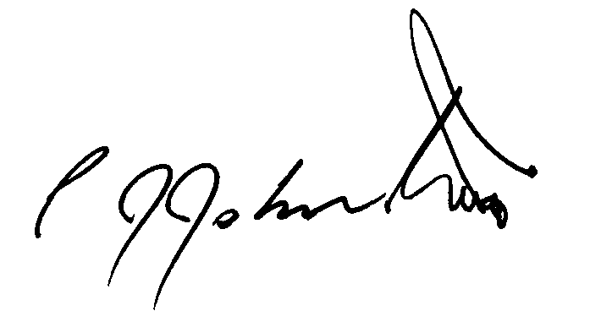
Philip J. Johnston
Ride Organiser, Muggaccinos Bicycle User Group

