**Attention Ms Danielle Haultain, PA, for Minister for Arts, Culture & Heritage**

A bicycle friend of mine, Ed Allen, retired last year as Principal Horn of the New Zealand Symphony Orchestra. On 10 March '12, following the National Concerto Competition in Christchurch, Ed mentioned to Christopher Finlayson, that a friend on his (retired social infrastructure banker ) had written a National Preventive Health Research Programme, known as Bohemian Teenagers Arts Assistance Programme. BTAAP essentially copies *El Sistema* which has successfully delivered a publicly financed voluntary sector music education program to the poorest areas of Venezuela for over 30 years which other countries have successfully followed.

Being a retired infrastructure banker, my focus is on Social Infrastructure Lifestyle Programmes that expend **x** to return multiples of **x**, or return **x** + **y**, not return less than **x**. Hence, my business plans go into significant detail to ‘nail down’ all the inputs, to avoid confusion and enable costings and estimate ROE.

My enclosed letter on 3 DVDs (copies) to Christopher Finlayson dated 27 Mar ‘12 points out that there are no intellectual property implications because my business plans provide for a Peppercorn Fee of $1 to purchase the I.P. from a few years of my R&D as a retired infrastructure banker. I previously was involved in financing a plethora of large infrastructure projects such as Sydney Harbour Tunnel which started with an Information Memorandum (legal document) and end with a profitable vehicle tunnel which has alleviated traffic congestion on Sydney Harbour Bridge.

If the Minister for Arts, Culture & Heritage is interested in exploring Bohemian Teenagers Arts Assistance Programme, I welcome him sending one of the enclosed DVDs to your Minister for Health, Tony Ryall, because my First National Preventative Health Research Programme, known as Youthful Exuberance Lifestyle Programme, will Materially Alter Lifestyle. YELP’s structure will enable Interested Adults who presently are overweight, have poor diets and maintain little exercise activity to Materially Alter Lifestyle Behaviour because Recreational Exercise Activity within a Local District Recreational Exercise Group, which provides a Local Community Common Bond Support Group, is ‘fun and addictive’. There are over 500 Defined Terms and 30 Sections in YELP because enthusing people to alter their Lifestyle Behaviour involves input from individuals, community groups, government, NGOs and industry groups under a structured *‘scratch and feel’* fully documented business plan.

Youthful Exuberance Lifestyle Programme employs the same business plan structure as Bohemian Teenagers Arts Assistance Programme. Both programmes will improve the mental and physical health of large numbers of adults and teenagers by providing Social Infrastructure which improves QOL, reduces health costs and increases GDP. Hence, if the Minister for Arts, Culture & Heritage is interested in exploring Bohemian Teenagers Arts Assistance Programme he may see merit in seeking the views of your Department of Health particularly for Youthful Exuberance Lifestyle Programme.

Regards

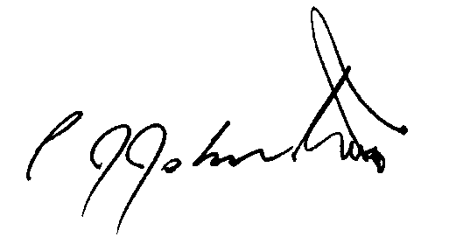

Philip J Johnston  
[**scribepj@bigpond.com**](mailto:scribepj@bigpond.com)  
61434715861