23 April 2008

Dear Mr Johnston

Thank you for your correspondence regarding a Business plan for the “Youthful Exuberance Lifestyle Programme’. I am replying on behalf of the Academic Directors of the Centre for Overweight and Obesity (COO) and Centre for Physical Activity and Health (CPAH), at the University of Sydney.

As you have gathered from our websites and COO Strategic Plan, both of these Centres are engaged in public health research regarding physical activity and prevention of overweight and obesity. We are aware of the health and economic benefits of any increases in physical activity across the population, including the cost savings related to major diseases such as diabetes.

As our focus is public health research, rather than program development or implementation, we are not qualified or in a position to review private-public partnership projects. Your proposal may be of more interest to agencies who are involved in implementing projects and the associated fund-raising, such as non-government agencies.

With regard to research, COO and CPAH are, at present, fully engaged in conducting a number of major research projects, including projects on diabetes prevention and the promotion of physical activity amongst adults, and are not in a position to initiate any new partnerships or program initiatives.

We wish you well in your efforts in promoting the benefits of physical activity.

Yours sincerely

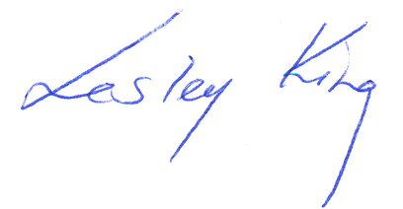
Lesley King

The NSW Centre for Overweight and Obesity is funded by the NSW Health Department

