5 Ronald Ave, Harbord NSW
0412 045.224 (02) 9114.6689
ScribePJ@TPG.com.au
27 November 2007

Mr. Warwick Anderson Grant's Help Desk 6217.9165 fax
Chief Executive Officer Research funding 6217.9045 fax
National Health & Medical Research
Council of Australia
GPO Box 1421
Canberra ACT 2601

Dear Mr. Anderson
Business Plan for NSW Department of Health or another Health Agency to -
I. implement a 12 month Pilot in NSW of a Youthful Exuberance Lifestyle Programme ("YELP") to achieve a Critical Mass of >5,000 new Participants in 14 Recreational Exercise Activities presently provided by +900 existing district recreational exercise groups; and
II. conduct a 9 months Research Programme (within the Pilot) in NSW to measure the Hypothesis' scope to materially reduce Seven Problems which presently costs Australia over $100 billion annually
Scope for cash injection and modelling resource input for YELP from major Australian companies under a Public Private Partnership
I refer to the enclosed letter to you dated 12 November 2007 which I posted to you -
(i) with 2 CDs two weeks ago; and
(ii) a week ago with a further copy CD, which I undertook to provide in my enclosed letter.
Each CD contains over 600 files which collectively provide a +300 page Business Plan for a Youthful Exuberance Lifestyle Programme. My letter to you dated 12 November 2007, the Attachment and Section Titles, summarise the Business Plan. By inserting the CD into a CD drive, my enclosed letter opens providing over 3,500 URLs to related Defined Terms and Section Titles within the Business Plan. If you save the CD to a hard drive, you need to click on
C:Youthful Exuberance Lifestyle Program/Invitations/Invitation_letter.htm.
A vital facet of my Business Plan is a 9 months Research Programme to quantify, using Purpose Built Quant Modelling Software and a Base Case Financial Model, the Hypothesis' scope to materially reduce the Seven Problems by calculating the Economic Return on Capex.
The Writer is an early retiree Commonwealth Bank Infrastructure Banker with a lifetime in voluntary sports administration. The Writer previously dealt with business associates from a few of the largest Australia companies (investment banks, law firms, infrastructure companies, 'et al') who -
A. understand how to develop infrastructure finance projects from an initial business plan to financial close and ultimately practical completion and commencing the operations phase; and
B. share the Writer's passion for the benefits of regular rigorous, challenging, recreational exercise, amidst a Common Bond Support Group which is the Hypothesis.
Should NHMRC exhibit early interest in my Business Plan, I am confident of attracting both cash injections and modelling input from some large Australian companies to develop Purpose Built Quant Modelling Software and the Base Case Financial Model. These companies employ modellers expert in creating base case financial models to measure economic return on equity and Capex.
A patent further benefit of accepting resource input from the private sector under the structure of a Public Private Partnership (PPP") is the encouragement the senior execs of these companies would provide to their employees for YELP, which would materially facilitate both the 9 months Research Programme and the 12 months Pilot.
2
In my last role at Commonwealth Bank I worked on PPP's in "Social & Corporate Infrastructure". PPPs are favoured by government as generally private equity carries 'inter alia' credit risk, construction risk and patronage risk during the concession period.
A PPP for YELP would have different drivers and a different equity structure, because -
A) the CEOs of major companies are invariably keen to -
(I) demonstrably encourage their employees towards a healthier lifestyle, and
(II) be associated with an explicit scratch and feel proactive healthy lifestyle programme with definitive Milestones and targets to create a more productive and cohesive Australia; and
B) Government needs to retain policy and management control over health projects, incl YELP.
Consequently, I envisage that say up to a dozen major Australia companies (incl an investment bank, a traditional bank, 2 major law firms, infrastructure companies etc) would each hold equity in a PPP, as well as a Health Agency which would retain control over YELP. The Purpose Built Quant Modelling Software and the Base Case Financial Model would represent intellectual property which, upon a successful Pilot, could be sold to other countries or perhaps provided to them as a goodwill gesture say under Australia's commitment to address Global Warming. Such a PPP would not be a cash cow, but enable material goodwill around brand name.
Section 17 "Budget for 12 months Pilot in NSW, including 9 months Research Programme" establishes that the development and rollout costs are exceedingly low due to -
a) the enthusiasm of Recreational Exercise Consultants who possess Ten Sports Administration Attributes; and
b) Three Low Cost Propagation Initiatives.

These costs would reduce under a PPP structure where a Health Agency on behalf of government, also held equity, and importantly retained policy and management control under a trust deed with the other equity partners.
As a former infrastructure banker the Writer views YELP as expending Capex in the Pilot, Propagation and Product Phases on Brownfield Infrastructure (Australian Interested Adults) to retrofit many of them (in varying degrees from minor to major re-fits - depending on each Interested Adult's state of disrepair) to strengthen them by re-igniting Youthful Exuberance (a trait that many adults can relate to, but presently believe has passed them by) to improve -
(a) their own productivity and QOL; and
(b) the nation's bottom line productivity by reducing the costly Seven Problems.
I welcome -
I. your response letter, and e-mail, which confirms receipt of my letter dated 12 November 2007; and
II. meeting with some of your delegates prior to Christmas, together with one of the afore-mentioned corporate execs who has a passion for rigorous exercise in the great outdoors, to discuss this Business Plan.
Yours sincerely
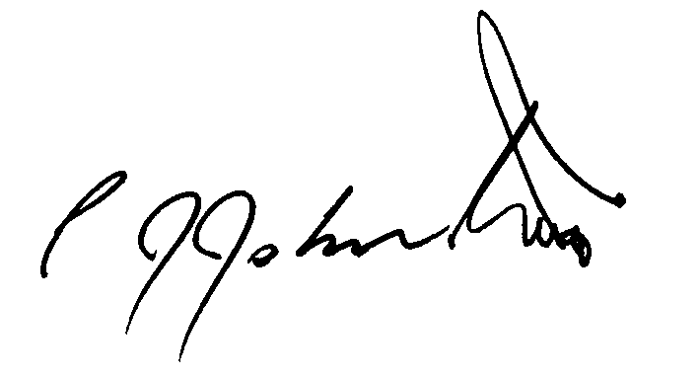
Phil Johnston
Ride Organiser and President Muggaccinos Bicycle User Group
Director of KOMpm Pty Ltd

