5 Ronald Ave, Harbord NSW
0412 045.224
(02) 9114.6689
ScribePJ@TPG.com.au
3 March 2008
Hon. Reba Meagher, MP (02) 9228 3555 reba.office@meagher.minister.nsw.gov.au
Minister for Health
Level 37, Governor Macquarie Tower
1 Farrer Place, SYDNEY NSW 2000
Ms Debora Picone
Director General
NSW Department of Health
73 Miller Street
North Sydney NSW 2060
Mr Philip Koperberg, MP. 02 9228.5488 office@koperberg.minister.nsw.gov.au
Minister for Climate Change, Environment and Water
Level 35 Governor Macquarie Tower,
1 Farrer Place, SYDNEY NSW 2000
Ms Lisa Corben
Director General
Department of Environment and Climate Change (NSW)
PO Box A290, Sydney South NSW 1232
Dear Ms Meagher, Ms Picone, Mr Koperberg and Ms Corben
Business Plan for Youthful Exuberance Lifestyle Programme ("YELP") to -
A. to reduce the >$100b annual cost of Seven Problems which each impact Health and Lifestyle Behaviour; and
B. to immediately enact IPCC's edict for a "dramatic shift in lifestyles" to mitigate Climate Change.
Revised Invitation Letter provided under this Covering Letter with two x 'Version 2' Business Plan CDs
On 5 Feb 2008 I posted an Invitation Letter to the above four addresses and enclosed two CD ROMs with each copy of that letter. Each CD ROM automatically opened my Invitation Letter to the above four addresses which provided several thousand URLs to navigate and assess my YELP Business Plan.
It involves a consortia of 'Public Sector' and major 'Private Sector' companies pooling their skills and influence to conjointly provide under an PPP a Youthful Exuberance Lifestyle Programme ("YELP") to reduce the >$100b annual cost of Seven Problems, most notably reduce Climate Change, Obesity, Hypertension and Recreational Drug Abuse.
Presently GPs, via Lifescripts, are the forefront of motivating Australians to Materially Alter Lifestyle. $5.5 million has been expended into Lifescripts since 2003. However, the Writer has been unable to source any data that Lifescripts has achieved its goals. My Business Plan contends that Recreational Exercise Consultants will achieve this vital role at a lower per capita cost and materially more effectively.
In addition, Recreational Exercise Consultants under YELP will develop/consolidate Common Bond Support Groups within local District Recreational Exercise Groups to ensure that Exercising locally within one of the 14 initial Recreational Exercise Activities is fun and addictive which strengthens the social fabric of communities.
2
A primary focus of YELP is to encourage Australians to Materially Alter Lifestyle by leading a Local Healthy Lifestyle where Economic Materialism, in particular recreational air flights and motor vehicle transport holds a lower priority, thereby leaving a smaller Personal Carbon Footprint.
After posting my Invitation Letter of 5 Feb 2008 I learnt that unless the reader's Internet Explorer is set to Arial font, that approx 10% of the text in my Business Plan would display in Times New Roman or other fonts which can make it a tad difficult to read when the remainder is in Arial.
Enclosed are two x Version 2 Business Plan -
(i) without that font default problem where all text should display in Arial; and
(ii) which details the proposed Annual King of the Mountain Challenge Series as the 4th Phase "Product" of the Business Plan to attract 200,000 Interested Adults (by end 2010 ) to log a Climb Time after climbing up a local KOM Climb under the 4th Product Phase which evidences their physical achievement.
The Annual KOM Challenge Series which capitalises on -
* the fervour of an Australian being the favourite to win the pending 2008 Tour de France; and
* burgeoning focus on and take-up of cycling for health and to reduce Climate Change,
to provide an annual safe, healthy exercise competition whereby 'State Health' and 'Environment & Climate Change' could award Abled, Disabled and Disadvantaged, whose Lifestyle Behaviour renders them the best in their Age Division or Disabled Category under Annual Challenge Series Competitions.
Both Federal and State Health strategies acknowledge the merits of Preventive Health (which includes diet and regular exercise) as opposed to incurring the increasing costs of repairing negligent Lifestyle Behaviour. Hence, my Business Plan contends what better way than for 'State Health' and 'Environment & Climate Change' departments to accredit the best performers in each Age Division and Disabled Category which lead a Local Healthy Lifestyle. It also entails an Annual Presentation Awards Dinner in each State capital to recognise -
(i) Australians who have Materially Altered Lifestyle Behaviour due to YELP; and
(ii) other Australians who materially foster 'Local Community' through YELP's Common Bond Support Groups.
Yours sincerely
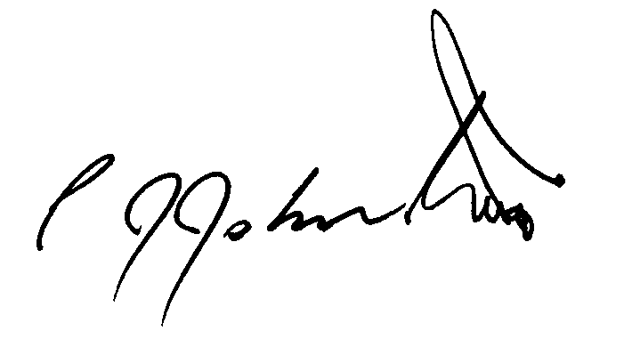
Phil Johnston
Ride Organiser and President Muggaccinos Bicycle User Group
Director of KOMpm Pty Ltd

