SYDNEY’S RAIL FUTURE
Modernising Sydney’s Trains

June 2012
Transport
MASTER PLAN
Sydney’s
RAIL FUTURE

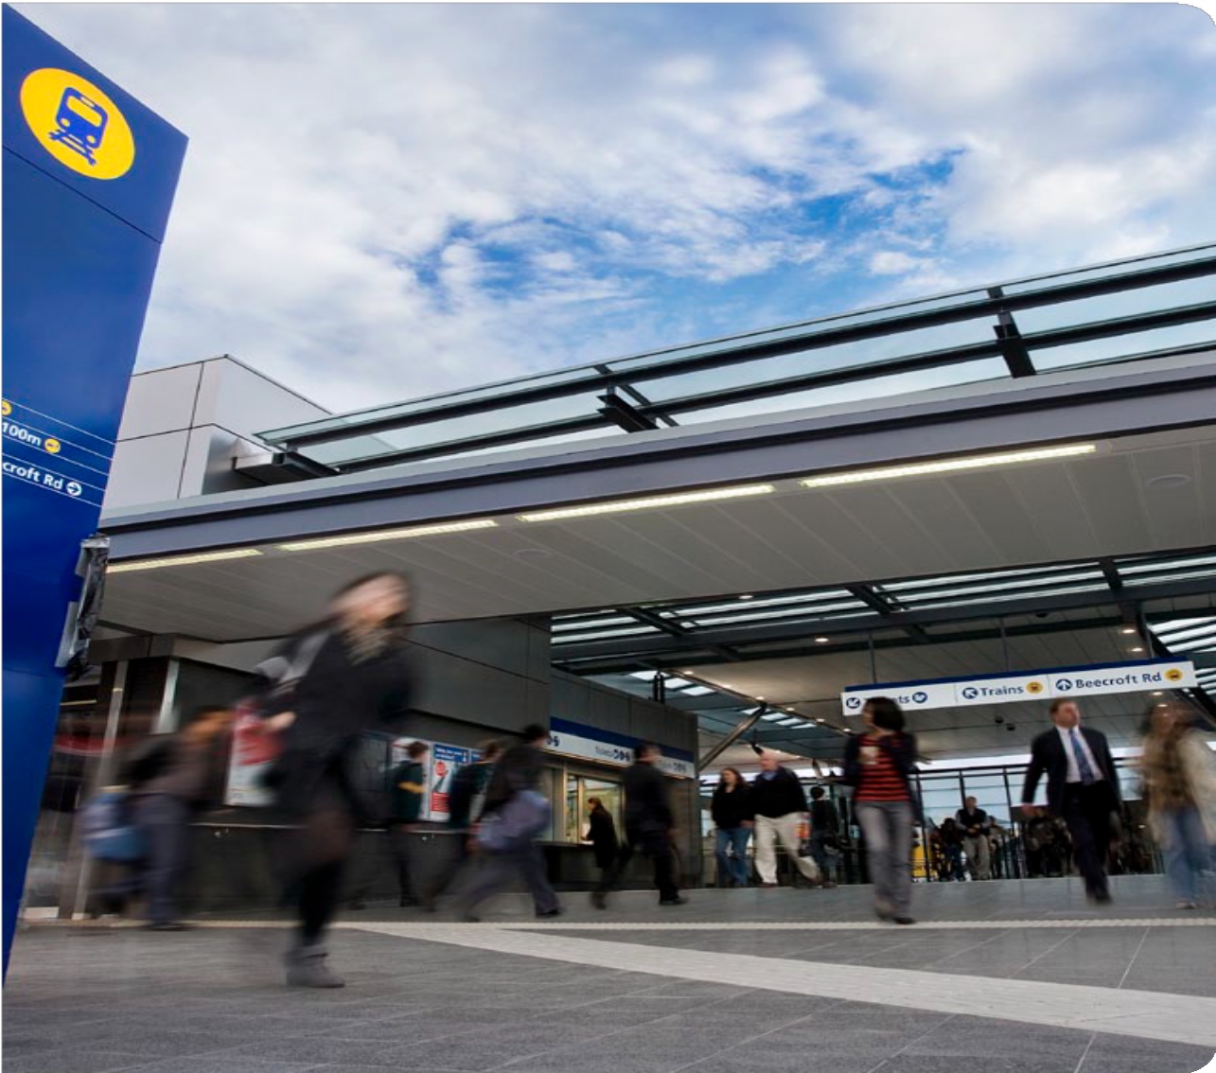

Sydney’s Rail Future Modernising Sydney’s Trains June 2012
ISBN: 978-1-922030-18-4
Copyright notice
© State of New South Wales through the Director General of Transport for NSW, 2012.
Transport for NSW
18 Lee Street
Chippendale NSW 2008

Disclaimer
While every reasonable effort has been made to ensure that this document is correct at the time of printing, the State of NSW, its agents and employees, disclaim any and all liability to any person in respect of anything or the consequences of anything done or omitted to be done in reliance upon the whole or any part of this document.

CONTENTS

MINISTER’S MESSAGE 4
Transport
MASTER PLAN
Sydney’s
RAIL FUTURE
THE CHALLENGES 5
THE SOLUTION 10
PUTTING THE CUSTOMER FIRST 13
YOUR TRAIN LINE 15
WE LISTENED 21
ALTERNATIVE FUTURES CONSIDERED 22

MINISTER’S MESSAGE

The NSW Government has developed a plan to transform and modernise Sydney’s rail network so that it can grow with our population and meet the needs of customers into the future.
Transport
MASTER PLAN
Sydney’s
RAIL FUTURE
It is clear that Sydney’s rail system is reaching the limits of its capability. At present, there are parts of the network where 20 trains are scheduled to run in the busiest peak hour but
frequently only 17 trains actually arrive during that same period.

This ageing and complex network cannot be expected to carry more and more passengers. We simply do not have capacity for the future.
Sydney’s rail system needs to be modernised.

Sydney’s Rail Future is a long term plan to increase the capacity of Sydney’s rail network through investment in new services and upgrading of existing infrastructure. It is a plan to improve the customer’s experience.
Work has already commenced to improve reliability and increase services across the network.

Significant technology investments and upgrades will see our community benefit from more reliable and more frequent services.
We will introduce single deck, rapid transit trains on the North West Rail Link. Sydney will also have a second crossing under the Harbour linking to a new CBD line and new stations, which will use rapid transit services that will also eventually operate on the Bankstown line and to Hurstville on the Illawarra line.
This plan will eventually enable Sydney Trains to carry another 90,000 to 100,000 people per hour in the peak.

Sydney’s Rail Future is an integral part of the NSW Long Term Transport Master Plan. Last year we committed to a program of consultation with the people of NSW and this strategy reflects the feedback we received from thousands of people interested in seeing improvements to rail services in Sydney. We also engaged with transport experts who provided invaluable input into the process.
The NSW Government is delivering this major rail program so that we can meet the challenges of a growing population and deliver a world class service people want to use.

Gladys Berejiklian MP Minister for Transport

THE CHALLENGES

A growing city
Sydney is a modern international city experiencing growth in population and employment. Sydney currently has a population of about 4.6 million, but this is projected to grow significantly over the
coming years to 5.1 million by 2021 and 6 million by 2031. Driven by population growth, employment
in Sydney is expected to increase from its current level of 2.1 million workers to 2.6 million by 2031.

As Figure 1 illustrates below, the Sydney CBD will remain the primary employment centre, and the global economic corridor, including Macquarie Park, North Shore, CBD and the Sydney Airport, will account for about a third of the employment opportunity in Sydney.
This growth is going to place pressure on a rail system already straining to cope with current demand from years of under investment.
Transport
MASTER PLAN
Sydney’s
RAIL FUTURE

Figure 1: Major employment centres Sydney 2031
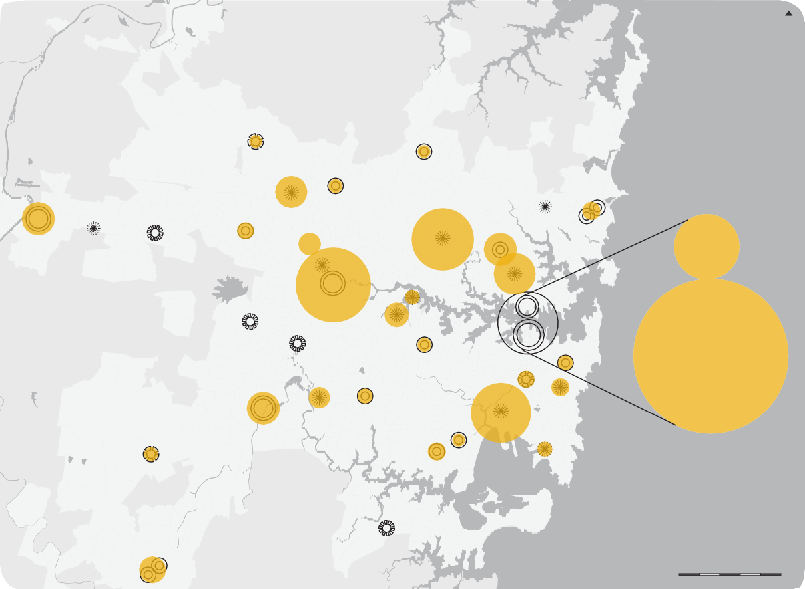
N
NORTH WEST GROWTH CENTRE
12K
Hornsby
Rouse Hill
12K
Norwest
Castle Hill
13K
31K
Mount Druitt
30K
Blacktown
16K
Frenchs Forest
17K
31K
Dee Why Brookvale
Penrith Penrith
Education and Health
21K
Macquarie
Park
61K
Westmead
Parramatta
58K
Chatswood
39K
St Leonards
Rhodes 14K
70K
Sydney Olympic Park
North Sydney
Prairiewood 23K
13K
Fairfield Burwood
Green Square
Sydney
14K
Bondi Junction
454K
16K
14K
Bankstown
Randwick
Education and Health
17K
SOUTH WEST GROWTH CENTRE
31K
Liverpool
20K
Bankstown Airport- Milperra
Sydney Airport
13K
Leppington
17K
56K
Kogarah
Hurstville
12K
16K
Port Botany
Sutherland
25K
Campbelltown Macarthur
0 2 4 6 8 10 km
Source: Transport for NSW

Capability
Transport
MASTER PLAN
Sydney’s
RAIL FUTURE
We cannot expect to continue to carry more and more passengers on a rail network that has not fundamentally changed for many decades. Even today, there are parts of the network where the daily task of transporting people is asking too much of a system that has been built over a period of more than 150 years.

Comparing Sydney’s rail system to major world cities shows that we have pushed the complex two-door double deck network further than any other operator.
The ageing and complex system has a number of ‘bottlenecks’ that effectively slow the whole network down:
- Large numbers of junctions – trains converge on the same line and must cross at ‘junctions’.
- Complex train timetables that demand trains with different service patterns share the same line, which can result in slower trains delaying fast and express trains.
- Crowded trains with 3 by 2 seating arrangements, which are slow to load and unload, resulting in long ‘dwell times’ (the time a train needs to stop in a station for passengers to board and alight).
- Crowded stations that rely on stairs instead of escalators as the principal means of accessing platforms and concourse levels.
- Narrow platforms in busy CBD stations, which hinder passenger flow between trains and stairs and make it difficult for customers on the platform to make way for passengers alighting from trains.
- Traditional signalling technology, which impedes optimised train running and maximum utilisation of line capacity.

Example of Sydney’s complexity: Western line peak morning traffic
The Western line is Sydney’s most heavily used and least reliable line. As shown in Figure 2 the Western line is complex to operate. It has 12 key bottlenecks where trains have to merge tracks with other lines, wait for opposing trains to cross, or face delays due to slow boarding and alighting at key stations.
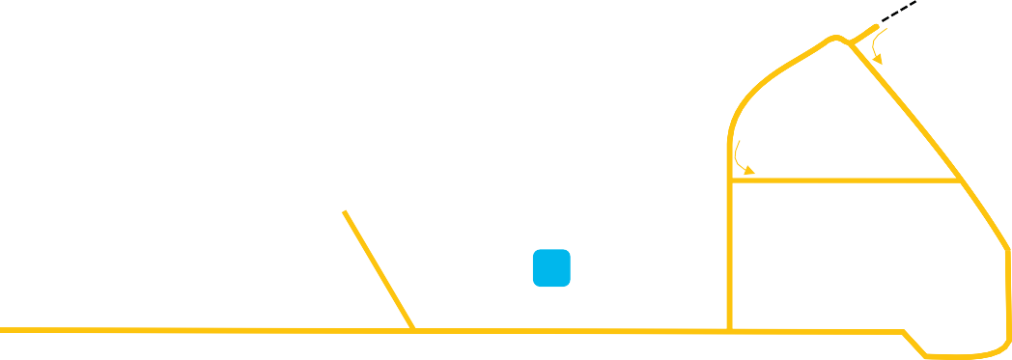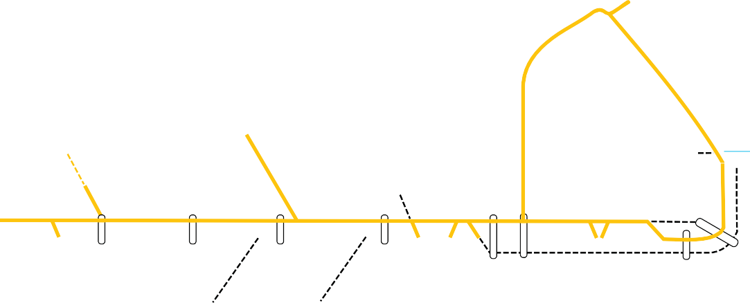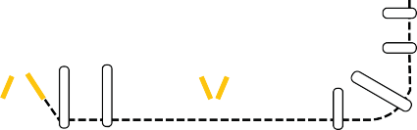Figure 2: Complexities on the Western line – bottlenecks

Hornsby
AM PEAK

Richmond line merges

Carlingford
Empty train to Flemington car siding
crosses inbound trains

Epping

North Sydney

Chatswood

12

Empty train to North Sydney

Emu

Penrith
Schofields

2
5
Flemington

Wynyard Town Hall Central
car siding
Extended platform dwells at
11
10 Town Hall

Plains
St Marys Blacktown
Parramatta

Granville Lidcombe Homebush Strathfield

Ashfield Illawarra Redfern Junction
and Central

1 3 4 6 7 8 9

Blue Mountains / West Suburban
merge
South line merges with Western line
Merge of Bankstown with Western line
CountryLink trains cross
inbound trains
Homebush flat junction crossing
Strathfield merge and flat junction crossing
Illawarra merge and conflicting crossing

Capacity
Transport
MASTER PLAN
Sydney’s
RAIL FUTURE
The closer we get to the capacity of the system, the less reliable it will be and the less it will meet the needs and expectations of rail customers.
Sydney’s rail network faces a number of capacity challenges:

- There are parts of the rail network, such as the Western line, where 20 trains are scheduled
to run in the peak hour, yet frequently only
17 trains actually arrive during that same period.

- As reliability challenges have increased, journey times by rail have been increased – indeed, journeys on many lines are between 10 per cent and 20 per cent slower today than in 1992.
- On current projections, if we simply do the minimum with the rail network and allow for modest increases in capacity alongside
committed rail projects, the network will run out of capacity at some point during the mid to late 2020s – this means that most lines running through the network will experience overcrowding.

- Without action, the capacity will be reached much sooner. This will mean that most lines running through the network will experience overcrowding, with the most affected areas being on the already heavily used lines coming into the CBD from the West and North Shore.
- The Government is adding new services to the network through the North West Rail Link and the South West Rail Link. This requires additional capacity on the rest of the system, and in particular, into the CBD.

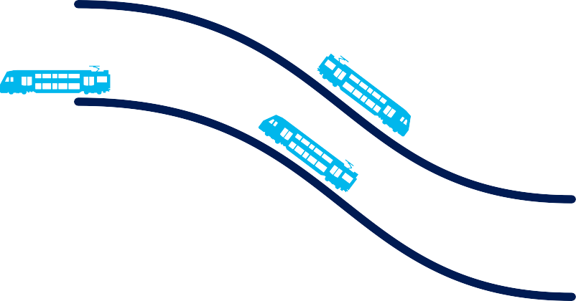Illawarra merge and conflicting crossing – trains in the busiest hour

15 trains 8 trains

Up Main To Central

9 trains 8 trains

Down Main From Central

12 trains 19 trains

Up Suburban To Central

14 trains 15 trains

Down Suburban From Central

Figure 3: Forecast network performance 2031 – without a second Harbour Crossing and new CBD line
Transport
MASTER PLAN
Sydney’s
RAIL FUTURE
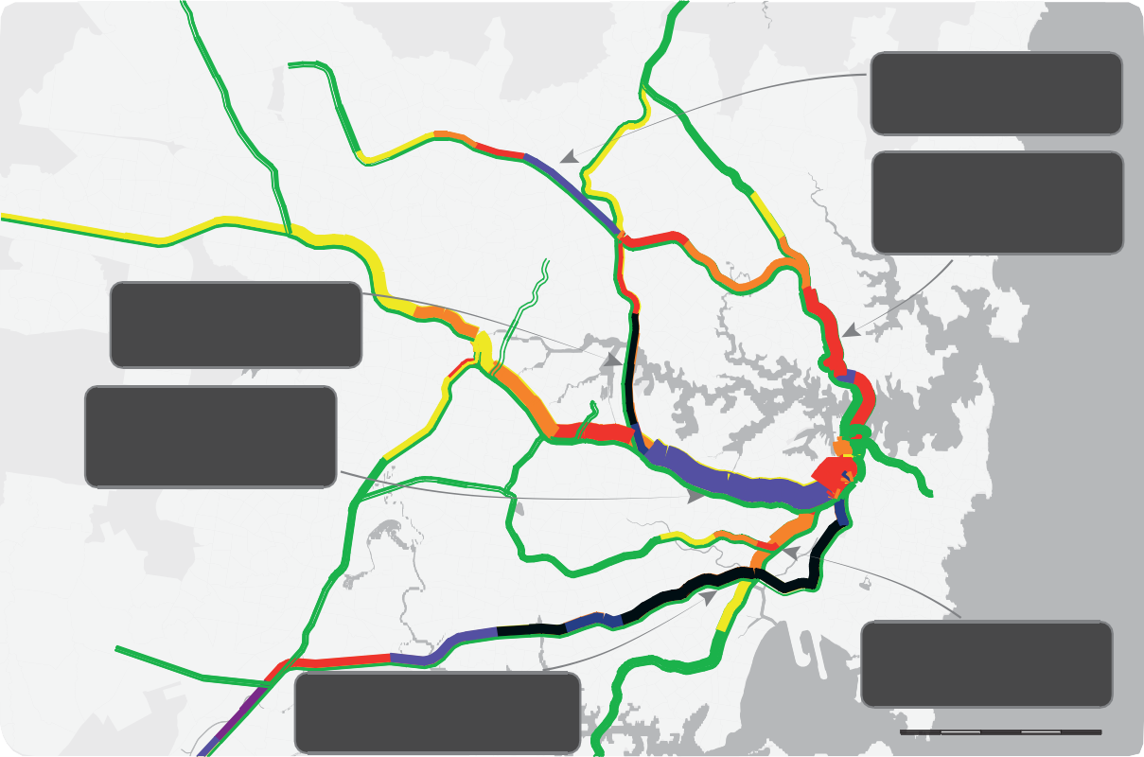
Rouse Hill
Hornsby
North West Rail Link
Signficant level of crowding upon approach to Epping
Castle Hill
Norwest
Blacktown
Epping
Macquarie
Park
Mount Druitt
Carlingford
North Shore Line
Total capacity exceeded on large sections of line between Chatswood and Wynyard
Chatswood
Northern Line
Passenger displacement starting to occur on approach to Strathfield
St. Leonards
Parramatta
North Sydney
Western Line
Crowding levels having a material reliability impact between Strathfield and Redfern
Sydney Olympic Park
Fairfield
Lidcombe
Burwood
Wynyard Town Hall Central
Cabramatta
Redfern
Green Square
Bondi Junction
Liverpool
Bankstown
Sydney Airport
Leppington
Glenfield
East Hills and Airport Lines
Passenger displacement on much of the line
between Revesby and Green Square
Hurstville
Bankstown Line
Levels of crowding with some reliability impact approaching Sydenham
0
2 4 6 8 10 km
Crowding Level
Very Low Low Moderate
CaHmigphbelltown
MacartVheurry High
Passenger displacement
Description of crowding for double deck trains
Passengers are mostly seated
Sutherland
Seated capacity is reached and people start to stand Standing space approaching full for reliable running Crowding with some reliability impact
Crowding starting to have material reliability impact
Additional passengers are unable to board the train
Cronulla
Note: The above passenger crowding levels are based on total capacity (including both seated and standing passengers).
This is a more generally accepted measure internationally rather than expressing capacity on the basis of seating alone.

Source: Transport for NSW

Figure 3 shows that by 2031 if major capacity improvements are not made, the CBD, Western, Northern, North Shore, Bankstown, East Hills and Airport lines and North West Rail Link will reach crowding levels during the morning peak period that are deemed ‘high’ or above. This suggests that these lines will reach maximum capacity limits or even exceed capacity.

Figure 4: Passenger movements at main CBD stations AM peak hour – comparison 2011 and 2031
Transport
MASTER PLAN
Sydney’s
RAIL FUTURE

Wynyard
Do Minimum 2031

Base Year 2011

Town Hall

Central

0 10,000

20,000

30,000

40,000

50,000

60,000

Source: Transport for NSW

CBD congestion
Passengers per hour

employment is forecast to rise from an estimated 8,000 in 2016 to more than 20,000 in 2031. The

Without improvements, the CBD will experience
significantly higher levels of congestion by 2031, as almost half of morning peak travel has a CBD station as its destination. Therefore, the expected growth in travel to the CBD is linked to the growth in demand across the various rail lines. Figure 4 shows the forecast increase in passenger movements, including boarding, alighting and interchange, through the main CBD stations in 2031 as a result of this increase in rail trips. By 2031 each of the three busiest CBD stations are expected to experience an increase of more than an additional 10,000 passengers per hour in the peak.

Barangaroo
At the new Barangaroo development alone
– the closest CBD rail station being Wynyard –
Wynyard Walk, now under construction, will allow workers to walk between Wynyard Station and Barangaroo. The current train network is not set up to deal with the extra commuters trying to get to work at Barangaroo.

Suburban bottlenecks
The Western and North Shore lines are the key bottlenecks of the network, as these lines have the highest level of interchange and station congestion in the CBD. A congested platform at Town Hall can create flow on delays at Blacktown and Penrith.
Growth in South Western Sydney and in the Sydney Airport Precinct will place increasing pressure on the East Hills line which must share track through the CBD with the busy Bankstown line.

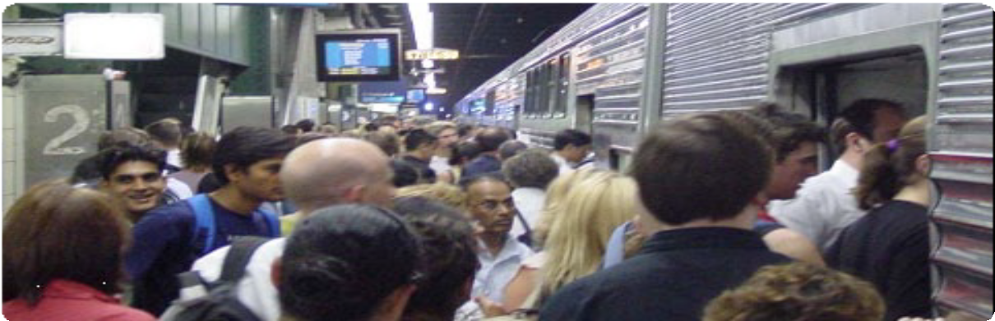

THE SOLUTION – SYDNEY’S RAIL FUTURE

Sydney’s rail system needs to be modernised. The challenge posed by the complex ageing system means that the current network cannot grow sufficiently to meet forecast demand. The current network does not deliver what customers want – shorter journey times and services that are more regular, more reliable and tailored to different customer needs.
Transport
MASTER PLAN
Sydney’s
RAIL FUTURE

Services tailored to customer needs
In line with the approach of focusing specifically on the different needs of customers, Sydney’s Rail Future will deliver a three-tiered system to respond to changing customer needs.

TIER 1:  Rapid Transit | TIER 2:  Suburban | TIER 3:  Intercity
- Frequent ‘turn up and go’ services without the need for consulting a timetable  - Fast single deck trains, with plenty of seats, more doors, designed for easy boarding and alighting. | - Timetabled services  - Double deck trains with more seats per train. | - Timetabled services  - Double deck trains for Central Coast, Newcastle, Wollongong and Blue Mountains services  - Comfortable services for long distance commute and leisure travel with on-board facilities for improved customer convenience.

Whole-of-network approach
A whole-of-network approach has been taken to long term planning for Sydney’s Rail Future. It has closely analysed anticipated future demand across the network to identify areas requiring
significant capacity increases. Change will not be delivered overnight. The implementation of the strategy will unfold over the next 20 years through the implementation of a long term program of service improvements, capital works and network upgrades.

Practical and cost efficient plan
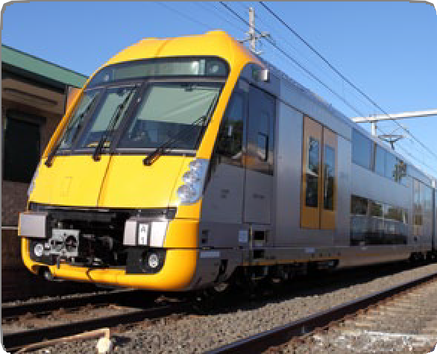
New investment and modifications to existing infrastructure will be the most efficient way to modernise Sydney’s rail network. Existing lines will undergo significant enhancements, such as Automatic Train Operation (ATO) that will improve capacity and performance. ATO does not mean driverless trains. ATO is a technique to improve the way trains accelerate and brake at stations to enable more trains on the line. The rapid transit lines will use single deck trains, which will also have ATO.

Fixing the Trains Program
Over the next 12 to 18 months, RailCorp will be restructured into Sydney Trains and NSW Trains, allowing each of the two new organisations to focus on delivering tailored services to their distinct customer segments.
Sydney Trains will serve customers who need quick, frequent and reliable trains in the metropolitan area.
NSW Trains will serve intercity, regional and country customers who travel longer distances and need comfortable and reliable services with on-board facilities.

Figure 5: Sydney’s Rail Future – A Three Tier Railway
Transport
MASTER PLAN
Sydney’s
RAIL FUTURE
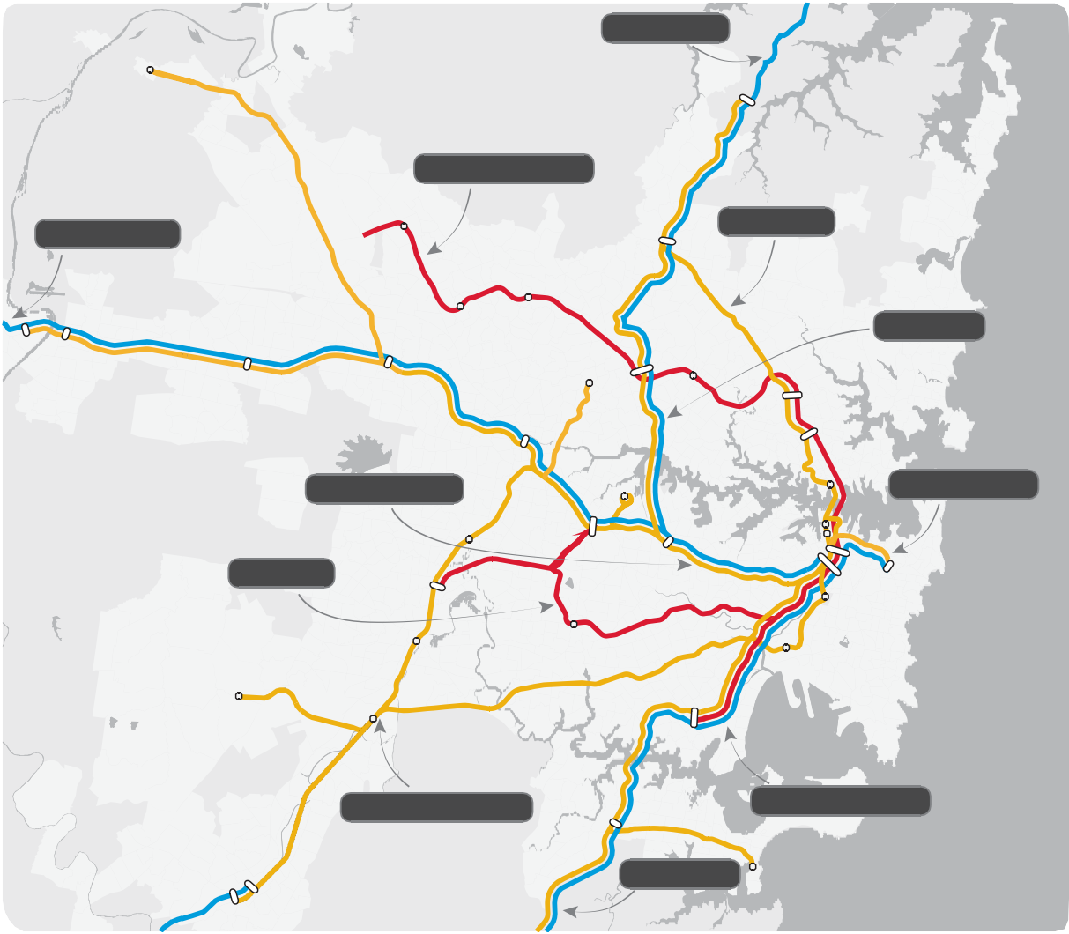
Central Coast
N
Richmond
Berowra
North West Rail Link
Rouse Hill
Blue Mountains
North Shore
Hornsby
Castle Hill
Penrith
Norwest
Main North
Emu Plains
Blacktown
Mount Druitt
Epping
Macquarie
Park
Carlingford
Chatswood
Parramatta
St. Leonards
North Sydney
West / Inner West
Sydney Olympic Park
Eastern Suburbs
Fairfield
Burwood
Lidcombe
Wynyard Town Hall
Central
Bankstown
Cabramatta
Bondi
Redfern Junction
Green Square
Liverpool
Bankstown
Sydney Airport
Leppington
Glenfield
Hurstville
South West / East Hills
Hurstville / Illawarra
Sutherland
South Coast
Cronulla
Campbelltown Macarthur
0 2 4 6 8 10 km

Rapid Transit Network (Single Deck) Suburban Network (Double Deck)
InterCity (Double Deck) and Regional Diesel

THE FIVE STAGES OF SYDNEY’S RAIL FUTURE

Operational efficiencies
Transport
MASTER PLAN
Sydney’s
RAIL FUTURE
1

2

Network efficiencies

3

New rapid transit system

4

Second Harbour Crossing

5

Southern sector conversion
- Timetable overhaul to introduce standardised and regular ‘clockface’ stopping patterns, more express services
- Significantly improved dwell management, with better management of door closure
- Platform de-cluttering to allow clear passenger entrance and exit
- Better incident recovery management through improved operational processes.

- Completion of South West Rail Link, station upgrades and Rail Clearways projects
- Introduction of even simpler timetables across the network
- Introduction of Automatic Train Operations
- Transition to dedicated fleet types for some lines
- Track infrastructure enhancement
- Platform re-design.

- Rapid transit trains are used to offer a comfortable, frequent, fast and high capacity link to busy inner areas
- Completion of the North West Rail Link and procurement of rolling stock for the new rapid transit single deck train system initially operating between the North West and Chatswood, with a cross-platform interchange to suburban services for those customers travelling to the CBD
- There will be a train from Chatswood to the CBD every three minutes in peak periods
- In line with the North West Rail link, upgrade of the Epping to Chatswood Rail Link to a high capacity rapid transit system.

- Completion of a new tunnel under the Harbour and a new Sydney CBD line, allowing services from the North West Rail Link to extend directly to the Sydney CBD
- The second Harbour Crossing will create the largest increase in capacity to the Sydney rail network for 80 years
- Untangling the CBD enables major capacity increases on the Western line.

- Extension of the new single deck service to Bankstown and Hurstville
- Continue major timetable changes to the existing suburban services to continue major capacity increases to the South West and Western Sydney
- Better express services introduced due to separation from rapid transit.

PUTTING THE CUSTOMER FIRST

The NSW Government is committed to putting the customer first. Driving this strategy is a commitment to:
  - Creating a more reliable service
  - Getting Sydneysiders to work on time
  - Maintaining a safe, clean and comfortable commuting environment
  - Running more services
  - Reducing travel times.

The future customer experience
Sydney’s Rail Future will positively influence customers’ experience of the rail network. People travelling along the corridors linking the north west, the global economic corridor and the Bankstown and Illawarra lines will be able to ‘turn up and go’ without consulting a timetable.
Passengers travelling on other lines will have access to suburban or intercity services, with improved reliability and additional services that will be greatly enhanced by a range of technological innovations.

Interchange
Some customers may need to interchange more than they currently do, but increased frequency of services on the new rapid transit system will reduce the inconvenience of interchange, as customers
will not need to wait long for a connecting service. Customers will in most cases be able to board the next train arriving at their platform in busy CBD stations. They will not have to wait at crowded CBD stations for what may be the third or fourth train.
Overall journey times will be reduced.

Safety
All new train carriages will be fitted with security cameras and there will be improved lighting at stations and car parks.

An alternative to cars
More services will be available throughout the day on many lines, giving customers real alternatives to using their car or other transport modes.

Sydney’s Rail Future is a modern approach that will accommodate population growth and ensure that the rail system provides an efficient and reliable backbone to the public transport system into the future.

Modern passenger information systems – integrated ticketing
Transport
MASTER PLAN
Sydney’s
RAIL FUTURE
Real-time information will be provided at stations by introducing more modern passenger information systems.
High-quality facilities will be put in place through an ongoing program of upgrades and redevelopment, including the construction of new car parks and improvement of lighting and other safety features at stations, as outlined in the Transport Access Program. Integrated ticketing will also make it easier for customers to switch transport modes.
WHAT IS THE TRANSPORT ACCESS PROGRAM?
The Transport Access Program is a new initiative to provide a better experience for public transport customers by delivering accessible, modern, secure and integrated transport infrastructure where it is needed most. The NSW Government has made available more than $770 million over four years to build key facilities and undertake much needed upgrade works at stations and interchanges.
The program aims to provide:
- Accessible stations
- Modern, efficient interchanges
- Commuter car parking
- Safety improvements, such as extra lighting, help points and other security measures
- Signage improvements.

KEY CUSTOMER BENEFITS – SYDNEY’S RAIL FUTURE
Transport
MASTER PLAN
Sydney’s
RAIL FUTURE

Faster more reliable services

Timetable improvements – less crossings at busy junctions
    - Major technological advancements, like Automatic Train Protection (ATP) and Automatic Train Operation (ATO)
    - Improvements to platform efficiency and design
    - Reduction in the time trains are stalled at stations - ‘dwell time’.

A new rapid transit system
    - A rapid-transit, high capacity, fast single deck train every five minutes, providing access
to key destination points through Sydney’s major employment and education centres
    - Rapid transit services for Hurstville, Bankstown, the lower North Shore, Epping to Chatswood and the North West Rail Link
    - A new high capacity service in the CBD
    - No timetable required on rapid transit system – turn up and go
    - Reliable with new infrastructure and technology.

Increased capacity
- More than a 60 per cent increase in services to the Sydney CBD, representing the biggest step change in capacity since the construction of the Harbour Bridge and city underground railway - an increase of up to 75 services over today’s busiest peak hour
- Ability to carry an additional 90,000 to 100,000 people per hour in the peak
- Major capacity improvements across the network with increases in the peak of more than:
- 60 additional trains across the Harbour and through the CBD (30 each direction)
- Up to 14 additional trains on the Western line.

Improved amenities

Greater customer information through countdown clocks and screens

Modern, clean and spacious new CBD stations

Transport Access Program – accessible stations, modern efficient interchanges, safety and signage improvements.

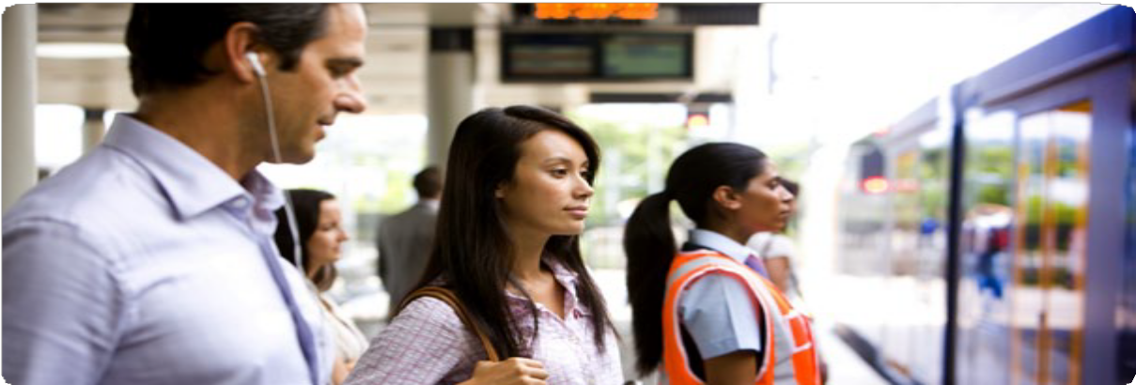

YOUR TRAIN LINE

Sydney’s Rail Future will modernise our train services, extending their reach and capacity. Benefits will be noticeable with the new 2013 timetable and will progressively continue in the following years.
Transport
MASTER PLAN
Sydney’s
RAIL FUTURE

New Harbour Crossing and new CBD line
The new Harbour Crossing and new CBD line will deliver a step change for Sydney’s rail services.
It will provide the foundation for a 60 per cent increase in the number of trains that can run during the busiest and most congested times. This will represent an increase of around 75 services over today’s busiest peak hour.

Additional capacity
This additional capacity will enable Sydney Trains to carry another 90,000 to 100,000 people per hour in the peak, delivering sufficient capacity to serve Sydney well into the future. Improved timetables, upgraded stations and advanced signalling systems will help to maximise the utilisation of new and existing tracks and deliver reliable services across the entire Sydney Trains network.
Sydney’s Rail Future removes bottlenecks and it enables trains on the Western line to be
separated onto three dedicated lines. Currently trains are sharing and merging across lines, causing delays and reducing capacity and the ability to run more trains.

Benefits all customers
The new Harbour Crossing and new CBD line will benefit all customers, not just those who commute across the Harbour and into the CBD. The additional capacity through Sydney’s most heavily used transit corridor will allow for a reduction in the network’s complexity that will
benefit services on all lines, because, for example, trains at Parramatta or Chatswood will not be delayed by conflicting train movements at the Homebush, Strathfield or Redfern junctions.
Reducing these bottlenecks frees up capacity across the Sydney Trains network.

A SECOND HARBOUR CROSSING AND NEW CBD LINE WILL:
- Unlock the CBD bottleneck and enable more services from the West, South West, Illawarra, Bankstown, North Shore and the North West
- Provide an extra 60 train services per hour through the CBD
- Create the largest increase in capacity to the Sydney rail network for 80 years
- Build new train stations relieving pressure on existing crowded platforms in the CBD
- Enable better connections to employment opportunities across Sydney.

Figure 6 – Your train line
Transport
MASTER PLAN
Sydney’s
RAIL FUTURE

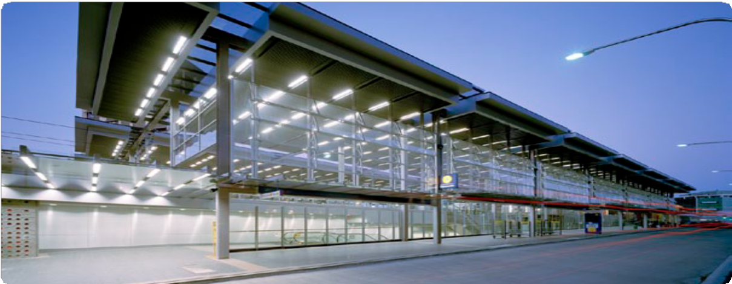Rapid transit tier
Intercity and Suburban tiers
To Gosford

Central Coast
Hornsby
Main North
North West Rail Link

To Blue
Richmond

Cudgegong Road
North Shore

Epping

Eastern Suburbs

Mountains

Penrith
Blacktown

Parramatta
Blue Mountains

Liverpool
Carlingford

Lidcombe
Bankstown

Bankstown
North Sydney

Central Redfern
Strathfield

West / Inner West
Sydenham

Bondi Junction

Leppington
Hurstville
South West / East Hills
Hurstville / Illawarra

To Goulburn To Wollongong
South Coast

Under the new three tier system each line will benefit as follows:
Transport
MASTER PLAN
Sydney’s
RAIL FUTURE

Tier 1: Rapid Transit

North West Rail Link
- Rapid transit services, initially 12 trains per hour during peak periods (a train every five minutes in peak periods) will be operated with new generation single deck trains, advanced signalling and dedicated track.
- The North West Rail Link trains will provide faster services than a double deck service. This relates to a journey time saving of 10 per cent. The trains will be fast, safe and highly reliable. Services will be intuitive, offering turn up and go convenience with high service frequency.
- The Macquarie Park and University area will move from the current service of a train every 15 minutes to a train every five minutes – from four trains per hour to 12 trains per hour.
- There will be a high frequency service to cater for the large number of customers getting
on and off at employment, commercial and educational centres between Rouse Hill and Chatswood, as well as along the lower North Shore towards the CBD.

North Shore
- Peak period services will increase from the current 18 trains per hour to 20 trains per hour prior to the new Harbour Crossing.
- Demand on this line will ease once the new Harbour Crossing is delivered, offering a higher capacity route from the North Shore to the CBD and to Sydney’s South.
- The new rapid transit service will also enable journey time savings of up to eight minutes between Chatswood and the CBD using the new Harbour Crossing, an improvement of 35 per cent over the current 23 minute journey.
- The additional capacity will lead to a significant improvement of rail services on the North Shore and allow for up to an additional 30 trains from the North Shore in the longer term.

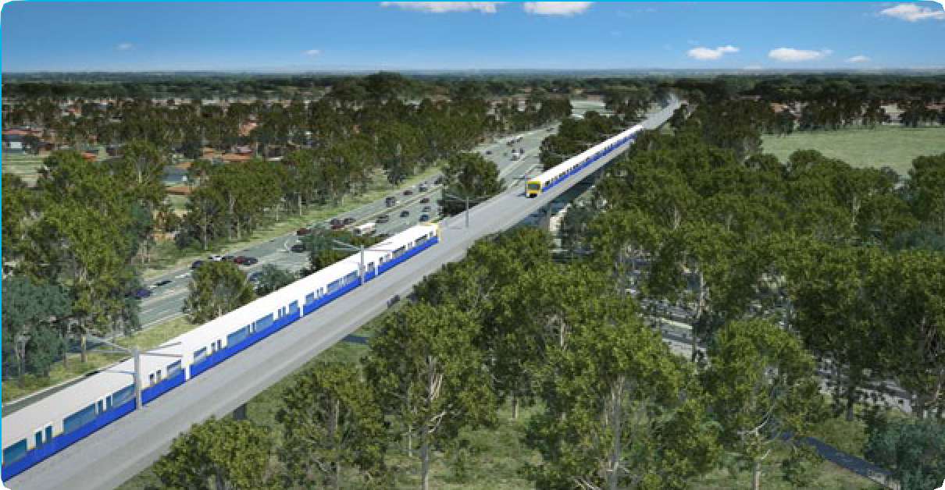

Bankstown
Transport
MASTER PLAN
Sydney’s
RAIL FUTURE
WHAT ARE RAPID TRANSIT TRAINS?
Rapid transit trains are used to offer a comfortable, frequent, fast and high capacity link between suburban regions and busy inner city areas using single deck rolling stock.
Sydney’s future rapid transit trains are expected to have the following features:
- Three or more doors per side per carriage, allowing fast boarding and alighting
- Level access between platform and train with reduced platform gap
- A mixture of seating areas, delivering a relatively high number of seats
•
•
Wide, open walkways between carriages
A fully air-conditioned passenger
environment
- A modern passenger information system
and train control systems.
  - The Bankstown line will receive new services in peak times from 2013.
  - With a new turnback at Lidcombe opening in 2013, Bankstown line trains will no longer get caught up with the Western line, improving reliability for both Bankstown and Western line services.
  - The Bankstown line will be converted for rapid transit trains, allowing the introduction of faster services with ‘turn up and go’ convenience for commuters with services more than doubling after connection to the new rapid transit system.

Illawarra line/Hurstville
  - Services will be better managed to avoid the current situation where some of the all-stop trains have fewer passengers while faster trains are overcrowded.
  - In the longer term, the stations from Hurstville to Wolli Creek will be connected to the rapid transit sector and provide a frequent and rapid connection across to the North Shore and allow up to an additional 10 trains per hour.

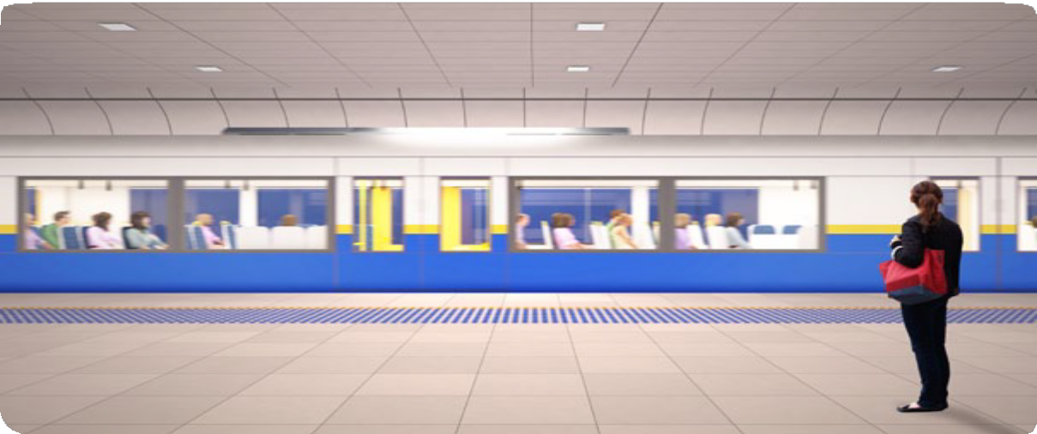

Tier 2: Suburban

West and Inner West
- In the first stage of the strategy, service frequency on the busiest of the three Western lines will be reliably operated at 20 trains
per hour. This will be achieved by reducing complexity, implementing better train management and reducing the ‘dwell’ time of trains at stations with crowded platforms.
- Later stages – which will introduce advanced signalling technology, including automatic train protection and Automatic Train Operation – will allow for the operation of extra services
on the busiest lines. Station upgrades will also be required to accommodate the additional demand on platforms and in stations.
- Eventually, with a second Harbour Crossing and CBD line and better utilisation of all three lines into the city from the west, capacity to the CBD will increase by up to 14 trains per hour along the Western lines, an increase of 35 per cent on today’s level.
- Commencement of North West Rail Link services will enable several thousand peak period customers from places such as Seven Hills and Richmond to choose the North West Rail Link, easing congestion and overcrowding on Western line trains.
- Greater emphasis will be placed on express services from the city to Parramatta, Blacktown and Penrith and more efficient interchanges at these main stations to other transport modes and services.
- Parramatta will be better connected to Liverpool and the south west, with all-day, frequent and reliable Cumberland services. Services will be faster with a fleet of modern trains, which feature improved acceleration and braking performance compared to the older non-air-conditioned rolling stock.
- Following the opening of the Homebush turnback and the introduction of new trains, the Inner West line will see the introduction of a reliable timetable offering higher frequency services. These measures will eliminate the
20 minute service gaps that can occur at some stations during peak periods.
Transport
MASTER PLAN
Sydney’s
RAIL FUTURE

Main North
- Service frequency on the North West Rail Link and Epping to Chatswood Rail Link will increase substantially, from a peak service of a train every 15 minutes to a train every five minutes.
- Two additional trains to service the busy North Strathfield to Rhodes corridor will be introduced in the shorter term. In the longer term, additional services will be added in line with demand.

South West and East Hills
- Sydney’s south west will see an increase in train services with the commencement of the 2013 timetable.
- New trains will be added to this part of the network and the Kingsgrove to Revesby quadruplication will become operational. This new track will separate express and all-station trains, which will increase service reliability.
- The opening of the South West Rail Link in 2016 will see a significant improvement to south west services.
- Upgrades to the power supply and safety aspects of the Airport line will allow for services from Holsworthy, Glenfield and the South West to be doubled from the current eight to up to 16 services per hour, to meet the needs
of the growing South West Growth Centre and Campbelltown region. With the addition of Revesby services, this will allow a total of 20 services per hour through the Airport line.

Eastern Suburbs
- Train service frequency will also be improved, with two additional services to be provided in the peak.

Tier 3: Intercity
Transport
MASTER PLAN
Sydney’s
RAIL FUTURE

Blue Mountains
  - Modern signalling technology on the Main Western line will allow trains to run faster and improve service reliability, reducing journey times from the Blue Mountains to Sydney CBD with express stopping patterns in peak periods.
  - Future Intercity trains will focus specifically on the needs of longer distance customers and will not simply be slightly modified short distance trains.
  - Trains into Sydney Central will be lengthened as demand requires.

Central Coast
  - New timetables will reduce overall journey times from Newcastle and Central Coast.
  - The completion of works on the Northern Sydney Freight Corridor will see reduced interaction between freight and passenger services and more reliable operation.
  - The creation of NSW Trains will see a stronger customer focus on these longer trips.
  - Future Intercity trains will focus specifically on the needs of longer distance customers.

South Coast
- Modern signalling technology on the South Coast line will allow trains to run faster and improve service reliability, reducing journey times with express stopping patterns in peak periods.
- Future Intercity trains will focus specifically on the needs of longer distance customers and will not simply be slightly modified short distance trains.

Figure 7: Sydney’s Rail Future – Passenger movements at main CBD stations AM peak hour – comparison

Wynyard

Town Hall

Central
2011 Base Year

2031 Do Minimum

2031 Sydney’s Rail Future (New platforms at Central and new
stations in the CBD)

0 10,000

20,000

30,000

40,000

50,000

60,000

Passengers per hour

WE LISTENED

NSW Long Term Transport Master Plan
Sydney’s Rail Future is a key element of the NSW Long Term Transport Master Plan. The Draft NSW Long Term Transport Master Plan will be released in the near future.
The development of the NSW Long Term Transport Master Plan is a 12 month process involving comprehensive consultation across the State designed to identify a clear framework for transport planning over the next twenty years.
So far the consultation process has included:

- A launch attended by more than 130 key stakeholders across business, community, customers, government and industry
- 8000 downloads of the NSW Long Term Transport Master Plan Discussion Paper and 1200 submissions from the public, industry and experts
- 14 Regional Forums held across NSW between February and May this year, attended by more than 1000 people
- 55,000 visits to the website.

Rail Advisory Committee
The NSW Government formed The Rail Advisory Committee in 2012 to provide advice and feedback to Transport for NSW about the rail strategy.
Its membership comprises key stakeholders, recognised rail experts, academics, rail and transport commentators and international experts.
The Committee engaged in discussion and the exchange of information on topics related to the development of a long term rail strategy and is assisting the project team in identifying key issues related to rail service provision.

Consultation
The NSW Government has consulted the public, industry and transport experts extensively through the NSW Long Term Transport Master Plan. The contributions have been highly valued and have informed Sydney’s Rail Future.
Transport
MASTER PLAN
Sydney’s
RAIL FUTURE
Specific suggestions were made through the consultation process to improve rail services, including:
- Investing in the existing rail network to prevent a deterioration in service quality
- Amending the timing of services to improve modal linkages
- Increasing the number of services in peak and off-peak times
- Developing incentives to attract rail patronage
- Expanding the rail network to promote social equity and provide greater access
- Delivering a rail service that is comfortable, efficient, reliable, safe and affordable
- Clearly defining performance and delivery standards to the community
- Improving the amenity of stations to create an inviting and safe environment
- Building more park-and-ride facilities at stations
- Investing in a rapid transit system to move passengers around the CBD and using heavy rail to bring passengers into the CBD from longer distances
- Supporting the rail network with feeder bus services
- Investing in heavy rail as the most effective transport mode to move a growing population.
Research conducted with Sydney rail commuters identified their top three service requirements:
- Time: Customers stated that more frequent and reliable trains followed by faster journey times are by far the most significant priorities
- Comfort: Air conditioning and seat availability are the most noted priorities
- Safety: Customers ranked safety on the train as the highest priority ahead of safety on the train stations.

ALTERNATIVE FUTURES CONSIDERED – HOW THE DECISION WAS MADE

The positive benefits of Sydney’s Rail Future, as described earlier in this document, were developed after an exhaustive and intensive program of research over a period of twelve
Transport
MASTER PLAN
Sydney’s
RAIL FUTURE
months. This section explains how key decisions were arrived at and the other broad options that were considered prior to the adoption of Sydney’s Rail Future.
The development of Sydney’s Rail Future was based on a whole-of-network approach to addressing current and future challenges and providing strategic direction for solutions.
Sydney’s Rail Future does not focus on new short- term projects – rather, it provides guidance on the strategy that will best meet future rail demand and provide the highest quality customer service while maximising the value of existing rail infrastructure and assets.
The NSW Government considered up to 15 different options for the future of Sydney’s rail system, which were ultimately grouped into four broad options. Careful analysis was conducted on the main alternatives, in particular key benefits and risks of each option and their performance against five key criteria.

CRITERIA FOR ASSESSMENT
The way in which new capacity is added in the coming years will fundamentally shape the rail network’s long-term evolution. To ensure that investment in new services and new infrastructure meets long-term performance requirements, the four key options outlined in Figure 8 have been assessed against five key criteria:

Rail planning
Planning and implementing rail strategies are not a short-term, ad-hoc process. Rail infrastructure – such as tunnels, bridges, stations and track alignment – usually have a lifetime in excess of a century. Decisions made back in 1930 have an impact on us today, and decisions we make
today will influence how Sydney will live and work 100 years from now. In planning for the future,
we are not starting over – the cost of new rail infrastructure demands that we maximise the use of existing assets before considering the construction of additional rail lines.

Strategic decision framework
To guide the planning decision making process, Transport for NSW created the ‘decision tree’, a framework for the assessment of four main options (including the preferred option) for the future of Sydney’s rail system, as shown in Figure 8.

1. Customer focus | Delivery of high-quality, customer-centric services that prioritise timeliness, safety and security, and comfort
2. Network capacity | Provision and management of capacity to match future population growth and meet increased demand for passenger rail travel where it is needed most
3. Network resilience | Improvement of on-time running performance and sectorisation, and reduction of incident occurrence rate
4. Delivery risk | Feasibility of construction, and risks in implementation
5. Cost effectiveness | Delivery of value for money, taking into account capital costs and whole- of-life costs, including operations and maintenance.

Figure 8: Decision tree
Transport
MASTER PLAN
Sydney’s
RAIL FUTURE
Sydney’s Rail Future Master Planning Decision Tree

Key Decision 1

Suburban Service

Key Decision 2

The Suburban Option
Existing all double deck Network with new CBD rail capacity and
new Harbour Crossing

Suburban Double Deck
or Differentiated
Single and Double Deck System

Diferentiated Service

Existing

Existing Network or
Independent Network

Existing Harbour Crossing

Convert existing Harbour Crossing or
build new Harbour Crossing

New Harbour Crossing
The Rebuild Option
Existing Network with new CBD rail
capacity converted and Harbour Crossing

Sydney’s Rail Future - Preferred Option
Existing Network with new CBD rail capacity and
new Harbour Crossing

The Independent Transit System Option
Independent Network

Independent Network
with new CBD rail capacity and
new Harbour Crossing

Main options considered
The following options were considered and rejected in favour of the preferred option – Sydney’s Rail Future. The key features of these three options, and why they were rejected, are detailed below:

Suburban Option
  - Continuation of an entirely double deck railway on the existing network, including a second Harbour Crossing and new CBD rail capacity.
  - This new infrastructure would be integrated into the existing Sydney rail network and operate with all double deck trains with a focus on seated capacity and timetabled services.
  - The Suburban Option would rely on the current technology and service patterns, which would present a challenge to the economical operation of Sydney’s railway.
- The North Shore and East Hills lines would be the main beneficiaries of the Suburban Option. Benefits for the West and Illawarra (Sutherland) would be limited and would require further investment to make a more than incremental difference to services on the Western and Illawarra lines.
- The Suburban Option does not offer the flexibility, customer focus and improved economic performance of the preferred strategy, and does not meet customer needs of more reliability, faster journey times and increased frequency across the network.

Rebuild Option
Transport
MASTER PLAN
Sydney’s
RAIL FUTURE
  - Conversion of existing Harbour Bridge rail services to single deck, rapid transit trains that would use the existing CBD alignment with upgraded stations.
  - The Rebuild Option would provide additional cross Harbour capacity for the medium rather than the longer term.
  - Under the Rebuild Option significant upgrading of the existing CBD infrastructure and stations would be required while rail commuters attempt to make over 600,000 journeys to and from the CBD every weekday. This would create major disruption and inconvenience to customer services and introduce high delivery risk and cost to this strategy.
  - Under the Rebuild Option, the requirement to rebuild parts of the network including at
Central and over the Harbour at the same time as maintaining services would bring significant delivery risks. Customers would have to accept years of inconvenience and service disruption.
  - The Rebuild Option offers the lowest cross Harbour capacity of any of the evaluated options. This may be sufficient for the immediate future, but would only exacerbate the problems the network will face as Sydney’s population continues to grow and demand for rail services increase.
  - There is a high risk in terms of reliability and network resilience in trying to bring more trains through the CBD, given the congested nature of the Town Hall and Wynyard stations.

Independent Option
- Delivery of a dedicated metro system, independent from the existing Sydney rail network, including a new Harbour Crossing and CBD line.
- The Independent Option would deliver the benefits of rapid transit services to customers only on new lines. It does not deliver significant benefits to the wider rail network.
- In the Sydney context an independent metro system would deliver few benefits in terms of service enhancement, capacity improvements or better operating efficiency on the existing rail network. A dedicated metro-style system would not maximise the use of the existing rail assets. It would create a separate system that would divert funding away from service improvements on the existing rail network and only provide benefits to customers who use the new lines.

Comparison of suburban and differentiated service models
Transport
MASTER PLAN
Sydney’s
RAIL FUTURE
A very large number of train operating plans are conceivable under the different options introduced in Figure 8. Various scenarios have been analysed and evaluated for each of the main options.
The main difference between the options considered was the delivery of suburban and differentiated service approaches. A suburban service involves the continuation of entirely double deck services, whereas the differentiated service involves the introduction of single deck services as a new customer benefit and frees up the system to provide benefits right across the network.

The suburban service model
  - Service differentiation can only be achieved via a variation in stopping patterns. Services that include express trains, all-stop trains and a mixed service of all-stop trains in central areas and express services in outer-suburban areas can be provided but adds complexity to the network.

The differentiated service model
  - Delivery of tailored services based on customer needs:
    - Frequent, ‘turn up and go’ services with an emphasis on reduced overall journey time and delivery of high capacity and high reliability on high-demand sections of the network
    - Conventional suburban double deck trains with seating and mixed service patterns on lines with a high percentage of longer suburban trips
    - Express double deck services from outer suburban areas including Newcastle, Wollongong, Central Coast, South Coast and Blue Mountains, with emphasis on comfort, reliable journey times and on-board customer amenities.
- Introduction of single deck rolling stock:
– Shorter dwell times at congested platforms through more doors and improved passenger movement on trains and trains well-suited to travel through a new CBD line.
- Implementation of modern train control technology:
- More trains per hour running on each line

- Highest possible service reliability

- A flexible operational response to future demand increases and the conversion of existing double deck lines to higher capacity, higher frequency single deck services.
The differentiated model improves service reliability and increases capacity across the Harbour. These approaches rely on applying modern single deck rolling stock and train control technologies for new infrastructure and upgraded alignments, which is the sensible approach to introducing advanced train technology.

Alternative rail futures for Sydney
Transport
MASTER PLAN
Sydney’s
RAIL FUTURE
Figure 9 summarises the outcomes of the assessment of the four key options (including the preferred option for Sydney’s Rail Future) against the five assessment criteria.

Figure 9: Comparative performance of alternative rail futures against key criteria

Key criteria | Suburban services  New CBD rail capacity and Harbour Crossing | Differentiated services
 |  | Existing network New CBD rail capacity and convert existing Harbour Crossing | New network New CBD rail capacity and Harbour Crossing | Existing network New CBD rail capacity and Harbour Crossing
 | Suburban Option | Rebuild Option | Independent Transit System Option | Preferred Option
Customer focus
Network capacity
Network resilience
Delivery risk
Cost effectiveness

No support for objective
Key:
Strong support for objective

Summary
The planning process has determined that Sydney’s Rail Future is the right option because it:

  - Offers tailored services, which better meet the expectations of the majority of customers
  - Provides the required capacity and flexibility to respond to Sydney’s growing demand for rail transport
  - Creates a more modern, resilient and faster service
  - Delivers a seamless and less disruptive way of modernising Sydney’s rail
  - Is more cost effective for the results it will deliver.

For more information visit:
- NSW Long Term Transport Master Plan website:
www.transportmasterplan.nsw.gov.au
Your comments on Sydney’s Rail Future can be submitted by:
- Email to: masterplan@transport.nsw.gov.au
- Or Writing to:
NSW Long Term Transport Master Plan Team Transport for NSW
GPO Box K659
Haymarket NSW 1240

