‘Scant’ evidence in the May budget of plan to boost flagging productivity
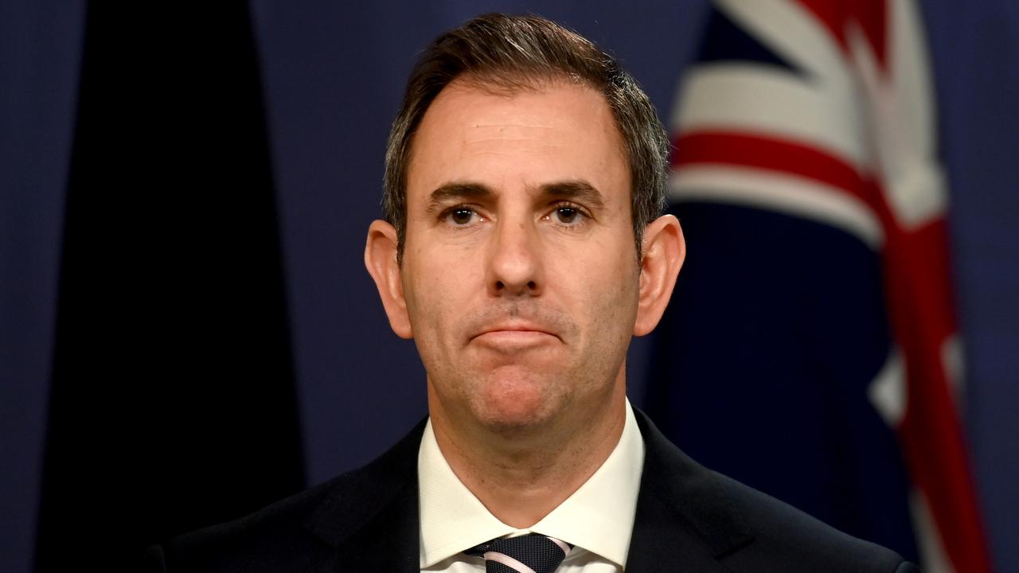
Treasurer Jim Chalmers says the country has a “productivity problem”. Picture: NCA NewsWire/Jeremy Piper

By PATRICK COMMINS ECONOMICS CORRESPONDENT @ComminsP

and GREG BROWN NATIONAL CORRESPONDENT @gregbrown_TheOz
10:20AM JUNE 12, 2023 19 COMMENTS

The May budget had “scant detail” on how the Albanese government plans to reverse the worst productivity slump on record, according to a new Parliamentary Library report.
READ MORE: Bosses too ‘busy’ to solve problem | Labor at mercy of productivity politics | Why interest rates could surge past 5pc | Recession to hit us with the shock of our lives | Fight inflation, not class war, Jim
“It seems likely that some could raise costs without improving the productive capacity of the economy.”
The budget refers to the Productivity Commission’s five-yearly blueprint for lifting national prosperity, “but none of the discussion indicates what specific proposals the government is going to implement”, the researchers said.
Australia, like the rest of the advanced world, has been trapped in a worsening productivity trend over recent decades – a deterioration that experts have struggled to explain and policymakers have failed to arrest.
Ahead of a meeting of the Council on Federal Financial Relations later this month, a spokesman for Jim Chalmers said “the Albanese government is absolutely focused on turning around the poor productivity performance we inherited by investing in people and their skills, fixing our broken energy markets, and supporting business innovation and growth”.
“Last month’s budget took further meaningful steps to improve productivity, such as supporting businesses to adopt new digital innovations like AI and investing effectively in the net zero transition,” the spokesman said.
Liberal senator Andrew Bragg, who commissioned the research, said it showed “the country is going in the wrong direction when it comes to productivity, and the government have done nothing about it”.
Senator Andrew Bragg. Picture: AAP Image/Julian Andrews
“In fact, it’s clear that their IR policy is going to make a bad situation much worse. When the Productivity Commission came to (senate) estimates, the chair (Michael Brennan) was quite clear about the need to provide more workplace flexibility, rather than less,” Mr Bragg said.
Reserve Bank of Australia governor Philip Lowe has said the May budget inflationary impact was “broadly neutral” and that energy caps and subsidies would lower the consumer price index by 0.75 percentage points in the coming financial year.
But Mr Bragg, who chairs the senate economics legislation committee, said if the government were serious about tackling inflation and lifting the country’s economic speed limit, they would stop all new discretionary spending and “have a serious implementation plan on the PC report”.
Average annual productivity growth in the decade leading into pandemic was 1.1 per cent, compared to 1.8 per cent in the six decades to 2020.
But that performance has become dire through the Covid-19 crisis, with productivity flatlining over the past three years, and dropping by a record 4.6 per cent in the year to March.

PATRICK COMMINS
ECONOMICS CORRESPONDENT
Patrick Commins is The Australian's economics correspondent, based in Canberra. Before joining the newspaper he worked for more than a decade at The Australian Financial Review, where he was a columnist and senior ... Read more

GREG BROWN
NATIONAL CORRESPONDENT
Greg Brown is the national correspondent in the Canberra press gallery. He previously spent five years covering federal politics for The Australian where he built a reputation as a newsbreaker consistently setting ... Read more

