1305, 12 Glen St - The Pavilion on the Harbour'
Milsons Point NSW 2061
scribepj@bigpond.com 0434 715.861
8 March 2021

Matt O'Sullivan mosullivan@smh.com.au
City Editor at The Sydney Morning Herald
1 Denison St,
North Sydney NSW 2060

Dear Matt
* Section 51(i) and Section 98 of the Australian Constitution behoove the Commonwealth Govt to enact legislation to 'Centralise' responsibility upon the most skilled Commonwealth Govt agency at evaluating 'what are and what are not cost-effective rail infrastructure projects', by legislating that the six States and two Territories must submit (to the Productivity Commission in ample time prior to Financial Close) a Conforming Cost-Benefit Analysis for all proposed rail infrastructure projects with forecast Capex that exceeds $20,000,000
* For those rail infrastructure projects over $100,000,000 Capex, the Productivity Commission would, at arm's length, allocate a score out of 100 points on the pertinent Conforming Cost-Benefit Analysis based on the Nine Steps of Cost-Benefit Analysis
* In 2009 the Productivity Commission offered to perform the above two responsibilities "to be a centre of excellence for cost–benefit analysis within the Australian Government"

There would be few people that would have seen first-hand so many cases of poorly planned and appraised major infrastructure projects, than yourself. Those infrastructure projects have burnt too much of the Public Purse, thereby impinging upon providing other social utilities.
I have recently expended at least 100 hours preparing a Discussion Paper regarding the aforementioned three bullet points that commences by -
a) informing that the Writer, worked for CBA for 37 years; the latter half in infrastructure finance; and
b) providing a welter of 'critical reports' and 'fault finding newspaper articles' that chronicle that billions of taxpayer funded dollars have been squandered annually on poorly planned and inadequately appraised 'rail infrastructure projects' resulting in cost blowouts, completion delays and usage/patronage paucity.
My Discussion Paper -
A) informs that Australian Government financial payments effectively support about 46 per cent of Australia's six states' annual fiscal revenue expenditure. "In aggregate, the States were estimated to receive Australian Government payments of $127.4 billion in 2019–20";
B) contends that, pursuant to Section 51(i) and Section 98 of the Australian Constitution, the Commonwealth Govt is obligated to enact legislation to 'Centralise' responsibility upon the most skilled Commonwealth Govt agency at evaluating 'what are and what are not cost-effective rail infrastructure projects', by legislating that the six States must submit (to the Productivity Commission in ample time prior to Financial Close) a Conforming Cost-Benefit Analysis for all proposed rail infrastructure projects with forecast Capex that exceeds $20,000,000; and
C) seeks the Productivity Commission to 'score/rank' all Conforming Cost-Benefit Analysis for all proposed rail infrastructure projects, pursuant to Section 98, with forecast Capex that exceeds $100,000,000.
Below is an extract from my Discussion Paper taken from Trains, pains and Berejiklian - The Monthly - Paddy Manning - March 2019 where a former member of the state government’s expert advisory panel makes damming allegations of fiscal wastage and conflicts of interest:
"Transport planner Dr Michelle Zeibots, a research director at the University of Technology Sydney, is a former member of the state government’s expert advisory panel and believes there is a deeper malaise in New South Wales. Transport projects are being designed and commissioned, she says, for the benefit of construction contractors and private investors, rather than the public. Zeibots goes on to say that when Berejiklian was transport minister she promised to put customers at the centre of everything, but Liberal Party heavyweights like former premier Nick Greiner and former Business Council chief Tony Shepherd strongarmed the Coalition into projects such as WestConnex.
“The desires of the construction sector were put front and centre, leaving Berejiklian’s customer service vision to wither. Most of the big-spend transport projects are about feeding industry, not serving customers and the community. People can feel this. The big spending has become an insult to most people’s intelligence … Adding insult to injury, Australians are paying three times more for comparable infrastructure projects than other industrialised nations. And for all the public investment, commuters and passengers get poor outcomes.”
My Discussion Paper finishes by asking the below Questions:
1. How many of the $120 billion p.a. circa that the Commonwealth Govt has funded to the States annually would have been better expended, had the Commonwealth Govt. accepted back in 2009 the Productivity Commission's offer to be 'a centre of excellence for cost–benefit analysis'?
2. Had the Productivity Commission been so appointed, would it have -
i) challenged the rationale/economics/logic of providing a juxtaposed rail system between Circular Quay and Central Railway;
ii) recommended that George Street be restricted to Govt buses only by diverting all cars etc to nearby roads, seemingly at about 10% of the cost of the CSELR light rail provision and operating costs over the next 50 years; and
iii) asked TfNSW to provide the annual patronage forecasts (at least 20 years of
Operations) that calc'd that CSELR would achieve
almost $4 billion worth of benefits?

Winners and Losers
The biggest Winners from the Commonwealth Govt legislating that the States submit a Conforming Cost-Benefit Analysis for all proposed rail infrastructure projects with forecast Capex beyond $20,000,000 to the Productivity Commission, relying upon Section 98, would be the State Premiers, Deputy Premiers, Transport Ministers, the Federal Treasurer and Australia's taxpayers. The biggest Losers would be the major transport infrastructure companies.
State politicians would be less likely to make premature announcements until their
Conforming Cost-Benefit Analysis, including a Base Case Financial Model, was robust because the Productivity Commission would opine on it.

Conclusion
The Australian Constitution, specifically Section 98, obligate the Commonwealth Govt to enshrine in legislation B) and C) above. Critical reports and fault-finding newspaper articles chronicle that Australia's States do not possess the specialist skills to appraise
Cost-Benefit Analysis and the robustness of the Base Case Financial Model that forecasts future costs/revenues to calc the Net Present Value and Internal Rate of Return. The Productivity Commission does.
I would like to marshal support for such binding legislation from concerned Australians and
N-F-Ps, not limited to SMH, The Monthly, www.fixnswtransport.com/issues.html,
EcoTransit Sydney, Transport Sydney. I have not previously written to, or spoken with, any other journalist about the information contained herein. I opted to approach you first-up because -
* of the opening paragraph of this letter; and
* I have paid $15 p/m to the SMH for many years because of the valuable role the SMH plays in investigative journalism - enormously valuable to Australia's 25.5 mil citizens.
I welcome your thoughts on my afore-mentioned proposal involving new Commonwealth Govt legislation that I expect would have the support of former top NSW rail executive Dick Day, Mehreen Faruqi, who has a doctorate in engineering and former director of Professionals Australia, Paul Davies.
Yours sincerely
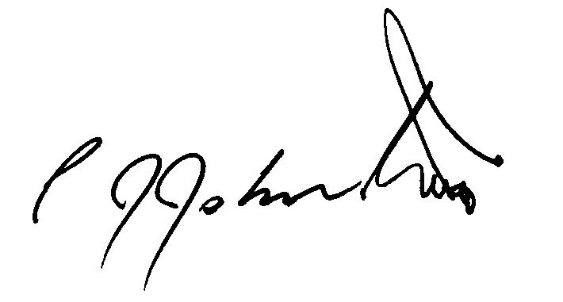
Philip J Johnston

