Unit 5, 13-15 Stokes St
Lane Cove North NSW 2066
scribepj@bigpond.com 0434 715.861
20 September 2023

Ms. Danielle Wood
Chair of the Productivity Commission
Locked Bag 2, Collins St East
Melbourne Vic 8003

Dear Ms. Wood communications@pc.gov.au

A seminal July 2009 publication "6. Evaluating major infrastructure projects: how robust are our processes? - Henry Ergas and Alex Robson - (largely republished on the Productivity Commission website in Aug 2009) as THE SOCIAL LOSSES FROM INEFFICIENT INFRASTRUCTURE PROJECTS: RECENT AUSTRALIAN EXPERIENCE offered for the Commonwealth Productivity Commission "to be a centre of excellence for cost–benefit analysis within the Australian Government" (bottom of page 162).
Australian States submitting (at least six weeks' prior to Financial Close) a Conforming C-BA for appraisal at arm's length by a specialist, non-conflicted, objective third party would be a lot cheaper than our six States continuing to rush into demolition/construction and learning from often exceedingly costly project management oversights.
It would also avoid associated State politicians from embarrassment due to cost blowouts, and/or completion delays and/or patronage paucity. Prior appraisal by the Productivity Commission will enable appreciably more of the Public Purse to be directed to aged care, child care, youth allowance, teachers, nursing, flood relief, road repairs, homeless accommodation et al.
The problem (pork-barreling / grey crime / conflicted or reckless Govt decision making) is deep rooted, unfair, wasteful and longstanding. The solution is swift, simple and steadfast because the Australian Constitution obligates decisive corrective redress.
References:
A. Letter to the Prime Minister, Anthony Albanese, dated 20 Jan 2023
B. Discussion Paper
C. Letter to the Chair of the Productivity Commission, Chris Barrett dated 8 Aug 2023
Would a couple of seasoned employees of the Commonwealth Productivity Commission read this Writer's Letter to the Prime Minister, Anthony Albanese, dated 20 Jan 2023 and the Writer's associated Discussion Paper. Each of these two documents implores the Commonwealth Govt. to rely upon pertinent clauses in the Australian Constitution (explained under 1st Reason - The Australian Constitution requires the Commonwealth Govt to evidence that 'Financial assistance to States' is expended cost-effectively) to pass specific new law/s to ensure that the 46% circa of Australia’s six States annual revenue expenditure (namely monies funded by the Commonwealth Govt. annually) is expended cost-effectively, meaning that the quantified benefits (both tangible and intangible) of future major infrastructure projects will exceed the quantified costs (both tangible and intangible). Upon the passing of such new Federal legalisation, Australia's six States would be compelled to submit a Conforming Cost-Benefit Analysis to Australia's 'productivity expert' at least six weeks prior to Financial Close for each prospective infrastructure project with a forecast Capex exceeding $20 million, initially limiting this obligation to proposed new rail infrastructure projects, then broadening the scope to road and communications, thence also including waste/recycling and water infrastructure et al.
The catalyst to the Writer researching +200 documents in Annexure A was the enormous waste of the Public Purse due to the former NSW Govt. closing down its famous George St to motor vehicles over a 3.2km section of new juxtaposed/duplicated/parallel tram/train tracks from Circular Quay to Central Railway station. That 3.2km of new tram tracks that duplicated an existing heavy rail line cost $1,000,000,000 circa due to -
a) successful litigation by both the Spanish contractor, Acciona, for an additional $576 million;
and
b) local small businesses due to lost sales over the protracted track laying task because Transport NSW failed to inform Acciona of utilities in the path (ostensibly electricity cables but also water, sewerage, drainage, gas) that needed to be relocated.
Perhaps successive NSW Premiers, Barry O'Farrell, Mike Baird and Gladys Berejiklian, did not know that a train line from Circular Quay to Wynyard, Town Hall and onto Central station had been conveying rail passengers since 1956. Why build another one adjacent and close down George Street to vehicles with rubber tyres?
My Discussion Paper asserts inter alia that NSW Govt diesel or electric buses with rubber tyres (not reliant upon a light rail network or needing electricity power supply overhead, or via a third rail) on the two CSELR routes to Randwick and Kingsford over the next 50 years would have cost 10% circa of the $3+ bil to lay tram tracks and build long trams and 50 years of operating costs of those overly frequent, heavy trams, that now have advertising stickers over many of the windows to conceal their emptiness outside peak hours. The previous Govt. buses provided almost double the number of 'stops' for passengers to aboard or alight.
Apart from the '16 Reasons' explained in the Writer's aforementioned Letter to the Prime Minister - 20 Jan 2023, the below four recent further developments escalated this request letter:
i) In announcing the appointment of a new Chair of the Commonwealth Productivity Commission, the Federal Treasurer, Jim Chalmers, assured that the Productivity Commission will remain fiercely independent as it should be. "In a rapidly changing global economy, the Productivity Commission is more important than ever in providing world-class advice on productivity as well as prosperity and progress more broadly."

ii) Federal Labor promises to rebuild public service capability - Feb 2023
iii) Five of Australia's six State Govt's 'cupboards are bare' ostensibly in NSW (Treasurer: Daniel Mookhey) and Vic. (Treasurer: Tim Pallas) due to recent un-costed mega-spending on new rail infrastructure, particularly light rail and also some deep tunnelling, where the monetary costs far exceeded the revenue benefits. Significantly less costly transport upgrade options have invariably been available.
iv) Due to substantive recent Brand Name damage to The Big 4 (PwC, EY, KPMG and Deloitte), Australia's six State Govt's will now be increasing 'public servant' resources. This Writer's Letter to the Productivity Commission accepting carriage for appraising future Conforming Cost-Benefit Analyses across the entire range of infrastructure would likely require additional personnel resources within the Commonwealth Productivity Commission.

By the Productivity Commission only sanctioning the Conforming Cost-Benefit Analysis for sought after future major infrastructure projects that will prove 'productive' ***, namely where the Cost-Benefit Analysis and its Base Case Financial Model establish a positive return on that expenditure, future substantive wasteful expenditure will be avoided.
*** Merriam-Webster definition of 'productive' includes "yielding results, benefits, or profits". This Writer interprets that the Merriam-Webster definition implies relevance to the Productivity Commission's charter.

The Discussion Paper asserts that by legislating our six States to submit a
Conforming Cost-Benefit Analysis will save two to three billion dollars circa annually of the Commonwealth Govt's 46% circa contribution within three years and considerably more than that after extended to road, communications, waste/recycling, water infrastructure et al

SMH article Liberal MP: Politicians ‘addicted’ to buying votes, take spending out of their hands (27 March 2022) includes "Australian politicians are so addicted to using infrastructure spending to buy votes that responsibility for nation-building projects should be taken out of their hands and assigned to an independent authority, departing Liberal MP John Alexander says.......... He said senior members from both parties should have got together in a room and locked the door until they could reach a compromise on the structure of a commission." Such a "commission" already exists as the Productivity Commission was created as an independent authority by an Act of Parliament in 1998 to replace the Industry Commission, Bureau of Industry Economics and the Economic Planning Advisory Commission.
A grossly under-appreciated asset within Australia is our determined culture of investigative journalism. Nick McKenzie displayed dogged commitment in the trial of Ben Roberts-Smith.
Eight unswerving newspaper journalists that have been critical of a dearth of a robust Business Case for proposed State infrastructure projects chronicles a welter of articles of billions of dollars of cost blowouts on major infrastructure projects, completion delays and patronage paucity due to repeating the same old, same old, namely not completing a
Conforming Cost-Benefit Analyses which includes to identify at least two alternative options, be it for transport, communications, waste/recycling or water infrastructure.
Yours sincerely
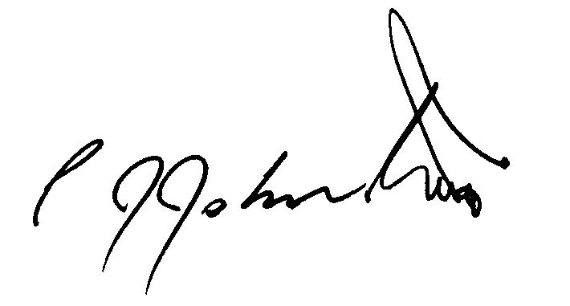
Philip Johnston

