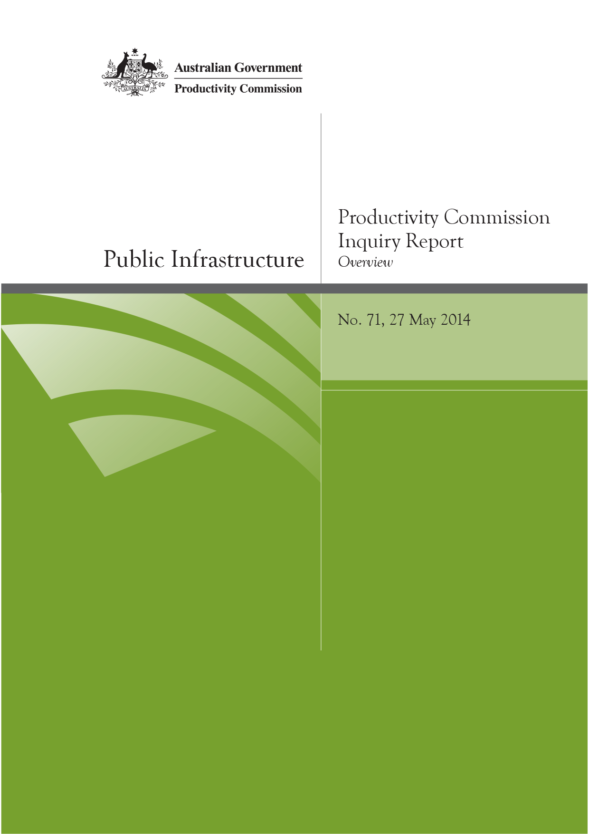
Public Infrastructure
Productivity Commission Inquiry Report No. 71

Commonwealth of Australia 2014
This work is copyright. Apart from any use as permitted under the Copyright Act 1968, the work may be reproduced in whole or in part for study or training purposes, subject to the inclusion of an acknowledgment of the source. Reproduction for commercial use or sale requires prior written permission from the Productivity Commission. Requests and inquiries concerning reproduction and rights should be addressed to Media and Publications (see below).
This publication is available from the Productivity Commission website at www.pc.gov.au. If you require part or all of this publication in a different format, please contact Media and Publications.
Publications enquiries:
Media and Publications
Productivity Commission
Locked Bag 2 Collins Street East
Melbourne VIC 8003
Tel: (03) 9653 2244
Fax: (03) 9653 2303
Email: maps@pc.gov.au
General enquiries:
Tel: (03) 9653 2100 or (02) 6240 3200
An appropriate citation for this paper is:
Productivity Commission 2014, Public Infrastructure, Inquiry Report No. 71, Canberra.
The Productivity Commission
The Productivity Commission is the Australian Government’s independent research and advisory body on a range of economic, social and environmental issues affecting the welfare of Australians. Its role, expressed most simply, is to help governments make better policies, in the long term interest of the Australian community.
The Commission’s independence is underpinned by an Act of Parliament. Its processes and outputs are open to public scrutiny and are driven by concern for the wellbeing of the community as a whole.
Further information on the Productivity Commission can be obtained from the Commission’s website (www.pc.gov.au) or by contacting Media and Publications on (03) 9653 2244 or email: maps@pc.gov.au

27 May 2014 |  |  | Melbourne Office  Level 12, 530 Collins Street  Melbourne VIC 3000  Locked Bag 2 Collins Street East  Melbourne VIC 8003  Telephone 03 9653 2100  Facsimile 03 9653 2199  Canberra Office  Telephone 02 6240 3200  www.pc.gov.au

The Hon Joe Hockey MP
Treasurer
Parliament House
CANBERRA ACT 2600

Dear Treasurer
In accordance with Section 11 of the Productivity Commission Act 1998, we have pleasure in submitting to you the Commission’s final report into Public Infrastructure.
Yours sincerely
Peter Harris AO  Presiding Commissioner | Dr Warren Mundy  Commissioner | Paul Lindwall  Associate Commissioner

Terms of reference

Public Infrastructure: Provision, Funding, Financing and Costs
I, Joseph Benedict Hockey, Treasurer, pursuant to Parts 2 and 3 of the Productivity Commission Act 1998, hereby request that the Productivity Commission (Commission) undertake an inquiry into ways to encourage private financing and funding for major infrastructure projects, including issues relating to the high cost and the long lead times associated with these projects.
Through this inquiry, the Commission is to conduct a broad ranging investigation into costs, competitiveness and productivity in the provision of nationally significant economic infrastructure and examine ways to: reduce infrastructure construction costs; address any barriers to private sector financing, including assessing the role and efficacy of alternative infrastructure funding and financing mechanisms, and recommending mechanisms and operating principles that may be applied to overcome these barriers; and, without limiting the generality of this reference, outline options to reduce construction costs.

Background
Efficient public infrastructure plays a key role in a competitive and productive economy and the ongoing funding and financing of infrastructure development in Australia is therefore of critical importance.
The capacity of government to meet expectations for improved infrastructure services is always limited, and the use of financing options involving the private sector can reduce the call on government resources, allowing scarce public funds to be targeted in a more effective manner.
While alternative financing and funding models offer opportunities to reduce the immediate call on governments, it should be noted that the application of new models is not a panacea. Ultimately infrastructure can only be funded through taxation, borrowings or direct user charges. There are difficult trade-offs to consider given increasing demand and competing priorities.

Scope of the inquiry
In reporting on funding and financing and the scope for reducing costs for public infrastructure projects, the Commission is to analyse and develop findings on the following:
- How infrastructure is currently funded and financed in Australia, including by the Commonwealth, the States and the private sector.
- The rationale, role and objectives of alternative funding and financing mechanisms, including:
- the full range of costs and benefits of different models
- the issues and costs associated with the allocation of project risks, availability of finance, contracting arrangements and delivery models for construction projects
- the disincentives to private sector investment
- broad principles for the use of these funding and financing mechanisms
- the roles of the Australian Government, the States and Territories, Local Government and the Private Sector in the implementation of these mechanisms, and the relationship between each of the parties
- creation of revenue streams to attract private sector finance; for example, through user charging, availability payments etc.
- Consider the financial risks to the Commonwealth posed by alternative funding and financing mechanisms, as well as their possible impact on the Budget and fiscal consolidation goals.
- Examine the cost structure of major infrastructure projects in Australia, including where infrastructure project costs have increased considerably, compared with other countries.
- Provide advice on ways to improve decision-making and implementation processes to facilitate a reduction in the cost of public infrastructure projects, including in relation to:
- measures to improve flexibility and reduce complexity, costs and time for all parties
- access to the market for domestic and international constructors, including barriers to entry, and what effect this has on construction costs
- ‘greenfield’ infrastructure projects.
- Comment on other relevant policy measures, including any non-legislative approaches, which would help ensure effective delivery of infrastructure services over both the short and long term.

Process
In undertaking this inquiry, the Commission should take into account the work being led by the National Commission of Audit to examine the scope for efficiency and productivity improvements across all areas of Commonwealth expenditure.
The Commission is to undertake an appropriate public consultation process including holding hearings and inviting public submissions. It will consult with the State and Territory Governments in undertaking this inquiry.
The Commission should release a draft report in March 2014.
The final report should be provided within six months of the receipt of these terms of reference.
The Government will consider the Commission’s recommendations, and the Government’s response will be announced as soon as possible after the receipt of the Commission’s final report.

J. B. HOCKEY
Treasurer
[Received 13 November 2013]

Contents
Terms of reference v
Acknowledgments x
Overview 1
Key points 2
What has the Commission been asked to do? 4
There is scope to do much better 6
Role of governments and improving decision making 8
Funding 11
Financing 13
Improving institutional and governance arrangements 18
Public infrastructure construction costs 22
Reform can begin immediately and will produce large economic benefits 35
Recommendations and findings 39
The full report is available at www.pc.gov.au

Acknowledgments
The Commission is grateful to everyone who has given freely of their time to discuss with it the very wide range of matters canvassed in the terms of reference, especially those appearing at the roundtable, hearings and providing written submissions.
The Commissioners would like to express their appreciation to the staff who worked on the inquiry, led by Ralph Lattimore and John Salerian and included Rick Baker, Melissa Edwards, Carole Gardner, Jared Greenville, Anthony Housego, Ellie Jepsen, Alex Maevsky, Ana Markulev, Ian Moran, Greg Murtough, Tom Nankivell, Bonnie Nguyen, Hudan Nuch, Chris Perks, Joshua Runciman, Carl Toohey, Elise Whalan and Kirsten Wren.

