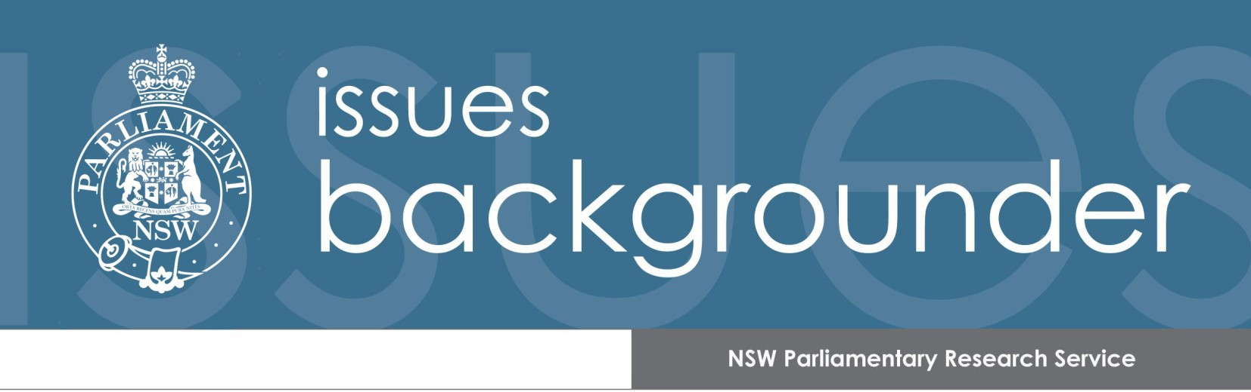
Number 2/August 2018

CBD and South East Light Rail: key sources

CONTENTS
- Introduction 1
- Government 3
- Statutory bodies 4
- Parliament 5
- Opposition and minor parties 5
- Academics 6
- Media 6

INTRODUCTION

In the lead up to the March 2011 NSW election, the Coalition announced that it would build light rail in the Sydney central business district (CBD) and conduct feasibility studies into extending the light rail network from Central Station to the University of NSW and University of Sydney.

In October 2012, Infrastructure NSW delivered its first 20-year State Infrastructure Strategy to the Premier. It recommended scoping a light rail project from Central Station to the University of NSW but “given the critical economic importance of maintaining a functional CBD” suggested that other solutions to bus congestion and capacity be implemented before committing to light rail in the CBD.

In December 2012, the NSW Government released a Long Term Transport Master Plan and a Sydney’s Light Rail Future strategy. These plans proposed construction of a light rail line from Circular Quay through George Street to Central Station and to the University of NSW via Anzac Parade and Alison Road. The estimated cost of this project was $1.6 billion.

The November 2013 business case summary stated:

…the state can expect to more than double its investment of approximately $1.6 billion, with a return of over $4 billion in total economic benefits. This equates to a benefit-cost ratio (BCR) of 2.5 or, to put more simply, $2.50 worth of benefits for each dollar invested.

Planning approval for the project was given on 4 June 2014.The contract to design, construct, operate and maintain the line was signed in December 2014 with the ALTRAC Light Rail consortium. The Minister for Transport issued a media release about the contract, which announced that the project cost was $2.1 billion and that the increased cost was “due to customer improvements to the original scope”. The media release also stated that light rail services were expected to commence in early 2019.

A 2016 NSW Auditor-General’s report commented on the cost increase and a reduction in the benefit-to-cost ratio:

While part of [the cost] increase was due to scope changes and planning modifications,
$517 of the $549 million increase was caused by mispricing and omissions in the business case.

At the same time, the project benefits had decreased from the 2013 business case estimate of $4.0 billion to an estimated $3.0 billion in December 2014. This was mainly due to increases in travel time assumptions.

These changes reduced the project’s benefit-to-cost ratio from 2.4 to 1.4, excluding wider economic benefits. The project still went ahead because the ratio remained positive.

The Minister for Planning approved several modifications to the project in February 2015. These included increasing the length of light rail vehicles and stop platforms.

Construction of the light rail line began in October 2015.

There have been construction delays, in particular along George Street, and the scheduled April 2018 date for completing major civil works was not met.

In April 2018, the media reported that the main contractor, Acciona, was suing the NSW Government for $1.1 billion for misleading and deceptive conduct in providing information about how to handle Ausgrid’s electricity cables along George Street. Transport for NSW has denied these allegations.

In May 2018, the Legislative Council’s Public Accountability Committee commenced an inquiry into the impact of the project on residents and businesses in the vicinity of the light rail route. The Committee is due to report by 1 December 2018.

On 2 July 2018, ALTRAC stated that “we will have civil construction substantially completed by the end of 2018”; and “the systems, signalling, cabling and stop fit out, will start in each zone as the substantial civil construction work is completed”.

The following pages provide a collection of key sources on the project, including government publications, parliamentary material, and media articles. Links are provided to the full text of sources. For copyright reasons, some linked items are only available to Members of Parliament and parliamentary staff.

Figure 1 Route Map
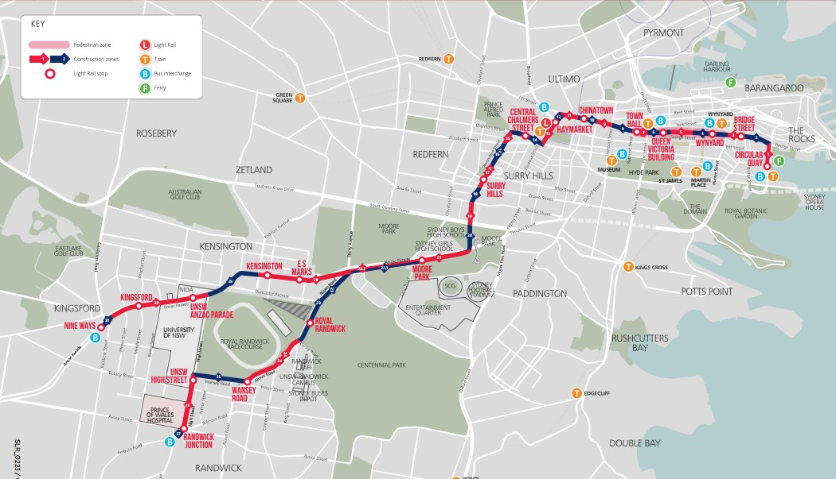
Source: Sydney Light Rail, Light Rail Benefits, Fact Sheet, January 2018

GOVERNMENT

Transport strategies
Future Transport Strategy 2056, March 2018

NSW Long Term Transport Master Plan Annual Update 2014, December 2014

Sydney’s Light Rail Future: Expanding public transport, revitalising our city, December 2012

NSW Long Term Transport Master Plan, December 2012

Project website Sydney Light Rail Business case
Transport for NSW, CBD and South East Light Rail: Business Case Summary,
November 2013

Planning documents
Department of Planning and Environment, CBD and South East Light Rail Project, [website]

Contracts
Transport for NSW, Sydney Light Rail Public Private Partnership Contract Summary, 25 August 2015

Transport for NSW and Randwick City Council, Development Agreement – Sydney Light Rail Project, September 2014

Transport for NSW and City of Sydney, Development Agreement – Sydney Light Rail Project, December 2013 (and Part 2).

Response to audit report
Transport for NSW, Response to Performance Audit: CBD and South East Light Rail Project, 10 February 2017

Ministerial media releases
Constance A, Updated business assistance program, 17 May 2018

Constance A, Sydney light rail tram hits the track for testing, 27 February 2018

Berejiklian G and Constance A, Hi George: Christmas instead of construction, 10 December 2017

Constance A, First fleet of light rail trams arrives in Sydney, 1 August 2017 Berejiklian G, Sydney Light Rail takes shape, 17 July 2017
Constance A, First tracks in place for Sydney’s Light Rail, 12 August 2016 Constance A, Statement: CBD South East Light Rail, 30 November 2016 Constance A, 2016 – The year of the light rail big build, 27 January 2016, Constance A, Bye George! Light rail construction starts tonight, 23 October 2015
Constance A, Final countdown to construction: Sydney Light Rail major works start October 23, 28 May 2015

Berejiklian G, CBD and South East Light Rail contract awarded with earlier delivery date, 18 December 2014

Berejiklian G, Huge win for customers as preferred bidder announced for CBD and South East Light Rail Project, 23 October 2014

STATUTORY BODIES
NSW Auditor-General, Performance Audit: CBD and South East Light Rail Project, November 2016

Infrastructure NSW, The State Infrastructure Strategy 2012 – 2032, October 2012

PARLIAMENT

Questions and debates

Date | House | Subject
19 June 2018 | LA | Project cost
23 May 2018 | LA | Project cost and completion date
12 April 2018 | LC | Compensation for businesses
19 October 2017 | LC | Article in The Australian
6 July 2017 | LC | Project costs and financial consequences
23 February 2017 | LC | Take note debate on Auditor-General’s report
15 February 2017 | LA | Project cost
9 August 2016 | LA | Progress on light rail projects
2 June 2015 | LA | The decision to have 67 metre long trams
28 May 2015 | LC | Changes to the administration of Sydney CBD
28 May 2015 | LA | How light rail will transform Sydney
26 May 2015 | LA | Compensation for businesses

Committee inquiries
Legislative Council Public Accountability Committee, Impact of the CBD and South East Light Rail Project, [Inquiry - commenced 22 May 2018]

Legislative Council Portfolio Committee No.5, NSW Budget Estimates 2017-18: Hearings, 1 September 2017

Legislative Council General Purpose Standing Estimates 2016-17: Hearings, 30 August 2016 | Committee | No.2, | NSW Budget
Legislative Council General Purpose Standing Estimates 2015-16: Hearings, 1 September 2015 | Committee | No.2, | NSW Budget
Legislative Council General Purpose Standing Estimates: 2014-15: Hearings, 19 August 2014 | Committee | No.3, | NSW Budget

OPPOSITION AND MINOR PARTIES

Media releases
Faruqi M, Light rail debacle shows need for parliamentary oversight, 20 April 2018

Daley M and Mookhey D, CBD South East Light Rail to hit capacity crisis on day one, 24 October 2017

Faruqi M, NSW Auditor-General’s damning report on CBD and South East Light Rail, 30 November 2016

Foley L, CBD and South East Light Rail project in shambles, 30 November 2016

Daley M, Compensate Anzac Parade bus commuters who will suffer for 2 years, 9 May 2016

Faruqi M, Greens MP calls for Parliamentary inquiry into CBD and South East Light Rail Project and the trees on Anzac Parade and Alison Road, 28 January 2016

Foley L, Baird Government must act to protect Sydney’s heritage, 27 January 2016 Foley L, CBD Light Rail – Right Mode, Wrong Location, 26 October 2015
Foley L and Park R, CBD to become a zone of chaos and confusion, 28 May 2015

Robertson J, Liberals confirm $500 million budget blowout in flagship CBD Light Rail, 18 December 2014

ACADEMICS
Keys E, Light Rail Development in Australia 2012 – 2016, Australasian Transport Research Forum, 2016

Newman P, The light rail genie is out of the bottle, but how many cities will get their wish?, The Conversation, 8 October 2015

MEDIA
Spanish company accused of using light rail lawsuit to duck damages bill, SMH, 1 August 2018

End of the line, DT, 28 July 2018

Removal of barricades is still months away, SMH, 2 July 2018

How did Gladys make such heavy work of light rail?, SMH, 29 June 2018

Upmarket retailer sues state over Sydney's bungled light rail project, SMH, 17 June 2018

Sydney's light rail a vanity 'toy’, AFR, 6 June 2018

Second firm takes legal action over Sydney's 'disastrous' light rail, SMH, 23 May 2018

Sydney's light rail chaos: who is to blame for delays and cost blowout?, The Guardian, 21 April 2018

Spanish contractor vows to finish Sydney's light rail project, SMH, 16 April 2018 NSW misleading on light rail says Acciona in $1.1b lawsuit, AFR, 14 April 2018

Light rail demands unjustified: Berejiklian, The Australian, 10 April 2018

Longer trips for light rail passengers without green-light priority, SMH, 21 February 2018

‘We’re the lucky ones’: George Street owners hold on tight, SMH, 29 January 2018

The word on the street: By George it was worth the wait, SMH, 6 December 2017

Angry retailers confront Transport Minister over impact of light rail on business, SMH,
10 December 2017

Totally off the rails, AFR, 10 November 2017

Berejiklian’s light rail to be caught short in peak hour, The Australian, 24 October 2017 Sydney retailers face yet another Christmas of rail disruption, SMH, 15 October 2017
Light rail at a crawl threatens to bring businesses to their knees, The Australian, 6 September 2017

Why Sydney’s new light rail trams won’t carry passengers on inner west line, SMH, 26 July 2017

Fading light at end of rail tunnel, SMH, 5 June 2017

Café owners count the costs of light rail construction, SMH, 16 April 2017

$2b light rail already at ‘crush capacity’, SMH, 21 February 2017 More media articles can be found here.

Author: Lenny Roth

Last updated: 1 August 2018

For further information please contact the Parliamentary Library on 9230 2768.

Issues Backgrounders are prepared by the NSW Parliamentary Research Service for Members of Parliament on Bills or subjects of topical importance.

This Issues Backgrounder provides links to parliamentary material, journal articles, media articles and interest group web sites to provide Members with detailed information relating to matters under consideration by the NSW Parliament. Although every attempt is made to ensure that the information provided is correct at the time of publication, no guarantee can be made as to its ongoing relevancy or accuracy. This Issues Backgrounder should not be considered a comprehensive guide to this particular subject and is only a representative sample of the information available. This Issues Backgrounder does not constitute a professional legal opinion.

