First thinngs ﬁrst
The State Infrastructure Strategy 2012 – 2032
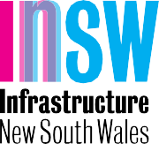
we inform

contents

Chairman’s foreword 4

CEO’s statement 6

Executive summary 9

Infrastructure NSW’s

principal recommendations 14
The context 15
  - Strategic framework 16
Key points 16
  - Introduction 16
  - Infrastructure and the NSW economy 17
  - Infrastructure NSW 20
  - The State Infrastructure Strategy 23
  - The Strategy’s regions 24
  - Economic benefits 26
  - Methodology 27
  - Infrastructure challenges 29
Key points 29
  - Introduction 29
  - NSW now and in the future 29
  - Forecast of the NSW economy in 2031 33
  - The state of NSW’s infrastructure 37
  - Global Sydney 44
Key points 44
  - Introduction 44
  - Global Sydney today 45
  - Global Sydney: the next 20 years 48
  - Infrastructure priorities
for Global Sydney 50

  - Greater Sydney 53
Key points 53
  - Introduction 53
  - Greater Sydney today 54
  - Greater Sydney in 2031 57
  - Greater Sydney Infrastructure priorities 59
  - Regional NSW 65
Key points 65
  - Introduction 65
  - Regional NSW today 66
  - Regional NSW in 2031 70
  - Infrastructure priorities in Regional NSW 70
The solution 76
  - Urban roads 77
Summary 77
  - Snapshot 77
  - The Sydney Strategic Road Network 78
  - Adequacy of Sydney’s Strategic Road
Network 79
  - The rationale for urban road investment 80
  - Developing Sydney’s Strategic Road
Network 83
  - WestConnex 86
  - Making better use of the road network 90
  - Roads across Metropolitan Sydney 91
  - Conclusions 93

  - Bus and light rail in Sydney 94
Summary 94
  - Snapshot 94
  - Scope 95
  - Buses and light rail compared 95
  - Bus and light rail within Sydney’s CBD 96
  - Light rail options and bus corridors
into Global Sydney 101
  - Bus corridors and light rail options
in Greater Sydney 103
  - Conclusions 105
  - Recommended actions for buses
and light rail 106
  - Passenger trains 107
Summary 107
  - Snapshot 107
  - Infrastructure NSW’s approach 109
  - The high capacity railway 109
  - Mainline acceleration program 113
  - Demand side strategies 113
  - Network expansion 114
  - Summary 116
  - International gateways 118
Summary 118
  - Snapshot 118
  - Container freight 119
  - Air travel 121
  - Road infrastructure around
the international gateways 122
  - Freight rail infrastructure around Port Botany124
  - Supplementary container
port capacity 126
  - A secondary airport for Sydney 127
  - Conclusions 128
10.0 Regional and interstate transport 130
Summary 130

  - Connecting people 136
10.1 Snapshot | 130 | 14.0 | Social infrastructure 14.1 Education | 173
10.2 Transport infrastructure in Regional NSW | 131 |  | Summary | 173

  - Improving local transport for
regional communities 137
  - Access to markets: bulk export freight 139
  - Access to markets: intrastate and
interstate freight 142
  - Conclusions 146
  - Energy 148
Summary 148
  - Energy snapshot 148
  - Prices and demand 149
  - Electricity distribution investment 151
  - Electricity transmission investment 153
  - Generation and gas 153
  - Recommended actions 155
  - Water infrastructure 156
Summary 156
  - Water snapshot 156
  - Demand and supply 157
  - Regional water and wastewater 159
  - Private supply of water services and
connection infrastructure 160
  - Flood mitigation 160
  - Recommended actions 163
  - Health infrastructure 164
Summary 164
  - Health snapshot 164
  - Supply and demand 165
  - Changing the portfolio of health
infrastructure 168
  - Full service procurement 170
  - Recommended actions 172

14.2 Arts, recreation and the visitor economy 180 Summary 180
14.3 Justice 186
Summary 186
  - Recommendations 188
Summary 188
  - Introduction 188
  - Recommendations 188
  - Conclusion 197
  - Funding and delivery 198
Summary 198
  - Funding 198
  - Financing 202
  - Procurement 204
  - WestConnex case study 205
  - Infrastructure NSW: next steps 207
Expert reports 211

Chairman’s foreword

Infrastructure NSW | State Infrastructure Strategy

It is with great pleasure that I provide the State Infrastructure Strategy to the NSW Government on behalf of
Infrastructure NSW, in accordance with the Infrastructure NSW Act 2011.

Chairman’s foreword Page 4

Infrastructure NSW was created in July 2011 for the purpose, in the words of the Premier, “to set New South Wales back on the path of investment in world’s best practice infrastructure planning and delivery to improve the lives of our citizens across this State. The people of New South Wales want our State to be number one again. … Providing the
infrastructure that New South Wales needs and deserves is the first step”.
The State Infrastructure Strategy is central to Infrastructure NSW’s purpose as it provides the Government with independent advice on the infrastructure needs of the State over the next 20 years. It looks across a broad range of sectors and identifies specific strategies and projects for priority consideration, complementing the work of line
and specialist agencies focusing their efforts in specific sectors.
There is a fundamental link between sound infrastructure investment and a healthy, productive State economy that makes for a successful, attractive society. Infrastructure networks enable people to gain access to jobs and prosperity. It enables services to be provided and goods to be delivered to markets locally and globally.
It is a matter of record that in recent times, NSW has handled this essential task poorly. The costs to the State can be seen most starkly in the erosion of public confidence in Government to plan and deliver
major infrastructure successfully and in the retreat of private investors from the infrastructure sector.
The effects on daily life in NSW are yet more profound. For every dollar that has been wasted on abandoned or poorly scoped projects, there is a commuter whose train journey is significantly longer than it should
be and a business whose road freight transport costs could have been reduced by well-directed investment. There are countless lost opportunities for NSW in terms of productivity, efficiency and quality of life as a result of investment that has been misdirected or withheld.
These failures of policy making have come as a result of overly politicised, short-term and insufficiently contestable processes for defining and pursuing infrastructure investment priorities. They have led, among other unhelpful consequences, to false perceptions regarding the state of our infrastructure.
While there have been some unforgiveable wasted opportunities, NSW also has good building blocks within its infrastructure networks that position us well against our global competitors, if we now look afresh at what the State really needs in order to succeed.
What Infrastructure NSW has sought to do is to set aside orthodoxies of opinion and see the bigger picture. It has sought, through research and wide engagement both within Government and across industry, to understand what can be done to make
NSW number one again as quickly as possible.
Simply put, being number one again requires infrastructure investment that will drive the State economy and create the biggest return to taxpayers. Given the limitations on available public funding,
it requires prioritisation – of dealing with first things first to gain the earliest possible return to the State – and on leveraging private capital and expertise wherever possible.
We trust that this report will, with the work of other agencies undertaking complementary sectoral planning processes, contribute to a more robust and contestable approach to infrastructure investment. On behalf of Infrastructure NSW, I wish to thank all the agencies that have contributed their time and expertise to this process.
The work of Infrastructure NSW has been greatly assisted by the advisory Board, which has extensive experience and specialist knowledge. As Chairman,
I would like to thank the Board members for their work and comments, which have been
extremely helpful to the Infrastructure NSW Chief Executive to meet his challenge of developing the State Infrastructure Strategy.

The Honourable Nick Greiner AC Chairman

Infrastructure NSW | State Infrastructure Strategy
Chairman’s foreword Page 5

CEO’s
statement

The Nobel Prize winning economist Paul Krugman famously said that “productivity isn’t everything, but in the long run it is almost everything”. The State Infrastructure Strategy has been underpinned by this notion, so that NSW will be in better shape in the future than it is today.
In the past decade, the NSW economy had the slowest growth in Australia and grew 25 percent more slowly than the Australian average. Sliding productivity is the most significant public policy issue challenging NSW. Sustained economic growth and individual prosperity for everyone in NSW can only be driven by increasing productivity. The right decisions about infrastructure investment are critical to achieving this goal.
The State Infrastructure Strategy is Infrastructure NSW’s independent advice to Government on the priority infrastructure investments and reforms needed to reverse current productivity trends.
A sustained improvement in economic performance requires the basic platforms for growth to be in place; in other words it needs a ‘first things first’ approach. As such, the Strategy concentrates on the State’s infrastructure networks: the transport links that connect people with jobs and goods with markets, and the utilities that supply power, water and data across NSW. It also ensures that the fundamentals of community wellbeing, especially health and education, will be addressed.
Effective implementation of this Strategy would increase the size of the NSW economy by over $50 billion and add over 100,000 more jobs.

Welcome to the year
2032...

You have to imagine the future to understand the decisions we need to take now. So Infrastructure NSW has defined
a vision for a better NSW in 2032.

NSW 2032
In 2032, NSW is characterised by its diverse employment choices and quality of life; built on a platform of world class infrastructure. The State offers an active, healthy and culturally rich lifestyle that attracts talented people from around the world. Long term economic prosperity has been delivered statewide; trade and employment growth has exceeded what was predicted 20 years ago.
Regional areas are thriving. Economic diversification beyond the traditional areas of agriculture and mining has been enabled by increased connectivity. High quality regional roads and railways connect communities with each other as well as to Sydney, and allow our producers to efficiently access world markets. Better bridges and local road improvements throughout regional NSW have significantly increased its economic competitiveness.
Newcastle is booming, with its increased economic footprint underpinned by significant population growth in the Lower Hunter. Upgrades to the F3, and increased efficiency at the port, have made the movement of passengers and freight around the Hunter seamless, meeting the needs of the resources industry.

Wollongong has reinvented itself – service industries have leveraged its strong education sector, while
Port Kembla has expanded its capacity for the bulk export of commodities. Improvements to passenger rail services and the F6 Extension mean that Sydney can now be reached quickly for employment and recreation.
Long term improvements in health have been delivered for a larger and older population. This includes hospital upgrades and more flexible models of care, including e-health.

Sydney 2032
At the heart of NSW and driving its economic success is Sydney: a global city of international significance. In the past two decades, Sydney has strengthened its leadership in high value add service industries, serving customers across Australia and Asia-Pacific.
Investing in the completion of our strategic road network has made strangling congestion on
inadequate arterial routes a thing of the past. The pay off to the State from investing in the WestConnex motorways project exceeded all expectations. The efficient flow of goods from Port Botany and Sydney Airport to the logistics hub in Western Sydney and to regional areas has been secured.
Sustained investment in effective public transport now provides people with real choices about how they move around the city every day. Rail services are operated to world class standards. Metro-style rapid transit services run on the busiest routes and Wynyard and Town Hall stations have been redeveloped. Fast and reliable express services have opened up new travel options from the outer
suburbs and beyond.
The CBD is a world class location for work and play because traffic no longer dominates. Buses have largely been removed from the streets by the construction of the underground bus rapid transit project, which was completed 10 years ago.
The enduring appeal of our global city is supported by its fusion of culture and business. Barangaroo and the new convention, exhibition and entertainment facilities at Darling Harbour have been a triumph. The Arts Ribbon around the CBD provides a wide range of attractions
for residents and has helped support a doubling of the visitor economy.
New high density communities have provided more housing options within easy reach of the CBD, particularly along a regenerated Parramatta Rd and in the South Eastern suburbs. Meanwhile, in Greater Sydney, more than 600,000 new homes have been delivered, meeting the needs of a growing population. School places have also kept pace with residential growth.
Parramatta has become the heart of Sydney, supported by significant transport improvements that have enabled more business growth. The two cities of Liverpool and Penrith are now realising their full potential for economic and population growth. Flood mitigation measures have already protected people and property in the Hawkesbury Nepean Valley.

Reflection 2032
In 2012 the NSW Government made tough decisions to concentrate on first things first. Facing sliding
productivity, they made decisions which were not universally popular.
The most recent OECD reports (2028-2032) have ranked Sydney among the top five cities in the world with respect to both productivity and liveability. NSW has enjoyed a sustained period of growth and is outperforming all other States in terms of both standards of living and population growth.
NSW is number one again.

Paul Broad
Chief Executive Officer
With thanks to The Hornery Institute for assisting with Welcome to the Year 2032.

Executive summary

The State Infrastructure Strategy: ‘First Things First’ is an assessment of priority infrastructure problems and solutions for the next two decades for
the NSW Government, the community, business and all who have an interest in the success of NSW.

The Strategy builds on the NSW Government’s existing public commitments and outlines a forward program of more than 70 urban and regional projects and reforms across transport, freight, aviation, energy, water, health, education and social infrastructure that should take priority over the next five, 10 and 20 years. Taken together, this program will improve the performance of the NSW economy.
According to Deloitte Access Economics, effective implementation of the Strategy would increase the size of the NSW economy by more than $50 billion (present value). This represents around a 2.4 percent increase to the economy and some 100,000 extra jobs.
The NSW economy is the largest and most diversified in Australia. Sydney alone contributes more to Australia’s economy than the whole of the country’s mining sector.
NSW is now largely a service-based economy dominated by the finance and insurance sectors. It will retain the same shape to 2032 with service industries expected to increase as a share of the overall economy.
As an internationally-facing economy, NSW is vulnerable to global competition and rapid changes in technology, which will continue to change the way we both live and work over the next 20 years. This is both an opportunity and a threat.
We need the infrastructure to support jobs, housing and services for over nine million people given the State’s population is forecast to grow by an additional two million people in the next 20 years, mainly in Sydney.
Growing the economy at a greater rate than the population and in a way that supports our service-based industries will enable NSW to continue to provide and improve the quality of key services, including transport, health and education.
The Strategy recommends infrastructure investments necessary to encourage the economy to grow at a greater rate than the population, supports our service-based industries and lifts the poor productivity of the last decade.
The right infrastructure will connect, build resilience and be cost effective and therefore will allow NSW to realise its potential as one of the best places in the world to live and work.

Infrastructure NSW
Established by the Infrastructure NSW Act 2011, Infrastructure NSW is tasked with preparing the 20 year State Infrastructure Strategy (the Strategy) for the Premier. The Act states that the Strategy must assess the current state of infrastructure in NSW and the
strategic priorities for infrastructure for the next 20 years.
This Strategy is Infrastructure NSW’s independent advice to Government on the specific infrastructure investments and reforms needed to make NSW number one again.

Need for the Strategy
NSW has spent an enormous amount on infrastructure in recent years: more than $70 billion in 2006-11, compared with $35 billion in 2001-06. In particular, there has been a step change in the levels of investment in
the public transport and electricity distribution sectors. However, simply spending money does not mean that critical infrastructure needs are being met efficiently.
A targeted infrastructure planning and investment strategy is critical to reversing NSW’s relative economic decline. Despite record spending on infrastructure, NSW has suffered in recent years from:
- A lack of coherent planning that responds to fundamental long term trends and economic realities
- Projects have been poorly scoped, or scoped with insufficient regard to budgetary constraints
- Inefficient operating practices and high cost bases in some areas that have prevented the benefits of new infrastructure being fully realised
- Projects that have been poorly delivered with frequent delays and cost overruns.

Strategic Framework
Infrastructure NSW’s framework makes economic impact a key test in determining funding priorities.
Emphasis has been placed on the need for more intensive use of existing assets and incremental improvements before making commitments to extremely expensive new infrastructure. Priority is given to those regions and sectors where high growth potential is being constrained by inadequate infrastructure.
Potential projects have been subject to multi-criteria assessment to gauge strategic fit, economic benefit and delivery risk.
Taken together, these approaches provide a framework for increasing the quality of infrastructure spending in NSW.

Infrastructure Challenges
The population of NSW is expected to grow by two million people by 2032, taking the State’s population to over nine million. New infrastructure is required to deliver high quality housing, jobs and services to areas experiencing growth.
NSW must remain a liveable and attractive place that attracts talented people and businesses in a competitive global marketplace. This requires connected and resilient infrastructure.
Infrastructure NSW’s assessment of the State’s existing infrastructure has highlighted critical infrastructure deficiencies in urban road capacity. It has also identified major deficiencies in the capacity of bus and train services to the CBD, regional rail, regional water and wastewater, flood mitigation and in the capacity of hospitals and schools.

Spatial Analysis
The Strategy has analysed NSW in three parts:
- Global Sydney - comprising the Sydney CBD and the inner suburbs, Global Sydney is home to over half of Australia’s globally competitive service sector jobs and contributes 41 percent to Gross State Product (GSP). It will remain NSW and Australia’s most important economic, social and cultural hub for the foreseeable future. It also includes the international gateways of Port Botany and Sydney Airport
- Greater Sydney - comprising the rest of metropolitan Sydney and the Central Coast. The region is home to 46 percent of the State’s population and contributes 34 percent of GSP
- Regional NSW - NSW has the highest regional population and largest and most diversified regional economy of any State. Regional NSW supports world class primary industries as well as important
manufacturing and tourism industries. More than a third of NSW citizens live and work in regional NSW. About 25 percent of the GSP is produced in the regions.
Global Sydney, Greater Sydney and Regional NSW are inseparable. The Strategy recommends infrastructure investments that have a positive impact across the whole State. For example, addressing the congestion around Sydney’s gateways provides benefits for the movement of freight and people all around the State.

Urban Roads
Sydney’s road network serves 93 percent of passenger journeys, and most growth in transport demand over the next 20 years will be met by roads under any plausible scenario. New road capacity is urgently required to meet the challenge of population growth and substantial increases in freight volumes. New roads will relieve legacy arterial roads such as Parramatta Rd, Pennant Hills Rd and Princes Highway, and permit urban regeneration in these areas.
The most pressing investment needs occur on the M4 and M5 corridors because of their importance to the freight and business transport task; connecting Global Sydney and the international gateways with the industries and residential areas in the West and South-West.
Infrastructure NSW has developed a scheme called “WestConnex”, which it proposes as Sydney’s next motorway project. WestConnex integrates the M4 Extension from Parramatta towards the Airport
with an expansion of the M5 East. Regeneration of the Parramatta Rd corridor and public transport improvements are integral parts of the scheme.
WestConnex is proposed to be delivered in stages over the next 10 years at a target cost of $10 billion.
The F3-M2 link and F6 Extension are also highly desirable to bring connections North and South of Sydney up to motorway standard. These roads are scheduled for development between years 10 and 20, but may be accelerated if the private sector can provide financing.

Buses and Light Rail
The principal issue facing bus services is congestion in the CBD. However, Infrastructure NSW has concluded that a high capacity light rail service on George St is likely to be incompatible with a high quality pedestrian boulevard, and the negative impacts on bus passengers from inner suburbs may be considerable.
Infrastructure NSW recommends the development of an alternative solution: a CBD Bus Rapid Transit (CBD ‘BRT’) tunnel from the Sydney Harbour Bridge to the Town Hall area, modelled on the underground bus way that already operates in Brisbane. Wynyard and Town Hall Stations would be reconstructed as rail/bus
transport interchanges, and the central part of George St would be fully pedestrianised.
Outside the CBD, Infrastructure NSW supports the construction of light rail from Central to Moore Park and the University of NSW via Anzac Parade. This development will improve the quality of transport to
these important activity centres and take advantage of a route that was purpose-built for trams. However, in order

to deliver value for money, the scope of this project will need to be carefully controlled.

Passenger Rail
Trains are essential to the economy of NSW, particularly for commuters to Global Sydney. In future, the passenger rail system will have three tiers: rapid transit, suburban and intercity. The North West Rail Link (NWRL) will introduce the rapid transit model to Sydney.
Additional capacity will be required in the core of the rail network, particularly the CBD, over the next 20 years. This must be provided using existing assets wherever possible, given the extremely high cost of new construction. Accordingly, Infrastructure NSW
recommends increased use of the City Circle to provide additional capacity for suburban services in the CBD within 10 years.
Beyond year 10, the extension of rapid transit from the NWRL to the CBD over the Sydney Harbour Bridge and then on to Strathfield is recommended. This approach requires the re-signalling and reconfiguration of existing lines. It will allow faster and more frequent services to the CBD for passengers on the Western, Northern and Southern Lines and high capacity metro-style services on the most congested parts of the network.
An incremental program to accelerate journey times on regional intercity routes is proposed, with a target of one hour journey times to Sydney from both Wollongong and Gosford. Accelerating journey times and more frequent services to the Hunter is recommended in the longer term.

International Gateways
Sydney Airport and Port Botany will grow rapidly over the next 20 years, and transport networks need to be upgraded to meet this challenge. Some important
steps can be taken in the short term, including cheaper train fares to the airport, more bus services and improvements at key road pinch points.
Most travel to and from the international gateways is forecast to remain on road for efficiency reasons.
Accordingly Infrastructure NSW’s medium term strategy is the construction of the WestConnex scheme.
Upgrades of rail links and intermodal terminals are also supported as part of a balanced approach.

Regional and Interstate Transport
Transport infrastructure is essential for the economy and quality of life in regional NSW. The State is home to the world class Hunter Valley coal export industry and vital agricultural supply chains, both of which rely on rail for bulk movements. Outside these sectors the road network is the backbone of regional transport.
Duplication of the Pacific Highway and the Princes Highway (to the Jervis Bay turnoff) are critical for economic growth along the coast. Inland, freight access needs to be improved through a bridge replacement program and investments to fix identified bottlenecks on both railways and roads.

Energy
Improving energy affordability and security will require significant reform in the energy sector. Changes to the regulatory process are expected to better balance the interests of network businesses and electricity users.
Infrastructure NSW supports the Commission of Audit’s recommendation that the Government undertakes a study that considers the scope and implementation strategy for privatisation of the distribution networks, and also supports consideration of options for the Government’s stake in Snowy Hydro.

Water
Infrastructure NSW recommends a comprehensive program of new and upgraded dams across regional NSW to mitigate the impact of future droughts.
Additionally, regional town water and wastewater systems should be brought up to national standards.
Augmentation of water supply in the Hunter region is needed within the next 10 years, with potential augmentation in Sydney before 2032.
The NSW Government should review flood mitigation options available in the Hawkesbury Nepean Valley, including raising the Warragamba Dam wall and upgrading roads in the valley.

Health Infrastructure
NSW’s health system faces growing demand from the ageing population, lifestyle diseases and new care technologies. This will require new models of care, including more beds in smaller, specialist medical facilities and repurposing community health centres.
The Northern Beaches Hospital should be delivered as a ‘healthcare precinct’ combining both public and private service provision in an integrated fashion.

Social Infrastructure
Population growth means that NSW’s school population will continue to rise. Infrastructure NSW

recommends that 90 percent of additional places are accommodated within existing schools, leveraging the existing infrastructure and achieving the better learning outcomes associated with larger schools.
Arts infrastructure will be upgraded over time, with a focus on Sydney’s Arts Ribbon where upgrades are proposed at the Opera House, the Art Gallery of NSW and new developments at Walsh Bay and Barangaroo. In conjunction with the new Sydney International Convention, Exhibition and Entertainment Precinct, these investments will contribute to the growth of NSW’s visitor economy.

Funding and Delivery
All new infrastructure is ultimately funded via taxation or user charges. Private financing in its own right does not create more money for infrastructure development. Infrastructure NSW proposes its priorities are delivered within a sustainable budgetary framework by using the following six funding strategies:
- Tolls on new and upgraded motorway links
- Restart NSW funding using net proceeds of assets sales and other windfall gains
- Reduction of public transport subsidies, consistent with regulatory determinations
- Limited reprioritisation of current capital plans
- Commonwealth contributions for projects that align with Infrastructure Australia’s key themes
- Value capture from beneficiaries of new infrastructure, where feasible.
WestConnex is proposed to be predominantly user funded, with limited Government financial support in the early years.

Recommendations
Infrastructure NSW’s recommendations have been made for each class of infrastructure and are phased between 2012-17, 2017-22 and 2022-32. The principal recommendations are summarised on the next page. The full list of recommendations is set out in Section 15 of the Strategy.
The recommendations have been developed to be realistically affordable and capable of being delivered.
The scoping estimate for the priority projects and programs (excluding existing Government commitments) is $30 billion. After deducting assumed user funding of
$10 billion, the incremental cost to the State is $20 billion over 20 years. This averages about $1 billion per annum, compared with total NSW Government capital expenditure of approximately $15 billion per annum.
These investments are necessary to allow the economy to grow at the level required to maintain and improve living standards for a larger population. Delivery of the right infrastructure will allow NSW to realise its potential as one of the best places in the world to live and work.

Global Sydney Greater Sydney Regional NSW
Facts | - 41% of the economy and 17% of population  - Global Sydney is an international leader in high value, knowledge-based service industries  - Sydney Airport and Port Botany are NSW’s principal international gateways | - 34% of the economy and 46% of the population  - Employment and housing patterns are generally dispersed and low density  - Over 93% of journeys are on road | - 25% of the economy and 37% of the population  - Australia’s largest and most diversified regional economy  - Internationally significant primary producer: coal, grain, livestock, viticulture, etc
Conclusions | - Landside transport infrastructure around the port and airport requires expansion  - Global Sydney must out-compete other cities in terms of liveability and business attractiveness  - Urban regeneration will help meet the housing challenge and improve our competitiveness | - Investment in new and upgraded roads is essential to meet the transport task in Greater Sydney  - Many people in Greater Sydney will continue to work in Global Sydney, requiring expansion of both road and rail capacity  - Parramatta and other centres require investment to realise their potential | - Regional producers require efficient and reliable access to markets  - Regions adjacent to Sydney will benefit from better transport links to the capital city  - Improvements to water security and quality are required
Infrastructure NSW’s principal recommendations
Now (0-5 Years)  2012-2017 | - Start construction of the North West Rail Link*  - WestConnex: planning and delivery of initial phases |  | - Fix Regional freight pinch points: road and rail  - Pacific Highway and Princes Highway: review scope and costs, then continue construction*  - Complete Northern Sydney Rail Freight Corridor (Stage 1) upgrades*  - Bridges for the Bush program: targeted bridge upgrades to improve freight efficiency  - Coal communities road and rail schemes in the Hunter Valley  - Mainline Rail Acceleration: Wollongong to Sydney pilot program
 | - Fix road pinch points and improve public transport in the Port Botany and Sydney Airport precinct  - Construct the new Sydney International Convention, Exhibition & Entertainment Centre*  - Anzac Parade light rail from Central to Moore Park and University of NSW  - Improve rail off-peak price incentives to spread demand in the CBD | - Fix road pinch points in Parramatta and other growing centres  - Hawkesbury Nepean floodplain: implement mitigation measures  - Construct Northern Beaches Hospital Healthcare Precinct*  - Construct F3-M2  (assumes unsolicited proposal, no Government contribution)  - Preserve motorways corridors, including Outer Western Sydney Orbital
Next (5-10 Years)  2017-2022 | - Completion of the North West Rail Link*  - Completion of WestConnex |  | - Complete duplication of Pacific Highway and Princes Highway (to Jervis Bay turnoff)*  - Mainline Rail Acceleration: Gosford to Sydney and Wollongong to Sydney (target one hour journey times)  - Construct an extension of the F3 to the Pacific Highway at Raymond Terrace  - Upgrade water and waste water in regional towns to meet national standards  - Augment water supply in the Hunter and regional areas  - Hunter Valley Coal Chain improvements: Liverpool Ranges
 | - Unlock City Circle spare capacity to relieve CBD station congestion  - Construct underground bus rapid transit in CBD  - Rebuild Wynyard and Town Hall interchanges  - Pedestrianise and revitalise George Street  - Invest in Sydney’s Arts Ribbon: Opera House, Art Gallery of NSW, Walsh Bay | - Incremental bus priority measures: Parramatta, Victoria Road and other strategic corridors  - Northern Beaches bus corridor improvement plan, incorporating Spit Bridge augmentation  - Moorebank intermodal terminal: construct supporting transport infrastructure  - Rollout of Managed Motorways program across the Sydney network
Later (10-20 Years)  2022-2032 | - Introduce metro-style rapid transit services from to Strathfield Chatswood via the Harbour Bridge  - extend NWRL services  - Plan Eastern Suburbs Railway extension to Randwick and Maroubra  - Continue investment in Sydney’s Arts Ribbon | - Construct the F6 Extension: Sydney Airport to Waterfall
 |  | - Construct a transitway from Parramatta to Epping/ Macquarie Park  - Plan Western Sydney Regional Airport | - Mainline Rail Acceleration: Newcastle to Sydney (target two hour journey times)  - Maldon to Dombarton rail freight line  - Augment interstate gas and electricity transmission

the
context

The NSW economy is the largest and most diverse in Australia. Sydney alone contributes more to Australia’s economy than the whole of the country’s mining sector.

However, since 2000 the State has been in relative economic decline.
Infrastructure NSW’s baseline economic forecast for the next
20 years shows that the growth forecast for NSW,
2.6 percent per annum, remains lower than the rest of Australia.
A targeted infrastructure planning and investment strategy is critical to reversing NSWs relative economic decline.
In line with the requirements of our Act, Infrastructure NSW completed a gap analysis between future needs and the current condition and capacity of infrastructure in NSW.

Strategic framework

Key points

Introduction

Good infrastructure is the foundation stone for a successful economy and productive, cohesive society.
The NSW Government’s infrastructure assets are worth almost a quarter of a trillion dollars and
new infrastructure investment is around $15 billion per annum.
NSW’s problem is not so much the quantity of investment but the quality. Poor infrastructure investment decisions for the past decade have contributed to the relatively poor State economic performance in comparison with the rest of Australia (which has grown faster than NSW since 1991).
Unless targeted where needed, infrastructure investment will achieve little – except to add to public debt and the cost of living.
Infrastructure NSW has consulted widely across Government and industry to better understand the key drivers of the effect of infrastructure on the
economy. Key issues include an excessive focus on big, long term projects rather than an approach that encourages making the most of existing assets and incremental opportunities and fixing pinch points.
A pipeline of projects remains an important concern, particularly to enable private sector investment.
The Strategy has focused on ensuring that future investment supports rapid improvement in the State’s position, with investment targeted at delivering the most benefit to the largest number of people.
This Strategy is Infrastructure NSW’s independent advice to Government on the infrastructure investments and reforms needed to ‘Make NSW Number One again’.
Infrastructure NSW asked Deloitte Access Economics to take a whole of economy perspective to assess
the flow on additional benefits of infrastructure recommendations.
Effective implementation of this strategy could increase the size of the NSW economy by over $50 billion (present value) or $18.4 billion a year (in current dollars) by 2032. This is around a 2.4 percent increase from the forecast baseline which means around 100,000 extra jobs by 2032.
Our infrastructure networks enable delivery of the basic facilities and services that are the foundation stone for a successful State economy and society.
A complex and interconnected series of networks and systems form the infrastructure base of NSW, working together to deliver these facilities and services.
‘Hard’ infrastructure – the large physical networks necessary for the functioning of a modern industrial nation, such as roads, railways and utilities – provides the people of NSW with the means to get to and from work and family. It also gives them access to everything from safe drinking water to internet connections and electricity to run the operating theatre equipment that saves lives in our hospitals. From the mundane to the life-changing, these hard infrastructure networks make NSW tick.
Hard infrastructure networks in turn enable the delivery of what is known as ‘soft’ infrastructure – all the institutions that are required to maintain the economic, health, cultural and social standards of the State, such as the financial system, the education system and the healthcare system.
Together, these networks provide the quality of life and breadth of opportunity that have made NSW one of the best places in the world to live.
Protecting that quality of life and ensuring the economic prosperity of NSW is at the heart of this Strategy.
It focuses principally on hard infrastructure networks and seeks to forecast, in line with NSW Government objectives, where future needs will be, how the priorities

for projects should be decided and how best to
Figure 1.1 State Infrastructure Portfolio July 2012

meet these needs from finite public funds and available private capital.

Infrastructure and the NSW economy
As a developed modern economy, NSW has a large existing infrastructure sector and a major portfolio of assets.
The Strategy covers both economic and social infrastructure investments by the NSW Government. The Strategy does not consider public housing, land and property utilisation, the planning system or local
Government reform. These areas are subject to separate Government reform processes.
Ports 1%
Justice 7%

Health 5%

Sports, Art, Culture 5%

Water 9%

Education 10%

Source: NSW Treasury.
Other 5%

$213 billion

Electricity 15%

Roads 30%

Rail 13%

The Government’s portfolio of infrastructure assets within scope amounts to $213 billion, with the largest

Figure 1.2 State Capital Program 2012-13
Other 10%

portion, $91 billion, in transport assets (Figure 1.1). In 2012-13 the capital budget is $15 billion, of which
$6 billion is for transport projects (Figure 1.2).
Within the scope of this Strategy, there is a mix of private and public infrastructure owners in the sectors and a mix of funding by Government and by user charges.
NSW has more Government ownership and less private ownership in the energy, rail and health sectors than other States. This is significant given that 72 per cent of all hard infrastructure spending in NSW (all sectors) is Government funded, compared to
55 per cent in Australia1.

- Port Jackson Partners, report for Infrastructure NSW 2011, Better Value Infrastructure Paper for COAG.
Sports, Art, Culture 2%
Justice 3%
Education 3%

Water 6%

Health 7%

Source: NSW Treasury.

$15 billion

Electricity 28%
Roads 19%

Ports 2%

Rail, Light Rail, Ferry 20%

Table 1.1 shows, for each sector, the asset managers, the sources of funding and the value of
Table 1.1 Scope of the State Infrastructure Strategy – Sector Descriptions

Government

NSW Government assets and NSW Government capital expenditure planned for 2012-13.
In considering this installed infrastructure base and allocation of capital, a key question is whether the funding is well directed towards areas of need that will help NSW communities and the State in general to prosper.

Transport
Roads | - Public Sector, from user charges, road user charges, vehicle registration, tolls  - Local Government, rates and council activity | $2.8b | - RMS  - Local Governments  - Tollroad concessionaire | $64b
Public Transport | - Public Sector, farebox revenue  - Local Government, rates and council activity | $3.3b | - RailCorp  - Country Rail Infrastructure Authority  - CountryLink | $27b
Airports/ Ports | - Airport and Port  - Corporations, from user charges (airport and shipping company fees)  - Shareholder contributions | $0.3b (Ports) | - Stated-owned enterprises  - Listed companies | $2b
Energy | – Energy companies and State-owned enterprises, from user charges (consumer) | $4.2b | - Private companies  - State-owned enterprises | $30b
Water | – State-owned enterprises and Local Government, from rates and user charges (consumer) | $0.9b (Including water and waste water) | - State-owned enterprises  - Local Government | $20b
Health, Social and other | - Public Sector  - Private health and education providers | $3.8b | - Public Sector  - Private health and education providers | $70b
Total |  | $15.3b | Total | $213b

Funding and Revenue Sources
Capital Expenditure
(2012-13) Asset Managers
Value of Assets (July 2012)

Over the past decade, NSW has achieved significantly lower economic growth than the rest of Australia and Victoria (as shown in Figure 1.3). In 1991, NSW accounted for 37 percent of Australia’s economy;
by 2011 this had fallen to 32 percent. NSW productivity and population growth has been sub-par for more than 10 years.
Figure 1.3 NSW Relative Economic Performance
5%

4%
Compound annual growth of GSP (real, 2009/10), 5 year rolling average

3%
Figure 1.4 NSW Relative Infrastructure Investment
5%
Engineering construction - excl. Mining and Heavy Industry (% GSP)

4%

3%

2%

1%

0%
The question for NSW is: what is the right formula for ensuring that State infrastructure investment is worth every cent?
The evidence is that infrastructure affects economic growth positively via the three ‘Ps’: productivity, participation and population3:
- Infrastructure directly affects productivity through reduced travel costs, better communications and increased production capacity.
- Infrastructure affects participation by increasing access to employment opportunities for people who may not otherwise join the labour force.
- Infrastructure affects population flows by improving the quality of life and encouraging more people to
1991
1992
1993
1994
1995
1996
1997
1998
1999
2000
2001
2002
2003
2004
2005
2006
2007
2008
2009
2010
2011

2% NSW
VIC
AUS excl NSW
remain in NSW, which facilitates economic growth.

1%

0%

NSW (32%)

VIC (23%)

Sub-par growth for 10+ years

AUS excl NSW (68%)
Source: Port Jackson Partners. Note: Engineering construction covers roads, highways and subdivision, bridges, railways, harbours, water storage and supply, sewerage and drainage, electricity generation, transmission and supply, pipelines, recreation and telecommunications.

The current Budget context provides additional imperative to consider how best to target and fund infrastructure wisely given the extent to which it dominates public expenditure.
1996
1997
1998
1999
2000
2001
2002
2003
2004
2005
2006
2007
2008
2009
2010
2011
This indicates that to deliver net benefits to the economy, infrastructure investments need to be of the right
type, in the right place, at the right time. It suggests that the greatest impact is gained by sharpening the focus of infrastructure projects on productivity and economic growth.
Conversely, poor infrastructure investment decisions

Source: Port Jackson Partners. ( ) gives % of national GDP.

However, NSW has invested more in infrastructure, in terms of percentage of GSP, than Victoria (the most comparable State, given the exceptional resources boom in other major States), as shown in Figure 1.4 below. This suggests that high levels of infrastructure spending do not guarantee better economic outcomes.
As the Treasurer noted in the 2012-13 Budget speech:
The deterioration in the State’s revenue position due to the write-down in the GST requires urgent and serious action. A further $2.4 billion in savings is identified in this Budget, building on those savings measures announced last year. At a time when households are tightening their belts, this Government will do the same2.

- NSW Treasurer Mike Baird, Budget Speech, 2012-13.
risk increasing the public debt burden and/or the cost of living without improving productivity or providing a
better life. A single major public infrastructure investment can cost every person in NSW thousands of dollars.
Therefore the benefits must outweigh the costs. Although there are other factors that would affect

- Deloitte Access Economics 2012, The NSW Economy in 2031-32: Report to Infrastructure NSW.

each State’s economic performance, this analysis suggests that the quality of investment is at least as important as that the quantity. Infrastructure performance is the result of planning, delivery and effective governance and market arrangements. Reform of infrastructure sectors introduced market incentives and efficiencies and delivered high productivity dividends in the 1980s and 1990s, but the reform agenda has stalled in the past decade.
Improving the planning, procurement and use of infrastructure will contribute to reversing this trend and delivering greater economic growth and enhanced standards of living in NSW.

Infrastructure NSW
The NSW Government is determined to ‘Make NSW Number One’, and part of achieving this is a vision for infrastructure:
...the right infrastructure, in the right places, not only boosting productivity and competitiveness, but makes a difference to peoples’ quality of life4.
To achieve this vision the Government created Infrastructure NSW in 2011.
Established by the Infrastructure NSW Act 2011
(the Act), Infrastructure NSW’s prime task is to prepare and submit to the Premier a 20 year State Infrastructure Strategy (the Strategy). The Act States that the Strategy must assess the current State of infrastructure in NSW and the need and strategic priorities for infrastructure
for the next 20 years. Further, the Strategy is to focus on major projects and reforms necessary for the successful provision and use of infrastructure. It is to be based upon independent and expert analysis and advice. The main points in the Act that relate to the development of the Strategy are summarised in Table 1.2.

- NSW Government 2011, NSW 2021 – A Plan to Make NSW Number One.

Table 1.2 Legislative Requirements

Requirements of Infrastructure NSW Act (2011)
The Infrastructure NSW Act (the Act) tasks Infrastructure NSW with 14 functions including:
  - preparation and submission to the Premier of a 20 year State Infrastructure Strategy
  - preparation and submission to the Premier of five year infrastructure plans and other plans as requested by the Premier
  - preparation of sectoral State infrastructure strategy Statements
  - review and evaluation of proposed major infrastructure projects by Government agencies or the private sector
  - advice on infrastructure planning and delivery assessment, economic or regulatory impediments and funding models
  - coordination of infrastructure submissions by NSW to the Commonwealth Government.

20 year Infrastructure Strategy
Part 4, Section 17 of the Act provides that the 20 year State Infrastructure Strategy must:
- assess the current State of infrastructure in NSW and the needs and strategic priorities for infrastructure in NSW for the next 20 years; and
- in preparing or reviewing the 20 year State Infrastructure Strategy, have regard to any State strategic priority of which Infrastructure NSW has been advised by the Premier.
Section 17 (2) provides some guidance on the criteria and objectives which may be considered when developing the 20 year State Infrastructure Strategy. Infrastructure NSW has taken this guidance into consideration in developing the Strategy and in particular, has developed a number of options to deal with identified deficiencies, including options relating to demand management and other policy, pricing and regulatory reform options.
Section 18 provides that the Premier is to consider any 20 year State Infrastructure Strategy submitted by Infrastructure NSW, and adopt the strategy with or without amendments, or refer it back to Infrastructure NSW for further consideration.

Further, the Premier must notify Infrastructure NSW of the Premier’s decision and make the adopted strategy publicly available.
Section 16 allows for the State Infrastructure Strategy to be reviewed every five years (and at such other times as the Premier directs or is considered appropriate).
Infrastructure NSW is then required to submit a revised strategy to the Premier.

year Infrastructure Plans
In addition to the 20 year State Infrastructure Strategy, Infrastructure NSW is also required to prepare and submit to the Premier a five year Infrastructure Plan
to identify specific major infrastructure projects to be undertaken as a priority in the following five-years.
These five-year plans are to be reviewed every year and a revised plan submitted to the Premier, if required. In preparing the five-year plans, Infrastructure NSW must have regard to the 20 year State Infrastructure Strategy adopted by the Premier.

Infrastructure NSW’s governance model (as established by the Act) comprises a Board, Chief Executive
Officer and management team. The Board comprises the CEO, an independent Chairman and nine additional Board members. The Board provides strategic policy direction and oversight for planning, management
and performance.
The Board is one of the most experienced in the country with a mix of leading business people with
expertise in infrastructure, working alongside the State’s most senior public servants.

Table 1.3 Infrastructure NSW Board
This Strategy was prepared by Infrastructure NSW following consultation with line departments, private sector proponents and other significant stakeholders including Infrastructure Australia.

The development of this Strategy has cost
$2 million, which was spent to investigate options and obtain advice from industry experts including Cisco, Deloitte Access Economics, Deloitte, Ernst & Young, Evans & Peck, GHD, Interfleet Transport Advisory, L.E.K, Molino Stewart, MR Cagney,
PriceWaterhouseCoopers, Sapere, SMART (University of Wollongong) and others. All reports prepared for Infrastructure NSW are available on our website.

The Strategy is the considered advice of Infrastructure NSW to the Premier of NSW, who told Parliament when introducing the legislation:
Nick Greiner AC | Chairman
Paul Broad | CEO, Infrastructure NSW
Roger Fletcher | Private Sector Member
David Gonski AC | Private Sector Member
Carolyn Kay | Private Sector Member
Max Moore-Wilton AC | Private Sector Member
Rod Pearse OAM | Private Sector Member
Chris Eccles | Director General, Department of Premier and Cabinet
Sam Haddad | Director General, Director of Planning and Infrastructure
Philip Gaetjens | Secretary, NSW Treasury
Mark Paterson AO | Director General, Department of Trade, Investment, Regional Infrastructure and Services

The Government, through Infrastructure NSW, is determined to set New South Wales back on the path of investment in world’s best practice infrastructure planning and delivery to improve the lives of our citizens across this State. The people of New South Wales want our State to be number one again. We want to restore that great sense of pride in our cities and in our regions, and to be confident in the opportunities for the future available to all our citizens. Providing the infrastructure that New South Wales needs and deserves is the first step5.
Infrastructure NSW is also charged by the Act to manage and monitor the implementation of the Strategy and the major infrastructure projects including their funding.

- Premier Barry O’Farrell, Infrastructure NSW Bill 2011, Second Reading, Hansard, 26 May 2011.
Infrastructure NSW has been asked to provide specific identification of individual projects that will require priority for Government consideration.
Infrastructure NSW’s findings and conclusions are informed recommendations to enable Government decision making and are not necessarily Government policy. The Government will consider Infrastructure NSW’s recommendations in conjunction with:
- the Department of Planning and Infrastructure’s advice, which will include the Metropolitan Strategy for Sydney and Regional Strategies, an integrated planning approach to meeting NSW’s housing, employment, land and recreational needs over the next 20 years
- Transport for NSW’s advice, which will include the Long Term Transport Master Plan, setting out an approach for delivering world class transport networks and services to the people of NSW.
Infrastructure NSW’s recommendations were formulated following extensive discussion with these State agencies among others.
Infrastructure NSW recognises that these agencies will be responsible for the detailed development of future plans for investment in their sectors and has sought to co-ordinate wherever possible. However,
Infrastructure NSW’s mission is to provide Government with independent advice in a ‘big picture’ context of all State infrastructure for the next 20 years. While there are some differences of emphasis, these are relatively few and Infrastructure NSW has noted a high degree of co-operation and common thought on where NSW needs to go next.

The State Infrastructure Strategy
The Strategy focuses on the strategic investments and reforms that Infrastructure NSW has assessed as being likely to have most impact over the next 20 years.
It is not intended as a comprehensive capital plan for the whole of the NSW public sector for the next two decades; as noted much of this detailed work properly devolves to the expertise of departments and specialist agencies at the coalface. It comprises recommendations for:
- investment in specific major projects
- wider policy and market reforms to improve how infrastructure is planned, procured and delivered, particularly reforms that introduce competition and increase private sector involvement and offer an opportunity for innovation and for greater efficiency.
In framing the priorities for this Strategy, Infrastructure NSW has taken the Premier’s directive that NSW should be number one again as per its mission Statement.
Infrastructure needs to act as a key enabler in getting the economy moving again and in so doing make the lives of all people in NSW better.
The Report of the NSW Financial Audit 2011 and Commission of Audit reports have highlighted deficiencies in asset management and infrastructure decisions across NSW Government agencies.
Some specific issues that Infrastructure NSW has considered include:
- Low levels of capital utilisation
Inadequate consideration has been made of options that can delay major capital investment by incrementally improving how assets are utilised.
For example, in the energy sector, the Australian Energy Market Commission has estimated that
$11 billion of electricity infrastructure is used for less than 100 hours per year.
Rail infrastructure primarily services commuter traffic between a small number of stations, rather than providing an all day network across Sydney. Only 35 percent of weekday journeys take place outside the AM and PM peak hours6, while half the stations on the network service only six percent of traffic in aggregate7.
- Poor project selection
Public infrastructure investment has in recent years lacked focus on projects that underpin productivity growth. For example, there has been limited investment in metropolitan roads despite widespread congestion, which is estimated to cost the Australian economy around $5 billion8.
A number of major projects that have been selected have either been delayed or cancelled – notably the Sydney Metro, a $400 million bill for taxpayers for nothing at all. The underlying failures leading to these outcomes have been poor planning and project selection, rather than an inability to deliver. NSW is in fact capable of delivering excellent results as projects

- CityRail 2010, Compendium of Travel Statistics.
- CityRail 2010, Compendium of Travel Statistics.
- Infrastructure Australia.
(such as the Westlink M7 indicate), given the right policy framework, long term planning and judicious use of private sector expertise.
- Poor value for money in delivery
Infrastructure construction costs in Australia have been rising between 5 and 7 percent per annum9, much faster than the wider inflationary trend.
Increases in project scope have produced even larger cost increases. In 2011, the NSW Auditor General found that 19 of the 43 major transport projects are late or over budget, with rail projects of particular concern10. For example the rail clearways program will be completed five years after the original completion date at a cost of $2 billion compared with a budget of $1.3 billion11.
- Low levels of private participation
Increasing use of outsourcing and divestment are a feature of modern Government service delivery and can deliver lower cost with greater innovation12. In general, private sector-led projects are delivered closer to time and budget than public sector led
projects. However, a significantly lower proportion of infrastructure investment is delivered by the private sector in NSW than the Australian average.

- Infrastructure Australia.
- Audit Office of NSW Overview.
- Auditor General’s Report 2011, Transport.
- NSW Commission of Audit 2012, Final Report: Government Expenditure.

  - Difficulty in predicting the future.
The acknowledged difficulty in predicting future demand and the disruptive change of new technologies means that when the unexpected occurs infrastructure assets can be stranded as a result. It is a better option to prioritise ‘no-regret’ options that will be required in all likely demand scenarios.
Wrong infrastructure choices and failures of implementation dampen economic growth, reduce productivity and get in the way of peoples’ lives. NSW needs to look honestly at its recent record if it is to avoid repeating such failures.
To summarise Infrastructure NSW’s thinking:
  - A ‘first things first’ approach is needed to ensure priorities for action are projects and policies that maximise economic benefits for all of NSW. NSW should focus on what will have the greatest impact in the shortest timeframe
  - Investment should support NSW’s strengths as a first priority, rather than seeking to create economic growth from scratch
  - Priority investments should benefit the greatest number of people
  - There has been a bias towards major projects at the expense of incremental projects that are capable of yielding substantial benefits and addressing critical pinch points
- NSW should also maximise the use of existing assets wherever possible before investing in new projects because it is both cost effective and it is capable of delivering quick improvements for the community that are sacrificed when there is too great a focus on big projects with long lead times
- A key objective is to ensure projects of all scale, both big and small, are done well. Governance of delivery and ongoing management of the asset is as important as the initial investment
- Establishing a solid pipeline of projects is important for future success as it enables meaningful private sector involvement.
Investment in infrastructure should be made when it can be shown to:
- support economic activity and improve amenity
- enable the movement of people, goods and information
- service the needs of households
- support the quality of life of individuals and resilience of communities
- connect individuals, businesses and communities with each other and the rest of the world.

The Strategy’s regions
Infrastructure NSW has divided NSW into three regions as shown in Figure 1.5. The Strategy examines each
of Regional NSW, Greater Sydney and Global Sydney separately.
Our analysis of the economy, (described in detail in Section 2), shows that the situation and imperatives, and therefore the infrastructure needs, of regional and rural NSW, the Greater Sydney area and Global Sydney are different.

Table 1.4 The Strategy’s Regions – Key Facts and Imperatives
Location Fact
Regional NSW | - Australia’s largest and most diversified regional economy, contributes 25 percent of NSW GSP.  - Home to over a third (36 percent) of population, with 36 percent of jobs.  - World’s largest coal port at Newcastle.
Greater Sydney | - Nearly half of the NSW population lives here (46 per cent)  - Lower proportion of jobs, (36 percent), and production, (34 percent).
Global Sydney | - Australia’s only global city. Nearly half  (41 per cent), of GSP is generated here from high value, knowledge-based industries.  - Only 17 percent of population, 28 percent of jobs.

Figure 1.5 The Strategy and Regions
Our Strategy examines each of Regional NSW, Greater Sydney and Global Sydney separately. The economic drivers and infrastructure imperatives for these three areas are very different:

Global Sydney

1 Ashfield
2 Botany Bay
3 Burwood
4 Canada Bay
5 Hunters Hill
6 Lane Cove
7 Leichhardt
8 Manly
9 Marrickville
10 Mosman
11 North Sydney
- Randwick
- Ryde
- Strathfield
- Sydney
- Waverley
- Willoughby
- Woollahra

Inland NSW

Murray

South Coast

North Coast

Hunter

Greater Sydney

North West

South West

West Central

South

North

Central Coast

Global Sydney

13

6
5

4

14 7
3
1

9

17 8

11 10

18
15 16

12
2

Regional NSW

Greater Sydney

Global Sydney

Population Jobs GRP/GSP

Population Jobs GRP/GSP
2011

37% |  |  | 46% |  |  | 17%
36% |  | 36% |  |  | 28%
25% | 34% |  |  | 41%

2031
34% |  | 48% |  |  |  | 18%
35% |  |  | 37% |  | 28%
23% | 34% |  |  | 43%

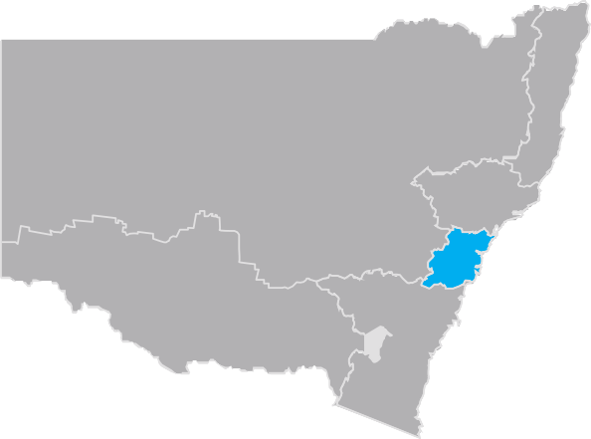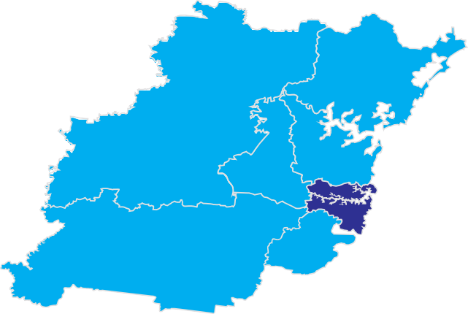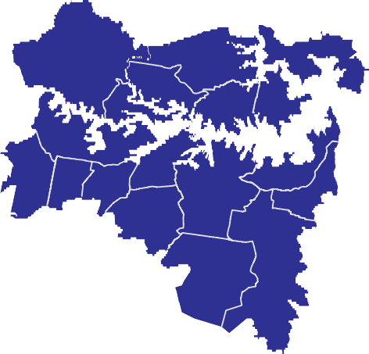
The context Section 1 Strategic framework Page 25

Infrastructure NSW | State Infrastructure Strategy The context SeIcnftriaosntru1ctSutrreaNteSgWic| fStraamteeIwnfroarkstPrucagtuere2St5 rategy
Source: Deloitte Access Economics.

Economic benefits
Infrastructure NSW commissioned Deloitte

Economic benefits of the State Infrastructure Strategy recommendations

Access Economics to model the economic benefits of the Strategy.
The model found that effective implementation of this Strategy could increase the size of the NSW economy by over $50 billion (net present value) or $18.4 billion a year (in current dollars) by 2032. This is around a 2.4 per cent increase from the long term baseline, which means around 100,000 extra jobs by 2032. The Deloitte Access Economics report can be found on the Infrastructure NSW website.
The economic benefits exclude the direct economic activity from the infrastructure capital and ongoing operating expenditure. This effect has been excluded as it is of little long term economic importance. The long term value of the Strategy to the economy is generated by the services.
The CGE modelling of the key infrastructure investments means that the Strategy assessment is focused on
the benefits of completed infrastructure rather than on funding sources or jobs created during construction.
To finesse the model, Deloitte Access Economics has relied on relationships identified in economic literature and adapted these to the specific circumstances of NSW as required. Each type of infrastructure project will have a different mechanism for how these benefits will manifest themselves in everyday life. That is,
each project will affect population, participation and productivity differently.
Infrastructure NSW and Deloitte Access Economics have estimated the potential economic benefits expected from the recommended strategies.
This detailed Comparable General Equilibrium (CGE) analysis was conducted from a whole of economy perspective to assess the flow on additional benefits of the recommended strategies in regard to
productivity, population and participation over the long term to 2032.
Effective implementation of the Strategy could increase the size of the NSW economy by around $50.8 billion (present value of the total benefits over the period to 2032), which is an increase in GSP of around $18.4 billion a year (in current dollars) by 2032, in today’s dollars.

To be conservative, not all benefits or the direct expenditure on the key infrastructure is captured in the model. Also the economic benefits of certain social infrastructure investments are not modelled.
This is around a 2.4 percent increase from the long term baseline as forecast by the NSW Treasury13.
This increase in growth means that there could be up to 100,000 more jobs created by 2032.
The analysis reveals that the investments improve quality of life, driving a significant increase in population which, in turn, lifts GSP. These include access to markets and less
congestion, all of which make NSW a more desirable place to live, leading to more jobs, more ideas and more demand for goods, all of which enhance economic activity.
An important result is that there are significant benefits for regional NSW. Gross Regional Product (GRP) is expected to increase by $21 billion reflecting the close economic ties between Sydney and Regional NSW.

- NSW Treasury, 2011-12, Budget Paper 6.

Methodology
Infrastructure NSW has undertaken a systematic approach to develop the Strategy and to identify
and prioritise potential projects and programs that add to the economic and social well being of the whole NSW community. The method follows the logical framework of problem analysis, option assessment and prioritisation illustrated in Figure 1.6.
Infrastructure NSW’s methodology was guided by the requirements of the Infrastructure NSW Act (2011).

Principles
Three principles have guided Infrastructure NSW in ensuring that the Strategy is affordable, achievable and delivers the best value across scarce resources.

Figure 1.6 State Infrastructure Strategy: Methodology
Infrastructure NSW guiding principles
Analysis
Options assessment
Options sequencing
State Infrastructure Strategy

Incremental improvement
Incremental improvement can address infrastructure problems more quickly and cost effectively than one-off major and mega projects, and should be thoroughly considered first to resolve problems. Major projects, if shown to be necessary and cost effective, should be the second option considered. Incremental improvements include operational and economic reforms that increase the utilisation of existing assets.

Investing in NSW’s strengths
The priority is those regions of NSW and sectors of the economy with the highest growth potential, which are constrained by inadequate infrastructure capacity.
Speculative infrastructure investment on the promise of creating growth has often led to waste, not regeneration, and should be avoided.

Affordability and fiscal sustainability
To be capable of being delivered the Strategy must be affordable and realistic. Rigorous prioritisation of
infrastructure investment ensures that the projects and reforms recommended deliver strong positive economic returns to NSW.

Analysis
Infrastructure NSW is required to analyse the challenges and gaps confronting infrastructure in NSW. This is discussed in Sections 2 – 5.
Infrastructure NSW considered the macro-economic challenges and trends: what is the situation today, and how will needs change over the next 20 years? Added to this was a ‘capability assessment’ of today’s infrastructure networks, and forward projections of infrastructure demand and economic forecasts.
The gap analysis was undertaken for each sector and the needs assessed for each of the Strategy’s regions: Global Sydney, Greater Sydney and Regional NSW.
The results of the analysis of the challenges and gaps inform the assessment of the various options.
- Incremental improvement  - Investing in NSW’s strengths  - Affordability & fiscal responsibility | - Macro-economic challenges & trends  - Capability assessment  - Gap analysis | - Strategic  - connectivity?  - a better life?  - resilience?  - Economic  - are benefits in excess of costs?  - Risk  - can delivery be adequately managed? | - Immediate 0-5 years  - Planning for growth 5-10 years  - Longer term vision 10-20 years | - Specific investment & reform recommendations  - Value for money  - Funding  - Private & public provision  - Assurance and delivery

Options assessment and prioritisation
To establish the priority projects and reforms, Infrastructure NSW applied a multi-criteria assessment to gauge strategic fit, economic benefit and delivery risk.
The options are discussed by sector in Sections 6-14.

Strategic assessment
Infrastructure NSW has applied a strategy evaluation method and an investment planning and prioritisation framework developed with Deloitte14 consisting of three criteria (described below). This approach is in line with that applied by Infrastructure Australia in its Reform and Investment Framework.
These three criteria also align with the Department of Planning and Infrastructure, Draft Metropolitan Strategy for Sydney: liveability, productivity and prosperity, healthy environment, accessibility and connectivity.

connectivity
Infrastructure worthy of consideration must deliver economic growth and productivity improvements by better connecting people and business with markets and services.

a better life
If the State is to continue to be an attractive place to work, live or start and run a business, infrastructure to be supported must improve the quality of life for the people of NSW, and the benefits must exceed the costs.

resilience
Resilient infrastructure ensures NSW has a reliable backbone, which meets the State’s needs now and into the future. It covers the capacity of public and private infrastructure to withstand disruption, absorb disturbances, act effectively in crisis and deal with climatic variability. Infrastructure that fails at times of greatest need is not resilient and is not serving the public interest because it destroys economic value.

- Deloitte Access Economics 2012, Economic Evaluation, CGE Models and Infrastructure and State Infrastructure Strategy Prioritisation Assessment, Report to Infrastructure NSW.

Economic assessment
Economic benefit cost analysis is the standard tool for rigorous and objective project assessment. To the extent possible it monetises all financial and non-financial impacts of a project to determine whether it offers net benefits to society.
Projects or reforms that demonstrate a potential to generate positive economic returns have been
prioritised accordingly by Infrastructure NSW. It should however be noted that in some cases projects are
at an early development stage and economic merit is correspondingly uncertain. In these cases the recommended priority determined by Infrastructure
NSW is necessarily more indicative, and could change in light of further detailed analysis.

Risk assessment
Infrastructure NSW has assessed the current State of development of each project, particularly in its
identification and assessment of delivery risks. It should be noted that some projects are at the early scoping and concept stages.
The risk assessment has also considered the proposed way in which the project or reform will be funded and financed, since financial viability can substantially affect project delivery and the realisation of community
benefits. Financial risk can be affected (either way) by the adoption of user-charging and/or using the private sector for delivery of the project, service or reform.

1.7.4. Option sequencing
Once the project or reform option has been assessed and prioritised, the Strategy has ranked each according to its recommended timeframe for delivery. This is summarised in Table 1.5 below.
Table 1.5 Strategy Priorities Timeframe
Period Description
Immediate actions  0 – 5 years | In the short term, Infrastructure NSW’s recommendations focus on ensuring the existing infrastructure asset base is of high quality and delivers value-for-money.  Recommendations in this period focus on packages of minor investments (for example, resolving pinch-points) and the most essential major investments, as well as regulatory and policy reforms.
Planning for growth  0 – 5 years | Given the long lead times for delivering infrastructure projects, this period includes many of the most important major infrastructure investments for the State – those projects which can have a ‘game changing’ impact on NSW’s economy  and society.
Longer term vision  0 – 5 years | Beyond 10 years, the phasing of projects is inevitably more subjective. The urgency for a project may change in response to economic or societal change. For projects beyond  the immediate horizon, Infrastructure NSW recommends that flexibility over the precise timing be retained.
Final confirmation of project priorities and their timing is to be determined in association with Infrastructure NSW’s review of agency project plans in accordance with the assurance framework described in Section 16, and will inform Infrastructure NSW’s five-year Infrastructure Plans.

Infrastructure challenges

Key points

Introduction

Over the next two decades:
- Some two million more people will live in NSW, of whom three quarters will settle in Sydney needing jobs, housing, transport and services
- NSW is the largest and most diversified economy in Australia and is predicted to grow by 70 percent
- The links between NSW and the global economy will be even closer
- Businesses, people and communities will need to connect efficiently and safely
- NSW and Sydney must remain liveable and productive places that attract talented people
and businesses given the ongoing role of services in the economy
- The Mining sector’s role in regional employment and development will increase
- The unpredictable rates of change and potential disruption from technology will only increase
- Competition for public capital will continue to be strong.
As a result, well-connected and resilient infrastructure networks will be even more important over the coming decades in delivering a better life for NSW citizens.
The economic success of NSW will rely on the ease with which ideas, people and goods can connect.
Infrastructure NSW’s assessment of existing infrastructure capability and forecast demand highlights that what matters most is to fix are:
- the constraints in regional road and rail freight networks
- land-side access to the State’s rapidly growing ports and airports
- congestion on the metropolitan road networks
- public transport services, by improving speed, reliability and frequency
- infrastructure for housing to help address the supply backlog
- quality of regional water systems and dams
- flood mitigation to protect people, communities and economies
- healthcare facilities, supported by service delivery reform
- education and cultural venues.
Having established the importance of the context in prioritising which infrastructure investments should occur, it is important to examine the State’s economic strengths and weaknesses and to consider future growth opportunities and trends. It is also important to understand the weaknesses and strengths in the current infrastructure asset mix in light of future demand.

NSW now and in the future
The NSW economy is the largest and most diversified in Australia. NSW is primarily a service based economy, with a number of particular strengths including:
- NSW GSP was $420 billion1 in 2010/11, which accounted for 32 percent of national GDP (the next largest state is Victoria which had a GSP of $317 billion, or 23 percent of the national total2).
- Regional centres and the NSW economy have benefitted from the unprecedented improvement in the national terms of trade and the rise of Asian demand for minerals and agricultural products.
- NSW has significant black coal reserves (accounting for 40 percent of the country’s total3), minerals and gas reserves.

  - Deloitte Access Economics 2012, The NSW Economy in 2031-32, Report to Infrastructure NSW.
  - Australian Bureau of Statistics.
  - Deloitte Access Economics 2012, The NSW Economy in 2031-32, Report to Infrastructure NSW.

    - Sydney is Australia’s only global city. Its economy is the sixteenth largest city economy in the world,
ahead of major cities like Singapore and Hong Kong4 and is a key driver of national economic performance.
    - Sydney is critically important to NSW and to Australia, contributing 75 percent of NSW’s GSP and 24 percent of Australia’s GDP. Within Sydney, Global Sydney accounts for 41 percent of NSW’s output.
    - NSW has experienced large growth of the financial services sector where NSW has a historic strength (accounting 16 percent of GSP in 2009)5.
    - Key economic centres include:
      - The largest coal export port in the world at the Port of Newcastle6.
      - Sydney’s CBD - 330,000 people work in the city centre7.
      - Parramatta is Australia’s second fastest growing city (second to Perth) with 8,000 new jobs created in Parramatta in 20118.
      - Sydney Airport is the primary gateway in the country accounting for 46 percent of Australia’s international passenger journeys, 23 percent of domestic air passenger journeys and 50 percent of international air freight9.

  - McKinsey Global Institute 2010, City Scope Database.
  - Deloitte Access Economics 2012, The NSW Economy in 2031-32, Report to Infrastructure NSW.
  - Newcastle Ports Corporation.
  - NSW Bureau of Transport Statistics, 2011.
  - Parramatta City Council.
  - Sydney Airport Corporation 2009, Sydney Airport Master Plan.
- Global connectivity - 65 percent of international companies represented in Australia, half of Australia and New Zealand’s top 500 companies and 30 percent of Australia’s employment in finance and business are in Sydney10.
- Demographic advantages – NSW has a low dependency rate compared to the OECD average which means that the State’s workforce does not have as large a burden of supporting the non-working population compared to other states. NSW has a low unemployment rate of 4.8 percent, which is below the national average (5.2 percent)11.
Despite these advantages, NSW has experienced lower population growth, productivity and economic growth than the rest of Australia (as outlined in Section 1).
NSW’s economic weaknesses, (including low population growth), are driven by the under-supply of housing and high cost of living and traffic congestion.
Lower population growth between 2000 and 2010 has caused lower economic growth in NSW than in the rest of Australia. Since 2000, Australia’s population increased by 3.1 million, averaging around 1.8 percent a year, the highest level of growth in Australia’s history. In the same period, NSW’s population increased by only 700,000, around one percent a year. This means that NSW became home for only 22 percent of Australia’s newest residents, compared to around a third (32 percent) of all Australians. Each year over the past decade, NSW has had an average net interstate migration loss of 24,000 people. (However, since 2010 the level of interstate

10 NSW Government, Metropolitan Strategy: Economy and Employment Strategy for Sydney.
11 Australian Bureau of Statistics 2012.
migration from NSW has fallen and the level of natural growth (fertility rates) has increased).
- Under-supply of housing has contributed to lower population growth. Building enough of the right housing is not only important for individual needs but also for the structure of our cities12. Housing construction in Sydney declined from 2000 to 2010 and is at historical low levels as shown in Figure 2.1.
- Under-supply of housing in established areas is reportedly due to planning complexity and delays and higher construction costs13. Sydney’s high cost of land (the highest in Australia) and lack of land supply in greenfield areas, combined with the under-supply in established areas, contributes to households in Sydney facing the greatest housing affordability pressures14 and, in turn, contributes to the high level of interstate migration.
- Road and traffic congestion impact on the economies of both NSW and Australia has been variously estimated between $5 billion and $8 billion per annum. In the Property Council’s ‘My City’ survey, 87 percent of surveyed Sydney residents were dissatisfied with the road network and traffic congestion, leading to Sydney ranking lowest in the liveability index of all cities in Australia.

12 Grattan Institute 2011, The Housing We’d Choose.
13 Grattan Institute 2011, The Housing We’d Choose.
14 NSW Government 2012, Sydney over the next 20 years: A Discussion Paper.

Figure 2.1 Sydney Regional Dwelling Production – Existing Urban & Greenfield Areas (1982-2014)

35,000

30,000

25,000

20,000
Annual Production

15,000

10,000

5,000

0

Global Trends and Driving Forces
Infrastructure NSW has considered two potentially disruptive trends which will influence the State’s infrastructure investment priorities and needs. These are global competition and technological change. As a result of these trends, the infrastructure networks needed in 20 years will not be designed and used as they are now.

Globalisation
NSW must compete against the other States and other international centres. To be globally competitive,
organisations in business, Government and civil society are searching for clever ideas to either incrementally improve or dramatically change their products, services and capabilities. Economic success will rely increasingly on the ease with which ideas and people can connect around the corner or across the world.
NSW’s two speed economy is fundamentally caused by global demand for resources driven by economic development in emerging Asian markets. Mineral exports and agricultural products have benefited while other trade exposed industries have suffered as a result of a high Australian dollar and a greater competition for
1982
1983
1984
1985
1986
1987
1988
1989
1990
1991
1992
1993
1994
1995
1996
1997
1998
1999
2000
2001
2002
2003
2004
2005
2006
2007
2008
2009
2010
2011
2012
2013
2014

Greenfield – Historical

Source: Department of Planning and Infrastructure.
Existing Urban Area – Historical
Greenfield – Forecast
Existing Urban Area – Forecast
labour and capital resources.
The negative and positive side of the two-speed economy are felt across NSW regions, as described in Section 5.
As NSW’s wealth is ever more closely connected to the world economy, trade in goods and services and demand for travel will continue to increase. This implies that investment supporting NSW air and sea gateways
is a priority.

In terms of direct infrastructure effects, the continued demand from emerging markets means a continued increase in the sheer volume of resources and goods that must be moved through NSW’s ports, the need to distribute products efficiently within our cities and a
potential shift in the mix of bulk and containerised freight.
Over the longer term, the economy’s expected sectoral adjustments mean that the demand for high-value skills and innovation is expected to intensify.
To win the war for talent, NSW needs to be a liveable and productive place. Therefore the Strategy has been guided by the principles of connecting people, building resilience and improving amenity to be globally competitive.

Technology and Infrastructure
Advances in technology have always driven human success and prosperity. Understanding the impact of new technologies is central to making sure infrastructure investment supports people and businesses in the coming decades.
Deloitte Access Economics advise that the Australian economy is at a tipping point in the shift towards a digital economy. Australia’s digital economy is worth as much as the nation’s iron ore exports and is forecast to grow by up to $70 billion over the next four years.15
New and emerging technologies will be a powerful and often disruptive source of innovation and renewal. In particular, the digital age is disrupting patterns of mobility and engagement (how we work, shop, meet friends, etc).
Failure to embrace these changes risks creating an infrastructure investment strategy that “hits the mark but misses the point”16, in other words, a plan for the wrong infrastructure.
A broad range of hard and soft infrastructure is needed to support a growing innovative economy, such as world class broadband communications, investment in vocational and skills education, improved connectivity for export and import of skills. Automating “hard” infrastructure - roads, bridges, railways, electricity
networks, hospitals and schools - can achieve significant productivity gains through the use of Information and Communications Technology (ICT) in infrastructure design, operation and optimisation17. A major study
has found that this could improve existing infrastructure performance (lowering operation costs and increasing capital utilisation) by 15 percent18.
The NSW Government has put in place some of the ‘building blocks’ for ensuring that NSW industries and the Government sector are well placed to embrace these changes, (including ICT and Telecommunications Boards), and supporting the growth of the digital economy through industry action plans and the establishment of a Digital Precinct in Sydney.
It is hard to predict how these new and emerging technologies (and reactions to them) will change infrastructure demand. Therefore the Strategy has prioritised those ‘no-regret’ options that will be required in all likely demand scenarios. The strategy takes an incremental approach and prefers the high value, small projects over mega projects which would be exposed to higher technology risks.

- Deloitte Access Economics, quoted by Australian Associated Press 31 August 2012.
- Cisco Systems 2012, Report to Infrastructure NSW.
- Digital Economy Industry Taskforce 2012, NSW Digital Economy Draft Industry Action Plan.
- The Climate group 2008, SMART 2020: Enabling the low carbon economy in the information age.

Technology-driven transformation19

New digital technologies have already changed patterns of mobility and work, retailing, leisure and learning. For example, soft infrastructure such as health services and justice services (vital for a better life) are increasingly provided remotely via ICT. The pace of change will only continue to rapidly accelerate.
The new capabilities of ‘cloud’ computing and the massive volume of distributed information seems to have changed the collective and cumulative impact of technology and communication. This is disrupting patterns of mobility and engagement in cities and regions and is driving major behavioural change.
More and more, work is something you do, not necessarily somewhere you go. New patterns of productivity and creativity are emerging as people find ways to work at home or, increasingly, in ‘third spaces’ that sit between the home and the traditional office.
The city of Amsterdam undertook a survey recently to look at the impact of a decision by every employee in the city to work one day a week either from home or from a ‘third place’ location like a smart work centre or a shared workspace ‘hub’. The study calculated that cost savings, in terms of time, commuting expenses and work travel, would be about €15 million every year.
As far back as 2006, some 30 million Americans, or about a fifth of the workforce, was estimated to be

- CISCO Systems 2012, Report to Infrastructure NSW.

regularly spending significant work time not at home or in the office but in these third or intermediate spaces. The development of smart work stations means new infrastructure systems and innovations that integrate land use planning with different business models for infrastructure provision.
But an enduring human need is for connection and collaboration. Workers still need an ‘office’, but less and less of the sort that has been used for the last 50 years or more. This is likely to lead to a different mix of cleverly designed places and spaces where people, workers and citizens can congregate and connect for all sorts of work-related reasons.
This focuses Infrastructure NSW’s attention on the importance of amenity of towns and suburbs -
appeal and design, facilities, risks and opportunities, all become a powerful element in the equation.
Evidence from leading cities and regions, including Amsterdam, Seoul, London, Paris, and the innovation hubs springing up in East London and Birmingham for example, suggests a powerful collision of design, economics, property development, science and technology is fuelling exciting experiments in new ‘office’ or collaborative work environments.
Enabling these innovation hubs requires a planning system that supports flexible development and transport infrastructure that accommodates new journey patterns.

Forecast of the NSW economy in 2031
Infrastructure NSW engaged Deloitte Access Economics to prepare a baseline economic forecast to 2031-32 for use by the Strategy, the Metropolitan Plan for Sydney and the Long Term Transport Master Plan.
Key forecasts are provided in Table 2.1.
Table 2.1 Key forecasts
2011 2031 Growth
Gross State Product  ($ billions, 2010 prices) | 420 | 731 | +70%
Population (millions) | 7.2 | 9.2 | +27%
GSP per capita ($,000) | 58 | 80 | +40%
Employment (jobs millions) | 3.6 | 4.4 | +22%
Source: Deloitte Access Economics.

NSW Demographic Forecasts
Infrastructure investment supports the daily movement of people, the freight of goods they consume, and
the economic and social services that they rely on. To a large extent, demographic patterns determine the allocation of investment.
More than 75 percent of population growth is expected to occur in Sydney, which will grow to become a city
of more than six million people by 2031 (growing by
33 percent). Regional population will grow to 3.1 million people (growing by 17 percent) with most growth expected to be along the coast.

Table 2.2 Population Growth by Region (millions)
2010-11 2031-32 Growth Average annual growth
NSW | 7.2 | 9.2 | 27% | 1.1%
Global Sydney | 1.3 | 1.7 | 31% | 1.3%
Greater Sydney | 3.3 | 4.4 | 33% | 1.3%
Regional NSW | 2.6 | 3.1 | 17% | 0.7%
Source: Deloitte Access Economics

Most of the forecast growth comes from immigration, with 56,000 new migrants expected per annum.
This growth and region breakdown is shown in Table 2.2.
Population ageing is expected to continue – the median age for NSW was 36 in 2011 and is expected to be
40 in 2031, driven primarily by increasing life expectancy. However, the proportion of children in NSW is forecast to increase over the next 20 years, as the long-term decline in fertility rates appears to be changing.
These trends are expected to lower the ratio of workers to non-workers during this period, which will impact our ability to afford the infrastructure investment needed.
Overall, NSW’s demographic position is more favourable than in much of the developed world.
The growing population will require investment in additional basic services: local roads, utilities, healthcare and education. It will also require investment in transport infrastructure to connect new housing centres with the greatest range of employment opportunities.
An ageing population will change the types of infrastructure that NSW requires. This will particularly be the case for social infrastructure – for example, an increase in the proportion of older people in an area will
be likely to increase demand for shared accommodation and healthcare services.
Changes in population distribution across regional NSW will present various challenges. Service delivery models will need to change to support growing areas
and to ensure delivery is cost-effective where population levels decline.

Industry and Job Forecasts
The State economy is expected to grow by an average annual rate of 2.6 percent per annum to 2031, from
$420 billion to $731 billion, over 70 percent total growth.
Employment is expected to grow from 3.6 million jobs to
4.4 million.
Sydney is forecast to grow faster than regional NSW and coastal regions faster than inland areas. Sydney’s share of GSP is expected to increase from 75 percent to 77 percent.
The growth in regional production and shares is shown in Figure 2.2.
The ongoing decline of the manufacturing sector and the impact of lower water irrigation allocations accounts for the lower growth forecast in the South Coast, Murray and Inland NSW.
2
2
Figure 2.2 Forecast Economic structure of NSW GSP growth by region

 |  |  |  |  | GSP share | GSP share
 |  |  |  |  | in 2011 (%) | in 2031 (%)
Sydney |  |  |  | 2.8% | 75 | 77
Inland NSW |  | 1.4% |  |  | 9 | 8
Hunter |  |  | 2.5% |  | 6 | 6
South Coast |  |  | 2.5% |  | 5 | 4
North Coast |  |  | 2.6% |  | 4 | 3

Murray 1.7%

0% 0.5% 1% 1.5% 2% 2.5% 3%

Source: Deloitte Access Economics.

Economic Structure
NSW is primarily a service economy, with this sector comprising 73 percent of GSP in 2011 and expected to make up nearly 76 percent in 2031. The manufacturing sector is expected to decline from 10 percent of GSP to seven percent over this period.
Important changes in the rates of growth between different sectors are shown in Figure 2.3 for the past decade, 2001 – 2011, and for the next two decades.
Key points are:
- The highest growth in the next decade, (2011 – 2021) is expected in mining, with information media and telecommunications sector experiencing the second highest levels of growth.
- The finance sector retains its share of the economy but does not grow as fast in the next two decades.
- The healthcare and social services sector and the professional, scientific and technical sector is expected to grow by 3.5 percent and 3.1 percent respectively. These sectors are growing due to
international demand in emerging economies as well as growth in the digital economy in Australia.
Figure 2.3 NSW economic structure and growth 2001-2031
Compound annual growth rate of gross value added to Gross State Product (real, 2009/10)

7%
Compound annual growth rate, per cent

6.0%
6%
5.1%
4.4%
4.3%
3.9%
3.5%
3.3%
3.1%
2.9%
2.9%
2.9%
3.0%
3.0%
2.9%
2.7%
2.6%
2.7%
2.7%
2.4%
2.3%
2.0% 2.1%
1.7%
1.7%
1.5%
1.3%
0.9%
1.0%
0.9%
0.2%

5%

4%
1.5%

3%

2%

1%

0%
Financial and insurance
Manufacturing
Professional, scientifc and technical services
Construction
Health care and social assistance
Transport, postal and warehousing
Public administration
and safety
Information media and telecommunications
Education & training
Mining

% of GSP in:

FY11* 16% 10% 8% 7% 7% 6% 5% 5% 5% 3%
FY20 16% 8% 9% 7% 7% 6% 6% 6% 5% 4%

FY32 16% 7% 9% 6% 7% 5% 6% 6% 6% 3%

2001-2011
2011-2020
2020-2032

Source: Port Jackson Partners.
* Per cent of FY11 GSP excluding value added by ownership of dwellings, taxes less subsidies and statistical discrepancies.

These growth industries depend on NSW attracting and retaining people with high skills in knowledge intensive industries. Also these businesses tend to thrive where there is strong connection enabling interaction between many people and businesses. NSW’s strengths are in industries where there will be strong continued global competition. It follows that NSW needs to protect
its competitive edge by prioritising infrastructure investments that improve productivity, build global connections and improve amenity. Losing the war for talent would have considerable negative consequences for Sydney and NSW.
Therefore, it is essential for infrastructure investment to make Sydney a more attractive place for the knowledge workers whose skill and expertise is at the heart of a successful services based economy.

The state of NSW’s infrastructure

Infrastructure Demand Forecasts
Based on the economic and demographic forecasts and the global infrastructure trends set out above, Infrastructure NSW has collected sectoral demand forecasts summarised in Figure 2.4 and daily travel summarised in Figure 2.5.
The key points are:
      - While population is expected to grow by 27 percent and economic output (GSP) is expected to grow by 70 percent, the demand for some infrastructure is expected to grow many times faster.
      - Private car trips are expected to grow by 27 per cent. Cars will remain the mode of choice for most journeys.
      - Demand for roads and rail for freight will continue to grow at a multiple of 1.5 to two times GDP growth. Freight demands over the next 20 years will more than triple for port container freight in Sydney and double for bulk freight.
      - The continuation of the shift away from a manufacturing base to a service based economy will see a greater demand for imported goods which drives the significant growth in port container traffic. This will result in increased land transport needs particularly around the Port Botany precinct in major regional arterial routes.
      - Continued growth is expected in the bulk commodities export of coal and minerals, and in agricultural products, driving the need for efficient transport connection to get product to market efficiently.
      - A shift in the demographic profile of our society (with an ageing population) will provide challenges for the health sector.
      - NSW is a desirable tourist, business and immigration destination in the region, reflected in the growth in visitor and air passenger travel numbers. This will place greater demands on our key transport hubs such as Sydney Airport and the associated land transport connections.
      - Public transport is expected to experience strong growth particularly supporting Global Sydney and other business centres.

Figure 2.4 Future Infrastructure Demands (percentage growth)

Road – Car Trips
2011 – 8.6m
2031 – 10.9m
27%

Road – Bus trips
2011 – 0.7m
2031 – 0.9m
16%

Train trips
2011 – 0.8m
2031 – 1.1m
37%

2.3 million more daily car trips need to be accommodated on our roads in 2031-32.
An extra 121,000 more bus trips each day need to be accommodated on our roads.
An extra 326,000 train trips each day are expected in 2031-32, including the new South West and North West Services.

Sydney Airport
2010 – 40m
2029 – 79m
98%
Port Botany – Container trade 2011 – 2m TEU
2031 – 7m TEU

272%

Coal Freight
2011 – 170mt
2031 – 370mt

117%

An extra 39 million Passenger trips are expected to and from Sydney airport by 2029.
Freight demand grows at a multiple of
1.5 to 2 times GSP and an extra 5 million TEUs are expected in 2031-32.
Export of coal is expected to more then double in the next twenty years.

Hospital Beds
2011 – 20,000
2031 – 25,500
28%

Housing Stock
2011 – 2.9m
2031 – 3.6m
26%

Electricity
2011 – 71.5 Twh
2031 – 81.1 Twh
14%

An extra 5,500 hospital beds may be needed by 2031-32.

TEU Twenty-foot equivalent unit
Twh Terawatt hour
mt Million Tonnes
More then 700,000 additional houses will be needed by 2031-32; this means around 35,000 each year.
Electricity consumption has fallen since 2009 and is only expected to increase by 14% in 20 years.

Figure 2.5 Moving around Sydney
What is important to note is that:
- 69% of trips are by car
- 93% of travel is on roads
- only 48% of transport budget is for roads

Each weekday there are over 17 million passenger journey across Sydney. If walking and cycling are excluded, there are nearly 14 million journeys.

Mode share (average weekday trips, 2010)
Bicycle & walk 19%

Bus, taxi & ferry 7%

Train, light rail & monorail
5%

Cars
69%

Road vs non-road travel (average weekday trips, 2010)

Not road 7%

Road 93%

Funding share to mode (2012-13, $ million)

F
Road 48%
Bus 3%
erry, keting r 3%
Rail 46%
tic & othe

TOTAL TRIPS 17 million TOTAL TRIPS 14 million TOTAL CAPITAL $6 billion

Source: NSW Bureau of Transport Statistics.

Note: Road does not include bicycle or walk trips.

Source: NSW Government.

Asset Condition and Capacity
Infrastructure NSW has undertaken a capability assessment of the public infrastructure sectors in order to identify deficiencies that have the most serious impact on the NSW economy and achievement of the Government’s objectives.

Section 1 described issues identified with the planning and procurement of infrastructure. This capability assessment covers asset condition and capacity to meet demand by sector.

Independent reviews of each sector have been carried out by GHD (transport, energy and water) and PwC (health, education, culture and justice).
Infrastructure NSW has adapted the Engineers Australia Rating Scale for this assessment, which considers present state condition and ability to meet demand. The

Rating Scale adapted from Engineers Australia Rating Scale contained in Infrastructure Report Card NSW 2010.
Grade Designation Definition – condition Definition – capacity
assessment is summarised in Table 2.3.

A | Very good | Infrastructure is fit for its current and future purpose | Infrastructure is capable of meeting its current and future demand
B | Good | Minor changes required to enable infrastructure to be fit for its current and future purpose | Minor changes required to enable the infrastructure to meet its current and future demand
C | Adequate | Major changes required to enable infrastructure to be fit for its current and future purpose | Major changes required to enable the infrastructure to meet its current and future demand
D | Poor | Critical changes required to enable infrastructure to be fit for its current and future purpose | Critical changes required to enable the infrastructure to meet its current and future demand
Table 2.3 Assessment of the Current State of Infrastructure
Sector Asset Class Condition Capacity Issues
Transport | Urban Roads (Section 6) | B | D | - Overall physical condition of State roads in urban areas recently improved 92 percent of all state roads are performing adequately in terms of ride quality and 98 percent performing in terms of pavement durability.  - Although the overall physical condition of roads is good, about 35 percent of road pavements are greater than 35 years old. Ensuring effective ongoing maintenance will be an important issue.  - Capacity of urban roads is deteriorating with rising congestion where average speeds are approximately 30 kilometres per hour (kph) in the morning peak and 42 kph in the afternoon peak.  - Congestion along Sydney motorways varies from 2.9 hours on the F3 Motorway at the Wahroonga to Somersby Interchange to up to 13 hours a day on the Eastern Distributor. Average AM peak travelling speeds for the M4 and the M5 range between 17 kph and 35 kph and 17 kph and 24 kph, respectively.
 | Buses (Section 7) | B | C | – Bus services into the CBD are constrained by available road space.
 | Rail (Section 8) | A | C | - The Track Condition Index (TCI) for RailCorp has improved over the years with a TCI of about 40.30, which reflects good condition20.  - Peak services operate well above capacity in terms of passenger loadings21.  - Increasing rail passenger flows into and out of the Sydney CBD during the peaks appears to be capped by available train paths.

Infrastructure NSW | State Infrastructure Strategy
- A score of below 40.00 indicates very good track condition.
- The Loading factor is used as an indicator of the capacity of CityRail network with respect to meeting demand.

The context Section 2 Infrastructure challenges Page 40

Table 2.3 Assessment of the Current State of Infrastructure (continued)

Sector Asset Class Condition Capacity Issues
Transport | Ports (Section 9) | Botany A | A | - Capacity at NSW major ports ie Port Botany is adequate due to recent infrastructure upgrades and is planned to grow in line with need. There is a lack of integration between ports, road and rail that has led to congestion problems22.  - While the current capacity is adequate, Port of Newcastle has development approval to double coal exports to 211 million tons per annum with a potential for a further 90 mtpa for Terminal 4 at Port Waratah Coal Services but this is contingent on take-or-pay contracts with coal producers.  - Likewise with Port Kembla, studies are progressing to expand its capacity to 25 mtpa in two phases with Phase 1 (by 2012) to 21 mtpa via operational improvements and Phase 2 (by 2015) to 25 mtpa via new infrastructure.
 |  | Newcastle B
 |  | Kembla B
 | Regional Roads (Section 10) | B | B | - Majority of regional roads are performing adequately in terms of ride quality.  - Journey speeds remain stable which indicates that capacity is adequate to meet existing needs.  - RMS has a continuous program of upgrading and modifying existing road assets to improve the connectivity and safety of major routes.  - 10 to 20% road network not suitable for high productivity/high mass limit vehicles.
 | Regional Rail (Section 10) | C | C | - The condition of the Country Rail network is significantly worse than the metropolitan network with severe operating  speed limits and axle load limits. About 55% of the grain rail network is Class 5 track which is limited to 40 kph speeds and operates to 19 tonne axle load limits. Many of these lines are further restricted to 20 kph operations because limitations with the track formation. Much of the network is characterised by timber sleepers on the branch lines and numerous timber bridges.  - Rail freight operations are constrained when the network is shared or interfaces with metropolitan passenger services. This is particularly apparent during the peak commute hours where curfews prevent freight train access on the metropolitan network.
Electricity Section 11 | Transmission & Distribution | A | A | - TransGrid’s network asset design lives vary between 20 and 50 years.  - Planned increase in interstate transmission capacity will allow wholesale trading across the national market to share spare capacity.
Water Section 12 | Metropolitan Water | A | A | - The condition of water supply infrastructure is good with water main breaks and the leakage index both exhibiting a downward trend. At the same time unplanned disruption and water quality complaints remain stable.  - The unprecedented increases in capital expenditure due to asset renewal for wastewater and augmentation of existing water supply to include desalination and recycled water over the past few years has introduced diversity into the supply sources to deliver a more reliable water supply system.

- Engineers Australia 2010, Infrastructure Report Card 2010: New South Wales.

Table 2.3 Assessment of the Current State of Infrastructure (continued)

Sector Asset Class Condition Capacity Issues
Water Section 12 | Non- metropolitan Water | C | C | - Regional water supply assets across the State are managed by local authorities. There is a high variability in the condition of water supply assets in different regions.  - Combined with the impacts of a prolonged drought event in many areas of the State and a low rates base and small scale operations, many local authority managed assets exhibit under investment leading to lower levels of service or environmental performance when compared with metro regions.
Water Section 12 | Metropolitan Wastewater | A | B | – There has been improvement in the condition of wastewater system for Sydney Water and Hunter.
 | Non- metropolitan Wastewater | B | C | - The varying ability of local authorities to fund timely and adequate investment results in high variability in the condition of wastewater assets across the regions of NSW. Some regional areas require upgrades to meet environmental licence conditions.  - Similar to water supply, wastewater in regional areas suffer from lower levels of service or environmental performance due to low rates base and small scale of operation.
 | Flood Mitigation and Stormwater | C | C | – Flood mitigation is inadequate in the Hawkesbury Nepean Valley area.
Health Section 13 | Hospitals | B | C | - The infrastructure is diverse and much of it is aging with 40 percent of assets more than 50 years old.  - Capacity: the configuration of health assets in NSW shows significant differences to other states including more public and fewer private hospitals and more large, multi-purpose and fewer specialist hospitals.
Social Section 14 | Schools | B | C | - Maintenance around 1.5 percent of asset value needs to be supplemented by higher minor works capital.  - Utilisation of primary schools above 100 percent in metropolitan areas.  - Existing facilities designs do not reflect technology-driven changes to how teaching and learning occur.
 | Culture venues | B | C | - Investment not informed by overarching policy or strategy.  - Infrastructure constraints with major cultural institutions limit ability to attract major events.
 | Justice | B | A | - Operational reforms have resulted in some asset classes, i.e. court houses having lower utilisation.  - Program of upgrades (courts) and new facilities (prisons) pave the way for reconfiguration rather than expansion of facilities.

The asset capability assessment has highlighted critical (red) and major (orange) infrastructure deficiencies in:
- metropolitan road capacity
- bus capacity, (due to road congestion)
- metropolitan rail capacity in peak periods
- regional rail condition and capacity
- non-metropolitan water and wastewater capacity
- flood mitigation asset condition and capacity
- health capacity
- schools and cultural venues capacity

Priorities – First Things First
Based on the Capability Assessment and the analysis of demand trends, Infrastructure NSW has identified the highest priority infrastructure challenges:
      - NSW’s trade patterns make its international gateways critical to the State’s economy. In recent years, rapid demand growth at Port Botany and Sydney Airport has impacted on NSW’s transport networks, particularly around these facilities. With growth forecast to continue, investment is urgently needed in landside infrastructure to allow access to these gateways.
      - The congested metropolitan road network means loss of amenity and worsening access to jobs. Sydney’s road network carries 93 percent of weekday journeys, that is nearly 13 million journeys a day and major arterials such as the M4 and M5 are
now congested up to 13 hours per day23.
- Much of the growth in transport demand will be by road over the next 20 years. Congestion will worsen without investment in road infrastructure.
- Rail public transport provides critical access to key employment centres – especially Sydney’s CBD. Rail carries a six percent share of journeys in Sydney, around one million on week days. Service quality
is perceived as poor, with overcrowding, speed, reliability and customer service identified as issues. Improved service quality and capacity are needed to support NSW economic growth.
- The regional road network cannot support high capacity, high productivity vehicles and 10 to 20 percent of the regional road freight task is constrained.
- The regional rail network is constrained by the condition of the network and the impact of shared use on operations. Growth in freight and growth in mining and agriculture will put more pressure on localised parts of the network.
- Infrastructure for housing is needed for the forecast growth of around 35,000 homes a year. A step change is needed in the number of houses built each year to meet demand, and supporting infrastructure investment (i.e. utilities and roads) is essential to enable this. The policies and actions proposed by the Department of Planning and Infrastructure24 are

- Ernst & Young 2011, Port Botany – Sydney Airport Precinct Scoping Study, report to Infrastructure NSW.
- Department of Planning and Infrastructure 2012, A New Planning System for NSW – Green Paper.
important to support this step change and expected to successfully re-shape Sydney with more intense residential areas closer to jobs and more employment land release in Greater Sydney.
- High electricity network investment has increased costs to households and reduced the competitiveness of NSW businesses. With subdued demand forecast over the next two decades, capital expenditure should reduce from historically very high levels.
- While investment in metropolitan water has
been high, investment is needed in some regional water systems.
- Under-investment in healthcare capital over the past decade has increased waiting times and the recurrent cost burden on the health budget.
Investment in new facilities in growing areas of the state is needed.
- The quality of education, cultural and justice infrastructure affects quality of life, creativity, innovation and the competitiveness of NSW. The pattern of demand is changing across these sectors and more targeted investment and more flexibility is needed.
The infrastructure imperatives from a spatial perspective are discussed in more detail in Sections 3, 4 and 5. The sectoral options are assessed and recommendations are in Sections 6 – 14.

Global Sydney

Key points

Introduction

Sydney is one of the select cities that directly influence global business and culture and is in turn directly influenced by global trends. This ‘global city’ status brings both opportunities and threats that have implications for the whole State, because history suggests that when Sydney succeeds, NSW succeeds.
Global Sydney’s economy is clustered in a corridor that extends from the CBD north to Macquarie Park and south to Sydney Airport. This area is home to many high value service industries such as finance, insurance, technology, health, education and tourism. It generates over 41 percent of NSW’s total economic output.
Global Sydney’s businesses reach outwards to interstate and overseas markets, and this has allowed Sydney to ‘punch above its weight’ on the world stage for many years. But Sydney’s future economic success is not assured. Service industries rely on access to a talented and creative workforce. If these people choose to live in other cities, business activity will follow them.
Over the last decade, other cities, both in Australia and internationally, have made great advances in their liveability and attractiveness for business. Meanwhile Sydney has ‘rested on its laurels’.
Global Sydney now needs to take positive steps to renew its claim as location of choice for the business owners and knowledge workers who can drive economic growth. While natural advantages of lifestyle and climate will remain important attractors, infrastructure has a critical role to play.
Infrastructure NSW has identified three infrastructure priorities that can make Sydney number one for global business:
- improving connectivity through better public transport and more housing close to the CBD
- creating an attractive urban environment that supports knowledge-based businesses and the visitor economy
- providing efficient transport links to our international gateways – Sydney Airport and Port Botany.
This section is the first of two relating to Sydney that considers the city’s infrastructure needs in a spatial context. This section deals with the areas of central Sydney that drive the city’s global economy. The next section deals with Greater Sydney, where the majority of NSW residents live and work.
Global Sydney comprises the inner urban communities of the City of Sydney, the Eastern Suburbs, the Inner West and the Lower North Shore. Global Sydney contains Australia’s most valuable and concentrated economic and cultural corridor, along with some of the country’s highest density residential suburbs.
The local Government areas (LGAs) that make up the Global Sydney area (shown in figure 3.1) are: City of Sydney, Waverley, Willoughby, Woollahra, Ashfield, Burwood, Canada Bay, Ryde, Strathfield, Hunters Hill, Lane Cove, Leichhardt, Manly, Marrickville, Mosman, North Sydney and Randwick.
The economic and demographic projections for Global Sydney show1:
- The population is expected to grow around
1.3 per cent per annum, or by 400,000 people, to more than 1.7 million people.
- GSP is forecast to grow by 2.8 percent per annum. Global Sydney’s share of the State’s economy in 2031 will be largely unchanged.
- The number of jobs in Global Sydney is forecast to grow by around 200,000 to 1.2 million in 2031.

  - Deloitte Access Economics 2012, Infrastructure and the NSW Economy.

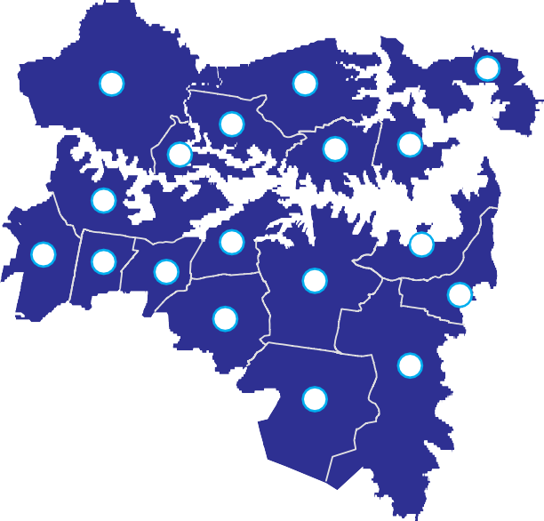Global Sydney today
Figure 3.1 Global Sydney by Local Government Area
8
13
17
6
5
11
10
4
14
7
18
3
1
15
16
9
12
2
Global Sydney Local Government Area
- Ashfeld 10 Mosman
- Botany Bay 11 North Sydney
- Burwood 12 Randwick
- Canada Bay 13 Ryde
- Hunter’s Hill 14 Strathfeld
- Lane Cove 15 Sydney
- Leichhardt 16 Waverley
- Manly 17 Willoughby
- Marrickville 18 Woollahra

Source: Department of Planning and Infrastructure.

Australia’s Global City
Sydney is frequently described as ‘Australia’s global city’. Despite a location distant from the world’s major trade flows and population centres, Sydney’s economy is the 16th largest city economy in the world, ahead of major cities such as Singapore, Shanghai and Hong Kong2.
‘Global city’ status refers to a matrix of economic and cultural influences, engagement with international trade and finance, and attractiveness to globally-mobile workers and visitors.
Global Sydney contains a density of economic activity more concentrated than the wider metropolitan area as a whole and other Australian cities. Global Sydney generates 41 percent of NSW GSP3, is home to most of Sydney’s museums, universities and tourist attractions, and is the State’s front door to the world.
Sydney is fortunate to possess one of the world’s most valuable ‘city brands’. The natural beauty of the harbour, the Opera House, the Sydney Harbour Bridge, the beaches and the climate have all combined to create a unique proposition that is recognised and admired worldwide.
Sydney’s city brand has made a major contribution to economic growth. Success has been based on applying skilled human capital to a range of service industries that collectively make up the ‘knowledge economy’. Half of Australia’s globally competitive service sector jobs are based in Sydney, primarily within Global Sydney4.
Sydney has been extremely successful in attracting talented workers from across the globe and as a result is a diverse, multicultural city. Almost 40 percent of the employees in the City of Sydney5 were born overseas, compared with 30 percent across Australia as a whole6.
While this is the sort of statistic that propels Sydney up the league charts of global cities, it also highlights a key risk – when location is a matter of choice rather than birth, the host city must maintain its competitiveness if it is to retain its dynamism.

  - McKinsey Global Institute 2010, Cityscope Database.

  - Deloitte Access Economics 2012, Infrastructure and the NSW Economy.
  - SGS Economic & Planning 2012, Mine or Mind.
  - City of Sydney 2011, Sydney at a Glance.
  - Australian Bureau of Statistics, 2011 Census.

What is a Global City?
The ‘global city’ concept refers to those metropolises that have the greatest social and economic impact on the world. These cities are characterised by their political and cultural influence, role in world trade
and global financial flows, and their attractiveness to tourists and globally mobile employees.
Global cities are highly connected to the rest of the world and are attractive to people in the high value and strongly influential knowledge-based industries.
Global cities typically have a strong presence in the research and development space and place a
premium on liveability, environment and accessibility.
Global cities develop where a combination of these factors work together in unison to make a uniquely attractive mix.
Sydney generally scores highly in many rankings of global cities. For example, the Globalisation and World Cities Research Network7, which looked at the

connectivity of cities and their role in the ‘knowledge- economy’, has classified Sydney as an Alpha + city, ranking it in the top ten of global cities, comparable to Paris, Tokyo, Singapore and Hong Kong.
In both 2007 and 2008 Sydney was rated the top city brand in the world by the Anholt-GfK Roper City Brand Index8, ahead of Paris, London, New York, Rome and Barcelona. It has subsequently fallen to third place, and liveability surveys now consistently place Melbourne ahead of Sydney.
Of greater concern is Sydney’s poor recent economic performance. Over the last decade Sydney’s growth underperformed relative to the rest of Australia9.
This finding is supported by a recent literature review of global city surveys conducted by the Sydney Business Chamber which noted that Sydney scored badly on the quality of its public infrastructure, particularly its transport networks.

The Economy of Global Sydney
Global Sydney’s economy is disproportionate to its relatively small geographic size. This high density economic cluster, unique in Australia, is central to the success of both the State and nation.
Global Sydney employs over 1 million people10. Geographically, Global Sydney contains the economic and cultural corridor that runs from Macquarie Park through North Sydney and the Sydney CBD to the Port and Airport Precinct as shown in Figure 3.2.
This is where many of the industries that contribute to Sydney’s global significance – finance, technology,
higher education, health and other service areas where knowledge and expertise create value – are located.
At Macquarie Park there is a high concentration of IT and pharmaceutical sector leaders, as well as Macquarie University.
The Sydney CBD and North Sydney area is the hub of the banking, financial services, insurance, funds
management and superannuation industries in Australia. The industries concentrated here have propelled Sydney into the top ranks of cities with global influence.
Meanwhile the Airport and Port precinct represents the gateway for both international passengers in and out of Australia and a key import and export hub, (including from Regional NSW), that powers the economy.

  - Globalisation and World Cities Research Network 2010, The World 8 Anholt-GfK Roper, City Brand Index; 2007, 2008 and 2011.

According to GawC.
- SGS Economic & Planning 2011, Australia Cities Accounts.
- Deloitte Access Economics 2012, Infrastructure and the NSW Economy.

Figure 3.2 Employment in key Global Sydney centres

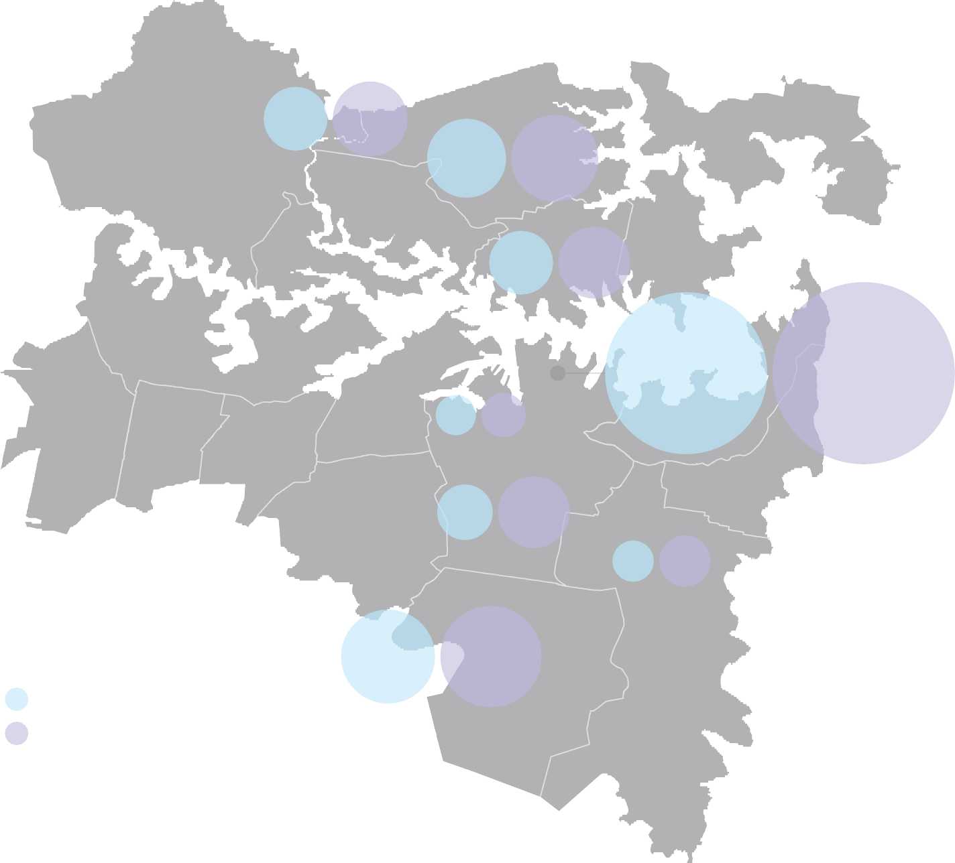
Population
2.0

1.5

45 61

Macquarie Park

68 84

1.0

0.5
Millions

Chatswood & St Leonards

44 56

0

Jobs

2011

2032

North Sydney
1.5

Ultimo & Pyrmont
Sydney CBD
18 22

34 56

288 363

1.0
Millions

0.5

0

2011 2032

Employment
2011

2031
Sydney South

98 114

International Gateways
19 29

Randwick

GRP/GSP
350
300
250
200
$ Billions
150
100
50
0

2011 2032

Source: Bureau of Transport Statistics; Deloitte Access Economics; Infrastructure NSW analysis. Note: All values are in (’000).

Education, Healthcare, Tourism and Culture
Sydney’s social infrastructure has historically been a strong feature in the city’s favour, supporting its
economic growth. Global Sydney is the centre of higher education, healthcare, the visitor economy and the city’s cultural life.
Four of NSW’s universities are located in Global Sydney: University of Sydney, UNSW, UTS and Macquarie University. Universities stimulate a large amount of knowledge-based activity. Travel services – mainly overseas education – is one of NSW’s largest export industries, generating overseas earnings of $12 billion in 2009, a quarter of all NSW’s exports11.
Three of NSW’s leading hospitals are located in Global Sydney: Royal North Shore, Prince of Wales and Royal Prince Alfred. Each generates a diverse range of healthcare-related activities.
Many of the world-class cultural and tourism attractions that drive the $20 billion visitor economy12, including the Opera House, Sydney Harbour and the city’s galleries, theatres and museums, are also in Global Sydney. This represents one third of Australia’s international tourism earnings.

Living in Global Sydney
1.3 million people13 (17 percent of NSW residents), live in Global Sydney in some of the highest density, oldest suburbs of Australia.

- NSW Trade and Investment 2011.
The natural and man-made attractions of Global Sydney help the city to score highly in international quality of life surveys. The Economist Intelligence Unit, ranked Sydney as the seventh most liveable city on the planet. Sydney should not rest on its laurels however as Melbourne was ranked first in the same survey14.
Where and how people live and work in Global Sydney has implications for the city’s infrastructure needs. For example, a much higher percentage of Global Sydney residents travel to work by public transport than Greater Sydney’s residents.

Sydney’s International Gateways
Global Sydney is home to two of Australia’s most economically important air and sea gateways. Sydney Airport is Australia’s largest airport with more than
45 percent of international passenger traffic15. Port Botany is Australia’s second busiest container port and handles more than $60 billion of trade16.
This focus of activity is unusual for a major city. Infrastructure NSW has been unable to identify comparable cities that co-locate their international gateways in such close proximity and so near to their primary commercial area.
Some vital statistics:
      - Sydney Airport handles more than 100,000 airline passengers each day, or 40 million passengers a year, supported by some 16,000 airport workers and tens of thousands of ‘meeters and greeters’.

14 Economist Intelligence Unit 2012, Global Liveability Report.
      - Port Botany moves around 5,000 containers on average every day, or around two million per annum. The vast majority arrive and depart by road17.
These infrastructure facilities are extremely important to NSW, connecting primary producers and businesses (both small and large) across the State’s regions with global markets.
Australia is a long way from its global trading partners. Efficient international gateways are essential to support the competitiveness of NSW’s goods and services exports, to attract international investment and highly skilled knowledge workers and to get imports to consumers cost effectively.

Global Sydney: the next 20 years

Global Sydney’s role in the NSW economy
As this section has shown, Sydney plays a key role in the success of both NSW, and more broadly, Australia.
The conclusion that must be drawn is that the success of Global Sydney, as the flag carrier for the State economy, needs to be supported and sustained in the interests of all. Investing in Global Sydney’s economic infrastructure is therefore a priority for the whole of NSW.
This does not mean that the infrastructure needs of the rest of the State should be ignored. It does, however, mean that some hard choices must be made. Investing in Global Sydney will result in benefits across NSW. For example, while investing in connecting infrastructure to Sydney’s International Gateways could be seen by some

- NSW Visitor Economy Taskforce 2012, Final Report. 15 Sydney Airport Corporation 2009, Sydney Airport Master Plan.

- Deloitte Access Economics 2011, Infrastructure and the NSW Economy.
- NSW Treasury, 2012-13 Budget Paper 4.
- Sydney Ports Corporation 2011.

as a Sydney-centric proposition, it will benefit regional businesses and exporters and importers.
This leads to the question of whether infrastructure investment can create the high levels of economic activity seen in Global Sydney in other parts of the State. The qualities that created Global Sydney are a
reflection of a mixture of geographic, historical, social and economic factors that are very hard to duplicate. Global Sydney is the result of what is known as ‘agglomeration benefits’, where clusters of industry build up because of proximity and connections as discussed below.
Infrastructure NSW’s expectation is that the employment centres of Global Sydney will remain the State’s principal centre of economic agglomeration over the next 20 years. The analysis prepared for Infrastructure NSW
by Deloitte Access Economics forecasts that around 200,000 additional jobs will be created in Global Sydney by 2031, leaving the region’s share of Sydney’s total jobs market unchanged from today20.
Economies of agglomeration: why do some places succeed over others?
Why do people and jobs cluster in particular areas Agglomeration effects are true at the local as well as within a city rather than being more evenly dispersed? the metropolitan level. This is why certain sectors (for
Cities form because they enable collaboration. Close example financial services in the CBD) cluster closely proximity lowers the cost of exchanging goods and together, even though this leads to them paying higher ideas. As Edward Glaeser puts it, cities “enable us to land, labour and transport costs.
work and play together, and their success depends on The benefits of physical connection – the invaluable
the demand for physical connection”18. face-to-face meetings and chance encounters close
Urban scale also spreads fixed costs and so enables proximity enables – are diminished by distance, even activities that are unviable at lower densities. Cities within a metropolitan area.
support greater labour specialisation as individuals The productivity benefits of agglomeration vary by
can move more easily between jobs. The reason why industry. They are highest in the financial services, people and firms accept the higher costs of being in a professional services, cultural and scientific sectors19 city is that there are productivity and social advantages – industries in which Global Sydney specialises.
that outweigh these costs.
These benefits (the economies of scale and the network effects) that cities provide are known as ‘economies of agglomeration’.
As a further indicator, BIS Shrapnel has forecast that over 90 percent of new office-based employment in Sydney over the next decade will be located in Global Sydney21. Barangaroo alone is forecast to accommodate 23,000 jobs. This is bigger than any centre in Greater Sydney, with the exception of Parramatta.
Global Sydney’s population is forecast to grow rapidly also. By 2031, the population of the region will have grown by 400,000 to 1.7 million people22. By comparison, between 1991 and 2011, the population of Global Sydney grew by 250,000.
The infrastructure investment challenges that arise from these findings is that significant energy needs to be directed into ensuring Global Sydney is highly
accessible, maintains its attractive lifestyle and remains open to the world.
The continuing importance of Global Sydney does not preclude the development of secondary and
supplementary business centres within Greater Sydney. The evidence from other global cities, like London and

- Glaeser, E 2011, The Triumph of the City.

- SGS Economics & Planning 2011, Agglomeration and Labour Productivity in Australian Cities.
- Deloitte Access Economics 2012, Infrastructure and the NSW Economy.
- BIS Shrapnel 2011, Forecasting the Distribution of Dedicated Office Employment in Sydney, Final Report for NSW Treasury.
- Deloitte Access Economics 2012, Infrastructure and the NSW Economy.

Paris shows that supplementary business centres play a crucial role as well. This issue is discussed in more detail in Section 4 dealing with Greater Sydney.

The Growth Challenge at Sydney’s Gateways
A special challenge within Global Sydney relates to Sydney’s gateways. Both Sydney Airport and Port Botany expect rapid growth in demand faster than the economy as a whole and faster than other areas of Global Sydney.
Passenger volumes at Sydney Airport are set to more than double from present levels over the next 20 years to over 80 million passengers in 2031, increasing from around 40 million in 201023.
Sydney Ports forecasts container trade through
Port Botany to nearly quadruple by 2031, reaching seven million containers, increasing from two million containers in 201124.
This growth will place significant demands on the already heavily utilised land and infrastructure around Sydney’s Gateways. This means that addressing these significant demands must be a priority in the State Infrastructure Strategy. Staying open for international business is an intrinsic objective if NSW is to be number one again.

Infrastructure priorities for Global Sydney

Growing the economy
Infrastructure NSW has determined that infrastructure that supports and sustains the continued growth of the economy of the CBD and other Global Sydney centres is one of the State’s highest priorities.
As a result the following critical infrastructure needs in support of this strategic goal are:
      - improving public transport access to and through the CBD and adjoining centres
      - increase the number of people living in areas accessible to Global Sydney
      - providing an attractive urban environment conducive for knowledge-based business and the visitor economy.
These are considered in further detail below.
Public transport and congestion in Global Sydney Every weekday, the population of Sydney’s CBD grows from its 50,000 permanent residents to around half a million people.
Almost 75 percent of commuter journeys to the CBD are by public transport – compared to only 24 percent of all work journeys in Sydney. Limitations on parking in the CBD means that public transport needs will increase as employment in the CBD grows over the next twenty years.
The commuter task is primarily handled by trains and buses – 44 percent and 28 percent respectively. Ferries transport around four percent of workers to the CBD25.
The rail system is often congested and services can be slow and unreliable. High demands placed on particular stations magnify the challenges, for example Wynyard alone carries 110,000 passengers each weekday.
There is no debate about the need to solve these problems. The question is how far the solution is to be found through a process of incremental reform or through major investment in new fixed infrastructure.
These issues are discussed in more detail in Section 8.
Buses primarily provide access from the inner suburbs, with passenger flows into the CBD concentrated
on a small number of major corridors. The primary issue with buses is congestion in the CBD. Buses cannot get through crowded CBD road space at peak hours. An infrastructure strategy for this issue is set out is Section 7.
On some bus corridors, forecast growth in demand indicates infrastructure investment is needed to ensure reliable access to the CBD and other centres in Global Sydney. Potential options for improving
passenger flows on key public transport corridors such as Anzac Parade and from the Northern Beaches are also discussed in Section 7.

- Steering Committee 2012, Joint Study on Aviation Capacity for the Sydney Region, Department of Infrastructure and Transport.
- Sydney Ports Corporation 2011.

- All transport data from the NSW Bureau of Transport Statistics.

Housing and Infrastructure
Land use is inextricably linked to infrastructure provision. Planning strategies for new development directly impact the efficiency with which the State’s existing stock of infrastructure is used and create the need for new utility and transport infrastructure.
Land use strategies for housing are particularly critical given population growth and Global Sydney’s high housing prices – both factors which challenge the quality of life.
The market evidence suggests that people are willing to live in more dense suburbs closer to the CBD26, trading off space for lifestyle and access to jobs. Two-thirds of existing CBD workers live in the inner suburbs around Global Sydney, which is reflected in housing prices.
Infrastructure NSW is supportive of more intensive residential land use within Sydney based on these market and community preferences.
Urban densification requires investment to ensure infrastructure systems can cope with growth in demand.
Infrastructure NSW has considered options where investment in enabling transport infrastructure can support urban renewal and housing growth in areas readily accessible to Global Sydney. These include along the Parramatta Road corridor and in South Eastern Suburbs. These issues are discussed further in Sections 6 and 8 respectively.
The implications for social infrastructure from in-fill development are important also. School populations in Global Sydney are expected to grow by 15 percent and demand is expected to grow by 17 percent in the next ten years. This is discussed Section 14.

Urban Environment
The competitiveness of Global Sydney as an attractive place to work, live, do business and entertain requires world class transport networks, and a vibrant open city environment, conducive to working, meeting, entertaining, and for retail and cultural pursuits.
Addressing the issue is challenging. The Sydney CBD is an undulating, high-density peninsula with road space that is narrow relative to the traffic it carries and the people movements it supports.
Section 7 outlines infrastructure options aimed at addressing the road space capacity issue in the CBD and enabling the improvement in the urban environment.
Infrastructure NSW also recognises the importance of a cultural precinct to both the general amenity of the city and the visitor economy. It supports the establishment and development of the Art’s Ribbon from Darling Harbour through Barangaroo to the Australian Museum. This is discussed further in Section 14.

Supporting the Growth of Global Sydney and its International Gateways
The other strategic priority for Global Sydney is supporting the growth of its international gateways. Infrastructure projects around this precinct are discussed in Sections 6 and 9.
Sydney benefits from their location. As 98 percent of containers never leave the metropolitan area27, exports will generally be more competitive and imports cheaper through Port Botany than alternative locations. Equally, the airport is well located as a large proportion of air travellers come from or are travelling to central areas.
Both Sydney Airport and Port Botany have the capacity to accommodate most of the rapid growth in demand they face over the next 20 years.
Sydney Airport conveyed 40 percent more passengers in 2012 than in 2000 with no net increase in flight movements as plane sizes have increased28.
Following completion of the Third Terminal in 2013, Sydney Ports estimates that Port Botany can handle a quadrupling of throughput to at least seven million containers per annum.
The most pressing infrastructure challenge for Sydney’s gateways is to ensure efficient landside transportation, rather than developing new capacity.
Over the longer-term, supplementary airport and container port capacity will also be needed.

- NSW Treasury 2012, Submission to the NSW Planning System Review.
- Sydney Ports Corporation 2011, Logistics Review 2010/11.
- Sydney Airport Corporation 2012, Investor Update.

Roads and public transport
The roads serving Global Sydney and Sydney’s international gateways are some of the most congested in Australia. The M5 East and General Holmes Drive are congested for more than 13 hours each day29.
The roads around Sydney Airport are also congested. Only 15 per cent of travel to and from the airport is by public transport30.
In the short term, much can be done to relieve congestion through targeted pinch point investment. Greater use of public transport to Sydney Airport also needs to be targeted. Over the medium term there
is no alternative to major investment to upgrade the capacity and connectivity of the motorways that support these gateways.

Freight
The vast majority of the freight task in and out of Port Botany is handled by road transport. This reflects the benefits road offers in terms of cost, reliability and flexibility.
The Government is targeting to increase the proportion of freight moved by rail from the Port.
Shifting freight onto rail has proven difficult. Major investment is underway by the Federal Government and private sector to expand the capacity of the State’s rail and intermodal infrastructure on the basis that the increased volumes this infrastructure will support will make rail freight a more viable alternative.

- Infrastructure Australia.
- Sydney Airport Corporation 2009, Sydney Airport Master Plan.

Greater Sydney

Key points

Introduction

Greater Sydney is where most Sydneysiders (over three million people) live. This suburban region stretches across Western and Southern Sydney in an arc to the Northern beaches and Central Coast. It is bounded
in the West and split in the North by the Hawkesbury Nepean Valley which represents a significant natural flooding risk.
Greater Sydney is home to a diversity of industries that are essential to NSW’s success. It is the NSW manufacturing heartland which, despite pressures, remains one of the most significant sectors in the NSW economy.
The logistics sector is increasingly important to the West and South-West, supported by Greater Sydney’s freight transport networks.
The success of Greater Sydney and Global Sydney are intertwined, with many of Global Sydney’s employees commuting in each day from Greater Sydney.
The service sector in Greater Sydney is growing in importance. Parramatta has been significant to
NSW’s fortunes since the earliest days of European settlement. Today it continues to grow as a key administrative and commercial centre, with more than 20 percent of Australia’s Top 500 companies now present in the Parramatta CBD1.
Greater Sydney’s Business Parks such as Norwest, provide highly skilled job opportunities in Greater Sydney. Health, education and other essential public services are also major employers.
The attractiveness of the region means a further
  - million people expect to call Greater Sydney home over the next 20 years.
Most of these new residents will be housed in existing urban areas. These new Sydneysiders, just like today’s residents, will work at jobs across the metropolitan region. While public transport will be important for some, cars will remain, for most people, the only practical option for their daily travel needs.
Infrastructure NSW has identified five infrastructure priorities to support this rapidly growing region:
    - local infrastructure for new houses
    - good roads for commuter, community and freight traffic
    - better public transport into key employment centres
    - new schools and hospitals in growing suburbs
    - flood protection for the Hawkesbury Nepean Valley.
Greater Sydney (as described in this section) is all of the Sydney Metropolitan Area other than the inner urban areas of Global Sydney.
It comprises the diverse suburban communities that ring Global Sydney from Campbelltown in the South to the Northern suburbs, Gosford and the Central Coast in the North and Penrith in the West.
It also encompasses the economic, administrative and social hubs of Parramatta, Liverpool, Campbelltown, Penrith, Blacktown, Sutherland and Hornsby.
The Greater Sydney sub-regions (see Figure 4.1) covered in this section are:
- South (Kogarah, Hurstville, Canterbury, Rockdale, Sutherland)
- North (Hornsby, Ku-ring-gai, Pittwater, Warringah)
- West Central (Auburn, Blacktown, Hills Shire, Holroyd, Parramatta)
- North West (Baulkham Hills, Blacktown, Blue Mountains, Hawkesbury, Penrith)
- South West (Bankstown, Fairfield, Wollondilly, Camden, Campbelltown, Liverpool)
- Central Coast (Gosford and Wyong).
Greater Sydney accounts for some 46 percent of NSW’s population and is home to nearly 3.3 million people.

- Parramatta City Council, http://www.mynewworkcity.com.au

It includes some of the fastest growing urban areas in Australia as well as and more established suburbs. Greater Sydney accounts for around 36 percent of
NSW employment (56 percent of Sydney employment), or 1.3 million jobs in 2011, and 34 percent of NSW’s economic output (45 percent of Sydney’s output), worth about $140 billion in 2011.
To illustrate the significance of this growth, it is worth considering that within the lifetimes of many Sydneysiders, much of Greater Sydney’s regional
employment centres and business parks were semi-rural. In the past 20 years since 1991, over
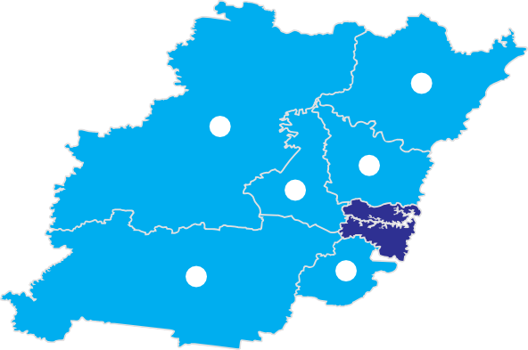70 percent of Sydney’s population growth (over 600,000 people) has been accommodated in Greater Sydney.
Figure 4.1 Regions of Greater Sydney
1
3
2
6
5
4
Greater Sydney
- Central Coast
- North
3 North West
4 South
- South West
- West Central
Source: Department of Planning and Infrastructure.
The economic and demographic projections for Greater Sydney for the next 20 years have forecast that the growth story of Greater Sydney is set to continue:
    - The population is expected to grow by 1.3 percent per annum (an additional 1.1 million people) to more than 4.4 million people. This is the fastest rate of growth of any region of NSW. This means that by 2031 Greater Sydney will account for nearly half NSW’s population
    - GSP is expected to grow at 3.0 percent per annum, the same rate as Global Sydney. This means that by 2031 Greater Sydney will contribute 35 percent of NSW’s economic output, about $250 billion2
    - Employment is forecast to grow by 1.0 percent per annum, (or around 300,000 jobs) to 1.6 million jobs.
What these figures show is that while Global Sydney is the engine room of the NSW economy, Greater Sydney is where most Sydneysiders live and work.

- Deloitte Access Economics 2012, Infrastructure and the NSW Economy.

Greater Sydney today
Greater Sydney is a complex and diverse amalgamation of communities spread over a vast urban footprint.
The Sydney metropolitan area is one of the largest cities in the world in terms of area. Spread across 4,000 square kilometres, it is equal in size to London and almost double that of New York City3.
The metropolitan area mixes suburbs that date back more than 200 years, such as Parramatta and the Macquarie Towns, with other areas like the North West where the population has grown rapidly within the past 20 years.
The population density of Greater Sydney’s suburbs varies but is generally lower in density than in Global Sydney as Figure 4.2 shows. These suburbs have the attraction of land prices much lower than in Global Sydney, making it a more affordable option for many families.
The economy of Greater Sydney is similarly diverse. While the economy of Global Sydney is dominated by financial services and knowledge-based sectors, Greater Sydney has a broader industrial base4.
    - Most of Sydney’s manufacturing output is produced in Greater Sydney, particularly in West Central and South Western Sydney.
    - Sydney’s logistics industry has increasingly located away from the relatively expensive lands around Port Botany and towards major transportation corridors such as the M7 motorway in Greater Sydney.

- City of Sydney, City of Sydney – A Snapshot.
- Department Planning and Infrastructure 2012, Sydney Over the Next Twenty Years: A Discussion Paper.

  - The construction industry is a major employer across Greater Sydney.
  - As most Sydneysiders live in Greater Sydney, a major focus is in sectors serving local population needs such as in healthcare, education and retail.
This industrial mix means Greater Sydney’s employment patterns are much more dispersed than in Global Sydney, where most activity is focused on a small number of high-density centres that are clustered closely together, with the CBD paramount.
Sectors such as manufacturing, logistics and construction do not benefit from close proximity (the ‘economies of agglomeration’ noted in section 3) in the way that many service sectors do. Preference is
given instead to less dense areas which generally bring lower land, labour and transportation costs.
While Greater Sydney contains important regional centres such as Parramatta, Liverpool and Penrith, these account for a much smaller proportion of employment in the region, and these centres are also relatively distant from each other. Most employment is spread across the region. This is shown in Figure 4.3.
The residential and employment patterns of the metropolitan area have implications for infrastructure investment in Greater Sydney, particularly for transport infrastructure. The concentration of jobs
in Global Sydney means many Greater Sydney residents commute into the region each day, often by public transport.
The majority of Greater Sydney residents work within the region however and rely on their cars to get to work. Congestion is a daily issue therefore for many lives across Greater Sydney. These issues are discussed in section 4.4.3.
The infrastructure issues facing Greater Sydney are not uniform, there are major differences between its different sub-regions. Through the capability assessment process described in section 2, Infrastructure NSW has looked
at the economic and demographic composition of each sub-region and its current infrastructure deficiencies, shown in Table 4.1.

Table 4.1 Infrastructure Deficiencies by Sub-Region in Greater Sydney
Greater Sydney
Sub-Region Population 2011 Major Industries Infrastructure Deficiencies
South | 650,000 | Finance and Services, Logistics | Road congestion, i.e. Princes Highway, adding to freight costs and commute times
North | 500,000 | Business Services, Technology, Education | Inadequate connectivity to F3 Freeway access to Global Sydney from Northern Beaches and school capacity
West Central | 680,000 | Secondary CBD – Finance and Insurance Services, Health, Education (UWS), Manufacturing | Access to Parramatta and Global Sydney, inadequate road links, school capacity
North West | 760,000 | Health, Education (UWS), Construction | Flooding risks, road congestion, i.e. M4 Motorway access to Parramatta and Global Sydney
South West | 410,000 | Logistics, Manufacturing, Construction | Road congestion, i.e. M5 Motorway, adding to freight costs and commute times, school capacity
Central Coast | 300,000 | Technology, Health, Manufacturing | Access to Global Sydney, inadequate road connectivity

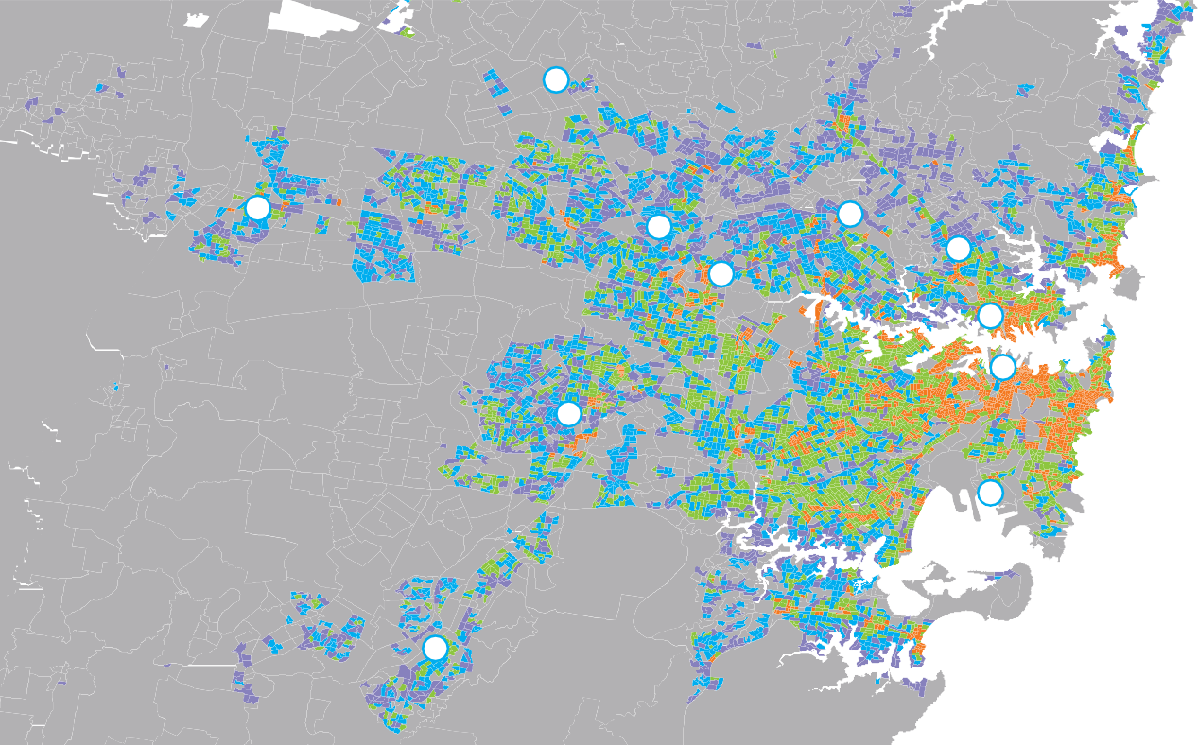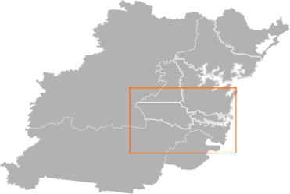Where and how people will live and work are the greatest drivers of infrastructure demand. As noted, over the next 20 years an additional 1.1 million people will call the region home, and around 300,000 new jobs will be created.
4.3 Greater Sydney in 2031
Key
Existing Housing Density per Hectare
0-6
6-9
9-12
12-25
25+
Source: Department of Planning and Infrastructure.
- Blacktown
- Liverpool
- Rouse Hill
- Campbelltown
- Penrith
- Sydney
- North Sydney
- Chatswood/St Leonards
- Sydney Airport/Port Botany
- Macquarie Park
- Parramatta
10
4
8
1
2
6
3
5
7
11
9
Figure 4.2 Residential Density Sydney 2011
To put this in context, this is double the population growth of Greater Sydney in the 20 years from 1991 to 2011.
It is not possible to have any certainty as to how Sydney will develop at the micro level, given the complexity of the many private decisions that will influence where Sydney’s growth will occur.
Analysis developed by Deloitte Access Economics for this Strategy indicates the following high level findings:
- As in recent years, housing growth is expected to come primarily through densification of existing urban areas. Over the past five years, only 15 percent of development has been in greenfield areas and over 80 percent of new homes have been built in multi-unit dwellings5. Most greenfield housing development is expected to be located in the North West and South West Growth Centres.
- Large numbers of people will continue to commute into Global Sydney from Greater Sydney each day.
- Over the next 20 years, the economy of Greater Sydney is expected to become more services based, with a reduction in manufacturing. This will present challenges in particular for the West Central and South West sub-regions, which have a particular focus in this sector of the economy.
- Service-based employment will grow in centres across the metropolitan area. Parramatta will

- Department of Planning and Infrastructure 2012, Growth Infrastructure Plan.

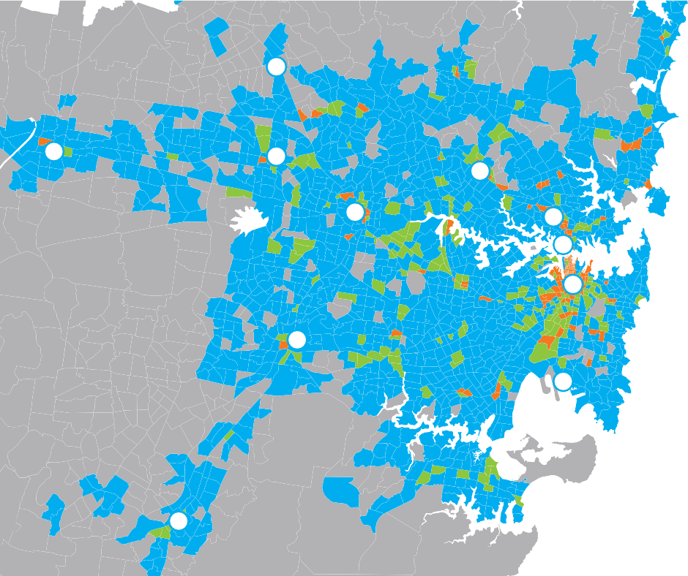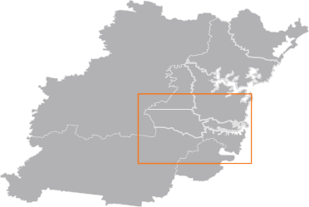continue its strengths in financial and insurance services. The healthcare clusters at Westmead and Liverpool will grow substantially. The education precinct centred around the University of Western Sydney at Rydalmere and Greater Sydney’s business parks, such as Norwest and Frenchs Forest will also grow.
- Sydney
- North Sydney
- Chatswood/St Leonards
- Sydney Airport/Port Botany
- Macquarie Park
- Parramatta
- Blacktown
- Liverpool
- Rouse Hill
- Campbelltown
- Penrith
Key
Jobs per hectare
1 or fewer
1 to 25
25 to 75
More than 75
Source: Transport for NSW.
10
4
8
1
2
3
6
5
7
11
9
Figure 4.3 Employment Density Sydney 2006
These findings imply Greater Sydney in 2031 will be a higher density region, with a greater proportion of its jobs located in its burgeoning employment centres.
Targets for the distribution of housing and employment are to be finalised by the Department of Planning and Infrastructure in the Metropolitan Strategy for Sydney.
The level of change should not be overstated however. The stock of existing houses is three times greater than those expected to be built over this period. The economies of agglomeration that benefit Global Sydney (and attract commuters from Greater Sydney) are expected to remain as strong as today. Much employment in Greater Sydney, particularly in locally facing roles, is expected to continue to be dispersed across the metropolitan area.

Greater Sydney Infrastructure priorities

Overview
The key infrastructure priorities that emerge from Infrastructure NSW’s capability assessment of today’s infrastructure deficiencies and Greater Sydney’s forecast population and employment growth are:
      - Housing. Houses need to be built at a much faster rate than during the last decade. Improving the co-ordination of the utility and local transport infrastructure networks that are needed to enable
this will be a major infrastructure challenge. Enabling residential development in those areas most accessible to employment is critical.
      - Transport. Greater Sydney’s new residents will work across the metropolitan area. As today, some will work locally, some will work elsewhere in Greater Sydney, and some will travel into Global Sydney. Sydney needs flexible transport networks that can support this complexity of journey patterns. Ensuring efficient freight movements within and through Greater Sydney is also essential to the economy.
      - Social Infrastructure. Investment in schools and healthcare facilities will be required in the fastest growing areas. In the health sector, new models of care are needed to ensure affordability as Sydney ages.
Parts of Greater Sydney also lie in the Hawkesbury Nepean Valley and are exposed to flood risk. Protecting people and the economy in this region is vital.

Infrastructure for Housing
Sydney’s lack of housing supply is one of the most significant economic issues facing NSW and drives the ongoing problem of housing affordability. It is estimated that the construction of an additional 8,000 dwellings per annum in New South Wales over the last decade would have directly increased GSP by 0.5-0.6 percent, or $2 billion per annum6.
Undersupply of housing in Greater Sydney in the past decade is reportedly due to lack of land supply in greenfield areas arising from the ‘Sydney is full’ approach, high cost of land, planning complexity and higher construction costs; the lack of on time delivery of lead-in infrastructure; and localised opposition to in-fill development7.
Like any market, house prices are subject to the laws of supply and demand. In Greater Sydney demand is
growing, supply is constrained and hence prices are high.
There is a reported housing supply shortage in
Greater Sydney of around 100,000 homes8. Addressing this and accommodating population growth means around 600,000 additional homes need to be built over the next 20 years.
Co-ordination of utility and transport infrastructure is essential to unlocking housing development, particularly in greenfield areas. The Government is introducing a series of reforms to improve the co-ordination of local infrastructure, including:
- increasing the release of land in growth areas zoned for residential development
- introducing new Growth Infrastructure Plans to link spatial planning with infrastructure planning and provision in high growth areas
- mandating a contestable lead-in infrastructure (water and roads) market
- creating the Housing Acceleration Fund to directly fund critical local infrastructure in high growth areas.
Infrastructure NSW supports these measures. Barriers still exist to greenfield development, however. Sydney’s vast size means that many greenfield developments can be a long way from major employment centres.
The North West and South West Rail Links will help connect Sydney’s two growth centres to employment opportunities, particularly in Global Sydney. There will also be a need for road investment to improve the connectivity of these growth centres to the existing urban area.
The majority of housing growth is taking place in existing residential areas. In-fill development leverages existing transport, utility and social infrastructure systems at a lower cost, helping to increase housing affordability.
The location of in-fill development is important. The Department of Planning and Infrastructure has examined the relative costs of different in-fill scenarios. Of the
cost drivers, transport congestion, crowding and social impacts from transport are most important and a balanced approach, where residential growth is focussed on local and strategic centres, achieved lowest costs9.
Infrastructure NSW supports this approach.

- BIS Shrapnel and Urban Taskforce 2010, Going Nowhere.

- Department of Planning and Infrastructure 2012, Growth Infrastructure Plan.
- BIS Shrapnel.
- Centre for International Economics 2012, Costs and benefits of alternative strategies for Sydney’s growth, Draft report.

Figure 4.4 Journeys to Work by Car – percentage of all people

Source: PSMA Australia.
Note: Sub-regional boundaries differ from Infrastructure NSW boundaries.

Percentage journey
to work by car (percent)
16-32
32-57
57-66
66-76
76-84

Transport Infrastructure
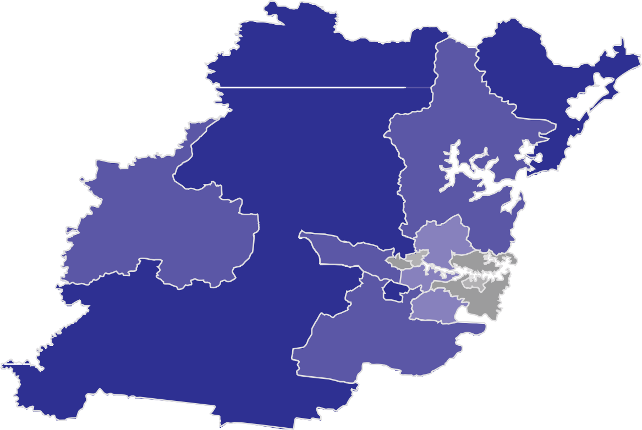Infrastructure NSW has taken a mode neutral approach to its assessment of transport infrastructure options in this strategy. This approach recognises that road and rail networks are mostly complementary to each other, rather than in competition.
The travel flows and transport infrastructure demands created by the dispersed housing and employment patterns of Greater Sydney are complex. Historic assumptions about Sydneysiders commuting to a single central business district by mass transit do not reflect the current position. While the travel flows into Global Sydney from across Greater Sydney are significant,
intra-suburban and cross-suburban commuting flows are even greater.
Private vehicles are better suited to this diffuse orbital travel than public transport, which needs relatively high demand along a given corridor to be viable. Over 80 per cent of non walking journeys in the metropolitan area on weekdays are by car10. More than 70 percent of Greater Sydney residents choose to drive to work each day (compared with around 20 percent by public transport), as shown in Figure 4.411.
These journey patterns are not unique to Sydney.
In Vancouver for example, despite an average population density more than two and a half times that of Sydney, 67 percent of journeys to work are by private vehicles12.

- NSW Bureau of Transport Statistics 2011, Household Travel Survey.
- Australian Bureau of Statistics, 2006 Census.
- Statistics Canada, 2006 Census.

What this tells us is that in complex metropolitan areas with a multiplicity of journey origins and destinations, there is often no realistic alternative to the car for many journeys. The evidence suggests that the expected densification of Greater Sydney discussed in this section is unlikely to change journey patterns significantly.
Conversely, radial journeys into Global Sydney or Greater Sydney’s major employment centres (such as Parramatta) are clearly best served by mass transit, which can transport higher numbers along a given transport corridor more reliably than car travel.
Over the next 20 years, Infrastructure NSW expects the car will remain the dominant mode of transport in Greater Sydney. Investment is needed to ensure sufficient road capacity is available and is utilised effectively, particularly along the motorway network. These issues are discussed further in Section 6.
For major employment centres, action will be needed to enable a higher proportion of journeys to be made by
public transport as these centres grow. Public transport in Sydney is discussed in Sections 7 and 8.
Plans will need to account for freight journeys to, from and within Greater Sydney as well. Most freight journeys are expected to continue to be undertaken by road, due to the cost, flexibility and reliability of road freight. Freight issues in Sydney are discussed in Section 9.
Sensible planning also requires the identification and preservation of potential road and rail corridors and sites for major infrastructure facilities (such as freight intermodal terminals) within Greater Sydney. The value of corridor preservation can be seen in roads such as the M7 Motorway, which was able to be
delivered affordably and without significant disruption to existing communities.
Parramatta
The Heart of Greater Sydney
Within Greater Sydney, the largest economic and employment cluster occurs around Parramatta, NSW’s second oldest settlement and the sixth largest business district in Australia.
Almost 50,000 people already work in the Parramatta CBD13. The wider area around Parramatta (including the Westmead Hospital precinct, Sydney Olympic Park and the University of Western Sydney Campus at Rydalmere) employs many more.
Parramatta benefits from good transport connections, space for office development and attractive urban amenities, such as cafes, parkland and the river. These attributes will support growth and attract infrastructure investment.
Parramatta’s comparative advantage is its position at the geographic heart of Sydney. Its future as an important business centre is assured, with a particular focus on Government services and the rapidly growing residential areas of Greater Sydney.
Parramatta will offer, even more than it does already, access to the highest quality healthcare, education and cultural services. Parramatta will continue to act as a major regional business and service centre with strong connections to Global Sydney.
A major priority to achieve these goals is substantial improvement in transport to and around Parramatta and the corridor between Epping and Parramatta, and improving the connectivity of Parramatta to Global
Sydney. Options to improve transport serving Parramatta are set out in Sections 6, 7 and 8.

Health Infrastructure
Around 70 percent of all NSW health assets are in Greater Sydney, including Westmead, St George, Liverpool, Bankstown and Concord Tier one hospitals. The development some 30 years ago of the health precinct around Westmead, which includes the State’s leading children’s hospital, was a direct response to the westward expansion of Sydney’s population. These trends are expected to continue over the next 20 years.
Demand for health care is forecast to grow around
17 percent over the next 10 years in Greater Sydney14. The proportion of the economy in the health and social services industry sector is expected to grow by 10 per cent in the next 20 years (from 6.6 percent to 7.3 percent)15. Importantly, public and private hospitals have created health precincts in Kogarah, Westmead, Hornsby, Campbelltown and Liverpool.
Each region’s utilisation of hospitals forecast growth in demand and major works proposed by the NSW Government are summarised in table 4.2.

- NSW Bureau of Transport Statistics 2011, Employment Forecasts.
- NSW Department of Health 2012.
- Deloitte Access Economics 2012, Infrastructure and the NSW Economy.

Table 4.2 Healthcare in Metropolitan Sydney
As with other parts of NSW, affordability will remain a challenge as an ageing population and new healthcare

Regional
Action Plan Area
South | 1.9 | 94% | 17% | St George Redevelopment
North | 1.8 | 80% | 16% | Hornsby Ku-ring-gai stage 1 Northern Beaches
West Central | 1.7 | 90% | 24% | Blacktown / Mt Druitt / Westmead
North West | 0.8 | 95% | 20% | Nepean Stage 4
South West | 2 | 80% | 16% | Liverpool / Campbelltown / Leppington
Central Coast | 1.8 | 90% | 7% | Gosford / Wyong

Source: PwC.
Average
Available Beds*
Bed
Occupancy Rate
Forecast Increase in
Demand for Acute Care
Proposed
Major Works
technologies increase healthcare spending. Getting the most out of the existing asset base (both public and private) through new models of care will be essential to manage these pressures.
Infrastructure NSW’s Health Infrastructure Strategy is set out in Section 13.

Education
School populations in Greater Sydney are growing at twice the rate of the rest of NSW, reflecting high levels of population growth as shown in Table 4.3. Parts of the
Greater Sydney area are experiencing very high capacity utilisation in primary schools including the Northern

*Beds per 1000 head of population.

Table 4.3 Education in Metropolitan Sydney
region (110 percent), West Central region (104.5 percent), and South West (103 percent)16.
A large program of work to expand the capacity of

Regional
Action Plan Area
Primary enrolments – growth in next ten years
Secondary Growth
Proposed Major Works
existing schools is planned, in addition to new schools across the metropolitan area.
Sydney’s education infrastructure needs are discussed in more detail in Section 14.
North | 16% | 15% | Lindfield; major expansions
West Central | 14% | 13% | Auburn primary school and high school
North West | 16% | 15% | The Ponds – 3 schools, Riverstone, Riverstone East, North Kellyville, Schofields, Glenmore Park, Blue Mtns, Penrith SSP
South and South West | 15% | 9% | Wentworth Point, Spring Farm, Edmondson Park, Oran Park, Rockdale, Leppington, Gregory Hill
Central Coast | 8% | 2% | Wyong, Lake Macquarie

Protecting People and the Economy
The recent experience in Queensland with the controversy over operating rules for Wivenhoe Dam during the 2011 floods, raises issues about the level of flood mitigation capability provided by major storages such as Warragamba Dam in NSW.

Source: NSW Department of Education and Communities. Note: Boundary of South and South West Combine.

- NSW Department of Education analysis, 2012.

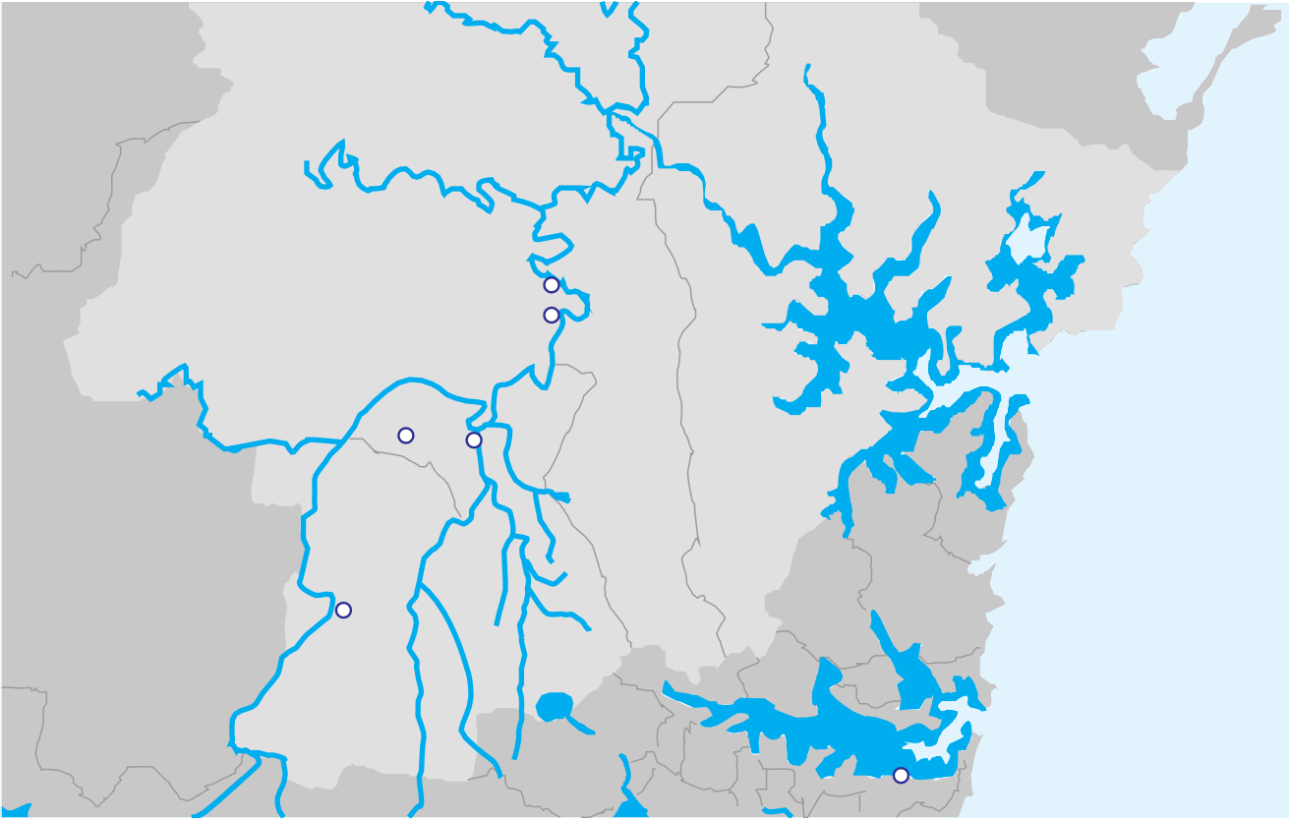The Hawkesbury Nepean Valley (HNV) (illustrated in Figure 4.5) is one of the most heavily developed and at risk flood plains in Australia.
Figure 4.5 Hawkesbury Nepean Valley
Macdonald River
Webbs Ck
Colo River
Gosford LGA
Hawkesbury LGA
Sackville
Ebenezer
Hawkesbury River
Grose River
Richmond
Windsor
Hornsby LGA
Penrith LGA
Baulkham Hills LGA
Eastern Ck
Penrith
Blacktown LGA
Warragamba River
Prospect Reservoir
Warragamba Dam
South Ck
Sydney
The flooding history in the HNV can be traced back to the very early years of European settlement. As early as 1817, a proclamation from Governor Lachlan Macquarie expressed "concern and regret for the recent calamities in which the unfortunate settlers on the banks of the
Nepean and Hawkesbury have been once more involved, by the late dreadful inundations of those rivers"17.
The largest flood recorded in the Valley occurred in 1867. Despite proclamations as far back as the early 1800s to avoid living in flood affected areas in the Valley, significant development of homes and businesses has
occurred. As more development has occurred, NSW has continued to invest millions in supporting infrastructure, which is also at risk.
During the 1980s and 1990s evidence emerged that floods significantly larger than any yet recorded could occur in the Valley18. This eventually led in the late 1990s to major upgrades of Warragamba Dam to prevent dam break during major flooding events to protect Sydney’s water supply. This decision only dealt with dam safety issues and ignored the major risk to the people and
businesses in the HNV and the NSW economy as a whole.
In reviewing the decision on dam safety, the extent of flood risk to people living and working in the HNV was revealed. The HNV has a unique flooding topography in Australia where a narrow gorge at Sackville restricts the rivers flow.

- Governor Macquarie 1817, General Orders.
- Sydney Water, 1995.

In heavy rains the water level rises quickly and incremental flood depths are very large compared to other flood plains. The water level at Windsor is normally at sea level. A repeat of the flood on record would see this rise to almost 20 metres high.
The NSW Government of the day not only wanted appropriate emergency plans for the HNV, it also wanted to substantially alleviate flood losses. An Environmental Impact Statement (EIS) was developed which looked at all the possible options.
The EIS reached the conclusion that raising the Warragamba Dam wall by 23 metres to temporarily store flood waters not only made the dam wall safe from the probable maximum flood but would also reduce flood losses in the Valley. The largest environmental impact of this option was the temporary inundation, upstream of the dam, to the undisturbed bushland.
At the time, it was considered that these biophysical costs would not outweigh the social and economic benefits to be gained from raising the dam wall.
A change in the NSW Government in 1995 saw a change in view where upstream biophysical costs were considered to be sufficient to outweigh the social and economic benefits as a whole19.
The previous NSW Government, in rejecting raising the wall of the dam, decided to mitigate the impact of flooding downstream through focused town and emergency planning. This included upgrading of
evacuation routes to provide more time for the people in the HNV to escape rising floods.
None of these actions comprehensively deal with the potential for homes to be flooded and destroyed
and the significant economic and personal loss which could occur20.
Despite these measures, development has continued in the HNV in areas that would be significantly impacted by a flood on record. The economic and social risks
still exist and are considerably greater than they were 20 years ago21.
Infrastructure NSW commissioned new modelling to provide up to date data on flooding impact from both a damages and economic impact perspective so that it could provide advice to Government as part of the
Strategy. The findings and the recommendations are set out in Section 12.

- Molino Stewart 2012, Hawkesbury Nepean Flood Damages Assessment: Final Report.
- Molino Stewart 2012, Hawkesbury Nepean Flood Damages Assessment: Final Report.
- Molino Stewart 2012, Hawkesbury Nepean Flood Damages Assessment: Final Report.

5.0 Regional NSW

Key points

This section examines the economies and infrastructure challenges faced by Regional NSW and the specific

NSW has the largest and most diversified regional
economy of any State in Australia.
Over a third of the population (37 percent), live and work in the regions, contributing around a quarter of the State’s economic output.
The development and future prosperity of Regional NSW and Metropolitan NSW, is firmly interlinked. Regional NSW supplies global markets and Sydney with produce, commodities and resources.
The continued development and support of regional infrastructure benefits the NSW economy as a whole and should not be looked at in isolation from
metropolitan infrastructure. NSW road, aviation and rail networks provide Regional NSW with the connectivity vital for regional and State prosperity.
Over the last decade, Regional NSW has experienced a two-speed economy caused by increased demand for coal and minerals on one hand and pressure on other industries, particularly manufacturing, on the other.
This raises challenges for the ability of infrastructure to service increased demand.
Infrastructure NSW has identified four infrastructure
objectives for Regional NSW:
- improve access to employment and to connect people and communities
- improve local transport networks
- efficient access to markets, particularly mining and agriculture products to domestic and international markets
- improve water quality and security.
Low population densities and ageing demographics make infrastructure investments more challenging in some areas than others. To some extent, new service models enabled by technology will ensure regions can continue to receive quality services.
challenges confronting individual regions including the Hunter and the Illawarra.

Introduction
NSW has the highest regional population and largest and most diversified regional economy of any State in Australia. Manufacturing is the largest industry in regional NSW (in terms of share of value add), followed by mining (which includes the coal industry and the emerging coal seam gas sector).
Regional cities are home to major hospitals and universities. Regional NSW has many areas of great natural beauty that appeal to domestic and international visitors as well as residents looking to migrate to regional areas.
The Deloitte Access Economics Report divides Regional NSW into five sub-regions for the purposes of the Strategy.
The composition of each sub-region is:
- Hunter – Upper and Lower Hunter
- South Coast – Illawarra, South East NSW and Southern Highlands and Southern Tablelands
- North Coast – Mid North Coast and Northern Rivers
- Inland NSW – Central West, Far West, Orana, New England and North West
- Murray – Murray-Lower Darling, Riverina.

The five sub-regions are based on differences in population (and population growth) and differences in industry structure in 2011. Figure 5.1 shows the
predicted population growth from 2011—2031 and the forecast GRP growth. The coastal regions are expected to experience the highest growth in GRP per capita
(of around 1.5 percent), while West of the Divide, the Murray and Inland NSW are expected to experience lower annual growth rates.

Regional NSW today
As described in Deloitte Access Economics Report1:
- 2.6 million people live in regional areas, which is more than a third (37 percent), of the NSW population;
- 36 percent of all NSW jobs (1.3 million in total), are in regional areas; and
- 25 percent of GSP ($107 billion), is produced in regional NSW.
Sydney relies on Regional NSW to supply the produce, commodities and resources that enable it to compete with its global peers.
NSW’s top export is coal, from the largest coal port in the world at Newcastle. The top five industries in
Regional NSW are manufacturing, mining, agriculture, construction and health and social assistance.
Regional NSW has experienced a two-speed economy. Mining and associated construction has dominated growth in the last decade while manufacturing has experienced pressure from the exchange rate and increased competition for capital and labour.

- Deloitte Access Economics 2012, The NSW Economy in 2031-32, Report to Infrastructure NSW.

Figure 5.1 Population, Jobs and Economy of Regional NSW

Population
5.0

4.0

North Coast
3.0

Inland NSW

0 % 1.4 %

Hunter

1.0 % 2.5 %

1.0 % 2.5 %
Millions
2.0

1.0

0

Jobs
3.0

2011

2031

Murray

0.3 % 1.7 %

South Coast

1.0 % 2.5 %

Sydney
2.0

1.0
Regional NSW Greater Sydney Global Sydney

2011

Population 37% 46% 18%
Jobs 36% 36% 28%
GRP/GSP 25% 33% 41%

2032

Population 34% 48% 19%
Jobs 35% 36% 29%
GRP/GSP 23% 35% 43%
Millions

0

GRP/GSP
300

2011 2031

Population growth rate per annum GRP growth rate per annum
200

100
$ Billions

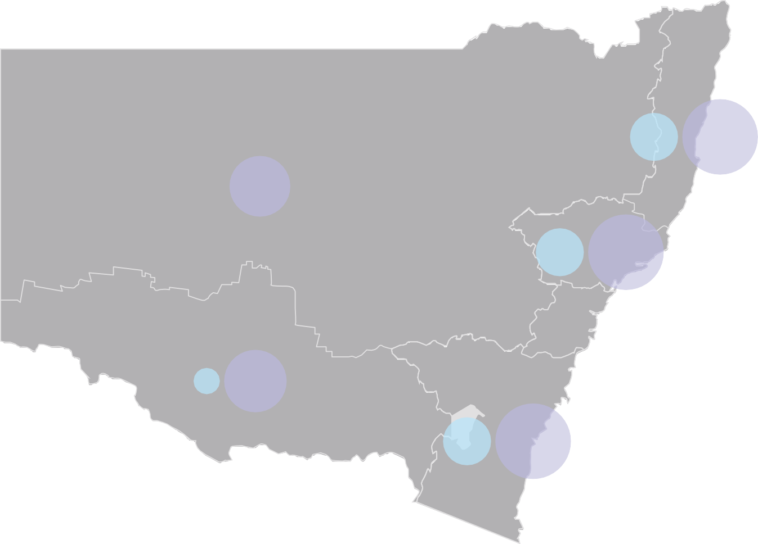
Source: Deloitte Access Economics.
0
2011 2031

Figure 5.2 North Coast Regional Demographic profile compared to NSW profile

Demographic Profile
Analysis of the demographic profiles of a number of
Table 5.1 Labour Market Statistics by Region
Region Employment Unemployment Ratio

Male
85 years and older 80 to 84 years
75 to 79 years
70 to 74 years
65 to 69 years
60 to 64 years
55 to 59 years
50 to 54 years
45 to 49 years
40 to 44 years
35 to 39 years
30 to 34 years
25 to 29 years
20 to 24 years
15 to 19 years
10 to 14 years
5 to 9 years
0 to 4 years
Female
regions shows a relatively high dependency ratio (the ratio of people aged under 15 and over 65 to total population) of around 0.36 compared to 0.33 for Sydney.
The proportion of the population from 20 to 40 years old is particularly low. This is partly the result of the past decade of drought when less labour was needed in agricultural production, encouraging migration away from some regional areas. The demographic profile of
North Coast, shown in Figure 5.2, illustrates this ‘missing’ age group compared to profile of NSW as a whole.
The impact of a lower proportion in this age group is reflected in forecasts for school growth, which are substantially lower than in Sydney. The profile above also illustrates the higher proportion in the ‘over 50’ age group.

Employment in Regional NSW
Creating and then sustaining employment opportunities is a critical issue for Regional NSW. A lack of employment opportunities has led to the need for people to leave the regional areas for work elsewhere.
Employment challenges vary considerably between the different regions in NSW.
Some regions are experiencing employment growth due in part to the expansion of mining activity. Regional
Hunter | 323,400 | 3.5%
Illawarra and South Coast | 364,300 | 7.1% Illawarra  3.8% South Coast
North Coast | 242,700 | 5.6%
Inland NSW | 245,000 | 5.8%
Murray Riverina | 138,700 | 5.1%
Source: Deloitte Access Economics.

Other regions are undergoing significant structural change. The Illawarra has the highest unemployment rate of any region in NSW reflecting the recent decline of Wollongong’s manufacturing base.
To a large extent, the creation of employment opportunities and economic diversity is achieved through investment of the private sector, but this needs to be supported by good planning, efficient approvals and timely investment in infrastructure. Infrastructure NSW supports the NSW Government’s recommendations in the Green Paper, A New Planning System for NSW (July 2012) to establish a regional approach to the release of land for industrial and residential development purposes.
Infrastructure NSW also notes that technology, mobility and patterns of work are changing and new

8% 7% 6% 5% 4% 3% 2% 1% 0% 1% 2% 3% 4% 5% 6% 7% 8%
NSW North Coast

Source: Deloitte Access Economics.
Note: Indicative Regional Demographic Profile (North Coast & NSW, 2010).
centres such as Dubbo, Orange and Broken Hill and
towns in the Hunter are experiencing housing shortages and affordability problems and low unemployment rates due to the rapid growth of the mining sector.
ways of working are able to increase access to jobs from regional areas. For example, Bowral and Moss Vale have 11 per cent and 10 percent of their workforce who tele- work from home2.

- KPMG presentation to Infrastructure NSW.

Every day people commute out from Newcastle to coal mines in the Hunter Valley and people in Regional NSW travel from regional airports to ‘fly-in, fly-out’ jobs in the mining states of Queensland and Western Australia.
The Illawarra and Lower Hunter regions are increasingly becoming integrated with the economy of the Greater Sydney region. Many residents commute by rail and many more make the journey by road
to work in Sydney every day. As Newcastle and Wollongong grow in size and importance to the NSW economy, they need faster and more efficient links to Sydney3. In Section 8, Infrastructure NSW assesses how faster rail journeys from the Illawarra and Central Coast to Sydney would help enable this integration and support these regions.

‘Fly-In, Fly-Out’ Employment
NSW is both a supplier of skilled labour to interstate (Queensland and Western Australian) and international mines and a user of ‘fly-in, fly-out’ (FIFO) labour in Far-West mines. The increasing use of FIFO and ‘drive-in, drive-out’ workforce practices worldwide provides an opportunity for employment without having to move residence, encouraging families to stay in rural towns. A highly mobile workforce, who establish their homes and raise their family in NSW, while working where the jobs are, provide a strong economic benefit to NSW.
The major challenge for access to remote work is aviation coverage limitations. The regulation of air routes and airport capacity is too slow
to adapt to demand, meaning that workers in many regional towns are effectively locked out of these opportunities.
NSW businesses and Government services are also increasingly a user of FIFO labour. FIFO is not only for miners. Health and legal professional services are provided in many regional areas by non-residents.

NSW mining is expanding in the North West (unconventional gas sources) and the South West (iron ore and minerals). Many workers will choose not to locate their families in mining towns for various reasons, including employment opportunities for other family members and social considerations.
The shortage of affordable housing in mine areas is the single biggest reason for workers not moving
to rapidly growing mine areas. As mines go through the development and construction phase to operations, both economic and social infrastructure struggles to keep pace.
The House of Representatives Standing Committee on Regional Development is expected to report shortly on the use of FIFO workforce practices in Regional Australia.

- Transport for NSW 2012, Draft Transport Master Plan.

Regional NSW in 2031
Table 5.2 Sub-Region Population and Economic Growth Rates 2011 - 2031
- The coastal areas are expected to grow faster than the inland areas due to resource endowments and

Population and Economic Growth by Region
The baseline economic and demographic forecasts prepared by Deloitte Access Economics for Infrastructure NSW shows that:
      - The population of Regional NSW is expected to grow by 0.7 percent per annum to 3.1 million, slower than Sydney’s growth of 1.3 percent per annum. This means that by 2031, the regional population is expected to fall from 36 percent to 34 percent.
      - GSP is expected to grow at a slower rate, (by

Sub-region
Population Growth Rate
GRP
Growth Rate
the impact of the ‘sea change’ and ‘tree change’ phenomenon. The coastal areas closest to Sydney – the Hunter and Illawarra – will also benefit from their proximity to Sydney. Newcastle is forecast to grow by 58,000 and Wollongong by 33,000 people by 2031.
      - Carbon pricing is expected to result in a dip in production in Regional NSW, with the greatest shock felt in the Hunter region.
Hunter | 1.0% | 2.5%
Illawarra and South Coast | 1.0% | 2.5%
North Coast | 1.0% | 2.5%
Inland NSW | 0% | 1.4%
Murray Riverina | 0.3% | 1.7%

      - The economy of each sub-region is expected to become more diverse and services based over

2.1 per cent per annum) than the Sydney growth of
2.9 percent per annum. This means that in 2031 the regional proportion of GSP will fall from 26 percent to 23 percent.
      - However, employment grows at nearly the same rate in Regional NSW as in Sydney (0.86 percent per annum compared to 0.97 percent).
The forecast growth is not experienced evenly across Regional NSW. The population and growth in GRP in each of the five sub-regions is summarised in Table 5.2:
Source: Deloitte Access Economics.

Deloitte Access Economics report4 that:
- The main factor affecting the Murray sub-region, agriculture in Inland NSW and overall regional economic and population growth in coming years will be decisions over water entitlements and allowances.
- The long drought has had an impact on forecasts and the population outcomes and movements of people throughout regional NSW may be different to the forecasts due to changes in weather conditions, changes in the terms of trade, the demand for resources and agriculture products, and the impact of new policies.
the next two decades, with a big shift away from manufacturing. Sectors with strongest growth are expected to be mining (particularly in the first decade), health and social services.

Infrastructure priorities in Regional NSW
The development and future prosperity of metropolitan NSW and Regional NSW are interlinked. Efficiently operated and developed metropolitan infrastructure
is as vital to the regional prosperity and lifestyle as specific and focussed regional projects. Each cannot be considered in isolation from the other.

- Deloitte Access Economics 2012, The NSW Economy in 2031-32, Report to Infrastructure NSW.

Connecting people
Every day in Regional NSW, people make 7.5 million trips5. Connecting people efficiently is central to the economic and social well-being of regional communities, businesses and individuals.
With nine out of ten regional passenger trips being by car6, the road network is vital in connecting regional people to employment opportunities, services and amenities. It is also important to note the small share of bus and train trips. These travel patterns are not expected to change over the next twenty years.
Figure 5.3 Mode share for trips beginning or ending in Regional NSW
Coach 4%
Air 3%
Rail 3%
Car 89%
Source: Transport for NSW.
A number of regions are expected to achieve steady growth in employment and population, driven in part by an increase in mining activity or relative proximity to Sydney. Infrastructure investment to increase access to high value employment opportunities is likely to lead to higher economic growth and reduced migration of young people from regional areas.
Over the next 20 years, targeted investment is needed to support these commuting patterns, by improving access to the metropolitan areas and access to air travel, both of which are discussed in Section 10.

Improving Local Transport
The implications of ‘two-speed’ economic and population growth for regional communities needs careful consideration.
Regions expected to achieve steady growth in employment and population will need additional investment in both hard and soft infrastructure. Local congestion and environmental issues can have major impacts of people’s quality of life.
For example, action is needed in the Hunter to manage the amenity effects of rapid growth in the size and frequency of coal transportation. Mining affected communities face a specific set of transport challenges associated with rail lines and crossings.
Across the regions, rural roads need adequate maintenance and upgrading where required for growing

Access to markets
The ability of NSW producers to get agriculture, industrial products and natural resources to market by road in a timely and efficient manner directly impacts on productivity and competitiveness – and hence the economic performance of Regional NSW. Regional production is heavily reliant upon efficient and effective transport networks.
Australia uses three times as much freight activity to produce one dollar of economic output than is the average across the Organisation for Economic Co-operation and Development (OECD)7. Freight costs and efficiency impact the total cost of all export and import goods, which are moved intrastate, interstate and to the major ports to service the export market. The current combined freight task in NSW is estimated at over 409 million tonnes per annum and is expected to increase to approximately 794 million tonnes per annum by 20318.
The majority of the NSW freight task by volume,
(60 per cent), is intrastate freight (origin and destination within NSW), highlighting the interdependence of the regional economy and the Sydney metropolitan area. The remaining 40 percent is made up of interstate freight (20 percent), export goods accounts for approximately 17 percent and imported goods is the smallest proportion of the freight task (around 3 per cent).
Regional freight supply chains operate into and out of the regional port gateways of Newcastle and Port Kembla9,

demand. Details of the priorities and investment options

- Transport for NSW 2012, Draft Long Term Transport Master Plan.
- Transport for NSW 2012, Draft Long Term Transport Master Plan.
for NSW highways are outlined in Section 10.
- National Road Transport Commission 2001, Options for Regulation of the Road Freight Industry.
- Transport for NSW 2012, Draft Long Term Transport Master Plan.
- The two small regional ports of Yamba and Eden are not reviewed in this strategy due to the relative size of their markets and stable growth prospects.

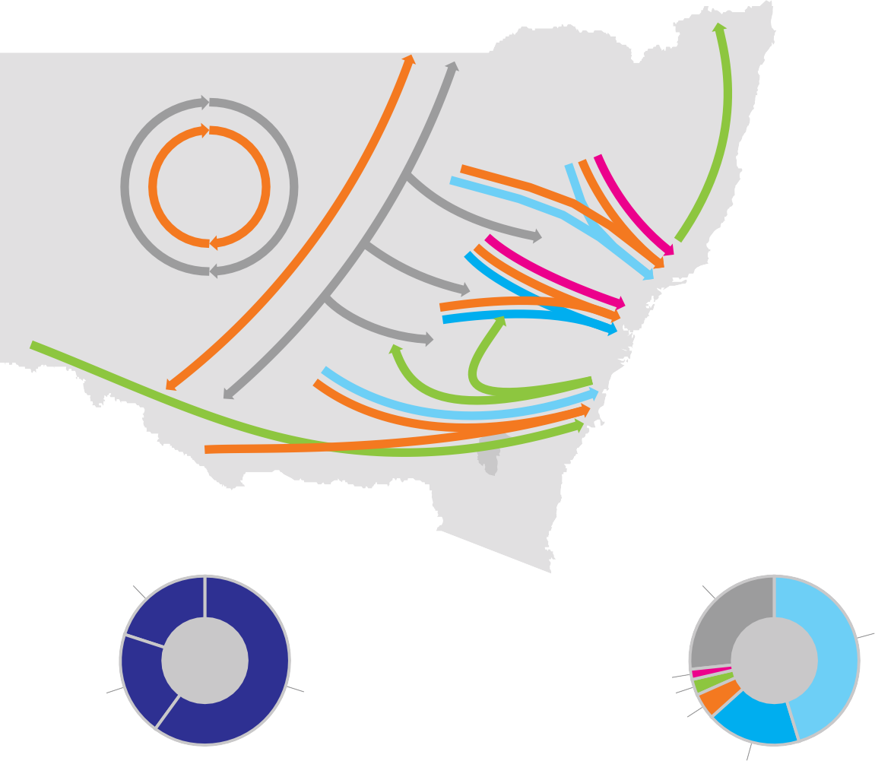to and from metropolitan markets (primarily Sydney) and within Regional NSW as illustrated in Figure 5.4.
Figure 5.4 The NSW Freight Task
Richmond-Tweed
North Western
Northern
Mid North Coast
Far Western
Central Western
Port of Newcastle Sydney
Port Kembla
Murrumbidgee
Illawarra
Murray
South Eastern
Approximate Freight Task NSW
Estimated Freight Share, 2011
Import/Export 20%
Other 28%
Coal 48%
Interstate 20%
Intrastate 60%
Meat <1%
Steel 2%
Grain 4%
Aggregates 18%
Source: BITRE.
Road is the most heavily used mode for freight transport, responsible for 63 percent of volume, followed by rail at 33 percent10.
As described in Section 2, there are deficiencies in the assessed capacity and condition of some sections
of both the regional road and rail network to meet current demand.
In addition, inefficient metropolitan road and rail network is as much an issue for Regional NSW as farm gate or last mile access. The cost for freight to access Sydney gateways is the highest on the Australian east coast.
Road transport costs per tonne equivalent unit (TEU) and warehousing costs per square metre were greater in the Sydney market than any other Australian capital city market11. These metropolitan based logistics costs have flow on effects to regional NSW, both on the cost effectiveness of accessing the key Sydney basin market and on the cost of supplying consumer and industrial goods to Regional NSW areas.
International demand for resources means that mining areas in the Far West of NSW, further from export ports, are becoming economically viable – including coal, mineral and coal seam gas mines that are now being developed. The road and rail links in Inland NSW will require significant investment if they are to be capable of carrying the expected level of mine and agricultural production over the next 20 years.

- Transport for NSW 2012, Draft Transport Master Plan.
- FALCONSW 2008, Four Key Supply Chain Opportunities for Innovation.

The Councils of Western NSW12 for example, has identified over a thousand kilometres of strategic links in the road network to mine areas that require initial sealing or rehabilitation if these roads and bridges are to be capable of supporting mine operations.
It may be beyond the capacity of the local Government sector to fund the freight network. In assessing the capacity and condition of the regional road network, Infrastructure NSW observed that the traditional road hierarchy and boundaries between local Government roads, State and Federal roads has not worked well to support the growing export-oriented regional economy. Partly as a result of this hierarchy, high productivity vehicle types can’t use many of our roads.

Bulk Export Freight Demand
Bulk export freight (coal, grain, minerals and metals) is moved by both the road and rail networks of Regional NSW to the processing plants and the port gateways of Newcastle and Port Kembla. It comprises around
15 per cent of the total freight task by volume (but around half of the freight task by weight). The majority of export bulk commodities utilise rail infrastructure to reach
the gateways.
Coal is the largest and fastest growing commodity freight task in NSW, (around 170 mtpa13), most of which moves through the Port of Newcastle14.

- Central NSW Councils 2011, Submission to the NSW Legislative Council, Standing Committee on State Development, Inquiry into Economic and
Bulk export freight in NSW is expected to grow rapidly over the next twenty years and will continue moving primarily through the Port of Newcastle and Port Kembla15. It is expected that demand will more than double and continue to rely on rail infrastructure, although road will also play an important role.
To meet this demand will require additional rail capacity to be developed and the network extended in a timely manner for the forecast growth in GSP.

Intrastate and Interstate Freight Demand
Non-export intrastate freight consists of the full range of commodities, agricultural products and goods.
The largest categories of these include construction materials, domestic coal, domestic grain, metallic minerals, waste, and containerised freight.
Intrastate freight relies predominantly on the State’s road networks to access local and international markets, although rail also contributes to the transport task.
The road network is the dominant mode to access both Sydney and Port Botany (for export) by containerised freight. Productivity and efficiency constraints on these roads are common and solutions need to be focused on increasing access of High Productivity Vehicles (HPV) and High Mass Limit (HML) vehicles to specific corridors for the major supply chains to enhance the competitiveness of the regional suppliers.
The interstate freight task is also significant. Approximately 60 million tonnes per annum of freight is moved to and from NSW comprising some 20 percent of the total state freight task by volume16.
The dominant corridors of interstate freight are the pairs of Sydney and Melbourne and Sydney and Brisbane. Of this freight task, the primary method of
transport is road with over 80 percent, followed by rail at approximately 10 percent and then sea and air freight on a mass tonnes basis. The large road freight task is based on overnight and ‘just in time’ delivery requirements.
Demand over the next 20 years is expected to see the interstate freight task more than double by 203117. Road freight is expected to continue to dominate the interstate freight task.
Major investments, (underway or proposed) for freight solutions on the road and rail network are discussed in Section 10.

Water Infrastructure
Water supply and sewerage services in Regional NSW are provided by 95 local councils, five county councils and five water supply authorities. These utilities provide water supply and sewerage services to 1.8 million people (or 98 percent of the State’s regional population).
The infrastructure investment in regional water utilities is substantial. The replacement value of water supply and sewerage infrastructure is about $23 billion and the associated services generate annual revenue of
$10.4 billion.
Lack of suitable water supply infrastructure can be clearly shown to inhibit economic growth18. If a local Government is not able provide a secure water supply

Social Development in Central Western NSW. 17 BTRE 2010, Interstate Freight in Australia, Research Report 120.

- Transport for NSW 2012, Draft Transport Master Plan.
- Newcastle Port Corporation 2011, Annual Report.
- Newcastle Port Corporation, Port Kembla Port Corporation.
- BTRE 2010, Interstate Freight in Australia, Research Report 120.
18 NSW Business Chamber, Keeping the Water Flowing: Protecting the Water Supply in the Murray-Riverina.

sufficient to allow additional connections, then new development and growth cannot proceed. For example, in 2004 Yass Valley Council imposed strict controls
on the approval of new Development Applications on the basis of lack of security in water supply. Following Council’s approval of the raising of the Yass Dam Wall, these controls were able to be lifted, demonstrating the clear nexus between investment in water infrastructure and economic development19.
Regional communities are facing a decline in the capacity of their water systems to meet future water demand.
A study conducted jointly by NSW Public Works and the NSW Office of Water, (using CSIRO methodology), estimates that global warming and climate variability is likely to cause a 30 percent reduction in the secure yield of many inland regional water systems by 2030.
Infrastructure investment will be needed for new water sources to augment water supply from existing declining yield sources, such as:
      - new dams and dam augmentations storing more water to counter prolonged droughts; and
      - increased pumping capacity and off-stream storages to extract the maximum allowable water from streams during periods of high stream flows.
The NSW Office of Water estimates the investment value of regional water utilities needed to counter the impacts of climate variability and global warming may be up
to $1.3 billion. This is in addition to the utilities’ current
factored in the costs associated with global warming and climate variability.
There are ongoing subsidies from the State Government to local water authorities for works to water and waste water systems for compliance with national health guidelines in Regional NSW.
Infrastructure in Western areas also experienced significant deterioration during the 2011 and 2012 floods. This has highlighted ongoing concerns regarding the ability of regional communities to deal with the impact of natural disasters like drought and flooding.
A number of areas to improve water management and security and improve resilience and flood protection have been identified in Section 12.

Energy Production in the Regions
Energy and gas production businesses are forecast to grow rapidly in the next 20 years and will increase this industry’s share of the economy from 2.5 percent to
3.5 percent over the next 20 years. Coal will remain a major source of energy for NSW20.
NSW regions in the North-West, Gunnedah basin and Upper Hunter areas have the benefit of very large reserves of coal seam gas for development of a new and extensive, high value energy industry. The NSW Government has estimated that production could provide 18,000 jobs, up to $1 billion in royalty revenue and add $3 billion a year to GSP21.
Energy infrastructure issues are discussed in Section 11.

Health
Thirty percent of health assets are physically located in regional areas, supported by the large, specialist hospitals located in and around Sydney that provide services to all of NSW.
The regional health and social services industry sector is expected to grow by 25 percent in the next 20 years (from 6.1 percent to 7.6 percent22). However, the large distances, a dispersed population, and difficulty in
attracting and retaining staff are all significant challenges in the delivery of regional health services. This is compounded by the specific impacts of an ageing population in all regional areas of NSW, particularly the North and South Coast regions that provide popular retirement destinations. Each region’s utilisation of hospitals, forecast growth in demand and the planned major works are summarised in Table 5.3.
Patients in regional areas are increasingly affected by the need to travel for specialist care and consultations. The National eHealth Strategy agreed by COAG in 2009 set out an action plan for eHealth based on implementing the national ‘health information highway’ infrastructure and rules to allow information to be seamlessly accessed and shared across the Australian healthcare system.

30 year capital program of $11 billion, which has not
20 Deloitte Access Economics 2012, The NSW Economy in 2031-32, Report to Infrastructure NSW.

19 Yass Valley Council 2008, Report to Council ‘Water Policy for New Developments’.
21 NSW Government 2011, Submission to NSW Legislative Council General Purpose Standing Committee No5, Inquiry into Coal Seam Gas.
22 Deloitte Access Economics 2012, The NSW Economy in 2031-32, Report to Infrastructure NSW.

Table 5.3 Hospital Utilisation by Region

Average

Bed

Forecast Increase in

Forecast Increase in Demand,
Regional health costs and services would significantly improve with increasing use of these tools, including audio conferencing, video conferencing and web meetings for consultations and telehealth services to remotely monitor

Regional Action Plan Area
Hunter New England | 3.2 | 75% | 13% | 41% | Tamworth Redevelopment and Stage 3
 |  |  |  |  | Maitland/ New Hunter
 |  |  |  |  | Morisset/ Kestral
 |  |  |  |  | Armidale Redevelopment
Illawarra | 1 | 97% | 24% | 67% | Bega Hospital
Southern | 0.5 | 75% | 24% | 67% | Goulburn Base Redevelopment
Mid North Coast | 0.7 | 95% | 13% | 183% | Kempsey Redevelopment
 |  |  |  |  | Port Macquarie Base Hospital
Northern Rivers | 0.8 | 95% | 13% | 42% | Lismore Base Hospital Stage 3
 |  |  |  |  | New Northern Rivers Hospital
Western | 1.5 | 74% | 5% | 41% | Parkes, Forbes Hospitals
 |  |  |  |  | Dubbo Hospital
 |  |  |  |  | Gulgong MPS
Murrumbidgee | 1.3 | 70% | 16% | 22% | Lockhart MPS
 |  |  |  |  | Wagga Wagga Stage 3
Far West | 0.2 | 66% | No increase | No increase

Sources: NSW Health; PwC.
*Beds per 1000 head of population.
Available
Beds*
Occupancy
Rate
Demand,
Acute Care
Sub-Acute
Care Major Works
and manage patients at home. However these tools are not yet in place for some communities. Detail of the strategies to meet sub-acute demand by care models that are ‘out
of hospital’ and to encourage private sector provision of public hospital services are provided in Section 13.

Social Infrastructure
The demographic differences in Regional NSW will have an impact on utilisation and development of education services across the regions. For example the impact
of demographic profile, with lower proportions of 20 to 40-year-olds, is reflected in the forecast growth in the school population. Primary school growth is expected to be four percent in Murray Riverina and eight percent in the coastal regional areas, which is less than half the forecast growth in Sydney. There is almost no forecast growth in the regional secondary school population
in the next ten years, compared to around 10 percent growth in Sydney.
Justice services are a vital community service. Increasingly the provision of justice services are being provided by innovative new IT solutions, without
the reliance on familiar hard infrastructure such as court houses, or even the physical presence of key participants.
Regional social infrastructure issues are discussed in Section 14.

the
solution

Securing the networks required to enable the efficient flow of people, goods and information is key to the success of NSW.

At the same time, ensuring the fundamentals of community wellbeing in health and education are in place is important.
The solutions recommend completing the missing motorways, fixing public transport, decongesting freight links and
investing in schools and hospitals. This strategy also recommends safer regional water supplies and containing flood risks.

6.0 Urban roads

Summary
- Sydney’s road network serves 93 percent of passenger journey and 86 percent of port freight movements. Even under high growth scenarios for rail freight and public transport, most growth in
transport demand over the next twenty years will be met by roads.
- Traffic on key corridors has grown by 50 percent in the last twenty years and investment in new roads has struggled to keep up with demand. Congestion currently occurs across the day on key corridors, and this has a real economic cost to NSW.
- New road capacity is urgently required to meet the challenge of population growth and substantial increases in freight volumes. In addition, new roads will relieve legacy arterial roads such as Parramatta Road, Pennant Hills Road and the Princes Highway, and permit urban regeneration in these areas.
- The most pressing investment needs occur on the M4 and M5 corridors because of their importance for the freight and business transport task; connecting Global Sydney and the international gateways with the industries and residential areas in the West and South-West.

- Infrastructure NSW has developed a scheme called WestConnex, which it proposes as Sydney’s next motorway project. WestConnex integrates the M4 extension towards the Airport with an expansion
of the M5 East. This new tollroad is proposed to be delivered in stages over the next ten years.
- The F3-M2 link and F6 extension are also highly desirable to bring connections North and South of Sydney up to motorway standard. These roads are scheduled for development between Years 10 and 20, but may be accelerated if the private sector can provide financing.
- We need to make the most of the existing network. Infrastructure NSW supports the managed motorways program and views the concept of variable road pricing as having merit over the longer term. A program of investment in congestion hotspots across the city is also recommended, including in Parramatta and other growing centres.

Snapshot1
- The road network is the dominant transport network in Sydney, and will remain so over the next twenty years under any plausible scenario.
- 93 percent of passenger travel in Sydney is by road (refer Section 2) – 12 million trips on an average weekday.
- The vast majority of freight journeys in and through Sydney are by road. At present, only 14 percent of container freight to and from Port Botany is moved by rail.
- Over 73 percent of the forecast growth in passenger journeys between 2011 and 2031 will be by car.
- Road demand is more sustained across the day than demand for the rail network. This reflects the variety of journeys (commuter, educational, social, freight, business, etc) that use the road network.
- Urban roads have received a relatively small proportion of NSW Government investment in transport in recent years. For example, most recent motorways in Sydney, have been privately funded and financed. In 2012-13, only 8 percent of transport capital expenditure is planned to be on Sydney’s roads.
- The section identifies Infrastructure NSW’s view on the priorities for investment in Sydney’s major roads over the next twenty years. It also considers options to better operate and manage demand for these assets.

  - All data and forecasts in section 6.1 from Bureau of Transport Statistics, 2011.

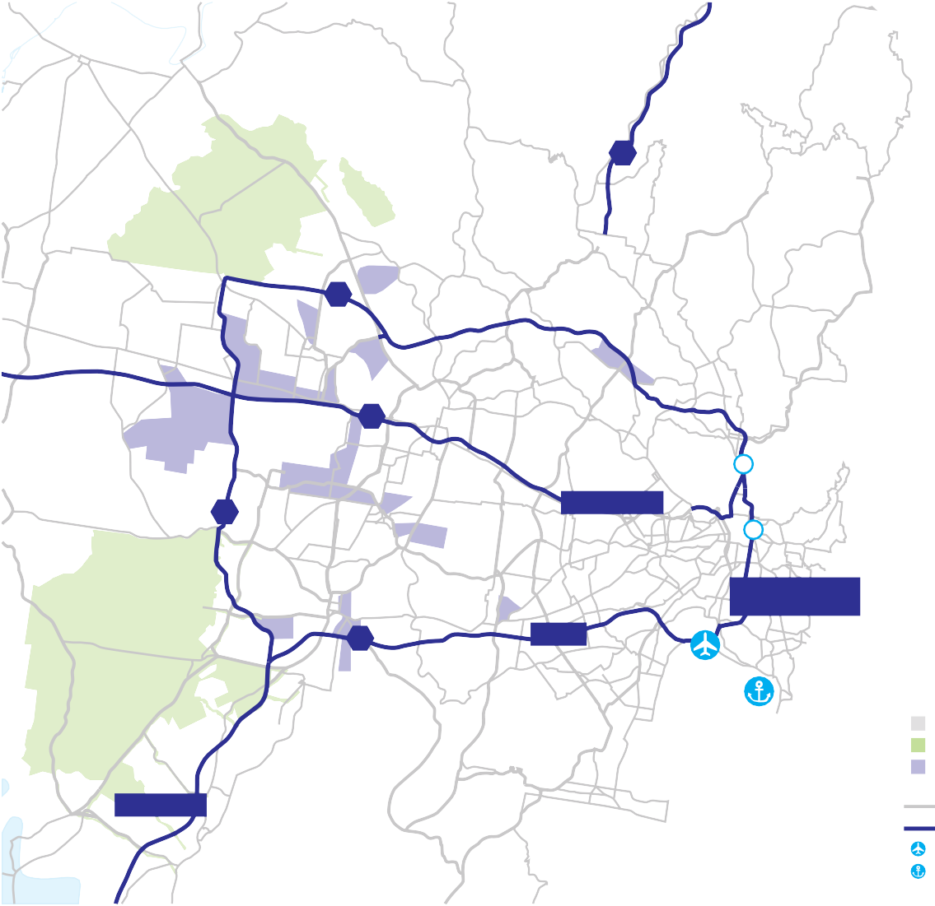The Sydney Strategic Road Network
Figure 6.1 The Sydney Strategic Road Network
Richmond
F3
Rouse Hill
North West Growth Centre
Hornsby
Castle Hill
M2
Penrith
Blacktown
Macquarie Park
Manly
Chatswood
M4
Parramatta
Ryde
North Sydney
M7
Parramatta Road
Strathfield
Burwood
Sydney
Bondi Junction
South West Growth Centre
Liverpool
Southern Cross Drive/ Eastern Distributor
M5
M5 East
Port Botany
Hume Highway
Sutherland
Miranda
Cronulla
Campbelltown
Source: Transport for NSW.
F6
Key
Urban Areas Growth Areas Business parks
and industrial areas Main roads Motorways
Airport
Port
For the purposes of the Strategy, the Sydney Strategic Road Network (“SSRN”), shown in Figure 6.1, is defined as comprising:
- the Sydney Orbital Network
- the M4 Motorway and Parramatta Road corridor
- the so-called missing links to connect the Sydney Orbital to the F3 and the F6.
The SSRN is the most important transport network in the State. The SSRN carries the bulk of the State’s
container freight and acts as a feeder and distributor for other modes – for example, rail, sea and air transport. It supports economic growth across the metropolitan area by connecting people to jobs and allowing businesses to trade with each other.
Much of the SSRN has been delivered through partnerships between Government and the private sector. These investments have transformed travel in Sydney and have had a profound impact on freight logistics. Ernst and Young has estimated the value of the tollroad network to the NSW economy at $22.7 billion2.
The success of the network in serving previously unmet need means that today, some two decades since this cycle of motorway construction began, congestion
is a major issue on many parts of the SSRN. Some motorway sections are operating well in excess of design

  - Ernst & Young 2008, The Economic Contribution of Sydney’s Toll Roads to NSW and Australia.

capacity. Where there are missing links, such as along Parramatta Road or Pennant Hills Road, traffic is forced to use the legacy road network. Traffic congestion in Sydney is forecast to cost the NSW economy $8 billion per annum by 20203.
In conjunction with the private sector, the Government is already delivering improvements to two of the most congested motorway corridors: the M2 will be widened by 2013 and the M5 West widened by 2014. While these projects are important, more needs to be done to meet future traffic requirements.

Adequacy of Sydney’s Strategic Road Network
This section analyses the performance of the SSRN today in terms of traffic and congestion, and
considers how growing travel demand is likely to affect performance over the next twenty years.

Demand
Traffic is most commonly measured in terms of Average Annual Daily Traffic (AADT), the average (taken over a year) of the two-way total 24 hour traffic flow. Table 6.1 summarises the AADT for major roads today:

  - Bureau of Transport and Regional Economics 2007, Estimating Urban Traffic and Congestion Cost Trends for Australian Cities.
Table 6.1 Current AADT on Major Arteries
Road Estimated AADT 2011
Sydney Harbour Crossings | 250,000
Eastern Distributor | 115,000
M4 (Mays Hill) | 170,000
M5 East (Bardwell Park) | 105,000
M5 West (Revesby) | 95,000
M7 (Kings Langley) | 60,000
M2 (North Ryde) | 70,000
Parramatta Road (Five Dock) | 100,000
Pennant Hills Road (Pennant Hills) | 80,000
Princes Highway (Blakehurst) | 80,000

Source: Roads and Maritime Services.

The high volumes on the motorways show how heavily people and businesses rely on those roads for access around Sydney. The motorways cater for high volumes of traffic in a more efficient manner than legacy arterial roads like Parramatta Road.

Congestion
AADT is a crude measure since it does not indicate the peakiness of demand, nor does it provide a measure of congestion.
Table 6.2 shows the periods of congestion (traffic travelling at lower than ‘design speed’ and experiencing periods of queuing) currently experienced on some major corridors.
Table 6.2 Periods of Congestion
Motorway Hours of Congestion
Sydney Harbour Tunnel | 8.6
M2 | 9.9
M5 | 10
M4 | 13
M5 East | 13.3
Eastern Distributor | 13.5
Source: Ernst & Young.

Importantly, congestion on roads such as the M4, M5 and Eastern Distributor is no longer a peak-only phenomenon, but is sustained for much of the day. The morning peak on the M5 East now starts to build from 5am.
Sustained congestion reduces the efficiency of commuter journeys, freight movements and business travel, hindering economic growth and affecting people’s quality of life.
Unlike the rail system, where demand is focused during peak hours, motorists have less opportunity to shift the timing of their trip where the road is congested through long periods of the day, and in
these cases the congestion indicates a greater need for capacity augmentation.

Servicing Global Sydney
As Section 3 notes, Sydney is unusual in having its CBD, airport and container port all in close proximity. While this has productivity benefits, it concentrates commuter, business and freight traffic on the eastern part of the SSRN and drives the need for new infrastructure.

Both the airport and port generate significant traffic, and demand generated by these facilities is growing much faster than general travel demand. By 2031, the number of people accessing Sydney Airport is expected to double to 200,000 per day4, and the number of containers travelling to and from Port Botany by road is forecast to triple5.
There is insufficient road capacity connecting the port and airport gateways to Greater Sydney’s residential and industrial centres. The M5 East is congested daily, and whenever an incident occurs, traffic delays can be lengthy. Parramatta Road carries high volumes of traffic for its configuration and has relatively poor connections towards the airport. Without new infrastructure, increasing demand will worsen congestion, with significant negative economic impact.
As has been noted in earlier sections, the data about road journey patterns in Sydney shows that traditional perceptions of suburban commuter traffic flowing primarily into the Sydney CBD are not correct. Relatively few private road journeys on the SSRN terminate in Sydney’s CBD, where, as Section 3 notes, public transport has a 75 percent modal share in peak hours.
Instead, the SSRN is a distribution system that allows traffic to bypass the centre to access its end destination at a wide variety of locations dispersed across the metropolitan area. The primary weakness in the existing distributor system is a lack of connectivity to the areas South and West of the CBD.

  - Based upon passenger forecasts in Sydney Airport Corporation 2009, Sydney Airport Master Plan.
  - Based upon Sydney Ports Corporation 2011, Freight Forecasts, and assumes 28 percent rail mode share in 2031.

Servicing Greater Sydney
The M2, M4, M5 and M7 corridors support the travel needs of Greater Sydney – already home to almost three quarters of Sydney’s population. Over the next 20 years, most residential growth in the metropolitan area will be in Greater Sydney, through in-fill and on greenfield sites.
As Section 4 notes, most Sydney residents do not work in defined metropolitan centres. Some 60 percent of employment is dispersed across the metropolitan area6.
Public transport cannot viably serve most of these jobs. Many other significant journey patterns, such as triangular or multi-stop trips, are also most effectively served by private vehicles.
A significant proportion of journeys on the SSRN are for business-related travel. On the M4 and M5 corridors, around 40 percent of users during business hours are on work-related business7. Road travel is the most suitable choice for workers travelling between widely dispersed locations (eg sales representatives) or who carry tools of trade.
Population and economic growth in Greater Sydney is likely to place most pressure on the SSRN East of Parramatta and on the M5 East. These assets are already operating well beyond design capacity. In
contrast, the current widening of the M2 and the latent capacity in the Lane Cove Tunnel should keep this corridor moving for a considerable time.

  - NSW Department of Planning 2010, Metropolitan Plan for Sydney 2036.
  - Bureau of Transport Statistics 2011, Household Travel Survey.

Conclusions
As Sydney’s population continues to grow, people will continue to expect mobility for work, business and recreation. Efficient delivery of consumer goods will remain important to NSW’s economy. This will only occur if a clear and realistic direction for Sydney’s SSRN is articulated and pursued.
Road links between Sydney’s West and South-West and Global Sydney are particularly critical. They allow people in Greater Sydney – particularly Western Sydney – to access Global Sydney, and connect Sydney’s gateways with the industrial lands of the West and South-West.

The rationale for urban road investment
The SSRN is critical for sustaining Sydney’s economy and quality of life. But urban road projects are not universally popular. Some commentators argue
that new roads do not solve congestion, that they discourage public transport use, or are environmentally unsustainable. This section considers these arguments in more detail.

Do new roads relieve congestion?
It is sometimes argued that building new roads is a futile exercise since within a few years, the road network will be as congested as it was before: new traffic (‘induced demand’) wiping out initial benefits.
This argument needs to be treated with care: new roads are not primarily required to increase journey speeds
for existing users in peak hours (a common definition

of congestion). Rather new roads provide the capacity needed for a growing population and economy. In some cases, new roads are desirable to relieve pressure on unsuitable legacy arterial roads, in order to stimulate urban regeneration and improve safety.
Accordingly, a reduction in journey times in peak periods is desirable, but the first task is to maintain existing performance standards and reliability levels as traffic grows.
In the last twenty years, traffic volumes on the SSRN have grown by approximately 50 percent, while travel speeds in the peak periods have remained broadly stable. The new roads built in the last two decades were the minimum required to maintain quality of network

Can public transport replace the need for new roads?
As in other major cities, public transport is the best option for journeys to dense employment centres – such as the Sydney CBD and Parramatta. In these areas, public transport is already the preferred choice for many employees and that will continue to be the case in future.
However, the overwhelming majority of Sydney’s journeys are dispersed in nature. For such trips the flexibility of the private car makes it the dominant choice. This pattern is the consequence of established land use patterns in Sydney and there is no indication in the available data that the patterns of demand will change in future.
Figure 6.2 Total number of trips per weekday
in Sydney Statistical Division, 2011-31
73% of total trip growth
7% of total trip growth
3% of total trip growth

15,000
Number of trips per 000’s

12,000

9,000

6,000

3,000

0

service and meet growth requirements.
There is some evidence that growth in vehicle kilometres travelled per person may now be stabilising8, but demand for freight is still increasing rapidly and our population continues to grow. The need to provide traffic relief on corridors such as Parramatta Road and Pennant
The forecast growth in demand for passenger road travel is shown in Figure 6.2. The vast majority of the growth in travel demand is expected to be accommodated by road.
The same is true for freight movements. The Government has set a target to double the share of port
Car

2011 2031

Source: Bureau of Transport Statistics.
Rail
Bus

Hills Road remains acute. Accordingly further investment
in the SSRN is required to maintain existing levels of mobility across the network, with targeted opportunities to reduce congestion in some locations.

  - Bureau of Infrastructure, Transport and Regional Economics, quoted in Infrastructure Australia 2012, Australian Infrastructure: Progress and Action, A report to the Council of Australian Governments.
container freight that is moved by rail by 2021. However, as Section 9 shows, meeting this target will still leave two thirds of the growth in container demand to be moved by road over the next twenty years.
Table 6.3 Forecast average annual growth rates by travel mode
Average Annual
Growth rate Car Train Bus
Historic | 0.9% | 0.8% | 1.0%
2011 – 2031 | 1.1% | 1.6% | 0.8%

Can’t we just manage our roads better?
As noted in Section 1, measures to improve asset utilisation are favoured by Infrastructure NSW as they often provide a cheaper and faster means of addressing congestion than investment in major new infrastructure.
In the case of roads, Infrastructure NSW has considered two main ‘better use’ options:
      - managing existing motorways more efficiently
      - road pricing
These are valuable options that should be progressed as discussed in Section 6.7. However, because of the underlying demand growth these options will provide only part of the solution to the capacity constraints on the SSRN which ultimately needs further development.

Are new roads environmentally sustainable?
The use of fossil fuels to power cars raises concerns about environmental pollution and energy security. However the embedded land use and travel patterns in Sydney require affordable personal transport. Even
under the most ambitious scenarios for land use change and growth in public transport, the absolute number of car journeys will continue to increase.
One of the most comprehensive studies into the issue of charging motorists for environmental costs9 suggested that there would still be very high levels of
demand for road travel relative to other modes even with environmental and other costs factored into prices.

  - Sir Rod Eddington 2006, The Eddington Transport Study: The Case for Action.
The most realistic and effective means to substantially reduce environmental impacts will be through continued improvements in vehicle fuel-efficiency, and a market-led shift towards alternative fuel technologies, not through restrictions on travel movements.
A second consideration is the environmental impact of continuing to use legacy arterial roads as part of the
SSRN. This has direct impacts on affected communities and discourages urban renewal and densification along these corridors.

Conclusion
It is unfortunate that roads and public transport have often been positioned as opposing alternatives competing for scarce public funding. In reality these
modes are complementary to each other, each having a valuable, but different role.
The evidence is clear that private road transport is – and will remain – the only viable option for most journeys in Sydney most of time, even with the targeted growth in public transport and rail freight sought by Government, and the expected increase in the population density of the city.
Better management of the SSRN is therefore essential, and is being pursued through a developmental process already. Road pricing is an emerging area that offers potential benefits in the longer term.
There will, however, be places where more capacity will be needed on the motorway system. Investment in the SSRN can be sustainable, if complemented by strategies to manage congestion and environmental impacts, and undertaken in tandem with investment in public transport.

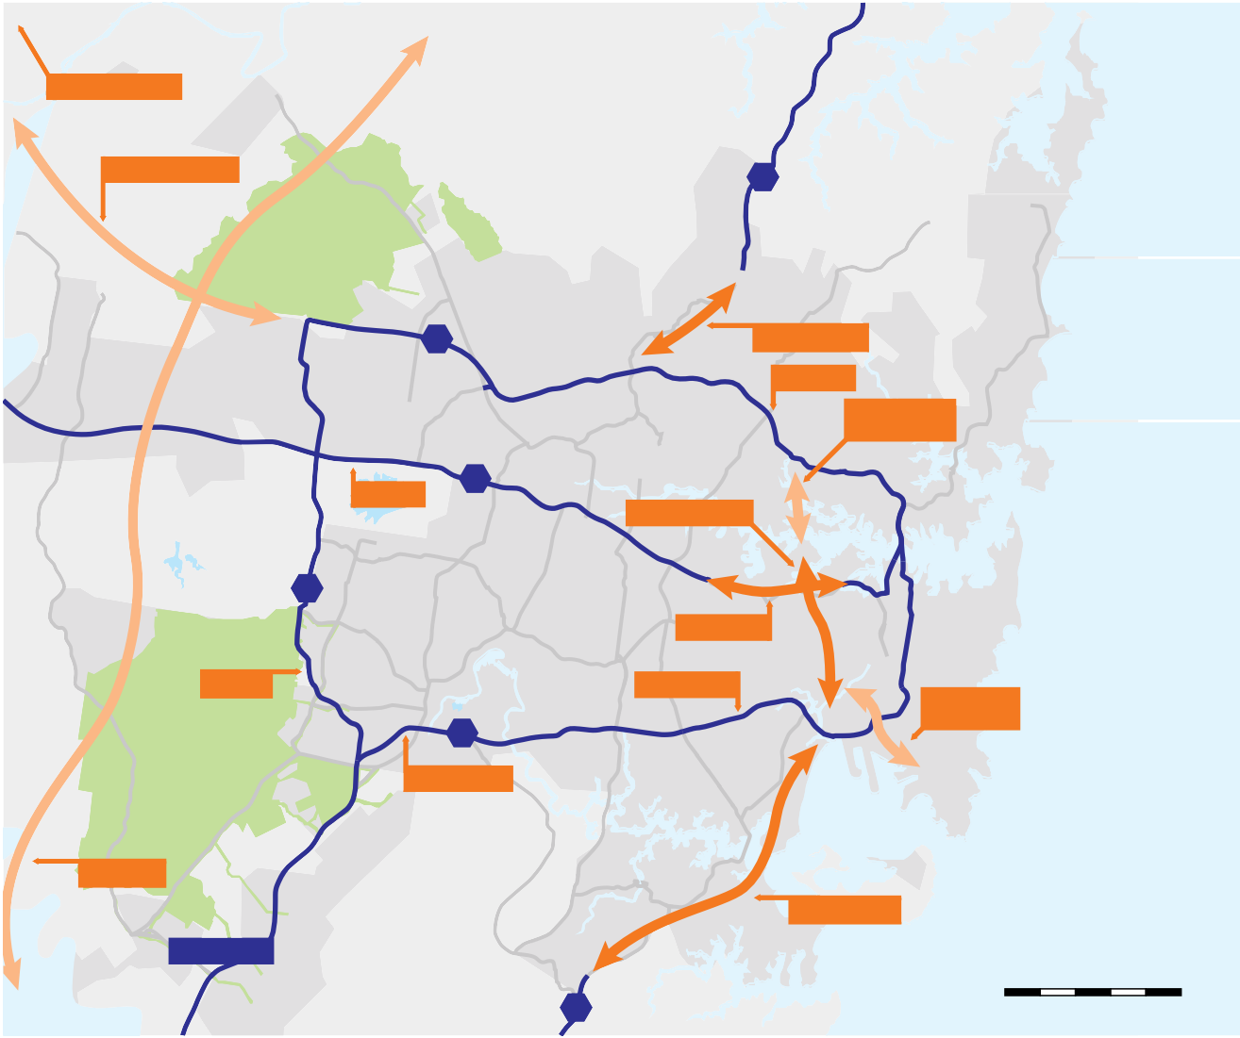Developing Sydney’s Strategic Road Network
Figure 6.3 Longer-Term Vision for the Sydney Strategic Road Network
Richmond
Bells Line of Road
Windsor
Palm Beach
Castlereagh Freeway
F3
Mona Vale
North West Growth Centre
Rouse Hill
Terry Hills
Hornsby
Castle Hill
M2
Connect F3 to M2
Penrith
Dee Why
Mt Druitt
Widen M2
St Marys
Brookvale
Blacktown
Epping
Macquarie Park
Enhanced North- South links
Manly
M4
Parramatta
Ryde
Chatswood
Widen M4
Inner West by-pass
Prairiewood
North Sydney
M7
Fairfield Cabramatta
Widen M7
Liverpool
Homebush
Strathfield
Chullora
M4 Extension
Enfield
Widen M5 East
Bankstown
Sydney
Bondi Junction
Enhanced Port Botany links
South West Growth Centre
M5
Kogarah
Widen M5 West
Port Botany
Hurstville
Outer Orbital
Sutherland
Connection to F6
Hume Highway
Miranda
Camden
Cronulla
Campbelltown
Source: Transport for NSW.
F6
0 2 4 6 8 10 kms

Network Vision for Sydney
No new motorway project has been tendered in NSW for almost a decade. One factor behind this has been the lack of an affordable coherent network strategy for the SSRN. Before any new project is commenced, NSW needs an overarching vision equivalent to the Sydney Orbital Network plan of two decades ago.
The Draft NSW Long Term Transport Master Plan (Draft Transport Master Plan) sets out a vision for the longer term of Sydney’s motorway infrastructure. This is shown in Figure 6.3. Infrastructure NSW is strongly supportive of this vision.
Infrastructure NSW supports extending and expanding the SSRN through the longer-term network vision set out in the Draft Transport Master Plan as one of the State’s highest infrastructure priorities.
Burwood

Overview of Options
Infrastructure NSW has reviewed each of the motorways identified by Transport for NSW, together with a potential Northern Beaches Link, which has been advocated
in a number of unsolicited proposals to the NSW Government.

Delivering Integrated Planning Outcomes, Not Just Roads
This Strategy has outlined the reasons why infrastructure investment needs to focus on economic benefits if NSW is to be number one again. A key element of economic success, as we have seen, is ensuring that NSW is an attractive place not only to work but also to live.
This means that investment in major infrastructure, such as roads, must do more than deliver economic connectivity. Cities are extremely complex, crowded structures and any new road building scheme needs to integrate with existing land uses and legacy road networks to deliver a better place to live.
The community rightly expects any major scheme to deliver tangible benefits for public transport and for urban regeneration. Infrastructure NSW considers that delivery of these wider integrated
planning imperatives is critical if NSW is to maximise the potential for infrastructure to make our urban landscape more liveable.

Prioritisation Analysis
Sequencing of the connections shown in figure 6.3 is essential. Neither the State nor the private sector has the resources to progress all of this program in parallel.
Infrastructure NSW has evaluated which motorways should be built first from the perspectives of traffic, wider benefits and serving key demand generators. A summary of this analysis is shown in Table 6.4.
Table 6.4 Sydney Strategic Road Network Development Options
Road Commentary
M4 Extension | This project proposes to extend the M4 motorway from Strathfield towards the CBD and the Airport, thereby connecting Global Sydney to Parramatta and Western Sydney.  A number of potential schemes have been developed but have not progressed to construction. The principal issues have been inadequate connections to the existing road network and affordability concerns.  Widening of the existing M4 between Parramatta and Strathfield is seen as an integral part of this option due to high demand along this section.
M5 East Expansion | The current 2x2 toll-free tunnel is severely congested for large parts of the day.  Options to duplicate the existing tunnels have been under consideration for some years, but have foundered on the lack of a viable scheme to distribute traffic to the North of Sydney Airport. Additional traffic cannot pass South of the Airport due to the existing congestion on General Holmes Drive.
F3-M2 Link | This project would link the Sydney Orbital to the F3 northwards to the Central Coast and Hunter. Current proposals require the construction of the longest road tunnel in Australia, which raises affordability issues.
F6 Extension | This project would link the Sydney Orbital southwards to the Sutherland Shire and the F6 to the Illawarra. A largely preserved transit corridor exists between St Peters and the Royal National Park at Loftus.
Inner West Bypass and enhanced North-South links to the M2 | This conceptual option proposes a motorway from the airport to the Victoria Road corridor, with a potential extension North to the M2. The road would form a Western bypass of the CBD to relieve pressure on the harbour crossings.  No reservation or detailed alignment exists and construction costs are likely to be very high.
Outer Western Sydney Orbital | This road would run on the Western edge of the Sydney Basin, connecting the South-West and North West Growth Centres via the Penrith area. No detailed alignment exists, but the corridor is generally undeveloped at present.
Castlereagh Freeway/Bells Line of Road | These projects would extend the existing M2/M7 West towards the Blue Mountains. These proposals are discussed in Section 10 due to their proposed role in improving connections to Regional NSW.
Northern Beaches Link | This road would link the Gore Hill Freeway with the Burnt Bridge Creek Deviation via a tunnel under Mosman and a new bridge over the Spit. It could be combined with a transitway for buses from the Northern Beaches to the CBD.

Table 6.5 Motorway Implementation Prioritisation Summary
Route | Traffic Flows | Congestion Relief | Wider benefits* | International Gateways | Global Sydney | Freight movement | People movement
M4 Extension | ✓✓✓ | ✓✓✓ | ✓✓✓ | ✓✓✓ | ✓✓✓ | ✓✓ | ✓✓✓
M5 East Expansion | ✓✓✓ | ✓✓✓ | ✓✓ | ✓✓✓ | ✓✓ | ✓✓✓ | ✓✓✓
F3 – M2 | ✓✓ | ✓✓ | ✓ | ✓ | ✓ | ✓✓ | ✓
F6 | ✓✓ | ✓✓ | ✓ | ✓✓ | ✓ | ✓ | ✓✓
Inner West Bypass/ Enhanced North South Link | ✓✓ | ✓✓ | ✓✓ | ✓✓ | ✓✓✓ | ✓✓ | ✓✓
Northern Beaches Link | ✓ | ✓✓ | ✓ | ✓ | ✓✓ | ✓ | ✓
Outer Western Sydney Orbital | ✓ | ✓ | ✓ | ✓ | ✓ | ✓✓ | ✓

* Wider benefits include potential urban regeneration and agglomeration benefits.

Servicing Key Demand Generators

Recommendations
Infrastructure NSW’s analysis indicates that the
M4 and M5 corridors have the most pressing need for augmentation because of their importance in supporting freight and business travel, high levels of existing demand and forecast population and economic growth along and around these corridors. Given the importance of connections to Sydney’s international gateways, Infrastructure NSW recommends the M4 connects to Sydney Airport as part of an integrated program of work.
A potential way to progress these links as a single integrated scheme – known as WestConnex – is set out in Section 6.6.
The immediate case for the other motorway options is less pressing.
The F3-M2 meets a strategic need in completing a motorway grade bypass of Sydney. This is important to freight traffic and for wider connectivity within NSW and along the eastern seaboard. However, the lack
of preserved corridor for this route make it expensive relative to the benefits it provides due to the expectation that the route would be in an eight kilometre long tunnel.
The NSW Government has received an unsolicited proposal for the F3-M2 which proposes developing this link without the need for any public support. This proposal is currently being assessed by Infrastructure NSW and other Government agencies.

Recommendation Infrastructure NSW recommends that the F3-M2 link should be the next priority following completion of the M4 and M5 upgrades.
This scheme could be accelerated if shown to be viable without public subsidy.
The lower forecast freight flows on the future F6 make its extension less of a priority in the short term. However, over the longer term, it will have an important role in connecting Southern Sydney to Wollongong and Port Kembla (discussed in Section 9). Existing analysis of this route is several years old and needs updating for
contemporary land use and demand patterns. Positively, the existing corridor along much of this route provides the opportunity to develop a more affordable scheme.
The completion of an Inner West Bypass to Victoria Road and potentially the M2 (the enhanced North-South link) is an attractive concept. Over the long-term, there is likely to be a need to relieve pressure on Sydney’s existing harbour crossings by providing a comprehensive Western bypass of the CBD. However in the absence
of a specific business case, it is difficult for Infrastructure NSW to identify the prioritisation of the project. It appears likely to be completed beyond the timeframe of
this strategy.

Infrastructure NSW has concluded that Northern Beaches Link is a lower priority for Government funding support because of the lower traffic volumes, the lack of through traffic, limited population growth on the Peninsula and the limited role of Military Road in the freight distribution network.
As with the F3-M2 link, the Northern Beaches Link could be accelerated if it can be built without public subsidy. In the short term, priority should be placed on incremental reforms to improve public transport from the Northern Beaches. These options are discussed in more detail in Section 7.
The construction of the Outer Western Sydney Orbital has also been assessed as falling outside the 20-year time horizon of the strategy. At present appropriate connectivity is provided by the M7, which can be widened as traffic grows.
Infrastructure NSW believes it is essential to preserve the corridor for this motorway in the near term, before development encroaches on the optimal route.

WestConnex

Reference Scheme
Recommendation Infrastructure NSW recommends development should begin on the F6 extension and proposed North-South links West of Sydney’s CBD beyond year 10 of the strategy.
To support the NSW Government in progressing the next motorway project in Sydney, Infrastructure NSW has worked with Transport for NSW and Roads and Maritime Services (RMS) to develop a high-level reference scheme that integrates the proposed M4 Extension, M5 East Expansion, and part of the Inner West Bypass.
This project has been named WestConnex, reflecting the connectivity it would provide between Greater Sydney and Global Sydney’s primary economic centres and international gateways.
Options to extend the M4 and expand the M5 have been considered over a number of years, but have struggled with scope and cost issues. Infrastructure NSW
has worked to value engineer the design options for these corridors to provide a more focused and affordable scheme.
Figure 6.4 indicates the proposed alignment of WestConnex.
A more detailed description of the constituent elements of the proposed WestConnex reference scheme, its benefits and delivery options is set out in the document WestConnex: Sydney’s Next Motorway Priority on Infrastructure NSW’s website.

Recommendation Infrastructure NSW recommends the identification and preservation of a corridor for the Outer Western Sydney Orbital.

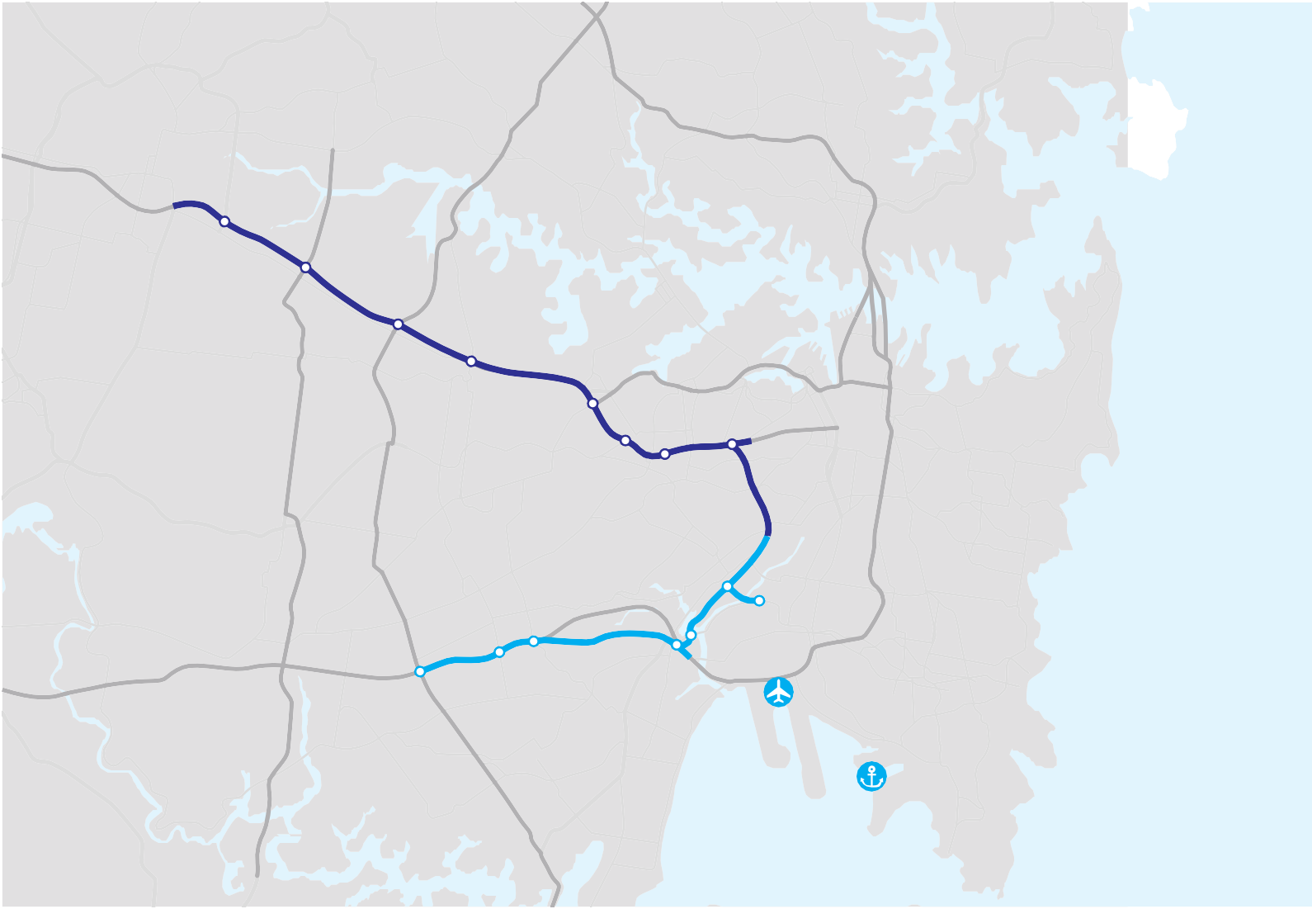Figure 6.4 WestConnex Reference Scheme

Parramatta

St Leonards

Crows Nest

North Sydney
- Reduced congestion on Parramatta Road near Granville by improving M4.
- Widening of the existing M4 to 4 lanes in each direction alleviates congestion for cars and trucks especially at James Ruse Drive where the motorway currently reduces from 3 to 2 lanes causing congestion in the morning and afternoon peak periods.
- A new M4 extension completes the Motorway missing link east of Strathfield and improves travel times for cars and trucks.
- The M4 Extension caters for cars and trucks, allowing Parramatta Road to cater for surface traffic and side road connections. This creates the

1
South Granville

Auburn
Newington Rhodes

2 Concord
Lidcombe
Canada Bay Five Dock

Sydney
opportunity for urban renewal along this section of Parramatta Road.
- The new tunnel from the St Peters area to the Camperdown area provides a motorway for vehicles accessing the international gateways
of the Port and Airport and removes through trucks from surface roads.
- WestConnex gives improved access to the major international

Chullora
Homebush Strathfield
Croydon 3
Burwood

Leichhardt
Taverners Hill Camperdown
gateway of Port Botany; and increases the economic efficiency of this international gateway.

Enfield

Croydon Park

Summer Hill
4
Lewisham
Ultimo

5

Bondi Junction
- Traffic has better choices to travel north of or south of the airport, improving traffic flow generally.

Bankstown

11

Punchbowl
Roselands

Riverwood

Beverly Hills

Campsie

Bexley

Earlwood
o

10
Arncliffe

Kogarah

Hurstville
Waterloo Marrickville
St Peters

Tempe
7 8
9

Alexandria

Mascot

Botany

Sydney Airport

6

Port Botany
- WestConnex gives improved access to the major international
gateway of Sydney Airport giving better road travel reliability, particularly in peak periods.
- Improved connections between Marsh Street and the M5 East.
- The M5 East widened to four lanes in each direction. This provides extra capacity in both directions for cars and trucks and alleviates extended congestion currently experienced in both directions.
- An upgraded M5 improves industrial access and business efficiency along the full M5 corridor.

Botany Bay

Project Benefits
WestConnex is intended to be more than a motorway.
Parramatta and Sydney Airport | via City Rd, Regent St | 35 | 52
Parramatta and Sydney Airport | via Sydenham Rd | 30 | 44
Eastern Creek and Port Botany | via Sydenham Rd | 30 | 44
Flemington to Sydney Airport | via KGR/M5 | 15 | 0
Revesby to Port Botany | via General Holmes Dr | 15 | 0
Liverpool to Sydney Airport | via Marsh St | 15 | 0

Table 6.6 Travel time savings with WestConnex in 2021 compared to travel via existing routes
Estimated time saving using

Traffic signals

It is a scheme designed to act as a catalyst to renew and transform the parts of Sydney through which it passes. WestConnex is intended to develop as an integrated land use and transport scheme delivering on road transport, urban renewal and public transport outcomes.

Key benefits include:
- Relieving congestion on the existing M4/Parramatta Road and M5 East
- Supporting freight movements between Sydney’s
Between Existing route
WestConnex (minutes)
Avoided

Gateways and the logistics hubs in Western and South Western Sydney
- Supporting people movements to Sydney Airport
- Acting as a catalyst for urban regeneration along key corridors, particularly Parramatta Road
- Enhancing orbital road connectivity South and West of the CBD
- Facilitating improvements in public transport, particularly on the Parramatta Road corridor
Forecast travel time savings and numbers of traffic signals avoided once WestConnex is completed are summarised in Table 6.6.
The strategic benefit-cost ratio for the WestConnex project has been assessed at more than 1.5. This is a traffic benefit-cost ratio that excludes consideration of wider benefits such as urban regeneration. This is a high return for a major transport investment in an inner urban environment. It reflects the high levels of existing
utilisation of these roads and the significant journey time savings that WestConnex would offer.

Design Considerations
Infrastructure NSW, RMS and Transport for NSW have identified opportunities for improving value for money and tailoring WestConnex more effectively to user needs than previous proposals through:
      - reducing the amount of deep tunnelling, which is expensive and reduces opportunities for connectivity with the legacy road network. The proposed design includes elements of slotting and surface grade road, as well as shorter tunnels.
      - optimising connection points to address as much potential demand as possible, and distribute traffic efficiently across the legacy road network.
      - improving the proposed road configuration to the North of Sydney Airport.
Consideration has also been given to the urban regeneration potential provided by the scheme, particularly along Parramatta Road. This is a significant opportunity for rejuvenation of a tired corridor that has the potential to play an important economic role in Sydney’s future.
Ultimately, should the Government adopt WestConnex, it is important that its procurement seeks to maximise the potential for innovation. As discussed in Section
16, rather than seeking to specify in detail every aspect of the WestConnex scheme, it would be preferable
for Government to provide the private sector with a high-level output specification based upon the work developed for the reference scheme.
This approach would only set out those aspects that are essential to meeting the scheme’s objectives, but offer flexibility for private sector creativity and innovation in how these elements are provided.

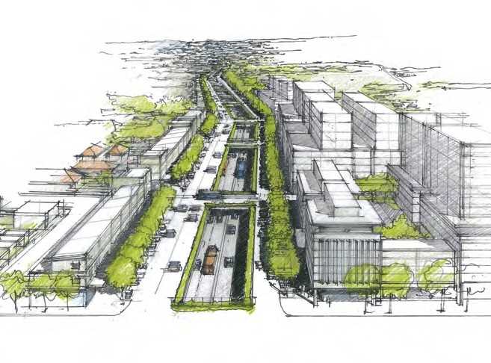Redeveloping Parramatta Road

Parramatta Road is Australia’s oldest transport artery: "Every chapter of Sydney’s history has been written on Parramatta Road.” It was constructed late in the eighteenth century and upgraded to its present form during the Great Depression. It was not built to be the primary East-West route for a city of over four million people. The result is predictable: congestion, a poor safety record and urban blight.
One of the aims of the WestConnex program is to support the regeneration of the Parramatta Road corridor. Infrastructure NSW believes that a slotted road concept would enable this more than a tunnelling approach. The slotted concept sinks the motorway below surface level while constructing a new local road at surface level.
Depressing the motorway reduces surface impacts such as noise and pollution, but allows traffic from surrounding suburbs to readily access the motorway. Capacity on the surface-level local road is managed in order to reduce through journeys made on the surface roads, support public transport and therefore enable redevelopment.
During construction, particular provision is made to ensure least disruption to local people and traffic.
This approach has been successfully applied in Sydney along parts of the Eastern Distributor. The approach is used a number of European cities, including Barcelona and Paris.
A conceptual outline of this approach is shown on the right:

Delivering WestConnex
WestConnex is a single integrated scheme. However, it is expected that WestConnex would be delivered in two stages if adopted by the Government:
      - A Northern Sector, comprising the M4 Extension, upgrades to the existing M4 between Strathfield and Parramatta, and a tunnel between the Taverners Hill area in Petersham and the St Peters area. This is shown in dark blue in Figure 6.4.
      - A Southern Sector, comprising the M5 East Expansion and the new connections proposed around Sydney Airport, shown in light blue in Figure 6.4.
The timetable for delivering these stages is still under consideration, although it is likely that much
development and construction would occur in parallel. Infrastructure NSW proposes WestConnex should be completed within ten years.
Analysis indicates that WestConnex could be primarily funded by user contributions supported by limited government support.
The tolling arrangements for WestConnex would be based on experience on other roads, in particular the M7. It is proposed that WestConnex’s tolls will comprise a distance-based charge, a flagfall charge and a maximum toll cap. The exact tolling mix would be subject to detailed development, should Government decide to progress WestConnex. Alternative funding mechanisms, which may include some degree of value capture, will also be taken into consideration, should the Government choose to proceed with the scheme.
WestConnex would require loan financing to bridge the timing gap between capital expenditure and future toll revenues. An element of private financing would be adopted to manage project delivery risks, but given the
pricing of risk in the current financial markets, Government financing and risk sharing may also be required to ensure a value-for-money outcome. These financing issues are discussed in more depth in Section 16.

Next Steps
The scale and complexity of the problems along the M5 and M4 corridors, and the latter’s inadequate connectivity to Sydney’s Gateways suggests a
transformational solution is needed. The solution needs to fit within and connect with the existing transport network and must also enable urban renewal.
The feasibility study that Infrastructure NSW has led with Transport for NSW and RMS suggests WestConnex is the solution to these issues.
WestConnex is a major undertaking but the price of not acting is greater. Infrastructure NSW’s analysis shows that WestConnex could be delivered at a target cost of $10 billion within ten years. Achieving this requires a new approach that learns from the best
of international design, procurement and delivery experience, and a funding strategy that incorporates user funding, supported by limited and affordable Government support.

Recommendation Infrastructure NSW recommends that Government progress the development of WestConnex, an integrated toll-road scheme designed to innovatively and affordably deliver the M4 Extension and M5 East Expansion projects within the next ten years.

Recommendation Infrastructure NSW recommends that urban renewal – in particular, the transformation of Parramatta Road – should be placed at the heart of the WestConnex scheme from the beginning.

Making better use of the road network
Improving asset utilisation needs to be central to the development of the SSRN, as with any other infrastructure network.

Managed Motorways
The managed motorways program is a collection of smart technology and infrastructure measures to get more efficiency out of the existing motorways. Managed Motorways increase the effective capacity of a road at lower cost than traditional road widening. Measures include ramp metering, variable speed limits, turning the unused shoulders into through lanes, enhanced driver information and accelerated obstruction clearance.
In combining these measures, the flow of vehicles onto the motorways via on-ramps will be controlled to minimise disruption to through traffic, and speed limits
will be electronically adjusted through the day to optimise

motorway traffic flows. Using shoulders makes more through lanes available at low cost. Improved driver information can be provided via variable message signs and over-riding of car radios, enabling drivers to make more informed decisions about choice of routes.
These measures have been effectively implemented in other countries, such as the United Kingdom (UK) and the Netherlands. Results from the UK have been
positive. Drivers experienced an improvement in journey times of up to 25 percent, and there was a 55 percent reduction in crashes10.
In NSW, a trial is proposed for the M4 motorway. Infrastructure NSW supports the Managed Motorways concept, and, subject to its successful trial, would recommend it be implemented across other congested Sydney motorways.
Recommendation Infrastructure NSW recommends the roll-out of the Managed Motorways program, subject to successful trial on the M4.

Time-of-Day Road Pricing
Time-of-day road pricing offers a way to discourage traffic from particularly congested locations, and can also provide funds to support investment.
Conceptually, variable road pricing is similar to the demand management strategies in the energy or aviation industries. When demand is highest (such as at peak hours), customers pay more to travel, moderating demand.

  - Highways Research Group, 2011.
Singapore is the leading exponent of road congestion pricing. Since the 1970s it has progressively rolled out an increasingly complex system, which has reduced traffic congestion during peak periods by 15-20 percent. In Sydney, a form of time-of-day pricing has been in place on the Harbour crossings since 2009.
Over the longer term, as Sydney grows to a city of six million people, road pricing may need to play a role in balancing supply and demand for road travel.
Potential road pricing options for the longer-term are discussed in an independent experts report prepared for Infrastructure NSW by SMART Infrastructure and ACIL Tasman. This report is on Infrastructure NSW’s website11.
This analysis suggests that ultimately it may be desirable to implement a comprehensive system of congestion pricing on the SSRN, but such far-reaching changes cannot be pursued in isolation of other reforms.
For example, existing road charges may need adjusting. The main existing road charges include fuel excise, registration fees, parking levies and vehicle taxes. These are levied by all tiers of government, and reforming them would require inter-governmental agreement. New technological charging systems may need to be installed and operated.
The complexities of delivering a comprehensive scheme, leads Infrastructure NSW to favour a graduated approach to time-of-day road pricing.
At this stage, Infrastructure NSW does not make any recommendations in this regard, pending more detailed study of the issues.

  - SMART Infrastructure and ACIL Tasman 2012, Pricing Congestion in Sydney: Discussion Paper.

Roads across Metropolitan Sydney
The wider road network, including major arterials, will also require improvement. Infrastructure NSW supports incremental options to address infrastructure problems where available. Some of the highest value infrastructure investments come from pinch point relief that addresses road congestion ‘hotspots’. This section highlights pressing areas for pinch point investment identified during the preparation of the Strategy.

Parramatta Ring Road
To address growing road congestion issues around Parramatta, Parramatta Council has proposed a ‘ring road’ concept, with an inner city ring road and outer regional ring road. These ring roads would utilise existing roads, but have improved flows through a series of upgrades at key locations.
The many cross-regional trips in the area, and the continued growth expected within Parramatta suggest that investment to improve the connectivity of Parramatta and adjoining regions is of value.
The proposed new road works would reduce intersection constraints and thus improve traffic flows around Parramatta for private vehicles and improve access
into Parramatta for buses. More efficient traffic flows at intersections around Parramatta could also reduce
congestion for buses and vehicles seeking access to and from Parramatta centre. On the southern M4 section of the regional ring road, a number of works could improve access and exit from the motorway. Some of these works could be part of the WestConnex proposal.

A secondary benefit of the ring road would be to improve access between the centre of Parramatta and the Camellia and Rosehill employment and industrial lands. These employment lands, which have the opportunity of further development and value uplift with the exit of the Shell Refinery, currently have poor access to Parramatta’s centre.
On face value, these proposals appear to have strategic logic both from a traffic management
perspective and the broader urban planning perspective of improving transport that will support Parramatta’s forecast employment growth. Infrastructure NSW recommends detailed assessment be undertaken of the proposed program with a view to its prioritisation within the next 10 years.

Roads Serving the Growth Areas
The construction of new dwellings in greenfield areas is focused on the North West Growth Centre, around Rouse Hill, and the South-West Growth Centre, around
Leppington. When developed, these will contain a larger population than Canberra and form an integral part of a Greater Sydney.
When completely developed over the next 30 to
40 years, the South-West Growth Centre will contain around 300,000 new residents12. Such significant growth needs to be supported by new transport infrastructure.
The South-West Rail Link will play an important role in connecting the Growth Centres to the Metropolitan Area. Road upgrades to serve such a large population are underway including the widening of Camden Valley Way and other roads.
At Rouse Hill, the major centre for the North West Centre, stage one of the town centre opened in 2008. When fully developed, the town centre will accommodate 12,000 jobs and operate as the regional focus for people living and working in the North West Centre13.
Over the medium term the North West Rail Link will connect to this Growth Centre. In the short term, works are identified for upgrading Richmond Road and
Recommendation Infrastructure NSW recommends targeted investments around Parramatta and other growing urban centres.
Schofields Road, however other road upgrades may also be required to serve bus priority and to support access to train stations, retail centres and employment areas.

Pinch points
The NSW Government is continuing to investigate and implement measures to reduce delays and manage traffic on major arterial roads across Sydney at pinch points. This targets peak hour traffic hot spots to improve overall efficiency of the traffic stream.
Various targeted approaches are used. These include lengthening turn bays, adding short sections of additional lanes, widening intersections, upgrading traffic signal facilities, installing bus priority measures, providing more Variable Message Signs and installing more cameras for traffic supervision.
Pinch points of special concern are evident in the surrounds of Port Botany and Sydney Airport, discussed in Section 9. Within the CBD, there are major pinch points, particularly for buses at key turn-around spots.

  - NSW Department of Planning 2010, Metropolitan Plan for Sydney 2036. 13 NSW Department of Planning 2010, Metropolitan Plan for Sydney 2036.

Conclusions
The case for new road investment on Sydney’s transport backbone – the Sydney Strategic Road Network – is strong. Other transport modes cannot accommodate
all of the forecast growth in demand. Options to better manage existing road space – while supported – are not sufficient. Without intervention, journey times and
congestion will worsen – impacting on the productivity of the NSW economy and Sydneysiders’ quality of life.
Infrastructure NSW has identified in outline a scheme – WestConnex – that can help support freight and people movements across the city, and support major urban redevelopment. Infrastructure NSW believes that, while ambitious, WestConnex can be delivered in ten years with sufficient will.
The delivery structures of the past need to be refreshed for WestConnex. Greater private sector involvement at the design phase, a new approach to procurement and delivery, combined with a revised tolling approach and limited Government financial support, will be needed to make this program viable. These issues are considered further in Section 16.
Other investments in the SSRN such as F3-M2 and the F6 Extension are desirable, but are of lower relative priority than WestConnex from an economic perspective. It is possible that the private sector may be able to offer proposals to accelerate the delivery of these schemes, if construction costs can be kept to reasonable levels.

Outside of the Sydney Strategic Road Network, investment is needed to unblock the most congested spots and provide access to important and growing centres.

Recommended Actions
Recommendations Years Type Cost and Funding Implications
 | Section 6 Urban Roads
1 | WestConnex planning and delivery of initial phases | 0 – 5 | Major project | Target estimate of $10 billion. Modelling indicates a government funding requirement of  $2.5 billion.
2 | Pinch points program around Parramatta and other growing centres | 0 – 5 | Program | Scoping of $300 million
3 | Identify and preserve corridor for Outer Western Sydney Orbital | 0 – 5 | Corridor | Cost of corridor preservation is not material. No assessment of land acquisition costs has been made.
4 | Construct F3-M2 | 0 – 5 | Major project | Proposal assumes private sector solution via current unsolicited proposal.
5 | WestConnex project completion Includes: Parramatta Road urban regeneration | 5 – 10 | Major project | Target capital cost included above. Regeneration will be through private investment – assume no net cost to Government.
6 | Roll-out Managed Motorways program to increase effective capacity | 5 – 10 | Asset utilization | Scoping of $300 million
7 | Identify and preserve corridor for new sub-surface motorway links West of the CBD (Airport – Gladesville – M2) | 10 – 20 | Corridor | Cost of corridor preservation is not material. No assessment of land acquisition costs has been made.
8 | Construct F6 Extension | 10 – 20 | Major project | Scoping of $3 billion assumes use of existing F6 transit corridor and surface construction. Assumption of two thirds user funding.

7.0 Bus and light rail in Sydney

Summary

Snapshot

- Buses and light rail provide accessible public transport on transit corridors where traffic flows do not support a heavy rail line.
- The principal issue facing bus services in Sydney is congestion in the CBD, which makes travel times slow and unreliable, and detracts from the amenity of the city streets. Congestion is particularly acute on the north-south spine from the Sydney Harbour Bridge to the QVB.
- The Draft Long Term Transport Master Plan proposes terminating local buses at the edge of the CBD, and potentially constructing light rail along George Street. This would allow the shared use of parts of George Street. Bus passengers would need to transfer to light rail or existing trains, or else walk to their final destination.
- CBD light rail may not provide transit benefits for some existing bus passengers who will be
required to interchange or walk a longer distance. Additionally, the narrowness of George Street may mean that a high capacity light rail service
is fundamentally incompatible with a high quality pedestrian boulevard along this corridor.
- Infrastructure NSW recommends the development of an alternative to light rail along George Street:
a Bus Rapid Transit (‘CBD BRT’) tunnel from the Sydney Harbour Bridge to the Town Hall area, modelled on the underground busway that already operates in Brisbane. Wynyard and Town Hall Stations would need to be reconstructed as rail/ bus transport interchanges, and the central part of George Street would be fully pedestrianised.
- The CBD BRT would offer bus passengers shorter and more reliable journey times, weather-protected access to their services and direct access to their destination without having to interchange.
- Outside the CBD, Infrastructure NSW supports the construction of light rail from Central Station to Moore Park and the University of NSW via Anzac Parade. This development will improve the quality of transport to these important activity centres and take advantage of a route that was purpose-built for trams. However in order to deliver value for money, the scope of this project will need to be carefully controlled.
- Infrastructure NSW recommends incremental investment in bus corridors across Sydney to improve travel times on key corridors such as the Northern Beaches and Victoria Road. In the longer term, a transit way (bus or light rail) from Parramatta to Epping or Macquarie Park is proposed to support growth in these centres.
  - Buses carry around one million passengers per day in metropolitan Sydney and perform 28 percent of the total commuter task1 to the CBD.
  - For areas not served by rail, buses are the primary form of public transport.
  - In the two hour morning peak, buses carry more people over the Sydney Harbour Bridge into Sydney’s CBD than those travelling over the Bridge by train2.
  - In the absence of significant local population increases, demand on Sydney’s bus corridors will be insufficient to justify new heavy rail or metro style rail on these corridors over the next 20 years.
  - Sydney is a low density city, and though growing, on past trends, it would take 75 years of such growth to achieve a density similar to Paris and 1,000 years to reach the density of Hong Kong3.
  - Buses therefore will remain the most appropriate public transport mode for most of Sydney over the next two decades.

- NSW Bureau of Transport Statistics, 2011.
- Parsons Brinckerhoff 2011, Sydney City Centre Access Study, prepared for Transport for NSW.
- Centre for International Economics 2012, Cost and Benefits of Alternative Strategies for Sydney’s Growth, prepared for NSW Department of Planning and Infrastructure.

Scope
This Section sets out a strategy for improving Sydney’s bus services and considers the rationale for potential Bus Rapid Transit (BRT) or light rail infrastructure investments on some of these corridors. The Strategy focusses on the CBD and a number of other key corridors where demand levels are high enough to potentially justify major investment. It also outlines the broader strategy for incremental investment across the wider metropolitan bus network.
The goal to make NSW Number One again requires a globally competitive Sydney with an urban environment conducive to meeting and doing business, walking, talking, shopping and access to retail and entertainment. Current bus services detract from the amenity of the CBD and have negative impacts in terms of congestion, noise and pollution. Reducing CBD bus congestion will greatly improve urban amenity in the CBD.

Buses and light rail compared
While from a technical perspective, buses and light rail are very different, from a transport perspective they fulfil a similar role. Both provide generally on-street public transport services with more frequent stopping patterns and lower speeds than heavy rail options. Both bus
and light rail can be segregated from existing traffic to increase journey speed and reliability.
The concept of expanding light rail, particularly in the CBD, has been the subject of much public
discussion. Modern light rail systems have an upmarket European style, provide a smoother ride for passengers,
and offer improved urban amenity (without the pollution and noise of diesel buses).
Light rail is however, significantly more expensive than bus services, has no material speed benefits, is less flexible in traffic and if service reforms to the operation of CBD bus services are implemented, does not offer significantly greater capacity.
As an example, light rail vehicles of 45 metres in length have a greater capacity than a high capacity bus, however high capacity buses can be run more regularly than light rail to meet demand.
Cost and delivery challenges mean light rail will only be a viable option over the next twenty years in Sydney compared to buses on a very small number of corridors.

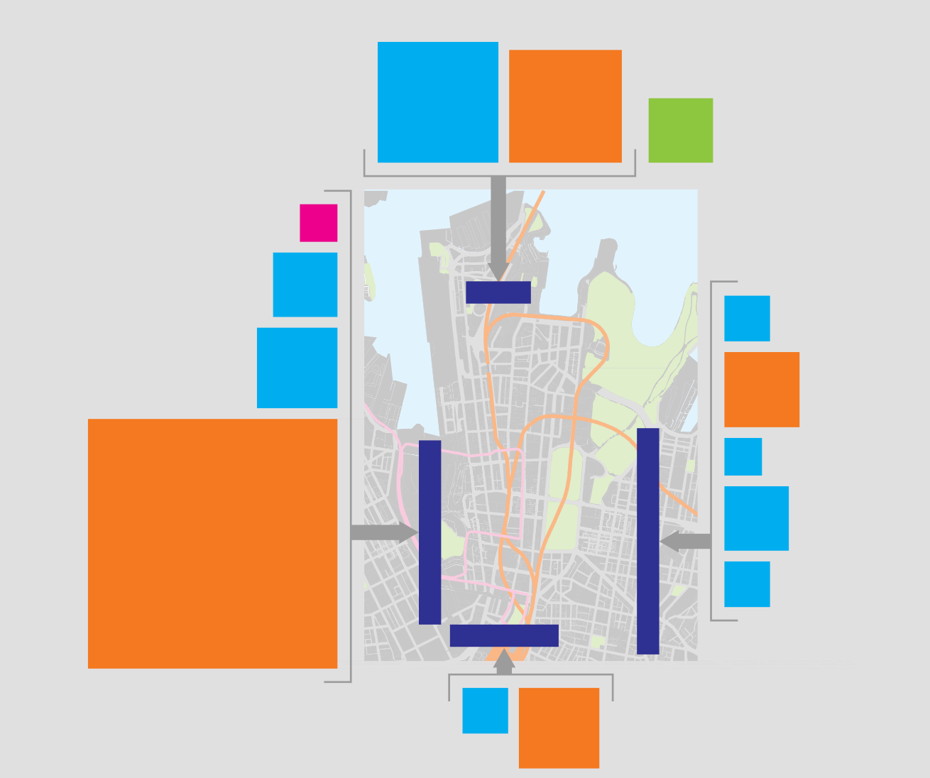Bus and light rail within Sydney’s CBD
Figure 7.1 Peak 2 hour traffic flows into the CBD
Bus
Rail
Ferry
20
18
6
Light Rail Inner West
2
Dawes Point
Millers Point
Buses Western Distributor
6
The Rocks
38,000
Circular Quay
Buses Eastern
3 Distributer
Buses Broadway
9
Wynyard
Martin Place
8
Rail
St James
2
Buses William Street
Sydney
Town Hall
East
Museum Sydney
6
Buses Oxford Street
Ultimo
Buses Foveaux/
3 Campbell Street
Heavy Rail
87
12,000
Central
Surry Hills
Bus
3
Source: Parsons Brinckerhoff. Note: All values are in ‘000’s.
9
Rail (Airport line only)

CBD Bus Demand and Congestion
Sydney’s bus service patterns have seen little change over the decades. Today’s bus services are remarkably consistent with the tram routes of the 1950s, despite significant changes to land use and employment growth in the CBD since that date.
Buses perform a critical role taking people to and from work in the CBD, especially from inner suburbs.
The morning peak two-hour passenger flows on buses and other modes are summarised in Figure 7.14.
As shown in Figure 7.1, the largest flows, (approximately two thirds of total CBD morning peak two-hour bus patronage), are from:
      - the Sydney Harbour Bridge, which brings in more bus passengers than passengers travelling over the Bridge on trains, and includes commuters from the North West and the Northern Beaches, as well as inner suburbs.
104,000
22,000
      - the Inner West, from where Broadway and
Western Distributor (Victoria Road) services combine on George Street.
The biggest issue with these services is congestion and unreliability on entering the CBD. Extended peak hour delays are the norm between the Sydney Harbour Bridge and Wynyard and between Town Hall and Wynyard.

- Parsons Brinckerhoff 2011, Sydney City Centre Access Study, prepared for Transport for NSW.

As CBD employment continues to grow (as it will with the forecast growth in Barangaroo) the demand for travel through and within the CBD will increase, leading to increased vehicular congestion, and further impacts on the amenity of the city centre.
The introduction of the North West Rail Link is forecast to reduce bus flows from the North only by about
14 percent in the period up to 20365.
Options to improve CBD bus congestion therefore must be a priority.

Short-term service reforms to reduce CBD bus congestion
NSW Draft Long Term Transport Master Plan
The Draft Transport Master Plan proposes major reforms to Sydney’s bus network.
Changes proposed for the CBD include implementation of through-routing and/or ‘near-side’ termination
of some bus services, rather than current ‘far side’ termination (i.e. buses travelling right through the CBD to Circular Quay).
Infrastructure NSW supports the general concept of bus re-routing to address congestion. The proposed approach would reduce the number of buses going to
Circular Quay, leaving a lower capacity but better utilised and less congested service on George Street and
other congested corridors. This is essentially a network design solution.

- Parsons Brinckerhoff 2011, Sydney City Centre Access Study, prepared for Transport for NSW.

Recommendation Infrastructure NSW recommends immediate review of CBD bus routes, particularly through increased use of ‘through- routing’, in order to reduce the number of buses contributing to congestion in the CBD.

Longer Term Options
Over the longer-term, as employment in the CBD grows, investment in substantial fixed infrastructure will be required.
Two potential infrastructure options have been suggested to relieve bus congestion and provide better amenity for the CBD.
      - The City of Sydney has proposed a CBD light rail route along George Street. Transport for NSW is assessing the feasibility of this option as part of an expansion of the existing light rail network. This scheme is intended to act as a north-south “transit spine” for journeys within the CBD.
      - A sub surface CBD Bus Rapid Transit system utilising in part the historic tram tunnels that run from the Harbour Bridge to Wynyard, which could increase commuter capacity whilst substantially removing buses from surface streets (including Harbour Bridge services as well as those on George Street) and allowing full pedestrianisation of parts of George Street.
Infrastructure NSW has assessed these longer term options in more detail below.

Light Rail in the CBD
Competing objectives for CBD light rail
As mentioned, both the City of Sydney and Transport for NSW have proposals for light rail along George Street.
The material reviewed by Infrastructure NSW indicates a need for greater clarity around the reason for introducing light rail into the CBD. The question is whether the primary objective is to augment mass transit capacity or to improve urban amenity, or both. Potentially, these two objectives appear to conflict.
A mass transit system, designed to meet peak commuter demand, requires frequent, high capacity services on a dedicated alignment away from pedestrians (for example, St Kilda Road in Melbourne). Conversely an urban amenity solution will be less intensive but provide less capacity.
Material produced by the City of Sydney clearly indicates a vision for improved urban amenity, with a pedestrianised George Street. However, given George Street’s high pedestrian volumes (comparable with Pitt Street and Martin Place) and relatively narrow width, this arrangement will require light rail to proceed at low
speeds for safety reasons. Such an arrangement seems incompatible with a mass transit commuter task and unlikely to provide an adequate substitute for existing bus services.
Transport for NSW is proposing a light rail service, which would operate every two to three minutes in the peak, with regular ‘turn up and go’ services operating across the day, evening and weekends. In the long term, Transport for NSW believes the new light rail service

could carry up to 12,500 passengers in the morning peak hour. The proposal is for light rail vehicles which are 45 metres long and capable of carrying up to 300 passengers (100 seated and 200 standing)6.
45 metre long light rail vehicles running every two minutes with a capacity of 300 passengers would carry only 9,000 passengers per hour. Higher capacity would require longer or more frequent vehicles, which would be more intrusive for other CBD users7.
Infrastructure NSW has reviewed NSW Bureau of Transport Statistics data which indicates that the existing combined peak hour demand on Anzac Parade and Broadway bus services is about 9,0008. This implies there would be little or no spare capacity in the current light rail proposal for future demand growth. Light
rail vehicles would be fully utilised, with two thirds of passengers standing.
Additionally, to provide a highly reliable mass transit service would require very high levels of intersection priority (with adverse implications for east-west traffic flows and pedestrian movement), and substantial infrastructure (e.g. pedestrians barriers and extended boarding platforms). This would be an extremely intensive transport operation in the George Street environment.
Whether physically segregated from pedestrians or not, a light rail service of the required capacity to act as an effective mass transit system would appear to
leave George Street even less open to pedestrians than at present.

Disruption
Delivering light rail into Sydney’s CBD is a significant construction project and would cause substantial disruption for several years. In particular, the
need to move utility services, e.g. electricity and telecommunications services currently below George Street could impose significant costs and delays. The impacts on retail business are also likely to be significant.
Given the critical economic importance of maintaining a functional CBD, Infrastructure NSW recommends that priority be given to implementing the short term bus service reforms to relieve CBD bus congestion described above and that consideration be given to the concept of a CBD bus rapid transit system as proposed below before any commitment is made to introducing light rail into the CBD.
Sydney’s CBD is extremely congested. Solutions that work in low density CBDs such as Dublin or Amsterdam are unlikely to work here. Delivering light rail to Sydney’s CBD is not impossible, but as other cities have learned to their cost, an ill-considered light rail plan can lead to years of disruption and financial disaster, for example:
- In 2008 the City of Edinburgh began construction of light rail, with a target completion date of early 2011. The latest completion date is now forecast for 2014, with project costs, at over $1 billion, at three times the original estimate9.
- Jerusalem started construction of light rail in 2002. With repeated delays and a doubling of costs to US$1 billion, it took nine years before it became fully operative in December 2011.
Recommendation Given the critical economic importance of maintaining a functional CBD, Infrastructure NSW recommends that other solutions to bus congestion and capacity be implemented before any commitment is made to CBD light rail.

CBD Bus Rapid Transit and Upgrades to CBD Interchanges
The Concept
Given the potential limitations of light rail as a solution to both urban amenity and mass transit objectives in the CBD, Infrastructure NSW has considered the option of providing more substantial and long-term improvements through an underground CBD Bus Rapid Transit (CBD BRT) concept, modelled on Brisbane’s successful system.

- NSW Government 2012, Draft Transport Master Plan.
- Based on a calculation of 30 services per hour x 300 passengers per vehicle. Higher capacity, using 60 metre trams, is not considered feasible in Sydney’s CBD, as it would be too obstructive for retail loading / access points.
- NSW Bureau of Transport Statistics, 2011.

- British Broadcasting Corporation, accessed at http://www.bbc.co.uk/news/ uk-scotland-edinburgh-east-fife-14919826

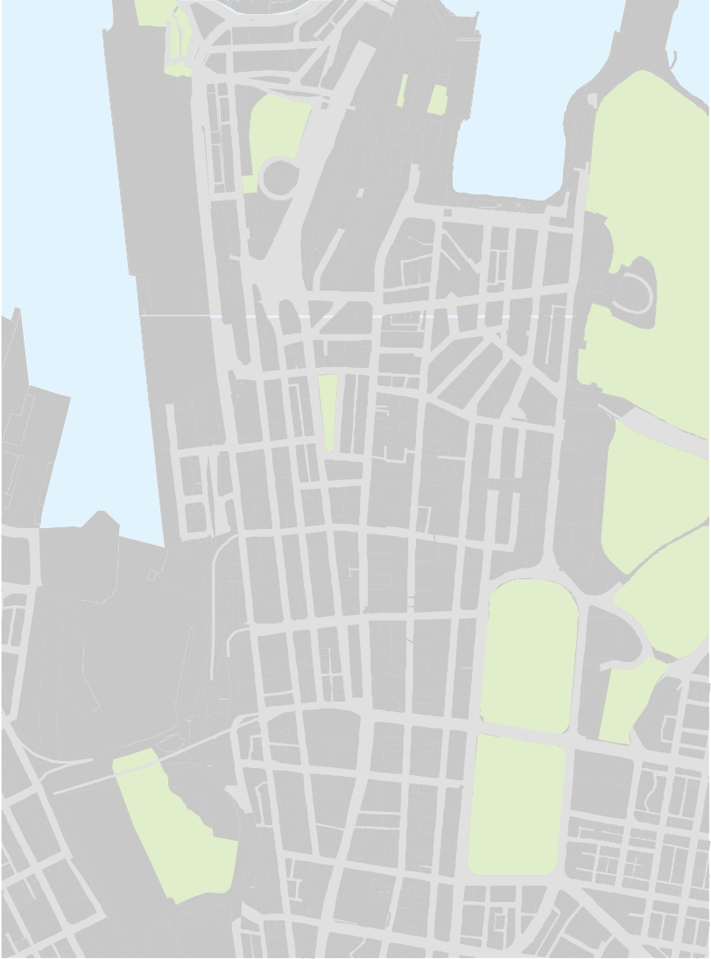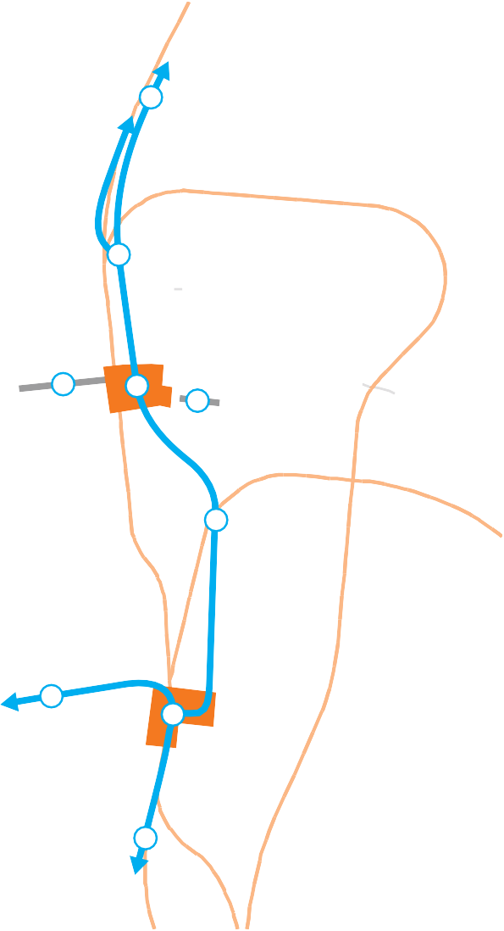The concept as applied to Sydney (illustrated in
Figure 7.2 Sydney CBD BRT Concept
1
2
Barangaroo
4
3
5
Wynyard
Sydney
6
8
7
Town Hall
East Sydney
Darling Harbour
9
Source: LEK.
- Buses to/from Harbour Bridge.
- Reuse old tram tunnels between Harbour Bridge and Wynyard.
- Reconstruct Wynyard interchange. New large scale commercial/of ce space above.
- Wynyard Walk.
- Hunter Connection.
- New bus tunnel between Wynyard and Town Hall (900 metres).
- Town Hall Square development. Bus ramp to surface and new civic development.
- Buses to/from Anzac Bridge and Victoria Rd.
- Buses to/from Broadway and Parramatta Rd.
  - Underground CBT BRT based on high level concepts.
  - Approximately 75 percent of peak Harbour Bridge buses moved to underground
CBD BRT.
  - All peak Broadway and some Anzac Bridge buses moved to CBD BRT.
  - Makes use of existing tunnel infrastructure from Wynyard to Harbour Bridge.
  - Assumes planned redevelopment of Wynyard and Town Hall stations.
Market St
Liverpool St
Figure 7.2), involves constructing a short new bus tunnel between new underground bus terminals at Wynyard and Town Hall, to serve buses entering the CBD from the highest demand corridors of the Sydney Harbour Bridge and Broadway.
With each bus terminal having two 55 metre platforms for each direction, the BRT would provide new capacity for up to 20,000 passengers per hour (double that offered by light rail), enabling the substantial removal of buses from surface streets10. This would reduce CBD congestion and enable pedestrianisation of George Street. If a viable business case is made in the future for the introduction of light rail, the existence of the CBD BRT would provide the mass transit commuter task which would enable light rail to provide a lower capacity system to support urban amenity objectives.
For bus users the CBD BRT would provide faster and more reliable travel times, whilst largely maintaining current service standards – with less forced passenger interchange and higher seating capacity than with
light rail.
Additionally, bus services from the West (Victoria Road) and the East (including William Street) may be connected into the CBD BRT via the Cross-City Tunnel (making
use of the tunnel’s current spare capacity), although the feasibility and merit of this requires detailed assessment.

- LEK 2012, Sydney CBD Access Strategy, prepared for Infrastructure NSW. A CBD BRT (excluding Cross City Tunnel connections) is estimated to be able to accommodate all current Broadway services, 75% of current Harbour Bridge services and about 50% of South-East bus services.

Table 7.1 Comparison of the different impacts of light rail and Bus Rapid Transit in the CBD
Light Rail BRT
Description of Projects | Anzac Parade to Central Station to Circular Quay along George Street. Partial pedestrianisation of George Street (shared with light rail). | Bus tunnel Harbour Bridge to Wynyard and Town Hall, possible East-West connections via Cross City Tunnel.  Redevelop Wynyard and Town Hall stations. Full pedestrianisation of parts of George Street.
Scoping Estimate | $1-2 billion | $2 billion
Bus Route Changes | Many routes terminated at edge or mid of CBD, or through-routing (through mid CBD). | Relatively few network changes required (some desirable to support high frequency “turn up and go” trunk services and to support more varied trip patterns).
Customer Impacts

Passenger Capacity | Will provide 9,000 customer trips per hour on George Street – assuming 45m vehicles every 2 mins (which is less capacity than current buses). There will be fewer light rail vehicles than the buses they replace, but the light rail vehicles will be more fully occupied. | New sub surface capacity of 20,000 customers per hour utilising standard buses (75 passengers per bus)
Standing | Two thirds of customers will be standing in the CBD when full; smoother ride mitigates. | One third customers standing in standard buses
Passenger Interchange | Forced interchange to access light rail from some suburbs where current direct bus services will cease. Customers on bus services that continue into the CBD will need to interchange onto light rail in the CBD to access north of Town Hall. | Relatively little forced interchange due to minimal change to existing bus services
Travel time and reliability | The trip from Wynyard to Town Hall will take longer than a sub-surface BRT due to intersections and other surface disturbances, and the interchange requirement. | Sub surface buses will travel from Wynyard to Town Hall consistently in 2-3 minutes.
Wider CBD Impacts

Pedestrian amenity | Shared pedestrian use of George Street. One light rail vehicle passes every minute in peak hours (combined up and down services assuming passing times of 30 seconds including a safety buffer) | George Street fully pedestrianised
Traffic congestion | Combination of additional light rail vehicles (with limited flexibility in traffic), likely continued bus services to mid CBD, and pedestrianisation will increase traffic congestion. | Additional sub-surface capacity allows for pedestrianisation without increasing CBD congestion
Wynyard and Town Hall stations | Does not include full redevelopment | Includes full redevelopment.

Delivery
Whilst conceptually appealing, the CBD BRT concept also presents a range of delivery challenges. Sydney Harbour Bridge buses could potentially gain access through the old Wynyard tram tunnels but making use of these tunnels to meet modern safety, ventilation and other standards would not be cost free, and connection to the Sydney Harbour Bridge will require careful
consideration of options to ensure capacity of the Bridge is not compromised11.
A new tunnel will be required from Wynyard to Town Hall. Identifying an appropriate alignment will be challenging. The sub-surface environment in the CBD is complex and a proposed new tunnel from Wynyard to Town Hall (where Broadway buses could access the BRT) would need to navigate existing sub-surface
infrastructure and building basements. It is also essential that the future option of a new rail line though the CBD – as proposed in Sydney’s Rail Future - is not precluded. Accordingly a range of tunnel alignment options will need to be considered12.
The new underground bus terminals will require total reconstruction of both sites, but there is the potential to integrate this with existing development proposals.
A Wynyard redevelopment would be highly desirable for rail users (including new commuters to Barangaroo) and new higher-rent commercial development could make a contribution to project costs.
At Town Hall, a new CBD BRT terminal and rail interchange could be integrated with retail
redevelopment and the City of Sydney’s plans for a new plaza (Town Hall Square, which was previously well developed as part of the abandoned CBD Metro project).
Actual construction of this underground infrastructure, though unavoidably disruptive, may be less so than the extensive surface works required for light rail.
The indicative cost of the CBD BRT tunnels has been estimated at $750 million13. With an allowance for risk and the Town Hall and Wynyard redevelopment,
Infrastructure NSW considers that $2 billion would be a realistic scope.
In conclusion, whilst the CBD BRT concept is currently at a relatively early stage of development, the potentially large benefits to public transport capacity, service quality, CBD congestion and amenity justify further detailed development of the concept.
Recommendation Infrastructure NSW recommends that the CBD BRT concept should be subject to a detailed feasibility and economic analysis. Subject to positive conclusions from this work and available funds, the CBD BRT could be delivered in years 5-10 of the Strategy.

Light rail options and bus corridors into Global Sydney

Anzac Parade Light Rail
Although CBD light rail poses difficulties, there is merit in considering the option of light rail from Central Station to the Moore Park recreational precinct, the
University of New South Wales and the Prince of Wales Hospital precinct.
Concerns with current bus services on this route relate to crowding, congestion and inadequate shelters, particularly at Central and the University. There is also a desire for faster and more reliable journey times.
Irregular service intervals create queuing and add to waiting times and congestion. A 2007 study identified a range of operational failings at major sites on the route contributing to passenger confusion, boarding delays and hence greater congestion14.
From an engineering and operational perspective, delivering light rail on the Anzac Parade corridor is less challenging than the CBD environment, offering a flat route (as far as Moore Park inbound) and the opportunity to re-use the segregated alignment used by light rail
until 1961.
Attempting to serve the mass commuter market from this proposed corridor, presents major challenges.
It would be difficult to match current bus travel times for South Eastern suburbs commuters to the CBD
(especially express services to the northern CBD via the

- MRCagney 2012, Inner Sydney Transport Strategy – Technical Support

14 Parsons Brinckerhoff 2007, Eastern Suburbs Transport Strategy, prepared for Australian Jockey Club, Centennial Parklands, Prince of Wales Hospital,

Services, prepared for Infrastructure NSW.
- LEK 2012, Sydney CBD Access Strategy, prepared for Infrastructure NSW.
- MRCagney 2012, Inner Sydney Transport Strategy – Technical Support Services, prepared for Infrastructure NSW.
Sydney Cricket & Sports Ground Trust and The University of New South Wales.

Eastern Distributor tunnel). Efforts to reduce travel times for light rail by tunnelling part of the route will substantially increase costs and could make the project unviable.
The difficulty of effectively serving the commuter markets on this corridor suggests a more realistic option may be to focus primarily on the recreational and student markets. Demand for the University alone already requires at least 85 buses per hour on top of the regular 60 buses per hour service scheduled from Central15. The aim would be to deliver a similar travel time to current buses, but with the superior travel experience that light rail offers for the peak heavy loadings.
It would be expected that most South Eastern Suburb commuters to the Northern CBD would continue to use existing bus services, at least until such time as a plan for substantially increased urban densities could justify an extension to the Eastern Suburbs Railway (refer Section 8).
With these less ambitious objectives, the project scope and costs would be managed down to achieve a practical and deliverable solution. A surface route
(rather than a tunnel) and a single terminus would reduce costs. With these assumptions, Infrastructure NSW would expect a scoping estimate of approximately $500 million (approximately $70 million per kilometre for seven kilometres). This is consistent with the cost per kilometre for Gold Coast Light Rail.
Given the target market, consideration should also be given to whether it be part-funded by the beneficiary institutions or their patrons, in order to reduce the costs to taxpayers.
The business case to support any investment by Government, and demonstrate value-for-money, will need to compare the preferred light rail proposal to alternative options, for example improving existing bus services or using higher capacity buses.
TfNSW has developed both bus and light rail options for this corridor and the detailed business case will be reviewed by Infrastructure NSW through its project assurance process (refer Section 16).
Recommendation Infrastructure NSW recommends that TfNSW scope the Anzac Parade light rail project from Central to the University of NSW, within a scoping estimate of $500 million. Subject
to a satisfactory business case the project could be delivered within the next 5 years.

Northern Beaches Rapid Transit
The CBD BRT would provide significant benefits for all bus services accessing the CBD from the
Sydney Harbour Bridge. However the Northern Beaches road corridor, from the Spit Bridge to North Sydney
can also suffer significant congestion, especially at weekends when lane space on Military Road is given up to car parking.
To improve the speed of bus services on this corridor, TfNSW has investigated building a new, higher-level (non-opening) six-lane Spit Bridge and then either providing permanently dedicated bus lanes (which assumes existing on-street parking is replaced with new
TfNSW analysis suggests the cost of these options is difficult to justify, especially given the relatively small time savings (negligible for all-stops services forecast in weekday peak hours), when parking clearways are already in force16. However, there is merit in pursuing further options including, for example:
      - measures to make six lanes available to traffic along the full length of Military Road (recognising that
this may require some property acquisition and/or accepting less space allocated to parking or turning lanes)
      - a ‘clip on’ lane added to the existing Spit Bridge (instead of a completely new bridge)
      - other short-term incremental measures to improve bus priority and junction flows.
Recommendation Infrastructure NSW recommends that TfNSW further investigate a range of potential enhancements to bus priority on the Northern Beaches corridor to develop
a value-for-money improvement plan for the coming decade – with a scoping estimate of up to
$200 million.

Over the longer term, the possibility of building a tunnel should be considered, which could free up surface road space as well as deliver substantial time savings to bus and car users. The option of a ‘Northern Beaches Link’ is discussed in Section 6.

off-street facilities) or building a dedicated bus tunnel

15 Transport for NSW 2004, Review of Bus Services in NSW, Final Report.
under Military Road.
16 Transport for NSW 2012, Northern Beaches Bus Rapid Transit (BRT) Study, Draft Feasibility Report.

Victoria Road Rapid Transit
Victoria Road is one of Sydney’s busiest traffic corridors and with high demand for bus services it has recently benefited from investment in substantial bus priority measures – particularly with the duplication of Iron Cove Bridge. The remainder of the Victoria Road corridor is likely to warrant a range of further bus priority measures over the next 20 years, including the introduction of dedicated rapid transit lanes.
Currently the biggest constraints appear to be on Anzac Bridge and final access into the CBD, where city intersection constraints and limited passenger drop-off zones on Druitt Street cause extended morning bus queues to back up on the Western Distributor.
Recent attempts to address this problem takes advantage of the ability of buses to be re-routed and provide duplicate capacity along multiple routes by diverting some buses to Bathurst Street. However, to be effective, this will require bus priority measures to be implemented on all incoming lanes.
The CBD BRT concept offers the prospect of overcoming this CBD access constraint by allowing buses to quickly access a Town Hall terminal via the Cross City Tunnel. This would also enable improved cross suburb connections, as services could continue on to the North via the CBD BRT to Wynyard and the Harbour Bridge, or to Eastern Suburbs via the Cross City Tunnel (and vice versa).

Recommendation Infrastructure NSW recommends that TfNSW develop a plan for bus priority on Victoria Road to implement an ongoing program of incremental investments.

Bus corridors and light rail options in Greater Sydney

Bus Network Reform
The bus network reforms outlined in the Draft Transport Master Plan will produce a consolidated network of more frequent and inter-connected services.
The objective of bus network reform is to improve services for current demand, whilst also attracting new demand at the margin. On key corridors this means moving away from the historic concept of universal access (which emphasises minimised walking distances rather than overall travel times), as this tends to relegate bus services to the status of service of last resort.
Improved service frequency, speed and reliability (targeting 25-30 kph to compete with cars), will also be targeted through investment in bus priority measures and investigation of longer term options for dedicated transit corridors17.
Network redesign, including more direct routing and wider spacing of bus stops (to reduce delays), will focus on improving speeds and frequencies on those corridors with greatest demand potential, whilst maintaining minimum service levels on secondary routes to ensure community needs are met.
Wider metropolitan network reform will also involve the development of a strategic transit network where passengers will be able to interchange between alternative transport modes utilising intersecting trunk and feeder routes (and rail lines) to support a broader variety of travel needs.
The development of a revised bus network and the new demand patterns that it generates will provide a clear basis for investing in incremental bus priority infrastructure to address congestion ‘hot spots’ on key corridors.
Accordingly, Infrastructure NSW supports the direction of reform outlined in the Draft Transport Master Plan which will develop a better integrated, but rationalised primary network of fast, frequent and direct services.
In the longer term, as Section 6 notes, the application of economic road pricing principles could be used to reduce traffic congestion. This would also be of benefit
to buses, which would be particularly useful on corridors where a dedicated bus lane cannot be justified.
Recommendation To support fast, frequent and direct services on a reformed metropolitan bus network, Infrastructure NSW recommends a program of incremental bus priority infrastructure investments on strategic bus corridors.

17 NSW Government 2012, Draft Transport Master Plan.

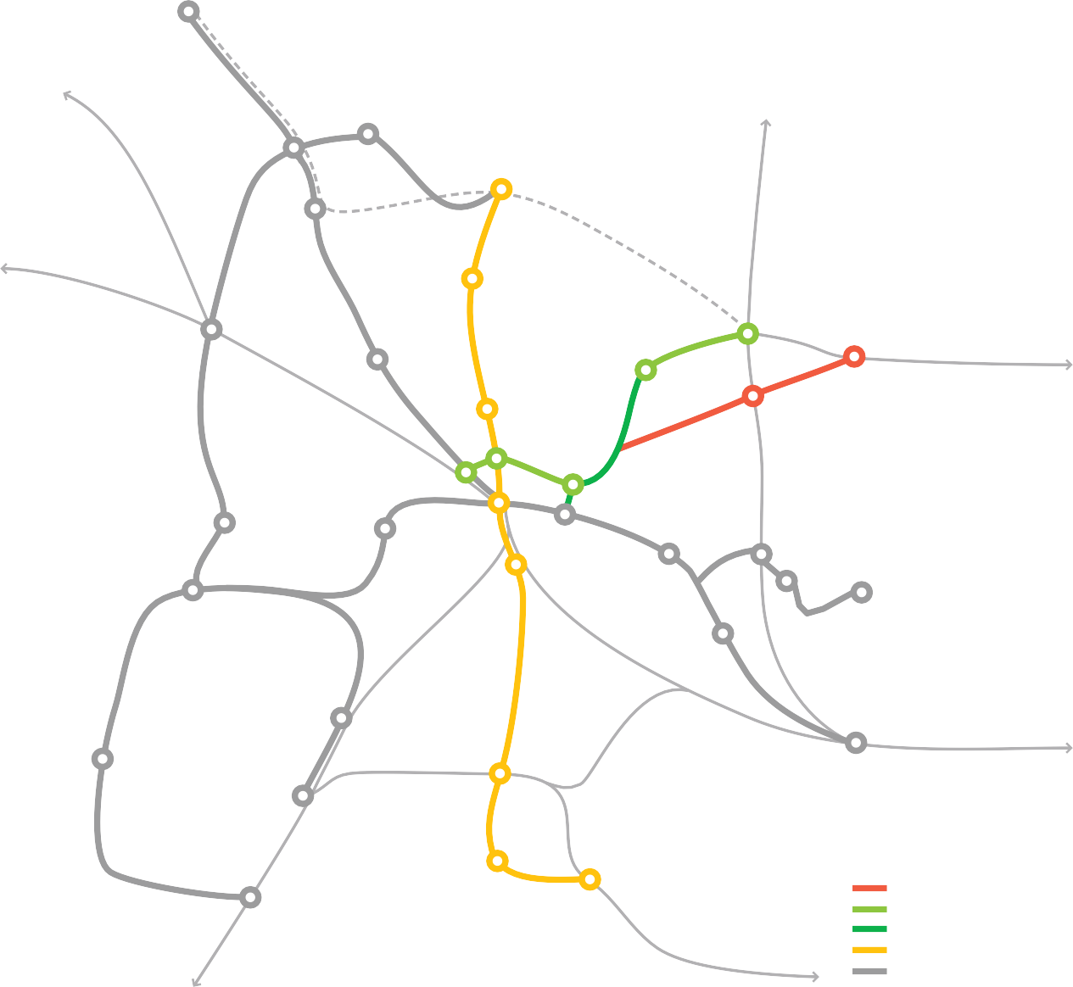
Figure 7.3 Western Sydney Light Rail Proposal

ROUSEHILL
to Richmond
PARKLEA
KELLYVILLE
to Hornsby
CASTLE HILL
NORWEST
to Penrith
BAULKHAM HILLS
BLACKTOWN
EPPING
WINSTON HILLS
MACQUARIE PARK
CARLINGFORD
to North Sydney
NORTHMEAD
PARRAMATTA NORTH
EASTWOOD
WESTMEAD
UWS/RYDALMERE
GREYSTANES EMPLOYMENT LANDS
WETHERILL PARK
PARRAMATTA CAMELLIA SOUTH
WENTWORTHVILLE GRANVILLE NEWINGTON
RHODES
CONCORD HOSPITAL
BREAKFAST POINT
OLYMPIC PARK
FAIRFIELD
BONNYRIGG
CHESTERHILL
STRATHFIELD
to Sydney
CABRAMATTA
BANKSTOWN AIRPORT
BANKSTOWN
LIVERPOOL
to Campbelltown
to Sydney
Source: Parramatta City Council.
Potential stage 1 links
Dundas – Macquarie Park Epping – Westmead Existing heavy rail line Castle Hill – Bankstown
T-Way City Rail
North West Rail Link

Western Sydney Light Rail
Parramatta City Council has recently launched a proposal for a Western Sydney Light Rail network and commenced an initial feasibility study. Stage 1, covering links to Castle Hill, Bankstown and Epping or Macquarie Park, is estimated at about $3 billion, with later stages planned to add another 105 kilometres at an additional cost of $6.5 billion. The draft proposed network is shown in Figure 7.3.
The Council proposes light rail as “a viable, quick-to- build solution for Western Sydney; an interim mode between bus and heavy rail options”18. It hopes that light rail will assist in building employment centres close to homes in Western Sydney, particularly in Parramatta.
To justify an investment of this scale there would need to be some confidence that it would address the key
constraints to greater employment growth in Parramatta. This Strategy argues that transport investments alone will rarely transform an area’s economic potential.
In Infrastructure NSW’s view, a more fundamental constraint is the connectivity of Parramatta to Global Sydney, and, more broadly, Sydney’s West to Sydney’s international gateways. Measures to improve this are considered in Sections 6 and 8.
However, Infrastructure NSW does recommend action to address the underlying problem – that is, the slow,
indirect and/or infrequent bus services north and south of Parramatta. For example, from Bankstown or Castle Hill to Parramatta, bus times are around about 60 minutes (including waiting time) compared to 30 minutes by car.

18 Parramatta City Council 2012, Western Sydney Light Railway Network.

The priority should be to address these travel issues by re-routing bus services to follow a more direct route, with less frequent stops (i.e. operating more like light rail), and then improving speeds through bus priority measures.
Additionally there is the potential to improve cross suburb connectivity, by joining routes north and south of Parramatta together. Through-running of services through Parramatta in this way will also address
the congestion caused by the current approach of terminating all services at Parramatta interchange.
In summary, whilst the Western Sydney Light Rail proposal is based on sound long term objectives, an immediate solution is the ongoing enhancement of bus services along the identified corridors. By building demand over time, the case for long term
investment in a fully dedicated busway or light rail will be substantially strengthened.

Recommendation Infrastructure NSW recommends TfNSW develop a plan for public transport into Parramatta and implement a program of incremental bus service improvements and bus priority measures.

Parramatta to Epping or Macquarie Park
One area for more detailed evaluation is an investment in better connectivity on the corridor between Parramatta and Epping or Macquarie Park. Given expected patronage levels, it is unlikely that a heavy rail line on
this route will be justified for many decades, but a rapid busway or light rail service (based on an extension of
the existing Carlingford heavy rail line) could improve connectivity into Parramatta and the employment centres around Epping and Macquarie Park at a much lower cost.
On the basis of busway costs of about $30 million per kilometre (compared to $57 million per kilometre for light rail), a rapid transit link could be provided for
approximately $500 million, approximately half the unit cost suggested for light rail19.

Recommendation Infrastructure NSW recommends TfNSW develop options for a rapid transit connection between Parramatta and Epping and/or Macquarie Park. Subject to business case outcomes, delivery could be targeted for the second decade of the Strategy.

Conclusions
Buses will remain the most appropriate public transport mode for most of Sydney over the next two decades.
In the short term, bus network reform offers the greatest potential for service improvements, particularly where combined with supporting rapid transit infrastructure and bus priority measures designed to deliver fast, frequent and direct services.
The most critical infrastructure issue impacting on buses in Sydney is the need to address bus congestion in the CBD. This is an economic issue issue as much as a transport service issue. The CBD needs to provide a world class environment for doing business; this street level amenity is vitally important.

19 Parramatta City Council 2012, Western Sydney Light Railway Network.
The short term solution to the CBD bus congestion problem requires network changes to improve bus capacity utilisation.
Longer term, substantial improvements to CBD public transport and street amenity should be investigated through a feasibility study for the CBD BRT. This concept would connect the Sydney Harbour Bridge and Broadway bus services via redeveloped terminals at Wynyard and a new Town Hall Square, with the possible option of connecting east-west routes via the Cross City Tunnel. This analysis of CBD BRT options should be undertaken in the short term so that this concept, if confirmed to be of merit, could be completed within the next 10 years.
Light rail proposals require a clear objective. They can suffer from confusion between mass transit and urban amenity roles. In the congested environment of the CBD, this distinction is critical. An amenity-based George Street light rail is possible, but is not in itself a solution to the bus congestion problem. CBD light rail
has significant negative impacts in terms of costs, CBD disruption and widespread network changes, whilst providing little or no apparent increase in capacity or reduction in travel times or congestion.
Light rail along Anzac Parade to Central Station could offer a better quality travel experience for the high volume traffic flows to the Moore Park precinct and the University of NSW, but it must be noted that for most South Eastern commuters to the CBD, light rail would not compete on travel time with existing bus services. Accordingly, the scope and costs of a line to Central Station need to be tightly controlled.

The Parramatta to Macquarie Park, Northern Beaches and Victoria Road corridors may warrant more substantial bus infrastructure investments; feasibility studies should be commenced to identify and evaluate appropriate scope of works to deliver value for money. Investments need to be staged on an incremental basis to promote and respond to demand growth.
In the rest of metropolitan Sydney, the emphasis should be on bus network design and incremental infrastructure improvements to support fast, frequent and reliable bus services on major corridors.

Recommended actions for buses and light rail
Recommended Actions Years Type Capital and Funding Implication
9 | Develop and construct Anzac Parade Light Rail from Central Station to Moore Park and University of NSW | 0 – 5 | Major project | Scoping of $500 million based on Gold Coast Light Rail assumes surface construction and no user contribution to capital costs.
10 | Reform CBD bus routing to reduce congestion | 0 – 5 | Asset utilisation | Operational reform – no capital works proposed.
11 | CBD Transit Improvement Plan: Construct underground Bus Rapid Transit | 5 – 10 | Major project | Scoping of $2 billion for a tunnel option from the Sydney Harbour Bridge to the Town  Hall area and development of Wynyard and Town Hall bus/rail interchanges. Potential opportunities for value capture exist.
12 | Pedestrianise central part of George Street | 5 – 10 | Major project | Cost included in Recommendation 11.
13 | Incremental bus priority measures for Parramatta and other strategic corridors | 5 – 10 | Program | Scoping of $200 million.
14 | Northern Beaches bus corridor improvement plan incorporating Spit Bridge augmentation and priority lanes | 5 – 10 | Program | Scoping of $200 million.
15 | Develop and construct transitway from Parramatta to Epping/Macquarie Park | 10 – 20 | Major project | Scoping of $400 million assumes a bus T-Way option.

Passenger trains

Summary

Snapshot

- Reliable, frequent and fast passenger trains are essential to the economic success of NSW and to the amenity of life, particularly in Global Sydney. The rail system must become world class, financially sustainable and attractive to commuters in Sydney and neighbouring regions.
- Infrastructure NSW endorses the three tier railway strategy developed by Transport for New South Wales (Transport for NSW) as the basis for rail infrastructure investment, including the North West Rail Link (NWRL). Once implemented, the rail system will comprise:
  - a rapid transit network using single deck trains operating at high frequency across the day
  - a suburban network using double deck trains providing high seating capacity, and with a particular focus on the commuter market
  - an intercity network serving the Central Coast/ Hunter, Illawarra and Blue Mountains, offering fast and comfortable services
- Additional capacity will be required in the core of the network, particularly the CBD, over the next 20 years. Existing assets must be used as intensively as possible before constructing new major infrastructure in the long term.
- Accordingly, the recommended strategy proposes increased use of the City Circle to provide additional capacity in the CBD within 10 years.
- Beyond year 10, the extension of rapid transit from the NWRL over the Sydney Harbour Bridge and through the Inner West to Strathfield is proposed. This approach requires the modernisation of existing lines as well as Wynyard and Town Hall stations.
- An incremental program to accelerate the intercity routes is proposed, with a target of one hour journey times to Sydney from both Gosford and Wollongong, and a two hour journey time from Newcastle. The focus of the program will be operational improvements supported by targeted capital works to reduce journey times.
- Planning for an extension of the Eastern Suburbs Railway to Randwick and Maroubra is
recommended after year 10, in conjunction with land use intensification in South East Sydney.
  - The passenger rail network of over 1,000 route kilometres and approximately 300 stations is to be split between Sydney Trains in the metropolitan area and NSW Trains elsewhere.
  - The core fleet of about 220 eight car electric train sets provides around 2,500 trains services each weekday, travelling at an average speed of 40 kilometres per hour.
  - Current infrastructure, buildings and equipment are recorded at a book value of over $20 billion1.
  - 44 percent of journeys to work in the CBD are by rail (refer Section 3). However, rail comprises only
5.3 per cent of all journeys in the Sydney region2.
  - Over the past 20 years, rail demand in Sydney has grown at a little over one percent per annum, effectively tracking general population growth. By comparison, rail patronage has grown by over five percent per annum in Melbourne and four
percent per annum in London over the same period.
  - Demand for rail services is forecast to increase 37 per cent over the next 20 years3.
  - The condition of RailCorp’s infrastructure has been assessed as very good (refer Section 2).
  - In 2010-11, the total cost of running the railway was
$3.5 billion, compared with farebox revenue of only
$700 million. In the four years from 2006-07 to 2010-11, operating expenses increased by $588 million, while farebox revenue increased by only $136 million4.

    - NSW Treasury, 2012-13 Budget Paper 4; asset values as at 30/06/11 excluding land, tunnels and other excavations prior to 2000.
    - NSW Bureau of Transport Statistics 2012, Transport Facts.
    - NSW Bureau of Transport Statistics 2011, Rail Options for the Sydney Greater Metropolitan area, Draft Options Paper.
    - RailCorp 2011, Annual Report 2010-11.

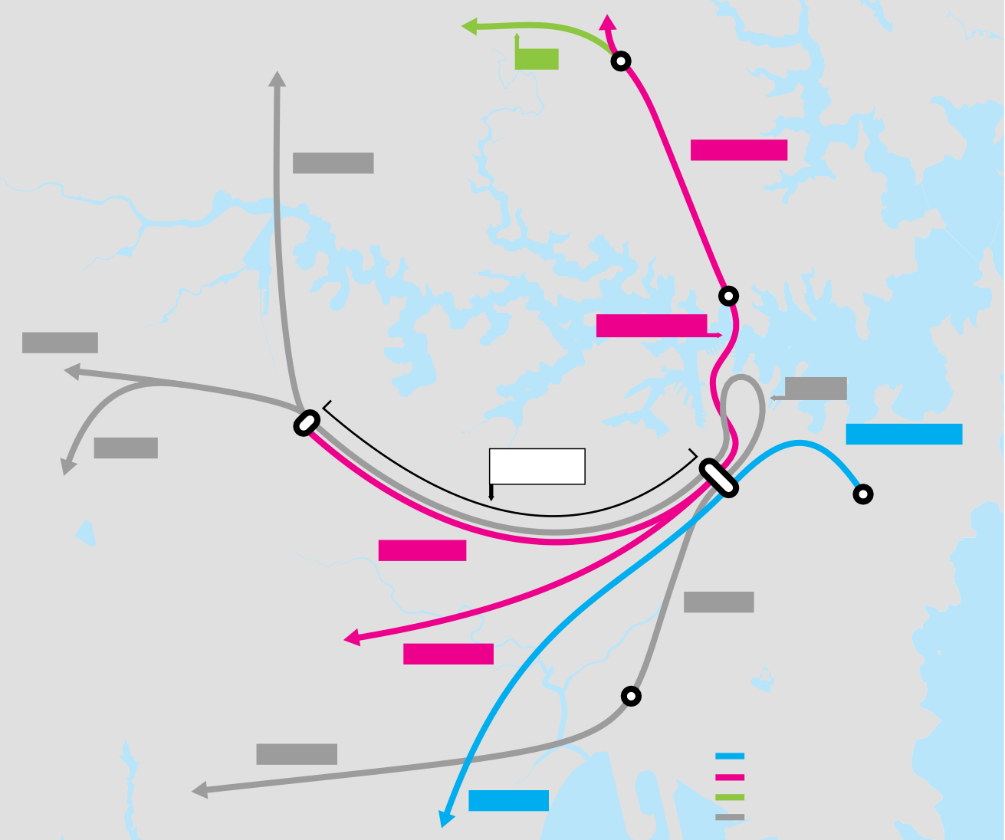Table 8.1 Cost Recovery Ratios in a Sample of Cities
Figure 8.1 Core Sydney Rail Network (simplified)
NWRL
Chatswood
North Shore Line
Northern Line
North Sydney
Harbour Bridge Line
Western Line
City Circle
South Line
Strathfield
Eastern Suburbs Line
Main West Lines (6 tracks in total)
Bondi Junction
Central
Inner West Line
Airport Line
Bankstown Line
Sydney Airport
Key
East Hills Line
Illawarra Line
Source: Transport for NSW.
Eastern Suburbs/Illawarra line Potential rapid transit corridors NWRL
Potential Suburban/City Circle corridors

Cost Recovery (%)
Year of data

Sydney (RailCorp) | 20% | 2010-11
London  (London Underground) | 75% | 2009-10
Montreal (Metro) | 57% | 2006-07
New York  (Metropolitan Transit Authority) | 56% | 2009-10
Sources: RailCorp 2011, Transport for London 2010; Societe de Transport de Montrèal; Metropolitan Transport Authority.
NWRL North Shore Line
Chatswood

North Sydney

Harbour Bridge Line
Northern Line
City Circle

Western Line Strathfield Central Eastern Suburbs Line Inner West Line
Southern Line Bankstown Line
Sydney
East Hills Line Airport

Illawarra Line

- Government railway subsidies in NSW significantly exceed international norms, as shown in Table 8.1. Each trip currently costs the NSW taxpayer around $9.45, compared with $6.81 only four years ago5.
- The configuration of the Sydney rail network is shown in Figure 8.1.
- The network exhibits strong demand peaks on weekday mornings and evenings, partly reflecting the relative lack of demand management strategies. Figure 8.2 summarises demand at CBD stations across the week. Similar patterns exist at other major Sydney centres.
- The peak passenger flows on the network occur between 8am and 9am on weekdays. Platform crowding most often occurs at Town Hall, Wynyard and Central in the evening peak.

    - RailCorp 2011, Annual Report 2010-11.

Infrastructure NSW’s approach
The Government has recognised that the current subsidy of passenger rail places an unsustainable burden on the taxpayer, and diverts funds which otherwise could be invested in new infrastructure.
In February 2012, Transport for NSW announced a reform of RailCorp to return the passenger railway to a more sustainable financial position and improve services to customers.
Infrastructure NSW considers that the passenger rail network should first achieve best practice operating performance and then develop an investment program that is realistic and affordable.

Figure 8.2 CBD Station Entries and Exits by Time of Day

30,000

25,000

20,000

15,000

10,000

5,000

0

This approach is consistent with the plans for operational reform of RailCorp and the strategic principles set out in the ‘Sydney’s Rail Future’ announcement June 2012.
Given that congestion issues are concentrated within a short period of the day and on a relatively small part of the network, Infrastructure NSW has focused on
targeted opportunities to provide additional capacity and manage demand.
This section is concerned with the Sydney passenger rail network. Transport services in Regional NSW are covered in Section 10.

The high capacity railway

Sydney’s Rail Future
The rail strategy in the Draft Transport Master Plan is based on “Sydney’s Rail Future”, released by Transport for NSW in June 2012. Sydney’s Rail Future sets out
a vision for the modernisation of the metropolitan rail network to provide more capacity.
The first two stages of ‘Sydney’s Rail Future’ focus on operational and network efficiencies, which are fully endorsed by Infrastructure NSW. Using existing rolling stock, these efficiency changes will reduce train delays at busy CBD stations and thereby enable the operation of more closely-spaced services to give a higher capacity system.
The later stages of Sydney’s Rail Future involve more radical changes including a three tier railway and a second harbour crossing. The proposed three tier railway comprises:
      - a rapid transit network utilising single deck trains operating to a turn-up-and-go service pattern
      - a suburban network using double deck trains on the majority of the existing network
      - an intercity network serving the Central Coast, Hunter, Blue Mountains and South Coast, using comfortable double deck trains.
Infrastructure NSW believes that the concepts underlying Sydney’s Rail Future form a sound basis

6 :00 7:00 8:00 9:00 10:00 11:00 12:00 13:00 14:00 15:00 16:00 17:00 18:00 19:00 20:00 21:00 22:00 23:00
for increasing network capacity and delivering the Government’s commitment for the NWRL.

Weekday
Saturday
Sunday
Source: CityRail.

Capacity on the suburban network
The current operations of CityRail provide a range of suburban and intercity services. Selected one hour peak flows into Sydney’s CBD are shown in Table 8.2.

Table 8.2 Peak hour train loadings
The peak load from the Main West Lines into the CBD is around 17,000 per line per hour (34,000 passengers across two lines). The loads on other lines are all below this level. Peak traffic over the Sydney Harbour Bridge is currently around 14,000 per hour (compared with the 16,000 peak hour flow on buses using lane seven of the
Taken together, the data in Tables 8.2 and 8.3 indicates that the network is not running at or near capacity in
an absolute sense. This finding is supported by work undertaken by Interfleet Technology for Infrastructure NSW, which identifies a range of potential ‘quick wins’ to add more capacity at peak periods.

Source: CityRail.

Measured at

Passengers - 1hr AM peak

Up tracks
bridge), although it is expected to increase to around 20,000 per hour per line in the peak after the NWRL opens in the next decade.
The Airport Line carries relatively few passengers; trains are crowded since only eight trains operate in the peak hour. The Eastern Suburbs railway is the most underutilised line, reflecting its limited catchment area of three stations. An opportunity to use this infrastructure more intensively is considered in Section 8.6.
Main West Lines(a) | Redfern | 39,700 | 3
Illawarra | Sydenham | 16,500 | 1 – 2
North Shore | Sydney Harbour Bridge | 14,300 | 1
Bankstown & East Hills via Sydenham | Redfern | 11,100 | 1
East Hills via Airport | Wolli Creek | 7,500 | 1
Eastern Suburbs | Kings Cross | 7,400 | 1

International benchmarking also indicates that Sydney’s existing lines carry far fewer passengers in peak periods than many railways overseas, as shown in Table 8.3.

Table 8.3 International Capacity Comparators
Accordingly the problem of rail capacity needs to be primarily understood in terms of unlocking latent capacity. The existing network ought to be able
to provide peak capacity of up to 40,000 per line per direction.

Capacity within the CBD
Rail services in the CBD use the Harbour Bridge Line (linking Main West and North Shore services via Town Hall and Wynyard) and the City Circle.
The Harbour Bridge Line experiences significant congestion under the current service pattern. This arises because it has heavy passenger flows in both directions, including a large number of interchanging passengers,

(a) ‘Main West Lines’ includes Western, Northern, South, Inner West and
Intercity services using the route between Strathfield and Central.
The Main West Lines carry the highest number of passengers, but have the benefit of a six track alignment from Strathfield to Central. However, capacity is currently constrained because:
      - the service pattern results in a number of bottlenecks
      - services are compressed from three lines into two lines North of Central (relatively few trains terminate at Central).

System

Source: Transport for NSW.

Trains per hour

Max people per sqm
Total line capacity (people per hour)
and intervals between services can be irregular.
However in contrast the City Circle is relatively lightly used. This situation has existed since the opening of the Eastern Suburbs Line in 1980. At present the City Circle carries 29 trains in the PM peak hour compared to 48 trains per hour in 19726. The spare train paths in the City Circle could carry around 25,000 extra passengers in the peak hour.
Sydney CityRail | 19 – 20 | 2.5 | 24,000
Paris RER (line A) | 25 – 26 | 3 – 3.5 | 40,000
Munich S Bahn | 28 | 4 | 45,000
Hong Kong MTR | 30 | 4 – 5 | 60,000

The busiest CBD stations are Town Hall and Wynyard as summarised in Table 8.4.

    - CityRail, December 1971 Metropolitan Timetable.

Table 8.4 CBD Station Utilisation
Station Entries – PM Peak
Station Platforms (15:00 – 18:30)
Town Hall | 6 | 39,000
Wynyard | 4 | 33,000
Martin Place | 2 | 12,000
Circular Quay | 2 | 8,000
St James | 2 | 4,000
Museum | 2 | 6,000
Total | 18 | 102,000

Source: CityRail.

Severe congestion is generally limited to two of the
18 CBD platforms; that is, Platform 2 at Town Hall and Platform 3 at Wynyard for around one hour in the PM peak. While operational factors play a part, the service pattern aggravates the situation because:
Rail capacity enhancement strategies over the past decade have focussed on the construction of a new line through the CBD – either a second harbour rail crossing, or a “relief” line from Central to Wynyard. As discussed further in Section 8.3.5, these proposals have very high capital costs. Unlocking the spare capacity in the City Circle could potentially deliver congestion relief much sooner and at a much lower cost.
The Bradfield-era flying junctions outside Central provide the basic infrastructure needed to feed more trains into the City Circle. However, this change would have significant operational implications, which are the responsibility of Transport for NSW.
Given the operational implications of restructuring the service pattern to increase utilisation of the City Circle, Infrastructure NSW has not commissioned detailed work on the options in this area itself.

Recommendation Infrastructure NSW recommends an independent study of options to use the City
Circle to provide additional CBD capacity in the medium term. This will require detailed analysis of the infrastructure and operational implications.

Rapid Transit Services
Infrastructure NSW fully endorses Transport for NSW’s proposal to progressively introduce rapid transit services using single deck trains onto parts of the network, starting with the NWRL. The rapid transit services will provide
turn-up-and-go frequencies and complement the double deck services on the legacy commuter network.
In the longer term, single deck trains offer the potential to cost-effectively increase network capacity, particularly on the Harbour Bridge Line. The potential capacity increases available are indicated in Table 8.5.

      - the largest flow of interchange passengers alighting in the CBD (from the North Shore) directly conflicts with the largest number of passengers boarding in the CBD (for the Main West)
      - Main West passengers can only board at two of the CBD stations.
Despite the steady increase in congestion on the

Table 8.5 Indicative passenger capacity of double deck and single deck train systems

Train capacity(1) Seats per train Trains per hour
Double deck | 1,200 | 890 | 20 | 24,000
Single deck – comfortable(1) | 1,200 | 600 | 30 | 36,000
Single deck metro – max(2) | 2,000 | 400 | 30 | 60,000

Total passengers per hour

Harbour Bridge Line at Wynyard and Town Hall, no attempt has been made to redistribute traffic towards the surplus capacity on the City Circle. Circular Quay, St James and Museum stations are currently used by very few passengers.
(1) Double deck assumes a nominal capacity of 1200 people with seating in line with Waratah train specifications. Planned frequency of 20 tph across the harbour bridge from Sydney’s Rail Future. Single deck ‘high seating’ capacity could have 500-600 seats (Source: Halcrow 2011), single deck would be based on standard international design with 3 doors per side.
(2) Source: MTR for Transport for NSW.

Single deck trains are able to operate at higher frequencies because delays at stations from passenger boarding and disembarking are less than with a
double deck fleet. Higher frequencies will require the introduction of new train control systems, using technology that is proven in service overseas.
Table 8.5 evidences that single deck rolling stock could provide over 50 percent more capacity than current services, which is enough to meet demand for several decades if demand continues to grow at its historic rate of just over one percent per annum.

Network Design Issues
‘Sydney’s Rail Future’ envisages that the rapid transit network will connect the NWRL with the Bankstown Line and the Illawarra Line as far as Hurstville, via a second harbour crossing and a new line through the CBD.
Infrastructure NSW acknowledges that this scheme represents one solution to the long term capacity challenges in the CBD. However in the absence of detailed cost estimates and economic analysis, it is unclear whether the proposed scheme is the best value- for-money solution to the problem.
The cost of the second harbour crossing scheme will exceed $10 billion and funding may not be available for many years. Further, the utilisation of rapid transit both south and west of the CBD appears sub-optimal. The current proposal will serve the Bankstown Line, which carries only 6,600 passengers in the peak hour, and part of the Illawarra Line which already has good access to the CBD via the Eastern Suburbs Line.
By contrast the heaviest traffic flows outside the CBD occur on the six-track Main West Lines between Strathfield and Central. The development work undertaken on the West Metro project, indicated that this corridor through the Inner West could offer a strong market for rapid transit services.
Accordingly, Infrastructure NSW has considered what other options may exist to bring the benefits of rapid transit to more customers, sooner and at lower cost.

An Alternative Approach
The alternative approach is to introduce rapid transit services on to the existing network. Services on the NWRL would be extended into the CBD using the existing Harbour Bridge Line. Trains would then continue on the existing Inner West Line from Central to Strathfield.
This approach would provide high capacity metro-style services on the most congested part of the network from Strathfield to Chatswood via the CBD. The target capacity for the rapid transit lines would be 40,000 passengers per direction per hour. It would allow passengers from the NWRL to travel to the CBD without interchanging at Chatswood.
Additionally, once rapid transit is introduced on the Inner West Line, the other four lines between Strathfield and the City could be exclusively used as express lines.
This would mean faster and more frequent services to the CBD for passengers on the Western, Northern and South Lines.
Based on an initial scoping, this scheme would require:
      - re-signalling of the North Shore, Harbour Bridge and Inner West Lines
      - junction remodelling outside Central to link the Harbour Bridge and Inner West Lines
      - new single deck rolling stock
      - upgrades of Wynyard and Town Hall interchanges as part of the CBD Transit Improvement Plan discussed in Section 7.
Reconfiguring the network in this way is a complex matter and careful attention must be paid to disruption impacts. However, the delivery of the Thameslink project through central London shows that modernisation
and expansion of an operating railway can be a viable alternative. A pre-condition for success will be
completion of Transport for NSW’s reforms to establish a rail operation capable of managing major changes.
Recommendation Infrastructure NSW recommends the introduction of metro-style rapid transit services between Chatswood and Strathfield via the Sydney Harbour Bridge, to allow direct running of trains from the NWRL to the CBD and free up capacity for faster and more frequent trains from the West.
Implementation of the recommendations in relation to the City Circle and rapid transit could deliver a three tier railway in the following form during the 2020s:

        - single deck rapid transit via the Sydney Harbour Bridge – serving the NWRL, North Shore, Inner West and Bankstown
        - double deck suburban via City Circle – serving the Main West, Main South and East Hills – and via the Eastern Suburbs/Illawarra Line
        - intercity to Sydney Terminal – serving the Central Coast, Hunter, Illawarra and Blue Mountains.

Mainline acceleration program

Introduction
The average trip on CityRail takes around half an hour and covers a distance of slightly under 20 kilometres. For these journey types, frequency and reliability of service are more important than speed.
However, there are significant markets where journey time is a more important driver of demand. These include the Central Coast, Hunter and Illawarra. Faster trains to these destinations would effectively expand the catchment area from which people can access jobs in Global Sydney and spread our growing population across a larger area.
Gosford and Wollongong are both 80 kilometres from Sydney. Express services currently take around 80 minutes from Gosford and 90 minutes from Wollongong, which limits the size of the commuter market. CityRail express services from Newcastle to Sydney generally take around two hours and 40 minutes, which is slower than the pre-war “Newcastle Flyer” steam train.
Based on international comparators, Infrastructure NSW
considers that reductions in intercity journey times would be likely to stimulate considerable demand growth. Journey times to Sydney of one hour from the Central Coast and Illawarra, and two hours from Newcastle, would require services to operate at an average speed of 80 kilometres per hour.

Incremental Approach
Funding constraints and the limited size of the market are likely to preclude the transformational approach of a new high speed line for at least 20 years. Accordingly, Infrastructure NSW’s proposed strategy is an incremental approach that seeks to deliver progressive reduction in journey times year by year. The emphasis in early stages will be on operational changes, including tighter timetabling and fewer intermediate stops.
Opportunities to increase actual running speeds on the main lines should be carefully re-examined from the bottom up, with a focus on identifying time savings which can be captured without major capital expenditure. Once these gains have all be achieved, higher cost improvements
can be considered to increase speeds, such as signalling upgrades, new trackwork and new rolling stock.
The existing lines to the North and South will never be fit for true high speed operation, given the topological constraints on the Illawarra escarpment and the Hawkesbury River crossing. However a target average speed of 80 kilometres per hour can accommodate some speed restrictions and does not require a 350 kilometres per hour high speed line.
An example of what can be achieved through incremental change is provided by Chiltern Railways in the UK. Chiltern operates a secondary line between
London and Birmingham, a distance of 180 kilometres. Through a program of incremental improvement over the last 15 years, journey times have been reduced from two hours 20 minutes to one hour, 40 minutes7. These reductions have been achieved on an operating railway, with relatively low levels of capital expenditure.
Recommendation The new NSW Trains should be given an objective of identifying and delivering journey time savings with a target of one hour journey times from Wollongong and Gosford to Central, and a two hour journey time from Newcastle to Central.
A phased approach is recommended:
- A pilot program for acceleration on the South Coast Line between Sydney and Wollongong over the first five years, to develop the new approach without interfering with the core of the network
- Extension of the concept to the Central Coast between years 5 and 10, with further incremental improvements to Wollongong services
- More capital works after year 10, and extension of the program to Newcastle services.

Demand side strategies

Peak Hour Pricing
Rail patronage is extremely ‘peaky’, particularly between 8am and 9am on weekdays. Abundant spare capacity exists in the off peak and at weekends. Price signals offer an option for managing demand in the peak.

    - Chiltern Railways, Network Rail timetables.

The anticipated impact of more differentiation between peak and off peak fares would be ‘peak spreading’, where some passengers choose to change the time of their journey earlier or later. The introduction of the Opal card provides the technology to allow a tailored pricing scheme to be introduced in the CBD.
Targeted peak price signals could provide a material contribution to the strategy for managing growing demand. Modelling suggests that a fare structure with a 25 percent peak surcharge for customers arriving
at CBD stations between 8 am and 9 am, along with a 25 per cent discount for those arriving before or
after this window, could reduce peak hour demand by about 10 percent, or potentially one to two train loads on each line8.
Recommendation Infrastructure NSW recommends that the Government considers strengthening off- peak travel price incentives following the introduction of the Opal card. The objective of any changes will be to spread demand in the CBD more efficiently.

Building Off-Peak Patronage
The introduction of clearer peak / off-peak price signals would form the starting point for a broader and more pro-active approach to increasing off-peak patronage.
Complementary measures to support this could include:
      - providing more frequent services in the “shoulder period” (i.e. just before 8 am and just after 9am)

    - Douglas Economics 2012, Modelling the Ability of Fare Incentives to Spread AM Peak passenger loads, prepared for Infrastructure NSW.
- ‘Clockface’ service frequencies across the day
- Rewarding regular travel in the off-peak, through bonuses to Opal card accounts.
Promoting off-peak and contra-flow patronage extracts more value from currently poorly utilised infrastructure, defers the need for expensive new capacity, and can also help provide “city shaping” benefits that bring more balanced travel patterns.
For example, consistent off-peak services to Parramatta (improving on the current three to 16 minute variability in service intervals) could contribute to employment growth in this key centre.

Recommendation Infrastructure NSW recommends that Sydney Trains operate an express train service between the CBD and Parramatta across the day, with a turn-up-and-go frequency level.

Network expansion

Assessing Growth Schemes
The rail infrastructure priorities over the next decade will be better utilisation of the existing asset base, and delivering the NWRL. Once these objectives have been achieved, consideration can be given to investment
in further network expansion. Infrastructure NSW has considered where planning for longer term expansion should best be directed.
A starting point is to examine areas of relatively high population density with strong demand for travel to a major centre. Unless there is a very substantial change
in employment patterns and mode choice, this indicates consideration of new lines connecting Inner Sydney to the CBD. The principal corridors of interest comprise:
      - Victoria Road – Anzac Bridge – CBD
      - Parramatta Road – Broadway – CBD
      - Northern Beaches – Mosman – North Sydney – CBD
      - Anzac Parade – CBD
The challenge for construction of metro railways on these corridors is the development of a viable business case. During 2008-10, detailed work was undertaken on both the Victoria Road and Parramatta Road corridors
(North West Metro and West Metro respectively).
The evidence from this exercise is that the costs of new construction are extremely high, particularly in the CBD, while patronage is likely to be modest. Infrastructure NSW has been unable to obtain any evidence that forecast passenger numbers on any non-rail corridor into the CBD will exceed the capacity of a well-run bus solution for at least 20 years.
Accordingly, Infrastructure NSW has concluded that the construction of a new metro network should not form part of the Strategy, as such a scheme is highly unlikely to represent the highest and best use of limited Government funds. Instead Infrastructure NSW recommends that the main focus of investment should be incremental improvements to the existing bus and light rail network, as set out in Section 7.
However, Infrastructure NSW has identified one incremental expansion for consideration: the extension

of the Eastern Suburbs Railway (ESR) to the South- Eastern suburbs. This project is more attractive because it can leverage the spare CBD access capacity of the existing line and support significant urban consolidation in locations likely to be appealing to the housing market.

Eastern Suburbs Railway Extension
The Eastern Suburbs Railway scheme authorised in 1967 was to run from the City to Kingsford. The original plans recognised the existence of significant demand for rail services in the South-Eastern suburbs, a combined catchment area of around 200,000 people.
The journey time by rail to Martin Place would be approximately 11 minutes from Randwick and
14 minutes from Kingsford/Maroubra. This is less than half the time for comparable bus services in peak hours.
However due to construction time and cost overruns, the line that finally opened in 1979 was truncated at Bondi Junction. The southern section was postponed indefinitely.
Thirty five years after the truncation of the ESR,
South-Eastern Sydney remains relatively less developed than might be expected given its proximity to the CBD and coastal position. The existing apartments growth centre in South Sydney would also be likely to extend East in response to a rail development.

Project Practicability
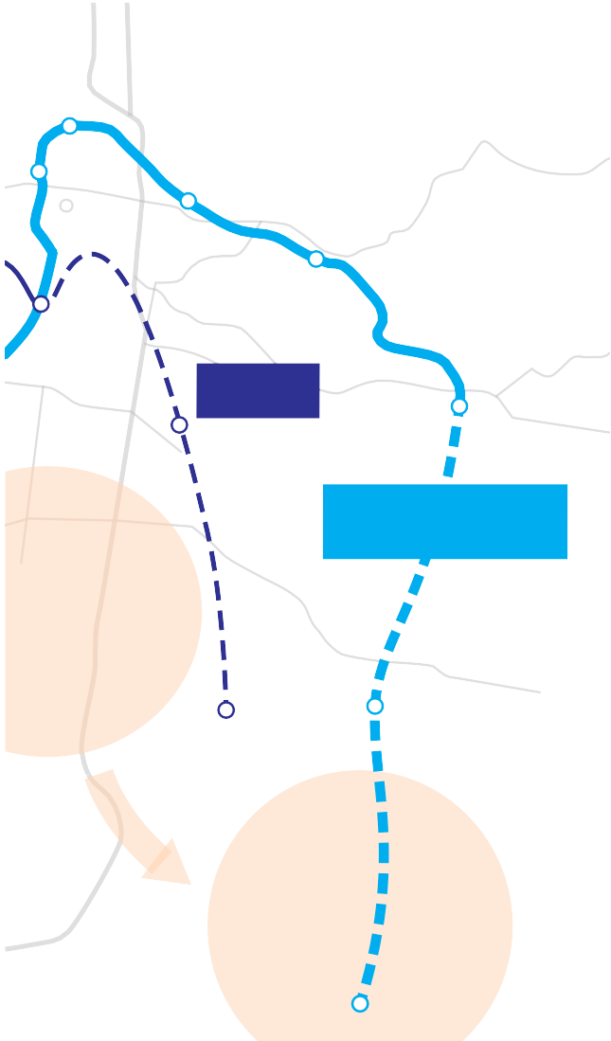A potential extension of the ESR is shown in Figure 8.3.
Figure 8.3 Potential Eastern Suburbs Railway Extension
Martin Place
Sydney
Town Hall
Taylor Square
Central
Kings Cross
Double Bay
Edgecliff
Bellevue Hill
Paddington
Surry Hills Moore
Park
Anzac Parade
Light Rail Bondi
Junction

Eastern Suburbs Railway Extension
Kensington

Existing apartments growth centre
University of NSW
Randwick
Coogee
Kingsford
East Lakes
Pagewood
Future land use change
Maroubra Junction
Lack of capacity in the CBD can be a constraint of rail expansion proposals. A key feature of the existing ESR is that it has a large amount of latent capacity even in peak periods. At present, patronage is only 7,400 passengers in the AM peak hour, less than half the number that travel in the reverse direction from the Illawarra. Furthermore the principal CBD station on the ESR is Martin Place, the most centrally located CBD station and one which has substantial platform and circulation space.
An extension of the ESR to the South-Eastern suburbs would require approximately six kilometres of new tunnels. New stations would be required at Randwick, to serve the health and education precincts, and at Maroubra Junction.
Based on these parameters, the scale of the project is approximately half the size of the Epping Chatswood Rail Link and one-quarter the size of the NWRL.
An extension of the ESR would complement, rather than compete with, a light rail line along Anzac Parade to Central. The heavy rail would provide the rapid journey times and mass transit capacity into the northern CBD that light rail is unlikely to offer (refer Section 7).
Recommendation Infrastructure NSW recommends planning for an extension of the ESR to Randwick and Maroubra between years 10 and 20 of the Strategy.

Summary

Conclusions
An efficient rail system is essential to NSW particularly in terms of managing commuter traffic to the CBD. Infrastructure NSW strongly supports the Government’s strategy to bring Sydney’s train services up to world- class standards and put the rail system back onto a sustainable financial footing.
Infrastructure NSW supports the three tier railway concept set out in Sydney’s Rail Future, including a rapid transit network that has the NWRL as its first stage. Infrastructure NSW recommends further work on how to best expand rapid transit services from Chatswood to the CBD.
Re-signalling the existing lines, combined with targeted capacity upgrades, could bring the benefits of this new technology to more customers, and more quickly, than a second harbour crossing.
Infrastructure NSW also recommends that work be undertaken to assess how the City Circle can be more intensively used, since this may defer the need to construct a new line through the CBD for several decades.
Infrastructure NSW has identified that faster train services from the Illawarra, Central Coast and Hunter may assist in managing the challenge of a growing population. Infrastructure NSW recommends that a program of incremental improvement to travel times be undertaken, with a target of a one hour journey time
between Wollongong and Gosford to Sydney, and a two hour journey time from Newcastle to Sydney.
Infrastructure NSW recommends a higher differential between peak and off-peak fares to the CBD following the introduction of the Opal ticket system. This should be complemented by targeted improvements to off-peak services, for example from the CBD to Parramatta.
An extension of the Eastern Suburbs Railway to Randwick and Maroubra is recommended as the most prospective network expansion option beyond
2022, conditional upon a definitive strategy for land use densification in the South-Eastern suburbs.

Recommended Actions

Recommendation Years Type Cost and Funding Implications

16 | Start construction of North West Rail Link | 0 – 5 | Major project | Existing Government commitment.
17 | Mainline Acceleration Program  Wollongong – Sydney pilot scheme | 0 – 5 | Program | Emphasis will be on operational improvements, supported by a scoping of $100 million for targeted works on speed restrictions and pinch points. Does not allow for major civil works, line re-signalling or new rolling stock.
18 | Turn-up-and-go express train service between Sydney CBD and Parramatta across the day | 0 – 5 | Asset utilisation | Operational reform – no capital works proposed.
19 | Improve CBD rail off-peak price incentives | 0 – 5 | Asset utilisation | Assume overall outcome is revenue neutral.
20 | Mainline Acceleration Program  Target one hour express service Wollongong – Sydney and Gosford – Sydney | 5 – 10 | Program | Continuation of pilot program from Years 0 – 5. Scoping of $1 billion for capital works.
21 | Unlock City Circle spare capacity to relieve CBD congestion | 5 – 10 | Asset utilisation | Scoping of $1 billion allows for reconfiguration of junctions and associated works outside Central to allow more services to access the City Circle. It does not include resignalling of the City Circle.
22 | Modernise Wynyard and Town Hall stations | 5 – 10 | Major project | Transport costs included within CBD Transit Improvement Plan (refer Recommendation II).
23 | Rapid transit extension from NWRL to CBD and Inner West, and release additional capacity on Main West Lines | 10 – 20 | Major project | Scoping of $5 billion assumes resignalling of North Shore, Harbour Bridge and Inner West Lines and new rolling stock. Works include capacity upgrades between Chatswood and North Sydney and junction works at Central.
24 | Develop extension of Eastern Suburbs Railway to Randwick and Maroubra | 10 – 20 | Planning | Cost of planning work is not material.
25 | Mainline Acceleration Program  Target two hour express service Newcastle – Sydney | 10 – 20 | Program | Continuation of previous program. Scoping of $500 million for capital works.

9.0 International gateways

Summary

Snapshot

- Sydney’s international gateways of Port Botany and Sydney Airport are considered together in this section due to their close geographic proximity,
which has implications for the portside and landside infrastructure of each facility.
- Port Botany and Sydney Airport have plans to accommodate much of the rapid growth forecast for container freight and air travel over the next 20 years. Achieving this primarily requires operational reform to lift productivity, not major capital works.
- The major infrastructure challenge that Sydney’s International Gateways face is to the landside infrastructure – the roads and railway lines – that connect them within the metropolitan area and across NSW.
- Emphasis has been placed on getting more port containers to move by rail, taking advantage of available capacity on the rail network. This has proven challenging because road freight has been cheaper and more reliable for the short- haul journeys that make up most port container
movements. The forthcoming opening of the Enfield Intermodal Terminal offers a test case for the short- haul rail freight market in Sydney.
- More can be done in the short term to improve travel to the Port and Airport, including providing cheaper rail travel and better bus services to the airport, and investing in key road pinch points.
- Even with more freight and airport customers using the rail network, most travel to and from the gateways will remain by road. Major investment is needed to augment the existing roads that link to Port Botany and Sydney Airport. The WestConnex scheme (refer Section 6) is Infrastructure NSW’s
principal response to the transport challenges faced by Sydney’s International Gateways.
- Once Port Botany reaches capacity, (which is not expected to happen during the timeframe of this Strategy), it is planned for Port Kembla to become NSW’s supplementary container port.
- There is no immediate need for supplementary airport capacity in Sydney. The growth of Western Sydney suggests that there is a case for a passenger airport targeting this market by the late 2020s. The RAAF Base Richmond could
perform this role for a period while a new facility is under development.
  - All of NSW, (including the regions), relies on containerised imports and exports of industrial and consumer goods moved through Port Botany.
Sydney Airport’s status as Australia’s primary aviation hub benefits the whole state.
  - Sydney’s international gateways are expected to grow strongly over the next 20 years.
  - Passenger numbers at Sydney Airport are forecast to double from less than 40 million in 2010 to over 80 million in 2031.
  - Sydney Ports forecasts container movements at Port Botany to grow from around 2 million TEUs in 2011 to 7 million TEUs in 2031.
  - Rapid growth in demand for freight and air travel will impact on the landside infrastructure and land use around the precinct.
  - Investment in both the State’s road and rail networks, including options for investment in intermodal freight terminals, will be needed but must recognise the primary role of road in moving freight around Sydney.
  - Supplementary airport capacity is not expected to be needed until the late 2020s, at its earliest. Additional container port capacity is not needed until the 2030s on current forecasts.

Container freight

Features of the container freight trade
Port Botany is principally a container port catering for 99 percent of NSW container movements1. Container volumes in NSW are shown in Table 9.1.
The container trade is characterised by the excess of imports over exports. The main freight supply chain task in connection with Port Botany is the distribution of import containers within Sydney: in fact 98 percent

Table 9.1 2010-11 Container volumes NSW
Ports Imports Exports Total TEU

 | Full | Empty | Total | Full | Empty | Total | Total
Port Botany | 1,000,453 | 20,107 | 1,002,560 | 458,703 | 540,823 | 999,526 | 2,020,086
Other | 2,219 | 8,243 | 10,462 | 11,523 | 506 | 12,029 | 22,491
Source: Ports Australia.

Table 9.2 Container Terminal Port Productivity Comparison

of import containers are destined for no further than 50 kilometres from the port gate2. It is this proximity to the market that provides Port Botany with its non- replicable competitive advantage.
The export trade is diverse and includes agricultural produce and some mineral exports from regional NSW, and manufactured goods primarily from metropolitan NSW. In addition, the export of empty containers (stored in container parks in the metropolitan area) is a significant task.
A feature of the container business is that growth is continuing at a long term trend of more than twice GDP growth – averaging seven percent per annum over the past 15 years3. Container trade through Port Botany is forecast to nearly quadruple by 2031, reaching over seven million TEUs4, up from two million TEUs in 20115.

- Ports Australia 2011, Containerised Trade Statistics.
- Sydney Ports Corporation 2011, Logistics Review 2010-11.
- NSW Government 2011, Port Botany and Sydney Airport Transport Improvement Program, submission to Infrastructure Australia.
- TEU = Twenty-Foot Equivalent Unit. The unit of volume used by the container freight industry, akin to a standard-sized container.
- Sydney Ports Corporation 2011, The Future of Sydney Ports: A 30 year Horizon.
Net Crane Rate (TEU/hour)

Source: BITRE
Port
Sydney | 26 | 834 | 19,708
Melbourne | 29 | 1,146 | 27,576
Hong Kong | 36 | 2,661 | 107,997
Shanghai | 35 | 2,061 | 45,135

* TEU per gross hectare of yard.

Portside infrastructure
Port Botany container operations have operated as a duopoly since establishment: the incumbent stevedores are Patrick (a subsidiary of Asciano) and DP World (formerly P&O). A third terminal has recently been developed, which will be operated by Hutchison Ports starting in 2013.
With the development of the third terminal, Port Botany now has the portside infrastructure to move at lEast seven million TEUs per annum, based on Sydney Ports Corporation estimates.
TEU per berth Metre Yard Utilisation*

Maximising the potential of Port Botany will require an uplift in productivity. The productivity improvements flowing from reform in the late 1990s have not been sustained and Port Botany lags behind international competitors. This efficiency gap is illustrated in Table 9.2.
As Section 3 notes, Infrastructure NSW assumes that through a combination of automation and more efficient labour arrangements, Port Botany will be able to realise its potential throughput. On this basis, Port Botany will be able to handle Sydney’s container trade for at lEast the next 20 years, and probably longer.

Landside infrastructure Container freight transport today
The main infrastructure challenge for Port Botany is providing appropriate landside infrastructure for
distributing containers across Sydney. This requires road and rail networks, plus supporting infrastructure such
as empty container parks, intermodal terminals, truck marshalling facilities and buffer zones.
The vast majority of containers move by road. At present, the Port Botany container trade produces around
3,900 truck movements daily6. A large proportion of these trucks use the M5 corridor, where port-related trucks are less than two percent7 of total traffic.
Only 14 percent of container movements through Port Botany went by rail in 2011, compared with 19 per cent in 20068. Less than half of paths on the existing rail line are utilised9.

Making rail competitive
The reason the market prefers road at present is because road transport is more flexible and more reliable than rail, and, in most cases, less expensive.
Rail is poorly set up to accommodate much of the containerised freight task. Less than half of rail journeys to or from Port Botany run on time10. Major delays can be encountered where rail passenger transport takes precedence over rail freight or due to inefficiency at the

port rail yards, where containers can be handled multiple times compared to a road equivalent11. These reliability challenges are a particular issue for time sensitive cargo.
The situation on cost is more complex. It has been argued that road freight does not pay the full costs of the infrastructure it uses12, distorting the market against rail freight. However, Infrastructure NSW is inclined to agree with the Productivity Commission, which found limited price distortions between road and rail, (once registration costs and fuel charges were accounted for) in its 2006 study13 into the issue.
Road transport has an inherent cost advantage for short haul cargo. This is due to rail’s high fixed (but low marginal) costs. In NSW, 85 percent of container movements are within the metropolitan area14.
Rail is cost competitive with road for journeys over longer distances. This is illustrated in the case of export container freight, a significant proportion of which originates in Regional NSW. Rail already has a
38 per cent share of export container freight, compared to a 15 percent share of import container freight15.
For short haul container movements where there is ‘double handling’ (i.e. requires transfer via a warehouse before its final destination), it is argued rail has the potential to compete with road freight.
Analysis by Deloitte Access Economics for Sydney Ports
Corporation16 suggests that rail could be cost competitive or cheaper than road freight for these movements providing the following circumstances were met:
- volumes to increase substantially to gain economies of scale
- portside handling movements to be reduced through terminal reconfiguration
- investment in intermodal terminal capacity, enabling rail to road transfer (and vice versa)
- investment in warehousing and empty container facilities close to these intermodal terminals. Much of the cost advantage that rail could potentially offer over road requires the creation of
warehousing precincts to be developed around the intermodal terminal.
The implications of this for Port Botany container freight are discussed in section 9.5.

Conclusions
There has been a strong emphasis on increasing the proportion of container freight that is moved by rail in recent years. However, even under optimistic projections of modal shift to rail, road will remain the dominant mode for Port Botany freight traffic, and the majority of freight growth over the next 20 years will be conveyed by road.
This situation is illustrated in Table 9.3, which shows the indicative mode split assuming seven million TEUs in

- Sydney Ports 2008, Port Freight Logistics Plan.
2031 under three scenarios. Even were rail to reach a 40

- Roads and Maritime Services 2011.
- Sydney Ports Corporation 2011, Logistics Review 2010-11.
- Australian Rail Track Corporation 2007, Submission to IPART – Port Botany Review.
- Sydney Ports Corporation 2010, PBLIS Train On-Time Running Report; average of headline KPI’s.
- Ernst & Young 2011, Port Botany – Sydney Airport Precinct Scoping Study report to Infrastructure NSW.
- Pacific National 2004, Submission to the Productivity Commission.
- Productivity Commission 2006, Road and Rail Freight Infrastructure Pricing.
- Sydney Ports Corporation.
- Sydney Ports Corporation.
percent mode share by 2031, road travel will still more than double during this period.

- Sydney Ports Corporation 2008, Enfield Business Case.

Table 9.3 Port Traffic Road / Rail Mode Share Scenarios

Air travel
scenario, there will be a full allocation of arrival and departure slots at Sydney Airport by 2027, with unmet

Port 2011
2031
28%
rail share
2031
40%
rail share
Growth
(TEUs)
28% rail share
Growth
(TEUs)
40% rail share

Introduction
Aviation is a significant economic driver in any global city. Airports and the associated inbound traffic support local employment and economic growth. Sydney Airport is an important contributor to the State’s economy, contributing around $7.4 billion17 per annum directly to NSW household incomes.
Total | 1,900 | 7,000 | 7,000 | 5,100 | 5,100
Road | 1,634 | 5,040 | 4,200 | 3,406 | 2,566
Rail | 266 | 1,960 | 2,800 | 1,694 | 2,534

Airports are also major travel generators. Car travel to
demand for more than 100 flights per day.
Conversely, SACL, the owner of Sydney Airport, believes that Sydney Airport has growth capacity for at lEast 20 years, based on a program of incremental changes to infrastructure, aircraft mix and operating practices.
Like any complex infrastructure asset, the capacity of Sydney Airport is a function of a number of different

Source: Sydney Ports Corporation; Infrastructure NSW analysis.

The complexities and constraints presented by Port Botany’s location, along with its forecast rapid growth, (discussed in Section 3), suggest that both
modes will need to substantially increase the volumes they carry to ensure the efficiency of the port supply chain over the next 20 years.
Greater focus should be given to accommodating container freight movements by road. This is because road freight will remain the dominant mode.
Sydney Airport has a greater impact on Sydney’s road network than freight travel to Port Botany.
Aviation demand is growing faster than the wider economy. By 2029, Sydney Airport Corporation (SACL) expects passenger numbers to more than double (compared with today), to 79 million people18.

Capacity constraints at Sydney Airport
The capacity of Sydney Airport is ultimately constrained by its location and operating restrictions imposed by Government.
Airport issues in and around Sydney have been assessed exhaustively by the ‘Joint Study on Aviation Capacity for the Sydney Region’ released by the Commonwealth and NSW Governments in 2012.
The Joint Study forecasts progressive capacity constraints at Sydney Airport from the mid-2020s and recommends Badgerys Creek as the preferred site for a secondary airport, with Wilton as an alternative. By
2027, the Joint Study estimates that, under a ‘no change’
factors. SACL has a concept stage proposal to address the terminal and gate capacity issues through reconfiguring the existing Domestic Terminal (T2 and T3) and the existing International Terminal (T1). This
proposal is in the concept stage and the extent to which this increases the capacity of Sydney Airport is yet to be determined. SACL and airline operators are progressing discussions to implement by 2019.
Aside from the physical constraints of the current facilities, there exist a number of regulatory restrictions including a curfew, a maximum movement limit and regional allocations. Each of these factors places a level of capacity constraint on Sydney Airport, the
modification of which has the potential to delay the need for supplementary airport capacity.
It is Infrastructure NSW’s view, based on the analysis noted above, that for the duration of the State Infrastructure Strategy, Sydney Airport will remain the hub airport for the Sydney region but additional secondary capacity may be needed from the late 2020s.

- Sydney Airport Corporation 2009, Sydney Airport Master Plan.
- Sydney Airport Corporation 2009, Sydney Airport Master Plan.

Public transport to Sydney Airport
Transport infrastructure will need to be upgraded to support the forecast growth at Sydney Airport. The constraints felt on transport infrastructure around the airport make this matter urgent.
Public transport is central to this. As a major activity centre, airports are well suited to public transport.
By world standards, the modal share of public transport to Sydney Airport is very low at 15 percent. If 40 percent of journeys to Sydney Airport were made by public transport today (the mode share of a number of major overseas airports) there would be around 25,000 fewer people travelling on the roads around this precinct each day, significantly reducing road congestion in the area.
Low public transport mode share is due partly to inadequate service provision. The airport is connected to Sydney’s CBD through the Airport Line, but lacks bus access. Only one bus service runs to Sydney Airport, whereas London’s Heathrow Airport, which has roughly double Sydney’s passenger numbers, which has 29 bus routes (and two rail connections)19.
Public transport usage is also low because private transport is often cheaper than public transport. It is cheaper for three people to share a taxi to Sydney Airport from the CBD than for them to travel on the Airport Line, due to the high Airport Station usage fee ($12 in 2012) Airports where public transport costs are relatively cheaper generally have a higher share of public transport usage20.

- Ernst & Young 2011, Port Botany – Sydney Airport Precinct Scoping Study report to Infrastructure NSW.
- Ernst & Young 2011, Port Botany – Sydney Airport Precinct Scoping Study report to Infrastructure NSW.

Recommendation Infrastructure NSW recommends in the short term that the NSW Government take action to improve public transport to Sydney Airport, including reducing the Airport Station Usage Fee and offering improved bus services.
More detailed analysis is needed of options to reduce the Airport Station Usage Fee. This should ideally be achieved in a way that is cost-neutral to the State. This could be achieved, for example, by the development of alternative funding sources that aim to spread costs more evenly across airport users.
As at Port Botany, the number of road journeys to Sydney Airport is forecast to rise over the next 20 years, even with significant modal shift to public transport, making major road investment around the airport essential.

Road infrastructure around the international gateways
In the short term, actions to improve traffic flows around Port Botany and Sydney Airport should include:
- continued improvement of the port gate/terminal interface
- investment in road infrastructure within Sydney Airport
- solving local port traffic bottle necks and pinch points on surrounding roads.
The Port Botany Landside Improvement Strategy (PBLIS), which was launched in 2011, is an example of
the improvements in transport to and from the port that can be achieved in the short-term through better supply chain co-ordination. Led by Sydney Ports Corporation (SPC), PBLIS is tasked with improving the competitive access and service arrangements of container movements between stevedores and transport carriers at Port Botany.
Evidence shows that PBLIS has been extremely successful in improving the road transport interface at Port Botany, not only in truck efficiency through the gate but also in spreading the volume of traffic across the
24-hour period.
SACL is preparing a revised Master Plan, which will include a ground transport plan, at the direction of the Federal Minister for Infrastructure and Transport. Its most recent Master Plan, (published in 2009) set out a series of planned upgrades to the internal road networks that serve the Domestic and International Terminals. The proposed terminal realignment could improve traffic flows around Sydney Airport by more evenly spreading traffic between its terminals.
Roads and Maritime Services is developing a package of short-term road “pinch point” investments that could relieve congestion on roads around Port Botany and Sydney Airport. This is shown in Figure 9.1.

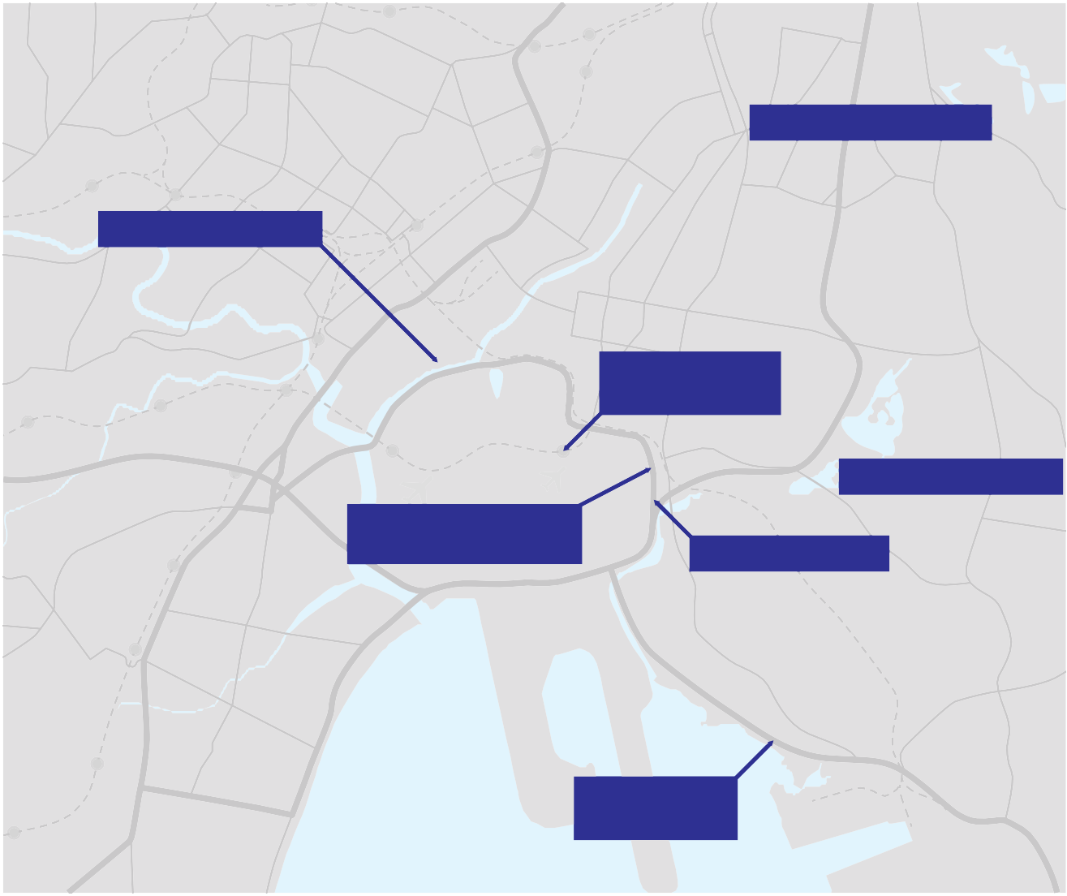Potential projects include:
Figure 9.1 Short term transport improvements around Sydney Airport and Port Botany
Alexandria
Moore Park
Dulwich Hill
Convert to one-way system
Marrickville
Kensington
New airport bus services
Randwick
Sydenham
Rosebery
Kingsford
Tempe
Reduction of airport station usage fees
Mascot
Eastlakes
New airport bus services
Arncliffe
General Holmes Drive road underpass below rail line
Pagewood
Widen Mill Pond Road
Maroubra
Botany
Eastgardens
Rockdale
Sydney Airport
Banksmeadow
Brighton-Le-Sands
Matraville
Foreshore Road truck layover area
Monterey
Source: Transport for NSW.
Botany Bay
Port Botany
- A road underpass of the rail line at General Holmes Drive level crossing. Closure of this rail level crossing will improve road movements, and provide benefits to rail freight by removing a major pinch point from the rail network.
- A truck layover area in the Foreshore Rd area. This will reduce freight movements on the road network by allowing container vehicle parking close to the port terminal.
- Implementing a one way system on airport approach roads. This option provides for converting both Bourke Rd and O’Riordan St (to their intersection near Green Square) into three-lane one way routes. This allows greater through capacity for these roads.
- Widening of Mill Pond Rd. This project includes for the provision for increased storage for city bound traffic released from General Holmes Drive, improving the efficiency of access to Botany Rd and Southern Cross Drive.
s
Recommendation Infrastructure NSW recommends the proposed road pinch points program around Sydney’s International Gateways is expedited with a view to its completion within three to five years.

In the medium and longer term, the principal road infrastructure solution for Sydney’s Gateways is the construction of WestConnex as described in Section
6. By the early 2020s, this would provide motorway standard access from Port Botany to the industrial lands of Western and South-Western Sydney, and improve access by road to Sydney Airport from the South-West (where many airport employees live), Inner-West and Southern CBD.

Freight rail infrastructure around Port Botany
This section discusses infrastructure options to increase the proportion of container freight moved by rail, taking account of the dynamics of this market set out in Section 9.2.
The freight rail infrastructure network includes:
- rail marshalling yards at Port Botany
- dedicated freight rail lines in the metropolitan area through the Metropolitan Freight Network
- rail lines shared with passenger trains
- intermodal terminals and surrounding warehousing infrastructure.

The vision for Intermodal Terminals
The private sector and the Commonwealth Government have separate schemes for a major intermodal terminal at Moorebank in Sydney’s South-West. Over the longer- term, Eastern Creek (at the junction of the M4 and M7 motorways) has been identified as another potential intermodal site21. Figure 9.2 summarises the current and potential intermodal terminal locations in Sydney.

Immediate rail infrastructure options
Infrastructure NSW is supportive of the intermodal concept. However, despite rail’s theoretical cost advantages discussed in section 9.2, for some types of short-haul freight, this market is essentially unproven in Sydney. At present, most intermodal demand in Sydney is for longer- haul export freight, and there is significant capacity available at a number of existing intermodal sites22.
Sydney Ports and Hutchison are currently developing a 300,000 TEU per annum intermodal facility at Enfield23, which will open in 201324. Enfield provides a test case for larger scale short haul intermodal freight in Sydney.
Recommendation Infrastructure NSW recommends that State public funding for additional intermodal terminal capacity in Sydney (including in relation to supporting infrastructure) be minimised until there is greater clarity on whether the short-haul rail freight market is viable.
This approach does not contradict either of the proposed developments in the Moorebank Precinct, where project investors propose to fund immediate supporting infrastructure (for example rail lines and precinct roads). Until these facilities demonstrate commercial viability, it would be imprudent to commit significant State capital in wider infrastructure upgrades.
Infrastructure NSW assumes that (in line with proponents’ estimates) Moorebank will be developed over the next five years. It is likely that major investment in supporting infrastructure around this precinct, given ramp up, will not be required until after 2017.
Infrastructure NSW supports other incremental reforms and investments designed to improve the reliability of Port Botany rail freight in the short and medium term. These include:
      - the recent transfer of oversight of the Metropolitan Freight Network from Railcorp to the ARTC
      - completion of the Southern Sydney Freight Line, which will deliver a dedicated freight rail network between Port Botany and Macarthur, in the South- West of the metropolitan area
      - targeted investment to remove bottlenecks that impact rail performance, for example through clearing the Enfield staging facility.

The major infrastructure requirement identified to

Longer-term rail infrastructure options

increase the proportion of container freight that moves by rail is investment in intermodal capacity.
The concept of intermodal terminals as inland ports has attracted a great deal of support in recent years.
- Transport for NSW 2012, Draft Transport Master Plan.
- Shipping Australia and Sydney Ports Corporation 2010, The Future of Sydney Ports: A 30 Year Horizon.
- 300,000 TEU is the maximum approved capacity for the Enfield International Terminal. Management’s assessment is that maximum theoretical capacity for this facility is 500,000 TEUs per annum.
- Sydney Ports Corporation and Hutchison Port Holdings 2011, Media Release: HPH to operate Enfield ILC, 2 August 2012.
Should the short haul import export intermodal market prove viable, either of the proposed investments in the Moorebank precinct, combined with Enfield and existing intermodal capacity, would create sufficient intermodal

Figure 9.2 Sydney Freight Network
Northern Sydney Freight Corridor N
Stage 1 (under construction)
North West Rouse Hill
Main West to Orbital Growth Centre Hornsby
Connection (indicative)

Norwest
Dee Why
Frenchs
Forest Brookvale
Epping to Thornleigh third Macquarie
St Marys track (under Construction) Park

Outer Orbital Corridor Rhodes
(Indicative alignment)

Smithfeld Nth Strathfeld
North Strathfield Rail Underpass (under construction)

Bondi Junction
Green Square
Randwick

Bankstown General Holmes Drive Level
South West Rockdale Crossing Closure (proposed)
Growth Centre
Kogarah

Hurstville
Leppington

Sutherland
Smeaton Grange

Castle Hill

Penrith Blacktown

Chatswood

Eastern Creek Intermodal Terminal (proposed)

Parramatta

Yennora

Clyde

North Sydney

Indicative alignment of the Western Sydney Freight Line (proposed)

Liverpool

Villawood

Chullora

Enfield Intermodal Logistics Centre (under construction)

Cooks River

Moorebank Intermodal Terminals (proposed)

Sydney Airport

Botany Freight Line and Botany Yard Capacity Upgrades (Under Construction)

Port Botany

Southern Sydney Freight Line (under construction)

Minto Intermodal Shipping Terminal
Key

Dedicated freight rail Shared freight rail Major freight road Intermodal terminal Freight activity precinct

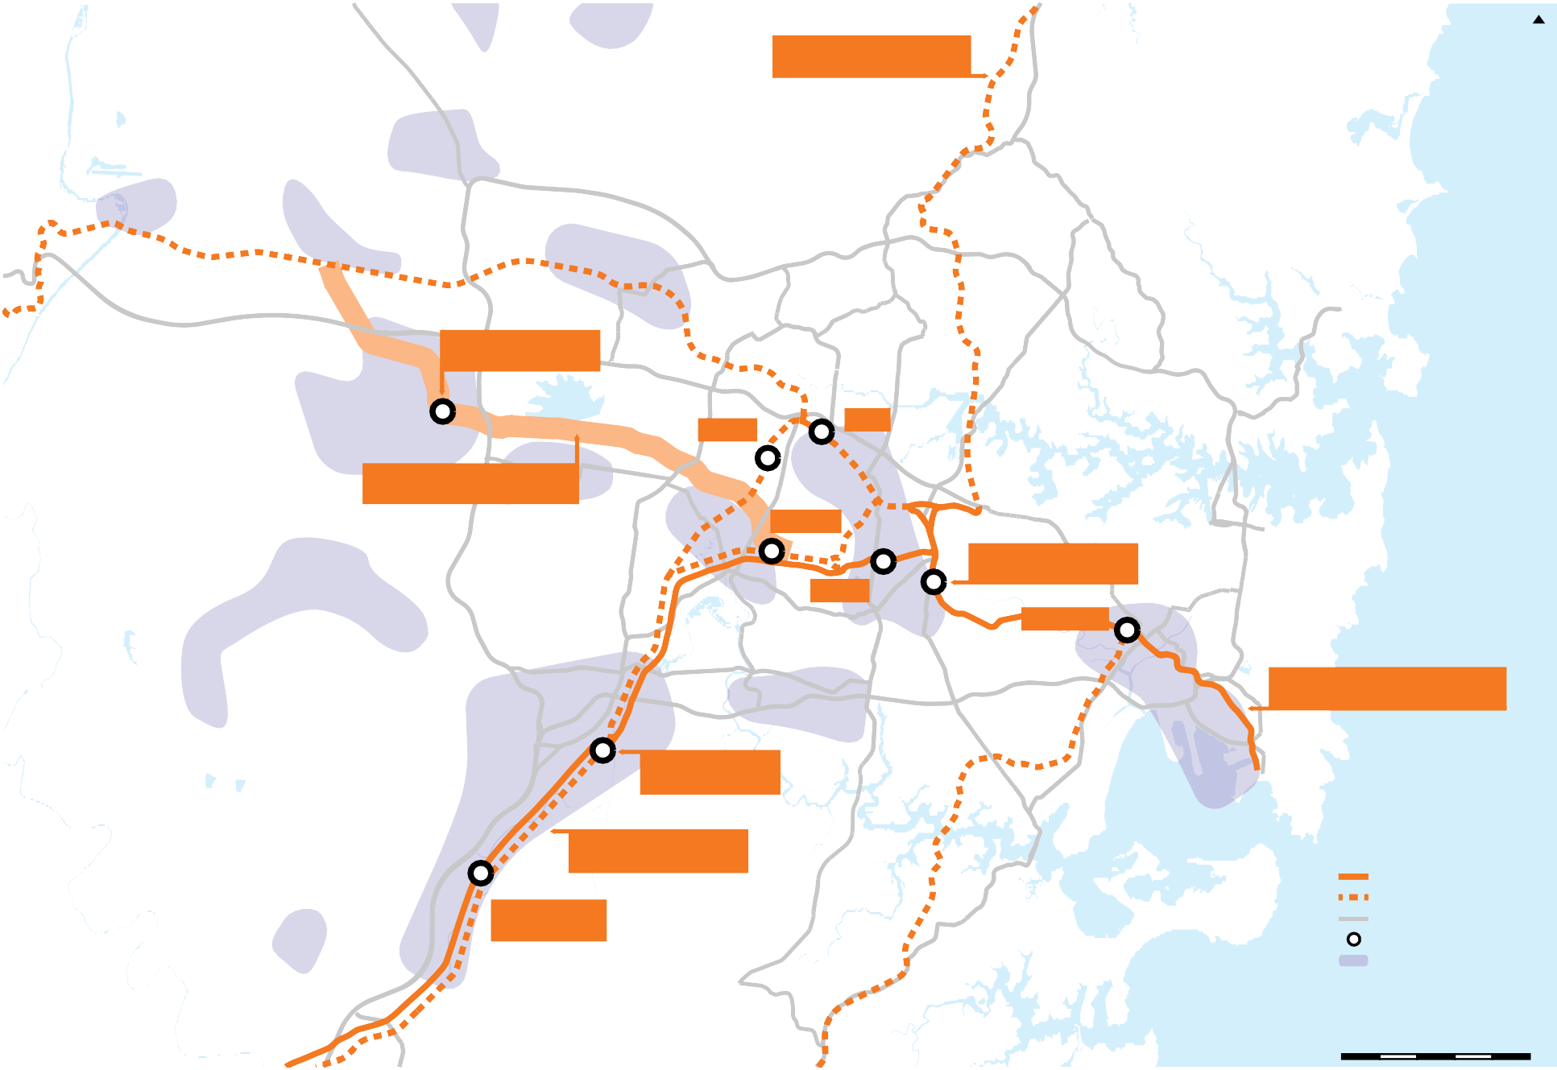

Source: Transport for NSW.
Campbelltown Macarthur

0 2 4 6 8 10 kms

capacity to accommodate growth in demand for rail freight until the late 2020s, even under an optimistic scenario. This is shown in Figure 9.3.
This analysis indicates that investment will be required in the Metropolitan Freight Network by the mid-2020s. Potential investments would be likely to include duplicating the Port Botany line and expanding capacity on the Southern Sydney Freight Line.
Longer-term major investment in connecting rail infrastructure (known as the Western Sydney Freight Line) would be required to make the proposed site at Eastern Creek viable. This decision is not possible
now, given the uncertainty over demand for short-haul intermodal freight.

Figure 9.3 Forecast container growth, forecast mode share and intermodal supply

10.0

8.0
Total trade (TEU, millions)

6.0

4.0

2.0
Recommendation Infrastructure NSW recommends that action be taken in the short term to identify and preserve a rail corridor for the Western Sydney Freight Line and land for the terminal at
Eastern Creek, given the paucity of alternative options should the short-haul freight market prove viable.

0.0

Supplementary container port capacity
Beyond the timeframe of this Strategy, there may be some benefit to the development of supplementary container port capacity in NSW. For example, an alternative facility could improve the resilience of NSW’s infrastructure in the event that Port Botany wharfage was incapacitated. Planning for this investment will need to start in the 2020s.
Required additional capacity*
Moorbank IMT (1.2 million TEU)*
The Government has announced its expectation that Port Kembla will provide the next logical tranche of container capacity, once Port Botany is fully utilised. Significant investment in landside infrastructure will be required to support Port Kembla.
The vast majority of containers to this facility would be expected to be destined for the Greater Sydney area. The recommended investments set out in this Strategy in WestConnex (over the next 10 years) and
FY 11/12 FY 12/13 FY 13/14 FY 14/15 FY 15/16 FY 16/17 FY 17/18 FY 18/19 FY 19/20 FY 20/21 FY 21/22 FY 22/23 FY 23/24 FY 24/25 FY 25/26 FY 26/27 FY 27/28 FY 28/29 FY 29/30 FY 30/31
in the F6 Extension (during the 2020s), will support the

Intermodal supply Forecast Container Growth
28% Rail Modal Share 40% Rail Modal Share
development of Port Kembla. Potential rail investments to Port Kembla are assessed in Section 10.

Source: Sydney Ports Corporation.
* Assumes volumes as per Commonwealth Government Moorebank IMT Business Case, 2012.

A secondary airport for Sydney

Considerations for a Secondary Sydney Airport
Whilst public discourse relating to a Secondary Sydney Airport (SSA) has been ongoing for around 30 years, the fact that a SSA has not been constructed is a result of a number of factors, including:
      - inability to establish a viable business case for a SSA that replaces Sydney Airport
      - Sydney Airport’s attractive location for business, situated around 8 kilometres from the Sydney CBD.
When determining any future SSA, consideration should be given to the increasing number of Low Cost Carriers (LCC), as well as the importance of landside transport infrastructure.
LCC have grown significantly, accounting for nearly
35 percent of scheduled seat capacity in 2010 up from
24 percent in 200425 (refer figure 9.4). LCC passengers tend to be more sensitive to pricing than full service passengers with a relatively lower time opportunity cost. LCC passengers tend to be more flexible in terms of travel times and dates, and more amenable to longer travel times to and from airport in return for cheaper fares.
In various international cities exists a hub airport, catering to full service passengers and secondary airports servicing LCC and freight aircraft.
In Melbourne, Avalon has been able to attract LCC and freight aircraft, against the backdrop of significant
Figure 9.4 Sydney region – Low Cost Carrier share of scheduled seat capacity 2004-10

60

51.7
50
48.0
47.2
44.8
42.0
43.2
39.6

24% 28% 30% 32% 34% 35% 35%
76% 72% 70% 68% 66% 65% 65%

40
Scheduled seats (millions)

30

20

10

0
2004 2005 2006 2007 2008 2009 2010

Low cost carrier Other

Source: Booz & Company; Referenced in Steering Committee.
Note: Shows seats available for sale by airlines (rather than actual movements). Includes services provided by Virgin Australia (then called Virgin Blue), which at the time was branded a Low Cost Carrier.
access issues. About 55 kilometres from the Melbourne CBD, Avalon is unserviced by public transport and competes against an airport at Tullamarine that has an unconstrained capacity and is curfew free.
In London, Heathrow has operational constraints similar to that of Sydney. Over time, excess demand has been transferred to secondary airports, whilst the hub airport has remained at Heathrow. Today Heathrow serves only 60 percent of the total London area passengers of 128 million per annum26.
Heathrow has remained the specialised international and business hub, while the other airports have skewed towards low cost and charter businesses.
Infrastructure NSW expects a similar trend in Sydney, with segmentation of the market summarised in figure
9.5. Sydney Airport will remain the hub, supported by secondary facilities to serve LCC, freight and some regional flights.

Western Sydney regional airport
As a conurbation of over two million people,
Western Sydney has a strong claim for its own airport, over and above the long term need for a secondary airport to take overspill traffic from Sydney Airport.
A secondary airport to serve Western Sydney and surrounding areas would generate substantial economic gains for local communities and create both direct and indirect employment.

25 Steering Committee 2012, Joint Study on Aviation Capacity for the Sydney Region, Department of Infrastructure and Transport.

26 UK Civil Aviation Authority 2010.

Figure 9.5 Sydney region – Airline market shares for passengers

Domestic passengers travelling for business

Domestic passengers
of the Western Sydney regional airport should occur. Further detailed assessment should be made of the options for the RAAF Base Richmond to take on some
^{3%} aspects of this role prior to the completion of a dedicated new facility in Western Sydney.
7%
28%
62%

2%
17%
34%
47%
Recommendation Infrastructure NSW recommends that the NSW and Commonwealth Governments conduct a strategic planning review for RAAF Base Richmond to assess how this site could progressively accommodate passenger flights from the late 2020s.
Recommendation Infrastructure NSW recommends that the integrity of the Badgerys Creek site is preserved to meet Sydney’s longer-term aviation needs. On current supply/demand forecasts, it is likely detailed planning for this site will need to commence by the 2020s, recognising the long lead times associated with airport development.

1%
International
62%
8%
29%
passengers

All passengers
21%
14%
24%
41%

0% 20% 40% 60% 80% 100%

Qantas / QantasLink
Virgin Blue / V Australia
Low cost carrier
Other airlines

Source: BITRE and Tourism Research Australia; Referenced in Steering Committee.

Infrastructure NSW believes that economic considerations should be given primacy in the location of a Western Sydney regional airport. Accordingly relevant considerations include customer catchment area, ease of access to the Sydney Strategic Road Network, and attractiveness as part of the logistics supply chain.
Having regard to these considerations, Infrastructure NSW is supportive of the concept of a secondary airport for the metropolitan area in Western Sydney. The Joint Study concludes that the preferable site is at Badgerys Creek. All the land required is already
owned by the Commonwealth, the site is accessible from the M7 Motorway and is close to the Western Sydney logistics hub. The study also raises the potential for RAAF Base Richmond to play a supporting role to Sydney Airport.
The main issue for a Western Sydney regional airport is timing. The short term recommendation is for both State and Commonwealth Governments to maintain the integrity of the Badgerys Creek site, and review the supply/demand balance on a five yearly basis to
determine when detailed planning for the development

Conclusions

Summary of findings
NSW has resilient infrastructure at its key international gateways. Port Botany and Sydney Airport are well located to serve the economy of Sydney and NSW more broadly. Port Botany has capacity to more than triple container demand and Sydney Airport, with its impossible to replicate geographical advantages, retains capacity to grow substantially during the lifetime of this Strategy.

Focus is needed on meeting the landside infrastructure demands of these gateways. However consideration is needed of the market dynamics of the different types of passenger and freight travel.
Infrastructure NSW believes too much focus has been placed on trying to get container freight off Sydney’s strategic road network, without adequate consideration as to why it is there – or what the true benefits and costs would be of such modal shift.
Conversely, too little has been done to move airport passengers onto public transport – despite
the potentially greater impacts this could have on congestion.
Even with significant modal shift, however, Infrastructure NSW sees no alternative to significant investment in road capacity. In the short-term this means a targeted program of ‘pinch point’ investments around the port and airport. In the longer-term, Infrastructure NSW recommends the WestConnex scheme to keep traffic moving around these essential gateways.
Once Port Botany reaches capacity, which is not expected to happen during the timeframe of this
Strategy, Port Kembla is expected to become a supplementary container port for NSW.
Finally, while there is no immediate need for supplementary airport capacity in Sydney, the growth of Western Sydney will support a regional airport in this area over the longer term.
Preserving optionality is critical given the paucity of sites that have a viable business case. This means preserving planning constraints that limit development around the most viable site, Badgerys Creek, and preparing RAAF Base Richmond for passenger aviation.

Recommended actions
Recommendations Years Type Cost and Funding Implications

26 | Port Botany-Sydney Airport Roads Pinch points Program | 0 – 5 | Program | Estimate of $330 million
27 | Reduce or remove Airport Stations usage fee | 0 – 5 | Asset utilisation | Assumes that the cost of this measure can be offset by a mix of alternative airport funding sources, passenger growth and adjustments to other fares
28 | Expand bus services to Sydney Airport | 0 – 5 | Asset utilisation | Operational reform – no major capital works proposed
29 | Moorebank Intermodal Terminal: site development | 0 – 5 | Major project | Terminal to be funded by Commonwealth and private sector
30 | Preserve rail corridor for the Western Sydney Freight Line and site for Eastern Creek Intermodal Terminal | 0 – 5 | Corridor | Cost of corridor planning is not material. No assessment of land acquisition costs has been made
31 | Preserve integrity of Badgerys Creek site for future aviation use | 0 – 5 | Corridor | Cost neutral
32 | Assess passenger travel options at RAAF Base Richmond | 0 – 5 | Planning | Cost of planning work is not material
33 | Moorebank Intermodal Terminal: supporting infrastructure | 5 – 10 | Program | Estimate of $300 million
34 | Incremental capacity upgrades on freight rail lines in Sydney area | 5 – 10 | Program | Assume delivery by ARTC based on user funding model
35 | Eastern Creek Intermodal Terminal | 10 – 20 | Major project | Assume delivery by ARTC based on user funding model
36 | Develop Western Sydney Regional Airport | 10 – 20 | Planning | Cost of planning work is not material

10.0 Regional and interstate transport

Summary
- Regional and interstate transport infrastructure supports the economy and quality of life of NSW by allowing people to access employment opportunities, connecting regional communities and supporting freight movements.
- Regional NSW has extensive and well–developed regional road and rail networks connecting population and employment centres across
the state. In recent years, the NSW State and Commonwealth Governments have undertaken major investment to improve the quality and capacity of these networks.
- The road network is the backbone of regional transport. Over 90 percent of passenger trips and almost two thirds of freight journeys are by road. Rail primarily moves bulk freight to local markets and port gateways for export.
- NSW’s economic success relies on reliable, efficient rail connections between the regions and NSW’s export ports. The Hunter Valley Coal Chain has been a good example of the private and public sector working together to achieve this. This model may be suitable for the rail lines to Port Kembla.

- A number of major road programs are underway. These include upgrades to the Pacific Highway and Princes Highway. Getting the best value for these major investments is essential. Infrastructure NSW is concerned that cost estimates for these programs appear very high.
- Unlocking the key constraints along the road and rail networks that limit freight movements are likely to have some of the highest economic benefits in the regions. This includes upgrading understrength road bridges, providing rail passing loops and ensuring roads and rail lines are well-maintained and effectively managed.
- Incremental measures to relieve pinch points are recommended over new major ‘single’ investments such as the proposed high speed rail and inland rail projects although corridor preservation
is recommended to preserve optionality in some cases.
- Growing freight movements bring both benefits and challenges to local communities. The local road and rail infrastructure of communities in coal areas or along key highways may require investment as trade grows.

Snapshot
- Long distances, low population densities and the nature of regional employment means the demands placed by passengers on the transport networks
of Regional NSW are very different to those of metropolitan NSW.
- The road network is the dominant mode for regional passenger travel. Over 90 percent of the 7.5 million journeys made each day are by car1.
- There is limited usage of regional and interstate public transport. Regional train services carry less than 6,000 passengers a day. Regional bus and coach services transport around almost three times as many, approximately 15,000 passengers a day2.
- 63 percent of freight movements in Regional NSW by volume are by road, 33 percent by rail3. Freight modal share varies substantially depending on the task. Most bulk freight, is transported via rail and sea, whereas most non-bulk freight is moved by road.
For example:
  - 70 percent of coal movements by volume are by rail
  - 80 percent of interstate freight movements (by volume) are by road
- Air travel plays a limited but valuable role for travel within NSW, both for passengers and freight movements.

- NSW Bureau of Transport Statistics 2006, Journeys to Work in Regional NSW.
- NSW Bureau of Transport Statistics 2006, Journeys to Work in Regional NSW.
- Transport for NSW 2012, Draft Transport Master Plan.

- Regional passenger transport demand is forecast to grow relatively slowly over the next 20 years, at around one percent per annum4.
- Freight demand is forecast to grow more rapidly than passenger demand. Over the next 20 years, the volume of freight being moved in NSW is expected almost to double5.
- Major investment has been undertaken in recent years on the regional road network in Regional NSW. This has been supported by Commonwealth Government funding through the Nation Building Program, which will invest around $11 billion in regional NSW’s roads over the period from 2008-09 to 2013-14. Projects have included investment in the duplication of the Hume and Pacific Highways, and in new routes such as the Hunter Expressway.
- Significant investment has also been undertaken in NSW’s regional and interstate rail freight networks during the same period. The Australian Rail Track Corporation (ARTC) is making major investments to upgrade rail links between Sydney and Melbourne as well as between Sydney and Brisbane, and to increase capacity in the Hunter Valley Coal Chain.

- BITRE 2002, Regional Public Transport in Australia: Long – Distance Services, Trends and Projections.
- Infrastructure Partnerships Australia and PwC 2009, Meeting the 2050 Freight Challenge.

Transport infrastructure in Regional NSW

Introduction
The passenger and freight transport infrastructure networks of Regional NSW are intertwined. All of the road network, and much of the rail network accommodates both forms of transport. These
infrastructure networks interconnect with the transport networks of both the metropolitan area and other States.
The road network underpins travel in Regional NSW. It serves both passenger and freight demand, particularly for intrastate and interstate freight movements. The
rail network is primarily used for the important role of carrying bulk freight from regional operations (agricultural and resource based) to access domestic processing, local markets, and port gateways.
Investment in regional transport infrastructure has to be appropriate to the tasks placed on it. Section 5 noted that focus is needed on investing in support of growing regions (particularly those around Sydney, along the coast, and in mining regions) while ensuring wider freight and passenger networks function effectively.
In developing the regional perspective, Infrastructure NSW engaged with representatives of Regional Development Australia across the State. A common theme that emerged from these discussions was perceived constraints in the current road freight network. Other specific proposals are outlined in Sections
    - –10.2.4.

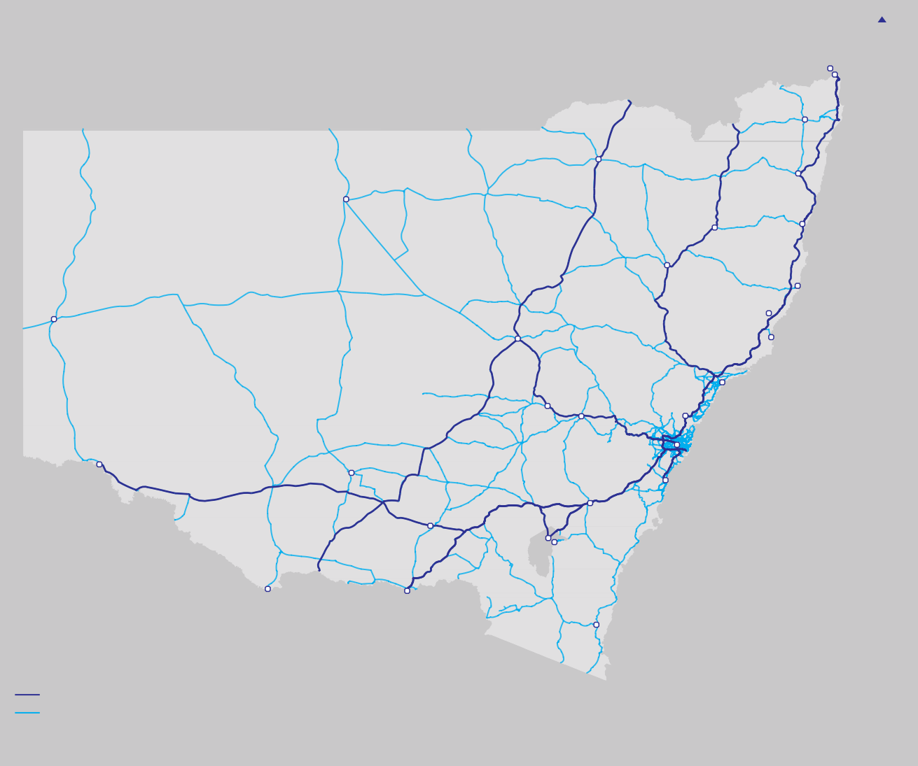NSW Highway Network
Figure 10.1 Major Road Network in NSW
N

Gold Coast (Qld) Tweed Heads
Lismore
Moree
Grafton
Bourke
Armidale
Coffs Harbour
Tamworth
Port Macquarie
Taree
Broken Hill
Dubbo
Forster-Tuncurry
Newcastle
Orange
Bathurst
Gosford
Sydney
Mildura (Vic)
Griffth
Wollongong
Goulburn
Wagga Wagga
Canberra Queanbeyan
(ACT)
Echuca (Vic)
Albury
Bega
Key
National Highway Network Other State Roads
Source: Transport for NSW.
NSW has an extensive, well-developed network of highways connecting the State’s major population centres. In total, NSW has over 18,000 kilometres of State roads and 3,000 kilometres of regional and local roads, and over 5,000 bridges. Around 4,200 kilometres of these roads comprise the National Highway
Network. State managed roads also connect to over 160,000 kilometres of council managed roads. The network of major roads is shown in Figure 10.1.
Principal highways that form part of the National Network include the Pacific Highway, New England Highway, Hume Highway, Great Western Highway, Newell Highway and Sturt Highway.
A number of investments have been proposed by regional authorities to upgrade these highways and other regional and rural roads,such as through the provision
of passing lanes, route duplication or community bypasses. The ongoing Pacific Highway duplication is one of the largest infrastructure programs in the State.

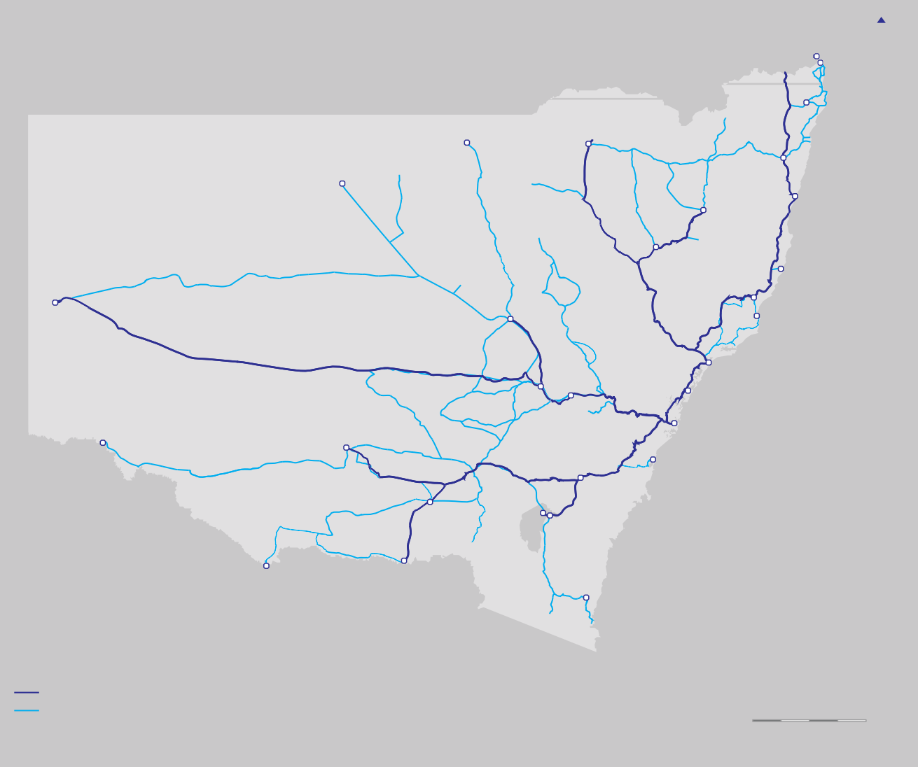Public Transport in Regional NSW
Figure 10.2 CountryLink Rail and Coach Services
N
G old Coast (Qld) Tweed Heads

Lismore
Lightning Ridge
Moree
Grafton
Bourke
Coffs Harbour
Armidale
Tamworth
Port Macquarie
Taree
Broken Hill
Dubbo
Forster-Tuncurry
Newcastle
Orange
Bathurst
Gosford

Sydney
Mildura (Vic)
Griffth
Wollongong
Goulburn
Wagga Wagga
Canberra
(ACT) Queanbeyan
Echuca (Vic)
Albury
Bega
Key
CountryLink Rail Service
CountryLink Coach Service
0 50 100 150 200km
Source: Transport for NSW.
Outside of Sydney, the passenger rail network totals 3,450 kilometres of track. Much of this network is leased by the ARTC. In 2012, the NSW Government announced that NSW Trains would be established, taking on the role of CountryLink in providing regional services and CityRail’s intercity routes. CountryLink also offers coach services to regional centres not currently served by rail.
Countrylink’s regional rail and coach network is shown in Figure 10.2.
The rolling stock used on longer distance rail services is close to age expired, and a decision is needed on the future of these services. Options to re-open regional rail lines to passenger traffic have been advocated by regional authorities and the private sector, for example the Casino to Murwillumbah Line on the North Coast.
In addition, a variety of regulated and deregulated private operators run bus and coach services in NSW. Community transport is also available, particularly in remote communities.

Regional Air Travel
Figure 10.3 Regional Aviation Services in NSW
N
Ballina
Moree
Narrabri
Coffs Harbour
Armidale
Tamworth
Port
Lord
Cobar
Macquarie Island
Howe
Broken Hill
Taree
Dubbo
Mudgee
Newcastle (Williamtown)
Parkes
Orange
Bathurst
Griffth
Sydney
Narrandera
Wagga Wagga Queanbeyan (Canberra)
Albury
ACT
Cooma
Moruya
Merimbula
Key
Airport serving less than 50,000 passengers (2011) Airport serving more than 50,000 passengers (2011)
Regional commercial air route
Source: Transport for NSW.
0 50 100 150 200km
Regional aviation infrastructure supports scheduled services within NSW (primarily to Sydney), across Australia and general aviation services. Current scheduled services are shown in Figure 10.3.
Air travel is an effective way of moving high value freight and passenger movements between NSW’s dispersed regional centres. It also allows efficient travel to remote worksite, for example for fly-in-fly-out movements.
Most regional airports are owned by local governments.
In some areas, regional authorities have identified that these facilities, and/or the landside infrastructure that support them, may have insufficient capacity to
accommodate demand growth over the next 20 years.
These include airports at Wagga Wagga, Dubbo, Parkes, Orange and Cowra.

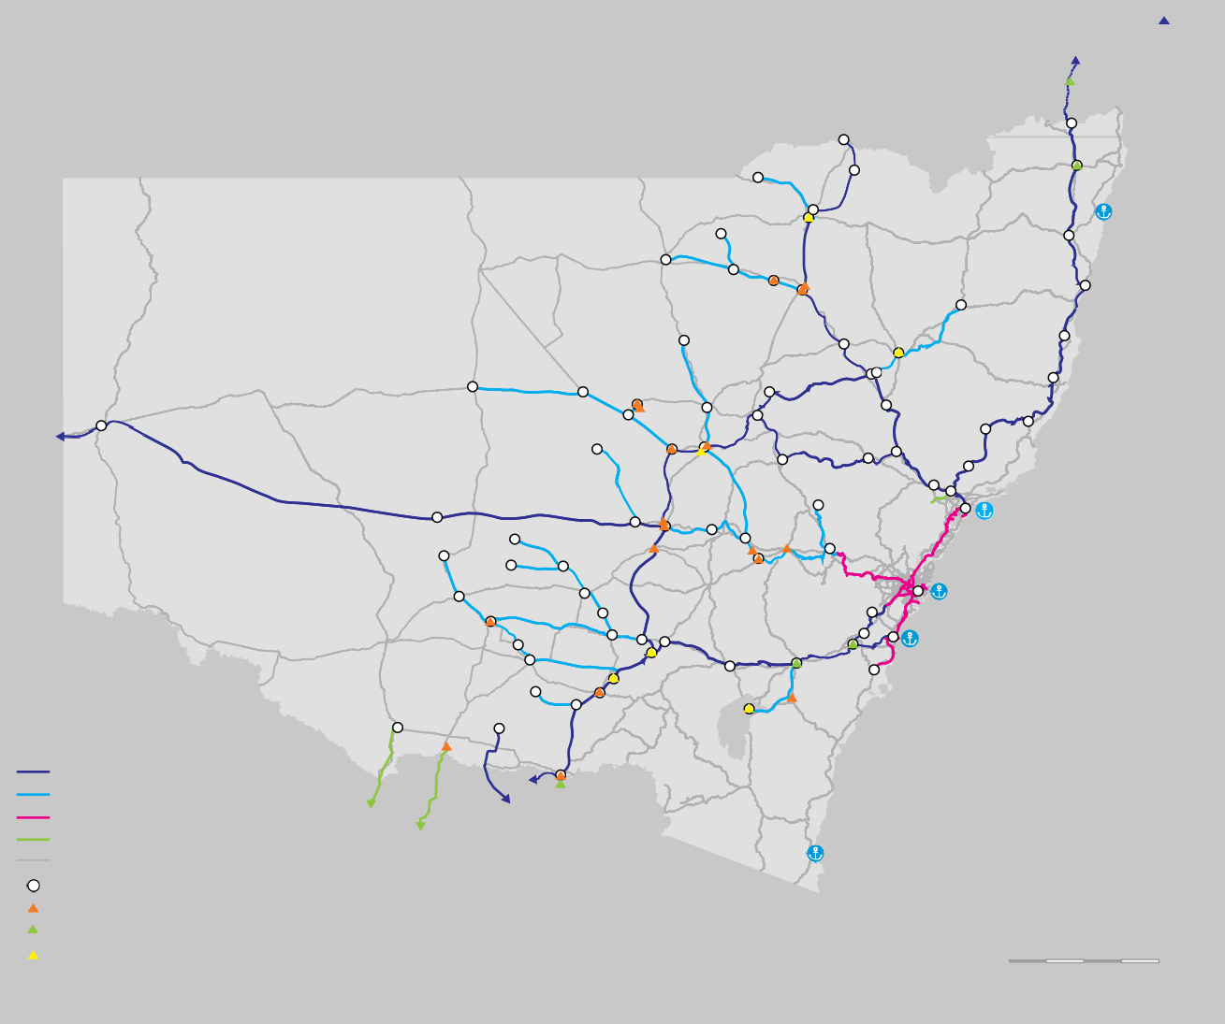NSW Freight Network
Figure 10.4 NSW Freight Network
N

Bromelton (QLD)
Casino
Moree
Yamba
Wee Waa Narrabri Junction

West Tamworth
Warren

Narromine
Dubbo

Parkes Forbes
Blayney
Newcastle
Bathurst
Sydney
Griffth
Cootamundra Harefeld
Wagga Wagga
Key
Tocumwal
Moss Vale
Goulburn Tarago
Canberra (ACT)
Port Kembla
Australian Rail Track Corporation network Country Regional Network – operational RailCorp Network
Other rail
National and state roads and highways Freight centres
Operational terminals Proposed terminals
Non-operational terminals
Albury Wodonga
(VIC)
Eden
0 50 100 150 200 km
Source: Transport for NSW.
The NSW freight network shares much of the road and rail networks shown in Sections 10.2.2 and 10.2.3.
It also includes the parts of the regional rail managed by the ARTC and the Country Regional Network that do not offer passenger services. In addition, the freight network includes:
      - NSW’s primary sea ports (Port Botany, Port Kembla and the Port of Newcastle), along with 28 smaller ports and harbours (such as Eden and Yamba)
      - Sydney Airport
      - 23 intermodal freight terminals.
The NSW freight network is shown in figure 10.4
A number of potential upgrades to this network have been suggested by regional authorities and/or the private sector, including investment to create an inland rail route for interstate freight between Brisbane and Melbourne through regional NSW, and investment to upgrade the coastal rail corridor between Sydney and Brisbane.
It should also be noted that regional road freight will benefit from ongoing upgrades to the National Highway Network.

Connecting people
This section considers infrastructure investments that could improve connections between regional communities and improve interstate travel.
Investments proposed or underway for the National Highway Network are discussed in Section 10.6, due to their important function as freight routes.

Improving access to the Metropolitan Area
Section 5 highlights the importance of connecting regional areas to Sydney, particularly those proximate to the metropolitan area. Already, 17 percent of the Illawarra workforce travel to Sydney for work each weekday 6.
The Grattan Institute has shown how improved connectivity can improve economic outcomes for both State capitals and their satellite areas7. For example, Ballarat in Victoria has benefited by investments to improve its road and rail links to Melbourne, and is now one of the fastest growing areas in Victoria.
The Illawarra and lower Hunter regions are blessed by natural beauty that make them attractive places to live.
At present, 80 percent of journeys from the Illawarra are by car 8. The area will also benefit from the proposed extension of the F6 recommended in Section 6, particularly for journeys to some of Greater Sydney’s dispersed employment opportunities.

- NSW Bureau of Transport Statistics 2011, Journey to Work data.
- Grattan Institute 2011, Investing in Regions: Making a Difference.
- NSW Bureau of Transport Statistics 2011, Journey to Work data.
Section 8 sets out options to accelerate rail services to the Illawarra and, over the longer term, to the Hunter region, which will improve access to Global Sydney from these regions.

Improving regional and interstate public transport
Over the next 10 years, the XPT fleet used on
long distance rail services will approach the end of its economic life. A decision will need to be taken on whether the substantial investment required for new rolling stock is justified given very low regional rail patronage, or whether alternative approaches should be a priority.
Alternatives could include greater use of coach services or service sharing on some routes with Great Southern Railway, a private sector operator of interstate passenger trains. These options may be more economically viable and could provide faster journey times.
The very limited role rail plays in regional transport leads Infrastructure NSW to conclude that the case for
investment to reopen historic railways lines to passenger traffic will need careful assessment on a case by case basis and is unlikely to be viable in most cases.
Infrastructure NSW has not assessed any of these proposed projects due to the absence, at this stage, of sufficiently detailed business cases. Transport for NSW is currently assessing the proposed reopening of the Casino to Murwillumbah rail corridor.

Supporting regional aviation
As Section 5 notes, regional air travel access is needed not only to connect people to and from jobs across
NSW and interstate (including for Fly-In-Fly-Out (FIFO) employment), but also to bring health and other professional services to regions.
The role of the NSW Government in this sector is limited to its role in licencing regional aviation. Market driven investment should fund airport expansion where required. Landside infrastructure upgrades around airports will primarily be on local roads.
As Section 9 notes, however, there is a case for expanding aviation capacity in Western Sydney over the longer term. State investment in supporting infrastructure would be needed to enable this.
From a regional perspective, additional aviation capacity in Sydney could improve connectivity to the metropolitan area. Potentially, a Western Sydney Regional
Airport could also be used as a hub for FIFO mining flights, improving regional access to these valuable employment opportunities.

Assessing the potential for high speed rail
The Commonwealth Government has been considering the potential to develop high speed rail services between Melbourne and Brisbane via Sydney. By definition, most of this infrastructure would be in NSW.
Project proponents argue that high speed rail could transform connectivity along the east coast, open up regional areas for development and improve the
productivity and competitiveness of Australia’s economy.
The success of similar projects in Asia and Europe is often noted. This debate is not new. The Hawke
Government considered the opportunities for a scheme in the 1980s.

The proposed scheme is expensive ($68 – $108 billion)9. Operating costs (due to the long distances noted) would also be high, relative to air travel10. A commitment of
this scale requires a high degree of certainty that it will achieve its identified objectives.
To date, Infrastructure NSW believes the case has not been made as to why a rail option would provide such transformative benefits that it would compete with aviation, even with a heavy subsidy.
High speed rail services are most competitive with short haul air travel where journey times are around three hours or below11.
These journey times are challenging to achieve along the east coast using proven technology as the major capital cities are so far apart. By way of comparison, the distance from Paris to Lyon, one of the world’s most successful high speed services, is 465 kilometre, whereas the identified route from Sydney to Melbourne is 823 kilometre and that from Sydney to Brisbane
821 kilometre12.
In addition, there is a trade off between offering faster end to end journey times, which implies fewer intermediate stops, and the achievement of the perceived regional economic benefits.

- Department of Infrastructure and Transport 2011, High Speed Rail Study: Phase 1.
- Steer Davies Gleave 2006, Air and Rail Comparison and Complementarity, prepared for the European Commission.
- Steer Davies Gleave 2006, Air and Rail Comparison and Complementarity, prepared for the European Commission.
- Department of Infrastructure and Transport 2011, High Speed Rail Study: Phase 1.
For these reasons, Infrastructure NSW does not see high speed rail as a priority for State investment over the next 20 years. Incremental improvements to the existing
National Highway Network and intercity rail lines, reflecting our “first things first” approach, should take priority.

Improving local transport for regional communities
This section considers options to reduce localised congestion, improve safety and mitigate amenity impacts in regional communities, particularly those experiencing rapid increases in demand, such as in mining regions.

Bypassing communities along major highways
In recent years, significant investment has been made to by pass communities, for example along the Newell Highway. However town bypasses are not appropriate in all areas.
Bypasses can benefit regional communities by reducing the number of trucks that travel through town centres, improving the amenity of regional towns, and, more widely, can improve freight and passenger journey times along major highways.
Conversely, bypasses can also reduce ‘passing trade’ in these bypassed communities.
Transport for NSW has set out the approach it uses to prioritise which communities along major highways are bypassed and the type of bypass it builds. Criteria include traffic volumes in the area, the hierarchy classification of the road and the town size.
Infrastructure NSW endorses this approach. Transport for NSW intends to set out its final program of proposed
town bypasses in the final Long Term Transport Master Plan by the end of 2012.

Managing the transport challenge in coal communities
Coal communities, particularly in the Hunter region, face a specific set of transport challenges. Rapid population growth, combined with increased through-traffic (particularly for heavy vehicles and on the rail network) can have adverse congestion, safety and amenity impacts that emerge relatively quickly.
For example, it is reported that Scone, which has the last rail level crossing on the New England Highway, could soon be ‘cut off’ for up to four hours a day due to the projected increase in the number of coal trains13. Other towns heavily affected by coal traffic include Singleton and Muswellbrook.
Recommendation Infrastructure NSW recommends that targeted investments are made to improve local infrastructure in coal community towns.

There is also the need to improve the connectivity of the Hunter Valley to Newcastle. The Hunter Expressway, due to open in 2013, will improve east-west connectivity between the Lower Hunter and Newcastle for passenger and freight movements, providing relief to the New England Highway in this area.
Further investment to augment the New England Highway may also be needed over the next decade as the coal sector grows.

- Hunter Valley Research Foundation 2010.

10.4.3 Upgrading the Princes Highway
One of the largest road programs proposed outside of the National Highway Network is on the Princes Highway.
This road, which connects Sydney to the South Coast, suffers congestion at peak periods primarily from local and holiday traffic, and also has a number of accident black spots.
Freight traffic on this route is limited, with most Port Kembla related freight travelling along Mount Ousley Road and then via Picton Road or Appin Road and the Hume Highway.
A strategic needs assessment has been conducted into duplicating the Princes Highway from Wollongong south to the turn off at Jervis Bay14. The analysis demonstrates that traffic flows south of Wollongong are relatively low outside of holiday periods.
Construction costs for duplicating this section of the Princes Highway are magnified by the area’s undulating geography and environmental sensitivity. For example, the Foxground to Berry Bypass is estimated to cost
$550 million to bypass a community of 1,500 people15. Total project costs for the proposed upgrade to the Princes Highway exceed $1.1 billion.
Infrastructure NSW expects that this upgrade will be completed during the early 2020s, noting other pressures on the State’s capital budget.

- Roads & Maritime Services 2011, Southern Coastal Corridor Strategy.
- Roads & Maritime Services, Princes Highway Upgrade – Proposed Foxground and Berry Bypass.

Recommendation Infrastructure NSW recommends a review of costs and scope of the Princes Highway program.

10.4.4 Maintaining the road network effectively
The condition of the regional and interstate road network is fundamental to supporting freight and other economic activity, and also for road safety. The extent of the existing network means that maintenance and renewal activity will be an important priority over the next 20 years.

State and Regional Roads
Table 10.1 shows NSW Government is spending more to maintain state and regional roads than other jurisdictions for the same or lesser road quality outcomes. A major reason for this difference is the higher freight task in NSW than other jurisdictions, but higher costs may also be partly due to less efficient procurement in NSW.
Table 10.1 Road maintenance in selected jurisdictions
WA VIC QLD NSW

Source: Third Horizon Consulting Partners.
Of the total road maintenance managed by NSW Roads and Maritime Services (RMS), 63 percent is carried out by an internal RMS labour force and a further 17 percent is contracted to local councils on a non-competitive basis. Only 19 percent is competitively outsourced, through a single contract for northern Sydney roads16.
Inefficient maintenance practices can lead to asset deterioration and/or higher longer term rectification costs. Longer term condition-based contracts could help to lock in a minimum level of economically efficient maintenance work, whilst still allowing some flexibility to vary discretionary asset standards.
Infrastructure NSW therefore endorses the finding of the NSW Commission of Audit for Roads and Maritime Services (RMS) to extend competitive tendering for roads maintenance in NSW.

Local Roads
Prioritising and funding road maintenance in regional NSW is challenging, given the lower population, traffic levels and rate base. These issues are important and are often as much about governance (who is responsible for what) and funding arrangements as they are about procurement approach.
Roads managed (000’s of lane km) | 53 | 51 | 71 | 80
Estimated maintenance spend ($,000’s/lane km) | 5 | 4.5 | 6 | 7
Road quality measure (%) | 99 | 91 | 94 | 91

Consultation with regional local councils, (undertaken as part of the COAG Road Reform Plan), identified the following overarching issues:
- Shortfall of funding to cover life cycle cost of roads: The Australian Local Government Association states that expenditure on roads has been less than the funding needed to sustain the networks at current

- Third Horizon Consulting Partners 2010, RTA Efficiency Review.

levels of service. For instance, life cycle expenditure (maintenance and renewal) for 2008–09 was estimated to be 79 percent of life cycle cost17.
  - Weak link between users and funding: Much road damage on regional roads can be attributed to heavy vehicles. However fees, charges and taxes imposed on heavy vehicles are collected at the State level.
International and domestic experience suggests outsourcing of road maintenance has the potential to deliver cost efficiencies and (where performance
contracts are adequately designed and benchmarked) improved asset conditions.
Infrastructure NSW supports the approach set out by the NSW Commission of Audit to improve the efficiency, of local road maintenance. This includes greater bundling of multiple council road contracts to realise economies of scale.

Access to markets: bulk export freight
This section considers the portside and landside infrastructure required to support bulk export freight movements through Port Kembla and the Port of Newcastle. These exports are important to the NSW economy and are forecast to grow rapidly.
Bulk exports include coal, grain, timber and minerals. The majority of export bulk commodities utilise rail infrastructure to access the port gateways. Coal is by

- Australian Local Government Association 2010, The Local Roads Funding Gap.
far the largest export commodity by weight in NSW with over 80 percent of the total bulk export volume or over 122 million tonnes in 2011, most of which moves through the Port of Newcastle. By 2031, the total coal freight task in NSW is expected to grow to 370 million tonnes18.
Some NSW produce is exported through ports in other states, such as through Melbourne and Brisbane. Due to distance, transport costs can be lower to these ports than to NSW ports from some parts of the state. Infrastructure issues relating to these ports are outside the scope of this Strategy.

Port of Newcastle and the Hunter Valley Coal Chain
Newcastle is the largest coal exporting port in the world.
The volume of coal moved through the port could more than double to 275mtpa by 202519. Coal exports currently represent 95 percent of the total volume of freight through the Port20.
Coal terminal owners have approved plans in place to develop portside infrastructure to deliver capacity in line with bulk demand forecasts. By 2031, the Port will have potential coal export capacity of 330 mtpa. This includes planned investment in a fourth terminal (T4) by Port Waratah Coal Services, which will increase capacity by 60 to 120 mtpa by itself 21.
As with other NSW export gateways, the key infrastructure issue for the Hunter region freight supply chains is efficient landside access to port facilities. Most coal is transported

- Ports Australia 2011; Trade Statistics for Bulk Cargo and Coal Exports.
- Newcastle Port Corporation 2011, Long Term Coal Export Forecast.
- Newcastle Port Corporation 2011, Trade Statistics.
- Newcastle Port Corporation 2011, Annual Report 2010-11.

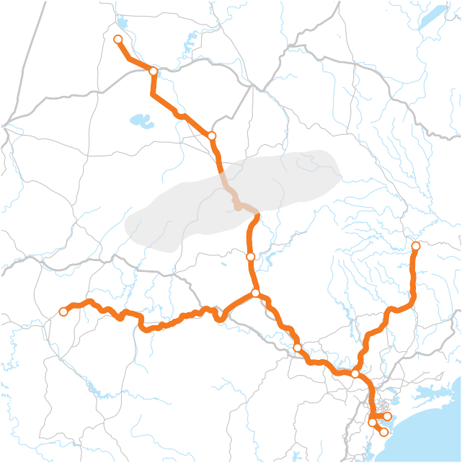
Figure 10.5 Hunter Valley Coal Chain (simplified)
Whitehaven
Gunnedah
Quirindi

Liverpool Ranges
Scone
Gloucester
Muswellbrook
Ulan
Singleton
Hunter Valley Coal Chain Main Line
50 kms
Maitland
Port Waratah
Kooragang Island
0
Newcastle
to the Port using the Hunter Valley Rail Network, managed by the ARTC. Branch lines feed off this line to individual coal mines. Collectively, the coal extraction and distribution network is known as the Hunter Valley Coal Chain. This network is shown in figure 10.5.
Rail infrastructure investment planning for the Coal Chain is coordinated through the Hunter Valley Coal Chain Coordinator (HVCCC) with different participants, including the ARTC, the Port of Newcastle, coal terminal operators and train operators working together to manage and develop capacity that matches demand generated through agreed coal volume contracts with landside and terminal capacity at the Port.

This capacity is aligned only to coal exports and allows limited access for the demands of the grain and other bulk commodity markets.
The HVCCC has proven itself effective in expanding the Coal Chain capacity as demand has increased substantially in recent years.
Over the next 20 years, significant investment is needed to increase the capacity of the Hunter Valley Coal Chain rail network. This will be funded by the private sector.
The ARTC has assessed options to increase capacity through the Liverpool Ranges to support coal volumes being transferred to the Port of Newcastle for export from the Gunnedah Basin. The ARTC has concluded that staged duplication of the existing line on the existing gradient is the best value solution.
An alternative alignment has been proposed that involves tunnelling through the Liverpool Ranges. While this option is significantly more expensive than the ARTC’s preferred solution, it would provide higher line capacity to the Gunnedah Basin, operational cost savings and improved transit times (and hence productivity improvements).
Current arrangements can make it challenging to develop major rail projects such as the proposed Liverpool Ranges tunnel.
At present, the forecast period used by the ARTC as the basis for their investment decisions only runs to 2020. This relatively short forecast period is partly used due to the difficulty of getting contractual commitments from
While this means that incremental approaches to capacity augmentation are generally favoured – which Infrastructure NSW supports – it risks, in some cases, necessary infrastructure not being provided in time to meet demand.
One option could be for the Commonwealth Government to take a more active role in underwriting demand risk in some circumstances to allow the ARTC to proceed with major rail investments.
This approach recognises Australia’s comparative advantages in resource extraction in some commodity sectors but relative disadvantages in getting resources from mine to market due to distance and other geographic factors.
Any move towards this more interventionist approach would need to appropriately balance the increased risks being borne by the public sector with the potential
rewards on offer. It is likely that the access pricing regime on any rail link financed in this way would differ from that on the wider freight rail network.

Recommendation Infrastructure NSW recommends increased capacity in the Hunter Valley Coal Chain through the Liverpool Ranges.
The rapid growth in demand for coal has priced grain off rail networks that supply the Port of Newcastle. This outcome reduces the competitiveness of grain exports through the port due to the higher costs associated with road transport.
a comprehensive review by the Commonwealth Government. The previous NSW Government committed to stabilise grain freight lines, a process that is currently underway22.

Access to Port Kembla
Exports through Port Kembla include coal, iron ore, and, to a less extent, minerals and grains. Port Kembla is also the NSW port for vehicle imports.
Port Kembla Ports Corporation forecasts that volumes through the port could grow from the current 33 to between 50–65 million tonnes per annum over the next 20 years23, depending on the Port’s ability to capture opportunities in the bulk export market.
The Government has also identified Port Kembla as a supplementary container port facility for NSW, once capacity at Port Botany is exhausted (discussed in Section 9).
Port Kembla has plans in place to provide the portside capacity that is forecast to be required over the next 20 years.
This will include expansion of capacity through its Outer Harbour development, and possible reuse of Inner Harbour quayside land. As a staged development, the Outer Harbour is well placed to deliver the required capacity uplift as demand grows through to 2031.
Growth at Port Kembla will increase the demands placed on the road networks that support the Port, including for journeys to Sydney (imported vehicles/cars) and journeys

potential rail users further in to the future and partly due
Infrastructure NSW has not considered issues relating

to regulatory timeframes.
to the grain rail network in detail in this Strategy following
- Commonwealth Government 2009, NSW Grain Freight Review.
- Port Kembla Ports Corporation 2012.

from regional NSW (for bulk exports). Around 20 percent of traffic volumes on Wollongong’s arterial roads are heavy vehicles24.
Specific areas of the road network that will need to be prioritised include Mount Ousley Road and Picton Road, which are already heavily used by freight. Investment
in the second half of this strategy in the F6 Extension, discussed in Section 6, will support Port Kembla by providing an alternative route to the metropolitan area.
The rail network has around a 60 to 65 percent modal share by volume for bulk exports through Port Kembla25. The port is served by three rail lines, as shown in
Figure 10.6
The Illawarra line, where freight and passenger traffic share rail paths, operates close to capacity. The Illawarra escarpment limits the additional capacity that can be provided cost–effectively along the Illawarra Line without significant investment. There are limited opportunities to expand freight volumes along this line.
An alternative for freight is the Moss Vale–Unanderra line, which is underutilised and has spare capacity for approximately an additional 6.5 million tonnes per annum26.
Should Port Kembla grow as rapidly as forecast, there will be a need for major investment in rail capacity over and above the potential offered by the Moss Vale– Unanderra Line over the medium term.
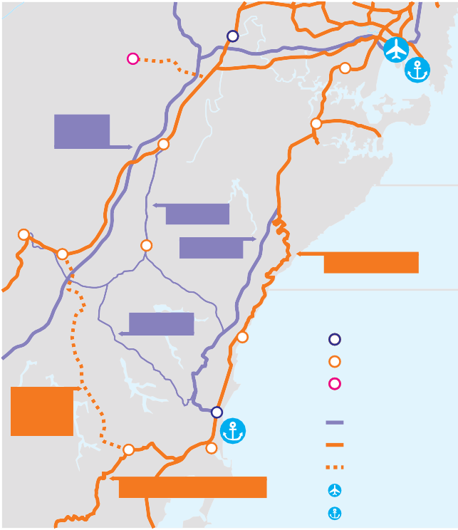The lead investment proposal is to construct a rail line from Maldon to Dombarton. This requires the construction of a 4 kilometre tunnel through the Illawarra escarpment and has a relatively high price tag of $625 million27. It is likely this project will not be progressed until the 2020s.
M5/Hume Highway
Picton
Maldon
Appin Road

F6 Freeway
Illawarra Rail Line
Picton Road
Maldon Dombarton Railway
Wollongong
Dombarton Port Kembla

Moss Vale Unanderra Railway
Source: Roads and Maritime Services.
Key
Regional cities Major centre
Planned major centre
Roads Rail lines
Planned rail lines Airports
Ports
Figure 10.6 Road and Rail Network
Supporting Port Kembla
The funding model applied by the HVCCC, could be applied to this project, with an open access regime allowing cost and risk to be spread among multiple investors.
Recommendation Infrastructure NSW recommends the Maldon to Dombarton rail line (not required for ten years on current demand forecasts) be predominantly funded by the private sector.

- NSW Bureau of Transport Statistics, 2011.
Recommendation Infrastructure NSW recommends the ARTC undertake the series of incremental investments it has identified for the Moss Vale–Unanderra line to increase its capacity. These investments are estimated to cost approximately
$125 million in total.
- Port Kembla Ports Corporation 2011.
- Hyder and Acil Tasman 2011, Maldon – Dombarton Rail Link Feasibility Study.

- Hyder and Acil Tasman 2011, Maldon – Dombarton Rail Link Feasibility Study.

Access to markets: intrastate and interstate freight
This section assesses transport infrastructure investments to support intrastate and interstate freight movements. Intrastate freight comprises the majority (around 60 percent) of the freight task by volume.
Interstate freight makes up around 20 percent of volumes28. These movements are primarily made by road.
This section also considers container freight exports from the regions through Port Botany. Wider issues relating to Port Botany are discussed in Section 9. Almost two thirds of exports through Port Botany travel by road29.
The freight tasks discussed in this section are diverse. They include agricultural and manufactured products accessing urban markets or container ports, timber and construction materials, and bulk minerals such as coal for power stations and iron ore for the steel industry.

Road and Rail freight movements from Western NSW
The Great Western Highway and Bells Line of Road form the main road freight corridors from Western NSW to Sydney and its ports. They are also the main road
access routes for residents of these areas to the city (and vice versa).
Both routes suffer from constraints that limit their freight movements. The Great Western Highway limits over height freight vehicles due to low level bridges along its route. The Great Western Highway allows high mass vehicle movements, but these are restricted on the Bells
Line of Road. Both the Great Western Highway and the Bells Line of Road constrain longer (19 metre plus B – double) vehicle movements.
Constraints for freight also exist on the rail network that connects Western NSW to Sydney and Port Botany.
These include delays due to passenger train movements taking priority, steep gradients and inadequate passing loops on some sections of the network.
The restrictions on the Great Western Highway as a freight route and the rail network have led for calls for investment in Bells Line of Road as an alternative route.
However a needs assessment led by Transport for NSW notes that these investments would be difficult to justify for the foreseeable future based on current low traffic volumes (below 5,000 vehicles per day)30. The challenging terrain means that the costs of any substantial upgrade could outweigh the benefits provided.
Existing investment plans will complete the duplication of the Great Western Highway to Katoomba over the next five years.
As noted in sections 10.6.3 and 10.6.4, further investigation is needed as to what investment and reform is needed to support freight movement from Western NSW to Sydney and its ports. This would include assessment of rail alternatives to develop a holistic picture.
Prior to this, the case for substantial investment in Bells Line of Road as a whole is unproven.
It is sensible however, given the limited road alignments available over the Blue Mountains, that action be taken to identify a corridor, should the Bells Line of Road be needed in the future. This should include the western extent of the road between Kurrajong and Richmond, which has been designated for future development as the Castlereagh Freeway.
Recommendation Infrastructure NSW recommends that a potential corridor be identified for the Bells Line of Road and the Castlereagh Freeway.

Duplicating the Pacific Highway Current Status
The Pacific Highway runs 670 kilometres from the F3 at Hexham to the Queensland border. It carries over half the freight task between Sydney and Brisbane, as well as a mix of long distance and local vehicle traffic. Road safety has been another major driver of investment in this corridor.
As at April 2012, 52 percent of the Highway
(346 kilometre) had been upgraded to dual carriageway and another nine percent (60 kilometre) was under construction. A further $7.7 billion is forecast to be needed for remaining unfunded works (giving a total program cost of over $16 billion). The NSW and Commonwealth Governments are in discussion around funding options for remaining works.

- Saha International 2008, Innovation in the NSW Freight Logistics Industry.
- Sydney Ports Corporation 2011.
- Roads & Maritime Services 2011, Bells Line of Road: Long Term Strategic Corridor Plan.

Scope of Remaining Work
The remaining undivided sections of the Pacific Highway comprise two main sections:
  - Port Macquarie to Urunga
  - Woolgoolga to Ballina
The economic merit of the remaining sections is much lower at 0.8 (Benefit Cost Ratio) than that of the Highway as a whole31. This reflects the relatively low
traffic volumes on the remaining sections – for example the traffic between Woolgoolga and Ballina is generally below 10,000 vehicles per day.
Given competing priorities for NSW and Commonwealth Government funds, the high cost and relatively limited benefits of these remaining sections raises questions about the:
  - relative merit of prioritising busier sections of the Pacific Highway corridor for upgrade sooner,
(in particular from the F3 to Raymond Terrace 40,000 vehicles per day)
  - appropriate scope of works and priority for those sections with relatively light traffic.

F3 Freeway to Raymond Terrace
The proposed investment to upgrade the F3 to Raymond Terrace appears to have a lot of merit. Traffic flows
along this section of the Pacific Highway are high and congestion can be an issue at peak hours.
By providing an uninterrupted highway and improved connectivity between the F3 and the Pacific Highway, the upgrade scheme would be likely to improve journey times and improve safety.

- NSW Government 2011, Pacific Highway upgrade, submission to Infrastructure Australia.

Recommendation Infrastructure NSW recommends a detailed assessment of the proposed upgrade to the F3 to Raymond Terrace be
undertaken, with a view to it being built within the next ten years.

Construction costs
Construction costs on the Pacific Highway appear to have increased significantly as the upgrades have progressed. The cost of the currently unfunded sections are estimated to be some 20–40 percent more per kilometre than the already delivered or committed sections, even after allowing for normal industry cost escalation32.
Current highway planning seems more focussed on delivering an outstanding engineering outcome than on controlling costs. The Ballina Bypass provides a recent illustration of the consequences of having high performance standards. For 12 kilometres of new road,
the cost was $640 million – more than twice the cost per kilometre of previous sections33.
Given the scale of the forecast spending and the limited resources available, Infrastructure NSW recommends that now is an appropriate time for an independent review of the scope of work, with a focus on value engineering (discussed in section 16). The independent review
should also consider how constraints such as work practices and planning approval conditions are adding to the budget.
RMS should also consider options to improve contracting efficiency. Currently the Highway is being

- Infrastructure NSW analysis.
- Infrastructure NSW analysis.
constructed through a large number of different contracts, which reduces the scope for economies of scale and in practice limits potential bidders to local suppliers.
Lower costs may be achieved if the remaining unfunded sections were issued as fewer, but much larger packages, which may attract international suppliers and increase competitive pressure.
Recommendation Infrastructure NSW recommends a review of the scope and costs of the Pacific Highway. This will also consider alternative procurement strategies which could improve value for money, subject to funding availability.

Improving Road Freight Productivity
Road freight productivity is linked to vehicle size and the amount of weight that can be carried. Over the last 40 years, road freight productivity in Australia has more than doubled, although analysis by the Bureau of Infrastructure, Transport and Regional Economics has shown that productivity growth has slowed in recent years34.
Moving heavier, larger vehicles requires road networks that can support them. NSW has a number of gaps in its High Mass Limits (HML) and High Productivity Vehicle (HPV) networks that can cause freight costs to be higher in NSW than in some other States.
While a significant proportion of the forward transport program is committed to major road upgrades, targeted minor projects need to be progressed also. In many cases, investments in ‘pinch point’ schemes can have very high returns because they can unlock constraints

- BITRE 2011, Truck Productivity: Sources, Trends and Future Prospects.

hindering HML and HPV movements along a whole corridor and the wider road network.
A network is only as strong as its weakest link.
A constraint on one part of the NSW road network can reduce productivity across the whole network.
A network-wide approach that takes account of the different types of freight movements and their transport requirements is therefore essential.
The traditional road hierarchy and boundaries between local government roads, state and federal roads appears to have sometimes held up necessary investment by preventing any single entity adopting a network-wide view.
One option that has been suggested to reduce some of the most pressing physical constraints on the road
network is the Bridges to the Bush program. This project carries very high economic benefits at a relatively low cost.
Bridges to the Bush seeks to address constraints in the network by enabling the key corridors to take heavier axle loads and longer vehicles by:
- implementing a programme to improve the mass limits of selected bridges throughout NSW to increase the capacity of the road network to carry freight and HML vehicles on key freight corridors. Currently 249 bridges have been assessed as unsuitable for HML B-double vehicles35.
- improving the condition, geometry and durability of regional road pavements
The program aims to prioritise investment on the bridges and connecting infrastructure that will have greatest economic impact.

- Road and Maritime Services 2012, Bridges for the Bush.

Recommendation Infrastructure NSW recommends the Bridges to the Bush program be progressed and implemented as soon as possible to address pinch points constraining the use of HML vehicles.

Wider pinch point investment will also be required to the road network. For example, highways will need investment where they travel through regional towns to allow more efficient truck movements without
unacceptable amenity impact and local roads also need upgrading in some cases to allow “last mile” movements.
Recommendation Infrastructure NSW recommends Transport for NSW develop and implement, with local authorities and other relevant agencies, a targeted program of local, regional and state road “pinch point” upgrades designed
to overcome constraints impeding HML and HPV access in Regional NSW.

Transport for NSW has proposed piloting HPV access to the Hume Highway to potentially offer a HPV route from Sydney to Melbourne. This pilot is made possible by the completion of the Hume Highway duplication in 2013.
This is an important pilot for the future regulation of road freight in NSW. Three quarters of the nation’s road freight moves through NSW for at least part of its journey.
It is suggested that additional infrastructure costs required to further upgrade the Hume Highway to support HPV movements could be met by direct
contributions from haulage users. Infrastructure NSW supports this approach.
Should this pilot prove successful, there is a case for the introduction of more cost reflective road pricing for heavy vehicles on all major interstate highways. Analysis by the Productivity Commission suggests that reducing the disconnect between road user revenues and spending decisions would improve freight efficiency.

Improving Rail Freight Productivity
It has been argued that intrastate and interstate freight productivity could be enhanced by increased use of rail freight. Rail freight has lower marginal costs than road, but higher fixed costs. Over a long enough distance, rail can be cheaper than road for freight movements given sufficient volume.
Balanced against this, is the Productivity Commission’s view that road and rail freight are complements rather than substitutes for much of the freight task and that, as Section 9 discusses, there is not a compelling case that road freight be subsidised relative to rail, even accounting for externalities. Road freight also benefits from inherent cost and service quality advantages over rail as costs can be shared with the dominant user,
i.e. passengers36.

Major investment programs
A number of major rail freight infrastructure projects have been suggested in recent years including:
      - Creation of an inland rail route between Melbourne and Brisbane via NSW

- Productivity Commission 2006, Road and Rail Freight Infrastructure Pricing.

  - The Northern Sydney Freight Corridor program, intended to reduce constraints on the rail network between Sydney and Newcastle and support Sydney–Brisbane freight movements.
The rationale for these programs is based upon the assumption of substantial modal shift to rail, leading to overall economic benefit through productivity improvements. However, the absence of significant congestion constraints on much of the interstate
highway networks would appear to lessen the case for these major projects.
The Hume, Newell and New England Highways facilitate the road transport task effectively, with congestion only experienced around the major urban centres where freight is competing with the dominant passenger and commuter road and rail tasks, particularly during peak periods. The duplication of the Pacific Highway will lessen constraints on this important corridor also.
It is also unclear whether there is potential for these interstate goods to be switched to rail. Without greater certainty about future demand, and reflecting the high costs of these proposed options, Infrastructure NSW is not able to support the prioritisation of these programs within the next 20 years at this stage, where they are additional to existing commitments.
In the case of inland rail, Infrastructure NSW concurs with the ARTC’s view that a new inland route, at a cost of around $5 billion, would not be viable until the early 2030s at the earliest 37.

- ARTC 2010, Melbourne to Brisbane Inland Rail Alignment Study.

Northern Sydney Freight Corridor38
There are currently a number of infrastructure impediments which limit the effectiveness of rail freight in the North – South rail corridor between Sydney and Newcastle including:
  - a lack of passing loops (for passenger services to overtake freight trains)
  - several steep inclines, especially adjacent to the Hawkesbury River
  - junctions causing critical delays such as at North Strathfield and Hornsby
  - passenger trains having priority over freight trains in urban Sydney.
In late 2010, the Commonwealth and the NSW Governments signed an inter-governmental agreement to commence work on a $1.1 billion upgrade (including
$840 million funded by the Commonwealth and $214 million by the NSW Government) to this corridor. Works include the following:
  - North Strathfield rail underpass
  - Hexham passing loops
  - Gosford North passing loops
  - Epping to Pennant Hills third track
In the longer term a more ambitious infrastructure works program is being considered which could include providing a dedicated rail freight track from

- NSW Government 2010, M5 East, M2F3, Northern Sydney Freight Corridor, Container Freight Improvement Strategy, submission to Infrastructure Australia.

North Strathfield to the Hawkesbury River, additional passing loops north of the Hawkesbury as well as potentially improved train control systems.
The challenging geography this route passes through makes these options very expensive. The estimated cost of these works is around $6.8 billion.
Further assessment is needed to identify whether there is a robust business case for these proposed investments, particularly given the high modal share of road for freight journeys along this corridor and the
small (although fast growing) share of the freight market that interstate movements comprise.
Focus may be better placed on addressing key constraints on the rail network to Brisbane, rather than more comprehensive programs.
One area within the wider Northern Sydney Freight Corridor program, which appears of strategic merit, is the proposed option to provide a rail bypass of Newcastle.
Current track alignments force all traffic (including interstate freight) on a circuitous route through the city. A bypass could improve transit times, and help alleviate pressure on an urban rail network increasingly under strain from the growth in the coal export task.
More detailed work is needed to identify a viable bypass option. The existing proposal – the Fassifern to Hexham Bypass is costly relative to the benefits it offers. Cost savings may be available through construction progressing in tandem (and sharing alignment
with) the proposed F3 to Raymond Terrace Project discussed above.

Minor Investment Programs
As with the road network, the existing rail network used by freight suffers from a number of constraints that limit the efficiency and reliability of rail freight movements.
Discussion with regional authorities and freight producers has identified the following issues:
  - Inefficiency exists in train control practices, particularly due to the use of manual rail points in some regional areas. This requires freight trains to stop while the points are changed.
  - An absence of regular passing loops or short passing loops on some sections of track can create delays.
Delays can also occur due to co-ordination issues between freight and passenger rail services on shared lines. For example, long distance XPT passenger trains can cause delays of multiple hours to freight trains.
Action to address these constraints and co-ordination issues are likely to have substantial productivity benefits. Again, as with the road network, governance issues – multiple state and federal rail infrastructure operators – have sometimes held up investment or created network management challenges.
The establishment of a specific freight division within Transport for NSW means a network wide program of rail ‘pinch point’ investments and operational reforms can be developed.

Recommendation Infrastructure NSW recommends Transport of NSW develop (with the Commonwealth Government and other relevant agencies) a targeted program of rail upgrades and reforms designed to overcome constraints impeding rail freight movements in Regional NSW.

Conclusions
The road network forms the backbone of Regional NSW passenger and freight transport infrastructure.
Infrastructure NSW does not believe this will change over the next 20 years.
Regional NSW has seen a majority of roads investment in recent years as the Commonwealth Government has invested to extend and improve the National Highway Network. The highest value projects have largely been completed however and therefore future investment needs to balance the benefits to local communities and the State as a whole.
Given the scale of major road programs in
Regional NSW, action is needed to contain costs and where possible, particularly with the Pacific Highway and Princes Highway programs. Finite funding means the alternative is likely to be further delay in delivering these programs.
In many cases, pinch point upgrades will be sufficient to meet the transport demands placed on the regional roads network over the next 20 years. Focus should
be placed on freeing up bottlenecks on corridors and around the ports and investing in regional bridges and bypasses. Maintaining the existing asset base is also essential.
The rail network has an important role in providing access to the metropolitan area and transporting bulk freight, particularly for export. It is less clear that its limited role for other passenger and freight markets will grow substantially over the next 20 years, relative to other modes.
Accordingly, priority on the rail network should be on incremental improvement – for example, accelerating services to Global Sydney and freeing up constraints that hinder regional freight movement.
Mega projects (inland rail, extending the Northern Sydney Freight Corridor and re-opening dormant passenger rail lines – are likely to be less of a priority. The capital costs of these investments are extremely high relative to the likely modal shift (and therefore benefits) that could be expected.
In most cases, the Hunter Valley Coal Chain presents an effective model for freight rail investment. Where demand is robust (rather than speculative) investment to relieve constraints and support rail networks is progressed by the private and public sectors working in partnership.

    - Recommended Actions

37 | Review scope and costs of Pacific Highway duplication and Princes Highway upgrade | 0 – 5 | Review | Cost of review is not material
38 | Freight pinch point program for key road and rail links | 0 – 10 | Program | Scoping of $1 billion
39 | Bridges for the Bush Program to improve freight productivity | 0 – 5 | Program | Estimate of $300 million stages 1 and 2
40 | Identify Bells Line of Road / Castlereagh Freeway corridor | 0 – 5 | Corridor | Cost of corridor planning is not material
41 | Coal Community road and rail schemes | 0 – 5 | Program | Scoping of $500 million
42 | Complete Pacific Highway duplication | 5 – 10 | Major project | Existing Government commitment
43 | Incremental upgrades of Moss Vale to Unanderra freight rail line | 5 – 10 | Major project | Assume delivery by ARTC based on user funding model
44 | Hunter Valley Coal Chain improvements – Liverpool Range | 5 – 10 | Major project | Assume delivery by ARTC based on user funding model
45 | F3 extension to Raymond Terrace | 5 – 10  5 – 10 | Major project  Major project | Scoping of $900 million
46 | Complete Princes Highway duplication to Jervis Bay turnoff |  |  | Existing Government commitment
47 | Maldon – Dombarton freight rail line | 10 – 20 | Major project | Assume delivery by ARTC based on user funding model

11.0 Energy

Summary
- Improving energy affordability and security will require significant reform of the energy sector.
- The NSW Government is delivering the sale of the generation businesses and has rationalised the network businesses, creating Networks NSW, to achieve efficiencies.
- Draft changes to the regulatory process, rates of return and reliability standards are also expected to better balance the interests of the network businesses and the electricity consumers.
- Infrastructure NSW will review the capital plans of the amalgamated distribution business, Networks NSW.
- Infrastructure NSW supports the Commission of Audits recommendation that the Government undertakes a study that considers the scope and implementation strategy for privatisation of distribution networks.
- Infrastructure NSW supports later investigation of options for the Government’s investment in Snowy Hydro Limited.

- The competitiveness of the national wholesale electricity market works best when there is enough transmission capacity between the states. Infrastructure NSW recommends:
  - projects to increase capacity between NSW to Queensland and NSW to Victoria; and
  - projects to strengthen supply to the Sydney metropolitan area.
- Acting to bring large reserves of coal seam gas to market is potentially game changing for NSW’s economic growth and productivity.
- Infrastructure NSW recommends supporting private sector investment by:
  - Facilitating the augmentation of the existing national gas transmission networks to connect new NSW supply areas;
  - Facilitating development of new industries, including, investigating options for LNG export infrastructure.

Energy snapshot
- The NSW Government has $30 billion invested in electricity infrastructure (in State Owned
Corporations (SOC)). This is $26 billion in network businesses and $4 billion in generation businesses. The electricity sector accounts for 27 percent of past capital and 28 percent of all the Government’s future capital program1.
- The electricity sector has invested an average of
$2 billion a year for the past decade. The capital plans of the businesses are to double this to an average of
$4 billion a year for the next decade to 2021.
- Each electricity business has borrowed heavily to fund its capital programs and this increase in debt (and forecast increases) contributes significantly to the increase in the Government net debt position. While each business has assessed its capital structure to be prudent, the consolidated position has caused the State to approach its borrowing limit. This has caused constraints on borrowing in other Government sectors.
- Electricity network investment in NSW is significantly higher than investment in other states where the private sector owns the network.
- The Government has decided to sell the generation businesses and amalgamate the network businesses to reduce pressure on electricity prices and the capital drag on Government resources.

  - NSW Treasury, 2012-13 Budget Paper 4.

- Infrastructure NSW recommends reducing the capital invested in electricity assets in the short term.
- Private sector investment in gas infrastructure and electricity generation over the next 20 years will increase competition in the energy market and lower production costs for the whole economy.

Prices and demand
The NSW economy has traditionally benefited from the competitive advantage of low priced energy based upon abundant reserves of coal. This long term competitive advantage has all but disappeared over the last
5 to 10 years.
The era of low cost energy is over. High levels of investment in electricity networks and the proliferation of primarily Federal Government renewable energy schemes have caused the average electricity retail bill to double over the past eight years for NSW residential customers, from around $800 to near $1,600 per annum. This is shown in Figure 11.1.
Figure 11.1 NSW Electricity bills for residential customers

2000

1500
$ per annum

1000

500

0
2004/05
2005/06
2006/07
2007/08
2008/09
2009/10
2010/11
2011/12
2012/13

EnergyAustralia Integral

Source: IPART.
NSW prices have also grown faster than prices in other States, reducing the attractiveness of NSW to businesses and as a place to live. This is shown in Figure 11.2 below.

Figure 11.2 Average Electricity Retail Prices 2001-11

20

15
c/kWh

10

5
2000/01
2001/02
2002/03
2003/04
2004/05
2005/06
2006/07
2007/08
2008/09
2009/10
2010/11
2011/12

NSW/ACT Victoria Qld SA
WA Tas NT
Source: KPMG for AEMC.

The forecast is for further large price increases over the next few years, these increases will continue to be driven by network price increases, carbon pricing and Federal renewable energy policies, which will drive changes in the mix of generation technology.

These price forecasts reflect:
- The cost of renewable generators, to meet legislated targets of 20 per cent by 2020.
- The majority of renewable plant will be wind which needs to be supplemented by back-up gas peaking plant.
- The combination of wind with peaking generation is an expensive generation mix and increases the price to business and households.
Higher energy prices are a risk for economic growth and are creating hardship for parts of the community2. The large increase in costs for industry is contributing to structural adjustments in NSW’s industrial composition. NSW is energy rich and these resources need to be maximised to ensure that NSW businesses are competitive.

Demand
As a result of these price increases, electricity demand is declining – demand in 2011 is at the same level as 2006. This is shown in Figure 11.3 below.

Figure 11.3 Electricity Despatched (GWH) History and Forecast

80,000

78,000

76,000
Annual energy (GWh)

74,000

72,000

70,000

68,000

66,000
05/06
06/07
07/08
08/09
09/10
10/11
11/12e
12/13
13/14
14/15
15/16
16/17
17/18
18/19
19/20
20/21
21/22

Peak demand
While energy demand is declining, peak demand has grown at nearly two percent per annum. The ‘gap’ between average energy and peak demand drives the price up further as more infrastructure is needed for
less time. Nationally, it is estimated that over $11 billion of infrastructure is used for less than one percent of the time3.
Infrastructure NSW has concluded that there are insufficient incentives on electricity network businesses to manage peak demand and there is evidence that:
- forecasts of demand (for capital planning) are conservative and do not take into account
the potential of demand management, including price elasticities
- high level analysis of data on energy flows are not used to any extent in capital planning
- automation and active configuration and balancing of electricity supply systems are not used to avoid capital expenditure.
This has contributed to the high level of electricity

Source: AEMO.
Actual
Projections (medium growth)
distribution investment and consequent high prices.

  - IPART 2012, NSW Retail Electricity Review.
  - Ernst & Young 2011, AEMC Power of choice: Rationale and Drivers for DSP in the Electricity Market – Demand and supply of Electricity, prepared for the AEMC.

Electricity distribution investment
Infrastructure investment by the NSW Government- owned network businesses has been the largest contributor (over 60 percent) to the electricity
price increases. Figure 11.4 shows that the network increases in NSW have been higher than national average.

Price increases are due to the investment in the electricity network. Investment has more than doubled in the past five years from around $2 billion per annum to over $4 billion per annum from 2012-13 to 2016-17 as shown in Figure 11.5 below.

This rate of investment represents a dramatic growth of over 80 percent in the Regulated Asset Base (RAB) as shown in the table below. This means that network
prices will continue to rise (as the largest portion is return on RAB).

Figure 11.4 Comparison of Network Prices from 2010/11 to 2013/14
18

16

14

12

10
c/kWh

8

6

4

2

0
2010/11
2011/12
2012/13
2013/14
2010/11
2011/12
2012/13

National NSW
Figure 11.5 Distribution Businesses’ Planned Investment in Electricity 2008-21

5,000
4,500
4,000
3,500
3,000
2,500
$M
2,000
1,500
1,000
500
0
2007/08
2008/09
2009/10
2010/11
2011/12
2012/13
2013/14
2014/15*
2015/16*
2016/17*
2017/18*
2018/19*
2019/20*
2020/21*

Transgrid Essential Ausgrid Endeavour
Source: NSW Treasury.
Note: Capital plans for 2014-15 onwards yet to be reviewed.

Distribution Transmission
2013/14

Source: AEMC.

Table 11.1 2009-2014 Regulated Asset Base Growth*

Regulatory incentives for investment
Reliability

RAB (2009
$million)
Investment
2009-2014 % Added
The regulatory framework is designed to support the national objective to promote efficient investment for the long term interests of consumers.
However, Infrastructure NSW has concluded that
TransGrid | 4,213 | 2,440 | 58%
Ausgrid | 8,431 | 7,837 | 93%
Endeavour | 3,744 | 2,721 | 73%
Essential | 4,382 | 3,826 | 87%

there has been high capital spending in NSW networks which is partly due to the high incentive for capital investment arising from the regulated cost of capital.
Table 11.2 below shows the history of regulated cost
As shown in Figure 11.6, reliability has improved by 25 per cent since 2006, or 25-30 minutes fewer
interruptions per year on average. Customers are getting very marginal and in many cases questionable benefit, given the significant cost increases that they face.
Figure 11.6 NSW Networks reliability performance: Customer minutes without supply
150

Total 20,770 16,824 81%
Source: Australian Energy Regulator.

Infrastructure NSW has concluded that the planned increase in investment and borrowing for electricity businesses is not the most beneficial use of the State’s constrained funding and borrowing capacity.
The economic reforms that have taken place in the energy sector have successfully delivered competition in the wholesale and retail gas and electricity markets. The competition reforms are complemented by national regulation of the monopoly transmission and distribution sectors. The Government therefore does not require
of capital:
Table 11.2 WACC Determinations – History and Comparison
UK Comparison: 1999-2004 2004-2009 2009-2014 Ofgem 2011

7% | 8.7% | 10.2% | 6%
Note: The Weighted average cost of capital (WACC) is the return on capital for regulated network business for a regulatory control period. It is calculated by the Australian Energy Regulator in accordance with the National Electricity Rules.

A large value wedge can occur between the return on capital, the weighted average cost of capital allowance and shareholder capital costs in Government-owned

140

130
SAIDI (Minutes)

120

110

100

90

FY06 FY07 FY08 FY09 FY10 FY11 FY12 FY13 FY14 FY15 FY16
NSW 2021 target (minutes) NSW performance (minutes)

direct investment in infrastructure in order to achieve
reliability and other objectives. Instead, stable and transparent policy and governance frameworks have replaced the need for direct Government investment.
and privately-owned networks.
Infrastructure NSW supports the Australian Energy Market Commission’s efforts to amend the regulatory framework through national reviews now underway4.
Recommendation Infrastructure NSW supports the Commission of Audit’s recommendation that the Government undertakes a study that considers the scope and implementation strategy for privatisation of distribution networks.

  - AEMC 2012, Draft Rule Determinations for economic regulation of network service providers, August 2012.
Source: NSW Department of Trade and Investment.

Infrastructure NSW has concluded that the NSW 2021 reliability target can continue to be achieved with lower (recommended) capital investment.
Infrastructure NSW supports the Government’s efficiency measures to amalgamate distribution businesses to reduce investment. The amalgamated business, Networks NSW, is yet to recommend a capital program which will be reviewed by Infrastructure NSW.

Electricity transmission investment
Infrastructure NSW considers that strengthening the transmission links between the regions will enhance competition in the national wholesale electricity market.
The capacity of inter-regional electricity trade has a direct impact on the wholesale costs and competitiveness
of the national market and therefore the prices paid by businesses and households. This is because market impacts from constraints or congestion prevent lowest priced generation being available to NSW consumers5.
A recent study investigating increased inter-regional power transfer capabilities in the national electricity market has demonstrated potential market benefits. The maximum net benefits (benefits greater than costs)
were found to occur when combining the three mainland components: Queensland to NSW; NSW to Victoria; and Victoria to South Australia. The results from the analysis indicate that the high capacity backbone may approach economic viability by approximately 2020-21 under high demand growth and high carbon price conditions.
Infrastructure NSW concurs with the proposed program submitted by TransGrid and contained in the National Transmission Network Development Plan to develop the southern high voltage link to supply the Sydney area, and to accommodate gas-fired generation development in the south and to strengthen the interstate links over the next 20 years.

Recommendation Infrastructure NSW recommends that the Government:
- prioritise transmission projects to strengthen the capacity of interstate flows in the national electricity market
- prioritise transmission projects to strengthen supply to the Sydney metropolitan area.

Generation and gas

Electricity generation
The Government will sell its electricity generation assets (expected during 2013) and all future investment in NSW generation will be made by the private sector. The
Government’s future role is to remove any barriers to that investment and to encourage the private sector to invest in the lowest cost generation available.
Infrastructure NSW supports the Commission of Audit’s recommendation for a review of the options to divest the public ownership of Snowy Hydro Limited.
Significant private investment will be needed over the next 20 years in electricity generation for both base load and renewable energy, despite the flattening of electricity consumption6.
Achieving the estimated additional 7,000 megawatts (MW) of base load generation capacity by 2029-307 will require significant time for planning and approval processes to be completed.
However, Infrastructure NSW has concluded that in the short to medium term the market is more likely to invest in higher cost, smaller plant units to manage supply and peak price risks. Further, Infrastructure NSW is concerned that the Federal Government’s 20 percent renewable energy target is crowding out other types
of viable investment. The emerging mix of generation technology will result in higher electricity prices.
Infrastructure NSW notes that the NSW Government will facilitate investment in low cost electricity generation, especially base load capacity, by providing consented development sites in the generation sale packages which are fuel and technology neutral. This would enable the buyer to choose the most cost effective investment and accelerate the development of the project by up to two years faster than would otherwise be the case.
Infrastructure NSW also supports the NSW Government’s policy for a review of the renewable energy targets and carbon policies to remove duplication of schemes that have the same objectives. The introduction of the carbon price suggests that the design and operation of the renewable energy targets across all schemes may no longer be efficient or effective. Closing down the various schemes would reduce generation costs and electricity prices.

  - AEMO 2012, Electricity Network Regulation Submission to Issue Paper.
  - AEMO 2011; prepared for the Electricity Statement of Opportunity.
  - AEMO 2011, National Transmission Network Development Plan.

Encouraging private sector investment in gas infrastructure
Infrastructure NSW considers that the development of the Coal Seam Gas (CSG) industry will be game changing for NSW, providing a number of strategic benefits. It will help to address the security risk of declining reserves of conventional natural gas from interstate basins; meet the increasing demand for gas
fired generation; and help to contain upward pressures on wholesale gas prices because of declining reserves and increased demand including for exports.
The CSG reserves have the potential to supply residential, commercial and industrial energy users and to substitute for the declining reserves of natural gas from traditional interstate sources. The vastness of the reserves has the potential to provide gas to other Australian states and for export to overseas markets.
Gas production in the eastern market is projected to grow at rate of five percent a year to 2,492 petajoules (PJ) in 2034-358. This is greater than the total amount of gas currently produced in Australia. In 2010-11, Australia in total produced 2,091 PJ of gas9.
The emergence of a NSW CSG industry is a significant opportunity that will provide employment and economic growth to regional areas in NSW as it has done in Queensland.
Timely investment in NSW CSG infrastructure offers a number of other strategic advantages:
- Lower cost supply for gas-fired generation. There are eight ‘committed’ gas generators in various stages of development.
- NSW relies on gas piped from interstate basins. Security of gas supply is an emerging issue due to the lack of conventional natural gas reserves within NSW and the decline in interstate conventional reserves. The major gas producers appear increasingly to be earmarking gas reserves for the export market as the LNG production and export facilities in Queensland10 come on line.
- New additional sources of gas, such as NSW CSG, will enhance competition among gas producers. Encouraging more competition in the gas sector will be important to counter the risk of higher wholesale gas prices that are emerging.
Uncertainty about availability and about prices in the future for gas in NSW can be alleviated by developing the CSG sector in NSW.
Securing new low cost sources of gas will be essential to meet increasing demand for gas in NSW. This, in turn, will fuel economic growth and prosperity.
The NSW Government, in its submission to the NSW Legislative Council Coal Seam Gas Inquiry, presented the position that ensuring security of gas supply for NSW electricity generation will require
bringing the State’s CSG reserves into production and/ or the expansion of transmission pipeline capacity from
interstate. Without bringing reserves into production or expanding interstate capacity, potentially significant price rises could be expected to flow on to large gas
consuming industries as well as smaller commercial and residential consumers. In addition, these price rises will flow into electricity prices as the penetration of gas fired electricity generation expands in NSW.
The Government is putting in place a series of measures to ensure that the NSW gas industry meets the safety, health and environmental requirements expected from the community. The planning and approval processes need to be streamlined, proportionate and timely.
NSW CSG reserves will need to be linked to the existing national gas transmission network if they are to address the supply demands from business, households and export customers. This will require additional intrastate pipeline infrastructure supporting the development of NSW gas sector and to ensure unconstrained access to gas supplies. Additional intrastate pipeline infrastructure from the NSW CSG-producing basins to gas markets will increase security of supply for NSW consumers.
This significant investment in gas transportation infrastructure will undertaken by private interests with regulatory oversight by the Government. The priority is to ensure that investment in gas infrastructure occurs in a timely manner and does not delay production or create supply bottlenecks.

  - Syed, A and Penney, K 2011, Australian Energy Projections to 2034-35, Bureau of Resource and Energy Economics.
  - Bureau of Resource and Energy Economics 2012, Energy in Australia 2012.
  - Santos 2012, GLNG to Purchase 365PJ of Gas From Origin Energy,
ASX Media Release, 2 May 2012. Origin Energy 2012, Origin Announces major gas sales agreement with GLNG, ASX Media Release, 2 May 2012.

Recommendation Infrastructure NSW recommends private sector investment to augment the interstate gas transmission network for developing gas resources by:
- putting in place a regulatory framework that ensures the development of a safe and environmentally responsible coal seam gas
industry that co-exists with agricultural production
- facilitating development of new industries, including, investigating options for LNG export infrastructure
- facilitating the augmentation of the existing national gas transmission networks to connect new supply areas including the Gunnedah Basin.

Recommended actions
The key strategies for NSW energy sector are listed below.
Recommendations Year Type Capital and Funding Implications
48 | Investigate options and strategy for privatisation of networks and Snowy Hydro Limited | 0 – 5 | Review | Cost of review is not material
49 | Upgrade electricity transmission lines to strengthen interstate capacity and Sydney supply | 5 – 10 | Major project | Existing agency program
50 | Augment interstate gas transmission network | 0 – 20 | Major project | Investment to be funded by the private sector

12.0 Water infrastructure

Summary

Water snapshot

- Every NSW community needs water infrastructure that meets national health and environmental guidelines or standards and guarantees a secure and affordable water supply.
- Being prepared for inevitable drought is more productive than restricting supply. Infrastructure NSW recommends the development of a comprehensive, prioritised program of new and augmented dams across NSW.
- Infrastructure NSW recommends aggregation of 105 local water and wastewater delivery authorities into around 30 regional delivery authorities to maximise efficiency and manage affordability (as previously recommended to the NSW Government).
- Infrastructure NSW recommends a prioritised program of work to bring all regional town water and sewerage systems up to required minimum drinking quality and environmental standards.
- Augmentation of supply for the Hunter region is needed within the next 10 years.
  - Given the multi-source complexity of water supply systems and the long lead times, planning for Sydney’s next supply should commence as part of the updated Metropolitan Water Plan.
  - Infrastructure NSW recommends the NSW Government review all the major flood mitigation options available, including raising the Warragamba Dam wall to significantly reduce the potential economic and social impact of flooding in the Hawkesbury Nepean Valley. If major flood mitigation is not provided, roads in the Valley will need to be upgraded to ensure people can evacuate.
    - The NSW Government has about $20 billion1 invested in the water sector in Sydney Water, Hunter Water, Sydney Catchment Authority and State Water.
    - Local government-owned water utilities deliver water and wastewater services in other parts of the state. There are 105 non-metropolitan local water utilities.
    - Other Government agencies with water responsibilities include NSW Treasury (as the shareholder of Government water business), NSW Office of Water (NOW),the Department of
Finance and Service (Metropolitan Water Directorate). The Office of Environment and Heritage (OEH) regulates environmental performance and NSW Health regulates public health standards.
    - Metropolitan investment is subject to oversight by Independent Pricing and Regulatory Tribunal (IPART) and planning for regional investment is reviewed by NOW and costs are recovered in user charges.
    - Over the past five years, capital expenditure across the metropolitan utilities has averaged $1.4 billion per annum, which included investment in the desalination plant. Budget forecasts for the next four years show a decline to $1 billion per annum for the metropolitan utilities.
    - Capital expenditure by the local government-owned water utilities has averaged $0.6 billion per annum over the past five years.

      - NSW Government, 2012-13 Budget.

Demand and supply

Background
Over recent years, water demand has been declining largely due to drought restrictions and successful demand management programs.
Water conservation measures implemented in Sydney and in regional areas have been outstandingly successful in managing demand. The total demand of the metropolitan region is similar to the level in the 1970s despite an additional one million in population.
For non-metropolitan NSW, the average annual residential water supplied per connected property has fallen by 52 per cent over the last 20 years.
However, caution is required. Since water restrictions have been removed, NSW generally has experienced two wet summers, resulting in low water consumption. On the other hand, the demand curve has been
Figure 12.1 Index of Residential Water and Sewerage Charges 1992/93-2010/11 (real)
140

120

100

80

60

40

20

0
The 2010 Metropolitan Water Plan’s2 water supply modelling indicates that, with recycling and efficiency measures, Sydney has enough water for future droughts and growing population until at least 2025. The Plan also allows for the Shoalhaven Transfer system to be augmented and operational from around 2025.
The Metropolitan Water Plan is being reviewed and will model a 50 year horizon. It is taking into account
changing water demand, Government decisions about environmental flows, potential impacts of climate change and the extent to which recycled water schemes and demand management programs can contribute to the supply demand balance.
The current Metropolitan Water Plan reports that there are a number of potential water source infrastructure options proposed including:
1993
1994
1995
1996
1997
1998
1999
2000
2001
2002
2003
2004
2005
2006
2007
2008
2009
2010
2011
2012
- the doubling of the desalination plant – the modelling assumes investment in Stage 2 plant to increase the

hardened due to the uptake of water efficient appliances
and plumbing fixtures which lock-in water efficiency. Future demand management gains and water restriction savings may be more difficult and costly to achieve and
Sydney Water

Source: IPART.
Hunter Water
capacity to 36 percent
- further drought response measures or augmentations such as additional recycling schemes

more difficult to estimate.
While demand has fallen, total water bills remained relatively stable due to the falling regulated price, until the 2008-12 Sydney Water and Hunter Water pricing
determinations. Sydney prices increased sharply in 2008 when the allowed capital included the desalination plant. This is shown in the Figure 12.1.

Metropolitan strategy
The Sydney metropolitan water supply and wastewater sector is in reasonable shape with respect to meeting future short term growth in demand from forecast population increases due to high levels of capital investment in desalination, accessing deep water storages and demand management programs during the recent prolonged drought. The desalination supply is climate independent; the capacity could be expanded to provide
      - augmentation of existing dams
      - expansion of the Shoalhaven transfer tunnel between Burrawang and Avon Dam (to operate when dam levels fall below 85 percent compared to current
75 percent)
      - upgrade of the Upper Canal to facilitate
additional transfers from coastal dams and provide greater redundancy and security for the water supply system.

up to 18 percent of demand and 36 percent with Stage 2.
      - NSW Government 2010, 2010 Metropolitan Water Plan.

Recommendation Given the multi-source complexity of water supply systems and the long lead times in commissioning infrastructure projects, Infrastructure NSW recommends that infrastructure planning for Sydney’s next supply commence as part of the current review of the 2010 Metropolitan Water Plan.

Upper Canal Program
The Sydney Catchment Authority plans to invest
$1.5 billion3 for the expansion of the Upper Nepean transfer scheme. Over the next 10 to 20 years the proposal is
to upgrade the transfer system from the Broughton’s Pass to Prospect Water Filtration Plant via either an underground tunnel or pipe to transfer the water which is currently transported in an open canal (Upper Canal).
Infrastructure NSW has concluded that the Upper Canal Program should not proceed until the Metropolitan Water Plan update is completed. This work will determine whether the Upper Canal needs to be expanded in the future to supply more water for Sydney from coastal dams and the Shoalhaven River, the cost of which would be paid by Sydney Water customers. A decision on the proposal should be made when the review is complete.
The proposed canal upgrade is also being driven by risks associated with operating and maintaining the 124-year-old infrastructure and by encroaching development and developer demands on this major component of Sydney’s water supply infrastructure.

      - NSW Government, 2012-13 Budget Paper 4; NPV total project nominal cost $2.1 billion.
Infrastructure NSW supports further investigation into how developers might contribute to the capital costs associated with development proposals that impact on the canal’s operation and pay for the capital costs directly driven by the impact of their activities on the Upper Canal.
The decisions about these investments are made more difficult by the current organisational arrangements.
Infrastructure NSW has found that responsibility for planning for Sydney’s water supply is disaggregated.
In the next 20 years, significant investment is required for water for the Sydney area, the scale of which is many times the Sydney Catchment Authority’s capital
program average spend which is $40 million per annum. Sydney Water receives 99 percent of Sydney Catchment Authority’s water and pays a largely (80 percent) fixed charge. This means that there is no effective efficiency or competitive incentive arrangement between
Sydney Catchment Authority and Sydney Water.
The cost burden of two separate organisations is passed to customers.
Infrastructure NSW notes that potential benefits of transferring water assets would be improved
execution efficiency capability, and reduced capital and operating cost.

Hunter and Central Coast regions
The Hunter region’s water supply is far less secure than that of the Sydney metropolitan area. Water storages in the Hunter are relatively small or shallow and subject to significant evaporation losses in drought conditions.
However, unlike metropolitan Sydney, the Hunter region
has useful groundwater resources. These should be further investigated and considered in future supply planning, particularly as drought reserves.
During the recent drought affecting the Central Coast, a water transfer pipeline was constructed connecting the Hunter Region with the Central Coast. The ability to move water between these two regions increases security of supply and resilience.
Hunter Water is developing an Interim Drought Management Plan. This plan outlines measures that would be undertaken on the demand and supply side for commercial industrial customers and households should the Hunter region experience dry conditions.
The NSW Government has identified the need for a new water plan for the Lower Hunter, and the Metropolitan Water Directorate is developing the Lower Hunter Water Plan. A key element of the new Lower Hunter Water Plan will be a suite of drought response measures.
Infrastructure NSW has concluded that the Hunter will need a major new water supply source by around
2020, the time to be verified by the Metropolitan Water Director’s plan. The decision not to proceed with the Tillegra Dam means that a further option(s) is required within the next 10 years. Hunter Water is currently developing options as part of its water management planning exercise (in conjunction with the Metropolitan Water Directorate). The NSW Government (State Water) is investigating Lostock Dam.
Options include:
- water sharing arrangements with the Central Coast including the option of water banking and transfers

  - new or upgraded storage dams including Chichester, Lostock and Grahamstown options
  - desalination and water recycling
  - accessing groundwater reserves – particularly during times of drought and then replenishing during good times to allow the reserves to recover
  - demand management.
Recommendation Infrastructure NSW recommends augmentation of supply for the Hunter region within the next 10 years.
for renewal and development of new facilities in regional areas. While this is largely funded through user charges, the Government provides direct support to local councils to ensure minimum standards. These requirements need to be prioritised with other competing State infrastructure needs for limited available funding.
To maximise the efficiency of water and wastewater management, aggregation of water and wastewater delivery needs to occur across Regional NSW. This process would be aligned with decisions about water infrastructure investment programs.
The NSW Office of Water (NOW) estimates that just under $1 billion is needed to bring all water supply systems to minimum drinking quality guidelines/ standards and to bring all sewerage systems to minimum environmental standards, incorporating $300 million of new State Government funding. A cost benefit analysis and assessment of affordability and funding share are yet to be carried out for this work.

Regional water and wastewater
Recommendation Infrastructure NSW recommends a prioritised program of work is undertaken across Regional NSW to bring water and sewerage systems up to required minimum drinking quality and environmental standards.

Local water utilities
Local Government-owned local water utilities (LWUs) are responsible for non-metropolitan water supply and wastewater management systems that have not seen the same increases in infrastructure spending as the metropolitan network.
As water supply and wastewater treatment options become increasingly more complex, the ability of small remote LWUs to deliver required services and maintain assets efficiently is severely constrained.
A number of reports to the NSW Government have recommended a review of the arrangements and aggregation of the NSW non-metropolitan sector.
Over the next 20 years, water and wastewater systems in regional areas are forecast to require significant investment

Quality of service
Generally, regional water quality and wastewater performance is lower than metropolitan water utilities (particularly in relation to water quality). Ensuring compliance with national health and environmental guidelines and standards therefore is a major driver of the need for additional infrastructure investment in regional water and sewerage systems.
The Government has been funding backlog infrastructure to bring all schemes to the national health and environment guidelines. The majority of these
(70 per cent) have related to sewerage works required to address health and environmental requirements.

Regional water security
Total demand in regional areas has fallen by over
Recommendation Infrastructure NSW recommends the various key conclusions for changes to regional water supply arrangements be considered, including aggregation of (from 105 to around 30 authorities) water and wastewater delivery authorities.
30 per cent in the past 10 years. Most LWUs applied water restrictions during this time.
Future demographic changes, including declining populations in some areas and the impacts on demand of new mining and energy developments in other areas, make demand forecasting difficult. NSW Government policy and objectives for growth in the regions may
also generate additional demand. The Office of Water estimates that regional water utilities have not in general factored successful implementation of the NSW 2021 Plan into infrastructure plans.
Climate variability is a major issue for forecasting secure water supply. The Office of Water has conducted pilot studies that indicate that LWUs face varying levels of threat to system yield from projected impacts of climate variability

over the next 30 years. Impacts are predicted to be lowest on the Central and North Coast and highest (approximately 30 percent reduction in yield) for inland utilities in mid and southern NSW.
The NSW Parliament’s Standing Committee on State Development is conducting an inquiry into the adequacy of water storages in NSW, which will examine these issues and proposals. While the Inquiry is yet to report, it is clear that new water supply sources are needed for Regional NSW over the next 10 years. A number (yet to be determined) of new dams are needed. Infrastructure NSW notes that dams need to be planned before the next drought cycle.
NSW Office of Water estimates that $2.6 billion may be required for higher economic growth with $1.3 billion required to counter the impacts of climate variability over 30 years. This work is in addition to the utilities current 30-year capital program of nearly $11 billion4.
A cost benefit analysis and assessment of affordability, impact on water markets and "take" levels under Federal agreements are yet to be carried out for this work.
The Government is considering a number of dams for urban and industrial demand in regional centres including:
- Lostock Dam augmentation in the Hunter catchment
- a second Fish River storage in the Macquarie catchment
- a ‘New Carcoar’ dam in the Lachlan catchment.
These projects are yet to be appraised and considered for funding.

      - NSW Office of Water.
Infrastructure NSW has noted that responsibilities for dams are disaggregated across the sector, partly due to the previous Government’s ‘no new dams’ policy.
Responsibility is divided between the Metropolitan Water Directorate, NSW Office of Water, State Water, local water authorities and advisory bodies including the Dam Safety Committee and the Office of Environment and Heritage.
Development of a comprehensive, state-wide program for dams (both water supply and flood mitigation functions) needs to be scoped, a business case prepared and program assessed as a matter of priority.
Recommendation Infrastructure NSW recommends the development of a comprehensive, prioritised program of new and refurbished regional dams throughout NSW to address the impacts of climate variability and drought scenarios.

Private supply of water services and connection infrastructure
A large proportion of future investment in new reticulation and connection is infrastructure in greenfield property and business developments. Competition has been in place since 2006 under the Water Industry Competition Act 2006. Developers are able to engage with private water utilities to provide decentralised schemes to shorten lead times for land release or reduce the cost of connection infrastructure.
However there are barriers to private participation including:
- demand forecasts and urban planning information are not generally known to the market
- lack of agglomeration of connection sites – a private supplier requires around 1,500 customers in one area to be viable.
The private market has focussed over recent years on decentralised systems and provision of recycled water as a bundled product.
Infrastructure NSW notes that increased involvement of the private sector potentially changes the demand for direct Government investment over the longer term. The NSW Government has announced measures to introduce contestability in the provision of water and road infrastructure required for new developments
(homes or businesses). Contestability is already in place for new electricity infrastructure.
Road, water and electricity infrastructure accounts for the majority of the increased cost of suburban development. Private supply of water services and connection infrastructure is expected to significantly lower this cost.

Flood mitigation

Protecting people and the NSW economy
Just as drought is a certainty in Australia, and central to water supply questions, floods are another natural
disaster that must be regularly confronted and managed by both the community and government.

In response to issues relevant to the resilience of NSW infrastructure in severe flood events, outlined in the Greater Sydney section 4. Infrastructure NSW
commissioned a study to update data on flood impacts in the Hawkesbury Nepean Valley (HNV)5.

Findings HNV flood damages study
In 2012, there are 21,000 residential buildings in the flood plain, more than 5,000 more than previously estimated. There is an additional 143 hectares of commercial and industrial property that has been added to the floodplain since 1990.
A repeat of the 1867 flood, the largest on record, could be expected to cause direct damages in the order of
$1.7 billion and $3 billion in total tangible damages. Included in the damages cost is flooding of 7,600 homes above floor level and the destruction of 1,200 homes.
A flood with a 1 in 1,000 chance occurrence per year, such as occurred in some Queensland catchments in 2011, would be expected to cause $4.3 billion in direct damages and an estimated $8 billion in total tangible damages
in the HNV. It would flood 14,000 homes above floor level and destroy 6,500 homes. At risk would be 43,000 residents and 9,000 employees of local businesses. The impact of such a disaster would be felt across the NSW
and Australian economy and impact negatively on people and businesses outside the HNV. The western railway line, for example, would be disrupted for up to six months which affects coal and other freight exports from Central and Western NSW. It would also disrupt 6,000 daily train commuters from the Blue Mountains and passenger services from Central and Western NSW.

      - Molino Stewart 2012, Hawkesbury – Nepean Flood Damages Report.
Flooding is a significant planning issue in the HNV. While in general, development is allowed at or above 1 in 100 year flood planning levels, the capacity of designated evacuation routes is a major constraint. Infrastructure NSW has been made aware of approximately 8,000 residential lots and 60 hectares of commercial and industrial land that have not been
developed due to evacuation constraints. (This is not a comprehensive survey of existing constraints)6.
There are a number of other developments currently in the planning phase where it is likely that flooding constraints will be a significant factor including Penrith Panthers Redevelopment, Riverstone West Industrial Development, Schofields Precinct Development and Marsden Park Development. These include more than 8,500 residential lots and over 150 hectares of commercial and industrial land7.
The State Emergency Service (SES) currently has plans to evacuate tens of thousands of people in floods above the 1 in 40 event with up to 60,000 needing evacuation in a repeat of the 1867 flood. Recent studies suggest the number is now closer to 90,000.
A 2011 report specifically on flood evacuation in the HNV 8, commissioned by the (then) Department of Planning, identified that in a major flood event today, in some scenarios, more than 22,000 people would not have time to evacuate due to inadequate road evacuation infrastructure. To remove the evacuation

      - Molino Stewart 2012, Flood Mitigation in the Hawkesbury – Nepean Valley: Answers to some recent questions.
      - Molino Stewart 2012, Flood Mitigation in the Hawkesbury – Nepean Valley: Answers to some recent questions.
      - Molino Stewart 2011, North West Sector Flood Evacuation Analysis.
constraints major road upgrades are required, including upgrading the M4 Motorway or the Great Western Highway to prevent queuing for Penrith and Richmond evacuation traffic.
It is estimated the cost for upgrading the roads to allow people in the HNV to safely evacuate is at least
$400 million to $600 million. At a minimum, this action should be taken if major flood mitigation is not provided in the HNV. Should the population in the Valley continue to increase as planned then further road upgrades will be required.
As part of its study9 Infrastructure NSW had a cost benefit analysis undertaken of providing significant flood mitigation to the HNV by raising Warragamba Dam wall. The project has one of the highest benefit to cost ratios (BCR) of the projects recommended by Infrastructure NSW. At an estimated cost of at least $0.5 billion the minimum BCR, based on a range of sensitivities, was higher than one, with an expected level of over two.
These estimates are based on the expected average impact of all possible flood events (minor and major) and do not give any extra weight to severe events to reflect risk aversion (though that could be justified given the major impacts a major flood would have on the NSW economy). In addition the quantified benefits are limited primarily to property damage to homes and businesses and are believed to be conservative. They exclude, amongst other things, the cost of total building failures and business failures, and intangible costs such as risk to human life and trauma.

      - Molino Stewart 2012, Hawkesbury – Nepean Flood Damages Report.

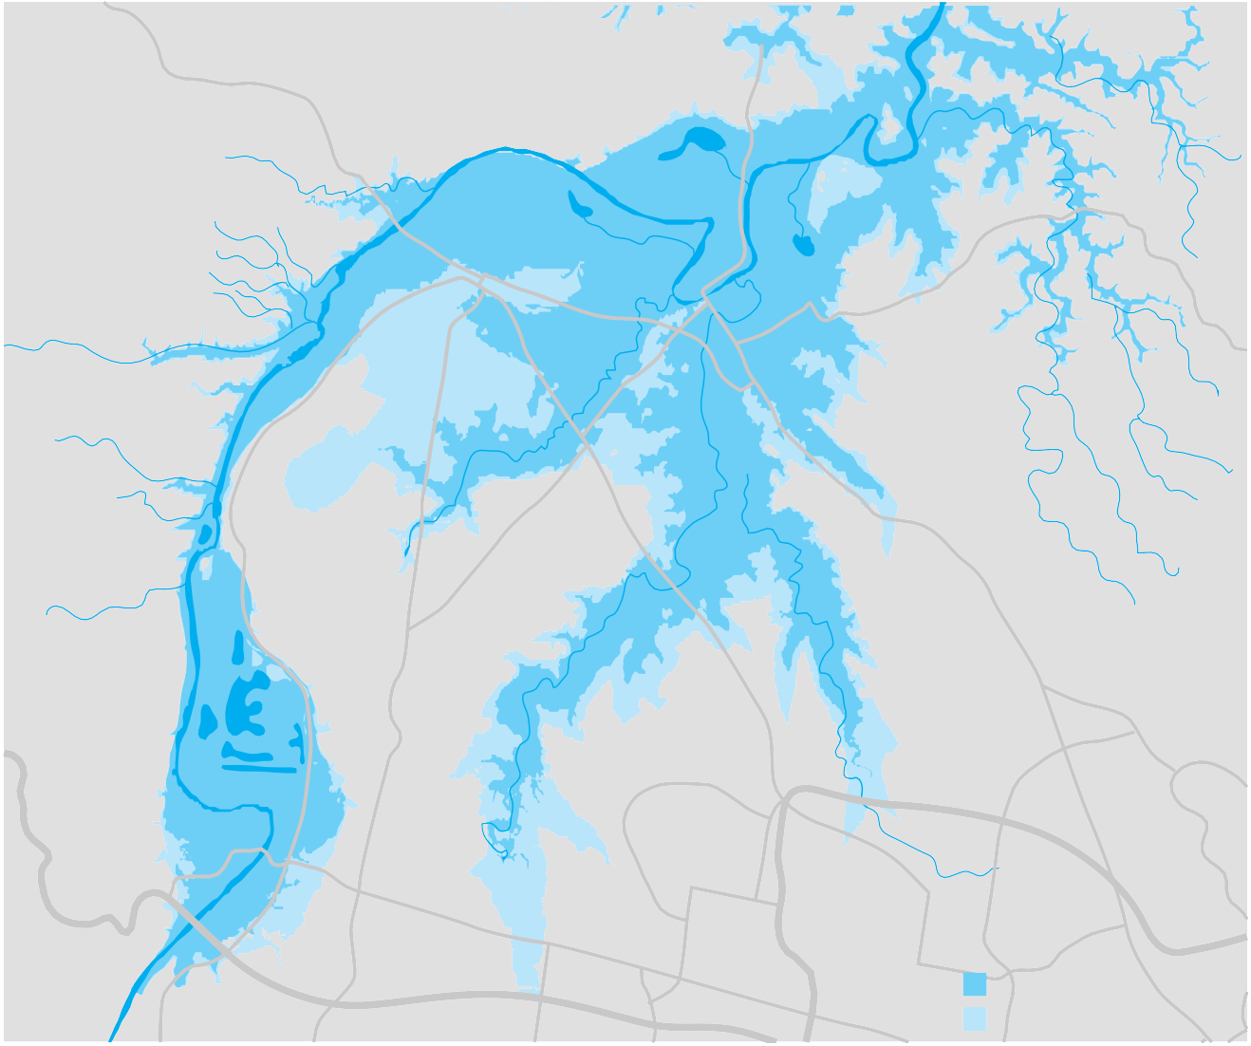A more detailed review of all the options to mitigate flooding in the HNV needs to be undertaken using the latest data available.
Figure 12.2 Potential Flood Levels
Wilberforce
North Richmond
Pitt Town
Richmond
RAAF Base
Windsor
McGraths Hill
Agnes Banks
Bligh Park
Londonderry
Windsor Downs
Riverstone
Castlereagh
Berkshire Park
Llandilo
Schofelds
Penrith Lakes
Cranebrook
Former ADI Site Developments
Dunheved
Shalvey
Hassal Grove
Quakers Hill
Whalan
Emu Plains
Penrith
Kingswood
Glendenning
Werrington
Woodcroft
Leonay
St Marys
Regentville
Key
1867 food extent
Probable maximum food extent
The decision taken in the 1990s of managing the issue through evacuation and planning has had either limited impact or benefit, or has been completely inadequate in reducing the social and economic impacts of flooding in the HNV.
Recommendation Infrastructure NSW recommends the NSW Government review all the major flood mitigation options available, including raising the Warragamba Dam wall, to significantly reduce the potential economic and social impact of flooding in the Hawkesbury Nepean Valley.
If major flood mitigation is not provided, roads in the HNV should be upgraded to ensure people can evacuate.

Governance of flood management in NSW
Infrastructure NSW has noted that an underlying problem inhibiting effective flood management in NSW is the lack of clear governance. Current arrangements spread responsibility for flood management across multiple Government agencies and local councils.
The lack of clear accountability creates the risk of inadequate risk management, and the dispersion of responsibility to councils without adequate overarching governance creates the risk of sub-optimal flood management, which in some cases may be reflected in excessively stringent planning development controls (with consequences for housing supply), as well as insufficient management of major risks.
To ensure that flood management issues are adequately addressed, including assessment of the option to raise the Warragamba Dam wall, it is recommended that the Government immediately conduct a review of current responsibilities with a view to ensuring a single entity has clear accountability for flood management within the State Government.

Recommended actions
The key strategies for water infrastructure are summarised below.

Recommendation Time years Type Cost and funding implications
51 | Hawkesbury Nepean floodplain implement mitigation measures | 0 – 5 | Major project | Scoping of $500 million, depending on option approved. Costs recoverable through user charges if included in regulated asset base.
52 | Merge regional water authorities from 105 to around 30 | 0 – 5 | Review | Assume revenue neutrality for Government.
53 | Water and wastewater upgrades in regional towns to meet national standards | 5 – 20 | Program | Scoping of $700 million, of which $200 million assumed to be user funded.
54 | Regional dam construction and safety upgrades | 5 – 20 | Program | Scoping of $400 million.
55 | Augment Hunter region water supply | 5 – 10 | Major project | Scoping of $500 million. Costs recoverable through user charges over time.
56 | Augment metropolitan Sydney water supply | 10 – 20 | Major project | No reliable cost estimate available until next revision of Metropolitan Water Plan.

13.0 Health infrastructure

Summary

Health snapshot

- Like health systems around the world, the NSW health system is facing considerable challenges to meet growing demand driven by an ageing population, lifestyle diseases and new care technologies.
- The NSW Government is delivering a prioritised capital program that will establish pro-actively planned ‘health care precincts’ with easy access to related private and public health services delivered by both government and non-government providers.
- It is recommended that the Northern Beaches Hospital be developed using this approach.
- Infrastructure NSW recommends that a proportion of new hospital beds be in smaller, specialist medical facilities (rather than multi-purpose hospitals) to improve efficiencies in delivery to public patients and cut waiting times.
- Meeting the challenges requires significant reform of soft infrastructure by introducing full-service
procurement, with potentially significant improvement to the health sector’s productivity, and implementing innovative models of care.
- Infrastructure NSW recommends repurposing community health centres to deliver a greater range of services in the community.
- Partnerships with the private and not-for-profit sector in the repurposing of these facilities will expand the delivery of new care models such as eHealth programs.
- Infrastructure NSW recommends long term reform to service purchaser models to achieve a better mix of services, while including the private sector. In the short term, Infrastructure NSW recommends investigation of excess capacity in the private sector and options to purchase full hospital services for public patients from the private sector to cut waiting times.
- NSW Health has infrastructure for support services such as medical imaging, pathology, pharmacy and surgical instrument sterilisation services and non-clinical services, car parking and nursing homes that are best provided by others. Infrastructure NSW recommends a targeted program to recycle capital to health priorities.
  - Like health systems around the world, the NSW health system is facing considerable challenges to meet growing demand driven by an ageing population, lifestyle diseases and new care technologies. NSW Health’s goals are to improve
health outcomes and meet the growth in demand for health services.
  - Demand for health care is forecast to grow by nearly 50 percent in the next 20 years, due to the ageing population and lifestyle diseases.
  - Supply of new hospital beds is estimated at around 275 beds per year (around 200 for acute care and 75 for sub-acute care). Without reform, this will put significant pressure on NSW’s capital and operating budget. Infrastructure NSW has identified initiatives from other states and around the world that meet
health sector outcomes with lower capital investment and therefore less embedding of fixed costs.
  - The NSW Government has announced a program of major new hospital works to start in 2012 and 2013 and NSW Health investment of around $10 billion is planned for the next 10 years.

    - The Government has $10.4 billion in health assets – 211 public hospitals, 143 community health centres, 87 child and family health centres and four nursing homes.
    - Health capital expenditure is less than 10 percent of total State infrastructure investment, but total health expenditure represents 27 percent of the entire NSW budget.
    - Public hospitals account for almost all the capital and 60 percent of the health operating budget.
    - Capital and operating expenditure doubled from 2001 to 2010 – an average growth rate of seven percent per annum. NSW’s capital expenditure per capita had been 24 percent lower than the average of the rest of Australia (in the decade to 2010).
    - Health capital budget is around $1 billion per annum. Health’s future capital requirements will be considered as part of a broader Asset Strategy Review, for the 2013-14 Budget process.
    - NSW has a smaller private health sector than Victoria or Queensland; if NSW had about the same number of public hospital and private hospital beds per 1,000 residents, it would have 2,179 less public hospital beds and 3,200 more private beds.
    - NSW Health has a higher proportion of private patients in public hospitals than any other state – 16 percent in NSW compared to nine percent in Victoria and five percent in Queensland; this in turn

Supply and demand
In responding to the growth in demand, Infrastructure NSW recommends that the management of existing hospital assets needs to be reformed first, while there is contemporaneous investment in renewal of health infrastructure. There is a need for the private sector to be used more efficiently, including in the deliverance of new care models.

Demand growth
The demand for health care and costs of services are increasing faster than the rate of population growth due largely to:
      - an ageing population – while population is forecast to grow by 30 percent by 2031, the forecast demand for health services may grow by 49 per cent1
      - average health expenditure per person over 65 years of age is four times more than for those under 65.
The Productivity Commission projected ageing will account for about half the increase in health expenditure as a proportion of GDP2
      - increasing prevalence of lifestyle diseases such as obesity and diabetes;
      - increased use of high cost and advanced technologies with shorter capital cycles
      - community expectations for certain care models and ready access to service options. Health needs are increasingly related to lifestyle factors requiring the system to change from a focus on treating illness to more illness prevention and ultimately over time the maintenance of wellness.
To meet forecast demand, NSW Health predicts an additional 200 acute beds and a minimum of
75 sub-acute beds are needed each year over the next 10 years3. This represents growth of only 1.5 percent per annum in the number of beds – lower than growth in demand because as models of care change, bed numbers decrease in relevance as more services are provided out of hospital.

discourages private investment.
- PwC 2012, Health Baseline Report.
- Productivity Commission 2005, Economic Implications of an Ageing
Australia. 3 NSW Health.

Managing existing hospital capacity to meet demand
NSW has 211 public hospitals with around 20,000 hospital beds.
Occupancy rates are increasing – the state average increased to 89.1 percent in 2011 compared to
85.1 percent in 2008. Occupancy above 85 per cent leads to increased waiting times for patients
in emergency.
The occupancy and availability are shown in Figure 13.1.
Figure 13.1 Bed occupancy and available beds at 30 June 2011 by Local Health District per ‘000 people
NSW also has more public hospital beds per capita than other states, NSW has a higher number of public
hospital beds per 1,000 residents (2.7 compared to 2.4 in Victoria, Queensland and WA) and fewer private hospital beds (1.0 compared to 1.4 in Victoria and Queensland and 1.6 in WA).
The reasons for more investment in public hospitals in NSW, and relatively fewer private beds include:
      - site availability and constraints of planning system
      - admitting specialists’ rights of practice at hospitals
      - lack of availability of services at accessible private hospitals
in NSW compared to nine percent in Victoria and less than five percent in Queensland, as shown in Figure 13.2 below.
Infrastructure NSW has concluded that these practices unnecessarily increase the demand for investment in public hospitals. Less use of public hospital beds by private patients would provide additional hospital beds for public care, reducing waiting times and reduce the need for new capital expenditure.
Figure 13.2 Share of public hospital separations funded from private health insurance, 2010-11

18

3.5

3.0

2.5

2.0

1.5

1.0

0.5

0.0
100%

90%

80%

70%

60%

50%

40%

30%
Central Coast
Far West Hunter New England IIIawarra Shoalhaven Mid North Coast Murrumbidgee
Nepean Blue Mountains
Northern NSW Northern Sydney South Eastern Sydney South Western Sydney
Southern NSW
Sydney Western NSW Western Sydney
Sydney Children’s Hospitals
      - NSW public hospital procedures encourage admitted patients to use their private health insurance.
In regards to private patients in public hospitals, public hospital CEOs have incentive to capture this revenue for both operating revenue and medical workforce retention reasons but do not have sufficiently clear accountability for long term capital implications.
Local Health Districts and hospitals are proactive in seeking private patient revenue as a means of generating additional operating income. While a proportion of patients who elect to be private patients in public hospitals are admitted through emergency departments and would most likely be treated in a public hospital
16

14

12
Percentage of separations

10

8

6

4

2

0
NSW VIC QLD WA SA TAS ACT NT

Average available beds Bed occupancy percentage (June)
Source: NSW Auditor General.
whether or not they were a public or private patient, another group of patients are elective admissions and could have been served in either public or private
facilities. NSW has a higher proportion of private patients in public hospitals than any other state – 16 per cent
Source: AIHW.

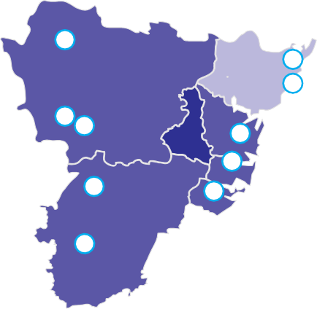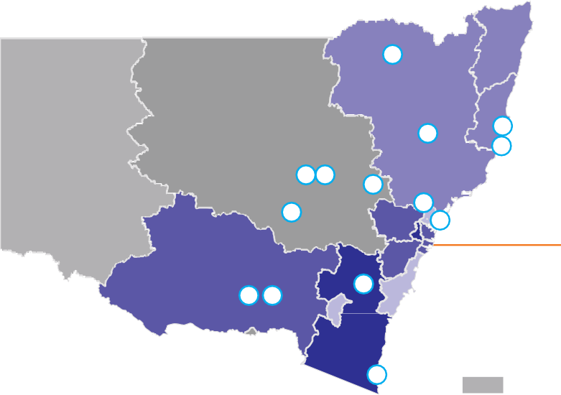Infrastructure NSW recommends that NSW Health review the current practice, including the role of private revenue targets, and reduce the high proportion of private hospital patients in public hospitals to free up hospital capacity for public patients. The current reliance on income from the privately insured patients would need to be replaced with public funding over the next five years.
15

Nepean Blue Mountains 20%
16 17
Central
20
Coast 7% 21
Western Sydney 24%
22

23
Northern Sydney 16%
18
Sydney 16%
Southern Western Sydney 16%
24
South Eastern Sydney 17%
Figure 13.3 Projected growths in rural acute activity and major hospital projects
6
Hunter
New England 13%
Far West -10%
Western 5%
1
Northern 13%
Mid North Coast 13%
8
7
5 3
4
2
10
9
Murrumbidgee 16%
13 14
11
4%
Southern 24%
12
Illawarra Shoalhaven 6%
Percentage growth in acute activity 2009-2017
Negative 1 to 5%
6 to 10%
11 to 15%
16 to 20%
21+%
New major health projects first 10 years
1

2
3
4
5
6
Tamworth Hospital Redevelopment Stage 2
Tamworth Stage 3 Redevelopment Parkes and Forbes Health Service Dubbo Hospital Stages 1 & 2 Gulgong Multipurpose Service Dubbo Hospital Stage 3/4
Northern NSW
- Port Macquarie Base Hospital
- Kempsey Hospital Redevelopment
- Morriset/Kestrel
- Maitland (Lower Hunter Strategy)
- Goulburn Base Hospital Redevelopment
- South East Regional Hospital Bega
- Wagga Wagga Hospital Redevelopment
- Wagga Wagga Hospital Redevelopment Stage 3
- Nepean Hospital Stage 4
- Blacktown/Mt Druitt Hospitals Stage 2
- Westmead Hospital Refurbishment and Expansion Stage 1
- Liverpool
- Campbelltown Hospital
- Gosford/Wyong
- Central Coast Growth Strategy
- Hornsby Kuringai Hospital Stage 1
- Northern Beaches
- Rozelle
Demand growth Source: NSW Health; Excludes chemotherapy, renal dialysis, unqualifed neonate, ED only and Hospital in the Home admitted services. Project Source: NSW Government.

Major new hospital works
Infrastructure NSW concurs with the Commission of Audit’s conclusion that ‘facilities are run down’4. There is a clear need for ongoing planned and systemic investment and management of health infrastructure, a regular program of renewal to extend life and to
upgrade to modern standards for efficiency in delivering contemporary acute health care services.
NSW’s capital health expenditure per capita has been consistently lower than any other state. Health capital expenditure as a proportion of total state government health expenditure in NSW in 2011-12 is five percent compared to 16 percent in Queensland and nearly
11 percent in Victoria.
The prioritised capital program over the next 20 years to meet expected growth in demand includes the major projects shown in Figure 13.3. The major hospital projects are those included in the 2012-13 Health Plans.
Infrastructure NSW, NSW Health and NSW Treasury are reviewing the capital plans to determine priorities for the 2013-14 budget.

- NSW Commission of Audit 2012, Government Expenditure, Final Report.

Changing the portfolio of health infrastructure
Figure 13.4 Acute Bed Days for Persons Aged 75 and over 13.3.1 Non-hospital service reforms to date
HITH services provide acute and sub-acute care to patients

Contemporary models of care can deliver efficiencies in both operating and capital costs while maintaining and even enhancing quality outcomes for patients. These models lower demand for high-cost hospital services over time and will significantly change the portfolio of health assets needed in the future.
NSW Health has introduced a range of contemporary models of care including Hospital in the Home (HITH),
a multi-purpose centre strategy to repurpose short stay wards and community support packages to improve patient care and reduce hospital admissions, especially for older people. This has significantly reduced demand for acute bed-days by 13.6 percent in the last four years as shown in Figure 13.4 below.
1,800,000
1,700,000
13.6%
1,600,000
1,500,000
1,400,000
Acute Bed Days
1,300,000
1,200,000
1,100,000
1,000,000
900,000
800,000
2000/01
2001/02
2002/03
2003/04
2004/05
2005/06
2006/07
2007/08
2008/09
2009/10
2010/11
2011/12*

Source: NSW Health.

Actual Forecast if no intervention
with certain conditions, who may otherwise occupy a
hospital bed in a lower cost setting. Various studies5 show significantly lower costs, by:
- avoiding treatment costs that would otherwise be incurred as a result of hospital acquired or associated infections
- avoiding Emergency Department (ED) presentations and ambulance transfers where transfer to an acute hospital ED is unnecessary
- improving hospital operational efficiency as a result of ensuring that the case mix of in-hospital services aligns with the services that can only be provided in a hospital setting.
A 2009 study showed the cost of episodes of acute care containing a HITH component were overall nine percent less expensive than in-hospital care while pure HITH was 38 percent cheaper than matched hospital care with the same or better clinical outcomes6.
NSW Health has actively stimulated the ‘Hospital at Home’ services sector and has invested in eHealth programs.
Information and communication technology (ICT) solutions have proven capability to support models of care that cost effectively shift some of the demand curve away from hospitals. Telemedicine, remote monitoring and other innovations in technology also provide a

- PwC 2012, Health Baseline Report.
- MacIntyre, C., Ruth, D., and Ansari, Z. 2002; cited by PwC.

platform for greater efficiency and enable improved care. Capacity for real time transfer of patient records between a patient’s clinicians, removing scope for errors in administering medication, more efficient in-hospital administrative systems and capacity for remote treatment and diagnosis offer enormous potential for transforming health care service models.

13.3.2 Developing partnerships with the private sector (including not-for-profit) to increase out of hospital care
Primary interactions with the health care system occur at a local level. As the primary coordinator of a patient’s out of hospital care, general practitioners (GPs) are integral to planning for primary health care and its effective and efficient integration with hospital-based services.
A combination of population age and lifestyle-based diseases generate demand for health services. As such, the interaction and collaboration of providers across the continuum of care is important in managing demand and providing opportunities for innovative care models, which might require less capital intensive investments.
Community health centres with a mix of GP, public health and private services (such as diagnostics) have potential to provide a convenient local access point to health services that facilitate integrated care.
The Commonwealth ‘Medicare Local’ GP Service program targets better co-ordination of care and reducing the pressure on public hospitals as a result of providing services to patients who could be better cared for in non-acute settings. The GP Service Centres are
operated by the private sector and deliver services that would otherwise be provided by public hospitals.
Partnerships with the private sector (including AHO and not-for-profit) to repurpose existing infrastructure would expand the delivery of new care models such as "Medicare Local" hospitals in nursing homes and
eHealth programs more rapidly than would otherwise be the case. The private sector could become a co-investor in the repurposing of existing facilities and public health service provider from these facilities.
Recommendation Infrastructure NSW recommends repurposing community and family health centres to deliver new models of care and a greater range of services, integrating Medicare Local or other GP services with community and family health centres. A trial reconfiguration program is recommended as a first stage.

13.3.3 Changing the ‘mix’ – specialist medical facilities
Australia is now starting to adopt the concept of specialist medical facilities (mini specialist hospitals) which provide a limited range of medical treatments such as dialysis, cancer treatment centres, cardiology diagnostics, sleep disorder therapy and day surgery. These facilities are purpose built and operate more efficient delivery models. Efficiency is derived partially from the medical specialisation, use of cutting edge technology and the ability to attract specialist staff who wish to work in the given field.
In the UK, Independent Sector Treatment Centres demonstrate the role of the private sector in providing elective surgery, diagnostic and other clinical services to National Health Service (NHS) patients. These facilities are owned and run by organisations outside the NHS. Involving the private sector was considered a viable alternative for creating additional capacity and provided greater choice to patients. As at September
2011, 252 facilities were opened under the NHS’s LIFT7 scheme with an additional 35 under construction with a total value of all facilities of £2,039 million. A review of the LIFT scheme carried out in 2008 concluded it had been particularly successful as a catalyst for building healthy communities by helping to shift hospital-based services into primary care8.
The expansion of existing hospitals to cope with increasing demand can be curbed through NSW Health developing specialist standalone facilities, as described above, or through the purchases of such services from the private sector.
Infrastructure NSW supports further investigation and development of specialist medical facilities as
alternatives for expanding existing hospitals, to improve efficiencies in delivery to public patients, cut waiting times and reduce capital costs.

- Local Improvement Finance trust (LIFT).
- PwC 2012, Health Baseline Report.

Full service procurement
Full service procurement is proposed for public health services to be delivered by the private sector. The proposed full-services procurement model is consistent with activity-based funding and increased accountability of Local Health Boards and is expected to significantly improve productivity in the health sector.

Full service provision
Infrastructure NSW supports long term reform to an outsourced model where the NSW Government would buy public hospital services, on an activity basis using an efficient price per service model.
As noted above, NSW has more public sector and less private sector hospital beds than other states. The Productivity Commission developed estimates (with

Figure13.5 Cost per casemix-adjusted separation by Jurisdiction and Sector, 2007-08

600

500

400

300

200

100

0
Whilst NSW Health/Local Health Districts already purchase services from the private sector, this mode of capital efficient procurement could be expanded and accelerated.
The recommendation for full service procurement of public health from private providers is very different to past Public Private Partnership (PPP) models.
To date, PPP models have been used in NSW to deliver infrastructure and provide maintenance and some support services. The traditional PPP models
reduced initial capital cost for government and provided capacity to accelerate infrastructure delivery as well
as enabling outsourcing of ongoing maintenance and asset management to ensure facilities stay in near new condition.
In the long term, a ‘buy’ rather than ‘build’ strategy could

significant caveats around the available data) that show the capital cost of health care per casemix-adjusted separation is much lower for private hospitals than public hospitals, as shown in Figure 13.5.
NSW VIC QLD SA

Public Private

Source: Productivity Commission.
WA TAS, NT Australia & ACT
significantly reduce costs by improving the competitive
character of the NSW health market and expanding choices for the community.
The recommended full service procurement strategy

These comparisons of private and public hospital activity between states are blunt but indicate that there are opportunities for lower costs by increasing the private sector’s proportion of supply of public health services in NSW.
Infrastructure NSW has also found that there is under-utilisation of private sector infrastructure. Private providers have submitted that there are at least 300 ‘moth-balled’ beds available for full-service procurement for public health use, without any substantial capital investment.
and specialist precinct strategies will create momentum for redressing the imbalance. Private providers should also have greater involvement in the planning and prioritisation process to better identify possible market entry points.

Co-location in health precincts
NSW is already well serviced with large full-service general hospitals. The recommended strategy for better leveraging capital investment at current and new facilities, is to establish centres of excellence in pro-actively planned ‘health care precincts’
with clusters of related health services delivered by government and non-government providers.
This derives benefits from both agglomeration and specialisation, and complements the existing network of large general hospitals.
Specialist centres, rather than having many general hospitals, provides the benefit of improving the quality of care where there is sufficient demand for services. Centres of excellence have greater capacity
to attract a critical mass of specialist clinicians, facilitate high standards of training and invest in advanced specialty equipment.
Given this approach, planning for a general hospital for the Northern Beaches Hospital site is an opportunity to develop a model of developing the public hospital
co-located with a private facility, timed and designed to match health demand and to complement rather than duplicate specialist services that are provided (or planned for) other locations in surrounding areas.
A precinct approach allows private operators to plan and establish services on the same site and derive the benefits of shared infrastructure, shared workforce and ancillary services.
Recommendation Infrastructure NSW recommends long term reform to service purchaser models for new public hospital capacity, to lower investment in capital intensive infrastructure and achieve a better mix of services.
In the short term, Infrastructure NSW recommends investigating excess capacity in the private sector and options to purchase full hospital services for public patients from the private sector.
Planning for co-location of public and private facilities will also increase the attractiveness of private sector service provision with the benefits of:
- knowledge transfer across public and private sectors (both clinical and management where these services are co-located)
- labour pool sharing and recruitment and retention
- demand and labour matching
- scales of economy – e.g. sharing of infrastructure and reducing the capital cost per patient; or price savings through greater buying power through suppliers of services.
Recommendation Establish pro-actively planned ‘health care precincts’ with clusters of related private and public health services delivered by
both government and non-government providers. Potentially, the Northern Beaches Hospital will be constructed using this approach.

Exit from support infrastructure
There are also opportunities for NSW Health to better utilise existing capital stock by exiting some clinical support services at existing sites such as medical imaging, pathology, pharmacy and surgical instrument sterilisation services and non-clinical support services, including car parking.
The private sector is already set up to provide these services at an efficient price. A planned careful exit of these services will mean that NSW Health can provide more beds where needed at a lower cost through recycling capital or repurposing existing facilities.
Recommendation NSW Health to reconfigure or divest surplus assets associated with exit from some support services such as medical imaging, pathology, pharmacy and non-clinical services, including car parking and nursing homes, in a targeted program.

Recommended actions

Recommendations Years Type

Cost and Funding Implications

57 | Construct Northern Beaches Healthcare Precinct, public and private facilities co-located | 0 – 5 | Major project | Existing Government commitment
58 | Divest non-core assets such as pharmacies and car parks | 0 – 5 | Asset utilisation | Potential capital savings
59 | Trial reconfiguration of existing health centres to support new models of care | 0 – 5 | Asset utilisation | Cost of trial not material
60 | Evaluate provision of new public hospital capacity by private sector providers | 0 – 5 | Review | Potential capital savings
61 | Upgrade and build new healthcare facilities in accordance with projected demand | 0 – 20 | Program | Existing Government commitment. Program will reflect NSW Health preferred models of care

14.0 Social infrastructure 14.1 Education

Education snapshot
Summary
- NSW’s school population is expected to grow by around 250,000 in the next 20 years, with more than a million students in 2031.
- Infrastructure NSW’s recommended strategy is for 90 percent of new students to be accommodated in existing schools, leveraging the existing infrastructure, with some conversions to renew the portfolio of education without increasing its footprint. Increasing the average size of schools makes better use of existing assets and provides better learning outcomes.
- In addition, 29 new schools, including eight in regional areas, are expected to be built across NSW in the next 10 years.
- A new classroom design for technology driven teaching methods and learning is recommended as an urgent priority. Input from the NSW Government’s Information and Communication Technology (ICT) Board, industry and the private sector will ensure the standard is innovative and reflects the next generation’s use of technology.
- Strategies are recommended to increase the use of school facilities by the community, such as playing fields and libraries.
- Local decision-making about minor capital works and infrastructure priorities will help to rapidly bring NSW schools up to the new national minimum standard. School principals and TAFE directors will have authority to prioritise work to meet local needs.
The NSW Government provides teaching and learning to over 1.4 million students.
      - the NSW Government has $21 billion1 invested in public education infrastructure.
        - 66 percent of NSW’s school student population attends Government schools (around 800,000 students).
        - TAFE delivers around two thirds of accredited training in NSW to around 600,000 students.
      - these services are provided through 2,234 schools and 130 TAFE campuses, accommodated in over 26,000 buildings.
      - investment in education infrastructure in the past decade was driven by changing class sizes and other policies; the school population did not significantly grow.
      - however, primary and secondary school populations are expected to grow, with over 70,000 new students in the next 10 years.
      - TAFE demand is not expected to grow as vocational learning is increasingly provided by the private market.
      - average expenditure by the NSW Government over the past 10 years has been around $500 million per annum across the school and TAFE sectors (excluding the Building the Education investment of
- the Education Department’s forecast investment in education infrastructure for the next 10 years is around $600 million per annum.
- higher education and the university sector is outside the scope of the Strategy. However, a robust and successful tertiary sector is vital to ensuring NSW
is attractive to both business and the knowledge workers who drive the economy.

Review of Funding for Schooling Findings
Infrastructure NSW’s recommendations and strategies for public education are informed by the findings and recommendations of the Commonwealth’s Review of Funding for Schooling, (the Gonski Review).
The Review reported a decline in education standards in the past decade and recommended increased funding. The report highlighted that the quality of infrastructure does have a strong influence on education outcomes (although it is difficult to measure)2.
The Review concluded that both additional infrastructure funding and better planning was needed to bring Government schools up to a quality standard and recommended the introduction of new national
facilities standards. The panel recommended the Commonwealth Government provide a substantial contribution3.

around $3 billion in the past three years).
2 Australian Government 2011, Review of Funding for Schooling, Final Report.
1 NSW Government, 2012-13 Budget Paper 4. 3 Australian Government 2011, Review of Funding for Schooling, Final Report.

Infrastructure NSW’s recommendations reflect some of the Gonski Review conclusions, as outlined below:
- Introducing new facilities standards (refer Recommendation 5)
- Joint planning with the private sector (discussed below)
- Greater local accountability for investment (refer to Recommendation 4).
New facilities standards
Infrastructure NSW supports a national minimum standard for education facilities if it is implemented consistently with the Local Schools, Local Decisions reform by the NSW Government. Infrastructure NSW supports publishing a minimum standard, (which would be known to communities) with
responsibility for maintaining that standard devolved to school principals.

Joint planning
The Review Panel observed that there are currently no coherent and transparent institutional or regulatory
arrangements by which the public and private education sectors can participate to agree the best approach to school provision4.

- Australian Government, 2011 Review of Funding for Schooling, Final Report.
The Review recommended a School Planning Authority be established in each state and territory to promote comprehensive and co-ordinated planning for schooling (across public and private sectors) and to avoid unnecessary duplication and under-utilisation of assets.
Infrastructure NSW notes that, collaborative co-planning could be achieved by:
      - providing greater opportunity for the private sector to identify market entry points through published demographic and planning information
      - removing any barriers against private schools in the planning, licensing process and promoting
coordination from the earliest stages of the planning process
      - increasing opportunities for shared use of facilities
e.g. design new schools to enable shared access to playing fields or libraries.

Inefficient investment in and use of school facilities
The Review identified community concerns about inefficient investment in and use of school facilities with some submissions to the inquiry raising the need for school facilities to be accessible outside of school hours for community use. The Department of Education and Communities has identified options such as open space sharing on a case-by-case basis. Infrastructure NSW notes that there is potential for greater collaboration and development particularly with other education providers and local councils.
These findings are built into the strategies and recommendations below.

School Demand
There were 435,000 primary students and 317,000 high school students in 2,234 NSW public schools in 2011. The school population is expected to grow to 486,000 and 335,000 respectively in the next 10
years, meaning nearly 70,000 additional public school enrolments are expected throughout NSW.
Demand for education infrastructure has been impacted by:
      - the post millennium ‘baby boom’ – the size of the student aged population is forecast to grow by nearly one percent per annum in the next 20 years
      - an increase in private enrolments to 34 percent from just under 31 percent in 2000
      - smaller class sizes introduced over the past 10 years which require more separate teaching spaces
and have reduced capacity to absorb additional enrolments within existing facilities
      - the increase in 2010 of the minimum school leaving age from 15 to 17
      - demand is managed to some extent through catchment boundaries, which are reviewed to direct students to schools with capacity.
Growth occurs largely in the primary sector in the next 10 years, which means that the secondary schools will see more growth in the second decade, as shown in Figure 14.1.

Figure 14.1 Forecast Annual Increase in Student Numbers – 2012-21
10,000
Figure 14.2 Teaching Space Utilisation for Public Primary Schools 2011
120
Figure 14.3 Teaching Space Utilisation for Public High Schools 2011
120

8,000

6,000
Number of students

4,000

2,000

0

(2,000)
2012
2013
2014
2015
2016
2017
2018
2019
2020

Primary

Secondary
100

80
Percentage

60

40

20

0
2021
100

80
Target Range
Target Range
Percentage

60

40

20

0

Source: NSW Department of Education and Communities.
Riverina
New England
Western NSW
Sydney
Illawarra South East
Western Sydney
South Western
Sydney
North Coast
Hunter/Central
Coast
Northern Sydney
NSW Total
Riverina
New England
Western NSW
Sydney
Illawarra South East
Western Sydney
South Western
Sydney
North Coast
Hunter/Central
Coast
Northern Sydney
NSW Total

Department of Education Regions Department of Education Regions

PTS Utilisation %

TTS Utilisation %

PTS Utilisation %

TTS Utilisation %

School capacity
Overall, NSW primary schools had a utilisation rate of permanent teaching spaces (PTS) of 99.1 per cent in 2011 (refer to Figure 14.2). Utilisation rates greater than 100 per cent are supported with demountable
accommodation, counted in the Total Teaching Spaces (TTS) ratio.
PTS = Permanent Teaching Spaces TTS = Total Teaching Spaces
Source: NSW Department of Education and Communities cited by PwC.

High schools have lower permanent teaching space utilisation5 rate of 86.5 percent, that is, there are
2,443 permanent teaching spaces more than required by the overall current level of high school demand as of March 2011 as shown in Figure 14.2 and 14.3.

- Teaching space ratios are calculated differently for high schools, based on teacher numbers times a ratio of face to face teaching time.
PTS = Permanent Teaching Spaces TTS = Total Teaching Spaces
Source: NSW Department of Education and Communities cited by PwC.

In high schools, low enrolments lead to poor student outcomes because the full range of subject choices and teachers for specialty subjects become unavailable to students and the average achievement level falls.

TAFE demand and capacity
Increased contestability of funding for vocational training and flat student numbers over the past eight years suggests that TAFE enrolment numbers will be lower than population growth.
Demand for infrastructure in this sector is more likely to be driven by the need for use of upgraded technology and industry compatible facilities to enhance the development of vocational skills. Future TAFE reforms may significantly alter asset requirements.
Around 575 hectares of land is shared between schools and TAFE, and in many cases the learning environments needed to deliver TAFE and high school courses are compatible.

Recommendation Given forecasts of demand, Infrastructure NSW recommends merging the asset management functions across the education portfolio to unlock the significant potential to improve asset utilisation across TAFE and high schools.

Infrastructure NSW supports greater local decision making by school principals and TAFE directors. Merging the asset ‘head office’ functions is consistent with the Commission of Audit recommendations for greater devolution and efficiency.

Meeting demand
Infrastructure NSW recommends a new approach to accommodating more students through greater use of existing assets. 90 percent of new students will be
accommodated by expanding existing schools. This has
the potential to lower the capital cost per student and improves educational outcomes, as research has shown that larger schools achieve higher results on average.
However, 29 new schools are expected to be built, in the next 10 years, subject to location reviews in due course. The proposed new schools and the demographic trends in each region as shown in Figure 14.4
(note: some of these projects are yet to be assessed or considered for funding).
Accommodating 90 percent of students in existing schools will meet demand at a lower capital cost and will reduce operating costs over the long term. Larger schools can have advantages over smaller schools including providing greater subject choice, more extra-curricular activities, ability to attract
experienced, quality teachers and capacity to provide more specialised infrastructure and equipment.
However, expanding existing schools in built up areas including large infill developments requires a new approach and a “Brownfield Partnership” model is being developed. The new approach involves
partnerships with developers, local councils and greater co-ordination across Government and with the private education sector.
These partnerships may involve:
      - Working with developers to expand school infrastructure at the time of building high density residential developments.
      - Active management of land and exploiting all opportunities for expanding using other Government land and sharing land (eg sporting fields).
      - Reconfiguration of a precinct of small schools to increase total capacity. Some opportunities exist for rationalistion and recycling capital to provide quality school outcomes.
Recommendation Infrastructure NSW recommends accommodating 90 percent of new students in existing schools. The increase in average size of schools makes better use of existing assets and provides better learning outcomes.

New classroom designs
The current standards for schools, including the spatial and technical requirements and design, were developed in the 1970s and do not reflect rapid technology
driven changes to how teaching and learning occur.
The Department of Education and Communities has started the project to review and modernise the designs, and develop a new classroom standard. The first step is to assess functionality and requirements of the physical learning environment which will involve case studies
of 13 schools.
Infrastructure NSW recommends that this work be supported and accelerated. This program should employ the Government’s ICT Board, industry and the private sector to ensure the standard is innovative and reflects the next generation’s use of technology.
Recommendation Infrastructure NSW supports rapid development of new classroom design and standards for technology-driven learning.

Figure 14.4 New Schools and Demographic Trends by region

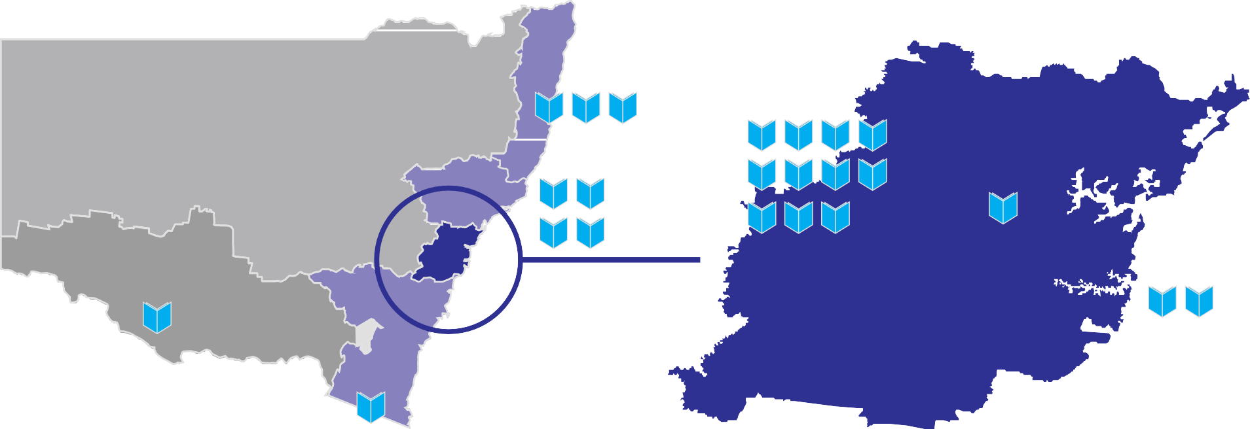
New South Wales
Greater Sydney
North Coast 8%
Western 19%
Inland NSW - 0.7%
Hunter 8%
Northern 16%
Murray 4%
Sydney (East and Inner west) 14%
South Coast 8%
Percentage growth in primary student numbers
South Western 15%
Negative growth 0-5%
5-10%
Greater than 10% New School

Source: Department of Education and Communities.
* Greater Sydney represented by Department of Education and Communities boundaries.

Infrastructure NSW | State Infrastructure Strategy

Local decisions for better value for money
The NSW Government is implementing the Local Schools Local Decisions policy and action plan aimed at improving teaching and learning in public schools by increasing the authority of local schools to make
decisions about how they deliver education and maintain facilities for students.
As part of this process, schools will manage a much greater proportion of their budgets. Schools have the choice to self-manage annual planned maintenance, and a $40 million “Local Schools Upgrade Fund”
has been established to empower local principals and communities to upgrade facilities based on local agreed priorities.
A large proportion of the existing capital budget is absorbed in refurbishments which are often avoidable if maintenance standards had been kept up. Infrastructure NSW supports a minimum facilities standard with local principals responsible for monitoring the standard.
Asset management plans will be provided to school communities about the condition of assets and when major refurbishments will occur. This can generate a range of benefits and leverage Parents and Citizens input to funding school facilities.
Impact of the Building the Education Revolution Between 2009-10 to 2010-11, the Building the Education Revolution (BER) fiscal stimulus provided an additional
$3 billion of additional investment in schools. The Commonwealth investment in infrastructure has not reduced the need for NSW Government investment in any measureable way and, in some cases, has caused local planning disruption and community dissatisfaction
with other facilities. Maintaining the Building the Education Revolution facilities could also cost in the order of $60 million per annum once the facilities age.

Community co-use
Recommendation Infrastructure NSW supports a new school facilities national standard (to be determined federally) and greater community use of facilities out of school hours i.e. libraries and, co-use of open space. These recommendation
could be delivered through the Local Schools Local Decisions policy.
The Department of Education has also initiated measures to increase the extent of engagement with the local community to ensure co-use of facilities (such as playing fields, libraries etc) are fully explored before building projects are authorised.
The Local Schools Local Decisions policy is fostering innovation and significant opportunities for co-use. Engagement at the early stages of planning with the local community means proposals are being generated that encompass greater co-use of facilities.
Case Study: Canada Bay LGA Primary School
- DEC has been working with City of Canada Bay Council to identify a site for new schools. The community is being encouraged to be involved in the school’s development and operation
- A council-owned site has been identified and there is in-principle agreement to use part of the site for the new school and to share the remaining playing field part with the local community
- The development will provide new parking and bus layover facilities for the school which will also be used by the community during sports events.

14.1.9 Summary of education recommendations
Table 14.1 Summary of recommended actions
Recommended action Years Type Cost and funding implications
62 | Target provision of 90 percent of new school places on existing school sites | 0 – 5 | Program | Potential capital savings
63 | New classroom design for technology-driven learning | 0 – 5 | Planning | Cost of concept development is not material
64 | Increase shared community use of school assets, including repurposing assets where appropriate | 0 – 5 | Asset utilisation | Potential capital savings
65 | Combine TAFE and school asset management function to increase utilisation | 5 – 10 | Asset utilisation | Potential capital savings
66 | Upgrade and build new educational facilities in accordance with projected demand | 0 – 20 | Program | Existing Government commitment. Program will reflect agency preferred models of learning

Arts, recreation and the visitor economy

Summary
- Our arts and recreational facilities support a vibrant and creative NSW. Cultural and sporting institutions are vital for attracting and retaining the people and skills that NSW needs to compete in the global economy.
- The NSW Government’s plan to double the visitor economy will require targeted investment in infrastructure relevant to visitors, particularly those coming from overseas.
- The Visitor Economy Taskforce has identified potential for arts infrastructure to act as an enabler to support visitor growth, creative industries and economic growth in regional NSW.
- Given constraints on NSW Government funding, new partnership models with the private sector will be required to deliver the infrastructure proposals from the sector over the timeframe of the Strategy.
In the area of the arts, Infrastructure NSW supports:
- Arts NSW’s Cultural Venues Plan, which includes the development of an Arts Ribbon around the CBD, the development of a world class arts and cultural precinct at Walsh Bay and phased renewal of the Opera House and expansion of the Art Gallery of New South Wales.
- The establishment of new partnership models with the private sector and the Commonwealth, based on the successful “Development Partnership” models used in London and New York.

In the area of Recreation, Infrastructure NSW supports:
- A review of Sydney Olympic Park to consider how best to realise the value of the NSW Government’s
$1.8 billion infrastructure investment in this precinct.
- Linking the Moore Park precinct with Central Railway Station by light rail.
For the visitor economy Infrastructure NSW supports the construction and delivery of the Sydney International Convention, Exhibition and Entertainment Precinct (SICEEP).

Arts and Recreation Snapshot
      - The NSW Government has about $9 billion invested in the Arts and Recreation portfolios, including
$3 billion in cultural institutions, more than $4 billion in collections and $2 billion in sporting venues.
      - The average expenditure by the NSW Government over the last 10 years has been $114 million per annum, 55 percent on sporting venues and
45 per cent on cultural venues1.
      - The capital budget for 2012-13 for the Arts and Recreation portfolios is around $250 million including major work at the Opera House ($82 million) and Sydney Cricket Ground ($72 million).
      - Some five million people attended a sporting event at NSW Government venues last year and 25 million
visited the many parks and outdoor facilities provided and operated by the NSW Government.
      - Nearly five million people attended a cultural venue at lEast once last year.
      - The Australia Bureau of Statistics (ABS) estimates that key cultural and arts sectors contribute over $4.5 billion annually (or four percent) to the NSW economy.
      - Infrastructure in Regional NSW to support cultural facilities is provided by local Government, supported by grants from the NSW Government. The majority of the State Government’s expenditure on arts
and recreation is provided to local Government and arts organisations.

1 Asset values and expenditure exclude Museum of Contemporary Art’s expansion as it is not a NSW Government owned institution.

- Infrastructure investment in these portfolios has, however, historically been ad hoc and without an overarching strategy.
- The NSW Government is preparing a Cultural Venues Plan and has initiated reform to the management
of recreational venues via development of the NSW Stadium Strategy and the establishment of Venues NSW.
- The NSW Government’s Visitor Economy Taskforce has also recognised the critical role of arts and recreation in achieving economic benefits from the visitor economy both in Sydney and in Regional NSW.

Recreation
NSW’s recreational facilities include leading sporting venues, beaches, parks and reserves. Many of these facilities have strong links to the community and are a core component of a high quality of life.
There are over 25 million visits to parklands each year
- 12 million visits to Sydney Olympic Park, 11 million at Centennial Parklands and around two million at Parramatta Park. The NSW Stadium Strategy and the
establishment of Venues NSW will improve management of Government-owned sporting and entertainment venues in the Hunter, Western Sydney and the Illawarra. Infrastructure NSW has considered the two largest
Figure 14.5 Attendance at Major Cultural and Recreational Institutions 2010/11
5.0
4.5
Total number of Attendees (m)
4.0
3.5
3.0
2.5
2.0
1.5
1.0
0.5
0

Industry Structure
Arts
Sydney has Australia’s largest community of artists across fields including music, film, performing arts, visual arts, museums and festival events. Ten of the 28 major performing arts group in Australia are located within the State. The Sydney-based cultural institutions also play an important role in Regional NSW through lending and touring collections, offsite presentations and providing online access to resources and digitised collections.
Future growth of these institutions, however, may be constrained by infrastructure limitations. For example,
infrastructure assets – Sydney Olympic Park and the Moore Park precinct.

Visitor Economy
Overall visitor numbers in Sydney have remained broadly flat over the past decade, averaging 2.7 million visitors per year. International holiday visitor numbers are lower in 2010 (1.9 million) than they were in 2001 (2.3 million).
The Visitor Economy Taskforce strategies to increase visitor numbers rely, to some extent, on the
attractiveness of our cultural institutions and programs.
As figure 14.5 illustrates, in 2010 3.6 million people attended the State’s four leading cultural institutions
Culture venues
Sydney Opera House Australian Museum
Museum of Applied Arts and Sciences Art Gallery of NSW
Centennial Park and Moore Park Trust Hunter Region Sporting Venues Sydney Cricket and Sports Grand Trust Illawarra Venues
Major Stadiums at Sydney Olympic Park Parramatta Stadium
Sporting venues and events

the Art Gallery NSW exhibition space, (23,000m²), is half
the size of comparable facilities in Canberra, Melbourne and Brisbane. Only two of the last 10 blockbuster exhibitions in Australia took place in Sydney2.
and 4.7 million people attended Government-owned sporting venues:
Source: Arts NSW, referenced in PwC; Repucom; INSW analysis
Note: Does not include estimated site visits or trips to parklands. Visits to parklands are estimated at 12.5million visits to Sydney Olympic Park, 11million at Centennial Park and over 1.7million at Parramatta Park. Figures for Major stadiums at Sydney Olympic Park and Parramatta Stadium not specifed for 2010/11; based on 2009/10 data.

2 PwC 2012, Arts and Recreation Report.

Private Participation and Funding
The arts sector is funded by ticket sales, sponsorship, philanthropy and the three levels of Government, Commonwealth, state and local. Arts ticket sales in NSW raised $465 million in 2009-10, the largest of any State, but this is not used to fund infrastructure.
Private funding for NSW cultural institutions has nearly doubled over the past decade and now accounts for over 10 percent of total funding. NSW accounts for the largest share of private sector support in Australia, 37 percent.
Arts NSW advise that private and philanthropic funding is directed to public facing works such as new galleries, acquisitions or extensions to exhibition space. All acquisitions made by the Art Gallery of NSW are fully privately funded.
Infrastructure NSW notes that arts cluster renewal and support of institutions in other cities has been driven, supported and delivered by businesses, industry groups and individuals in a “Development Partnership” model. For example, development partnerships have been used in London and New York to increase funding for clusters as part of broad regeneration efforts3.
Investment in infrastructure could also generate more philanthropy for collections, sponsorship of programs and events and increase self-generated revenue.
Infrastructure NSW proposes that Arts NSW and the Australian Business Arts Foundation develop the new “Arts Development Partnership” approach to infrastructure funding.

Figure 14.6 Arts sponsorship & giving by State/Territory
100

80

60

40

20

0
09/10 09/10 09/10 09/10 09/10 09/10 09/10
NSW VIC QLD WA SA TAS ACT
Donations Sponsorship
Source: Australia Business Arts Foundation; cited by PwC.

Recommendation Infrastructure NSW recommends a new approach to arts funding by supporting the establishment of an Arts Development Partnership which explores alternative partnership models for capital funding.

Developing the Arts Ribbon
Arts and cultural policies and investments that are integrated with broader development and regeneration effort achieve the highest benefits. Infrastructure NSW supports the development of the Arts Ribbon linking the cultural venues around Sydney Harbour and the CBD.
Government funding is limited, and accordingly alternative funding sources will be critical, particularly in respect of planned refurbishment of the Opera House.
In the next five years, the Arts Ribbon will be stimulated by committed investments at Walsh Bay, Barangaroo and Darling Harbour.
The Barangaroo Delivery Authority proposes the following core cultural components for Barangaroo:
      - a new Australian Centre for Indigenous Culture including a Gallery of Art and performance spaces
      - a new Australian design centre
      - a landmark public art commission.
These projects will be privately funded. At this time there is no detailed timeline or funding strategy for delivery of these assets.
Infrastructure NSW has reviewed the following infrastructure priorities within the Arts Ribbon that are highest value in the proposed NSW Government’s Culture Venues Plan (while noting that other proposals, State Library and Australian Museum, are being prepared).

3 Global Sydney, A Five Year Strategy for a Vibrant & Competitive City of Sydney.

Walsh Bay Arts Precinct
Figure 14.7 Cultural venues around Sydney’s Harbour and CBD
McMahons
North Sydney Milson Park
Point
Parramatta River
Berrys Bay
Lavender
Bay Kirribilli
Mosman Bay

Cremorne Point
Port Jackson
Birchgrove
Mort Bay
Dawes Point
Walsh Bay
Balmain
Balmain East
The Rocks Cove
Sydney
Sydney Opera House
Barangaroo
Darling Harbour
Museum of Contemporary Art
Johnsons Bay
Farm Cove
Royal Botanic Gardens
Pyrmont
Bay Wynyard
Maritime Museum
Woolloomooloo
State Library Bay of NSW

Elizabeth Bay
Rozelle Bay
Cockle Bay
Sydney Exhibition and Convention Centre
Market St
Blackwattle Bay
Art Gallery of NSW
Woolloomooloo
Potts Point
Elizabeth Bay
Darling Point
Chinese Gardens
Australian Museum
Haymarket
Rushcutters Bay
Double Bay
Glebe
Powerhouse Museum
Darlinghurst
Ultimo
Paddington
Camperdown
University of Sydney
Woollahra
Surry Hills
Source: PwC.
Redfern
A priority action in NSW 2021, and hence the main priority for Arts NSW, is finalising long-term plans for Pier 2/3, Wharf 4/5 and Sydney Theatre at Walsh Bay and the development of the Walsh Bay Arts Precinct.
The vision for Walsh Bay is to create a world class arts and culture precinct that supports and nurtures Sydney’s home-grown culture and creativity, including the next generation of artists, performers and cultural innovators.
It will be a distinctly Sydney experience profiling the State’s major arts organisations in a renewed urban environment. It will complement neighbouring cultural activities at Barangaroo, Sydney Opera House and the Museum of Contemporary Art. A masterplan for the investment has been completed.

Art Gallery of NSW
The Art Gallery has reached the capacity of its current footprint and proposes to double the floor area through the construction of a new wing, possibly to the North East of the existing building, at an estimated capital cost of $400 million. The concepts for the expansion of the gallery could include new transport links and a doubling of the existing exhibition space as well as allowing for blockbuster exhibitions and more of the permanent collection to be on display.
There is an opportunity for this proposal to be integrated with a broader vision for improved access to the Royal Botanic Gardens and the Domain. No design or funding strategy has yet been identified for this scheme.

Sydney Opera House
The Sydney Opera House is currently undergoing staged refurbishment and a broad ranging renewal proposal is expected to be finalised in 2012-13.
The current works are modular – works to improve access have commenced at a cost of $152 million and accounts for the increase in the arts capital budget
in 2011-12 and 2012-13. The proposed next stage is refurbishment of the Opera Theatre. The Opera House reports that, without renewal, the Opera Theatre may have to be repurposed to a drama or recital hall.
Infrastructure NSW has concluded that the scale of expenditure proposed by the Opera House is likely to be beyond the funding capacity of the NSW Government.
The Sydney Opera House is a World Heritage listed site, with iconic status. Given the significance of the Opera House to Australia and the visitor economy, Infrastructure NSW is of the view that future funding discussions should be held with the Commonwealth, the private sector and individual philanthropists to fund the project.

Sydney International Convention, Exhibition and Entertainment Centre
The Sydney International Convention, Exhibition and Entertainment Precinct (SICEEP) will deliver Australia’s largest convention, exhibition and entertainment facilities on a 20 hectare site in South Darling Harbour by the end of 2016.
SICEEP has been designed to complement Sydney Olympic Park (SOP) over the longer term. As the
a ‘two precinct’ model for exhibitions, with the largest exhibitions potentially moving out to SOP.

Recommendation Infrastructure NSW supports Arts NSW’s Cultural Venues Plan (draft) and focus on the development of an Arts Ribbon around the CBD, the development of a world class arts and cultural precinct at Walsh Bay and phased renewal of the Opera House and expansion of the Art Gallery of New South Wales.

All projects are subject to future detailed planning work and approvals.

14.2.6 Sports and Recreational Precincts Sydney Olympic Park
Sydney Olympic Park (SOP) comprises a 640 hectare precinct at Homebush, under the management of the Sydney Olympic Park Authority. The site includes sporting venues, parklands, the Royal Agricultural
Society (RAS) showground, commercial development and residential development. There is over $1.8 billion of infrastructure at SOP, most of which has been funded by the NSW Government4.
The SOP has largely achieved its masterplan to provide capacity for a daily population of over 51,500 people
in addition to visitors and event patrons, including more than 31,500 jobs and about 6,000 new dwellings housing approximately 14,000 residents. Sydney Olympic Park’s major event capability is up to 250,000 patrons at any one time.
SOP is now a maturing asset, which requires a new strategy that can move forward from the Olympics era. With more than a decade’s worth of operating experience, it is now possible to assess the strengths and weaknesses of the current customer offering at SOP. Consideration can also be given as to how best to realise value from the Government’s investment in the precinct.
Recommendation Infrastructure NSW recommends a review of Sydney Olympic Park to identify the optimal development path. The focus of this review should be identifying a business plan that best meets the State’s development and financial objectives.

Moore Park Precinct
The Moore Park provides a sporting and recreational precinct that includes the Sydney Cricket Ground (SCG), the Sydney Football Stadium (Allianz Stadium) and the Entertainment Quarter. It also adjoins the Centennial Parklands.
The NSW Government has allocated $72 million towards a major renewal of the SCG by the end of 2014. This upgrade will secure the SCG’s future as a leading sporting venue for the next generation.
Public transport to the Moore Park precinct is currently provided by special event buses from Central and Circular Quay. While these arrangements have generally proved adequate, the experience falls short of world class standards. For example, Melbourne’s leading venues are well served by both trains and trams.

Homebush site evolves, Sydney will enjoy the benefits of
4 Sydney Olympic Park Authority.

14.2.7 Summary of Arts and Recreation Recommendations
Table 14.2 Summary of arts and recreation recommendations
Recommendation Year Type Cost and funding implications

67 | Construct the new Sydney International Convention, Exhibition and Entertainment Precinct | 0 – 5 | Major project | Existing Government commitment
68 | Identify strategy to improve asset utilisation at Sydney Olympic Park | 0 – 5 | Review | Cost of review is not material
69 | Investment in Sydney’s Arts Ribbon  Opera House, Art Gallery of NSW and Walsh Bay | 0 – 20 | Program | Government funding constraints will require a staged approach and significant contributions from private sector and Commonwealth. Scoping of $1 billion, with assumed net State funding of $600 million
As noted in Section 7, Infrastructure NSW recommends the development of light rail from Central to the UNSW at Kingsford via Anzac Parade. This line would be ideally placed for the core public transport provision for the Moore Park venues, with buses required only for supplementary capacity at the largest events.

Justice

Justice snapshot
Summary
- The justice sector requires less investment in infrastructure in the next 20 years.
- As a result of lower demand and technology driven improvements in service models, there is an opportunity to reconfigure and dispose of surplus justice infrastructure in NSW.
- The NSW Government has expanded policing with more community and transport police presence; this means more police stations are needed.
- Infrastructure NSW recommends repurposing underused Court Houses, which would provide additional capital for the police program.
- There is no forecast need for new large correctional facilities. Infrastructure
NSW recommends a review of the benefits of a full service outsourcing model for correctional facilities.
      - The NSW Government has $5 billion invested in justice assets.
      - Justice infrastructure includes 163 court facilities, 33 correctional centres, nine juvenile custodial centres (two will be closed in 2012-13) and
1,500 police stations and residences.
      - Capital expenditure has averaged $324 million per annum over the last 10 years but forecast expenditure over the budget estimates is nearly 25 percent lower at $263 million per annum.
      - Less investment is needed over the next 20 years because existing infrastructure largely meets existing demand and ICT is facilitating improved access to services with less reliance on physical infrastructure. Some assets are already under-utilised – court houses have an average utilisation rate of 52 per cent.

Demand
Demand across the justice portfolio is relatively flat and in some areas declining. In 2010-11 the prison inmate population declined (for the first time in 13 years) by 337, around three percent of capacity, and a 2006 program to provide 1,000 additional beds will be suspended after securing 850 new beds.
Court houses in particular have excess capacity. This results from a combination of:
      - Policies to reduce recidivism including through greater use of non-custodial punishment for less serious offences, particularly for juvenile offenders.

      - Greater use of technology across the portfolio which means there is less need for individuals to be physically present e.g. ‘virtual’ court proceedings.
      - The decline in the prison population in tandem with the opening of a new correctional centre on the South Coast allowed for closure of three prisons in 2011.
There is higher demand for police infrastructure. Increasing police numbers means targeted expansion of some facilities is needed to accommodate additional
police and delivery of new community services, including transport policing.

ICT enabled service delivery
A variety of delivery models have potential to generate capital and operating cost savings if delivered effectively and if they are accompanied by disposal of under-utilised assets. Information and Communication Technologies (ICT) is reducing the dependence on physical assets.
For example, remote witness and video conferencing facilities are being expanded across the State allowing witnesses to give evidence from remote locations thereby reducing the need for purpose built buildings.
As a result, less physical infrastructure is needed. Investment is needed in technology infrastructure.
Recommendation Infrastructure NSW recommends reconfiguring and disposing of surplus court house, with increased use of technology to offset capital requirements

Centres of Excellence and justice precincts Co-location of court, police and education facilities (University law faculties) has some agglomeration
benefit and also provides potential for development of specialty centres.
A justice precinct strategy was the basis for investment in a new building in Parramatta and is being partially implemented in Newcastle. It was originally envisaged that State and Federal Police and Court facilities as well as the University of Newcastle University Law Faculty would be co-located. Currently, a NSW court complex is under construction with potential for re-location of the Newcastle University Law Faculty.
Shortcomings in cross-portfolio planning and securing agreement with the Commonwealth Government has hampered this initiative and future cross-sector planning needs greater integration.

Private sector provision
The level of involvement of the private sector in NSW is lower than Victoria, which has a much higher proportion of inmates in private facilities. Two prisons in NSW are currently operated by the private sector – Junee and Parklea. The private sector designed and built Junee Correctional Centre in the early 1990s. Parklea was originally publicly built and operated but its management and operation was contracted out in 2009.
Some facilities within prison complexes have also been delivered using PPPs including an 85 bed prison hospital to replace an existing facility, and a new 135 bed forensic hospital within the Long Bay Correctional Complex at Malabar, completed in 2008.
There are varying estimates of cost savings for private prisons relative to public prisons – these include 11 to 30 per cent in the United Kingdom and five to 15 percent in the United States1. However, there are no comparisons available for NSW on a like-for-like basis, including consideration of the many maintenance roles currently performed by prisoners.
Infrastructure NSW supports development of a full service outsourcing model for correctional facilities.

Table 14.3 Summary of justice recommended actions
Recommended Action Year Type Cost and funding implications
70 | Reconfigure court house assets, with increased use of ICT for less capital intensive delivery | 0 – 5 | Asset utilisation | Potential capital savings

1 The expected savings for contracting out the management and operation of Parklea and Cessnock prisons was $15 million per annum.
Source: General Purpose Standing Committee No.3 2009.

15.0 Recommendations
Summary
- This section summarises the Strategy recommendations by sector.
- The recommendations in the Strategy have been developed to be realistically affordable and capable of being delivered.
- The new projects and programs recommended by Infrastructure NSW are estimated to cost approximately $30 billion over 20 years.
The indicative funding mix comprises $20 billion in Government funding and $10 billion in
user funding.
- The cost to Government of Infrastructure NSW’s recommendations averages $1 billion per annum, out of a total Government capital spending envelope of around $15 billion per annum.
- In all cases, Infrastructure NSW’s recommendations will be subject to future planning work, business cases and NSW Government approval.
- Section 16 outlines a funding and delivery strategy for implementing the recommendations.

Introduction
The Strategy’s recommendations are those projects and other actions that will best deal with identified infrastructure deficiencies, as required by the Infrastructure NSW Act 2011.
Infrastructure NSW’s recommendations reflect a “first things first” approach. Priority has been given to those projects that:
    - address the most pressing deficiencies identified in Section 2
    - have the most impact on NSW productivity and economic growth over the next 20 years
    - support the attractiveness of NSW as a place to live and work
    - prioritise incremental projects that yield substantial benefits and address critical pinch points early
    - make better use of existing assets wherever possible. The Strategy reflects the objectives and goals in
NSW 2021 – A Plan to Make NSW Number One. Its
recommendations will be considered by the Government alongside the Draft Transport Master Plan and the Draft Sydney Metropolitan Strategy.

Recommendations
The recommendations made by Infrastructure NSW in Sections 6 to 14 are listed in Table 15.2.
Recommendations are classified by delivery timeframe: 2012-17 (0 – 5 years), 2017-22 (5 – 10 years) and 2022-32
(10 – 20 years). Recommendations are also in six distinct types as defined in Table 15.1.

Table 15.1 Recommendation Types

Major Project | Single capital investment of over $100 million
Program | Bundled works costing over $100 million in aggregate
Asset Utilisation | Proposals to make better use of latent capacity in existing infrastructure assets
Review | Further work proposed under the Infrastructure NSW Act – sectoral strategy or project plan as appropriate
Corridor | Identification and preservation of land for future infrastructure project
Planning | Development work on infrastructure pipeline

Infrastructure NSW has also noted the cost and funding implications of each recommendation. This approach has been adopted to provide the Government with confidence that the overall strategy is capable of being delivered based on realistic assumptions regarding the quantum
of Government and user funding available. This issue is examined further in Section 16.

Two distinct terms are used to provide capital cost guidance:
    - “Estimate” is an assessment of the expected cost of the infrastructure elements of a project, where a concept project solution is available
    - “Scoping” is used to set an indicative expectation of appropriate expenditure to achieve a particular set of benefits and objectives. It is a top down
measure to assist in the efficient allocation of capital. This concept recognises that there are many infrastructure proposals which are desirable, but not at any price.
In all cases, Infrastructure NSW’s recommendations must be subject to detailed planning and business case preparation prior to procurement.
The cost of implementing the recommendations is summarised in Table 15.3. The cost of each project is analysed by funding source and by proposed delivery timetable. The costs are estimates and scoping developed by Infrastructure NSW and reviewed by Evans & Peck.
Table 15.3 excludes projects which are already included in agency plans and capital forecasts, such as the North West Rail Link and Pacific Highway duplication.
It also excludes projects which are expected to be sponsored by the private sector, or fully funded by users, for example energy sector projects.

Table 15.2 Summary of Recommendations
Recommendations Years Type Cost and Funding Implications

Section 6 Urban Roads
1 | WestConnex: planning and delivery of initial phases | 0 – 5 | Major project | Target estimate of $10 billion. Modelling indicates a government funding requirement of $2.5 billion
2 | Pinch points program around Parramatta and other growing centres | 0 – 5 | Program | Scoping of $300 million
3 | Identify and preserve corridor for Outer Western Sydney Orbital | 0 – 5 | Corridor | Cost of corridor preservation is not material. No assessment of land acquisition costs has been made
4 | Construct F3-M2 | 0 – 5 | Major project | Proposal assumes private sector solution via current unsolicited proposal
5 | WestConnex project completion  Includes: Parramatta Road urban regeneration | 5 – 10 | Major project | Target capital cost of WestConnex included above. Regeneration will be through private investment – assume no net cost to Government
6 | Roll-out Managed Motorways program to increase effective capacity | 5 – 10 | Asset utilisation | Scoping of $300 million
7 | Identify and preserve corridor for new sub-surface motorway links west of the CBD (Airport – Gladesville – M2) | 10 – 20 | Corridor | Cost of corridor preservation is not material. No assessment of land acquisition costs has been made
8 | Construct F6 Extension | 10 – 20 | Major project | Scoping of $3 billion assumes use of existing F6 transit corridor and surface construction. Assumption of two-thirds user funding
Section 7 Bus and Light Rail
9 | Develop and construct Anzac Parade Light Rail from Central to Moore Park and University of NSW | 0 – 5 | Major project | Scoping of $500 million based on Gold Coast Light Rail. Assumes surface construction and no user contribution to capital costs
10 | Reform CBD bus routing to reduce congestion | 0 – 5 | Asset utilisation | Operational reform – no capital works proposed
11 | CBD Transit Improvement Plan: Construct underground Bus Rapid Transit | 5 – 10 | Major project | Scoping of $2 billion for a tunnel option from the Harbour Bridge to the Town Hall area and development of Wynyard and Town Hall bus/rail interchanges. Potential opportunities for value capture exist
12 | Pedestrianise central part of George Street | 5 – 10 | Major project | Cost included in Recommendation 11
13 | Incremental bus priority measures for Parramatta and strategic corridors | 5 – 10 | Program | Scoping of $200 million
14 | Northern Beaches bus corridor improvement plan incorporating Spit Bridge augmentation and priority lanes | 5 – 10 | Program | Scoping of $200 million
15 | Develop and construct transitway from Parramatta to Epping/Macquarie Park | 10 – 20 | Major project | Scoping of $400 million assumes a bus T-Way option

Recommendations Years Type Cost and Funding Implications

Section 8 Passenger Rail
16 | Start construction of North West Rail Link | 0 – 5 | Major project | Existing Government commitment
17 | Mainline Acceleration Program  Wollongong – Sydney pilot scheme | 0 – 5 | Program | Emphasis will be on operational improvements, supported by a scoping of  $100 million for targeted works on speed restrictions and pinch points. Does not allow for major civil works, line resignalling or new rollingstock
18 | Turn-up-and-go express train service between Sydney CBD and Parramatta across the day | 0 – 5 | Asset utilisation | Operational reform – no capital works proposed
19 | Improve CBD rail off-peak price incentives | 0 – 5 | Asset utilisation | Assume overall outcome is revenue neutral
20 | Mainline Acceleration Program  Target one hour express service Wollongong-Sydney and Gosford-Sydney | 5 – 10 | Program | Continuation of pilot program from Years 0 – 5. Scoping estimate of $1 billion for capital works
21 | Unlock City Circle spare capacity to relieve CBD congestion | 5 – 10 | Asset utilisation | Scoping of $1 billion allows for reconfiguration of junctions and associated works outside Central to allow more services to access the City Circle. It does not include resignalling of the City Circle
22 | Modernise Wynyard and Town Hall stations | 5 – 10 | Major project | Transport costs included within CBD Transit Improvement Plan (refer Recommendation 11)
23 | Rapid transit extension from NWRL to CBD and Inner West, and release of additional capacity on Main West Lines | 10 – 20 | Major project | Scoping of $5 billion assumes resignalling of existing North Shore, Harbour Bridge and Inner West lines and new rollingstock. Works include capacity upgrades between Chatswood and North Sydney and junction works at Central
24 | Develop extension of Eastern Suburbs Railway to Randwick and Maroubra | 10 – 20 | Planning | Cost of planning work is not material
25 | Mainline Acceleration Program  Target two hour express service Newcastle – Sydney | 10 – 20 | Program | Continuation of previous program. Scoping of $500 million for capital works
Section 9 International Gateways
26 | Port Botany-Sydney Airport Roads pinch points program | 0 – 5 | Program | Estimate of $330 million
27 | Reduce or remove Airport Stations usage fee | 0 – 5 | Asset utilisation | Assume that the cost of this measure can be offset by a mix of alternative airport funding sources, passenger growth and adjustments to other fares
28 | Expand bus services to Sydney Airport | 0 – 5 | Asset utilisation | Operational reform – no major capital works proposed
29 | Moorebank Intermodal Terminal: site development | 0 – 5 | Major project | Terminal to be funded by Commonwealth and private sector

Recommendations Years Type Cost and Funding Implications

30 | Preserve rail corridor for the Western Sydney Freight Line and site for Eastern Creek Intermodal Terminal | 0 – 5 | Corridor | Cost of corridor planning is not material. No assessment of land acquisition costs has been made
31 | Preserve integrity of Badgerys Creek site for future aviation use | 0 – 5 | Corridor | Cost neutral
32 | Assess passenger travel options at RAAF Base Richmond | 0 – 5 | Planning | Cost of planning work is not material
33 | Moorebank Intermodal Terminal: supporting infrastructure | 5 – 10 | Program | Estimate of $300 million
34 | Incremental capacity upgrades on freight rail lines in Sydney area | 5 – 10 | Program | Assume delivery by ARTC based on user funding model
35 | Eastern Creek Intermodal Terminal | 10 – 20 | Major project | Assume delivery by ARTC based on user funding model
36 | Develop Western Sydney Regional Airport | 10 – 20 | Planning | Cost of planning work is not material
Section 10 Regional Transport
37 | Review scope and costs of Pacific Highway duplication and Princes Highway upgrade | 0 – 5 | Review | Cost of review is not material
38 | Freight pinch point program for key road and rail links | 0 – 10 | Program | Scoping of $1 billion
39 | Bridges for the Bush Program to improve freight productivity | 0 – 5 | Program | Estimate of $300 million stages 1 and 2
40 | Identify Bells Line of Road/Castlereagh Freeway corridor | 0 – 5 | Corridor | Cost of corridor planning is not material
41 | Coal Community road and rail schemes | 0 – 5 | Program | Scoping of $500 million
42 | Complete Pacific Highway duplication | 5 – 10 | Major project | Existing Government commitment
43 | Incremental upgrades of Moss Vale to Unanderra freight rail line | 5 – 10 | Major project | Assume delivery by ARTC based on user funding model
44 | Hunter Valley Coal Chain improvements – Liverpool Range | 5 – 10 | Major project | Assume delivery by ARTC based on user funding model
45 | F3 extension to Raymond Terrace | 5 – 10 | Major project | Scoping of $900 million
46 | Complete Princes Highway duplication to Jervis Bay turnoff | 5 – 10 | Major project | Existing Government commitment
47 | Maldon-Dombarton freight rail line | 10 – 20 | Major project | Assume delivery by ARTC based on user funding model

Recommendations Years Type Cost and Funding Implications

Section 11 Energy
48 | Investigate options and strategy for privatisation of networks and Snowy Hydro Limited | 0 – 5 | Review | Cost of review is not material
49 | Upgrade electricity transmission links to strengthen interstate capacity and Sydney supply | 5 – 10 | Major project | Existing agency program
50 | Augment interstate gas transmission network | 0 – 20 | Major project | Investment to be funded by the private sector
Section 12 Water
51 | Hawkesbury Nepean floodplain: implement mitigation measures | 0 – 5 | Major project | Scoping of $500 million, depending on option approved. Costs recoverable through user charges if included in regulated asset base
52 | Merge regional water authorities from 105 to around 30 | 0 – 5 | Review | Assume revenue neutrality for Government
53 | Water and wastewater upgrades in regional towns to meet national standards | 5 – 20 | Program | Scoping $700 million in total, of which $200 million assumed to be user funded
54 | Regional dam construction and safety upgrades | 5 – 20 | Program | Scoping of $400 million
55 | Augment Hunter region water supply | 5 – 10 | Major project | Scoping of $500 million. Costs recoverable through user charges over time
56 | Augment Sydney metropolitan water supply | 10 – 20 | Major project | No reliable cost estimate available until next revision of Metropolitan Water Plan
Section 13 Health
57 | Construct Northern Beaches Healthcare Precinct | 0 – 5 | Major project | Existing Government commitment
58 | Divest non-core assets such as pharmacies and car parks | 0 – 5 | Asset utilisation | Potential capital savings
59 | Trial reconfiguration of existing health centres to support new models of care | 0 – 5 | Asset utilisation | Cost of trial not material
60 | Evaluate provision of new public hospital capacity by private sector providers | 0 – 5 | Review | Potential capital savings
61 | Upgrade and build new healthcare facilities in accordance with projected demand | 0 – 20 | Program | Existing Government commitment. Program will reflect NSW Health preferred models of care

Recommendations Years Type Cost and Funding Implications

Section 14 Social Infrastructure
Education

62 | Target provision of 90 percent of new school places on existing school sites | 0 – 5 | Program | Potential capital savings
63 | New classroom design for technology-driven learning | 0 – 5 | Planning | Cost of concept development is not material
64 | Increase shared community use of school assets, including repurposing of assets where appropriate | 0 – 5 | Asset utilisation | Potential capital savings
65 | Combine TAFE and school asset management functions to increase utilisation | 5 – 10 | Asset utilisation | Potential capital savings
66 | Upgrade and build new educational facilities in accordance with projected demand | 0 – 20 | Program | Existing Government commitment. Program will reflect agency preferred models of learning
Arts, Recreation & the Visitor Economy

67 | Construct the new Sydney International Convention, Exhibition and Entertainment Precinct | 0 – 5 | Major project | Existing Government commitment
68 | Identify strategy to improve asset utilisation at Sydney Olympic Park | 0 – 5 | Review | Cost of review is not material
69 | Investment in Sydney’s Arts Ribbon: Opera House, Art Gallery of NSW and Walsh Bay | 0 – 20 | Program | Government funding constraints will require a staged approach and significant contributions from private sector and Commonwealth. Scoping of  $1 billion, with assumed net State funding of $600 million
Justice

70 | Reconfigure courthouse assets, with increased use of ICT for less capital intensive delivery | 0 – 5 | Asset utilisation | Potential capital savings

Table 15.3 Summary of Funding Requirements
Real $ billion | Indicative Funding Mix
 | Total | Users | Government

Timing of New Government Funding
0-5 Yrs | 5-10 Yrs | 10-20 Yrs | Total

Roads
WestConnex | 10.0 | 7.5 | 2.5
Pinch points: Parramatta & other growing centres | 0.3 | - | 0.3
Managed Motorways rollout | 0.3 | - | 0.3
F6 Extension | 3.0 | 2.0 | 1.0
TOTAL | 13.6 | 9.5 | 4.1

2.0 | 0.5 | - | 2.5
0.3 | - | - | 0.3
- | 0.3 | - | 0.3
- | - | 1.0 | 1.0
2.3 | 0.8 | 1.0 | 4.1

Bus and Light Rail
Anzac Parade Light Rail | 0.5 | - | 0.5
CBD Transit Improvement Plan | 2.0 | - | 2.0
Incremental bus priority measures: Parramatta and corridors | 0.2 | - | 0.2
Northern Beaches Bus Corridor Improvement Plan | 0.2 | - | 0.2
Transitway Parramatta-Epping Macquarie Park | 0.4 | - | 0.4
TOTAL | 3.3 | - | 3.3

0.5 | - | - | 0.5
- | 2.0 | - | 2.0
- | 0.2 | - | 0.2
- | 0.2 | - | 0.2
- | - | 0.4 | 0.4
0.5 | 2.4 | 0.4 | 3.3

Passenger Rail
Mainline Acceleration Program (all phases) | 1.6 | - | 1.6
Unlock City Circle spare capacity | 1.0 | - | 1.0
Rapid transit extension | 5.0 | - | 5.0
TOTAL | 7.6 | - | 7.6

0.1 | 1.0 | 0.5 | 1.6
- | 1.0 | - | 1.0
- | - | 5.0 | 5.0
0.1 | 2.0 | 5.5 | 7.6

Real $ billion | Indicative Funding Mix
 | Total | Users | Government

Timing of New Government Funding
0-5 Yrs | 5-10 Yrs | 10-20 Yrs | Total

International Gateways
Port Botany and Sydney Airport pinch points | 0.3 | - | 0.3
Moorebank supporting infrastructure | 0.3 | - | 0.3
TOTAL | 0.6 | - | 0.6

0.3 | - | - | 0.3
- | 0.3 | - | 0.3
0.3 | 0.3 | - | 0.6

Regional Transport
Regional pinch points | 1.0 | - | 1.0
Bridges to the Bush | 0.3 |  | 0.3
Coal Community schemes | 0.5 | - | 0.5
F3 Extension to Raymond Terrace | 0.9 | - | 0.9
TOTAL | 2.7 | - | 2.7

0.5 | 0.5 | - | 1.0
0.3 | - | - | 0.3
0.5 | - | - | 0.5
- | 0.9 | - | 0.9
1.3 | 1.4 | - | 2.7

Water
Hawkesbury Nepean flood mitigation | 0.5 | 0.5 | -
Regional dam construction/upgrades | 0.4 | - | 0.4
National standards for regional towns | 0.7 | 0.2 | 0.5
TOTAL | 1.6 | 0.7 | 0.9

- | - | - | -
- | 0.2 | 0.2 | 0.4
- | 0.2 | 0.3 | 0.5
- | 0.4 | 0.5 | 0.9

Arts, Recreation & Visitor Economy
Arts Ribbon | 1.0 | 0.4 | 0.6
TOTAL | 1.0 | 0.4 | 0.6
GRAND TOTAL | 30.4 | 10.6 | 19.8

0.1 | 0.2 | 0.3 | 0.6
0.1 | 0.2 | 0.3 | 0.6
4.6 | 7.5 | 7.7 | 19.8

Conclusion
The major projects and programs recommended in the Strategy have been developed to be realistically affordable and capable of being delivered.
The recommended projects (excluding existing Government commitments and projects that are included in agency plans) are estimated to cost
$30 billion over the next 20 years.
After deducting proposed user contributions of over $10 billion, a Government funding task of $20 billion remains, of which $4.6 billion is scheduled to arise in the first five years. This represents around 6 percent of NSW’s total capital spending over this period.
Funding mechanisms are discussed in Section 16.

Infrastructure NSW believes that the prioritised pipeline of projects will:
- ensure that infrastructure investment has a direct impact on NSW productivity and economic growth
- improve the utilisation of our existing assets
Deloitte Access Economics has estimated the potential economic benefits from the recommended strategies, measuring the flow-on benefits to productivity, participation and population as outlined in Section 1.
Effective implementation of the Strategy could increase the size of the NSW economy by around $50.8 billion (present value) over the period to 2031, which is an increase in Gross State Product of 2.4 percent.

16.0 Funding and delivery

Summary
- All new infrastructure is ultimately funded via taxation or user charges. Private financing in its own right does not create more money for infrastructure development.
- NSW Government spending on infrastructure has doubled since 2006 and now amounts to $15 billion per year. There is little room to increase spending further whilst retaining the benefits of NSW’s AAA credit rating.
- Infrastructure NSW proposes its priorities are delivered within a sustainable budgetary framework by using the following six funding strategies:
  - tolls on new and upgraded motorway links
  - Restart NSW funding, using net proceeds of asset sales and other windfall gains
  - reduction of public transport subsidies, consistent with regulatory determinations
  - limited reprioritisation of current capital plans
  - Commonwealth contributions for projects that align with Infrastructure Australia’s key themes
  - value capture from beneficiaries of new infrastructure where feasible.

- Public private partnerships (PPPs) need to evolve to reflect current market conditions. This includes
steps to mitigate the gap between public and private cost of capital, and limited sharing of demand risks if necessary.
- Procurement strategies can have a material impact on value for money. Infrastructure NSW’s recommendations include the use of special purpose delivery entities, output specifications and transparency around project contingency costs.
The overarching objective is to improve the quality of infrastructure outcomes by encouraging innovation.
- A case study for WestConnex shows how the funding and delivery principles proposed by Infrastructure NSW can be put into practice. WestConnex is proposed to be predominantly user funded, with limited Government financial support in the early years.
- Infrastructure NSW’s next steps include the preparation of a detailed five year plan for infrastructure priorities and implementation of a project assurance framework to improve capital management and the delivery of project benefits.

Funding
The recommended actions set out in the Strategy (summarised in Section 15) have been designed to be realistic and affordable. This Section considers in more detail the constraints and opportunities for delivering the Strategy’s priorities.

Funding versus Financing
The distinction between funding and financing is an important one that is sometimes lost in public commentary:
      - all new public infrastructure is ultimately funded via taxation or user charges1
      - project financing (public or private) is used to meet the immediate cash needs of infrastructure
construction; this only changes the timing of required funding payments2
The Government’s capacity to fund new infrastructure is limited to the difference between revenue (primarily taxation) and recurrent expenditure on Government services and policies. This means that Government- funded infrastructure investment can only sustainably grow in line with the economy and tax revenues (about
5 percent nominal or 2 percent per annum in real terms)3.

- Value capture mechanisms such as special levies are also a form of taxation.
- Efficient management of the State’s balance sheet operational savings and recycling of assets provides additional Government financing capacity.
- 5.0% p.a. nominal capital expenditure growth is based on revenue growth of 5.0% assuming CPI is 2.5%, NSW population growth continues at about 1%
p.a. and productivity growth increases tax revenues per capita by about 1.5%
p.a. 2.0% real growth in infrastructure spending assumes 3.0% construction cost escalation. The 2011 NSW Financial Audit (Lambert Report), estimates a medium-long term trend revenue growth rate of 5.2% p.a.

The Government’s capacity to finance major infrastructure (even if it is user funded) can also be constrained due to the need to preserve a conservative risk profile consistent with an AAA credit rating.
Private sector debt and equity can be used to finance capital expenditure through PPPs, but must ultimately be repaid by either user charges (for example, road tolls) or availability payments made by Government (funded by taxation). Private finance does not in its own right create more infrastructure funding capacity. The principal purpose of private financing is to better manage project risks and thereby deliver better

Figure 16.1 NSW Capital Program 2001-16,
ve year blocks
80
70
60
50
($ billion)
40
30
20
10

Capital spending on transport increased from a total of
$11 billion in the five years to 30 June 2006 to $20 billion in the five years to 30 June 2011. It is forecast to increase a further 60 percent to $32 billion in the five years to

30 June 2016. Transport spending is concentrated on roads outside of Sydney and the rail network in and around Sydney.
Other Government-funded expenditure includes health, education and other social infrastructure. Total
expenditure of $17 billion in the five years to 30 June 2011 was boosted by $3 billion of Commonwealth stimulus spending. Total expenditure in the five years to 30 June

value-for-money outcomes.
0
2001/06 Actual
2006/11 Actual
2011/16 Budget
2016 is forecast to be $15 billion.

Constraints on Funding Government Funding
Over the last decade, the NSW Government’s capital
Transport Infrastructure Commercial Sector
Source: NSW Treasury.
Social Infrastructure
Commonwealth funding of NSW infrastructure projects is currently forecast to fall from $2 billion in 2011-12 to
$1 billion in 2015-164. This places further pressure on the

expenditure has grown rapidly as noted in the 2011 Lambert Report. Capital spending has increased from an average of $7 billion per annum in the early 2000s, to an average of around $15 billion per annum today.
Trends in capital spending are most easily understood when divided into three categories as shown in Figure 16.1:
- Transport infrastructure – mainly spent on rail and road projects, transport spending is overwhelmingly funded by government
- Social infrastructure – including health, education and other investments which are funded by government
- Commercial Sector – including electricity and water, where spending is generally funded through user charges over time.
The largest increase in spending in recent years has been in the commercial sector, particularly on electricity distribution networks, with a total of $37 billion spent
in the five years to 30 June 2011. This expenditure is forecast to fall to a total of $29 billion in the five years to 30 June 2016, but this is still more than twice the historic level. Spending on electricity distribution networks, in particular, is forecast to remain at high levels compared with the long-term trend.
This enormous investment has placed the State’s balance sheet under strain. Although the new debt can be repaid through user charges, the risk profile of NSW’s balance sheet has changed. This has potential implications the State’s credit rating, and, as a result,
the capacity of Government to finance non-commercial infrastructure investments is currently limited.
State’s ability to invest in new infrastructure.

User Funding
Users already fund a substantial proportion of the State’s infrastructure. User charges can support the allocation of capital to the most urgent infrastructure needs, and help increase economic efficiency. Even
without taking account of the State’s funding constraints, Infrastructure NSW favours user charging as a principle.
In practice, the application of user charges in the infrastructure sector can sometimes be opposed by sections of the community. This is particularly true if there is no clear linkage between a charge and a specific infrastructure improvement.
These issues are discussed further in 16.1.3.

- NSW Treasury, 2011/12 Budget Paper 2.

Implications for the Strategy
Infrastructure NSW has concluded that it is highly unlikely that Government spending on infrastructure can be materially increased in real terms during the next 20 years without threatening the State’s credit rating and increasing NSW’s cost of borrowing. This constraint has underpinned Infrastructure NSW’s strategy for the
selection and prioritisation of projects, and the preference for better utilisation of existing assets where possible.
Within the next five years, only very limited new Government funding will be available, due to the scale of existing project commitments. Beyond five years, project commitments are inherently less fixed and capital is potentially more available.
Infrastructure NSW has focused on ensuring the priorities for the next five years are affordable and deliverable. Section 16.1.3 sets out the proposed funding strategies to allow delivery of the projects proposed during this first period of the Strategy.

Funding Strategies
Infrastructure NSW has identified the following six strategies to secure funding for the recommendations in Section 15.

Motorway Tolls
Road tolls have played an important role in funding new infrastructure in Sydney since Governor Macquarie’s establishment of the Parramatta Road turnpike in 1811. Most of the roads that form the Sydney Orbital Network are currently tolled under concession agreements held by private sector investors.
The Draft Transport Master Plan proposes the introduction of distance based tolling on NSW motorways, in particular the introduction of a standardised cents-per-kilometre charge across the entire Sydney motorway network. It is proposed that revenue raised be allocated to a new transport fund to improve and upgrade transport networks. Infrastructure Australia has also commented favourably on the potential for a new network-wide charge on Sydney’s motorways5.
This model has the potential to raise significant sums of additional revenue, and may have efficiency benefits, but it faces a number of obstacles prior to implementation, in particular:
- community opposition to the introduction of tolls on roads that are currently free and are not being upgraded
- equity impacts arising from increasing the proportion of revenue raised from motorists in Greater Sydney, particularly the West and South-West, who have relatively longer journeys
- valuation and financing issues arising from unwinding existing tollroad concessions.
Infrastructure NSW is concerned that the practical effect of pursuing a network tolling structure will be that new road projects are deferred for a number of years, while the new scheme is developed and implemented.
Recommendation Given the urgency of delivering the missing motorway links identified in Section 6, Infrastructure NSW recommends that focus is placed on tolling only new and upgraded roads.
This approach will allow an incremental introduction of distance based tolling on the Sydney motorway network as it is expanded over the next twenty years.

This strategy is considered further in relation to WestConnex in Section 16.4.

Restart NSW
The NSW Government has established Restart NSW as a fund for investing in new infrastructure, which is administered by Infrastructure NSW and NSW Treasury.
Restart NSW is funded from the net proceeds of asset sales, windfall revenues to Government and borrowings, including the issue of Waratah bonds. The divestment
of assets for which there is private sector demand, including ports and electricity assets, will allow priority projects to move forward using Restart NSW.
The objective of Restart NSW is to improve the economic growth and productivity of the State by funding essential infrastructure. Restart NSW will provide initial funding
to accelerate the delivery of the priorities identified in the Strategy6.

- Infrastructure Australia 2012, Progress and Action Report to Council of
Australian Governments. 6 Restart NSW, Fund Act 2011.

Recommendation As the Government’s asset sales program proceeds, Infrastructure NSW will provide advice to Government on the use of Restart NSW to fund the delivery of the prioritised projects.

Reduction of public transport subsidies
The rationale for subsidising public transport is that many of the benefits flow to the wider community, rather than to the user. For example, road congestion can be reduced if commuters adopt public transport. However, the level of public transport subsidy in NSW is very high by international standards.
As noted by the Commission of Audit, only around
20 percent of the urban rail network’s costs are currently recovered through fares. This is due to both operational inefficiency and fare levels being kept below levels recommended by their independent regulator.
Analysis by the regulator7 states that CityRail’s costs are almost $400 million per annum higher than the level it judges to be efficient. Other analysis has indicated an even greater inefficiency8. TfNSW is starting to address the cost side of the equation through its rail reform program. More substantial reform will be needed over the medium-term to improve efficiency and release funds for capital investment.
In 2009, the regulator determined that CityRail fares should increase by CPI plus three percent per annum. However actual increases in fares since 2009 have only increased in line with inflation, so that CityRail’s farebox
revenue is now around $65 million per annum less than it would have been under the regulator’s determination.
For ferries and buses, while the levels of inefficiency identified by the regulator are less acute, the same cap on real fare rises has applied in recent years.
The regulator is in the process of reviewing rail fares for the period from 2013-2016. Increasing rail fares in line with CPI plus three percent over four years could
deliver the equivalent of $2.0 billion of additional funding capacity for new infrastructure, providing costs are kept under control9.
In the UK, fares on the London Underground and London suburban rail services have progressively increased in real terms over the last two decades. Despite these fare increases, patronage on these networks has grown much faster than on the Sydney network (refer Section 8.1). Fare increases have been used to fund major network enhancements, improving the customer experience.

Recommendation Consistent with the NSW Commission of Audit, Infrastructure NSW recommends that the NSW Government reduce the proportion of funding that transport agencies receive from public subsidy to the levels determined
as efficient by IPART. This will be achieved through a combination of operational efficiencies and modest fare rises.

Reprioritisation
It is possible that funding contributions from users and from Restart NSW will be sufficient to support the delivery of the priority projects. To the extent that a
funding shortfall exists, Infrastructure NSW proposes a limited reprioritisation within the State’s existing capital program. For example a reprioritisation of $2 billion would affect only three percent of the budgeted capital program over the next five years.
Any reprioritisation of capital investment will be challenging. However, the significant benefits offered by the priority projects are essential to making NSW Number One again.
The process for turning the strategy into a fully funded infrastructure program is through the Five Year Infrastructure Plan, discussed in more detail in section 16.5.2.
Recommendation Infrastructure NSW will develop the Five Year Infrastructure Plan in conjunction with Treasury and Agencies. This process will consider opportunities to reprioritise capital works to allow the priorities identified in the Strategy, where endorsed by Government, to proceed.

- IPART regulates public transport fares in NSW.
- LEK 2008, Cost Review of CityRail’s Regular Passenger Services.
- Based on 2010/11 RailCorp fare revenue, 1.2% pa patronage growth and a 4% Government discount rate.

Commonwealth
Commonwealth funding may augment the funding options under the State’s control. The Federal Government has made significant contributions to NSW infrastructure projects in recent years, particularly the Pacific Highway, freight rail upgrades and the M7.
Infrastructure Australia has identified a number of key themes and challenges that are consistent
with the approach taken by Infrastructure NSW. In particular there is a shared focus on improving the liveability and productivity of our cities, the efficiency of our international gateways and the prosperity of regional areas.
The challenge is to ensure that NSW’s infrastructure projects are best positioned to secure Commonwealth support going forward. This requires a more rigorous approach to planning and selecting projects for submission to Infrastructure Australia, as well as a more thorough exposition of their benefits relative to Infrastructure Australia’s priorities.
Nonetheless it must be recognised that current fiscal pressures at the Federal level mean that Commonwealth support cannot be seen as an alternative to the other funding strategies set out in this section, in particular the user funding options.
Recommendation Infrastructure NSW will develop and co-ordinate funding submissions to Infrastructure Australia that best respond to Infrastructure Australia’s key themes and challenges.

Value Capture
Some infrastructure projects, especially in transport, can increase the value of nearby landholdings and other assets over time. Where the taxpayer has made a financial contribution, it is desirable that a share of this value should be recovered by Government.
“Value capture” mechanisms have been devised which can contribute to the funding for new projects. Most of these schemes involve a charge on owners of assets whose value is enhanced by new infrastructure provision. Examples include the special business rate levy in the City of London to support Crossrail and
the rates supplement on the Gold Coast to contribute towards the construction of light rail.
Challenges for value capture mechanisms include identifying the beneficiaries, quantifying the gains and crystallising cashflows to Government. In the short term, value capture will not provide a substitute for the other funding strategies set out in this section.
Recommendation Infrastructure NSW supports the use of targeted value capture mechanisms, including special purpose property levies, in situations where there is a clear link to new infrastructure.

Conclusion
There are six strategies available to Government to unlock the funding required for delivery of the
Strategy’s identified priorities. With the exception of Commonwealth contributions, all are under the control of the NSW Government, albeit that they involve difficult choices.

Infrastructure NSW supports user charges for the new infrastructure prioritised in the Strategy. This reflects the constraints on Government funding in the short to medium term and the benefits that user charging can bring to project selection and scoping.

Financing
NSW’s AAA credit rating ensures the lowest possible cost of borrowing, which allows more funds to be spent on infrastructure over time. However within the constraints of its credit rating, the State’s balance sheet has only limited potential to finance new infrastructure, even if it is user-funded. This means that delivery of the Strategy’s priorities will require at least some private sector financing.

Public-Private Partnerships (PPPs)
Under PPP arrangements, new infrastructure is financed by the private sector. This finance is repaid either through user charges (such as tolls) or availability payments from the Government.
PPPs are most commonly used for large, complex projects, which by their nature tend to involve significant risks and a high public profile. The primary purpose of pursuing a PPP model is to better manage project risks and thereby deliver better value-for-money outcomes. The key advantages of PPPs are:
      - contracted time and cost outcomes for Government
      - clarity around project definition
      - payments tied to service delivery, not asset provision
      - whole-of-life cost management

The development of PPPs in NSW has not always been smooth and it is vital that lessons are learned to improve outcomes for future projects.
The PPP market has matured both from a procurer and bidder perspective. There is a clearer understanding on both sides that a successful project must be a genuine partnership and that this requires a higher level of interaction than has sometimes occurred in the past.

Recommendation PPPs should continue to be considered for all major infrastructure projects, consistent with past practice, subject to meeting value for money hurdles set out under the National PPP Guidelines.

Cost of Capital
Other than construction costs, the cost of capital is the main driver of the price of new infrastructure assets.
An efficient long term cost of capital in both private and public sectors is fundamental to the efficient delivery of major infrastructure projects.
Since the start of the Global Financial Crisis in 2008, private sector investors have a much reduced appetite for risk. As one of the small number of AAA-rated issuers left in the world, the NSW Government is now able to raise funds more cheaply than it has for 70 years. NSW bond yields are currently in the order of four percent per annum.
Conversely, private finance is now significantly more expensive – for example the weighted average cost of capital (WACC) for social infrastructure is currently 9 – 10 percent compared with 6.5 percent before the Global Financial Crisis.
Accordingly, the challenge for NSW is to devise financing strategies that preserve the benefits of PPPs, whilst not incurring costs of capital that do not represent good value for money.
Infrastructure NSW recommends that this challenge is addressed in two principal ways:
      - provision of direct capital grants. This will not impair incentives on the private sector so long as there
is a sufficient amount of private finance to attract proponents and provide appropriate returns
      - payout of a significant proportion of project debt after completion of construction. This mitigates the impact of the WACC differential on whole of life basis, and is consistent with the reduced risk profile of mature PPPs
Government grants have been used on recent Queensland PPPs, while debt pay down is an option for the SICEEP project.

Recommendation The current differential between public and private cost of capital, if sustained, requires an evolution of the PPP model to ensure value for money for Government.

Risk Allocation
In most infrastructure PPPs, demand risk is retained by the public sector through availability-based payment mechanisms. The major exception has been in the road sector, where full traffic risk has historically been
passed to the private sector. However the financial failure of the last four tollroad projects in Australia (Cross City Tunnel, Lane Cove Tunnel, Clem 7 and Airport Link) has
significantly eroded investor confidence in greenfields tollroads.
In order to promote new greenfields tollroads, it is likely that the NSW Government will need to respond to market conditions and reconsider risk allocation on traffic demand.
At one extreme, the State could wholly retain demand risk, and tender an availability-based PPP. Other options include a sharing of traffic risks. This may take the form of a cap and collar arrangement on toll revenue for a certain period, or a blending of greenfield and mature revenue streams. Assessment of these options will need to take account of the implications for the State’s balance sheet.
Refinancing risks are also of concern to some investors, particularly for very large projects. Given the unavailability of long term debt in Australia, projects are exposed to illiquid debt markets when refinancing is required.
Recommendation Infrastructure NSW recommends a limited reassessment of PPP risk allocation as required by market conditions, recognising that
any changes must demonstrate value for money to Government.

Sources of Capital
Australian capital markets for infrastructure have historically lacked depth and liquidity compared with North America and Europe, notwithstanding the world’s fourth largest pool of superannuation funds. Additionally, some of the financing options available

prior to the Global Financial Crisis, such as monoline bond credit enhancement, 20 plus year debt and listed tollroad equity, are not readily available. As a result, the ability of the private sector to provide sufficient financing capacity for the largest Australian infrastructure projects continues to be a matter of debate.
Infrastructure NSW recommends that the NSW Government continues to work with the Commonwealth Government to promote the development of capital markets in Australia, including tax incentives to foster the organic development of domestic greenfield equity and long term debt markets.
Australian superannuation funds can do more to contribute to financing Australian infrastructure. This will be a gradual process, dependent in part on consolidation of the funds industry which will mitigate liquidity risks and support a higher level of analytic expertise.

Procurement
The priorities identified in the Strategy need to be delivered using best practice procurement approaches.

Delivery Model
Better outcomes can be achieved for both Government and private parties through clear and accountable project delivery and governance arrangements during pre-tender, procurement and post-contract phases.
For major and complex projects, Infrastructure NSW recommends the following approach:
      - early establishment of a project-specific delivery entity, separate from the agency client
      - integrated project team, combining public and private sector skill sets and including independent industry experts
      - establishment of dedicated governance arrangements with representation from various levels of government
Recommendation Infrastructure NSW recommends that the Government continue to engage with the Australian superannuation industry regarding a risk transfer arrangement for greenfields investment that represents value for money to taxpayers.
      - interactive engagement with industry and other government agencies throughout the process
      - transparent scope control and change process
      - delegated authority to resolve key project issues as they arise during both procurement and delivery.
This is the approach taken in successful offshore projects and other Australian states.

Technical Specifications
Innovation in tender processes can save Government money, and provide superior outcomes. However innovation can only be applied in tender processes that facilitate and reward innovative thinking.
There are two distinctly different approaches to technical specification in infrastructure tenders, which have a major impact on the level of innovation: output specification and input specification.
An output specification defines the performance outcome required by Government. By contrast, an input specification defines how the solution is to be provided. The two approaches are compared in the Table 16.1.
Recommendation Output specifications, rather than input specifications, should be used for the procurement of major infrastructure projects. This approach is most likely to improve the value for money in infrastructure procurement, by encouraging private sector innovation.

Project Contingency
All infrastructure projects require a contingency to pay for unanticipated cost items. The level of contingency for major infrastructure will vary depending on the project risk assessment, but will generally be in the range of
15 percent to 30 percent of the cost.

Table 16.1 Two Approaches to Technical Specifications for New Infrastructure
Output Specification Input Specification
Benefits | Bidders can innovate in a much broader area, improving value for money.  The “mission critical” objectives for a project are emphasised over subordinate factors. Government can bring projects to market much sooner and at lower cost | Evaluation of competing bids is easier because the scope for variations between bids is low. Earlier confirmation of detailed scope can be given to the public and for Environmental Impact Statements.
Risks | Requires an interactive engagement process with bidders.  Technical aspects of bid evaluation may be more complex where bids differ substantially. Government may have to underwrite a share of bid development costs. | Government’s specification may exclude better value alternatives. Scope may become “gold plated”.  Government may underestimate the cost impact of the inputs specified.

NSW practice has been to set project budgets on a 'P90' basis, where there is a 90 percent chance that the actual cost will be less than budget and a 10 percent chance that it will be more. The benefit of this approach is that there is a high degree of certainty that the budget will not be exceeded.
However the disadvantage of the P90 approach is that project contingency is set at a very high level. Once budgets are approved, there is little incentive on the deliverer to underspend and accordingly the tendency is for contingency to be absorbed within the project or the delivery agency.
Escalation of contingency is one mechanism by which the cost of procuring infrastructure tends to increase faster than other prices. Contingency can allow for scope to
be upgraded to include ‘nice to have’ elements. Typically these items then become part of the base scope of future projects.

Recommendation Contingency for major infrastructure projects should be managed in a transparent fashion at the centre, in order to improve management.

Planning
Industry reports that a major source of cost and time delays for projects is the planning system for major infrastructure. Infrastructure NSW supports:
      - new arrangements for Commonwealth and state environmental assessment and planning approvals - a single process to eliminate the time
delays and costs associated with duplicate reviews and assessments (as submitted to the Council of Australian Governments in April 2012, Better Value Infrastructure Plan)
      - the NSW Government’s proposed amendments to the planning system (A New Planning System for NSW Green Paper July 2012) to introduce regional growth plans and subregional delivery plans.

WestConnex case study
As described in Section 6, The WestConnex scheme has a target cost of $10 billion over the next 10 years. Accordingly it presents significant challenges in terms of funding, financing and procurement approach.
Infrastructure NSW has applied the concepts set out in Sections 16.1 to 16.3 to its development of the WestConnex scheme.

User Funding
Given its existing commitments, the NSW Government is extremely unlikely to have the capacity to fund WestConnex itself over the next ten years. Accordingly development of the project in the short to medium term will require a tolling structure that can fund the great majority of the delivery cost over time.
Initial modelling indicates that around 75 percent of the funding for WestConnex can be sourced from user charges, having regard to:
      - significant high value traffic flows, particularly freight, with strong growth characteristics
      - substantial mature traffic flows on the existing M4 east of Parramatta and on the existing M5 East

The proposed tolling scheme will comprise a distance- based charge and a flagfall charge for access to WestConnex. It is proposed that the total toll will be capped for cars (as on the M7) and that trucks and commercial vehicles will pay a higher toll (as on the M2). The precise level of tolls will not be set until further traffic modelling for WestConnex has been completed.
It is envisaged that tolls will be imposed on the existing M5 East and the existing M4 east of Parramatta in lockstep with construction work to expand these corridors.
Time of day tolling is not proposed as a mechanism for managing congestion, in accordance with Government policy. However some form of dynamic tolling may
be considered at particular pinch points to avoid overloading the legacy road network.
Infrastructure NSW proposes engaging with the market to identify ways of expanding the pool of capital available to finance WestConnex using toll revenues. This will include discussions with domestic and overseas superannuation funds.

Government Financial Support
Infrastructure NSW has assumed that Government funding using Restart NSW and other sources may become available for the approximately 25 percent of the scheme not funded by users. The precise level of potential Government funding is uncertain and will
depend on factors such as the outcomes of the asset sales program and the achievement of spending targets.
In addition to any funding contribution, it is likely that the Government may have to provide financing support for WestConnex during the construction and ramp-up
phase. This recognises that in the current market, the necessary quantity of financing may not be available at commercial rates. Additionally the use of private finance alone may burden the project with higher interest costs than are justified to achieve risk transfer.
Government’s financing support may include equity and debt contributions into WestConnex which will be repaid over time as traffic flows mature. Infrastructure NSW proposes working with NSW Treasury and the market
to identify any opportunities to generate upfront finance by the securitisation of future revenue streams that may accrue to Government.
WestConnex will provide material productivity benefits to NSW and Australia by improving transport links
to Sydney’s international gateways. Accordingly WestConnex is a strong candidate for funding support from the Commonwealth Government. Infrastructure NSW will make a submission to Infrastructure Australia for consideration as part of the 2013-14 budget process and the Nation Building Two scheme. This submission will make the economic case for allowing all categories of vehicle to use WestConnex, and not restricting access to trucks, light commercial vehicles and buses.

Demand Risk
As discussed in Section 16.2, the financial failure of recent tollroads has resulted in the private capital now being generally unwilling to take unprotected exposure to greenfields traffic risk. In addition some contractors are unwilling to participate in processes where traffic forecasting is the principal driver of bid competitiveness, and traffic forecasters are generally concerned about their risk exposure.
However in the case of WestConnex, a majority of traffic will comprise mature traffic flows on the existing M5 East and M4 corridors. Infrastructure NSW recommends that a reference case of traffic forecasts be commissioned and made available to bidders under appropriate reliance conditions.
There are reasonable grounds for expecting that private sector financiers will be able to take a view on the reference case traffic flows. For greenfields traffic on the central part of WestConnex, a cap and collar arrangement may be appropriate for a transitional
period. The principal purpose of any arrangement would be to protect debt from traffic risks and preserve the capital position of equity under downside scenarios.
At this stage, Infrastructure NSW is of the view that significant and substantial components of traffic risk on WestConnex can be transferred to the private sector. Subject to Government’s approval for the development of WestConnex, Infrastructure NSW will directly engage with the market regarding the optimal mechanism for transferring patronage risks to the private sector.

Procurement
A disciplined procurement approach is essential if WestConnex is to be delivered within the budget nominated by Infrastructure NSW. The procurement structure must have a rigorous focus on achieving the core project outcomes and providing value for money.
Accordingly Infrastructure NSW recommends that WestConnex be delivered by a special purpose vehicle, with a project team blending skills across Government supported by private sector consultants. Under this model, TfNSW will take on a client role.

Innovation will be critical to the successful delivery of WestConnex. New ideas are required to minimise the capital cost of the project, and optimise the traffic flows within a complex urban environment. Accordingly, great care needs to be taken to define the minimum set of mandatory criteria that is presented to the market.
To accommodate this new approach, it is likely that the traditional approach to Environmental Impact Statements will need to be amended. Subject to consultation with the Department of Planning, Infrastructure NSW recommends the development of a strategic EIS across the whole WestConnex scheme,
to be followed by a detailed EIS for each section once a preferred tenderer has been appointed.
The sizing of contract packages will be a function of range of factors, including procurement efficiency, security package requirements and delivery timetable.

Infrastructure NSW: next steps
This section has set out a series of recommendations to reform how new infrastructure is funded, financed and procured. Section 16.5 explains how Infrastructure NSW will work with State agencies to ensure these reforms are implemented on major new infrastructure projects.

Infrastructure NSW Responsibilities
Infrastructure NSW has been tasked with the functions needed to implement the Strategy’s recommendations.
Infrastructure NSW will:
      - prepare a five year infrastructure plan, based on the Strategy adopted by the Premier, identifying the specific infrastructure projects to be undertaken as a priority
Requirements of Infrastructure NSW Act (2011)
The Infrastructure NSW Act (the Act) tasks Infrastructure NSW with 14 functions including:
- preparation and submission to the Premier of a 20-year State infrastructure strategy
- preparation and submission to the Premier of five-year infrastructure plans and other plans as requested by the Premier
- preparation of sectoral State infrastructure strategy statements
- review and evaluation of proposed major infrastructure projects by government agencies or the private sector
- advice on infrastructure planning and delivery assessment, economic or regulatory impediments and funding models
- Coordination of infrastructure submissions by NSW to the Commonwealth Government.
Five Year Infrastructure Plans
Infrastructure NSW is required to prepare and submit to the Premier a five year infrastructure strategy
to identify specific major infrastructure projects to be undertaken as a priority in the following five years. These five year plans are to be reviewed every year and a revised plan submitted to the
Premier, if required. In preparing the five year plans, Infrastructure NSW must have regard to the 20 year State Infrastructure strategy adopted by the Premier.
      - employ an enhanced major projects assurance and review process to improve the planning and procurement of infrastructure
      - prepare sectoral state infrastructure strategy statements to plan the next steps for the reforms which have been recommended throughout this document. The relevant recommendations for further work, which may lead to a strategy, are listed in Section 15
      - revise the State Infrastructure Strategy each five years or earlier as requested by the Premier.

Five Year Infrastructure Plans
The Strategy that is adopted by the Premier will be implemented through annual Five Year Infrastructure Plans. Infrastructure NSW will submit the first five year plan to support the 2013-14 Budget.
Infrastructure NSW (working with NSW Treasury and Agencies) will identify the major infrastructure projects to be undertaken as a priority in the next five years and publish this in the annual Five Year Infrastructure Plan.
In order to do so, Infrastructure NSW will:
      - review major projects, using the review and assurance process, described below, for projects above $100 million to determine the five year plan major infrastructure priorities.

      - review each agency’s Total Asset Management Plans and infrastructure strategies. Each agency prepares and submits a Total Asset Management Plan annually outlining their infrastructure strategies and capital requirements
      - work with NSW Treasury to ensure the prioritised list informs the 2013-14 budget process
However, Infrastructure NSW notes that the vast majority of the Government’s ongoing infrastructure program consists of projects under $100 million (the threshold
for the Major Projects Assurance process).10 The task of identifying, scoping and prioritising these smaller projects is an ongoing task carried out by the various Agencies on a day to day basis.

Major Projects Assurance Process
Infrastructure NSW has established an enhanced project assurance and review process, Major Projects Assurance, to review and evaluate major infrastructure projects with a capital investment value of more than
$100 million. This oversight will help the Government ensure that infrastructure projects are:
      - the highest priority and scoped for maximum value-for-money
      - delivered in a timely and efficient way
      - managed and maintained efficiently over their life
NSW Treasury will continue to manage the process for independently reviewing agencies’ capital project plans for projects between $10 million and $100 million.
This “Gateway Review” process is based on the similar system first established in the UK and recommended in Infrastructure Australia’s guidelines, largely adopted by all Australian states. It aims to ensure agencies follow a sound and rigorous approach to developing, evaluating and delivering infrastructure projects.
The NSW Financial Audit 2011 (the “Lambert Report”) identified significant failures in NSW Government infrastructure planning and variable compliance with the Gateway Review process, particularly for a number of very large, high-profile transport projects. It specifically identified the problem of projects being approved without supporting economic or financial analysis (or assessed as having community benefits worth less than their costs), and then subsequently running over budget in cost and/or being delayed or cancelled11.
The NSW Commission of Audit Interim Report noted that many projects which had been subjected to the Gateway Review process rated poorly on affordability and
Value for Money due to a failure to adequately explore alternative options to desired service outcomes, and a lack of proper business cases including economic and financial appraisals12.
Accordingly, for projects over $100 million, Infrastructure NSW will now strengthen the assurance process by applying a mandatory Major Projects Assurance process across the full project lifecycle. The process is illustrated in Figure 16.2. Infrastructure NSW endorsement of major infrastructure projects will be dependent on participation in the Major Projects Assurance process.
Each of the “gates” in this framework can be used to test project scoping and delivery plans, assess project delivery and benefit risks, and encourage new approaches to be considered to maximise value-for-money.
The monitoring and reporting role provides an opportunity for individual agencies and Infrastructure NSW to work together on each major infrastructure project to ensure that due consideration has been given to the imperatives of:
- cost control and “value engineering” so projects are scoped for maximum value-for-money
- management of contingency budgets to minimise scope creep
- use of high level output specifications as a means of encouraging innovative private sector solutions to the desired outcomes
Infrastructure NSW’s assurance framework will assist Government with this project development and prioritisation process by providing independent advice on project merit and risks.

- About 50% of Transport’s program, 70% of Health’s program and almost all of the rest of the Budget-funded capital program consists of projects under
$100 million.
- Refer to Chapter 8, Part B (Volume 1) and Chapter 16, Part C (Volume 2).
- NSW Commission of Audit 2012, NSW Interim Report: Public Sector Management.

An important new component of the Major Projects Review process is an initial “gate zero” for project justification, which occurs at the time of initial project inception. At this initial stage the options considered should be wide-ranging and should include, for example:
  - alternative service delivery models that are less asset-intensive
  - options for new asset capacity versus better utilisation of existing assets
  - different forms of infrastructure with differing value-cost characteristics
  - substantial variations in scope and standard
  - alternative timing for delivery
  - the use of pricing or other mechanisms to moderate demand.

Figure 16.2 Major projects assurance framework

Objectives
Develop a framework to increase confidence and assurance in planning and implementation of selected major projects through their entire lifecycle, specifically;
- Prevent projects failing or not realising their stated objectives/ benefits.
- Improve clarity in feasibility phase of projects.
- Drive better governance.
- Inform CIC intervention.

Benefits
- Leverage from existing NSW Government assurance and reporting frameworks.
- Visibility and transparency for respective stakeholders across government.
- Opportunity for early detection of potential symptoms and root causes of project distress/ failure.
- Early intervention where problems are detected.
- Enhanced investment decision making and project governance.

Project lifecycle
Identification and Feasibility
Development
Implementation Finalisation
nd options
a
Strategic
a
Business case
Procurement strategy
Project tendering
Solution implementation
Operations
ssessment

Major Projects Review Stages
0
Program/ Project
justification

Prerequisites
- Why
- What
- How
- When
- Options
- Needs
- Desired outcomes

Content

Reporting

Regular diagnostic and status reporting Reporting content configure to project phase
Leverage existing reporting frameworks where applicable

Strategic Assessment
- Service performance
- Actual cost & benefit
- Customer experience
- Future needs
- Lessons learned
1
Strategic assessment

- Confirm outcomes & objectives
- Ensure stakeholder
- Review project governance
- Review project plans

Business Case
2
Business
case

- Assess options
- Review cost & benefit
- Review scope of work
- Review project brief
- Review risks
- Confirm market interest

Procurement Strategy
3
Pre-tender

- Review specifications
- Review procurement process
- Review project documentation
- Confirm development & delivery approach

Tender Evaluation
4
Tender
evaluation

- Evaluation of bids
- Negotiation, selection or award tender
- Revisit business case
- Confirm decision will provide value for money

The asset is ready for delivery
5
Pre-commissioning

- Project close out
- Confirm testing & commissioning
- Ensure handover to operations is robust
- Change management
- Lessons learned

Handover

Review outcomes
- Independent peer review of project health.
6
Post implementation
- Project specific recommendations for improvement.
- Decision point opportunity whether to proceed to the next stage.

Monitoring
Project reviews
Participation in Steering Committees as required Leverage existing governance frameworks where applicable
Monitoring and reporting outcomes
- Ongoing insight into project status and health.
- Lead indicator of potential issues or project distress.

Expert reports

BT Australasia Pty Ltd (July 2012), “iNSW Report: Information Communications and Technology Infrastructure Requirements for the Health Sector: A BT Point of View”.
Cisco Systems, Internet Business Solutions Group (IBSG) (November 2011), “Technology and Infrastructure”.
Deloitte Access Economics (March 2012), “The NSW Economy in 2031-32: The role of Infrastructure, driving forces and forecasts”.
Deloitte Access Economics (September 2012), “Infrastructure and the NSW Economy”.
Deloitte Touche Tohmatsu (September 2012), “Infrastructure NSW: State Infrastructure Strategy Prioritisation Assessment”.
Douglas Economics (May 2012), “Modelling the Ability of Fare Incentives to Spread AM Peak Passenger Loads”.
Ernst and Young (December 2011), “Port Botany – Sydney Airport Precinct: Scoping Study”.
Evans & Peck (September 2012),“Review of Project Cost Assessments”.
GHD (March 2012),”NSW Infrastructure Capability Assessment: Transport Hypotheses Evidence”.
GHD (September 2012), “NSW Infrastructure Capability Assessment: Transport Baseline Report”.
GHD (January 2012), “NSW Infrastructure Baseline: Water Service Baseline Discussion Paper”.
GHD (June 2012), “Infrastructure NSW: Input into the 20 Year State Water Strategy”.
GHD (April 2012), “NSW Infrastructure Baseline: Energy Baseline Report”.
Infrastructure NSW, Roads and Maritime Services and Transport for NSW (October 2012), “WestConnex – Sydney’s Next Motorway Priority”.
Interfleet Transport Advisory (April 2012), “Rail Infrastructure Strategy Review – Summary”.
Interfleet Transport Advisory (April 2012), “Final Report of Rail Network Strategic Review”.
L.E.K. (June 2012), “Sydney CBD Access Strategy”.
Molino Stewart (July 2012), “Hawkesbury – Nepean Flood Damages Assessment: Final Report and Addenda”.
Molino Stewart (February 2011),”North West Sector Flood Evacuation Analysis: Final Report”.
MR Cagney (August 2012), “Inner Sydney Transport Strategy – Technical support services”.
Port Jackson Partners (January 2012), “Construction Spending and Macroeconomic trends in Australia: Implications for NSW’s State Infrastructure Strategy”.
Port Jackson Partners (December 2012),”Trends in Engineering Construction across States”.
Port Jackson Partners (January 2012),”Engineering Construction – Trends in Funding and Provision”.
PwC (June 2012), “NSW Infrastructure Baseline: Preliminary Health Baseline Report”.
PwC (June 2012), “NSW Infrastructure Baseline: Preliminary Education Baseline Report”.
PwC (June 2012),”NSW Infrastructure: Recreation and Arts Baseline Report”.
PwC (June 2012), “NSW Infrastructure Baseline: Justice Baseline Report”.
REPUCOM International (June 2012), “Australian Arts Sector Funding Review”.
SAPERE (August 2012), ”Energy Infrastructure Strategy”.
SMART Infrastructure Facility, University of Wollongong/ACIL Tasman ( April 2012), “Pricing Congestion in Sydney: Discussion Paper”.

Infrastructure NSW | State Infrastructure Strategy
Expert reports Page 211

