Infrastructure review finds billions in cost pressures
Andrew Brown November 6, 2023 - FacebookTwitterWhatsappEmail
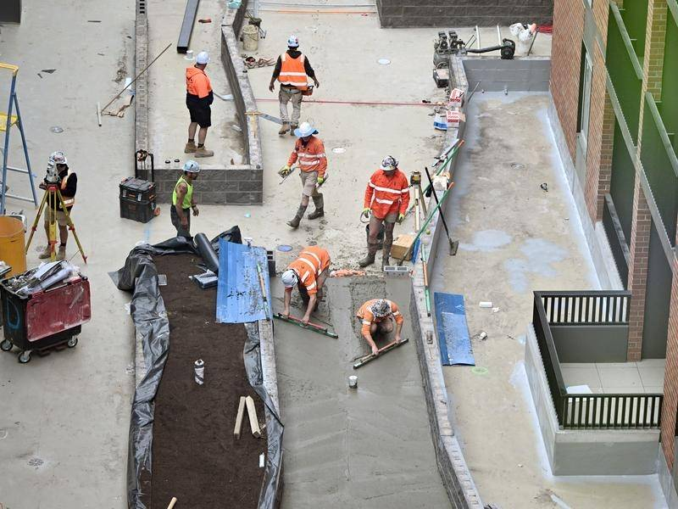
Poor management of the infrastructure program has led to the cost of several projects to balloon.
Multiple federal infrastructure projects are on the chopping block in a bid to ease inflation, with a review finding billions of dollars worth of cost pressure.
An independent review of the infrastructure investment program has found $33 billion of cost pressures to the economy, with that figure tipped to grow even further.
Infrastructure Minister Catherine King said the investment pipeline, which had increased from 150 to 800 projects under the previous government, had not been managed well.
However, the minister did not say how many infrastructure projects would be cut.
"It is simply just not sustainable for the pipeline to continue the way that it is after a decade of being used for political purposes," she told ABC radio on Monday.
"There's been evidence that this infrastructure pipeline has not been managed and not been managed well, and obviously, that is also causing inflation pressures."
The review looked at about 200 infrastructure projects in the pipeline, with recommendations being made about cancelling some.
"It's made some recommendations around making sure we've got planning money and we slow the process down so we know what the costs are," Ms King said.
"We have to do this in partnership, we have to do it in collaboration with states and territories, they are partners with us, we are investors along side them."
The management of the program had led to the cost of several projects to balloon, Ms King said.
The minister indicated talks were under way with each jurisdiction on what projects would still be needed.
"We're going through each of those with our state and territory counterparts, trying to make sure we've got the right data, making sure that we've actually factored into account now the importance of various projects across the country," she said.
"What I don't want to do is promise people that we're going to build something when it clearly is not going to be built."
The infrastructure pipeline was estimated to be worth more than $120 billion.
Ms King announced a 90-day review of the pipeline in May in a bid to make the program more sustainable.
At the time, 162 programs in the pipeline had a government commitment of $5 million or less.
Projects that had been announced in the budget or had already started construction were not impacted by the review.
Opposition infrastructure spokeswoman Bridget McKenzie said ditching entire projects would create uncertainty in the sector.
"The responsible approach is to have better collaboration and co-operation between the states and the federal government on prioritising projects - not cutting them," she said.
"Minister King's 'short, sharp' 90-day review into infrastructure spending is now 100 days overdue, and now the treasurer is blaming critical infrastructure spending for his inflation problem."
Chief executive of the Australian Constructors Association Jon Davies said critical infrastructure projects could not afford to be cut due to migration numbers.
"With over 500,000 migrants predicted to enter the country this year, we cannot afford to cut back on building schools, hospitals and transport infrastructure," he said.
"We could afford to build everything we need, without any significant inflationary impact, if we focus on improving the construction industry's productivity."
Ms King said funds were being used to build more housing, along with projects to ease congestion.
Australian Associated Press

