NSW Treasurer Daniel Mookhey set to warn state's credit rating is under threat in budget update
The Treasurer Daniel Mookhey is expected to deliver a warning that the state's two AAA credit ratings are under threat, as he hands down a budget update this week.

Key points:
- Moody's and Fitch reaffirmed the state's AAA credit ratings last year
- The state's deficit for this financial year is set to hit $12 billion
- The budget will be delivered in September after it was delayed
He will deliver a statement to parliament outlining the state's finances after delaying the yearly budget until September.
NSW had its AAA credit ratings reaffirmed by Moody's and Fitch last year.
S&P Global has the state at a AA+ rating.
The agencies will conduct another review this year.
Since taking office, the Minns government has been painting a bleak picture of the state's finances and foreshadowed that cuts to spending will need to be made.
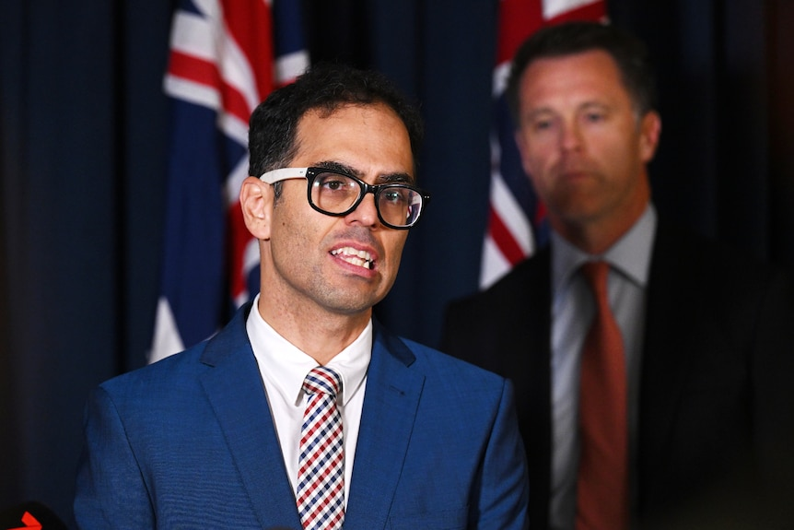
Since taking office the government has been painting a bleak picture of the state's coffers.
The state's gross debt is on track to reach $187.5 billion, while the deficit for this financial year is forecast to be $12 billion and $7 billion next year.
The government has also made it clear it's facing a $7 billion "black hole", which is the funding needed to continue the previous government's programs.
But the money has not been allocated past the end of this financial year.
The list includes additional nursing positions in public hospitals, cybersecurity and the Active and Creative Kids vouchers.
Last week the government announced it would be scaling back the voucher program and it would be means tested from next year.
It says that will reduce government spending on the scheme from $136 million annually to about $28 million.
The opposition has criticised the move and questioned whether other cost of living measures will be scaled back.
It has been pushing the government to confirm whether the Regional Apprentice and University Student Travel Card scheme is on the chopping block.
At the same time, Labor has had to find $669 million for the problem-plagued state insurer, icare.
The government says it must pay the bill to ensure compensation is available for injured public sector workers.
In this week's budget update, the treasurer is also expected to address a number of accounting practices and funds that were set up by the previous government that Mr Mookhey has previously criticised.
They include the Transport Asset Holding Entity, which is a state-owned corporation to manage the state's rail assets.

It says that will reduce government spending on the scheme from $136 million annually to about $28 million.
The opposition has criticised the move and questioned whether other cost of living measures will be scaled back.
It has been pushing the government to confirm whether the Regional Apprentice and University Student Travel Card scheme is on the chopping block.
At the same time, Labor has had to find $669 million for the problem-plagued state insurer, icare.
The government says it must pay the bill to ensure compensation is available for injured public sector workers.
In this week's budget update, the treasurer is also expected to address a number of accounting practices and funds that were set up by the previous government that Mr Mookhey has previously criticised.
They include the Transport Asset Holding Entity, which is a state-owned corporation to manage the state's rail assets.

