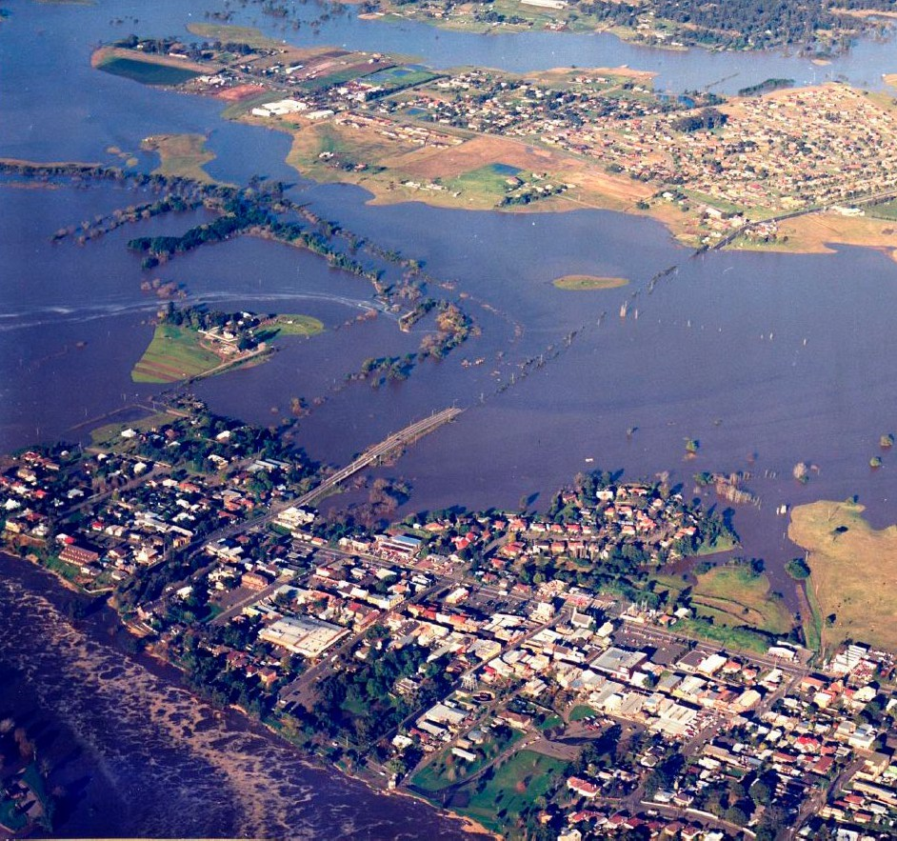
Hawkesbury-Nepean Valley Flood Risk Management Strategy

Hawkesbury-Nepean Valley Regional Flood Study

July 2019

Overview

Front cover: Flooding at Windsor 1988. Photo: RAAF Richmond
Page 14 photos:
Top left: Antonin Cermak, Fairfax Media Centre: D. Bewsher
Bottom: RTA RMS
Back cover: Nepean River at Penrith 1978 flood. Photo: Penrith City Library

This document was published by Infrastructure NSW. For enquiries please contact: mail@insw.com

Flooding in the Hawkesbury-Nepean Valley

The Hawkesbury-Nepean floodplain was formed by flooding over millions of years. While there have not been any moderate or large floods since 1992, the valley has a long history of damaging floods.

Since records began in the 1790s, there have been about 130 moderate to major floods in the valley. The largest flood in living memory was in November 1961, when the water reached
14.5 metres above normal river height at Windsor.

The largest flood on record was in 1867, and reached 19 metres above normal river height at Windsor. The floodwaters from the river nearly reached the corner of High and Woodriff Streets in Penrith, and most of Emu Plains was under water.

If a flood similar to the record 1867 flood happened in the valley now, more than 90,000 people would need to be evacuated from the floodplain and more than 12,000 homes would be impacted by floodwater.

The NSW Government released Resilient Valley, Resilient Communities – Hawkesbury- Nepean Valley Flood Risk Management Strategy (Flood Strategy) in May 2017. This Flood Strategy details how the NSW Government, local councils, businesses and the community are working together to reduce and manage the flood risk in
the Hawkesbury-Nepean Valley. One of the actions in the Flood Strategy is to prepare a new regional flood study for the valley.
Figure 1 – Hawkesbury-Nepean Valley Regional Flood Study area
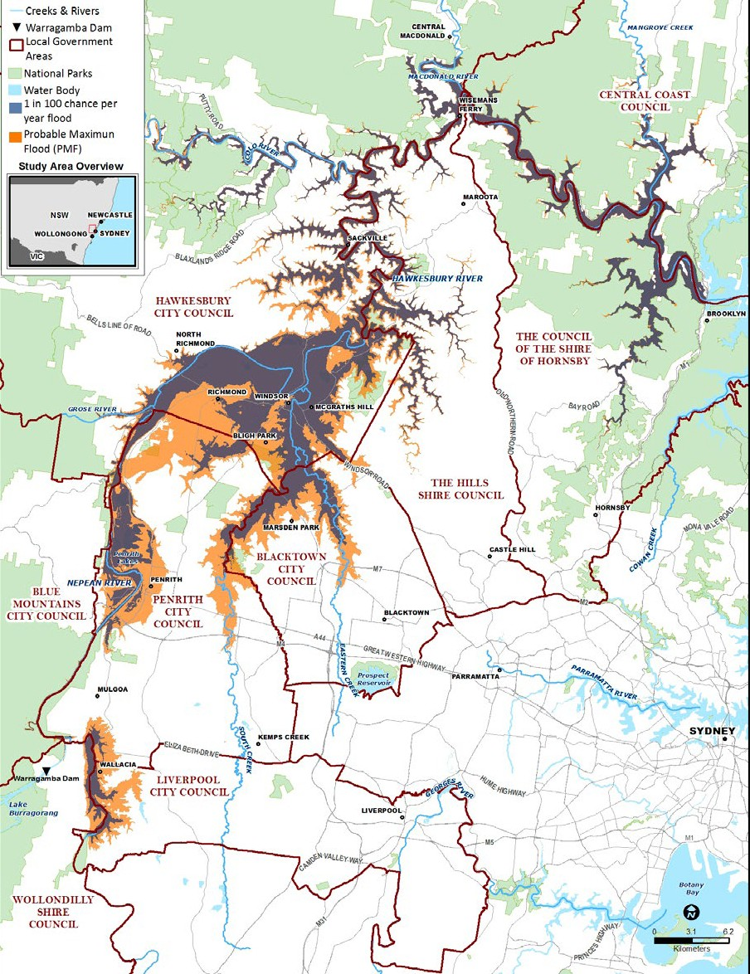
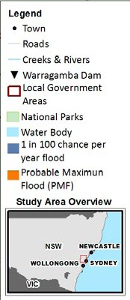

Probable Maximum Flood (PMF)
Town
Roads
Creeks & Rivers
Warragamba Dam Local Government Areas
National Parks Water Body
1 in 100 chance per
year flood
Probable Maximum Flood (PMF)

Hawkesbury-Nepean Valley Regional Flood Study Overview

Hawkesbury-Nepean Valley Regional Flood Study

The high flood risk in the valley means that having the best available flood information is essential.

The Hawkesbury-Nepean Valley Regional Flood Study 2019 (Regional Flood Study) identifies the flood affected areas in the Hawkesbury-Nepean River Valley, and assesses the impacts of climate change.

The study area is between Bents Basin near Wallacia and Brooklyn Bridge, and falls mainly within Penrith, Hawkesbury, Blacktown and The Hills local government areas. Other councils within the floodplain are Wollondilly, Liverpool, Central Coast and Hornsby (see Figure 1).
This high-level overview describes how the Regional Flood Study was developed, how it will be used, and some key results across the valley.

What is a flood study?
A flood study is a technical investigation of the way floods behave within a
river catchment. It is a vital part of floodplain management.

The aim of a flood study is to define existing flood behaviour, particularly the chance and severity of different sized floods happening.

Why develop a new Regional Flood Study?

The last regional flood studies for the Hawkesbury-Nepean were prepared more than 20 years ago. Since then there have been considerable advances in the science of flood modelling, as well as changes to the floodplain.

The new Regional Flood Study uses:

» more extensive and accurate data
- new rainfall probabilities released by the Bureau of Meteorology, which are based on a wider range of information, longer rainfall records, and were extensively tested
- new topography available through ‘LiDAR’ surveys in 2011 and 2017, which used an aircraft to map the ground surface to a high resolution and show recent changes to the valley’s landscape
» new modelling techniques, which can better model the complexity of rainfall and flooding. A ‘Monte Carlo’ approach was applied which produces thousands of modelled flood events to better represent the variability of real floods.
» improved methods for considering the impacts of climate change.
The study also uses best practice approaches and up-to-date flood guidelines:
» NSW Government’s Floodplain Development Manual, 2005, and subsequent guidance
» Australian Rainfall and Runoff, 2016
» Managing the Floodplain: A Guide to Best Practice in Flood Risk Management in Australia, 2017.

Accessible flood maps and risk information help build the community’s resilience to floods.

How will the Regional Flood Study be used?

The Regional Flood Study will support and inform:
» up to date and accessible public flood information, including flood maps with flood extents and depths
» emergency management and evacuation plans including the NSW State Emergency Service’s Hawkesbury Nepean Flood Plan
» regional land use and road planning, particularly the development of a new regional land use planning framework and a road evacuation master plan
» local council land use planning, including through local environmental plans, development control plans and other council flood plans and policies
» more accurate pricing of flood risk to help infrastructure owners make decisions about flood risk mitigation measures, and for the insurance industry to more accurately price insurance premiums
» the ongoing assessment of flood mitigation options.

A large and complex floodplain

The Regional Flood Study covers Hawkesbury-Nepean River flooding from Bents Basin near Wallacia down to Brooklyn Bridge. It covers
a large area and includes the backwater effects of flooding in South Creek and Eastern Creek.

Modelling river flooding in the Hawkesbury- Nepean Valley is complicated because of the many tributaries and their catchments that contribute to the floods.

The main tributaries are:
» Nepean River
» Warragamba River
» Grose River
» South Creek
» Colo River
» Macdonald River.

Floodwaters from these tributaries back up behind natural choke points created by narrow sandstone
gorges (see Figure 2). This can cause rapid, deep and widespread flooding.

The study area covers three main floodplains:
» Wallacia
» Penrith/Emu Plains
» Richmond/Windsor (including backwater flooding in South Creek and Eastern Creek).

Downstream from the Richmond/Windsor floodplain, the river winds its way through around 100 kilometres of confined, sandstone gorges all the way to Brooklyn. Along this stretch, numerous small floodplains form in the narrow areas between the river and the steep valley sides.

Different types of flooding
This Regional Flood Study focuses on flooding from the river, or riverine flooding. It does not include the effects of localised, shorter duration

flooding, caused by local runoff during rainfall events. Studies of this local catchment and overland flooding are usually undertaken by local councils.

Effects of Warragamba Dam on river flooding
Warragamba Dam is located in a narrow gorge on the lower section of the Warragamba River,
3.3 kilometres before it joins the Nepean River near Wallacia.

The catchment above Warragamba Dam makes up around 80% of the total catchment to Penrith and 70% to Windsor. Therefore it has a major influence on flooding in the valley, contributing the majority of flows in the largest floods.
If the storage level behind Warragamba Dam is very low, it can help hold back the inflows during floods. However, in large rainfall events, the dam can fill and spill quickly. This is what happened in 1998, when the dam went from 56% storage level to full and spilling in around two weeks.

If the storage is close to full, the dam cannot hold these inflows back. History shows that most of the large floods occur during wet periods when the dam is nearly full. This variability has been taken into account in the new Regional Flood Study.

Figure 2: Hawkesbury-Nepean Valley landscape

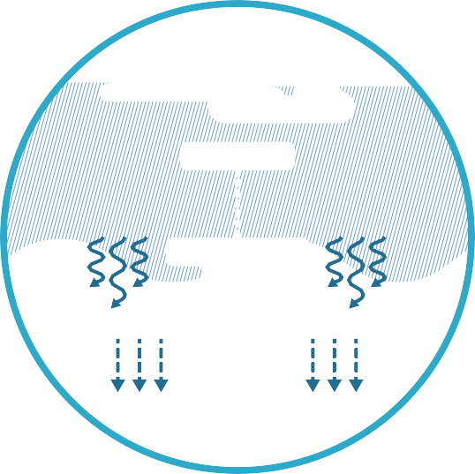

Eastern Creek

Rainfall

Surface water runof

Infiltration

Flood warnings
During actual floods, the Bureau of Meteorology may issue flood warnings for major, moderate or minor flooding. These categories relate
to the impacts and consequences for local

communities, and not on the likelihood of the flood as outlined on page 8.

For more information visit: www.bom.gov.au/water/awid/

Describing flood events

Floods are most often described in terms of the chance that floods of a certain size could happen, and the height floodwaters reach at specific locations.

Flood maps often use this information to show different types of floods. Knowing how likely a flood is to affect you and what impact it can have helps you to prepare for future floods.

Chance of a flood happening
To work out how regularly an area might flood, we look at the chance or likelihood of different scales of flood. For example, the term ‘1 in 100 year flood’ refers to a flood that has a 1 in 100 (or 1%) chance of happening or being exceeded in any given year.
Expressed another way, it means that a person living to 80 years of age has more than a 55% chance of experiencing this type of flood during their lifetime.

The largest flood possible is called the probable maximum flood or PMF. It is an extremely rare and unlikely flood, however a number of historical floods in Australia have approached the scale of a PMF. In New South Wales, all properties within the footprint of a PMF are considered to be within the floodplain for that region.

The table below compares the likelihood of different flood events within an 80 year lifetime.

Likelihood Chance of happening in any year Probability of occurring at least
 | AEP (%) | AEP (1 in X) | once in an 80-year lifetime
Very high | 20% | 1 in 5 | 100%
High | 5% | 1 in 20 | 98.3%
Medium | 1% | 1 in 100 | 55.3%
Low | 0.2% | 1 in 500 | 14.8%
Extremely low | .001% | 1 in 100,000 | < 0.1%

The technical term used to describe the chance of a flood happening is Annual Exceedance Probability (AEP). The AEP is normally expressed as a probability of a particular size flood, or larger, happening in any given year.

Height of floodwaters
An important consideration is the likely impact of a flood, and height is one indicator of how severe the flood might be. Using key locations in the floodplain, we can compare the heights of different flood events.

Floods are usually measured as above Australian Height Datum (AHD), which is approximately equal to mean sea level.

The largest flood on record which took place in 1867 reached approximately 19.7 metres AHD at Windsor – or around 19 metres above normal river height (see figure 3 below). This flood is estimated to be around a 1 in 500 (0.2%) chance per year event.

The 1 in 100 (1%) chance per year flood is the default flood planning level in New South Wales. Such a flood would reach 17.3 metres AHD at Windsor.

28
Flood dominated More frequent, larger floods
Drought dominated Less frequent, smaller floods
Flood dominated
More frequent, larger floods
Drought dominated Less frequent, smaller floods
Flood dominated
More frequent, larger floods
Drought dominated Less frequent, smaller floods
1799–1820
1821–1856
1857–1900
1901–1948
1949–1990
1991–present
‘Major’ flood level
‘Moderate’ flood level
Floods below 10m (pre-1857) or 8m (post-1857) not shown

26
Flood level at Windsor (metres above mean sea level)

24

22

20

18

16

14

12

10

8

6
1790 1800 1810 1820 1830 1840 1850 1860 1870 1880 1890 1900 1910 1920 1930 1940 1950 1960 1970 1980 1990 2000 2010 2020

Figure 3 – Hawkesbury-Nepean floods at Windsor 1790 to present

Patterns of flooding
The flood history of the Hawkesbury-Nepean Valley suggests periods that last for decades of frequent, higher floods. These can be followed by similar length periods of infrequent, smaller floods. This pattern has been described as flood- dominated and drought-dominated regimes (see figure 3 above).

On top of these underlying regimes, are large annual variations in rainfall and runoff.

Ultimately, floods are naturally occurring events. It’s impossible to say when the flood will come.

Developing the Regional Flood Study

The NSW Government developed the new Regional Flood Study so we have the best available information to help with planning and decision making.
The Regional Flood Study uses flood modelling. A model is a mathematical representation of how a
Step 2 – Hydrological assessment

system works. In the case of flooding, those systems relate to rainfall, runoff, river flows and movement of water across a floodplain.

Specialist flood experts WMAwater Pty Ltd were contracted to prepare a new regional flood
study using the latest available data and a robust methodology. Local councils within the study area were consulted on the draft flood study, and it was reviewed by an independent flood expert.

The steps taken to develop the new Regional Flood Study are outlined below and in Figure 4.

Step 1 – Data collection

A range of data was collected including:
Hydrology is the study of how rainfall is converted into runoff from a catchment over time. It takes into account the rainfall (eg amount, timing and location) and ground conditions in the catchment.

The hydrological assessment tells us how much water is likely to be generated and how it will move through the catchments during rainfall events.

A hydrologic model (RORB) was developed to calculate the river flows resulting from rainfall events in the Hawkesbury-Nepean Catchment. To achieve the best possible results, the model was calibrated using five historical flood events (1964, 1975, 1978, 1986 and April/May 1988). It was verified using another two floods (July 1988 and 1990.)

Step 3 – Hydraulic assessment
Hydraulics is the study of the physical movement of water flow along rivers and creeks and over floodplains. Hydraulic modelling is used to determine flood levels, extents, depths, velocities (speed and direction) and hazard.

up to 220 years of river flood records
rainfall records from the Bureau of Meteorology
catchment characteristics such as land use types

A hydraulic model (RUBICON) was developed to calculate peak flood levels resulting from the flood flows identified by the hydrologic assessment.

topographic and river channel surveys

The RUBICON model was calibrated and verified using 10 historical flood events. This involved comparing the modelled results to the actual observations for:

surveys of bridges and other structures.
» peak flood levels
» flood stage hydrographs (continuous records of river height over time)
» flows in the Nepean River at Penrith.

The 10 historical flood events used were in 1961, 1964, 1975, 1978, 1986, 1987, 1988 (two events),
1989 and 1990. The hydraulic modelling was used to simulate thousands of flood scenarios to represent the variability of floods in the valley.
This method is called Monte Carlo modelling.

July 2019
Figure 4 – Developing the Regional Flood Study
HYDROLOGIC MODEL
» Converts rainfall into runoff
» Output: flood hydrographs
HYDRAULIC MODEL
» Converts flows into levels
» Output: flood levels
RESULTS
» Flood level contours
» Extents, depths, velocity, hazard
» Time to rise/fall
» Time above critical levels
» Travel time
OUTPUTS
» Flood mapping and other products
11

DATA COLLECTION
» Rainfall and runoff
» Catchment characteristics
» Dam starting level
» Timing of tributary inflows
» Topography/structures
» Tides

Step 4 – Expert review
The draft Regional Flood Study was reviewed by specialist consultancy Rhelm to check the validity and accuracy of the data, method and results.
The review found that the methodology was appropriate for the regional scale of the study. It uses complex hydrologic methods and represents some of the most rigorous assessment undertaken in Australia. The reviewer suggested that in
future a more detailed hydraulic model could be developed to better represent the behaviour of flows in some areas of the floodplain.

Councils within the floodplain were also consulted about the draft Regional Flood Study. Their comments have been considered in the final Regional Flood Study.
‘Monte Carlo’ modelling
To capture the real variability of floods, a ‘Monte Carlo’ approach was used. This models flood variability by randomly
combining the range of inputs that generate and influence flooding. The variable
inputs include where and when rain falls, soil moisture levels, the storage level of
Warragamba Dam at the start of an event, the timing of inflows from the various tributaries, and the tides.

Using this approach, close to 20,000 possible flood events were modelled, which represents the range of floods that could be experienced over a 200,000 year period.

To validate the Monte Carlo approach, the results were compared to a flood frequency analysis using the actual flood records at Windsor starting from the 1790s. This found a very good match up to the 1 in 100 (1%) chance per year flood, and good alignment for rarer events.

Regional Flood Study results

The Regional Flood Study provides the most up-to-date regional information for Hawkesbury-Nepean River flooding ranging from frequent to very rare floods.

The study details flooding for 11 different events, ranging from highly likely floods with a 1 in 5 (20%) chance per year, through to an extreme event, the probable maximum flood (PMF).

Key findings
This Regional Flood Study reinforced why the flood risk in the Hawkesbury-Nepean Valley is so high – the flooding can be so much deeper and wider in this valley than in other floodplains.

» Difference between 1 in 100 (1%) chance per year flood and PMF
In the Hawkesbury-Nepean there is a greater
range in depth between the 1 in 100 (1%) chance per year flood and the PMF. In most floodplains, the difference is typically two to three metres. However, if this valley the difference is about:
- 21 metres at Wallacia
- 7 metres at Penrith/Emu Plains
- 9 metres at Richmond/Windsor
- 7-10 metres in the Lower Hawkesbury.

» Extent of flooding
Most river valleys tend to widen as they approach the sea. The opposite is the case in the Hawkesbury-Nepean. Narrow downstream sandstone gorges between Sackville and Brooklyn create natural choke points.
Floodwaters back up and rise rapidly, causing widespread flooding.

In a 1 in 500 (0.2%) chance per year event, the flood can be up to 20 kilometres wide in the Richmond/Windsor floodplain.
Variability of flooding
The Regional Flood Study has reinforced that every flood is different.
The ‘Monte Carlo’ suite of floods shows that at North Richmond, the rate of rise can vary between
0.3 to 1.4 metres/hour, even when the same peak is reached (19.8m for a 1 in 500 chance per year event). Understanding this variability is important for evacuation planning.

More specific findings across the floodplain are on pages 14-15.

Comparing results
Compared to the previous regional studies, this Regional Flood Study found that:
» 1 in 100 (1%) chance per year flood levels are unchanged for the Richmond/Windsor floodplain
» the flood level of the 1 in 5 (20%) chance per year event has decreased across the valley because the new study allows for Warragamba Dam to be below its full water
supply level and able to hold back inflows from smaller floods
» at Wisemans Ferry, flood events between
1 in 20 (5%) chance per year and 1 in 200 (0.5%) chance per year have increased by up to
0.7 metres as a result of updated data and the new modelling approach
» peak flood levels for the PMF have increased at several sites because of new approaches to modelling this extreme event and updated information.

Climate change
Using the best available information, this Regional Flood Study has assessed the impacts of climate change on flooding.

Based on Commonwealth Scientific and Industrial Research Organisation (CSIRO) and the Bureau of Meteorology climate change projections, increases in global temperatures will lead to an increase in the intensity of rare rainfall.

Low, mid and high climate change projections were modelled in line with Australian Rainfall and Runoff guidelines (2016). The results from these investigations indicate an increased flood risk due to projected climate change.

An increase in rainfall intensities of 9.1% by 2071 under projected medium greenhouse gas emissions would increase the 1 in 100 (1%)
chance per year flood level across the floodplain. Specifically, it would increase by:
» 1.1 metres at Wallacia
» 0.5 metres at Penrith
» 0.7 metres at North Richmond and Windsor
» 0.6 metres at Wisemans Ferry.

Consistent with advice from the NSW Chief Scientist, the study also assessed the impacts of a
0.4 metre and 0.9 metre sea level rise which is in line with previous NSW Government guidance.

The assessment found that the 1 in 100 (1%) chance per year flood level could increase by more than 0.1 metres downstream of Wisemans Ferry, with negligible increase above Leets Vale.

Regional Flood Study outputs
The following are the key outputs of the Regional Flood Study:
Flood Study Overview
(this document)
Volume 1 – Main Report
Technical Regional Flood Study report in three volumes
Volume 2 – Appendices
Volume 3 – Map book with 382 maps including:
» flood levels, extents and depths
» flood hazard
» floodways and flood storage areas.

13

Figure 5 – Hawkesbury-Nepean River flood extent for a 1 in 500 (0.2%) chance per year flood

Nepean River at Emu Plains – August 1990 flood. (1 in 20 (5%) chance per year event)
Lower Hawkesbury River in flood – 1986. (1 in 10 (10%) chance per year event)

Wisemans Ferry

Limit of study area

Richmond

Windsor
Brooklyn Br

Emu Plains Penrith

Wallacia

Blacktown
1990 flood at Windsor, 13 metres above normal river height. (1 in 20 (5%) chance per year event)

Parramatta

Sydney

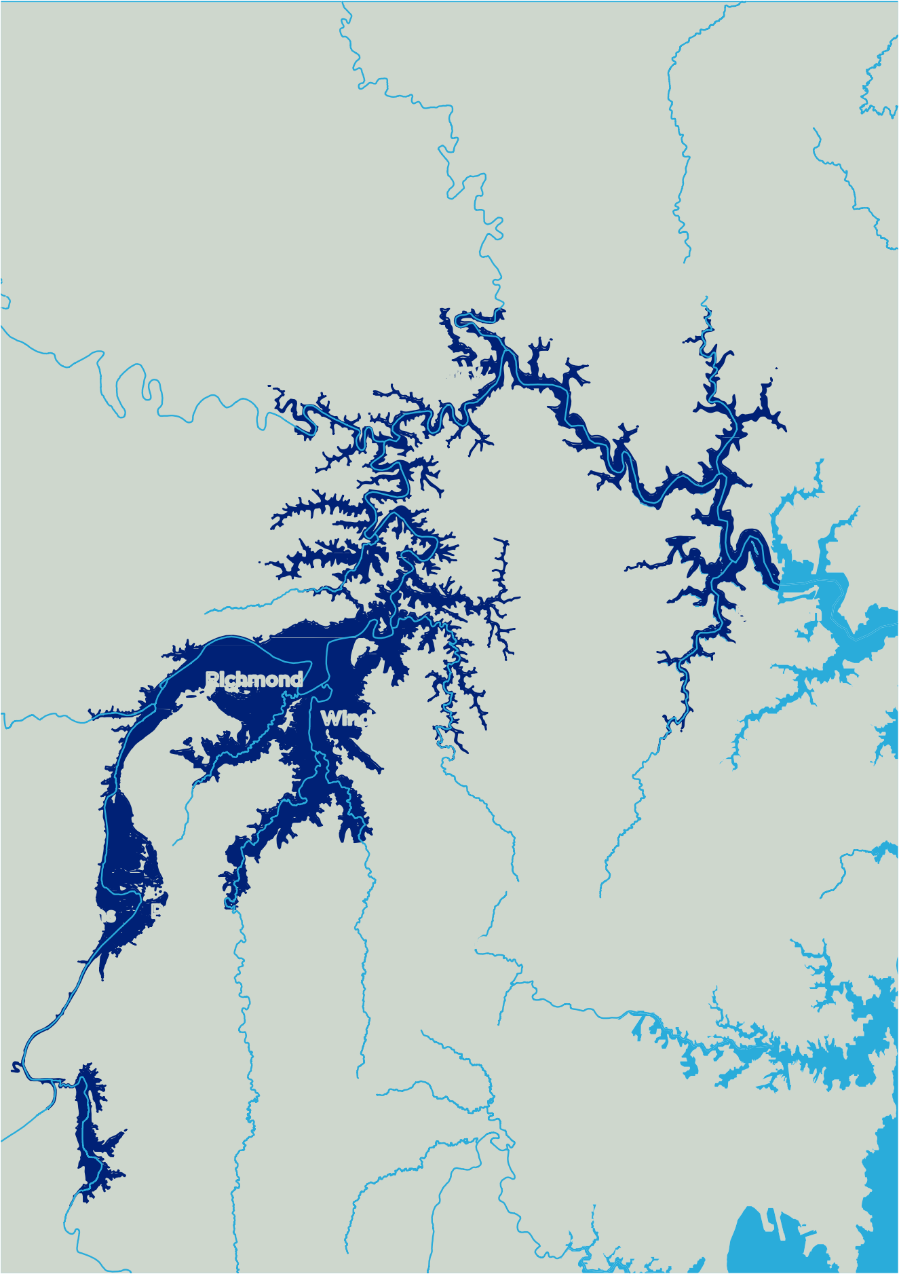
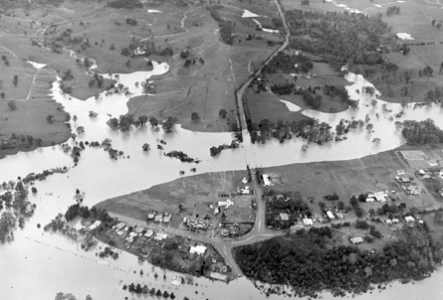
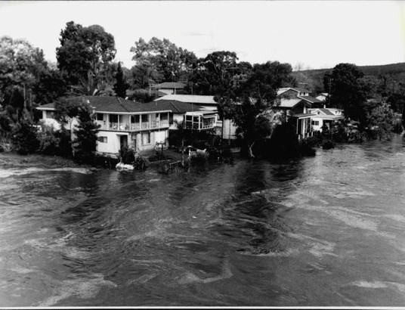
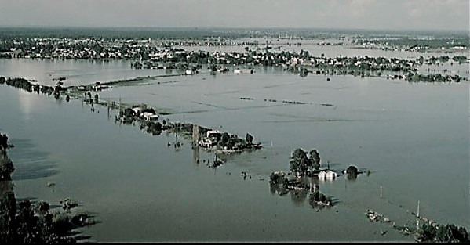
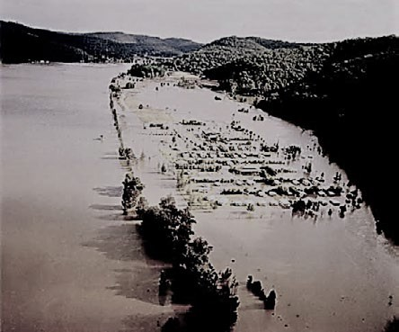

Floodwaters at Wallacia – June 1964. (Between 1 in 50 (2%) and 1 in 100 (1%) chance per year event)

Results in key areas
The following discusses some of the high-level results in areas along the Hawkesbury-Nepean Valley, from Wallacia to Wisemans Ferry.

The map (Figure 5) shows the extent and depth of flooding for the 1 in 500 (0.2%) chance per year flood, which is similar to the worst flood on record (1867 flood).

Wallacia
While the Wallacia floodplain is relatively small, it has the potential for the deepest flooding in the valley. The Nepean and Warragamba rivers meet downstream of Wallacia, and floodwaters can back up behind the narrow gorges between Wallacia and Penrith.

In a 1 in 20 (5%) chance per year event, floodwaters inundate low lying parts of Wallacia and Park Road, the main evacuation route to the east, is cut.

In a 1 in 500 (0.2%) chance per year event, floodwaters would cut all major evacuation routes. In the rarest and most unlikely flood (PMF), the village of Wallacia would be completely inundated.

Penrith/Emu Plains
During a 1 in 100 chance per year flood, the floodwaters would remain mostly within the banks of the Nepean River. However, there would be flooding in Emu Plains on the southern side of the railway embankment, and up the Peachtree and Boundary creeks in Penrith.

The study shows that for a 1 in 500 (0.2%) chance per year event, much of Emu Plains would be inundated and floodwaters would extend east to Woodriff Street in Penrith.

In the most extreme flood (PMF), large areas of Penrith would be inundated. Floodwaters would extend as far as two kilometres along the Great Western Highway east of the Victoria Bridge. The flood extent would include Emu Heights to the west of the Nepean River.

For this floodplain, higher resolution flood modelling and mapping is available from Penrith City Council’s Nepean River Flood Study (2018).

Richmond/Windsor
The Richmond/Windsor floodplain is the most flood-affected area within the valley. Even in a relatively frequent 1 in 5 (20%) chance per year event, there is extensive flooding of low-lying river flats between Richmond and Pitt Town.

In the 1 in 100 (1%) chance per year event, the flood extent increases substantially. McGraths Hill would be completely submerged, Pitt Town would become a flood island, as would be parts of Windsor and South Windsor. A key evacuation route, Windsor Road, would be inundated as far as Vineyard Railway Station (six kilometres from Windsor Bridge).

In an event similar to the record 1867 flood, Windsor would be completely isolated, Jim Anderson Bridge roadway would be around two metres under water, and the floodwater would extend up to 20 kilometres at its widest.

Very little land would remain above floodwater in the Richmond/Windsor floodplain in an extremely rare PMF.

South Creek and Eastern Creek
Floodwaters from the Hawkesbury River can back up into South Creek and Eastern Creek causing flooding in adjacent suburbs.
In a 1 in 100 (1%) chance per year event, floodwaters would inundate properties in parts of Windsor Downs, Berkshire Park, Shanes Park and Llandilo. The Richmond Road evacuation route would be cut at South Creek Bridge. Along Eastern Creek, backwater flooding would impact
properties at Vineyard, Riverstone and Schofields.

If the worst flood on record happened today, the backwater effects would be higher and extend further, impacting more properties including in parts of Marsden Park.

Lower Hawkesbury River
Downstream of Cattai Creek near Ebenezer, the main Hawkesbury River enters gorge country which continues for many kilometres all the way to Brooklyn.

Along these gorges, narrow floodplains form between the riverbank and the valley sides. Due to the steep gorges, roads in the Lower Hawkesbury are often close to the river and are cut by relatively small floods.

Tide levels have some minor impacts on flooding, especially downstream from Wisemans Ferry, and especially for frequent floods such as the 1 in 5 (20%) chance per year event.

Next steps

Maintaining contemporary flood information is critical to inform land use and emergency planning, increase community resilience, and support response and recovery from floods.

For the first time, this Regional Flood Study has generated a large range of potential events that mimic the way actual floods happen and vary.

As the next step, a higher resolution regional model will be developed for land use and emergency planning.
This new model will draw on inputs from this Regional Flood Study to provide a more detailed understanding of flood behaviour. It will better represent some of the complex flows in the floodplain, including flow pathways and velocity of floodwaters

More information
Visit

www.insw.com/flood-strategy more information about the Regional Flood Study

Visit

www.ses.nsw.gov.au/hawkesbury-nepean-floods more information about flood risk and
preparing for a flood

Contact

Your local council for flood risk information specific to your property

Hawkesbury-Nepean Valley Regional Flood Study Overview

Hawkesbury-Nepean Valley Flood Risk Management Strategy

In May 2017, the NSW Government released Resilient Valley, Resilient Communities – Hawkesbury-Nepean Valley Flood Risk Management Strategy (Flood Strategy) to reduce and manage the significant flood risk in the valley.

The Flood Strategy is the result of years of investigation into the best ways to reduce the flood risk in the Hawkesbury-Nepean.
It contains an integrated mix of measures being delivered by the NSW Government with local councils, businesses and the community.

Under Phase One of the Flood Strategy (2016- 2020), Infrastructure NSW is overseeing and coordinating the delivery of a range of important flood risk reduction measures (see below).

 | Action | Timeline
 | Warragamba Dam Raising proposal – EIS and detailed concept design | 2016-2020
 | Coordinated flood risk management | 2016-2020
 | Community awareness and education | 2017-2020
 | Improved weather predictions and flood forecasting | 2018-2019
 | New flood evacuation signage | 2018-2019
 | Regional land use and road planning framework | 2018-2020
 | Detailed planning for local road upgrades | 2018-2020
 | Better flood maps and information for the community | 2019-2020
 | Flood emergency response and recovery exercises | 2019

18

July 2019

19

