67 Coronga Crescent,
Killara NSW 2071
9513.9532 wk
0404014725 mob
9498.3684 home
27 December 2006

Ken Sharpe (02) 4886.4286 ph
Spurfield
Illawarra Highway
Burrawang NSW 2577

Dear Ken

Booking camping access at Robertson Showground
for up to 20 campers over Friday 16th and Sat. 17th March 2007

Refer my phone call to you about 3 weeks ago.

This letter confirms my desire to book for up to:
- 15 campers for Friday 16^{th;} and
- 20 campers for Saturday 17th March 2007.

The reason that more campers are expected for Sat night is that some will drive from Sydney on Sat morn’ whereas most will drive on Friday arvo.

I hope you will allow me to reschedule for another w’end shortly after, if the weather is particularly wet on Friday 16th March.

Please excuse my tardiness in not providing this confirmatory letter earlier. Alas pre-Xmas was hectic in my day job at Commonwealth Bank.

I confirm that I have administered a bicycle group called www.Muggaccinos.com for yonks.

Over the last 10 years, our bicycle group has stayed at about 20 towns in NSW either at B&B’s, hotels, motels or camping in the warmer months to cycle during the days.

Our most recent camping was at Berry Showground where about 16 cyclists camped from 13th to 19th November. Feel from to seek a reference from Hugh McCowatt, Berry Parks Management Committee - 4448.6053 ph. It was the 3rd year in a row that Muggaccinos camped at Berry in mid-Nov and we will be back next Nov.

I understand that your casual fee is $8 per night per head per night.

I will phone you in a few days to determine if I should post a cheque for say $50 deposit, or if you have a bank account that I can remit the $50 directly to, which is the procedure that Hugh McCowatt preferred.

Cheers

Philip Johnston /tmp/in/input.doc

67 Coronga Crescent,
Killara NSW 2071
9513.9532 wk
0404014725 mob
9498.3684 home
4 February 2007

Ken Sharpe (02) 4886.4286 ph
Spurfield
Illawarra Highway
Burrawang NSW 2577

Dear Ken

Booking camping access at Robertson Showground
for up to 20 campers over a weekend, although some only camping on the Saturday night

I refer to –

- my letter to you dated 27 December [1 pg] which indicated my desire to book Robertson Showground for up to 20 push bike cyclists to camp for day rides from Robertson; and

- my phone call to you in early January when I undertook to remit $50 to your NAB account.

Enclosed is a cheque for $50 deposit, as alas I lost your NAB details. I have left the payee vacant, as I wasn’t sure whether it should be made payable to Robertson Showground or some associated bank account.

Unfortunately, the weekend of 24/25 March doesn’t suit a few prospective cycle attendees.

I will phone you later this week to try and obtain an available w’end from –

- Friday 27 and Saturday 28 April – 1st preference
- Friday 4 and Saturday 5 May – 2nd preference
- Friday 11 and Saturday 12 May – 3rd preference

Cheers
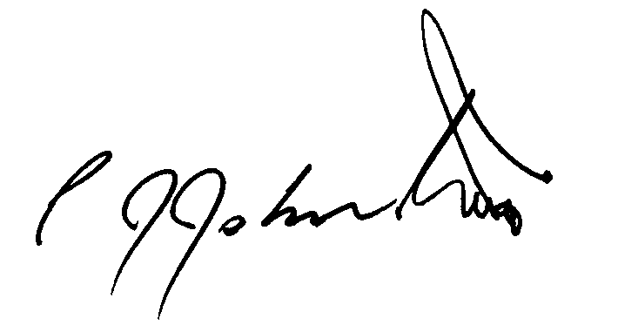

Philip Johnston /tmp/in/input.doc

67 Coronga Crescent,
Killara NSW 2071
0412 045.224 mob
9498.3684 or 9114.6689 home
2 May 2007

Ken Sharpe (02) 4886.4286 ph
Spurfield, Illawarra Highway
Burrawang NSW 2577

Dear Ken

Seeking to re-book camping at Robertson Showground for 3 days
Friday 14th, Sat 15th and Sunday 16th March 2008 (week before Easter) departing around 11am Monday 17th - for up to 20 campers

Thank you for administering our camping booking last weekend.

Our lean contingent who braved the gloomy weather forecast thoroughly enjoyed camping in the high country of the quaint hamlet of Robertson, where the verdant ground beneath us dried-up fast.

If the weather forecast had been for a fine weekend another dozen cyclists who had committed would have attended.

I am confident of attracting about 26 cyclists in mid-March 2008 for our 2nd Tour de Robertson with –
* 18 to 20 camping for up to 3 nights at Robertson Showground; and
* another 6 to 8 cyclists –
- braving the noise at the Roberson Inn; or
- staying in the quaint but dearer accommodation at
Burrawang Village Hotel (8km WSW); or
Lloran Log Cabins, Yeola Road, Robertson (7km South) ; or
- staying at nearby Robertson Motel.

As the weather will be warmer, I expect most to camp, particularly as the location is marvellous and we enjoy access to the pavilion.

Per chance, if the weather forecast on Thursday 13th March 2008 is ominous, we would like to postpone to the week after Easter being Friday 28th March to Sunday 30th March inclusive. If I sought to invoke this option, I would ‘phone you by 9am on Thursday, 13th March.

I will phone you in a week or so to confirm that you received this letter as confirmation of the above camping booking.

Cheers
Philip Johnston /tmp/in/input.doc

