“I Begged Them To Let Me Die”: How Federal Prisons Became Coronavirus Death Traps.

The Bureau of Prisons was unprepared and slow to respond. Then officials took steps that helped spread the virus.

Sonia Rodriguez and her fiancé Johnny Joe “JJ” Desilva Jr, the federal prison in Elkton, Ohio, and a letter sent from another prisoner describing conditions during the COVID-19 outbreak. PHOTO ILLUSTRATION BY SUNGPYO HONG/VICE NEWS. IMAGES VIA SONIA RODRIGUEZ, THE BUREAU OF PRISONS, AND FRANCISCO MIRELES.
By KERI BLAKINGER and KEEGAN HAMILTON
Coverage of the COVID-19 pandemic, criminal justice and immigration.
He sounded like he was dying.
That was Sonia Rodriguez’s first thought when her fiancé called her from federal prison near Cleveland. The gravelly voice she had known since high school had turned into a wheeze. He could barely finish a sentence without pausing to catch his breath. He said he was coughing up blood.
Rodriguez, a 49-year-old who handles accounting at a bakery, knew she was taking on a lot when she reconnected with JJ—officially Johnny Joe Desilva Jr.—while he was serving time. She knew his past involvement in gangs and drug trafficking would make the road to married life long.
But now she feared she would lose her strong fiancé to sickness. To COVID-19. While he was in the federal government’s care.
“He asked if I knew how much he loved me,” she said, crying as she remembered. “I thought I would get a call from him the next day.”
She didn’t. It was as if he had vanished.
The coronavirus had arrived at the Elkton Federal Correctional Institution, where, as one prisoner put it, there were suddenly “people walking around looking like the living dead.”
With over 163,000 people in custody, the federal Bureau of Prisons is America’s largest jailer. The BOP touts its prisons as “safe, humane, cost-efficient, and appropriately secure.” But what happened at Elkton is typical in many ways of the grim conditions and bungled responses at federal lockups across the country. The agency confirms active cases at 69 of its 122 prisons. As of Wednesday, it reported at least 6,245 prisoners and 673 staff infected over the course of the pandemic at its prisons and halfway houses.
And the truth is much worse than the BOP’s official numbers indicate.
VICE News and The Marshall Project spoke with more than 85 federal prisoners or their family members, and 25 staff members at prisons with coronavirus outbreaks. We obtained dozens of internal BOP memos, emails, and other documents, and reviewed images and videos recorded on contraband cell phones.
We found that the BOP was unprepared for the pandemic and slow to respond, and that top officials even took measures that contributed to the spread of the virus.
The official death toll stands at 86, including one staff member. Our reporting on the BOP’s handling of the coronavirus outbreak shows:
- Staff ignored or minimized prisoners’ COVID-19 symptoms, and mixed the sick and healthy together in haphazard quarantines.
- Thousands of prisoners were shipped around the country in February and early March, taking the virus with them, according to BOP records obtained by VICE News and The Marshall Project.
- Correctional officers and other staff felt pressured to work even after being exposed to sick prisoners.
- The BOP failed to follow its own pandemic response plan, which called for spacing out prisoners. Photos and videos show sick men in bunk beds just two feet apart.
- Federal officials have allegedly tried to conceal the extent of the outbreak by limiting testing—so that they didn’t have to report positive cases—and refusing to recognize one staff death. As of Tuesday, they had completed testing on less than 13 percent of prisoners in BOP-run facilities.
- Prisoners reported being quarantined in filthy buildings that had been vacant for years or in tents that flooded during rainstorms. Some described listening to their friends dying around them.
BOP Director Michael Carvajal declined an interview request from VICE News and The Marshall Project. Elkton’s warden referred us to the BOP main office. A spokesperson sent a statement in response to a detailed list of questions, declining to comment on numerous allegations involving specific prisoners, and maintaining that the agency’s response to the pandemic was carefully planned and coordinated, and that it took an array of precautions to contain the outbreak.
“We are deeply concerned for the health and welfare of those inmates who are entrusted to our care, and for our staff, their families, and the communities we live and work in,” the statement said. “It is our highest priority to continue to do everything we can to mitigate the spread of COVID-19 in our facilities.”
Attorney General William Barr has twice issued orders to release medically vulnerable prisoners or move them to home confinement, but the Justice Department has nonetheless fought to keep the vast majority of them incarcerated. Less than 3 percent of federal prisoners have been sent to home confinement, and some of them—including former Trump allies Paul Manafort and Michael Cohen—didn’t even meet the official criteria to qualify.
The BOP’s handling of the crisis under Barr and Carvajal has drawn scrutiny from Congress, with lawmakers questioning how the outbreak spiraled out of control and how the agency spent $100 million allotted to it for pandemic response. The inspector general for the Justice Department is investigating.
Rep. Jerrold Nadler, a Democrat from New York, slammed the Justice Department in a recent committee hearing, saying, “At best, it has slow-walked its response to COVID-19. At worst, they have been derelict in their duty to prevent deaths in the facilities that they operate.”

Sign up for the latest news.
Daily news and opinion about criminal justice

A weekly roundup of top stories from the web

New and notable Marshall Project stories

Essays from people involved in the system
SUBSCRIBE
Email list managed by Mailchimp

But the most furious criticism has come from the BOP’s rank and file. The American Federation of Government Employees Council of Prison Locals, which represents over 30,000 federal prison workers, has lambasted Carvajal and the BOP leadership during the pandemic.
“They're making it worse,” said Joe Rojas, the union’s Southeast regional vice president. “They're making the virus explode instead of containing it.”
The BOP counts one correctional officer’s death from COVID-19. But the parents of another staffer say the agency is refusing to acknowledge that the virus also caused their daughter’s death. The union has sued for hazard pay and filed at least two workplace safety complaints alleging that staff were exposed to infection without being given protective gear.
Prisoners have filed at least 11 class-action lawsuits against Carvajal and wardens to try to compel releases and improve conditions. At Elkton, a federal judge ordered officials to move or release hundreds of medically vulnerable prisoners. That would not only protect those who got out but also allow better social distancing for those who remain behind bars. Two men involved in the case died from COVID-19 while the government appealed.
For many during the pandemic, the only way out of federal prison has been in an ambulance.
“I begged them to let me die”
The BOP says its response to the pandemic began in January. According to records shared with VICE News and The Marshall Project, the paper trail begins with a two-page memo to the agency’s health staff on January 31, describing what little was known at the time about the virus and its symptoms. It advised anyone who had recently traveled to China to undergo screening.
The agency had no permanent leader when the outbreak began—an interim director had been in charge since scandal erupted over the prison death of billionaire Jeffrey Epstein in August 2019. On February 25, the attorney general gave the job to Michael Carvajal. A U.S. Army veteran who started off as a corrections officer in 1992, Carvajal rose through the ranks to become a warden and eventually a senior official in Washington, D.C., where his job included emergency planning.
Four days after Carvajal took over, the agency issued another memo that warned “the virus is likely to cause a pandemic.” The memo called for increased screening of staff and prisoners, distribution of personal protection equipment, and other basic preparations.
The BOP stopped allowing visitors at prisons on March 13 as the seriousness of the U.S. coronavirus outbreak became apparent. The first confirmed case of COVID-19 in a federal lockup was recorded the week after, at a detention center in Brooklyn.
At Elkton, the staff grew frustrated as prisoners started to get sick. Joseph Mayle, a counselor at Elkton and the local union chief, said that initially there wasn’t clear guidance from headquarters to contain the disease—it was up to the warden and union staff to figure out how to respond.
“It took two or three weeks to finally do anything,” Mayle said. “There was no across-the-board ‘This is what everyone needs to be doing here.’ It’s a crock of shit.” He says there are still no rules to prevent officers from moving between quarantine areas and uninfected housing units. (The BOP said, “As much as possible, staff are being assigned to the same posts and not rotating.”)
By late March, JJ Desilva had been ill for days. He told his fiancée the medical staff at Elkton said it was just the flu and gave him some ibuprofen, but he knew something was wrong when he drank Gatorade and couldn’t taste it. Then came the uncontrollable coughing.
He told Sonia they moved him on March 28 to a hastily set-up quarantine unit. He didn’t have access to the prison email system there and, for the first few days, no way to call home. When he was finally allowed to use the phone, he told Rodriguez that he was with 70 coughing, sweating men crammed onto cots in what was normally the visitation room.
A BOP spokesperson said “all symptomatic inmates are treated per CDC guidelines,” and “all institutions have areas set aside for quarantining and isolation.”
The sickest people at Elkton and other federal prisons have ended up in community hospitals. That’s what happened to Desilva, who the day after his April 1 conversation with Rodriguez was moved to an intensive care unit in a nearby hospital and put on a ventilator.

WE ARE WITNESSES
Intimate portraits of people who have been touched by the criminal justice system

Nobody told her. The next day, prisoners started dying at Elkton.
The first was Woodrow Taylor, a 53-year-old from Cincinnati serving five years on a nonviolent drug conviction. According to the BOP, his condition “quickly declined” and he died in a hospital. Two men followed him within the next 24 hours.
Elkton holds about 2,300 men at two prisons in the same compound. Both are considered low-security and have open, dormitory-style housing. Two or three beds are stacked in cubicles that measure about 80 square feet, with low walls and no door. There’s room for only one person at a time to stand up.
That setup is typical for low-security federal prisons, making them excellent incubators for COVID-19. The BOP has been aware of the risk for years. After the MERS coronavirus outbreak in 2012, the agency created a “Pandemic Influenza Plan.”
“In large dorm settings or camps, isolation may not be a possibility,” the BOP plan states. “If isolation is not feasible, attempt to place the beds of sick inmates at a distance of at least 6 feet from other inmates.”
COVID-19 afflicted federal prisons across the country.
Yazoo City, Mississippi
PRISONERS: 3,902PRISONER CASES: 173PRISONER DEATHS: 3STAFF CASES: 32
Prisoners complained about poor medical care, haphazard quarantines and not enough testing; under 10 percent of prisoners at the complex were tested, BOP data shows. “We were just locked in the cell for 72 hours straight,” one prisoner wrote. “Then they would let us out of our cells for 15 minutes, literally, to shower, call home, clean our cells. Fifteen minutes every three days.” The prison may say it took care of people, he added, “but, man, that is such a damn lie.” The bureau declined to comment on the allegations or specific conditions of confinement, citing safety and prisoner privacy.
A cell phone video posted April 3 on Facebook by an Elkton prisoner, Aaron Campbell, showed men packed together in their cubicles, sleeping and wheezing. After the post went viral, Campbell said in a letter to VICE News that he was sent to “the hole” as punishment for having a contraband phone. He claimed officials told him he would not face additional discipline if he issued a statement saying the video was fake. He refused.
“Instead of trying to help these people, they are covering it up and trying to control the public’s perception of the situation here at Elkton,” Campbell wrote from solitary confinement, where he said he was still being held nearly two months later. The BOP and Elkton did not respond to questions about Campbell’s allegations.
VIDEO BY KEEGAN HAMILTON, ANDREA PARK, KIMMY GORDEN, AND KRISTIE FERRISO.
Nearly 20 percent of federal prisoners are over 50, including about 10,000 older than 60—the demographic most vulnerable to COVID-19. The sickest and oldest tend to be grouped in low-security prisons like Elkton, minimum-security “camps,” or medical centers. Much like nursing homes in the free world, these prisons have become death traps during the outbreak.
Many behind bars have underlying medical conditions exacerbated by years of poor health care. The most recent oversight report on medical staffing, in 2016, raised red flags about systemwide shortages of BOP doctors and nurses, including 12 prisons that had “crisis” levels. At Elkton, a state medical official who visited in early April told Ohio’s governor that staffing at the prison was “only 50 percent of what it should be.”
An Elkton staffing report from April 2020, obtained by VICE News and The Marshall Project, shows the only two paramedics’ jobs and two nursing roles were vacant. Thirty-one other positions were unfilled across the prison, including three counselors, whose duties include making early-release recommendations and coordinating lawyer calls and visits. Mayle, the local union chief at Elkton, said counselors have seen caseloads double from 150 to 300 prisoners per worker in recent years.
Amid budget cuts and a temporary hiring freeze under President Trump, the BOP has lost more than 4,600 employees—about 12 percent of its total staff—including correctional officers, psychologists, and administrators. The shortage means medical staff are forced to take guard shifts in addition to performing their normal duties.
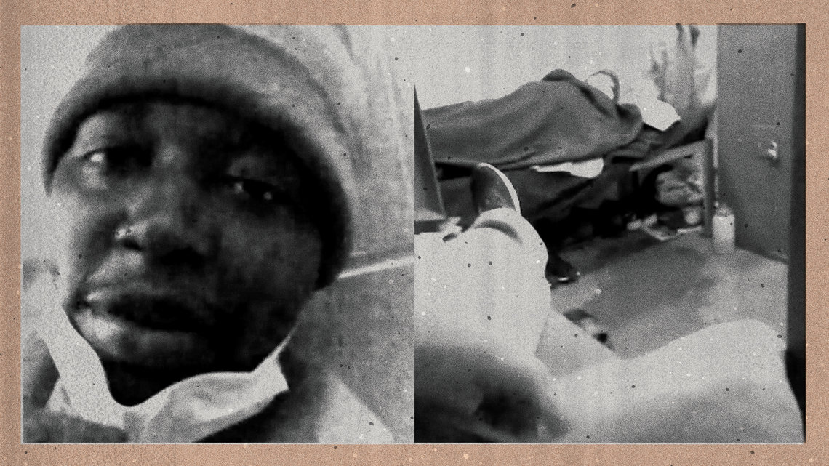
Elkton prisoner Aaron Campbell said he was sent to “the hole” as punishment for posting a video on Facebook that showed sick inmates packed together in dorm-style housing units.
PHOTO ILLUSTRATION BY SUNGPYO HONG/VICE NEWS. IMAGES VIA AARON CAMPBELL/FACEBOOK.
Prisoners say that during the pandemic, they became de facto nurses—with no training or protective gear—caring for men “going in and out of consciousness, throwing up, trembling, cold sweats, fever, spitting up blood when they cough,” as one prisoner at Elkton wrote in a letter to VICE News.
Michael Bear, a 67-year-old imprisoned at Elkton for drug and gun convictions, said he was coughing and feeling miserable when he saw a doctor there in late March.
“He took my temperature and my vitals and said I wasn't sick,” Bear recalled. “He told me to get the hell out of the clinic and then not come back.”
Bear later collapsed and had a seizure. He wasn’t isolated until nearly a week later. A day later, he was sent to the hospital.
He spent 24 days in a medically-induced coma. He said he remembers one dream from that time: He could see his dead wife, and wanted to be with her.
“I begged them to let me die.”
“He’s a number; not a human”
While Bear was in a coma, Rodriguez was desperately trying to get updates on her fiancé.

BECOME A MEMBER
Join the community that keeps criminal justice on the front page.

Was JJ too ill to pick up the phone?, she wondered. Was he in a hospital? Or had he simply been moved to a place where he couldn’t make calls?
She had learned not to expect easy answers to such questions.
“He’s a number; he’s not a human,” she said. “The prison doesn’t care.”
When Rodriguez’s phone finally rang two days after Desilva’s last call, it was a prison nurse bearing the bad news that he was on a ventilator. But the woman on the other end of the phone wouldn’t tell her where he was or give any more information on his condition.
Rodriguez understood that the prison couldn’t direct her to the hospital where he was—corrections officials often consider that information a security risk. So she and Desilva’s family frantically mounted a search, scouring Facebook for staff at medical centers near Elkton. They made call after call, as Rodriguez tried to find the man she had known for more than three decades.
The two had met in East Moline, Illinois. He was her high school crush, but they’d gone separate ways. “Life happened,” as she put it. For Rodriguez, that meant working as a school secretary and raising kids with her first husband.
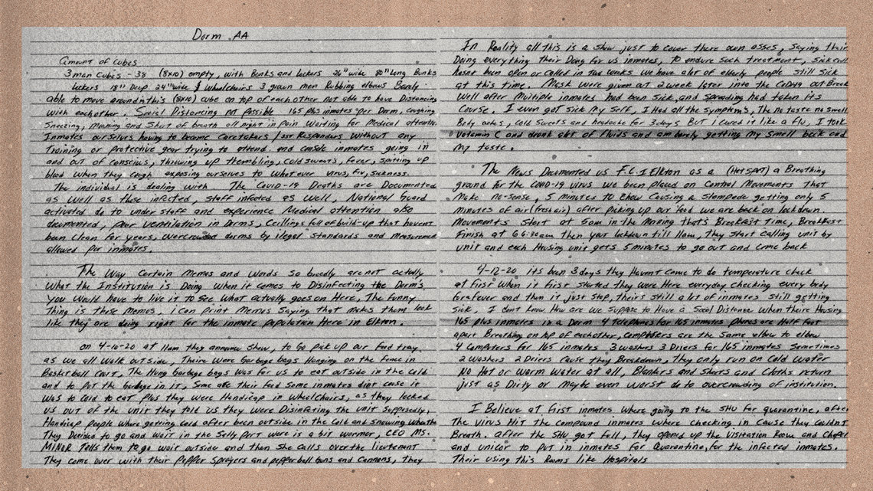
A letter from Elkton inmate Francisco Mireles describing prison conditions in April.
PHOTO ILLUSTRATION BY SUNGPYO HONG/VICE NEWS
Desilva became involved in the Latin Kings gang, selling drugs and feuding with rivals in conflicts that sometimes turned violent. He did a brief stint in prison for bank fraud in the mid-’90s and was released, only to be re-arrested in 2004 and convicted on federal charges including drug trafficking, threatening to kidnap someone, and carrying an illegal firearm.
She contacted him on a whim in 2018, she said. He had almost two decades left on his sentence. They started exchanging letters and talking on the phone. They picked up exactly where they’d been as teens, she said, but both a little wiser.
“I knew what he had been involved in,” she said, “but I figured after 20-some years in prison he can’t be the same person.” He remembered her so well, down to the lilac dress she’d worn to a quinceañera nearly 25 years earlier.
“Clearly his feelings were so real, that this stood out to him after all this time,” she said.
Soon, every month she was driving eight hours to see him. Before long, he proposed, getting down on one knee in the middle of the visiting room.
It was one of Desilva’s relatives who found the clue to his hospital: a Facebook post from a healthcare worker in East Liverpool, Ohio, about 15 miles south of Elkton, grumbling about an influx of patients from the local prison.
A relative called the hospital and got connected to his room, but the person who answered would not confirm that Desilva was there. Later, Rodriguez said, a hospital representative called back and apologized, but said she’d have to contact the prison for details about his condition.
Rodriguez said she spent the next four weeks pestering and cajoling medical professionals, chaplains, and prison staff into sharing crumbs of information.
“Every day you wake up to the same thing, not knowing if he’s OK,” she said. “It’s a nightmare.”

OPENING STATEMENT
Sign up for our daily newsletter covering the best in criminal justice news.

At one point she found out he’d been put on dialysis—but nothing more. She heard he was scheduled to come out of sedation, then got no updates for days. The Elkton union chief said staff tried to provide updates as often as possible to family members of hospitalized prisoners, but to Rodriguez the stretches of days with no word felt cruel.
By April 6, the situation at Elkton had grown so dire that Ohio Gov. Mike DeWine deployed the National Guard, sending military medical personnel to provide support. At the time, the BOP had only confirmed eight prisoners and one staff staff member at Elkton with COVID-19.
The union told a different story, reporting that 37 men at Elkton were hospitalized. An additional 71 were in isolation with severe symptoms. Three staff members were sick, and others who had been exposed were still coming to work.
”The movement is just so much”
All over the country, from Oakdale in Louisiana to Danbury in Connecticut to Butner in North Carolina, federal prisons were facing the same problem: a rapidly spreading disease and no coherent strategy to contain it.
Officers are told to self-quarantine if exposed, but there were barely enough workers to keep the prisons running before coronavirus. And until late April, staying home meant taking sick leave, which is limited. The BOP still has not organized testing for the staff going in and out, even at hot spots like Elkton.
On April 11, BOP Director Carvajal gave his first—and so far, only—interview about the coronavirus crisis unfolding in his prison system. He told CNN that his first few weeks on the job in February had been “quite overwhelming” but that overall he was pleased with his work.
"I don't think anybody was ready for this COVID,” Carvajal said. “So we're dealing with it just as well as anybody else, and I'd be proud to say we're doing pretty good."
In February and early March, while the outbreak was gaining steam, records show over 10,000 people flying through the federal transfer center in Oklahoma City, a main transit hub, on the way to other prisons.
Carvajal ordered a halt to prisoner movement on March 13, but there’s evidence that they were still being shipped around the country well into April.
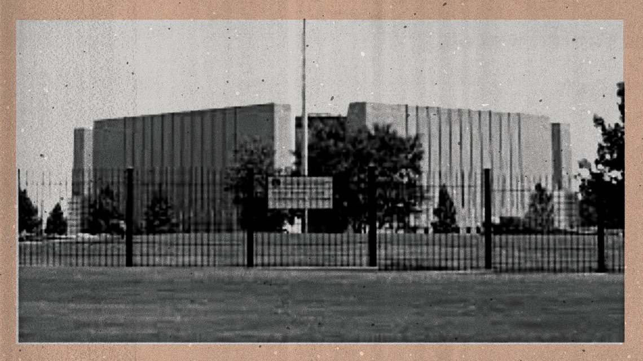
Thousands of prisoners were shipped through the federal transfer in Oklahoma City in February, March and April, according to records obtained by VICE News and the Marshall Project.
PHOTO ILLUSTRATION BY SUNGPYO HONG/VICE NEWS. IMAGE VIA THE BUREAU OF PRISONS.
New prisoners kept arriving at Elkton, even as the death toll reached nine. According to workers, new inmates were continually sent to Elkton throughout March and April.
Records obtained by VICE News and The Marshall Project show nearly 70 prisoners being transported by plane in late April. Smaller groups were being flown almost weekly.
“We are moving inmates in such a high volume, we have airlifts, buses, going out—the movement is just so much,” Anthony Sanon, union president at the Metropolitan Detention Center in Brooklyn, said in early April.
A BOP spokesperson said prisoner movement nationwide was down 95 percent from March 13 to April 23 compared with the same period last year. The issue is partly beyond the BOP’s control: Federal courts have continued to pump more people into the system.
But the agency formally resumed transfers in late May, announcing plans to move 6,800 recently sentenced people from temporary detention centers into prisons in order to “alleviate population pressures.”
A new “guidance” document obtained by VICE News and The Marshall Project says that prisoners are supposed to be tested and strictly quarantined during travel. But Sandra Parr, a national union official, says sick people have already been pushed out the door: “They’re shoving Tylenol and Motrin in ’em so they don’t have a fever, then putting them on a plane.”
A union official at the Federal Medical Center-Carswell in Texas filed a whistleblower complaint on April 7, alleging that the BOP “knowingly misleads the American public” about the movement of federal prisoners during the pandemic. The complaint followed the arrival on March 20 of a woman who tested positive for COVID-19. Andrea Circle Bear was almost nine months pregnant; she gave birth by emergency C-section while on a ventilator. Circle Bear died on April 28. Her baby survived and is living with a grandparent.

THE NEXT TO DIE
A detailed, up-to-date schedule of upcoming executions in the United States

Carvajal later testified that the agency reviewed the cases of over 30 pregnant women in federal custody and transferred 24 to “community confinement.” The others, he said, “weren’t eligible or appropriate” to serve out their sentences at home.
The continued transfers had lethal consequences at the Grady County Jail, a small lockup in Chickasha, Oklahoma, that has a contract with the U.S. Marshals Service to house overflow federal prisoners, typically for a few days or weeks at a time. The conditions there were ripe for an outbreak, as dozens of men were packed into a dorm with stacked bunk beds, no hot water, and no access to the outdoors or sunlight for weeks. One prisoner at Grady—activist and hacker Jeremy Hammond—reported that by the end of April half of his dorm had fallen ill. “Basically, they don’t give a fuck about us,” he said. A federal prisoner died there from COVID-19 on April 28. A BOP spokesperson referred questions to the U.S. Marshals Service, which said it “does not own or operate” Grady and other private detention centers. The jail did not respond to a request for comment. Joshua Lepird, president of the union at the Oklahoma City transfer center, which is about 30 miles northeast of Grady, estimated that more than half of his facility’s 52 confirmed COVID-19 cases in early June were people who’d been transferred from the jail. He blamed an intentional lack of testing across the system. “Here's the truth: They don’t want to know how many positive inmates they have,” he said. “The numbers are higher than they’re admitting.”
“They try to downplay it as much as possible”
The first federal prisoner to die during the pandemic was still reporting to work at the prison factory in Oakdale, Louisiana, when he collapsed in late March. Patrick Jones, 49, was serving time on a nonviolent drug conviction. Prisoners at Oakdale say Jones was sent back into their dorm-style housing unit while he was sick, causing the virus to spread. A BOP spokesperson said the allegations about Jones could not be verified.
Many of the BOP factories kept operating, paying workers between 23 cents and $1.15 an hour. Eventually, some were repurposed to make cloth face masks—even though at first prisoners were not allowed to wear masks while they worked.
Carvajal has touted the masks as an example of the agency’s swift and effective response to the outbreak. Several videos on the agency’s website open with him wearing a blue surgical mask, which he removes as he begins speaking. The mask, he says in one, came from a women’s prison in Minnesota.
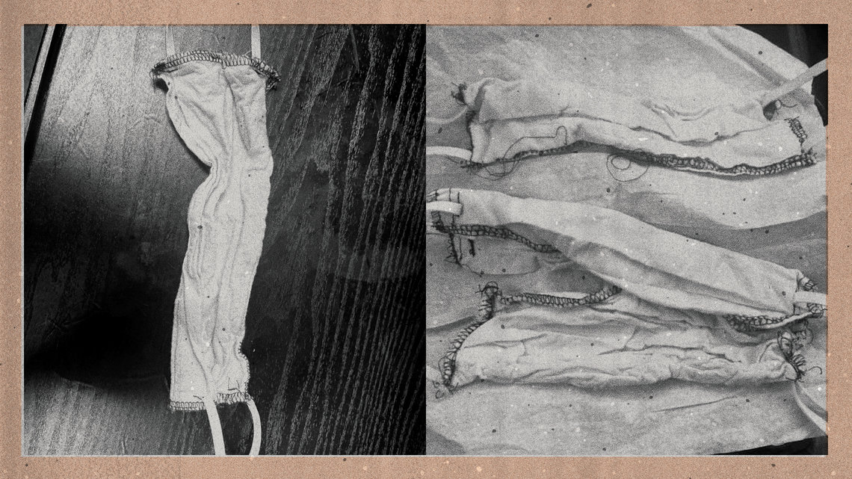
Cloth face masks made in prison factories were handed out to prisoners and staff at Carswell Federal Medical Center in Texas and the Coleman Federal Correctional Complex in Florida.
PHOTO ILLUSTRATION BY SUNGPYO HONG/VICE NEWS. IMAGE VIA FEDERAL BUREAU OF PRISONS SOURCES.
But photos of other masks sent to VICE News and The Marshall Project by both staff and prisoners show a different product, with haphazard stitching and threadbare white fabric. Several correctional officers said it resembled the material used to make prisoners’ boxer shorts. “I wouldn't put that thing on my dog,” one fumed.
The BOP says N95 respirator masks and other protective equipment for staff was stockpiled before the pandemic, but some officers said they couldn’t get the equipment when they needed it. In April, at least four prisons in the Southeast ended up with Chinese KN-95s that staff said appeared to not meet federal safety standards.
At the federal penitentiary in Atlanta, Robin Grubbs, a 39-year-old case manager, was worried about a quarantine unit that had been set up outside her office, according to her father, Gary Grubbs. “They didn’t give her no mask or nothing like that,” he said.
She didn’t show up for work on April 14; her coworkers found her unresponsive in her living room.
A spokesperson for the Georgia Bureau of Investigation said an autopsy was not performed on Grubbs because she tested positive for COVID-19, which was listed as the “probable cause of death.”
Her father said he was told Wednesday that toxicology results showed she had no drugs in her system or other explanation for her sudden death. The GBI spokesperson confirmed the death from “natural” causes.
George Grubbs is certain his daughter got sick at work.
"The only place she went was home and her job,” Grubbs said. “We feel that it had to come from the prison. That’s the only place we know that she’d been around it."
The Clayton County Police Department in suburban Atlanta, which is investigating the death, provided an incident report stating there were “no signs of foul play.” A police spokesperson said “the cause of death has not been made official.”
The BOP said “there is no evidence or information relating to a cause of death.”
Kelvin Williams, the Atlanta union chief, said the agency doesn’t want to acknowledge Grubbs as a COVID-19 victim because it would be obligated to pay her family benefits. “The bureau thinks about the long-term effect of admitting something like that has happened,” Williams said. “They try to downplay it as much as possible.”
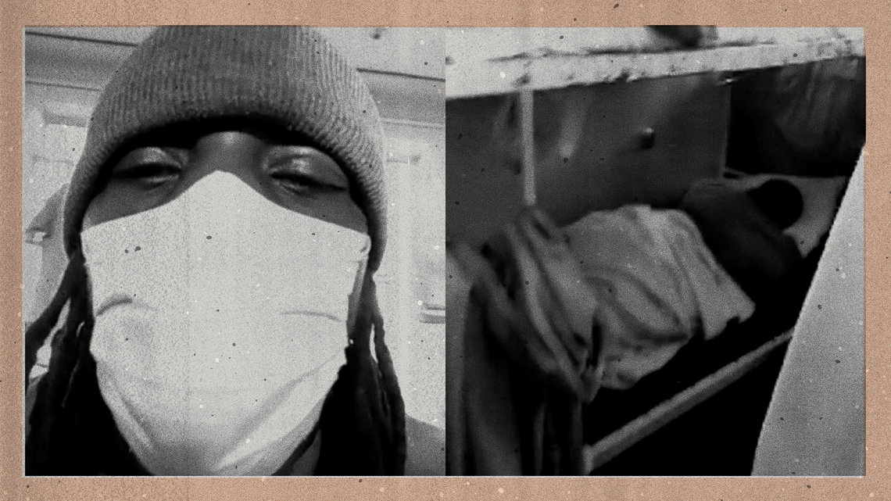
Federal prisoners in Milan, Michigan, used a contraband cell phone to post a video on social media about grim conditions they faced during the pandemic.
PHOTO ILLUSTRATION BY SUNGPYO HONG/VICE NEWS. IMAGES VIA DION MANE/FACEBOOK.
“It was like watching a horror movie”
While Desilva was on a ventilator at the hospital for much of April, prisoners at Elkton said they were allowed out of their housing units for just a few minutes each day, including for trips to the mess hall. The rush for food triggered stampedes.

THE RECORD
The best criminal justice reporting from around the web, organized by subject

More and more fell ill and were wheeled out on gurneys. At the peak, according to court records and Elkton staff, 46 prisoners were hospitalized, with 18 on ventilators.
“As far as I can tell, they ended up taking about one in every five out of here,” Donald Schlittenhardt, a 54-year-old Elkton prisoner, wrote on April 9 of his unit. “That puts your odds no better than playing Russian roulette with a six-shooter.”
Schlittenhardt, who uses a wheelchair and is serving 20 years on a drug conviction, said officers with pepper spray were summoned when he confronted medical staff in early April about not doing regular temperature checks and ignoring sick prisoners.
Mayle, the staff union president, described the encounter as an “isolated incident with a few disgruntled inmates who did not want to go into isolation.”
Schlittenhardt and two other prisoners also said officers threatened them with tear gas and pepper spray when they objected to having to eat lunch outside in 40-degree weather while their housing unit was being disinfected.
It’s not just Elkton. At prisons across the country, men and women who were sick or had been exposed to COVID-19 reported being held in horrifying conditions. And because the entire BOP system was in lockdown, even prisoners who were not ailing were confined to their bunks or cells, and some didn’t see sunlight for weeks.
At the minimum-security camp in Lompoc, California, prisoners say they were ordered to pick up one man who collapsed because the officers were afraid of touching him. The prisoners said medics didn’t arrive for about two hours. The BOP said it could not respond to the specific allegation, but that its staff respond to medical emergencies immediately.
Meanwhile, sick men were isolated in a mothballed section of the prison that had previously been used as “the hole.”
One prisoner there—who said he’d already been dealing with untreated cancer for a year—reported receiving only one hot meal a day and showering just once in 18 days. He could hear men coughing into the common area through their cell bars, and said he listened as the guards rushed to one prisoner’s cell and said he was “gone.”
“I can’t even believe this is happening in the United States,” he said. “It was like watching a horror movie.” A BOP spokesperson said only one of Lompoc’s four deaths from COVID-19 actually occurred at the prison itself; the others were in the hospital.
But more than 93 percent of the people inside the low-security prison contracted the virus.
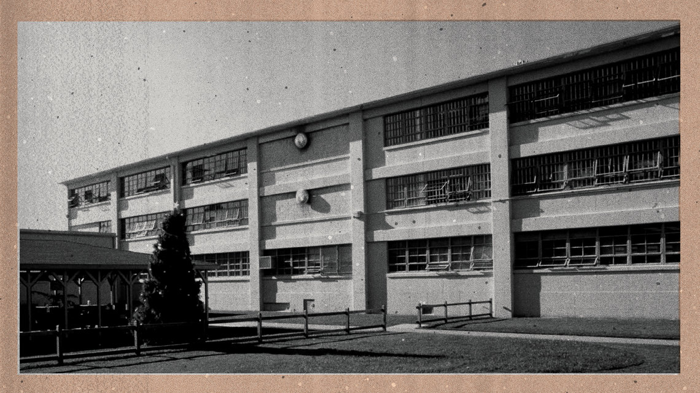
More than 93 percent of prisoners at the low-security prison in Lompoc, California, have tested positive for COVID-19.
PHOTO ILLUSTRATION BY SUNGPYO HONG/VICE NEWS. IMAGE VIA ASSOCIATED PRESS.
“I know this changed him”
On April 28, Rodriguez got the call she’d been hoping for: “Hey, gorda,” the familiar deep voice growled. “How are you guys?”
Desilva still sounded weak—but he was finally out of the hospital.
She burst into tears.
“I know this changed him,” she said. “He said the nurses were surprised he made it; he was on the verge of dying.”

CASE IN POINT
An examination of a single case that sheds light on the criminal justice system

But her fiancé was now in isolation, still without regular phone or email access. Eventually he’d be sent back to a dorm packed with other men. Like many prisoners, he asked for compassionate release. Like most of them, he has not yet gotten it.
Changing policies and internal agency opposition to releases have kept many behind bars. Lashonda Hall, serving 43 years at the prison in Tallahassee for a nonviolent drug crime, called her family to tell them she was being released to home confinement. When staff came back and told her there’d been a mix-up and she hadn’t served enough of her time, she couldn’t bring herself to let her family know.
“COVID-19 does not care how much of your sentence you have done,” she said.
Bernd Appleby, a 68-year-old prisoner serving two years for a white-collar tech crime, was initially told he didn’t qualify for release because of a minor disciplinary infraction, according to his wife. During the Super Bowl, he bet on the losing team and had to make good afterward: He owed a single ice cream sandwich. When he mentioned it in an email to a friend, he got written up for gambling.
At Elkton, Alvin Turner, a 43-year-old from Michigan serving time for a nonviolent drug charge, petitioned the courts to be sent home early, bolstering his case with a letter from prison staff saying he had taught financial literacy to more than 60 people. The BOP announced his death from COVID-19 on April 13.
The day of Turner’s death, the ACLU sued Carvajal and Warden Mark Williams, arguing that conditions at Elkton violate the Eighth Amendment’s prohibition on cruel and unusual punishment. Prisoners gave sworn declarations describing “complete chaos,” “ambulances leaving at all hours,” and feeling like they’d been handed death sentences.
Federal Judge James Gwin has sided repeatedly with the prisoners at Elkton, ordering the BOP to swiftly release or transfer 837 people who’d been identified as medically vulnerable.
After prison officials declared that only five people met the criteria, Gwin issued a blistering ruling that said Williams and Carvajal were “thumbing their nose at their authority to authorize home confinement” and risking the lives of both staff and prisoners in the process.
The government first appealed to the Supreme Court, which declined to hear the case, then got the lower court’s ruling overturned by the Sixth Circuit—a decision that dims the prospects of success for similar claims at other federal prisons.
BOP officials continue to maintain that releases are unnecessary and the situation at Elkton is under control.
Mayle, the Elkton union president, defended the staff’s handling of the outbreak.
“We followed CDC guidelines and did everything in our power to ensure the health and safety of staff and inmates,” Mayle said. “I believe the ball was dropped” by higher-ups, he added.
As of June 8, according to the Elkton union, nine prisoners remained hospitalized, including four on ventilators. Mass testing revealed 749 confirmed positive cases, including 505 held in isolation because they are symptomatic or otherwise known to be infected. More than 50 staff members have tested positive. The death toll still stands at nine.
More than two months after he started coughing, Desilva still struggles. He has congestive heart failure and painful swelling in his legs and feet, which landed him in the hospital again briefly in late May. The long-term effects of COVID-19 are still unknown, but he and Rodriguez suspect it’s the cause of his health problems.
They have a lawyer working on a compassionate release request, which notes his plan to marry Rodriguez. But it’s not clear whether prisoners who’ve already had the virus would qualify. In the meantime, Desilva is worried about being moved to a prison farther away from his fiancée, and he’s haunted by dreams of his blurry days in the hospital.
“It’s hard for him to get sleep. And when he does, he has nightmares,” Rodriguez said. “He wakes up screaming or crying.”
Correction: An earlier version misidentified U.S. District Judge James Gwin.
This story was updated to include additional information from the Georgia Bureau of Investigations.
Keri Blakinger is a staff writer whose work has focused on prisons and prosecutors. She previously covered criminal justice for Houston Chronicle, and her work has appeared in the Washington Post Magazine, VICE, the New York Daily News and NBC News. She is the organization's first formerly incarcerated reporter.
Tags: →DEATH IN PRISON →PRISON DEATH →FCI OAKDALE →FCI-LOMPOC →FCI ELKTON →REGIONAL REPORTING →PRISON HEALTH →BUREAU OF PRISONS →COVID-19

The latest on coronavirus and the justice system.
SUBSCRIBE

