Attention: Nayuka Gorrie
1st Attachment is a htm file of your article (with Witt Church) We need to abolish prisons to disrupt a society built on inequality which includes “….this conference highlights this movement is growing and strong, and has moved beyond imagining a world without prisons and is ready to build it.”
2nd Attachment is a htm file of The Guardian article Think prison abolition in America is impossible? It once felt inevitable dated 19 May 2018 (referred to in your above article) that includes “…..Increased public attention focused on the prison system, stoked by highly visible prison rebellions in New York City in 1970 and in Attica in 1971, led to a sense that dramatic change was inevitable. It was now just a question of sorting out the practicalities.”
3rd Attachment is a htm file of The Progressive Policy Think Tank paper What is Abolitionist Feminism, and why does it matter? (an embedded thread in your above article) which includes “…..Feminist abolitionists validate the nuanced role prison has held in their lives, while reassuring people that it is about building solutions not tearing down walls and leaving nothing in its place.”

“My name is Philip Johnston. I retired 10 years ago after a long career at one of the Four Pillar banks where, in the latter part, I administered as ‘Agent bank’ several large infrastructure projects (purchase of Sydney Airport and Brisbane Airports post-privatization, construction of Sydney Harbour Tunnel ‘et al’).

I attained a B.A. with a major in Economics and a Masters in Applied Finance from Macq Uni.

Femicide Australia Project research shows 108 adult men, 48 adult women and 17 children and young people were killed due to domestic violence in 2017.

Australian Femicide Facebook reported 63 women murdered to 5 October 2018.

Impact For Women reports that 70 women and 20 children had been killed in Aust. since 1 Jan 2018 (as at 13 Nov 2018) due to domestic violence.

The Red Heart Campaign reports (as at Nov 2018) that 19 children aged 17 years or younger and 66 women have dies from domestic violence in 2018:

Over 50% of inmates released from Australian prisons in 2014 had returned to prison within three years.

After reading over 150 papers, submissions, articles, reports, I have written a discussion paper titled 'Looking Outside the Cell' (available on a DVD and also USB Stick Flash Drive) that prosecutes the case to sentence both Corporal and Capital Punishments on a restrained basis, the latter being sentenced for some criminals for some premediated murder/s, to reduce –
I. the magnitude of a Dozen Problems within the Australian prison system; and
II. the horrendous annual homicide rates caused by domestic violence.

The Scandinavian countries and Texas USA have achieved success with Restorative Justice and are not experiencing the Dozen Problems to the same unsustainable extent as in the remainder of the USA states, the UK, Canada and Australia.

A burnt DVD provides greater integrity than a USB Stick and will auto-open (in a Windows operating system) at my 'Looking Outside the Cell' discussion paper. A reader can readily click on embedded threads therein to review source material relied upon.

I will post a DVD or a USB Stick to anyone who -
A. agrees the need to re-introduce both Capital and Corporal Punishment; and
B. emails me at scribepj@gmail.com that that they are prepared to expend at least –
* three hours to read my paper 'Looking Outside the Cell'; and
* will then email me or ‘phone me with their comments.”

Phil Johnston aka Bank Teller
0434 715.861

From: Philip Johnston [mailto:scribepj@bigpond.com]
Sent: Monday, November 19, 2018 11:08 AM
To: 'law.criminology@sydney.edu.au' <law.criminology@sydney.edu.au>
Subject: Will the Sydney Institute of Criminology publish my invitation set out under the heading “Discussion Paper – Thinking Outside the Cell” on the moderated bulletin board of Australian criminologists, CRIMNET?

https://wordvine.sydney.edu.au/files/2038/21166/#notices-4

Below is a ‘print screen’ of the above webpage which lists “Would you like us to feature information for you?”.

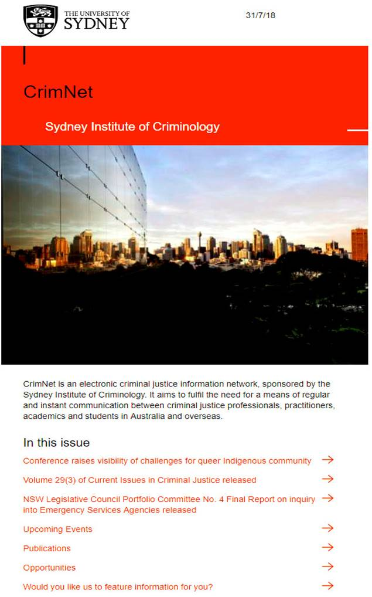

Will the Sydney Institute of Criminology publish my invitation set out below under the heading “Discussion Paper – Thinking Outside the Cell” on the moderated bulletin board of Australian criminologists, CRIMNET?

My further below indented text –

A. outlines my ‘Thinking Outside the Cell’ model for Australia’s Correctional Services prisons (based on research evident in Attachments ‘C’ and ‘E’) to reduce the magnitude of a Dozen Problems (Attachment ‘B’) with the Australian prison system and the horrific incidence of homicides annually resulting from domestic violence; and

B. invites readers (to contact me –Phil Johnston - at scribepj@gmail.com) who share my belief that sentencing of both Corporal Punishment and Capital Punishment need to be re-introduced on a restrained basis, for some criminals. In the case of Capital Punishment for some premediated murders, to reduce –
I. the magnitude of a Dozen Problems (Attachments ‘B’) within the Australian prison system; and
II. homicides due to domestic violence.

Attachment ‘D’ is one of over 150 articles, reports, submissions (listed in Attachment ‘C’) that I have –
1. downloaded a PDF or a html file;
2. extracted the text and saved the text in a htm file;
3. read and colour background interesting aspects of those papers; and
4. linked the htm file with an embedded thread, so readers can readily validate the source of all information in my Discussion Paper.

Discussion Paper – Thinking Outside the Cell

“My name is Philip Johnston. I retired 10 years ago after a long career at one of the Four Pillar banks where, in the latter part, I administered as ‘Agent bank’ several large infrastructure projects (purchase of Sydney Airport and Brisbane Airports post-privatization, construction of Sydney Harbour Tunnel ‘et al’).

I attained a B.A. with a major in Economics and a Masters in Applied Finance from Macq Uni.

Femicide Australia Project research shows 108 adult men, 48 adult women and 17 children and young people were killed due to domestic violence in 2017.

Australian Femicide Facebook reported 63 women murdered to 5 October 2018.

Impact For Women reports that 70 women and 20 children had been killed in Aust. since 1 Jan 2018 (as at 13 Nov 2018) due to domestic violence.

The Red Heart Campaign reports (as at Nov 2018) that 19 children aged 17 years or younger and 66 women have dies from domestic violence in 2018:

Over 50% of inmates released from Australian prisons in 2014 had returned to prison within three years.

After reading over 150 papers, submissions, articles, reports, I have written a discussion paper titled 'Looking Outside the Cell' (available on a DVD and also USB Stick Flash Drive) that prosecutes the case to sentence both Corporal and Capital Punishments on a restrained basis, the latter being sentenced for some criminals for some premediated murder/s, to reduce –
I. the magnitude of a Dozen Problems within the Australian prison system; and
II. the horrendous annual homicide rates caused by domestic violence.

The Scandinavian countries and Texas USA have achieved success with Restorative Justice and are not experiencing the Dozen Problems to the same unsustainable extent as in the remainder of the USA states, the UK, Canada and Australia.

A burnt DVD provides greater integrity than a USB Stick and will auto-open (in a Windows operating system) at my 'Looking Outside the Cell' discussion paper. A reader can readily click on embedded threads therein to review source material relied upon.

I will post a DVD or a USB Stick to anyone who -
A. agrees the need to re-introduce both Capital and Corporal Punishment; and
B. emails me at scribepj@gmail.com that that they are prepared to expend at least –
* three hours to read my paper 'Looking Outside the Cell'; and
* will then email me or ‘phone me with their comments.”

Phil Johnston aka Bank Teller
0434 715.861

