1305, 12 Glen St,
Milsons Point NSW 2061
0434 715.861
scribepj@bigpond.com

Insert an enclosed DVD in a Windows PC to auto-open this Letter_to_Peter_Norman_9-Mar-19.htm
If using a MAC or the enclosed USB Stick Flash Drive, or the enclosed DVDs do not auto-open, then open this letter at Punishment/ACPC/Letter_to_Peter_Norman_9-Mar-19.htm
To navigate my submission, click on the countless blue embedded threads therein
To leave a page and return to the previous page, click on the arrow at top left of screen

9 March 2019

Peter Norman peter.norman@courts.sa.gov.au
ACPC Chairman
Level 2, Sir Samuel Way Building
Victoria Square, Adelaide 5000
Dear Mr. Norman

Will ACPC (nee ACPC and After-care Council to 1975) facilitate Australians with some understanding of the Criminal Justice System that want the following three adverse consequences et al reduced -
A. read my Discussion Paper Thinking Outside the Cell (either on a DVD in a DVD Case or on a USB Stick Flash Drive); and
B. complete my Peer Review Form (Word document) and email it to ACPC?
1. Dozen Unsustainable Problems Within Australian Prison System
2. Femicide and Filicide murders in Australia annually
3. Exceedingly high annual recidivism/re-offending rates in Australia

The Writer refers to his Prior emails with ACPC over recent months.
A burnt DVD provides greater integrity than a USB Stick. A DVD will auto-open (in a Windows operating system) at my Discussion Paper by clicking at Windows pop ups on the RHS of their screen when prompted, whereupon the peer reviewer can readily open to the 'primary page' Letter_to_Peter_Norman_9-Mar-19.htm and click on multiple embedded threads therein.
110+ Defined Terms avoid uncertainty/misinterpretation. 180+ documents, reports, articles, discussion papers et al in Articles & Reports are linked with embedded threads. In the vast majority of the 180+ 'documents' in Articles & Reports, the text from a downloaded PDF has been extracted and saved in a dedicated htm file. Pertinent sections of text within those reports are coloured. The actual PDF of the primary source document/report/article is accessible by clicking on the initial thread at the top of the associated webpage.
None of those 180+ 'documents' have attempted what I seek to achieve, namely to present a Discussion Paper that sets out how to materially decrease the tangible and intangible costs/failings/weaknesses of Australia's Criminal Justice System, not limited to 1. 2. and 3. above.
– 2 –
I am hopeful that academics/practitioners that profess to have an understanding of Australia's Criminal Justice System, and are concerned about 1. 2. and 3. above, will -

A. display requisite courage/concern to complete my Peer Review Form (Word document); and

B. email their completed Form to ACPC.
Relying upon ACPC's CONSTITUTION AND RULES, in particular Clause 4 'Objects', I seek ACPC to publish my Discussion Paper Thinking Outside the Cell at Crime Prevention Articles after it has measured at least three completed/submitted Peer Review Forms, together with publishing all 'accepted' email submitted Peer Review Forms as annexures to Thinking Outside the Cell. Hence, worthwhile contributions by peer reviewers would be recognised and their comments/views available for consideration and 'Comment' on the ACPC website by people that have registered on the ACPC website - in the same manner that financial contributors to the SMH can post a 'Comment' or tick an 'affirmative' to an existing 'Comment'.
It would be a simple 'web enhancement' task to enable readers to post their written 'Comments' on ACPC's website under the prefix of their email address, where accepted written 'Comments' are viewable by other readers.
Webpage Femicide and Filicide lists various Not-For-Profits that would likely be acutely interested in my Discussion Paper, worthwhile Peer Reviews and written 'Comments' from lots of interested readers.
The Father of Restorative Justice, Captain Alexander Maconochie, encountered strident criticism for his 'soft' treatment of inmates during his four year stewardship at Norfolk Island from 1840, during an era of vicious physical punishment; 'soft' treatment wasn't the Current Wisdom for controlling hardened criminals on 'works gangs'. Accordingly, traditionalists spoke out judgmentally.
Doubtless, today there are opponents of Thinking Outside the Cell, because they hold the Current Wisdom, albeit that it wasn't the Current Wisdom amongst 97% of the 108 billion 'circa' Homo sapiens' 125,000 years' occupancy of terra firma. Such opponents invariably have no understanding of –

* the Sadistic, Brutal, Premeditated, Unprovoked Murder/s committed by the 35 Never to be Released Inmates et al, explained in Most Heinous Of Convicted Murderers,

* the abject QOL of Lifers 'Never to be Released'; or

* $150,000 pa Administrative Cost per inmate upon the Public Purse of retaining each, often in a 'vegetable state', in a Maximum Security Prison until each dies from old age.

– 3 –
Below are extracts from Last man hanged: 50 years in Australia without an execution - BBC News - 2 Feb 2017:

“Crusading commentator-turned-politician Derryn Hinch opposed capital punishment for decades before the horrific rape and murder of Sydney nurse, Anita Cobby, by five men, including three brothers, in 1986. Hinch, a senator who heads his own Justice Party, says the death penalty should apply in cases such as Knight's, where no doubts exist.
"If Australia had the death penalty, a lot of young women could be alive today," Hinch wrote in 2012.The recent case of a motorist accused of deliberately killing people in Melbourne has shocked the nation
"If our touchy-feely parole boards spent half as much time considering victims and their families as they do to rushing serial, violent criminals back on to the streets, this world would be a safer place. And if a federal government had the guts - or a state government had the independence and backbone - to hold a referendum on the return of capital punishment for some crimes, it would pass by a majority of about 75% to 25%."
SMH Note From The Editor - Wed, Mar 6, 2019 encapsulates topical community concern about halting domestic violence and Govt's recently announced budgets for preventative programmes. The recent patent 'line in the sand' stand announced by the Aust. Rugby League over domestic violence by denying such accused ARL football players the things that mean most to them (playing the game, earning high incomes, associated status) will have a far greater impact on reducing domestic violence amongst its players, than prevailing court concerns that are not in the mindset of many young footballers used to prevailing through physical power.
Australians now want 2. (further above) to be treated/reduced, with flow-on effects to 1. and 3. above. Deterrents have to hit where they in actuality hurt, as prescribed in the 1st Throng and 2nd Throng - Deterrents that over 97% of the 108b Homo sapiens that have lived on terra firma over the last 125,000 years or so.
Yours sincerely
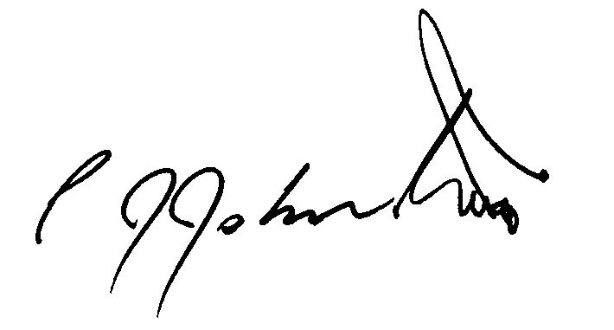
Philip J Johnston

