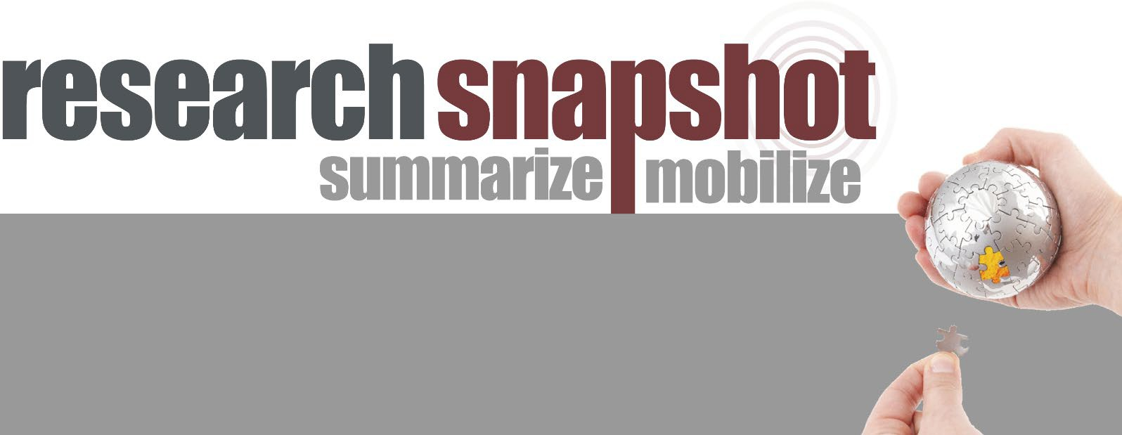

Using big financial data to understand how gambling is associated with financial, social, and health outcomes

What this research is about
Gambling is a popular leisure activity. However, it can lead to addiction and harmful consequences for some people. Previous research has identified many types of gambling harms including financial, relationship, work, study, health, and socially deviant acts. Most studies have relied on surveying a small number of participants. Also, the use of self-report survey can lead to biases. For example, people often cannot accurately recall their gambling spending.
In this study, the researchers used transaction data from everyday banking to examine how gambling is associated with 31 financial, social, and health outcomes. Financial transaction data provides an objective way to measure outcomes related to gambling. These datasets also involve large numbers of people who can be tracked over time.

What the researchers did
The researchers used three datasets provided by the UK’s largest retail bank, Lloyds Banking Group (LBG). A transaction was defined as any spending behaviour using a debit or credit card. It included electronic or
in-store transactions. To identify gambling transactions, the researchers relied on the bank’s pre- existing categories. These included offline and online bookmakers, casinos, lotteries, and other gambling platforms. Gambling using cash and gambling at other types of retailers (e.g., buying a lottery ticket at a supermarket) were not captured.
The first dataset involved 102,195 adults who were active customers in each month in 2018. An active customer was someone who had made at least 12 transactions per month in their account. If an account was shared with another person, only the transactions

What you need to know
This study examined how gambling is associated with financial, social, and health outcomes. The researchers examined transaction data provided by a large retail bank in the UK. The largest dataset involved 6.5 million adults. The results showed that people who spent more of their monthly income on gambling had greater financial distress and were less likely to plan financially. They also had a more negative lifestyle (e.g., spent less on fitness and social activities). People who spent more on gambling had a higher risk of being unemployed and being on disability payments in the future. They also had a higher mortality rate.
made by the primary account holder would be used. The researchers used this dataset to examine how gambling was associated with financial, lifestyle, and well-being outcomes.
The second dataset involved 6.5 million adults who were active customers in each month in 2013. The researchers tracked these customers from 2014 to 2019. The aim was to understand how gambling was related to longer-term outcomes of unemployment, disability, and mortality (death). The third dataset involved 101,151 adults who were active customers from 2012 to 2018. The researchers used this dataset to track how gambling might change over time.

What the researchers found
Financial distress, lifestyle, and well-being
Of the 102,195 customers, 43% made at least one electronic gambling transaction in 2018. There were some customers who made many gambling

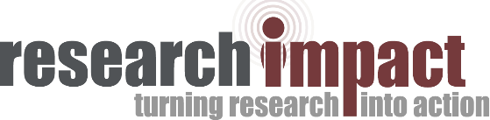

transactions and spent large amounts of money on gambling. The top 10% spent more than £1,800 on gambling in 2018, close to 8% of their total spending.
People who spent more of their monthly income on gambling were more likely to use an unplanned bank overdraft, miss a credit card, loan, or mortgage payment, and take a payday loan. These customers spent less on insurance and mortgage repayments, had smaller total savings, and made smaller pension contributions. They were less likely to hold a credit card, loan, or mortgage. They owed a larger amount of money on their credit card balances and were also more likely to be facing debt collections.
People who spent more on gambling spent less on self-care, fitness, social activities, education, and hobbies. They also spent less on travelling and on bars and pubs. They were more likely to spend at night, suggesting that they were awake at night to gamble.
Unemployment, disability, and mortality
People who spent more on gambling were more likely to be unemployed and to claim disability in the next five years. They also had a higher mortality rate.
Time course of gambling
The researchers used the year 2015 to compare the level of gambling before (2012–2014) and after

About the researchers
Naomi Muggleton is affiliated with the Department of Social Policy and Intervention at the University of Oxford in the UK. Paula Parpart is with the Department of Experimental Psychology at the University of Oxford in the UK. Philip Newall is with the School of Health, Medical and Applied Sciences at CQ University in Australia. David Leake is with Applied Science at Lloyds Banking Group in the UK. John Gathergood is with the School of Economics at the University of Nottingham in the UK. Neil Stewart is with the Warwick Business School at the University of Warwick in the UK. Please see the article for more author affiliations. For more information about this study, please contact Naomi Muggleton at naomi.muggleton@spi.ox.ac.uk.

Citation
Muggleton, N., Parpart, P., Newall, P., Leake, D., Gathergood, J., & Stewart, N. (2021). The association between gambling and financial, social and health outcomes in big financial data. Nature Human Behaviour, 5, 319-326. https://doi.org/10.1038/s41562-020-01045-w

Study funding
This study was funded by the Lloyds Banking Group and the Economic and Social Research Council (ESRC).

(2016–2018). Gambling remained at the same level
for most people. But, a few individuals started to

gamble heavily, while others who gambled heavily stopped gambling. Among the top 10% who gambled heavily, half were already doing so three years before. About 6.9% who did not gamble six months before began to gamble heavily. Only 4.6% of those who gambled heavily stopped gambling six months later.
These results suggest that gambling is persistent, and some people started gambling heavily at a rapid pace.

How you can use this research
This study can inform policy makers, financial institutions, and researchers. Policy makers and financial institutions could find ways help detect people who spend heavily on gambling and ensure that people who gamble at a low-level remain so.

About Gambling Research Exchange (GREO)
Gambling Research Exchange (GREO) has partnered with the Knowledge Mobilization Unit at York University to produce Research Snapshots. GREO is an independent knowledge translation and exchange organization that aims to eliminate harm from gambling. Our goal is to support evidence-informed decision making in safer gambling policies, standards, and practices. The work we do is intended for researchers, policy makers, gambling regulators and operators, and treatment and prevention service providers.
Learn more about GREO by visiting greo.ca or emailing info@greo.ca.

This work is licensed under the Creative Commons Attribution-Noncommercial 4.0 International License. 2021

