How slot machine operators are taking over UK high streets
The Guardian 18 March 2024 3 days
In the corner of a dimly lit room, the face of a middle-aged woman is bathed in the greenish-yellow glare of a giant slot machine. Next to her, an increasingly agitated man jabs furiously at the “spin” button, as the jackpot eludes him yet again.
It is early afternoon on a weekday and they are among half a dozen punters robotically feeding banknote after banknote into the mesmerising terminals of an “adult gaming centre”.
These slot machine farms are one of the few high street venues quietly flourishing on Britain’s high streets despite, or perhaps because of, the cost of living crisis. But an investigation by the Observer raises questions about how they are regulated and whether their operators are bending the rules to squeeze cash out of potentially vulnerable customers.
Analysis of corporate records also reveals how every pound that drops into the slot eventually rolls uphill, helping to enrich billionaire owners and fund political lobbying.
That lobbying now appears to be on the verge of bearing fruit. Regulations governing high street slot machines are likely to be eased, even as the government cracks down on online gambling.
With one eye on a looser legal landscape, the sector’s major players are plotting aggressive expansion, pitting their vast resources against cash-strapped local authorities and the communities they serve.

Gambling on growth
Slots operators are dab hands at bringing in customers and keeping them playing. Staff offer free tea, coffee and snacks – a small expense given how quickly the outlay comes flooding back.
With an in-store cash machine close at hand, it is all too easy to keep absent-mindedly feeding money into seductive games such as Luck o’ the Irish and Jackpot Gems.
Such temptations can be destructive. Wendy Hughes, 64, lost more than £2,000 over the course of 16 hours, spread across two days of play, in the Stockport branch of Merkur, one of the two companies that dominate the sector.
“I just keep loading the £20s in,” Hughes says. “Sometimes I’m in such a daze that I just don’t really care any more.”
Hughes tells how the bookmaker she worked for directed her to start playing machines, on a demonstration setting, to lure in paying customers. It kicked off a descent into addiction that has kept her coming back to spend what little money she has – even when she fell gravely ill with lung cancer.
Hughes’s losses help to explain why operators are doing so well. Income from the £2-a-spin category “B3” machines, the sector’s workhorse, soared by 46% to reach a record £381m in the year to the end of March 2023, according to the Gambling Commission.
On average, each machine now makes £30,500 a year, sucking up the equivalent of an average person’s annual salary.
Some of the machines belong to small, regional, family-owned amusement arcade businesses, or motorway service station companies, which are typically owned by private equity.
But no one collects more from these cash guzzlers than the two major players – Admiral, with 275 shops in the UK, and Merkur, with 230. Admiral is the UK division of the multinational gaming group Novomatic, a private company owned by an Austrian billionaire, Johann Graf. Merkur is a German brand with another billionaire owner, the Gauselmann family.
Between them, the UK divisions of these two companies pulled in combined revenues of more than £420m in the last year for which accounts are available. Little wonder, then, that both are now eyeing a bigger piece of the UK high street.
Merkur opened 38 venues last year, as part of its “UK expansion project”, on top of 36 the year before. Admiral is also in growth mode, promising on its website that “if we’re not already on your high street, we might be very soon”.
From Barnet to Aberdeen and from Norwich to Birmingham, the pair – as well as their smaller rivals – are submitting planning and licence applications, often for 24-hour opening.
Objections from councillors, residents and even the police have met with mixed results. In South Shields and Sunderland, Merkur has been pushing local councils hard to be allowed to open all night, securing a year-long “trial run” in South Shields.
In Enfield, north London, a smaller rival succeeded with an application despite opposition from more than 1,000 local people and the local MP. The council said it was “compelled by law” to issue a licence.

Risk and regulation
They may be growing but, in the midst of intense scrutiny of the gambling industry in the past few years, adult gaming centres have largely flown under the radar, as attention has focused on high-octane products such as fixed-odds betting terminals and virtual, online slots games.
But Dr Matt Gaskell, a consultant psychologist and the head of the NHS Northern Gambling Service, points out that, even at £2 a spin, the appeal of these games can present significant risk.
“It’s the structural characteristics of the slot machine that lend themselves to prolonged play,” he says. “At low stakes, your money can last longer. Patients talk to me about losing long periods of time. It just adds to the preoccupation and the constant reinforcement and engagement with that product. And generally they leave you alone in those places.”
Hughes’s experience showed that allowing customers to play for longer periods could result in large financial losses, as well as mental harm. But she is far from alone.
In responding to a subject access request submitted by Wendy’s family, Merkur accidentally enclosed data relating to another of its customers. The unidentified person had lost more than £750 in just over an hour.
Data collected by the Gambling Commission in 2019 shows that adult gaming centres hosted sessions of more than an hour on at least 150,000 occasions in the space of six months.
What’s more, it appears that some firms may also be doing some gaming of their own.
Under Gambling Commission regulations, the number of £2 (category B) machines allowed in a gaming centre is limited to four times the number of their lower-intensity £1-a-spin cousins (category C). According to the government’s white paper on gambling reform, published last year, some companies have found an ingenious way around this.
A tablet, such as an iPad, technically counts as a machine. By sticking a rack of lower-stakes category C tablets at the back of the shop, some companies have been able to pack the rest of the floor with higher-stakes machines. It’s a tactic apparently in evidence at the Stockport Merkur, where a trove of tablets are ignored by customers.
Rather than cracking down, ministers look set to loosen the rules, allowing more of the higher-stakes machines, according to proposals outlined in the white paper.
There is some logic to this. Lower-stakes machines are less popular with punters, meaning many of the terminals simply stand there wasting electricity – at an average annual cost of £1,600, according to government calculations.
Changing the allowable ratio – to 50:50 under one proposal – could save the sector £20m in energy costs alone, according to government calculations.
However, the effect on punters is much harder to predict. Moreover, ministers are also looking at whether to allow gamblers to pay with contactless debit cards, making payment even easier.

Lobbying for expansion
With millions at stake – and the future of regulation up in the air – it’s no wonder that operators are pouring some of the money they make from punters into political lobbying. In February last year, Merkur boasted of meeting its 65th MP, meaning it had glad-handed 10% of the House of Commons, including the gambling minister himself, Stuart Andrew.
Rival Admiral says that it also engages with “stakeholders” in the UK, and it is a member of the sector’s trade association, which has itself lobbied ministers.
Merkur said: “We take any allegations against our staff extremely seriously,” adding that Hughes’s case had been “fully investigated” and reported to the Gambling Commission in January.
“We have established that the customer interaction measures recommended by the Gambling Commission were fully in place.
“Regrettably, it would appear that on this occasion individual members of staff at our Stockport venue fell short of what was required of them. Extensive retraining has taken place.”

Related
shefnews.co.uk

Merkur Casino withdraws application for new slots location in Sheffield following public backlash
A slot machine company has withdrawn their application for a new premises in Sheffield following opposition from people in the area. Merkur Casino made the application on December 18 but decided to withdraw it on Wednesday. They planned to open the venue on Sheffield City Centre High Street, with it being listed as a'Bingo Premises', which some&hellip;
BINGO・5 days
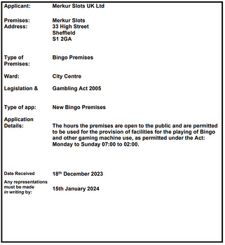
Yogonet

UK: BGC welcomes online slot stake limits, but cautions against potential customer drift to black market
Betting and Gaming Council (BGC) CEO Michael Dugher, soon to transition to the role of Chair, issued a statement welcoming the recent announcement of new stake limits for online slot games. " We welcome the Government's decision on new stake limits for online slots games, which provide enhanced protections for young people. The BGC supported&hellip;
INCIDENTS・25 days
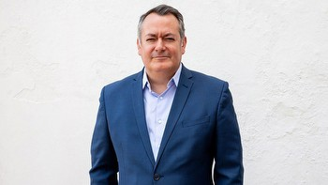
The Guardian

Digital slot machine limit of £2 set to cost gambling operators in UK millions
The government is set to impose new limits of as little as £2 a spin for online slot machines, the Guardian understands, in a move that could cost casino companies hundreds of millions of pounds. Ministers have been consulting on imposing a maximum stake for the digital casino-style games since publishing a white paper on gambling reform last&hellip;
INDUSTRY・27 days
The Guardian

Record revenues at UK gambling firms amid rise of online slot machines
Gambling firms are raking in more money than ever from UK punters, fuelled by a surge in the use of online slot machines, which the government is considering curbing due to their association with heavy losses and addiction. The betting and gaming industry's revenues reached £15.1bn in the year to March 2023, or £10.95bn excluding the National&hellip;
FINANCE・01 December 2023
theneweuropean.co.uk

The costly rise of the high street casino
Holloway Road in north London has a 24-hour casino under the Merkur Slots brand - formerly known as Cashino - tucked between a Vodafone shop and one of what must be the city's last few photo development shops. A few miles away, Bethnal Green also has a Slots, which sits between Daily Essentials and another unnamed but similar shop, its facade&hellip;
GAMBLING ADDICTION・04 October 2023
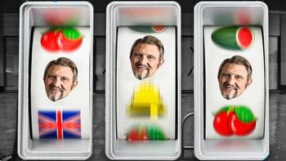
theweek.com

Britain's gambling habit: are we dicing with serious damage?
A free daily digest of the biggest news stories of the day - and the best features from our website Thank you for signing up to TheWeek. You will receive a verification email shortly. There was a problem. Please refresh the page and try again. A great deal. The UK is one of the world's biggest gambling markets, and the world's biggest online&hellip;
GAMBLING ADDICTION・30 September 2023
National World

Gambling White Paper: proposed new UK Gambling Act laws
Culture Secretary Lucy Frazer has said a long-awaited Gambling White Paper, due to be unveiled in Parliament today (27 April), will help "redress the power imbalance between punters and operators" while preventing addiction. Following the explosion of online betting and a number of high-profile cases where customers suffered significant losses or&hellip;
LAW・27 April 2023
The Guardian

Overhaul of UK online gambling laws could see £2 slot machine limit for under-25s
Online casinos will face tougher restrictions under government proposals to overhaul Britain's gambling laws, but the majority of measures will be subject to further consultation, signalling even more delay to long-awaited changes. A white paper, the result of a review launched in 2020, is due to be published on Thursday, after being postponed&hellip;
LAW・27 April 2023
Yogonet

UK Government reportedly set to cap online slot spins at £2, potentially costing casinos millions
The UK government is reportedly on the verge of implementing new restrictions on online slot machines, with spins potentially limited to as little as £2 ($2.5). This regulatory move is anticipated to be disclosed on Friday and could have significant financial implications for casino companies, possibly amounting to hundreds of millions of&hellip;
INDUSTRY・26 days
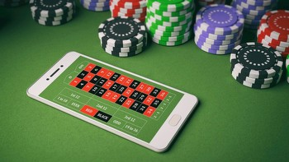
The Shields Gazette

24-hour trial approved for adult gaming centre Merkur Slots in South Shields' King Street amid problem gambling concerns
Earlier this year, South Tyneside Council's planning department registered a planning application for the Merkur Slots premises at 48 King Street in the town centre. The adult gaming centre, which offers low stakes slot machines, bingo machines and tablets, was established on King Street after being granted planning permission in February,&hellip;
INCIDENTS・29 November 2022
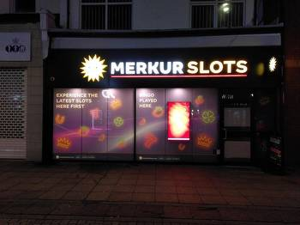
Malta Independent

Casino operators in the UK and Malta wary of White Paper on gambling reform
The UK government's long-awaited White Paper on gambling reform, which is expected to be published in the coming weeks, is likely to be watered down according to The Times, but the reported changes will still have far-reaching implications, primarily for online gambling operators in the United Kingdom, and potentially for operators in Malta&hellip;
LAW・15 July 2022
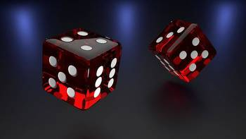
Business Matters

New curbs for online gambling ‘catastrophe’ as Premier League clubs escape sponsor ban
Ministers will publish a review of the 17-year-old gambling legislation amid concerns that it has been rendered outdated by the explosion in popularity of online betting. The curbs will include maximum stakes of between £2 and £5 for online casinos, a ban on free bets and VIP packages for those who incur heavy losses, and "non-intrusive"&hellip;
GAMING AUTHORITIES・29 June 2022
Daily Mail Online

Ministers are set to unveil new online gambling curbs in bid to stem addiction crisis
Boris Johnson is bringing in online gambling regulations to stem the'catastrophic' impact of addiction - but will not ban bookies' logos on football shirts. Ministers will publish a review of legislation, including new curbs on minimum stakes, 'non-intrusive' affordability checks and banning free bets and VIP packages for those who lose big&hellip;
GAMBLING ADDICTION・29 June 2022
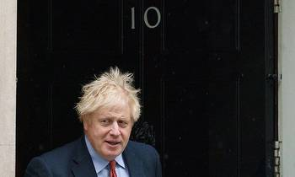
Harrow Online

The best casinos in and around Harrow
Daniel Dancer's hidden fortune isn't the only treasure waiting to be found in the streets of Harrow. Our neighbourhood and its surrounding area, is full of thrilling gambling adventures, giving you plenty of chances to take home big winnings while also having a great time. Below, you'll find three recommendations for a night of gambling on the town&hellip;
POKER・12 May 2022
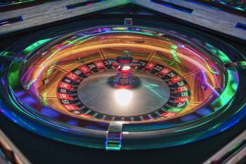
Somerset County Gazette

Merkur Slots venue opening in North Street, Taunton
A HIGH street'entertainment venue' is opening in Taunton town centre next week. Merkur Slots adult gaming centre goes live in a Grade II listed building in North Street on Monday next week (April 4). The business will offer people the chance to play on gambling machines, including bingo machines and tablets, 24 hours a day. Players will be able to&hellip;
JOBS・29 March 2022

