5 Largest Contributions in Responsible Gambling Implementation
largest.org 6 days
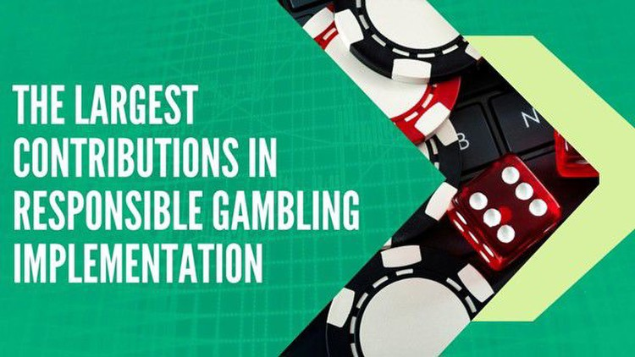
There are many involved in gambling either for the thrill or to earn more money. Whatever the reason may be, some seem to be getting addicted to gambling. And over the years, close to 430,000 people found it difficult to overcome being addicted to gambling. In a bid to help interested gamblers come out of their addictive state, Great Britain came up with a gaming commission. UKGC came into existence in 2007 to regulate every gambling site.
With this effect, GamStop and other alternatives have been pulled out from this commission. Moving on into the article, you will get to explore their contributions to responsible gambling implementation.

1) UKGC & GamStop
UKGC, United Kingdom Gaming Commission, works to assist vulnerable gamblers to overcome being addicted and exploited through customer age verification from gambling companies. As a product of UKGC, GamStop came into existence as a self-exclusion system to help any interested gambler to cut short their excessive gambling activities.
Every registered gambling site on UKGC is expected to link up with GamStop and follow their regulations. However, since UKGC is the only regulatory commission in the UK, many gambling sites do not register with UKGC and GamStop. Therefore, they are regarded as casinos and sports sites not on GamStop self-exclusion operated by foreign authorities.

2) GamCare
GamCare is another non-governmental organisation saddled with the responsibility of providing solutions to anyone affected by gambling harms. They provide support, therapeutic attention or care and create structured awareness against the harms that come with gambling.
Founded in 1997, GamCare is regarded as the leading provider of information, advice, support and attention for anyone who has problems with gambling activities. Also, it is involved in creating self-exclusion programs for any interested gamblers. In addition, awareness about responsible gambling and encouragement of responsible gambling are created.
Every UK gambling site registered with GamCare is expected to undergo an assessment with a fee. Also, they are expected to follow the rules provided by GamCare in contrast to those NonGamStopBetting.org casinos that don’t cooperate with GamStop, GamCare and other self-exclusion systems. GamCare assesses the gambling businesses and ensures that the necessary measures to protect people from getting harmed in gambling-related issues are in place.
As part of the national gambling support network, GamCare is among the organisations in Great Britain equipped with the capacity to provide personalised support and free consultation for individuals undergoing harm from gambling activities.

3) Gordon Moody Association
This is another non-governmental charity company with the duty of helping vulnerable gamblers overcome the damage caused by gambling and contribute to rebuilding their lives. Moreover, expertise is available to help interested gamblers. The supported environments are provided by the Gordon Moody Association for the benefit of any interested gamblers.
Gordon Moody Association has become the leading organisation providing gambling therapy services in the United Kingdom of Britain. Founded in 1971, Gordon seeks to provide reliable treatment for anyone affected by the harms of gambling activities. As a result, in 2004, the Gordon Moody Association launched a special support service named Gambling Therapy as its international support service. Through this, many are saved from the harms of gambling and recover from their loss.
Gordon Moody reaches out to their target audience [vulnerable gamblers] through residential, online and outreach services with their unique service for gamblers. However, these services are for gamblers within and outside the UK. These services include addiction, alcohol, drug and gambling support.

4) Gamblers Anonymous
This is an association of players who come together to share their experiences, strengths, and possible hopes of overcoming their gambling problems. The sole purpose of creating such an association is to help each other overcome the gambling problem.
Here, they organise meetings, forums, chat rooms and other helpful meetings that can strengthen their members. The requirement to become a member of the Gamblers Anonymous is the desire to stop being a gambler.
Their contributions to responsible gambling implementation are to bring together vulnerable or compulsive gamblers and give them access to express their possible experiences. And this equipped them with the necessary measures to overcome their vulnerability to gambling activities.

5) GambleAware
GambleAware is another organisation with a governance process created to bring to the awareness of gamblers or individuals about the harms and risks involved in gambling. They collaborate with other organisations to reach out to people by carrying out research, educating, giving awareness and increasing the knowledge of people regarding the risks and dangers of being addicted to gambling activities.
Another thing to note is that GambleAware is an independent company funded by voluntary donations from the gambling industry.

The Bottom Line
The above-listed organisations have contributed largely to the implementation of responsible gambling. They consistently create support, awareness, therapeutic services, and education about the effects of gambling. Moreover, they are saddled with the responsibility of helping affected gamblers recover from their addictive nature. Therefore, they restrict gambling players from some gambling sites. Without a doubt, these organisations have effectively contributed to the betterment of society.

