Reforms to the regulation of vapes
Find out about changes to the regulation of all vapes in Australia.https://www.tga.gov.au/products/unapproved-therapeutic-goods/vaping-hub/reforms-regulation-vapes
Reforms to the regulation of vapes seek to address the significant public health issues caused by vaping, particularly among young people.
Vapes include vaping substances, vaping accessories and vaping devices.
From 1 January 2024:
- the importation of all disposable vapes is banned, with very limited exceptions
- the Special Access Scheme C (SAS C) pathway, is available to facilitate legitimate patient access to therapeutic vapes, for smoking cessation and the management of nicotine dependence
- a form for importers and manufacturers of therapeutic vapes is available to notify the TGA about compliance with the relevant product standards prior to importation into Australia, or release for supply of vapes manufactured domestically (notices are required for goods imported or released for supply on or after 1 March 2024)
- an application form for therapeutic vape importers is available to apply for licences and permits for importing therapeutic vapes (licences and permits are required for goods imported on or after 1 March 2024).
From 1 March 2024:
- the importation of all vapes is banned unless importers have an import licence and permit from the Office of Drug Control- external site
- therapeutic vape importers and manufacturers are required to notify the TGA about compliance with the relevant product standards before importation to Australia or release for supply in Australia
- the Personal Importation Scheme for vapes is closed
- travellers may bring a small quantity of vapes into Australia
- some changes to the quality requirements for therapeutic vapes for smoking cessation and the management of nicotine dependence, including restrictions on flavours to mint, menthol and tobacco
- a new medical device standard applies to therapeutic vaping devices that were previously excluded from the therapeutic goods framework.
These changes are being implemented through therapeutic goods and customs legislation.
The first stage of the vaping reforms has been implemented through amendments to three regulations and nine new or revised legislative instruments under the Therapeutic Goods Act 1989 and the Customs (Prohibited Imports) Regulations:
- Therapeutic Goods Legislation Amendment (Vaping) Regulations 2023- external site
- Customs Legislation Amendment (Vaping Goods) Regulations 2023- external site
- Therapeutic Goods (Excluded Goods) Amendment (Vaping) Determination 2023- external site
- Therapeutic Goods (Medicines—Authorised Supply) Amendment (Vaping) Rules 2023- external site
- Therapeutic Goods (Articles that are Not Medical Devices) Amendment (Vaping) Declaration 2023- external site
- Therapeutic Goods (Medical Devices—Specified Articles) Amendment (Vaping) Instrument 2023- external site
- Therapeutic Goods (Standard for Nicotine Vaping Products) (TGO 110) Amendment (Vaping) Order 2023- external site
- Therapeutic Goods (Medical Device Standard—Therapeutic Vaping Devices) Order 2023- external site
- Therapeutic Goods (Information Specification—Therapeutic Vaping Goods and Vaping Devices) Instrument 2023- external site
- Customs (Prohibited Imports) (Vaping Goods) Approval 2023- external site.
All amendments are reflected in updated compilations of the following principal instruments:
- Therapeutic Goods Regulations 1990- external site
- Customs (Prohibited Imports) Regulations 1956- external site
- Therapeutic Goods (Medical Devices) Regulations 2002- external site
- Therapeutic Goods (Excluded Goods) Determination 2018- external site
- Therapeutic Goods (Medical Devices—Specified Articles) Instrument 2020- external site
- Therapeutic Goods (Articles that are Not Medical Devices) Declaration 2023- external site
- Therapeutic Goods (Medicines and OTG—Authorised Supply) Rules 2022- external site
- Therapeutic Goods (Medical Devices—Authorised Supply) Rules 2022- external site
- Therapeutic Goods (Biologicals—Authorised Supply) Rules 2022- external site
- Therapeutic Goods (Standard for Therapeutic Vaping Goods) (TGO 110) Order 2021- external site
- Therapeutic Goods (Exempt Monographs) Determination 2021- external site
- Customs (Prohibited Imports) (Vaping Goods) Approval 2023- external site
On 21 March 2024, the Minister for Health and Aged Care introduced the Therapeutic Goods and Other Legislation Amendment (Vaping Reforms) Bill 2024- external site into Parliament. If passed, the Bill will prohibit the importation, domestic manufacture, supply, commercial possession and advertisement of non-therapeutic and disposable vaping goods. Therapeutic vaping goods will continue to be available and subject to regulation under the Therapeutic Goods Act 1989 in line with other medicines and therapeutic goods.
The reforms cover all vapes, including vaping devices, irrespective of nicotine content or therapeutic claims. However, the existing regulatory arrangements for cannabis vapes will be preserved, subject to some minor changes relating to reusable cannabis vaping devices and empty device accessories. Further information about the changes for the importation of cannabis vapes can be found at the Medicinal cannabis hub.
The following chart explains how the anticipated changes would affect access to vapes when the proposed reforms are fully implemented:

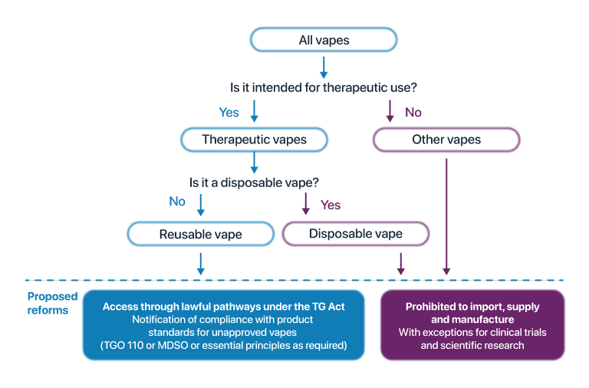

Other changes
During 2024, product standards for therapeutic vapes will also be strengthened, including to reduce permissible nicotine concentrations, require plain pharmaceutical packaging, and enhance the regulatory requirements for vaping devices. A transition period will be allowed for businesses to comply with the new requirements and these changes are not expected to commence until late 2024.

How were the reforms developed?
The TGA has conducted two significant consultations on the potential reforms to the regulation of vapes since November 2022.
Between 30 November 2022 and 16 January 2023, the TGA conducted a public consultation on proposed reforms to the quality standard for nicotine vaping products (2022 Consultation). Further information about the 2022 Consultation is available here- external site.
A second, targeted consultation was conducted between 7 September 2023 and 21 September 2023 on proposed reforms to the regulation of vapes generally (2023 Consultation). Further information about the 2023 Consultation is available here- external site.
In October 2023, an impact analysis was undertaken to assess the impacts of the proposed changes to the regulatory requirements for vapes and is available here- external site.

Importing, supplying, prescribing, dispensing and accessing vapes

Vapes: information for patients

Learn how patients can access vapes, where their doctor considers that it is appropriate for smoking cessation or the management of nicotine dependence.

Vapes: information for prescribers

Learn about changes to the regulation of vapes, and what the changes mean for prescribing therapeutic vapes for patients for smoking cessation or the management of nicotine dependence.

Vapes: information for pharmacists

Learn about changes to the regulation of vapes, and what the changes mean for sourcing these products and the requirements for dispensing.

Vapes: information for importers, manufacturers and wholesalers

How Australian sponsors can import, manufacture and supply vapes for smoking cessation or the management of nicotine dependence. This page also includes information on how wholesalers can supply vapes to Australian pharmacies.

Vapes: information for retailers

Businesses that supply vapes through retail stores such as tobacconists, vape shops or convenience stores in Australia will be impacted by changes to the regulation of vapes.

