Exemptions, loopholes and problem gamblers: Political party split on pokies

SMH - Alexandra Smith and Jessica McSweeney October 22, 2025
26 View all comments
The NSW Liberals will push to axe exemptions that allow pubs and clubs to operate poker machines during the 4am to 10am shutdown period, despite opposition from Nationals colleagues, who have argued that regional venues could be unfairly disadvantaged.
Venues claiming financial hardship or boosted tourism benefits can apply for a shorter shutdown period, and those that had pokies before 1997 can be allowed different shutdown hours.
Under a Greens bill before the NSW upper house, the mandatory shutdown period would be extended to cover midnight to 4am, with no exemptions, in a bid to stop problem gamblers playing.
Research has shown that almost 12 per cent of punters play pokies between midnight and 8am, and late-night play was strongly linked to problematic gambling behaviour.
In Monday’s shadow cabinet meeting, the Liberals were supportive of the removal of any exemptions, despite push-back from their Nationals colleagues, according to a source with knowledge of the meeting. However, the shadow cabinet broadly agreed that the Greens’ proposed midnight cap was too restrictive.
A senior Nationals source with knowledge of the meeting said the junior Coalition partner was not prepared to commit to changes to the shutdown period without consultation with venues and before the Minns government had responded to an independent panel report on its cashless gaming trial.
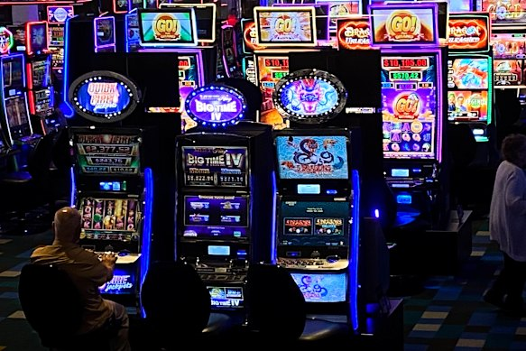
Poker machines at Bankstown Sports Club, the second most profitable club by gaming revenue in NSW.
The parties will take the proposal to their respective party rooms, before a vote on the Greens’ bill in the final sitting period of the year, however the differing positions could cause a split in the Coalition.
Greens MP Cate Faehrmann said her bill would be a simple way to reduce gambling harm and simplify a “patchwork of exemptions, a regulatory system riddled with loopholes, and an industry that is profiting off the misery of extremely vulnerable people”.
The Herald last month revealed three of the 10 most profitable clubs in NSW by gaming revenue are operating under extended trading hours as part of the hardship exemption.

Courts ‘Not a chook raffle’: The billion-dollar institution in crisis
A review of the shutdown hours by Liquor and Gaming NSW published earlier this year found 20 per cent of all venues with poker machines have a variation to the shutdown period.
Many venues that hold the early opener variation still shut down for six hours, but will close earlier in the night and open earlier in the morning. That creates the possibility for gamblers to simply find another venue with different shutdown hours to continue gambling.
The review found that of 674 venues with variations, 97 per cent of gambling turnover was generated outside the typical shutdown period of 4am to 10am.
The Coalition took a policy to the 2023 state election vowing to introduce a cashless gaming card after a scathing report from the NSW Crime Commission found that pokies were used by criminals to wash dirty money.
NSW Labor resisted the plan although committed to a trial of the technology.
The government appointed an independent panel to oversee the trial along with various other gambling measures such as banning the external signage of gambling rooms, reducing the cash input limit from $5000 to $500 and banning political donations from clubs with poker machines.
But the trial was hampered by the withdrawal of technology provider Aristocrat midway through the process, which meant 11 of 27 venues that had signed up could no longer participate. By the end of the trial, just 32 poker machine players were active participants in the research.
The government is yet to respond to the independent panel’s report.

