[Crown’s secret lobbying operation to get poker machines at Barangaroo](https://www.smh.com.au/national/nsw/nsw-on-track-to-reduce-pokies-to-national-average-by-2079-20250612-p5m6w0.html)

**SMH -** [**Harriet Alexander**](https://www.smh.com.au/by/harriet-alexander-giiuu0) **-** June 12, 2025

Crown Resorts executives are ramping up a push to have poker machines at their Sydney casino after an encouraging meeting with Gaming Minister David Harris, and are also holding discussions with opposition and crossbench MPs.

Crown is not permitted to operate poker machines at its Sydney casino under its licence with the NSW government, and allowing the company to operate them would require legislative change.

Crown is lobbying the government to have cashless poker machines at its Sydney casino.

But two MPs have confirmed that Crown has approached them with a proposal to install 500 cashless pokies in Sydney to prove that the technology works, while removing 500 cash poker machines from venues elsewhere in NSW.

The revelations come as a damning audit of gambling regulations in NSW found that it would take 55 years for NSW to reduce its poker machine numbers to the national average at the current rate, and that the government had no targets to reduce gambling harm.

A NSW auditor-general’s report released on Thursday found the Minns government’s regulatory strategy did not put enough emphasis on high-risk gambling and was more focused on recent legislative changes such as gaming room signage that incentivised venues to focus on compliance instead of identifying and preventing harm.

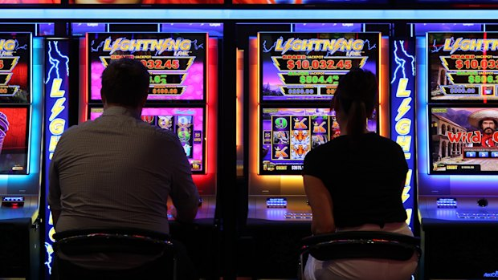

Pubs and clubs are engaged in a battle for punters’ wallets

NSW had 87,749 poker machines operating across 2000 venues in 2023-24, and they generated a profit of $8.4 billion, which the auditor-general took as the best measure of loss to patrons. They accounted for half the machines operating in Australia. The Independent Liquor and Gaming Authority, which regulates poker machines in NSW, has an annual budget of $4.9 million.

The report found that the number of machines had reduced by 13,758 since laws were introduced to decrease the amount of pokies in 2001, which was an average of 598 per year.

“At this rate, it will take more than 55 years for NSW to reach parity with the national average for gaming machines per 1000 adults,” the report found.

The Minns government recently lowered the legislated cap on poker machine entitlements from 99,000 to 95,739, but this is still higher than the number in operation. The total number of machines in operation has actually increased in each of the last two financial years.

The government has produced a series of strategy and policy documents over the last two years, but compliance programs had not been evaluated, and its enforcement activities were limited by staff resources, with just 12 inspectors – all of them based in Greater Sydney.

“The [government’s] strategy for regulating gaming machines is not based on a clear understanding of current levels of gambling harm, and it does not set any targets for reducing harm associated with gaming machines,” the report found.

“As a result, the Department [of Creative Industries, Tourism, Hospitality and Sport] does not know whether its regulatory strategy is effective in minimising gambling harm.”

Other evidence – including an 8.5 per cent increase in calls to the GambleAware Helpline in 2023-24 and an increase in gambling machine losses in each of the last three years – suggested gambling harm was not decreasing.

Crown’s pitch for poker machines to be introduced to its Sydney casino is premised on them being fitted with cashless technology that requires players to commit upfront to how much they wish to spend.

A government-sponsored trial of cashless gambling in NSW failed to produce meaningful data due to the low participation rate. The technology has been used in Victoria for two years.

One person involved in the discussions with Crown, who was not authorised to speak publicly, said Crown wanted to prove the technology was easy to install and effective in reducing gambling harm, undermining claims by the NSW gambling industry that it was unproven and difficult.

“I guess they were trying to call the government’s bluff and say, ‘Your gaming trial was ridiculous, we know that cashless can work’,” the MP said.

But independent MP Alex Greenwich said that to allow poker machines at Crown would be a betrayal of the agreement the government made with the people of NSW that allowed the resort to be given public land for a restricted gaming facility without poker machines.

“With gambling harm on the rise, we need fewer venues with large poker machine floors, not new ones right on the harbour,” Greenwich said.

“I call on Labor and the Coalition to stick to their promise that there will be no poker machines at this site.”

A Crown spokesman said the company met regularly with regulatory and government stakeholders to discuss a range of matters relating to its business and the industry.

Gaming Minister David Harris said the government was “not actively considering” any proposal to install poker machines at Crown Casino.

The casinos have long claimed that they are at a competitive disadvantage by the requirement for them to conduct extensive Know Your Customer checks on their patrons and not accept cash, while mini-casinos in the suburbs can take cash and are lightly regulated.

A Wesley Mission analysis of the latest data released by Liquor and Gaming NSW showed that $2.17 billion was lost on poker machines in NSW in the first 90 days of 2025.

The auditor-general’s report recommended the implementation of harm minimisation targets and an increased focus on regulatory improvements that had the biggest impact, such as staff compliance with responsible gambling conduct and the operation of venues with late-night opening.

Research shows that gambling harm is most likely to occur after midnight, but one in five venues have exemptions to the mandatory shutdown period from 4am to 10am, and 36 venues have “hardship” provisions that allow them to be exempted from harm minimisation measures.

These were granted 20 years ago and the Independent Liquor and Gaming Authority has not reviewed them since.

The auditor-general recommended that ILGA periodically review the licence conditions of venues in the highest-risk areas and make amendments where required. Poker machine losses were disproportionately concentrated in lower socioeconomic areas.

The report comes as the NSW government has also dropped a plan to end tax concessions at casino-style clubs, which cost NSW residents $964 million in foregone tax income in 2023-24, according to the latest budget papers.

Clubs do not have to pay any tax on gambling profits under $1 million, and only 28.4 per cent tax on gambling profits under $20 million, compared to the 50 per cent tax on pubs’ gambling profits.

Opposition leader Mark Speakman said the report showed that the government had been passive on gambling reform.

“The auditor-general’s report shows harm is rising, inspections aren’t happening, and Labor has broken every promise it made,” Speakman said.

But Harris said the government had implemented more comprehensive gambling reforms over the last two years than the Liberal Party had done in the previous 12 years. His department and ILGA accepted the recommendations made in the report, he said.

“This is complex reform, and changing behaviour takes time,” Harris said.

Wesley Mission chief executive Stu Cameron said successive governments had done nothing of substance to reduce gambling harm. The NSW government had been sitting on the recommendations of the Independent Panel on Gambling Reform for seven months.

“Now it is in black and white,” Cameron said. “The NSW government has done next to nothing to reduce gambling harm while clubs and hotels pocket billions.”