Unit 5, 13-15 Stokes St
Lane Cove North
Sydney NSW 2066
0434 715.861
scribepj@bigpond.com
29 November 2025
Ms. Jenny Bopp
Principal Statistician
Queensland Government Statistician’s Office
Level 22, 1 William Street, Brisbane Queensland
Dear Ms Bopp
Do you know of any Govt. Dept. or regulatory body with data of the rampant increase in poker machine licences in NSW from the 1980s up to 2001? As at 30 June 2002, NSW had just over half (51.24%) of the 199,002 poker machines in all of Australia.
Poker machines were not allowed in NSW hotels until 1997/98 when under the stewardship of Bob Carr, then NSW Premier. At end May 2025, 996 Licensed Clubs and 1,145 Hotels in NSW held Poker Machine entitlements.
In NSW, more hotels have poker machines than licensed clubs have poker machines.
There are no poker machines in WA outside of Crown Perth Casino, Burswood WA.
Did any NSW Dept effectively audit poker machine regulations at clubs/hotels prior to the last 10 years or so? If so, how many poker machine licences were forfeited in NSW clubs/hotels due to breaches of Gaming Machine Regulations?

I have been undertaking further research (for The Wesley Mission) into the reasons for the burgeoning growth of poker machines in Australia. Recently, The Greens are also taking an interest.

Greens introduce Bill to ‘Power Down the Pokies’ from Midnight to 10am

Below is an embedded thread to some of my research re the inordinate growth in poker machine licences, particularly in NSW hotels:

https://muggaccinos.com/GamblingReform/Put_Pokies_in_their_place.htm

Some citizens are vulnerable to alcohol. Others to nicotine. Others to gambling. Other folk to illegal drugs. Others to spending money beyond their means. Some are susceptible to more than one vice. A vital role of government is for regulators to protect gullible folk that cannot protect themselves, to halt greedy and unscrupulous people preying upon them.
The Tobacco Advertising Prohibition Act 1992 banned any advertising in Australia that may encourage or persuade people to smoke or use tobacco products.

NSW still has more poker machines than any other state in the world, even though there are at least 50 states in other countries with larger populations than NSW 8.69 million. 11 states are in the USA.

‘Virtually no oversight’ of suburban poker machine dens - Alex Mitchell, AAP - June 16, 2025

Poker machines were not allowed in NSW hotels until 1997/98 under the stewardship of Bob Carr, NSW Premier.

The three Excel files in each of the following two embedded threads evidence that as at
end May 2025 996 Licensed Clubs and 1,145 Hotels in NSW held Poker Machine entitlements.
- NSW Liquor & Gaming – NSW Clubs gaming machine data – 996 poker machines in NSW Clubs – to end May 2025
- NSW Liquor & Gaming – NSW Hotels gaming machine data – 1145 poker Machines in NSW Hotels to end May 2025

- 2 –

Ipso facto, there were more poker machines in NSW hotels than in NSW clubs
as at end Feb 2025.

‘Gambling capital of Australia’: Six charts that show the scale of poker machine use in NSW - SMH - Matt Wade and Craig But Nov 7, 2022

141 new poker machines were switched on across NSW since March 2025, despite the Minns government saying it was reducing the gaming machine entitlement cap.

WA has no poker machines outside of the Crown Casino (nee Burswood Casino) because the WA State Govt was cognisant of financial losses suffered by relatively uneducated residents that were often mesmerised by the ringing bells, flashing lights and hope for a large payout.

Your email sent to me (Thurs, 6 June 2024 3:17pm) referred me to Australian gambling statistics, 39th edition, 1997-98 to 2022-23 that was being released in late 2024:

Total gambling expenditure (nominal value) by state and territory, 1975–76 to 2023–24 (table)

Total gambling turnover (nominal value) by state and territory, 1975–76 to 2023–24 (table)

If the above 39th edition can cover ‘gambling expenditure’ and ‘gambling turnover’ since 1975, why can no regulator provide details of the number of poker machines at end of each financial year in NSW pre 2001?

How can my attached image evidence the above two BLUE embedded threads that list
‘gambling expenditure’ and ‘gambling turnover’ by state since 1975? Yet no authority can provide data on the number of poker machines in NSW from that earlier era when poker machine licences were readily issued to clubs and hotels in NSW?

I seek to provide quantitative evidence to Wesley Mission that State and Territory Govts from at least the early 1990s approved many additional poker machines in all except WA, and it is therefore incumbent upon those current State and Territory Govts to reduce those poker machine numbers by identifying material breaches of regulations, and the hours of operation, because 30% approx. of players are vulnerable to addiction with associated financial losses evident in a welter of recent newspaper articles e.g. The rest of the world is in disbelief at what the gambling industry has pulled off in Australia. We need real reform - The Guardian - Tim Costello - Jan 2023

2nd Attachment provides useful data that I largely sourced from Bill Browne, Director of the Democracy & Accountability Program, The Australian Institute - around mid-2024.

3rd Attached file is a recent response letter from Ms Sarah Low, A/Executive Director, Regulatory Policy, Department of Creative Industries, Tourism, Hospitality and Sport dated
3 Nov 2025. Page 2 provides two possible sources of poker machine data in NSW pre-2001.

Yours sincerely
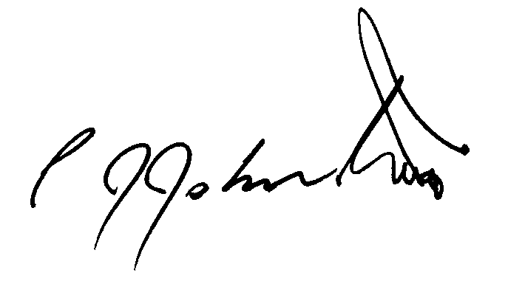

Philip J Johnston

