How much poker machine venues really give back to Queensland through grants and donation

By Kenji Sato - 612 ABC Brisbane - 26 January 2024

Pokies venues took more than $3.2 billion from Queensland punters last year, but in some cases clubs donated less than 1 per cent of winnings back to the community.
According to the Office of Liquor and Gaming, the amount of money Queenslanders sank into pokie machines in 2023 was 18 per cent higher than in 2021.
The Brisbane Greens are calling for a ban on pokie machines in buildings owned by Brisbane City Council, all of which are either charities, RSLs, or clubs.
Clubs Queensland has described the proposal as short-sighted, saying that clubs give back to the community through sporting and community grants.
Annual reports published by the Australian Charities and Not-for-profits Commission show many pokies venues give a fraction of their gambling winnings to charity.
In 2022 the Gaythorne RSL Sub Branch made more than $7.1 million in pokie revenue and donated $24,194 to charity, or 0.34 per cent of total pokie earnings.
That year, the Geebung-Zillmere-Bald Hills and Aspley RSL Sub Branch made more than $6 million in the pokies and donated $11,352, or 0.18 per cent, of gambling income.
The Kedron-Wavell services club made more than $27 million in the pokies in 2021 and its annual report states it has contributed over $936,000 to the community.
Upon questioning by the ABC, a club spokesperson clarified that much of that money was an "accounting consideration", which factored in services.
The spokesperson said the club had placed a dollar figure on in-kind services and "indirect" benefits to the community.
Those included events such as Anzac Day, Remembrance Day, VP Day, RSL Sub Branch costs, and free usage of their rooms to certain groups.
It valued the club's complimentary room usage at more than $200,000, and its contributions to the veteran community at $251,490.
In terms of direct donations, the club cited $150,000 in community grants, $254,781 in sponsorships, and $30,686 in individual donation requests.
Considering only these direct donations, Kedron-Wavell gave 1.6 per cent of its pokies revenue to charity.
Chief executive Lyndon Broome said the club was committed to preventing harmful gambling practices.
"The club has a progressive approach to gambling harm minimisation,"
Mr Broome said.
"This is underpinned by our onsite, in-house chaplain and customer care program, which focuses on active monitoring and early intervention."
Annual reports show the Brisbane Broncos Leagues Club made $12.5 million through the pokies in 2022/23 and donated $268,000, which is 2.1 per cent.
All of these clubs cater to overnight gamblers, with the Broncos Leagues Club open to 2am, Kedron-Wavell to 3am, Gaythorne RSL to 4am, and Geebung RSL to "late".
Each club earned at least 60 per cent of its entire revenue stream through poker machines.
An internal Clubs Queensland "benchmarking report" says clubs with at least 50 pokie machines should aim to make the majority of their revenue through pokies.
It notes that a club with between 101 to 200 machines should make 64 per cent of its revenue through pokies, and 31 per cent from food and drink.
The report shows that 71 per cent of wage expenses would typically go towards food and bar staff, but only 8 per cent towards running the pokies.
Despite the low revenue and high costs associated with food and drink, the report notes that gambling peaks during and after meal times.

Community opposition
A Clubs Queensland spokesperson said community clubs collectively donated $460 million annually to local organisations in the state.
"Queensland's 1,200 community clubs have more than 4 million members, employ almost 25,000 Queenslanders, and engage more than 41,000 volunteers," the spokesperson said.
"Fortunately, Queensland's governments at local and state level understand the role that community clubs play and provide their support for the continuation of these vital contributions."
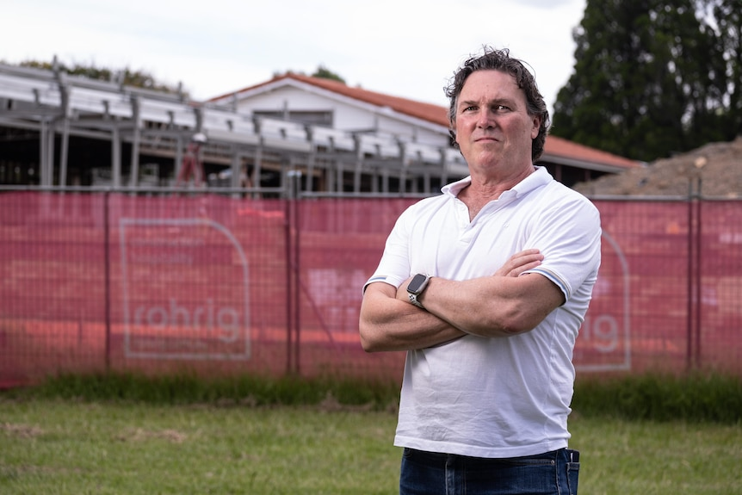
Mr Woolley says Stafford needs a community hub, not a racing club.
Several of these venues have received stiff opposition from community groups that oppose poker machines in their neighbourhood.
Joe Woolley led opposition against the Brisbane Racing Club, which is turning the defunct Stafford Bowls Club into a community club with 50 poker machines.
"We found it offensive that a community asset would be handed over to a for-profit corporation that [initially] intended to put in 76 poker machines,"
Mr Woolley said.
"It would drag millions and millions of dollars out of a lower socio-economic community to subsidise grandstands and property development in Ascot and Hamilton."
Office of Liquor and Gaming figures show there are 1,084 pokies sites in Queensland and 45,518 licensed gaming machines.

