NSW Gambling Survey 2024

Commissioned by the NSW Responsible Gambling Fund

October 2024

Page | 1

[**NSW Gambling Survey 2024**](https://www.gambleaware.nsw.gov.au/-/media/nsw-gambling-survey-2024-report.ashx?rev=94d18ccb266b434e9c8f9e391ea1cf1b)

##### Prepared for:

The NSW Responsible Gambling Fund

##### Prepared by:

Prof Matthew Browne* A/Prof Alex M T Russell* Georgia Dellosa

Prof Matthew Rockloff Prof Nerilee Hing

* These authors contributed equally to this report.

##### Name of institution:

Experimental Gambling Research Laboratory, Central Queensland University October 2024

|  |  |
| --- | --- |
|  |  |
|  |  |

# Acknowledgements

This project was commissioned by the NSW Office of Responsible Gambling with funding from the NSW Government’s Responsible Gambling Fund. The report has undergone independent peer review, which was overseen by the Office.

We would like to thank the participants for taking the time to complete the survey. Thanks also to the team at Ipsos for their work on conducting the interviews, preparing and weighting the data, and assisting with analyses, in particular Steven Pukallus, Andrew Ross, Shannon Coughlin, Elise Li, Hannah Caine, Alex Simmons, Phil Hughes and Vicky Wang, as well as the team of telephone interviewers.

# Executive summary

### Introduction and study overview

The NSW Gambling Survey 2024 provides a comprehensive snapshot of gambling behaviour, problems, and harm in NSW. This study, involving 10,000 adult participants, builds upon previous surveys conducted in 2019, 2011, and 2006, offering insights into current gambling patterns and how they have evolved over time.

The primary objectives of the survey were to -  
a) measure gambling participation rates,   
b) assess the prevalence of gambling problems and gambling-related harm,  
c) identify high-risk demographic groups and gambling forms, and   
d) examine attitudes towards gambling and help-seeking behaviours.

The study employed computer-assisted telephone interviews and used validated measures including the Problem Gambling Severity Index (PGSI) and the Gambling Harms Scale (GHS-10). A key methodological advancement in this survey was the inclusion of measures to quantify harm to both gamblers and affected others (GHS-10-AO), providing a more comprehensive understanding of gambling's societal impact.

The survey methodology involved random sampling of NSW adults using mobile phone numbers from the Integrated Public Number Database (IPND), which includes unlisted numbers. Interviews were conducted between March and May 2024. To focus on groups of special interest, core questions were asked of all participants, while more detailed questions were asked of subsampled respondents. The subsample included one-quarter of non-gamblers, one-half of non-regular gamblers who had a PGSI score of 0 (i.e., people experiencing minimal-risk gambling), and all participants who gambled at least weekly on forms apart from lotteries and scratchies or who had a PGSI score of 1 or higher (i.e., were experiencing low-, moderate- or high-risk gambling). This approach allowed for a more efficient allocation of survey resources while maintaining the ability to gather in-depth information on key issues and limiting the burden on participants. The response rate (completions amongst those eligible) was 7.9%, and cooperation rate (completions amongst those who were eligible and with whom contact was made) was 84.4%.

### Gambling participation trends

The NSW Gambling Survey 2024 reveals that overall gambling participation in NSW has remained relatively stable since 2019, with 53.5% of adults reporting gambling activity in the past 12 months, compared to 53.0% in 2019. This stability follows a significant decline from 69% in 2006 and 65% in 2011, suggesting a plateauing of the downward trend observed in previous years.

Despite the overall stability, significant shifts have occurred in the prevalence of specific gambling forms since 2019. Traditional gambling activities have continued to decline, with participation rates dropping for electronic gaming machines (EGMs) from 15.7% to 14.3%, instant scratchies from 13.0% to 11.0%, race betting from

12.9% to 9.9%, casino table games from 5.3% to 4.3%, and keno from 9.5% to 7.7%. In contrast, buying lottery tickets has increased from 37.0% to 40.9%, remaining the most prevalent form of gambling in NSW. Sports betting has also seen growth, rising from 6.1% to 7.6%.

Online gambling has emerged as a key trend, with 26.6% of NSW adults reporting some form of online gambling in the past year. This was predominantly for lottery tickets (20.4%), sports betting (6.7%) and race betting (6.5%). The growth in online sports betting is particularly notable, increasing by approximately 50% since 2019 (from 4.2% to 6.7%), with a similar change in online race betting (from 4.7% to 6.5%). Online casino gambling has increased slightly from a low base of 0.5% in 2019 to 0.8% in 2024.

Demographic patterns in gambling participation persist, with men (58.7%) more likely to gamble than women (48.5%). This difference is most pronounced in younger age groups. Higher gambling participation rates are also observed among those living outside of Sydney, those without a tertiary degree, those identifying as Aboriginal and/or Torres Strait Islander, English speakers, employed individuals, and those who are married or living with a partner.

### Gambling problems and risk

The prevalence of high-risk gambling in NSW (previously referred to as problem gambling; please see reporting conventions in Chapter 2) has remained relatively stable, with 0.9% of the adult population classified as experiencing high-risk gambling according to the PGSI, compared to 1.0% in 2019. Additionally, 3.1% were categorised as experiencing moderate-risk gambling, and 6.7% as experiencing low- risk gambling. In total, 4.0% of NSW adults were classified as experiencing moderate- to high-risk gambling.

Despite the stability in overall gambling participation and PGSI prevalence rates, the survey reveals concentrations of risk among specific populations. Men are over twice as likely to experience moderate- to high-risk gambling compared to women (5.7% versus 2.3%), with the highest risk observed among men aged 18 to 24 (9.3%).

Other groups more likely to be experiencing moderate- to high-risk gambling include people identifying as Aboriginal and/or Torres Strait Islander, those currently single or living alone, and individuals without tertiary education.

Gambling frequency is a critical risk factor, with almost one in three NSW residents (30.5%) who gamble weekly or more experiencing moderate- to high-risk gambling. This risk is even higher for at-least monthly participation in certain forms, such as casino table games (50.1%) and EGMs (35.0%). Notably, while younger women and language other than English (LOTE) speakers are less likely to gamble regularly, those who do gamble at-least weekly were substantially more likely to experience moderate- to high-risk gambling (47.8% for women under 40, 61.1% for LOTE speakers).

The NSW Gambling Survey 2024 also highlighted the risks associated with specific gambling forms. Gamblers engaging in less common and internet-based forms, such as online poker and fantasy sports, showed the highest rates of being moderate- to high-risk (59.0% and 41.8% respectively). Among mainstream (i.e., more prevalent) forms, casino table games (19.2%) and EGMs (18.5%) were associated with the highest rates of moderate- to high-risk gambling.

EGMs remain the largest contributor to gambling harm in NSW. In contrast, although the aggregate impact is relatively minor, online gambling emerged as a significant risk factor at the individual level, with online gamblers nearly five times more likely to experience moderate- to high-risk gambling compared to those who do not gamble online (9.2% vs 2.1%). This finding underscores the potential risks associated with the increasing prevalence and accessibility of online gambling platforms.

Whilst gamblers typically underestimate their losses, across different PGSI categories they tend to do so at a similar proportional rate. This means self-report data can be employed to compare relative spend across PGSI categories. In accordance with similar comparisons done elsewhere, the survey revealed that people experiencing minimal-risk gambling (previously non-problem gambling) comprise 80.0% of the gambling population but account for only 13.7% of total gambling losses. Most losses (86.3%) come from those in the low-risk, moderate- risk, and high-risk categories combined.

### Gambling harm

The NSW Gambling Survey 2024 provides crucial insights into gambling harm, offering a more comprehensive picture of impact than captured by PGSI categories alone. A significant proportion of the population - 14.5% of gamblers and 7.8% of all NSW residents - reported experiencing at least one harm from gambling in the past year. As with gambling problems, there is a spectrum of impact, and many of these individuals are reporting less-severe harms. Nevertheless, even those reporting just one harm are significantly different from un-harmed gamblers: they spend about twice as much on gambling, they are about four times more likely to experience low-, moderate- or high-risk gambling, and they report significantly lower life satisfaction.

The survey quantified gambling harm using the Gambling Harms Scale (GHS-10), measuring impact in terms of Health-Related Quality of Life (HRQoL) and Years Lived with Disability (YLD). The total harm to NSW gamblers from their own gambling was estimated at 105,515 YLD. Importantly, the impact of gambling extends beyond the gamblers themselves, with 12.7% of NSW residents reporting experiencing harm from someone else's gambling. The total impact on affected others was estimated at 158,877 YLD, approximately 1.5 times the impact on gamblers themselves.

For gamblers, the most frequent harms were financial impacts including reduction in savings, reduction of available spending money, and decreased spending on recreational activities, followed by emotional impacts such as feelings of regret, shame, and distress. For affected others, frequent harms included getting less enjoyment from time spent with people they care about, feeling angry about not controlling their gambling, and feelings of hopelessness. Financial impacts, such as late payments on bills, were also reported by affected others.

The distribution of gambling harm across demographic groups revealed significant disparities. Younger men under 40 years of age bear about half of the total impact (42,719 YLD) from their own gambling. Other population segments experiencing a disproportionate burden of harm include individuals identifying as Aboriginal and/or Torres Strait Islander, LOTE speakers, those not in a relationship, those without tertiary education, and those living alone. For affected others, harm was more evenly distributed across age and gender, although women generally tended to incur more harm than men.

The NSW Gambling Survey 2024 also revealed that 7.1% of NSW residents currently experience legacy impacts from gambling that occurred more than 12 months ago, with those identifying as Aboriginal and/or Torres Strait Islander being disproportionately affected. In total, one in five NSW residents (21.0%) reported experiencing at least one harm from either their own gambling, another's gambling, or legacy gambling harm.

### Key gambling forms and demographic segments of concern

The NSW Gambling Survey 2024 identified EGMs as the primary source of gambling harm, accounting for more than half of all harm to gamblers (57,832 YLD). This was followed by wagering products (including horse racing and sports betting) and casino games. Despite their widespread engagement, lotteries, keno, and bingo showed no statistically detectable connection to gambling harm or PGSI score when accounting for participation in other forms of gambling. The disproportionate impact of EGMs is

attributable to the higher PGSI scores associated with the product, combined with moderately high rates of engagement.

Demographic analysis revealed intersecting effects of age, gender, and education that result in an unequal distribution of harm in the community. Younger men (under 40) without a tertiary degree emerged as the segment incurring the most harm from their own gambling (26,706 YLD). In contrast, older women with a tertiary degree collectively experienced the least harm from their own gambling (13,586 YLD). For harm from others' gambling, younger women without a tertiary degree were most affected (26,706 YLD), while older men with a tertiary degree were least affected (13,586 YLD).

Other demographic groups experiencing disproportionate impacts include people identifying as Aboriginal and/or Torres Strait Islander, who make up 3.4% of the population but account for 8.2% of gambling harm and 8.6% of harm to affected others. LOTE speakers, while having lower overall gambling participation, face substantially higher risks when they do gamble regularly. Those without tertiary education are not only more likely to gamble but also at higher risk of being classified as experiencing moderate- to high-risk gambling. These findings highlight the interplay between social vulnerability and gambling risk, pointing to the importance of both individual risk factors and broader socio-economic contexts.

### Attitudes, awareness and help-seeking behaviours

The NSW Gambling Survey 2024 revealed that a substantial majority of NSW residents (79.7%) believe that gambling has done more harm than good for the community, a figure consistent with the 2019 findings. This negative perception was more prevalent among women, older adults, those living in Greater Sydney, individuals with a tertiary degree, non-Aboriginal and/or Torres Strait Islanders, non- LOTE speakers, those who did not gamble and less-than weekly gamblers, and those affected by someone else’s gambling. Despite the overall negative view expressed about gambling, about four in five respondents (78.1%) agreed that it is the individual's responsibility to manage their own gambling, with men more likely to endorse this opinion than women. This perspective was also more common among those living outside Sydney, without tertiary education, living alone, gamblers and regular gamblers. Those experiencing high-risk gambling, those reporting three or more harms from their own gambling, or any harms from another ’s gambling were less likely to endorse the statement regarding self-responsibility.

Awareness of responsible gambling messages and support services was relatively high among NSW residents. Nearly two-thirds (65.2%) reported seeing responsible gambling messages during or at the end of betting advertisements, while 54.8% were aware of GambleAware advertising. However, awareness of more specific

resources, such as the GambleAware website (15.6%) or GambleAware Week (9.0%), was considerably lower. This suggests that while general messaging is reaching a broad audience, awareness of specific support services is not as high.

Help-seeking behaviours among those classified as moderate- to high-risk gambling remain low. Only 13.5% of those engaged in moderate-risk and high-risk gambling reported seeking help for gambling-related issues. Among those who did seek help, personal support (such as talking to family or friends) was the most common form (71.4%), followed by professional help (41.5%). Notably, the vast majority (87.5%) of regular gamblers or those with some level of risk who did not seek help reported that they did not feel they had a problem. Rates of self-exclusion were also low. Only 1.4% of gamblers reported trying to self-exclude from a venue and 1.2% from online operators.

### Implications and conclusions

The NSW Gambling Survey 2024 presents a complex picture of gambling in the state, revealing stable overall participation rates but significant shifts in gambling forms and patterns of harm. The findings provide insights into gambling behaviours beyond the traditional focus on ‘problem gambling’ prevalence. While only 0.9% of NSW adults meet the criteria for high-risk (previously problem) gambling, one in five residents report experiencing some form of gambling harm. This discrepancy highlights the wide-ranging impacts of gambling across various levels of participation, including effects on individuals other than the gamblers themselves.

This aligns with public health perspectives on gambling harm minimisation, which consider the broader societal context of gambling behaviour.

The survey’s use of Health-Related Quality of Life measures to quantify gambling harm represents a significant methodological advancement. By estimating YLD, the study provides a tangible metric for comparing gambling's impact to other public health issues. The finding that harm to affected others exceeds harm to gamblers themselves (158,877 YLD vs 105,515 YLD) is particularly notable and highlights the relational and societal context of gambling harm, extending beyond individual gamblers. This data provides a quantitative perspective on the distribution of gambling's impacts across different groups.

The NSW Gambling Survey 2024 provides a comprehensive and up-to-date picture of gambling behaviour and associated harms in the state. The survey's findings offer a rich and reliable evidence base to inform policy, prevention and support, highlighting several key areas of interest. These include:

* 1. The significant and continuing role of EGMs in contributing to gambling problems and harm.
  2. The concentration of harm among specific demographic groups, such as young men without tertiary education and people identifying as Aboriginal and Torres Strait Islander.
  3. The rapid growth of online gambling, particularly sports betting.
  4. Continued low rates of help-seeking behaviour among those engaging in moderate- to high-risk gambling.
  5. Relatively stable rates of gambling problems, despite declining participation rates.

These findings, along with other data presented in the survey, provide valuable insights into the current gambling landscape in NSW. The survey's use of Health- Related Quality of Life measures and YLD calculations offers a quantitative perspective on gambling's impacts. By presenting this comprehensive data, the survey fulfills its purpose of informing stakeholders about the nature and extent of gambling and gambling harm in NSW, providing a solid foundation for future policy considerations and responses.

# Table of contents

Acknowledgements 3

Executive summary 4

1. Introduction and study overview 4
2. Gambling participation trends 4
3. Gambling problems and risk 5
4. Gambling harm 6
5. Key gambling forms and demographic segments of concern 7
6. Attitudes, awareness and help-seeking behaviours 8
7. Implications and conclusions 9

List of Figures 15

List of Tables 17

Chapter 1: Introduction 19

* 1. Background 19
  2. How has gambling changed in NSW since the 2019 survey? 19
  3. Research objectives 21
  4. Structure of the report 22

Chapter 2: Methodology 23

* 1. Overview 23
  2. Sample characteristics 23
  3. Methods overview 25
     1. Mobile phone only sampling frame 25
     2. Weighting 25
     3. Subsampling 26
     4. Survey instrument 26
  4. Reporting conventions 28
     1. Problem Gambling Severity Index labels 28
     2. Gender labels 28
     3. Statistical reporting and conventions 29

Chapter 3: Gambling participation 32

* 1. Gambling prevalence (last 12 months) overall, and over time 33
  2. Gambling prevalence (last 12 months) by age, gender, location and other demographics 33
  3. Gambling prevalence (lifetime) overall, and by age, gender and location 36
  4. Underage gambling overall, and by age, gender and location 37
  5. Online gambling (last 12 months) overall, and by age, gender and location 38

Chapter 4: Gambling participation and frequency on each form 40

* 1. Gambling prevalence for each form (last 12 months) overall, and over time 41
  2. Gambling participation on each form by age, gender and other demographics

. 43

* 1. Frequency of gambling on each form (last 12 months) by age, gender, location and other demographics 52

Chapter 5: Gambling problems 59

* 1. Individual items on the PGSI, and compared to 2019 60
  2. Problem Gambling Severity Index, groups overall, and over time 61
  3. Problem Gambling Severity Index moderate- to high-risk categories by age, gender, location and other demographics 62
  4. Problem Gambling Severity Index by engagement with each form 64
  5. Problem Gambling Severity Index by weekly vs non-weekly gamblers 66
  6. Problem Gambling Severity Index by engagement with online gambling 69
  7. Lifetime gambling problems 70

Chapter 6: Gambling harm 72

* 1. Indicators of harm to gamblers 73
  2. Harms to affected others overall, and by age, gender, location and other demographics 78
  3. Legacy harm 81
  4. Harm from all sources 83
  5. Changes in harm between 2019 and 2024 84

Chapter 7: Which forms and demographic segments are associated with problems and harm 85

* 1. Which gambling forms contribute the most to gambling problems and harm? 86
  2. Which demographic segments experience the most gambling problems and harm 88
  3. Which demographics are most strongly associated with harm to affected others?

. 92

* 1. Harm, gambling problems and wellbeing 94
  2. Total gambling losses incurred by PGSI category and harms 98

Chapter 8: Attitudes, awareness and use of support services 100

* 1. Awareness of GambleAware and support services 101
  2. Help-seeking 102
     1. How many sought help 102
     2. What kind of help 102
     3. Where help-seekers heard about professional help 102
     4. Why respondents did not seek help 103
  3. Self-exclusion from venues 104
  4. Self-exclusion from online operators 105
  5. Attitudes towards gambling overall, and by age, gender, location, gambler status, and PGSI groups 106
  6. Perceptions of responsibility 109

Chapter 9: Detailed gambling behaviour 113

* 1. Expenditure 114
  2. Time spent per session 117
  3. Where respondents gamble (near home or work) 121
  4. Time of day overall, and by PGSI status 121
  5. Venues used for EGMs, keno, racing, sports, esports, lottery 123
  6. Loyalty scheme membership (EGMs, casino table games) 126
  7. Favourite EGM features 128
  8. Consuming alcohol while gambling 129
  9. Restrictions on race and sports betting 129
  10. Fantasy sports 129

Chapter 10: Discussion 131

* 1. Summary of key findings 131
  2. Trends in gambling participation 132
  3. Gambling problems and risk 132
  4. Gambling harm 133
  5. Converging evidence on sources and segments of impact 134
  6. Contribution of different forms to population impact 136
  7. Demographic segments of specific concern 137
  8. A focus on affected others 139
  9. Limitations 140
  10. Conclusion 141

References 144

Appendices 146

* 1. Subsampling and weighting 146

Weighting data 146

Weighting calculations 147

* 1. Technical notes on analysis methods 152
  2. Survey instrument 153
  3. Comparison of individual harm items between 2019 and 2024 209
  4. Gambling prevalence and PGSI groups by Local Health District 211

# List of Figures

Figure 1 Survey flow 27

Figure 2 Changes in gambling participation over time 33

Figure 3 Participation in any gambling activity in the last 12 months (weighted), overall and by age and sex, 2024 34

Figure 4 Gambling participation in the lifetime by age and gender, 2024 36

Figure 5 Percentage of respondents who first participated in any form of gambling while under the age of 18 (main-sample weighted) 37

Figure 6 Overall prevalence of online gambling by age and gender, 2024 38

Figure 7 Gambling participation by form of gambling activity and over time, 2006- 2024 42

Figure 8 Participation in each form of gambling by age and gender, 2024 44

Figure 9 Participation in each form of gambling by age and gender, 2024 (continued)

. 45

Figure 10 Participation in each form of gambling by age and gender, 2024 (continued) 46

Figure 11 Participation in each form of gambling by age and gender, 2024 (continued) 47

Figure 12 Participation in each form of gambling by age and gender, 2024 (continued) 48

Figure 13 Participation in each form of gambling by age and gender, 2024 (continued) 49

Figure 14 Frequency profile of gambling on each form among those who participated on that form 53

Figure 15 Frequency profile of gambling on each form among those who participated on that form (continued) 54

Figure 16 Frequency profile of gambling on each form among those who participated on that form (continued) 55

Figure 17 At-least monthly participation in select forms of gambling by age and gender 56

Figure 18 At-least monthly participation in select forms of gambling by age and gender 57

Figure 19 PGSI risk category prevalence among NSW residents, 2006-2024 61

Figure 20 Prevalence of moderate- to high-risk gambling (previously moderate- to problem gambling), by age and gender, 2024 62

Figure 21 Percentage of respondents who engaged in each form in the last 12 months who were classified as moderate- to high-risk 65

Figure 22 Lifetime gambling problems by age and gender 70

Figure 23 Burden of gambling harm to gamblers by age and gender 76

Figure 24 Burden of gambling harm to affected others by age and gender 79

Figure 25 Legacy harm by age and gender 81

Figure 26 Prevalence of harm from all sources: own gambling, others’ gambling and legacy harm 84

Figure 27 Proportion of gambling harm and PGSI scores attributable to each form. 87 Figure 28 Proportion of gambling harm and PGSI scores attributable to each demographic variable 89

Figure 29 Impact incurred by key population segments due to harm from one’s own gambling 91

Figure 30 Relative importance of demographic factors in determining harm to affected others 92

Figure 31 Impact incurred to key population segments from gambling harm to affected others 93

Figure 32 Cross-tabulation of GHS-10 with the PGSI 95

Figure 33 Cross-tabulation of PGSI with the GHS-10 96

Figure 34 Combined effect of PGSI category and harm on life satisfaction 97

Figure 35 Total gambling losses by PGSI category 98

Figure 36 Aggregate gambling losses by GHS-10 harm bands 99

Figure 37 Self-exclusion and re-entry (venues) 104

Figure 38 Self-exclusion and re-entry (online) 105

Figure 39 Agreement or disagreement that gambling has done more harm to the community than good 106

Figure 40 Percentage of respondents who agree or strongly agree that gambling does more harm than good in the community by age and gender 107

Figure 41 Agreement or disagreement that it is the individual’s responsibility to manage their own gambling 110

Figure 42 Percentage of respondents who agree or strongly agree that it is the individual’s responsibility to manage their own gambling by age and gender 110

Figure 43 Robust mean expenditure by age and gender, 2024 115

Figure 44 Time spent per session by gambling form 118

Figure 45 Usual session length amongst EGM gamblers by PGSI category 119

Figure 46 Usual session length amongst casino table game gamblers by PGSI category 119

Figure 47 Usual session length amongst keno gamblers by PGSI category 120

Figure 48 Proportion of gamblers in each PGSI category by time of day 122

Figure 49 Venue by gambling form, 2024 124

Figure 50 Preferred venue for EGM gambling by PGSI categories 125

Figure 51 Preferred venue for keno gambling by PGSI categories 125

Figure 52 Loyalty card membership for EGMs and casino table games by PGSI category 127

# List of Tables

Table 1 Unweighted and weighted sample data and population data for key demographics 24

Table 2 Acronyms and terms used in this report 31

Table 3 Participation in at least one gambling activity in the last 12 months by demographics 35

Table 4 Percentage of residents who have gambled in their lifetime 36

Table 5 Percentage of residents who first gambled when underage 37

Table 6 Percentage of online gambling participation by location 39

Table 7 Participation in online gambling activities, 2006-2024 39

Table 8 Participation in select forms in the last 12 months by demographics 51

Table 9 Participation in select forms at-least monthly in the last 12 months by demographics 58

Table 10 Prevalence of NSW residents endorsing each question on the PGSI 60

Table 11 Prevalence of moderate- to high-risk gambling by demographics 63

Table 12 Prevalence of moderate- to high-risk gambling by gambling frequency for specific forms 66

Table 13 Prevalence of moderate- to high-risk gambling by gambling frequency 68

Table 14 Prevalence of people engaged in moderate to high-risk gambling by online gambling status 69

Table 15 Self-reported lifetime gambling problems by demographics 71

Table 16 Prevalence of gambling harm indicators among gamblers 74

Table 17 Burden of gambling harm by gambling frequency 75

Table 18 Burden of gambling harm by spend 75

Table 19 Burden of gambling harm to gamblers by demographics 77

Table 20 Prevalence of gambling harm indicators due to another’s gambling 78

Table 21 Burden of gambling harm for affected others by demographics 80

Table 22 Legacy gambling harms by demographics 82

Table 23 Percentage of respondents who reported seeing responsible gambling messaging or GambleAware material 101

Table 24 Type of help sought amongst help-seekers 102

Table 25 Why respondents did not seek help 103

Table 26 Percentage of respondents who agree or strongly agree that gambling does more harm than good in the community by demographics 108

Table 27 Percentage of people who agree or strongly agree that gambling does more harm than good in the community by gambling behaviour and risk 109

Table 28 Percentage of respondents who agree or strongly agree that it is the individual’s responsibility to manage their own gambling 111

Table 29 Percentage of respondents who agree or strongly agree that it is the individual’s responsibility to manage their own gambling 112

Table 30 Robust mean expenditure by demographics 116

Table 31 Robust mean expenditure by gambling behaviour and risk 117

Table 32 Where respondents gamble by PGSI category 121

Table 33 Time of day by PGSI category 121

Table 34 Loyalty membership by PGSI category 126

Table 35 Features of EGMs that participants are drawn to 128

Table 36 Unweighted and weighted N for select variables in the full sample 149

Table 37 Unweighted and weighted N for select variables in the subsample 150

Table 38 Comparison of prevalence of specific harms with prior survey 210

Table 39 Gambling prevalence and PGSI groups by Local Health District 211

# Chapter 1: Introduction

### Background

This report presents the findings from the NSW Gambling Survey 2024 funded by the NSW Responsible Gambling Fund. It compares findings with the 2019 study and highlights statistically significant differences.

Gambling prevalence surveys have been undertaken in NSW since 1996. The NSW Government undertakes prevalence studies to assess and monitor changing trends in participation, emerging technologies and the extent of different levels of problem gambling, as well as the demographic and geographic profile of gamblers. Recent prevalence surveys were conducted in 2019 (10,012 participants, Browne et al., 2019), 2011 (10,000 participants, Sproston et al., 2012) and 2006 (5,029 participants, AC Nielsen, 2007). The NSW Gambling Survey 2024 includes a sample of 10,000 participants and aims to provide a current snapshot of gambling participation, related behaviours and impacts from gambling.

In 2024, the survey added validated measures of gambling harm experienced by people from their own gambling (the Gambling Harms Scale [GHS-10]), as well as gambling harm experienced by people other than the person who is gambling (the Gambling Harms Scale for Affected Others [GHS-10-AO]), to measure the negative impacts of gambling. One motivation for this expanded focus is a growing recognition that gambling harm is conceptually distinct from problem or gambling disorder (Browne et al., 2017). That is, harm represents a focus on the financial and social- psychological *consequences* of excessive spend on gambling, whilst gambling problems or disordered gambling emphasises the cognitive and behavioural indicators of compulsive, uncontrolled or excessive engagement with the activity. A second motivating factor is to provide for a population-level understanding of impact. Gambling harm instruments employed in the present survey (Browne, Newall, et al., 2023) are grounded in Health-Related Quality of Life (HRQoL) and provide for an assessment of aggregate impact to different segments of the population, which goes beyond categorising and estimating the percentage of individuals who experience high-risk gambling (previously problem gambling).

### How has gambling changed in NSW since the 2019 survey?

This section outlines the changes to gambling products, availability, venues, legislation and regulation in NSW since the previous survey, to provide context for comparisons with 2019 data, although the timing or scale of some of these changes mean they have not impacted on the results of this survey.

In early 2020, the COVID pandemic forced the closure of all gambling venues during intermittent periods of lockdown, as well as restrictions on how many people could be at a venue. The last lockdown period ended in October 2021 and restrictions eased as of February 2022. COVID did not influence the 2019 data and is likely to have minimal effects on the 2024 data, given that longitudinal research has found that gambling in Australia had largely returned to pre-pandemic levels by 2022 (Hing et al., 2024). However, please note the potential role of COVID on the uptake of online wagering activities, noted below.

In 2022, Sydney’s second casino, Crown Sydney, opened VIP-only gaming areas for table games, but has no EGMs. Since the last survey, there have been government inquiries into both NSW casinos (Crown Sydney and The Star), which have led to changes in their operations, including requirements for enhanced responsible gambling practices.

Clubs and hotels have also had changes to regulation and legislation, such as amendments to the *Gaming Machines Regulation 2019*. These amendments focus on reducing money laundering and gambling harm, including reducing the maximum cash input into an EGM from $5,000 to $500 and venues being required to appoint Responsible Gambling Officers.

In March 2024, the NSW Government began a staged trial in which a digital player card or app would be used instead of cash at EGMs, with the aim of reducing money laundering and gambling harm. While the timing of the trial for some venues coincided with the fieldwork period of this survey (March-May 2024), the trial included 14 of the over 2,000 venues with EGMs in NSW and so should not have influenced the findings of this survey.

There have also been changes to the regulation of online gambling since the previous survey in 2019, including the implementation of some measures from the National Consumer Protection Framework for Online Wagering. This includes the introduction of new messaging to replace the “gamble responsibly” tagline, the National Self-Exclusion Register (BetStop) and stricter customer verification requirements.

In addition, a Point of Consumption Tax was introduced to ensure that taxes on online wagering are collected based on where the bets are placed, rather than where the operator is licensed. In NSW, this tax was introduced at 10% on 1 January 2019 and increased to 15% effective 1 July 2022.

In November 2019, the Australian Communications and Media Authority started blocking illegal offshore gambling sites, such as online casinos, EGMs and poker. This step made it more difficult for Australian residents to access these sites, potentially impacting on online casino and online poker gambling.

The uptake of digital technologies has continued since 2019, potentially accelerated by the COVID pandemic. This is reflected in a 33.7% increase in wagering expenditure in NSW from 2019-2020 to 2022-2023, the most recent data available (Queensland Government Statistician’s Office, 2024). In addition, some operators have recently begun offering online keno in NSW. This conduct is subject to investigation by Liquor & Gaming NSW.

### Research objectives

The purpose of this study was to collect data on gambling participation and gambling harm in NSW, building and maintaining comparability with previous prevalence surveys where possible. The NSW Office of Responsible Gambling were involved in all aspects of study development, sampling design, setting of objectives, and reporting structure.

Specifically, the objectives were:

* + - to measure gambling participation across gambling forms in the NSW population, and to compare levels of participation with previous NSW gambling surveys
    - to measure the prevalence of different levels of problem gambling as

classified by the PGSI

* + - to measure the amount of gambling harm in NSW, including to affected others, reporting on both specific harm indicators as well as global impact to health-related quality of life
    - to determine the degree to which different gambling forms are associated with gambling harm and problems, and which socio-demographic risk factors are associated with problems and harm, including to affected others
    - to examine the socio-demographic characteristics associated with gambling and different levels of problem gambling risk severity, overall and for each activity
    - to examine the beliefs of gamblers and their behaviours, including frequency and expenditure, across the levels of problem gambling risk
    - to assess help-seeking behaviour among those experiencing moderate- to high-risk gambling
    - to assess attitudes towards gambling, and beliefs about gambling, among

gamblers and non-gamblers

All these objectives were addressed in the analysis and reporting. However, the report structure was finalised after data collection to provide the most clear and comprehensive overview of the results.

### Structure of the report

This report is organised into the following chapters:

* + - **Chapter 2: Methodology** describes the survey design, sampling methods, and analytical approaches used in the study.
    - **Chapter 3: Gambling participation** presents findings on overall gambling prevalence, trends over time, and participation rates for different gambling forms.
    - **Chapter 4: Gambling participation and frequency on each form** provides detailed analysis of participation and frequency for specific gambling activities.
    - **Chapter 5: Gambling problems** examines the prevalence of gambling problems using the Problem Gambling Severity Index (PGSI) and analyses risk factors.
    - **Chapter 6: Gambling harm** explores the extent and nature of gambling- related harm, including impacts on gamblers and affected others.
    - **Chapter 7: Forms and demographic segments associated with problems and harm** identifies which gambling forms and population groups are most associated with gambling problems and harm.
    - **Chapter 8: Attitudes, awareness and use of support services** presents findings on public attitudes towards gambling, awareness of support services, and help-seeking behaviours.
    - **Chapter 9: Detailed gambling behaviour** provides in-depth analysis of specific gambling behaviours, including expenditure, time spent gambling, and gambling contexts.
    - **Chapter 10: Discussion** synthesises key findings, discusses implications, and offers conclusions based on the survey results.

# Chapter 2: Methodology

This chapter summarises the methodology used for the prevalence survey to assist in interpreting and understanding the results. It includes a high-level description of the methodology. More information is provided in the appendices and a separate technical report with further details is also available.

The project was carried out in compliance with ISO 20252, the Australian Data and Insights Association (ADIA) and The Research Society (TRS) standards and approved by the CQUniversity Human Research Ethics Committee (approval number 24616).

### Overview

The survey involved computer-assisted telephone interviews (CATI) with 10,000 adults aged 18 years or over living in NSW. The fieldwork period started with an initial pilot on 7th March 2024 and full launch on 27th March 2024, with pilot data included in the final dataset. Fieldwork was completed on 25th May 2024. The response rate (completions amongst those eligible) was 7.9%, and cooperation rate (completions amongst those who were eligible and with whom contact was made) was 84.4%.

In consultation with the NSW Office of Responsible Gambling, the Experimental Gambling Research Laboratory at CQUniversity designed the survey to facilitate comparisons with previous years, while also updating measures such as including the Gambling Harms Scale (GHS-10, 10 items) and the Gambling Harms Scale – Affected Others (GHS-10-AO, 10 items). Fieldwork and descriptive analyses were conducted by Ipsos Australia, with detailed analyses conducted by CQUniversity.

### Sample characteristics

The sample is described in Table 1 below. Due to the use of probability sampling, the sample characteristics are very similar to those of the NSW population. This is best seen through comparing the last three columns in the table. Only light statistical weighting (i.e. weights close to unity) was required to ensure an exact correspondence of key demographics with the NSW population.

The sample also included representative coverage of Aboriginal and Torres Strait Islander peoples (3.4%), and people who speak a language other than English as their main language at home (14.6%).

##### Table 1 Unweighted and weighted sample data and population data for key demographics

|  |  |  |  |  |  |  |
| --- | --- | --- | --- | --- | --- | --- |
|  | **No weight** | **Weight** | **Pop’n** | **No weight** | **Weight** | **Pop’n** |
|  | **Including don’t know,**  **refused, other** | | | **Excluding don’t know,**  **refused, other** | | |
| **Gender** | | | | | | |
| Male or man | 52.2% | 48.7% | 49.1% | 52.7% | 49.1% | 49.1% |
| Female or woman | 46.9% | 50.5% | 50.9% | 47.3% | 50.9% | 50.9% |
| *Non-binary/gender diverse* | 0.4% | 0.3% | *-* | *-* | *-* | *-* |
| *Refused or don’t know* | 0.5% | 0.5% | *-* | *-* | *-* | *-* |
| **Age** | | | | | | |
| 18-24 | 14.4% | 11.3% | 11.3% | 14.4% | 11.3% | 11.3% |
| 25-29 | 10.0% | 9.0% | 9.0% | 10.0% | 9.0% | 9.0% |
| 30-34 | 9.1% | 9.4% | 9.4% | 9.1% | 9.4% | 9.4% |
| 35-39 | 8.5% | 9.1% | 9.1% | 8.5% | 9.1% | 9.1% |
| 40-44 | 8.2% | 8.6% | 8.6% | 8.2% | 8.6% | 8.6% |
| 45-49 | 7.3% | 7.6% | 7.6% | 7.3% | 7.6% | 7.6% |
| 50-54 | 8.0% | 7.9% | 7.9% | 8.0% | 7.9% | 7.9% |
| 55-59 | 6.6% | 7.1% | 7.1% | 6.6% | 7.1% | 7.1% |
| 60-64 | 6.9% | 7.3% | 7.3% | 6.9% | 7.3% | 7.3% |
| 65-69 | 6.3% | 6.5% | 6.5% | 6.3% | 6.5% | 6.5% |
| 70+ | 14.7% | 16.1% | 16.1% | 14.7% | 16.1% | 16.1% |
| **Location** | | | | | | |
| Sydney | 65.9% | 65.6% | 65.6% | 65.9% | 65.6% | 65.6% |
| Rest of NSW | 34.1% | 34.4% | 34.4% | 34.1% | 34.4% | 34.4% |
| **Aboriginal and/or Torres Strait Islander** | | | | | | |
| Aboriginal | 3.2% | 3.1% | 2.6% | 3.2% | 3.1% | 2.7% |
| Torres Strait Islander | 0.2% | 0.2% | 0.1% | 0.2% | 0.2% | 0.1% |
| Both | 0.1% | 0.1% | 0.1% | 0.1% | 0.1% | 0.1% |
| Neither | 95.6% | 95.7% | 92.5% | 96.5% | 96.6% | 97.2% |
| Refused or don’t know | 0.9% | 0.9% | 4.8% | - | - | - |
| **Main language at home** | | | | | | |
| English | 84.1% | 85.1% | # | 84.4% | 85.4% | # |
| A language other than English | 15.6% | 14.6% | # | 15.6% | 14.6% | # |
| Refused or don’t know | 0.3% | 0.3% | # | - | - | # |

*Note: n = 10,000. No weight refers to unweighted sample data, weight to weighted sample data, and population to population data. Data sources: ABS Population Statement 2023, June 2024 figures for age, gender, part of state. Aboriginal and Torres Strait Islander data from 2021 Census. The ABS collected sex, rather than gender, with no non-binary/gender diverse option available. #The Census language question referred to* any *language other than English spoken at home, not the* main *language, and therefore cannot be compared.*

### Methods overview

This section includes a broad overview of the methodology. For further details, including detailed information about the weighting and subsampling, refer to the appendices and technical report.

##### Mobile phone only sampling frame

The 2019 prevalence study was a dual frame sample design and was split 70/30 between mobile (70) and landline (30) phone numbers, with numbers sourced from *SamplePages*. However, since 2019, the use of landline phones has declined. In 2022, about 1.6% of Australians had a landline, but not a mobile phone, and this is strongly biased towards older Australians1. Further, in 2022, 63% of Australians had a mobile but not a landline, and 34% had both a mobile and landline. Given this continual decline in landline ownership, and the almost ubiquitous nature of mobile phone ownership, contacting potential participants via landlines in 2024 would have decreased sample quality.

Therefore, the 2024 study used only mobile phone numbers. Phone numbers were provided from the Integrated Public Number Database (IPND). The IPND is a record of most Australian phone numbers, including listed and unlisted numbers.

Permission was received from the Australian Communications and Media Authority to use the IPND database for this study on 20th February 2024. While previous surveys have used random digit dialling (RDD) to randomly select participants from the population, the use of a list of telephone numbers still allows for random selection from the population, which is crucial for representative samples.

Other details about the methodology are provided in the separate Technical Report.

##### Weighting

While the random selection from the population should result in a sample with approximately similar age, gender and location characteristics to the population, weighting is used to correct deviations to further maximise representativeness of calculated statistics. The sample was weighted for age, gender and location based on data from the Australian Bureau of Statistics for NSW. In addition, weights were applied based on the number of mobile telephone numbers participants had regular access to, to account for people with multiple numbers having an increased probability of being selected.

Table 1 above shows unweighted and weighted demographics, as well as population figures. The weighted and unweighted figures are very similar, indicating minimal

1 <https://www.acma.gov.au/publications/2022-10/report/how-australians-make-voice-calls-home>

effect of weighting, which is ideal. In the final weighted sample, age, gender and location are identical to the population as the sample was weighted on these variables. Aboriginal and Torres Strait Islander people are slightly overrepresented in the sample.

All estimates (e.g. means and percentages), in this report are calculated using population weights unless explicitly specified otherwise.

Due to rounding and exclusion of don’t know/refused responses, percentages may not sum to 100%.

##### Subsampling

To invest available sampling effort into gambling groups of special interest, core questions were asked of the whole sample of 10,000 participants, while more detailed questions were asked only of subsampled respondents. This subsample comprised 1) all people who gambled regularly (at least once a week over all forms, excluding lotteries, overseas lotteries and scratchies) or who had a PGSI score of 1 or more (regardless of how often they gambled); 2) half of the people who gambled non-regularly and had a PGSI score of 0; and 3) a quarter of people who did not gamble in the last 12 months. Additional weighting was applied for analyses on the subsample to correct for this differential subsampling. A total of 4,374 participants were subsampled. The shorter survey, completed by the full sample, took 11.3 minutes to complete on average, while the full survey took 16.4 minutes on average.

Further details on the weighting and sampling methodology are contained in the appendices and technical report. Due to differential subsampling, both unweighted and weighted ns are reported in the appendices.

It should be noted that the subsampling and subgroup analyses conducted for this report are not prejudicial to the population representative nature of the data. For example, a statistic calculated on “EGM gamblers who gamble monthly or more often”, is representative of members of the NSW population who satisfy this criterion.

##### Survey instrument

The full survey instrument is provided in Appendix A.3. Figure 1 below outlines the survey flow. In the 2019 study, Aboriginal and Torres Strait Islander Status and main language questions were only asked of subsampled participants. However, relatively low prevalence and therefore lack of statistical power meant that only limited conclusions could be drawn in relation to these groups. Thus, in the present study these questions were asked of all participants to facilitate further analyses.

##### Figure 1 Survey flow

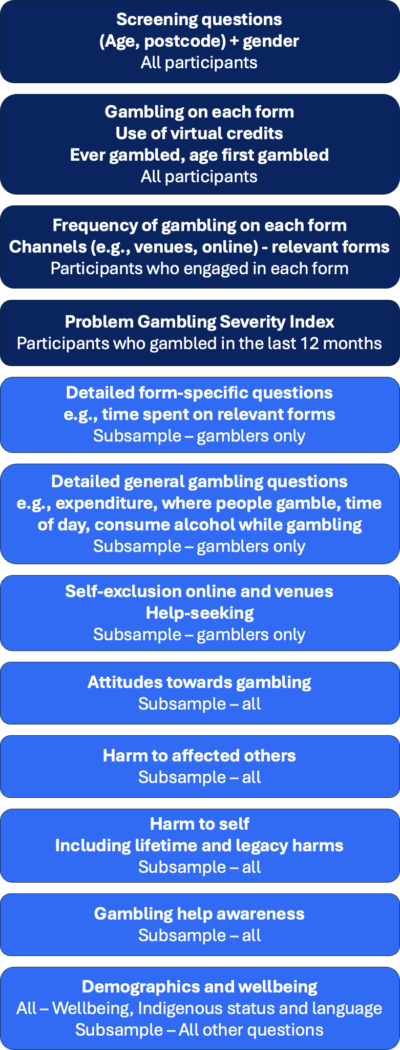

*Dark blue sections were asked of the entire sample (n = 10,000). Light blue sections were asked of the subsample (n=4,374).*

### Reporting conventions

##### Problem Gambling Severity Index labels

The Problem Gambling Severity Index categorises participants into four categories. The labels for these categories are “non-problem gambling”, “low-risk gambling”, “moderate-risk gambling” and “problem gambling”. While these labels reflect what the PGSI measures, i.e., problem gambling, they are often adjusted to other potentially stigmatising terms, such as referring to people as “problem gamblers”.

For this report, with guidance from the NSW Office of Responsible Gambling, we have employed alternate terms for the PGSI categories. These terms are:

* + - * **“minimal-risk gambling”,**
      * **“low-risk gambling”,**
      * **“moderate-risk gambling”** and
      * **“high-risk gambling”**.

These terms help to minimise references to people in the problem gambling category as “problem gamblers”. Similar terms have been used before (AGRC, 2023). In addition, we have avoided the term “no-risk gambling”, as this may infer that everyone in that category gambles at a level that is entirely without risk.

Where it is necessary to refer to people in these categories, phrases such as “people experiencing high-risk gambling” are used. Binary analyses compare minimal-risk and low-risk gambling to moderate-risk and high-risk gambling, and the combined category for the higher risk groups is referred to as **“**moderate- to high-risk gambling**”**. To help readers with the change, we have included reminders about how the new labels align with the previous labels at regular intervals in the report.

Some analyses in Chapter 7 determine the relative importance of demographics and gambling forms in relation to gambling problems. These analyses use a continuous variable to measure gambling problems, reported as a log transformation of the raw PGSI score (+1). Rather than reporting the level of risk for each group, the analyses in Chapter 7 refer to PGSI scores, such as one group tending to have higher PGSI scores than another.

##### Gender labels

Many analyses feature comparisons by age and gender. These questions show data for each age category, including overall the whole sample, and then separately for men and women. A total of 38 participants responded to the question about gender with an answer other than man or woman. While separate lines are plotted by age group for men and women, it was not possible to plot a line for people who identified as another (or no) gender by age group, due to small numbers. However, an overall

statistic for people identifying as another (or no) gender is reported in each of these plots. Verbatim responses indicated a wide range of gender responses amongst these 38 people, such as non-binary, no gender, they/them, trans man, transsexual, transsexual woman, unspecified, bi gender and unspecified. Points could not be plotted separately for each identity, due to low numbers of responses, so these 38 respondents are plotted together under a single category, referred to as **“non- binary/gender diverse”**. This terminology was based on guidance from ACON as well as discussions between NSW Office of Responsible Gambling staff and NSW Government inclusivity teams.

##### Statistical reporting and conventions

Statistical comparisons are made between binary categories but not across multi- level factors or interactions. Comparisons with prior surveys are made only between the 2024 survey and 2019 survey, but not with surveys prior to 2019. For readability, the text sometimes refers to the present survey data as ‘2024’. Although all field- work was conducted in 2024, many key measures are based on a 12-month time frame (unless specified otherwise) and therefore technically provides a snapshot of the 2023-2024 period. A similar approach is applied when referring to prior surveys, with the year denoting the time at which survey fieldwork was completed. The authors recognise that it is a long document, and some users may refer only to specific sections. For this reason, certain acronyms (e.g., LOTE) are spelled out in full (e.g., language other than English) in some places in the report. Table 2 summarises the technical terms used in the report.

Most statistical comparisons reported are with respect to binary categories, for example comparing moderate- to high-risk gambling prevalence rates among people living in Sydney or the rest of NSW. Significant effects are noted with asterisks. If present, they indicate a statistically significant difference: \**p*<.05, \*\**p*<.01, \*\*\**p*<.001. In tables, when significant differences are present, the asterisks are shown next to the larger statistic, which is also shown in **bold**. However, some comparisons are made with respect to multiple categories. Reporting multi-category comparisons creates a small reporting dilemma in terms of which category is compared to which. Reporting all possible category comparisons presents readability issues, and avoiding multi-level statistical comparisons completely is undesirable. In this report, multiple-category groups are typically *ordered* groups, such as PGSI risk categories (minimal- to high-risk). Thus, we opted to select the split at which we judged the mean difference to be most informative, and where significant, highlight the grouping for which the statistic is higher, as described above. Where no discernible ordered effect exists, no test was conducted. This approach provides for a more informative and readable summary. However, they are necessarily post-hoc comparisons with researcher discretion involved, and the usual caveats that should be applied to such comparisons should be borne in mind.

Figures and tables indicate who was asked each question, and the source of the data (i.e. the question wording, or calculations to create the relevant variable). There are some instances where reporting is based on the whole sample, even some relevant data were only captured from some participants. For example, to determine online gambling participation, answers from numerous questions were considered. If people bet on sports, they were asked if they bet on sports online, but anyone who did not bet on sports was not asked that question. However, it can be inferred that they had not bet on sports online because they had not bet on sports at all. In the same way, it was possible to determine online gambling status for everyone, even if some people were not asked all relevant questions.

Where participants refused or did not know the answer to a question, they are not counted towards the percentage, i.e., percentages are amongst those who answered the question. Missingness due to refusals or not knowing varied by question, but there were typically <100 missing cases per question, i.e., less than 1% of the data.

For demographic analyses, some questions were asked of the full sample, specifically age, gender, location, Aboriginal and Torres Strait Islander status and main language. When the dependent variable was asked of the full sample, comparisons within these demographic variables are also based on the full sample, while comparisons based on other demographic variables (e.g., income) are based on the subsample. Due to the weighting procedure used, all analyses can be considered representative, even if based on the subsample.

Analyses were organised to ensure that cell sizes were sufficient to detect meaningful differences. The most notable case of this is combining those in the moderate-risk and high-risk groups for certain comparisons, since the number of those in the high-risk group in the sample is insufficient for further breakdowns. Since the risk factors for moderate-risk gambling and high-risk gambling are very similar, this results in little loss of information. In case where cell sizes are low enough to preclude firm interpretation (<30 cases) this is noted in the text.

Supporting text around tables and figures is designed to draw out particularly salient differences or effects. In general, these are differences that are both statistically significant and of meaningfully large magnitude. The supporting text is not intended to exhaustively repeat all information in figures and tables.

**Table 2 Acronyms and terms used in this report**

|  |  |  |
| --- | --- | --- |
| **Acronym** | **Definition** | **Notes** |
| PGSI | Problem Gambling Severity Index | Population screen for gambling problems (Ferris & Wynne, 2001). |
| Minimal-risk gambling | People whose gambling shows no identifiable signs of problems | PGSI category associated with a score of 0, previously referred to as “non-problem gambling”. |
| Low-risk gambling | People who, based on their scores on the PGSI, show low-level gambling problems | PGSI category associated with a score of 1 or 2. It is the same as the original PGSI category of low- risk gambling. |
| Moderate- risk gambling | People who, based on their scores on the PGSI, show moderate-level gambling problems | PGSI category associated with a score of 3 to 7. It is the same as the original PGSI category of moderate-risk gambling. |
| High-risk gambling | People who, based on their scores on the PGSI, show high-level gambling problems | PGSI category associated with a score of 8 or higher, previously referred to as “problem gambling”. |
| Moderate-to high-risk gambling | People who, based on their scores on the PGSI, show moderate- to high-level gambling problems. | PGSI category associated with a score of 3 or higher. It is the same as the original PGSI categories of moderate-risk gambling and problem gambling combined. |
| GHS-10 | The 10-item Gambling Harms Scale | Population screen for harm arising from one’s own gambling (Browne et al., 2023). |
| GHS-10-AO | The 10-item Gambling Harms Scale for Affected Others | Population screen for harm arising from another person’s gambling (Browne et al., 2023). |
| HRQoL | Health Related Quality of Life | A public health concept whereby one (1) reflects a 12-month period of ideal health and wellbeing and zero (0) reflects a life not worth living. Morbidity from health conditions, including harmful gambling, is understood as a decrement (e.g. -0.17) to this index. See Ashing-Giwa (2005) for an overview. |
| YLD | Years Lived with a Disability | For a condition such as harmful gambling, HRQoL decrements may be summed over individuals to capture the aggregate impact to health and quality of life (morbidity) incurred by population segments. This measure excludes any increased risk of mortality. The version calculated here includes only the last 12 months, not integrated over the lifespan. |
| LOTE | Language other than English | Participants were asked whether English was the main language they spoke at home (yes/no). Note that this is a separate question to whether they would like to complete a survey in another language. |
| Non-sports betting | Betting on events like elections, reality TV, sometimes called novelty betting | Participants were asked if they had bet on a non- sporting event, such as who will win an Academy Award, a political event, or a reality TV show. |
| Regular gamblers | People who gambled at-least weekly on select forms | At-least weekly gambling on any combination of gambling forms. However, if people only took part in lotteries, overseas lotteries or scratchies, they were not included as regular gamblers, even if they did so at-least weekly. |

# Chapter 3: Gambling participation

* Most NSW residents (80.6%) have gambled at some point in their life.
* Past-year gambling participation in NSW has remained relatively stable since 2019 (53.5% in 2024 compared to 53.0% in 2019).
* More men (58.7%) than women (48.5%) participated in gambling in the last year, with this difference most apparent in younger age groups.
* Gambling participation was higher among those outside of greater Sydney (59.7% versus 50.2%), who spoke English at home (56.3% versus 37.3%),

married people (55.0% versus 51.9%), unemployed people (57.0% versus

47.6%) and those without tertiary education (60.7% versus 46.7%).

* NSW adults who were more likely to gamble include those: living outside of Sydney, identifying as Aboriginal and Torres Strait Islander, who mainly speak English at home, in full or part-time work, and with a higher household income.
* About a quarter of NSW adults (26.6%) gambled online, most commonly buying lotto tickets (20.4%), followed by sports betting (6.7%) and race betting (6.5%). Online sports and race betting has increased since the 2019 survey (up from 4.2% and 4.7% respectively).

For the purposes of this report, gambling prevalence in the last year included a diverse range of activities:

* Pokies or poker machines
* Betting on horse or greyhound races (including virtual races)
* Lottery tickets (both online and in-person)
* Overseas lottery tickets via online services
* Instant scratchies
* Keno (at venues or online)
* Bingo or housie for money
* Casino table games (not including online versions)
* Betting on sporting events
* Betting on esports events
* Fantasy sports betting
* Betting on non-sporting events (e.g., elections, awards shows)
* Online casino games
* Online poker games
* Informal private betting (e.g., card games, mahjong)
* Any other gambling activities not specifically mentioned
* Gambling using virtual credits, cryptocurrency, or video game items

### Gambling prevalence (last 12 months) overall, and over time

In 2024, just over half (53.5%) of NSW adults participated in at least one gambling activity in the last 12 months. This participation rate has remained stable since 2019 (53.0%), following a significant decrease from 65% in 2011, and 69% in 2006 (Figure

2).

##### Figure 2 Changes in gambling participation over time

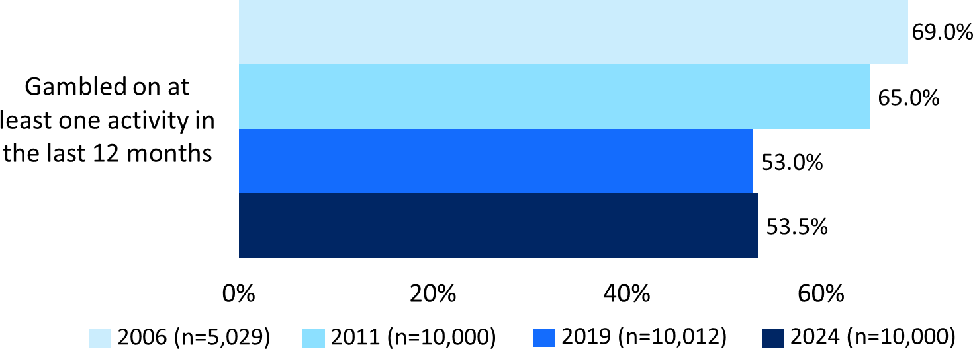

*”I’m going to read out a list of gambling activities. Could you please tell me which of these you have spent money on during the last 12 months?” (Any). Base: All Respondents over time as shown in graph. Asterisks (if present) indicates a statistically significant difference: *p<.05, **p<.01, ***p<.001.*

### Gambling prevalence (last 12 months) by age, gender, location and other demographics

Overall, NSW men (58.7%) reported higher participation than NSW women (48.5%) on at least one gambling activity in this period. This gender difference occurs in all age groups from 18 to 54 years (Figure 3). The difference tends to be greatest for younger people, and much smaller around age 55-64 and older.

##### Figure 3 Participation in any gambling activity in the last 12 months (weighted),

**OVERALL AND BY AGE AND SEX, 2024**

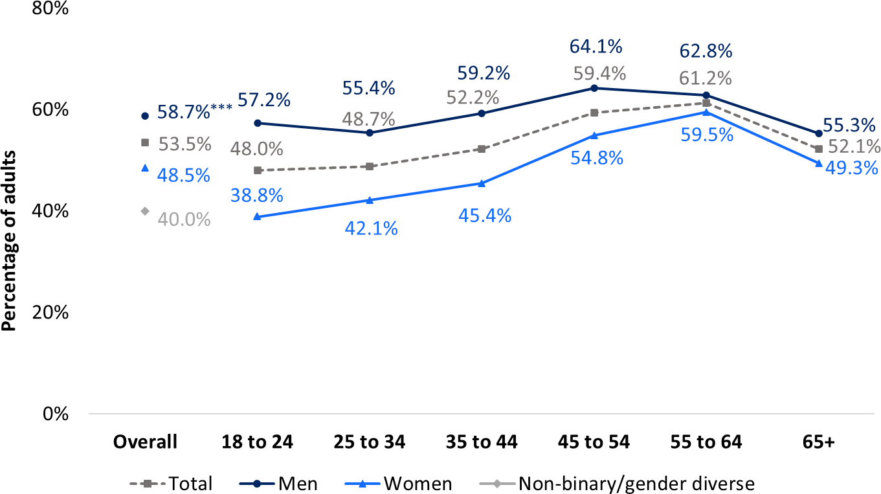

*“I’m going to read out a list of gambling activities. Could you please tell me which of these you have spent money on during the last 12 months?” (Any). Base: All Respondents (n=10,000). Asterisks (if present) indicates a statistically significant difference: *p<.05, **p<.01, ***p<.001.*

Some population groups were more likely than others to report gambling on at least one activity in the last 12 months (Table 3). These were people living outside of Greater Sydney (59.7% compared to 50.2% of those in Greater Sydney); Aboriginal and/or Torres Strait Islanders (60.9% vs 53.3%), people who spoke English at home (56.3% compared to 37.3% of LOTE speakers), those working (57.0% compared to 47.6% of those not working), people without a tertiary qualification (60.7% compared to 46.7% of those with a tertiary qualification), and people who are married (55.0% compared to 51.9% for unmarried people).

##### Table 3 Participation in at least one gambling activity in the last 12 months by demographics

|  |  |
| --- | --- |
|  | **% Yes** |
| **NSW adults** | 53.5% |
| **Location** | |
| Greater Sydney | 50.2% |
| Rest of NSW | **59.7%\*\*\*** |
| **Aboriginal and/or Torres Strait Islander** | |
| No | 53.3% |
| Yes | **60.9%\*\*** |
| **Main language at home** | |
| English only | **56.3%**\*\*\* |
| LOTE speaker | 37.3% |
| **Marital status** | |
| Not currently married (including divorced, separated, widowed and single) | 51.9% |
| Married or living with a partner | **55.0%**\* |
| **Employment status** | |
| Not working (including student, retired, etc) | 47.6% |
| Working (full time, part-time, casual) | **57.0%**\*\*\* |
| **Tertiary education** | |
| No | **60.7%**\*\*\* |
| Yes | 46.7% |
| **Personal income, per year** | |
| Nil or negative income | 44.0% |
| $30,000 or less | 48.8% |
| $30,000 - $49,999 | 54.1% |
| $50,000 - $69,999 | 56.8% |
| $70,000 - $99,999 | 55.4% |
| $100,000 - $149,999 | 60.1% |
| $150,000 or more | 64.7% |
| **Children in the household** | |
| No | 53.4% |
| Yes | 53.7% |
| **Cohabiting with another adult (group/couple)** | |
| No | 52.9% |
| Yes | 54.0% |

*“I’m going to read out a list of gambling activities. Could you please tell me which of these you have spent money on during the last 12 months?”. Base: All Respondents (n=10,000); respondents who participated in at least one gambling activity in the last 12 months. Asterisks (if present) indicates a statistically significant difference: *p<.05,*

*\*\*p<.01, ***p<.001.*

### Gambling prevalence (lifetime) overall, and by age, gender and location

Most NSW adults report gambling at some point in their life. Four in five NSW adults (80.6%) have gambled for money and/or something of value (e.g. cryptocurrency or virtual credits) during their life (see Figure 4).

Overall, NSW men (85.2%) reported higher lifetime gambling participation than women (76.4%). This is observed in all adult age groups except ages 55 to 64 where lifetime participation between men (90.9%) and women (88.2%) was similar. As shown in Table 4, lifetime gambling was more common in areas outside of Greater Sydney (86.4%) compared to those living in Greater Sydney (77.6%).

##### Figure 4 Gambling participation in the lifetime by age and gender, 2024

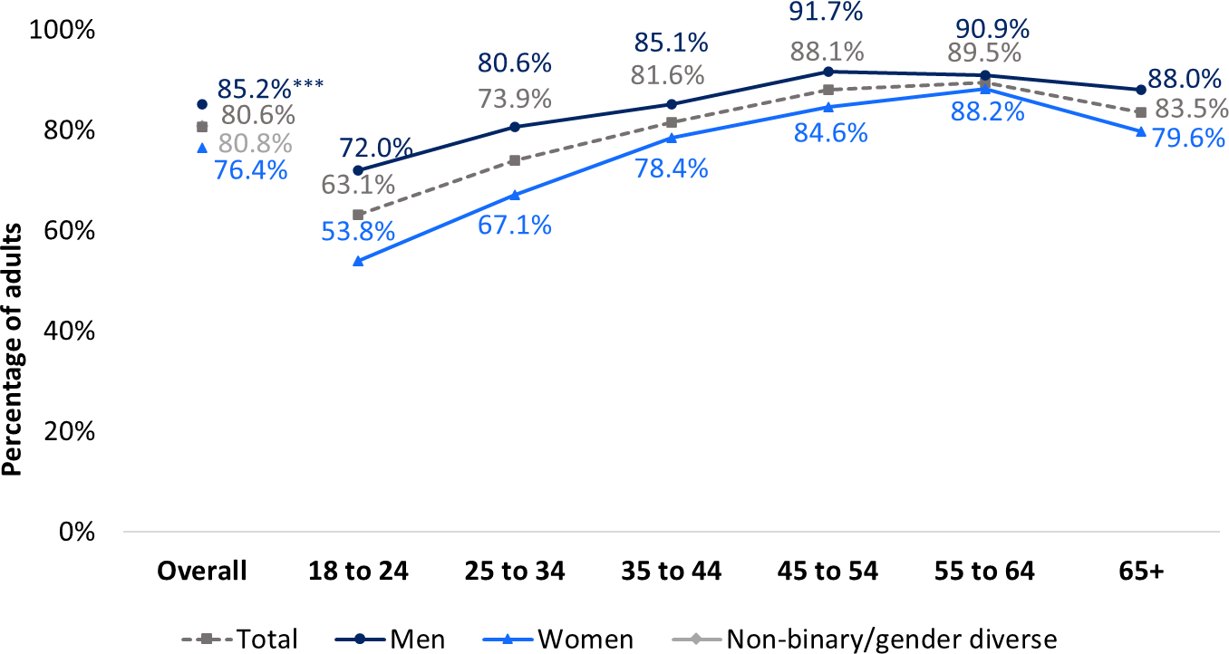

*“Have you ever gambled in your lifetime?”. Base: All Respondents (n=10,000). Asterisks (if present) indicate a statistically significant difference: *p<.05, **p<.01, ***p<.001.*

##### Table 4 Percentage of residents who have gambled in their lifetime

|  |  |
| --- | --- |
|  | **% Yes** |
| **NSW adults** | 80.6% |
| **Location** | |
| Greater Sydney | 77.6% |
| Rest of NSW | **86.4%\*\*\*** |

*“Have you ever gambled in your lifetime?”. Base: All Respondents (n=10,000). Asterisks (if present) indicate a statistically significant difference: *p<.05, **p<.01, ***p<.001.*

### Underage gambling overall, and by age, gender and location

About one in ten (10.6%) NSW residents said they had first gambled when under the legal age of 18 (see Figure 5) with men more likely to have done so. Those residing in the rest of NSW were slightly more likely to have gambled when underage than those in greater Sydney (Table 5).

##### Figure 5 Percentage of respondents who first participated in any form of gambling while under the age of 18 (main-sample weighted)

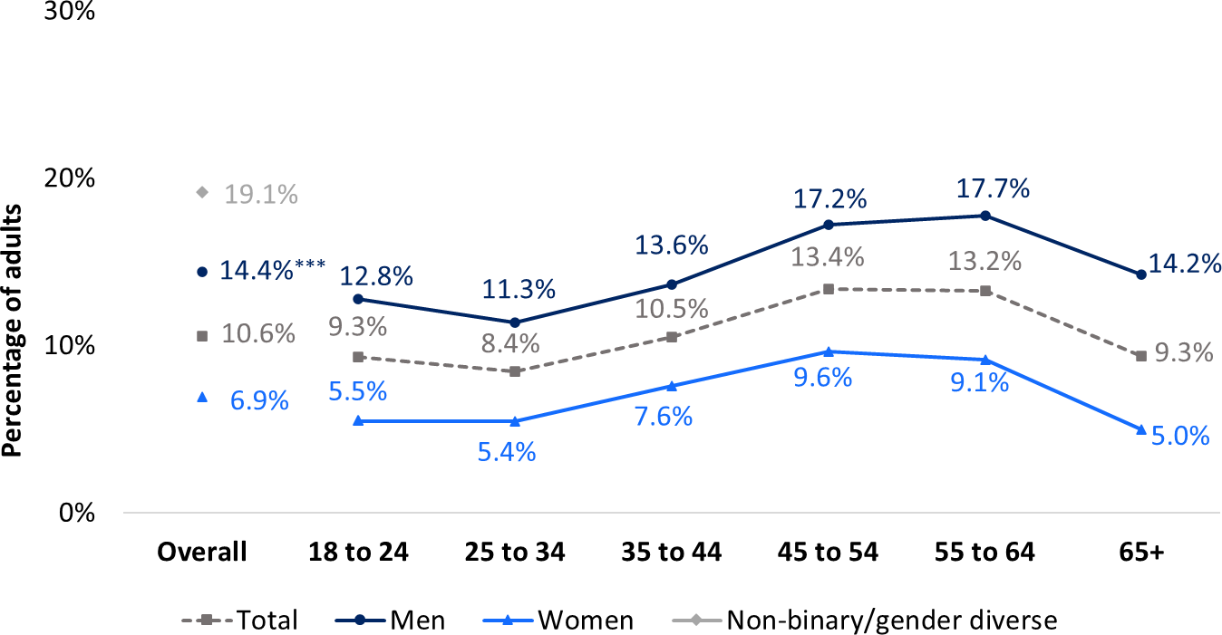

*“How old were you when you first gambled?”. Base: All Respondents who reported gambling in the last 12 months or lifetime (n=7,737). Asterisks (if present) indicates a statistically significant difference: *p<.05, **p<.01,*

*\*\*\*p<.001.*

##### Table 5 Percentage of residents who first gambled when underage

|  |  |
| --- | --- |
|  | **% Yes** |
| **NSW adults** | 10.6% |
| **Location** | |
| Greater Sydney | 10.0% |
| Rest of NSW | **11.5%\*** |

*“How old were you when you first gambled?”. Base: All Respondents who reported gambling in the last 12 months or lifetime (n=7,737). Asterisks (if present) indicates a statistically significant difference: *p<.05, **p<.01,*

*\*\*\*p<.001.*

### Online gambling (last 12 months) overall, and by age, gender and location

Online gamblers are defined as those who had spent money on one or more online gambling activities. This was captured in the survey in the following ways:

* + - All respondents were asked if they had spent money on a range of gambling

forms specifically referencing online activities over the last 12 months. These activities included “bought overseas lottery tickets via online services”, “played casino games, such as Blackjack, Roulette, or poker machine games, online (including via mobile phone) for money rather than points”, and “played poker games online for money rather than points”.

* + - Respondents who indicated they had participated in each gambling form were asked what venue(s) they used for each form and whether an online venue was involved. These included lotteries, race betting, sports and esports betting, and keno.

As shown in Figure 6, one in four NSW adults (26.6%) reported spending money on at least one gambling activity online, and this was significantly higher among men (31.6%) than women (21.8%). The gender difference is observed for most age groups, except those aged 45 to 64, and tends to be greatest for younger people.

The prevalence of online gambling participation was similar across Greater Sydney and the rest of NSW (

Table 6).

##### Figure 6 Overall prevalence of online gambling by age and gender, 2024

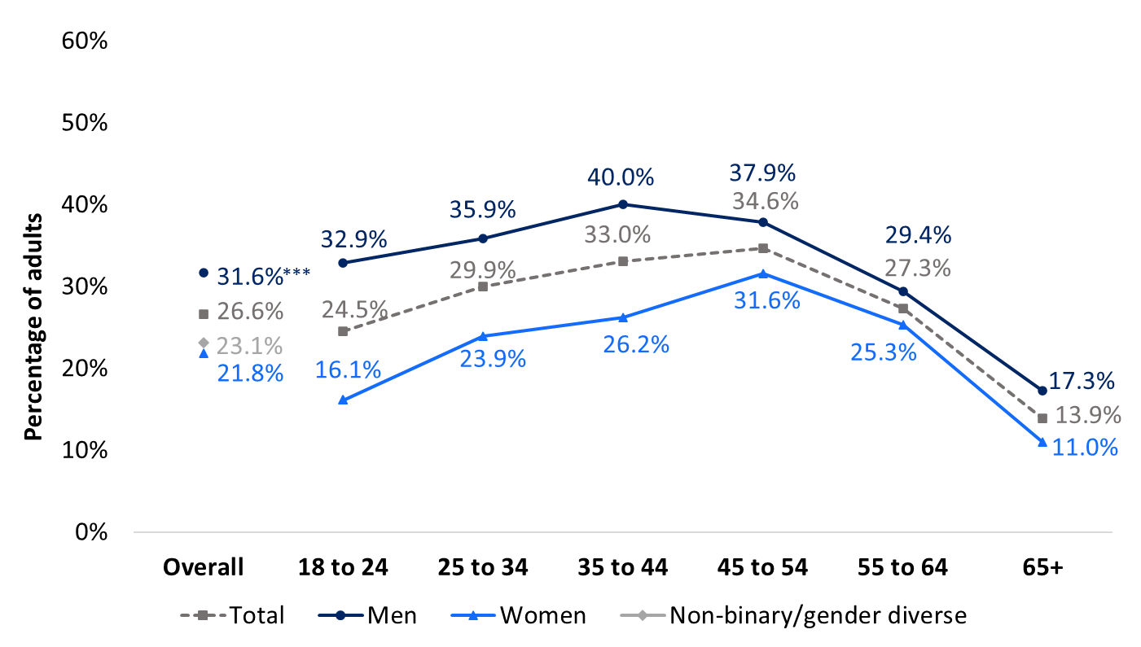

*Based on numerous questions, as outlined in the text above. Base: All respondents (n=10,000). Asterisks (if present) indicate a statistically significant difference: *p<.05, **p<.01, ***p<.001.*

##### Table 6 Percentage of online gambling participation by location

|  |  |
| --- | --- |
|  | **% Yes** |
| **NSW adults** | 26.6% |
| **Location** | |
| Greater Sydney | 26.3% |
| Rest of NSW | 27.1% |

*Based on numerous questions, as outlined in the text above. Base: All respondents (n=10,000). Asterisks (if present) indicate a statistically significant difference: *p<.05, **p<.01, ***p<.001.*

The range of online gambling products has expanded over time. The comparison of online gambling prevalence can only be made where the same online activities are captured in prior surveys. Table 7 below shows the participation in online gambling by activity over time where measures are available. Participation in online casino games has almost halved since 2011, whilst online betting on racing and sports has increased by approximately 50% from 2019 to 2024. Nevertheless, buying lottery tickets is by far the most prevalent form of online gambling.

##### Table 7 Participation in online gambling activities, 2006-2024

|  |  |  |  |  |
| --- | --- | --- | --- | --- |
|  | **2006 (n=5,029)** | **2011 (n=10,000)** | **2019 (n=10,012)** | **2024 (n=10,000)** |
| Played casino games online/ on the internet | 1.0% | 2.0% | 0.5% | 0.8% |
| Betting on horse or greyhound races, by placing bets online (including app) | - | - | 4.7% | 6.5%*** |
| Betting on sporting events, by placing bets online (including app) | - | - | 4.2% | 6.7%*** |
| Betting on esports events, by placing bets online | - | - | 0.5% | 0.5% |
| Played poker games online for money rather than points | - | - | 0.3% | 0.4% |
| Bought lotto tickets online (including apps) | - | - | - | 20.4% |
| Bought overseas lottery tickets via online services | - | - | - | 1.4% |
| Played keno online | - | - | - | 0.2% |

*Based on numerous questions, as outlined in the text above. Base: All respondents (n=10,000). Asterisks (if present) indicate a statistically significant difference: *p<.05, **p<.01, ***p<.001.*

# Chapter 4: Gambling participation and frequency on each form

* + - Buying lottery tickets remains the most prevalent form of gambling.
    - The percentage of people gambling on EGMs, instant scratchies, race betting, casino table games, overseas lotteries and keno has trended downwards since 2006. However, EGMs, scratchies and race betting are still common forms of gambling.
    - The percentage of people gambling on lotteries and sports betting has increased since 2006.
    - Most people who gamble do so less regularly (less than 6 times per year), although some forms (particularly sports and race betting) are associated with more regular gambling.
    - Men were generally more likely to gamble than women, except for scratchies and bingo, where older women are more likely to take part.
    - Participation in casino table games, informal and private betting, and sports betting were highest amongst men and younger cohorts.
    - The prevalence of EGM, race betting and keno participation was higher in

regional areas of NSW. These forms, as well as sports betting, also show higher participation among those who are working, who identify as Aboriginal and/or Torres Strait Islander, those without tertiary education, and people who speak English (rather than LOTE) at home.

* + - Regular gambling on EGMs, casino table games, races, sport and keno was more prevalent among men. While regular EGM gambling was more common among older than younger women, rates among men are similar across age categories. Older men had the highest rates of casino table game gambling, race betting and keno gambling.

### Gambling prevalence for each form (last 12 months) overall, and over time

The 2024 survey reveals significant shifts in gambling participation across various activities since 2019. While overall gambling participation has remained relatively stable, there have been notable changes in the prevalence of specific forms of gambling. Most traditional gambling activities have seen a decline in participation, with a few exceptions showing increases. These trends continue patterns observed in previous surveys, particularly the decline in EGM participation since 2011. The key changes are summarised below.

Declining activities:

* + - Electronic Gaming Machines (EGMs): Continued downward trend from 27% in 2011 to 15.7% in 2019, further decreasing to 14.3% in 2024.
    - Scratchies: Significant decrease from 13.0% in 2019 to 11.0% in 2024, following a major drop from 28% in 2011.
    - Race betting: Further decline to 9.9% in 2024, down from 12.9% in 2019 and 24% in 2011.
    - Keno: Small but significant decrease from 9.5% in 2019 to 7.7% in 2024.
    - Casino table games: Slight but significant decrease from 5.3% in 2019 to 4.3% in 2024.
    - Overseas lotteries: decreasing from a low base of 3.9% in 2019 to 1.4% in 2024. However, in 2019, this category included online keno, so the decline might be due to this change.

Increasing activities:

* + - Lottery tickets: Rose from 37.0% in 2019 to 40.9% in 2024.
    - Sports betting: Increased from 6.1% in 2019 to 7.6% in 2024.
    - Online casino gambling: Small increase from 0.5% in 2019 to 0.8% in 2024.

Figure 7 shows the participations rates for all forms from 2006 to 2024, including summary statistics from the present survey and the three prior surveys.

##### Figure 7 Gambling participation by form of gambling activity and over time, 2006-2024

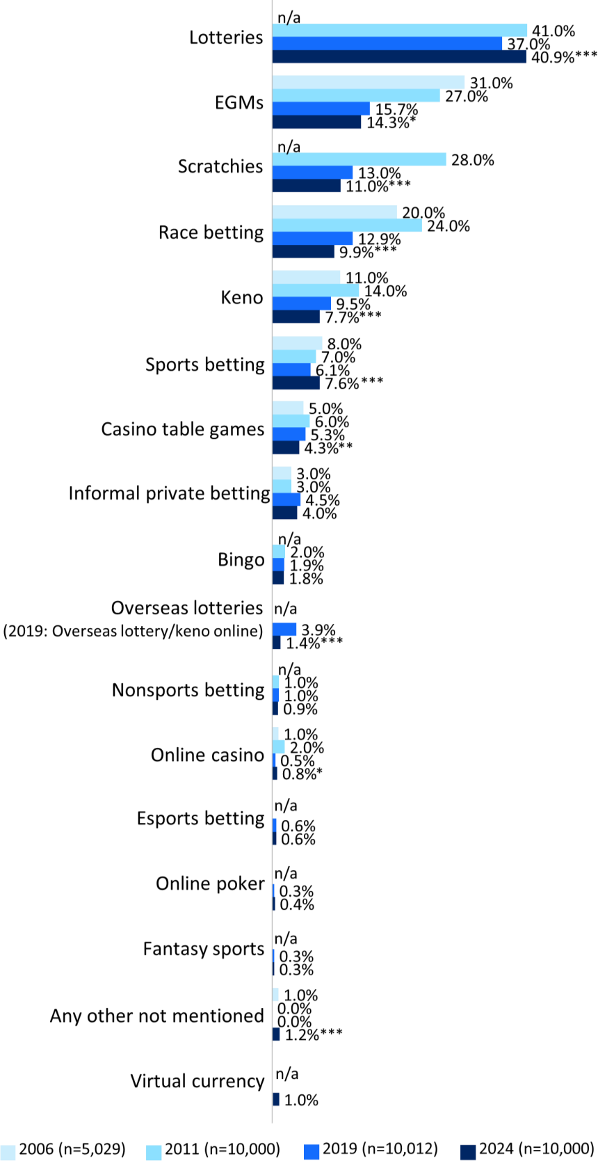

*“I’m going to read out a list of gambling activities. Could you please tell me which of these you have spent money on during the last 12 months?”. Base: All Respondents over time as shown in graph. Asterisks (if present) indicates a statistically significant difference: *p<.05, **p<.01, ***p<.001. Note that minor amendments have been made in the gambling forms list in 2024 as noted in the figure.*

### Gambling participation on each form by age, gender and other demographics

Figures 8-13 show the percentage of all adults who had gambled on each form in the last 12 months along with a breakdown by age and gender.

Men participated in all gambling activities at a higher rate than women, except for purchasing scratchies (most common for women aged 45-54) and gambling on bingo (most common for women aged 55-64). There was no difference between men and women for the “any other not mentioned” category.

For men and women, the percentage buying lottery tickets tended to increase with age, being least prevalent among those aged 18-24, and most prevalent for those in the 45-54 and 55-54 age brackets. The age profile was also relatively similar for both genders. Race betting was most prevalent in the 45 to 54 age bracket, although it was also relatively prevalent for those in the 18 to 24 age bracket.

Participation in EGMs, casino table games, informal and private betting, and sports betting, was most prevalent amongst men and younger cohorts, and decreased with age. For example, sports betting was highest among men aged 18-24 (21.2%) but declined to 4.1% for men aged 65 and older, approaching the very low participation rate for women (0.6%) in this age cohort.

Other activities, such as keno or scratchies showed relatively little trend with respect to age, and only minor differences between men and women.

While low participation rates preclude firm conclusions, participation in novel forms (e.g. betting on events like elections or reality TV) esports betting and fantasy sports betting appears highest amongst young men. Similarly, gambling with virtual currencies like cryptocurrency showed a skew towards younger men.

##### Figure 8 Participation in each form of gambling by age and gender, 2024

**EGMS**

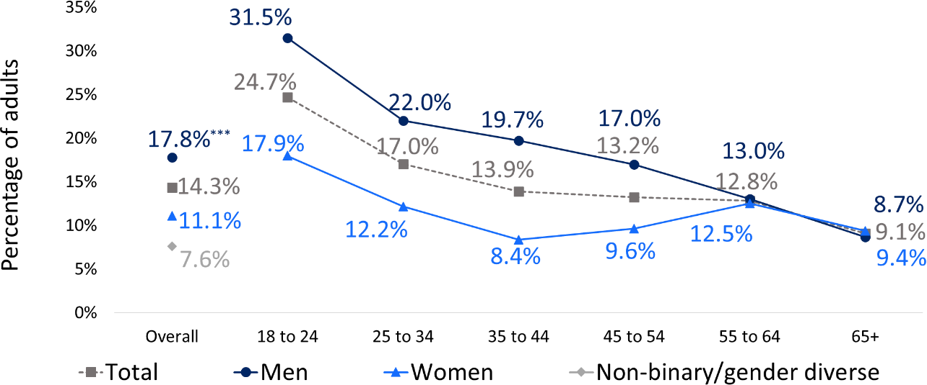

##### Casino table games

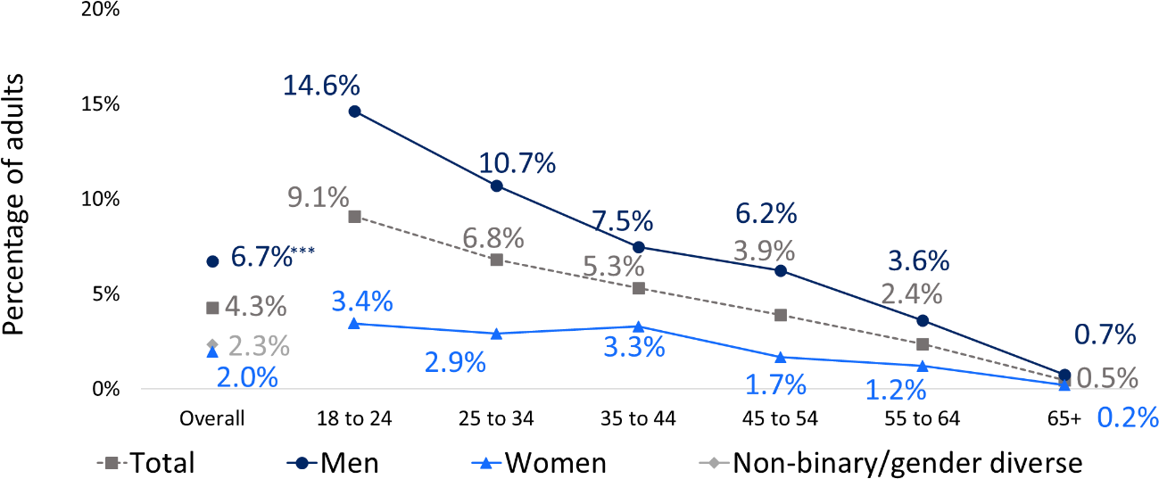

**Keno**

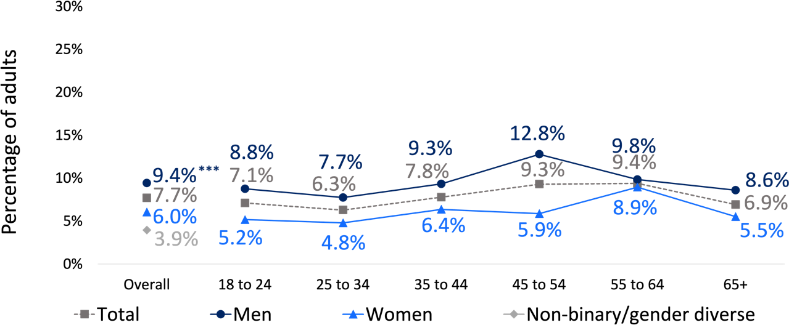

*“I’m going to read out a list of gambling activities. Could you please tell me which of these you have spent money on during the last 12 months?”. Base: All Respondents (n=10,000). Asterisks (if present) indicates a statistically significant difference: *p<.05, **p<.01, ***p<.001*

OFFICIAL

**Figure 9 Participation in each form of gambling by age and gender, 2024 (continued)**

**Lotteries**

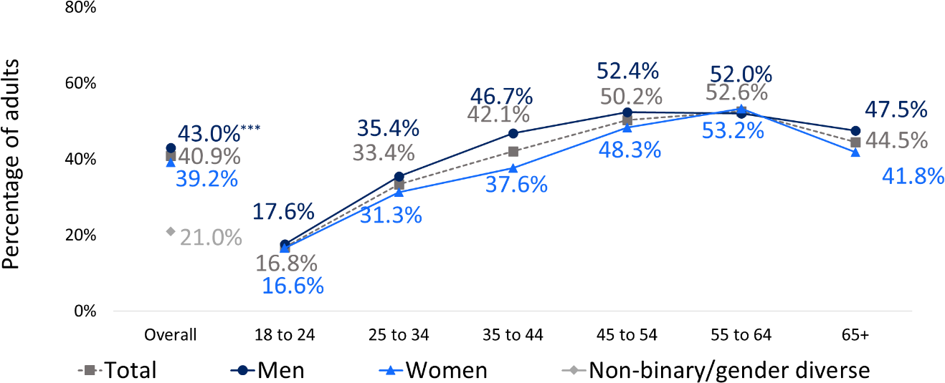

**Scratchies**

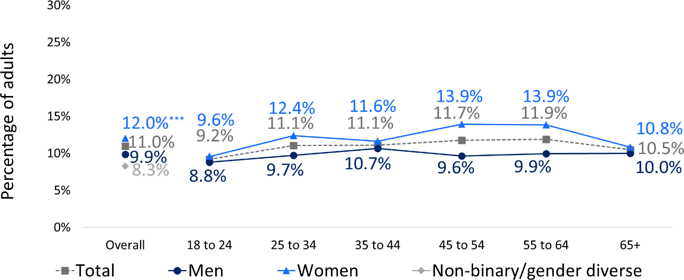

**Overseas lotteries**

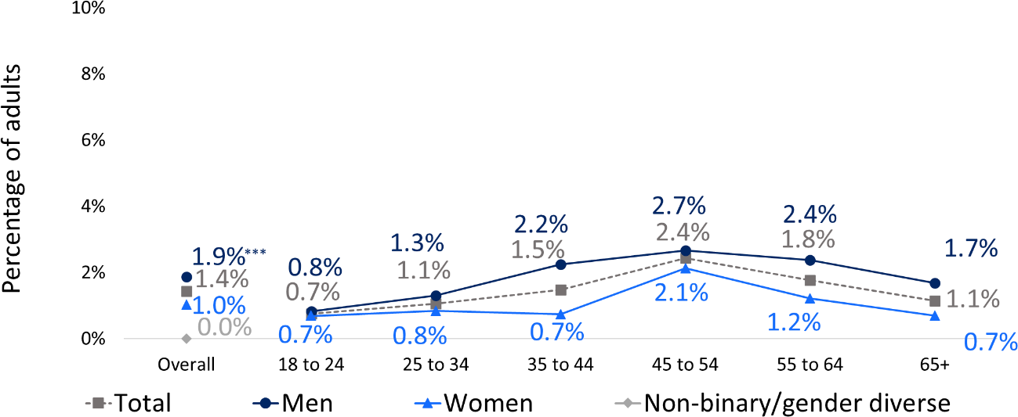

*“I’m going to read out a list of gambling activities. Could you please tell me which of these you have spent money on during the last 12 months?”. Base: All Respondents (n=10,000). Asterisks (if present) indicates a statistically significant difference: *p<.05, **p<.01, ***p<.001.*

OFFICIAL

**Figure 10 Participation in each form of gambling by age and gender, 2024 (continued)**

**Race betting**

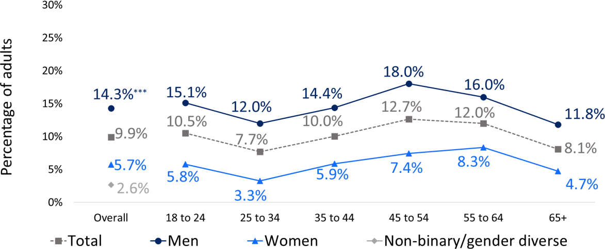

**Sports betting**

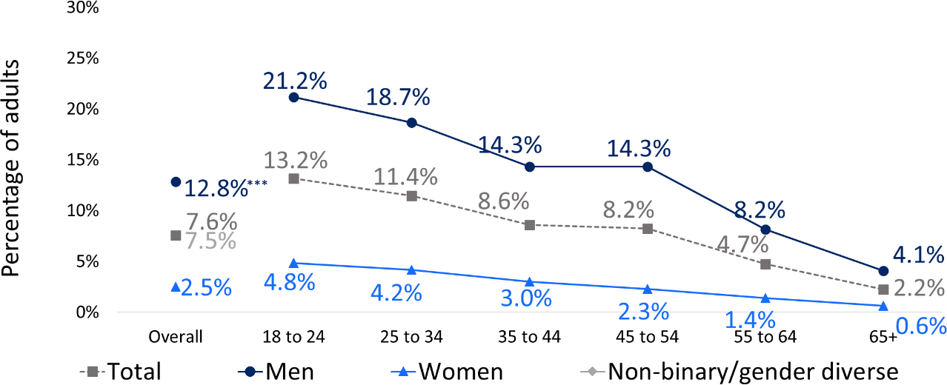

**Non-sports betting**

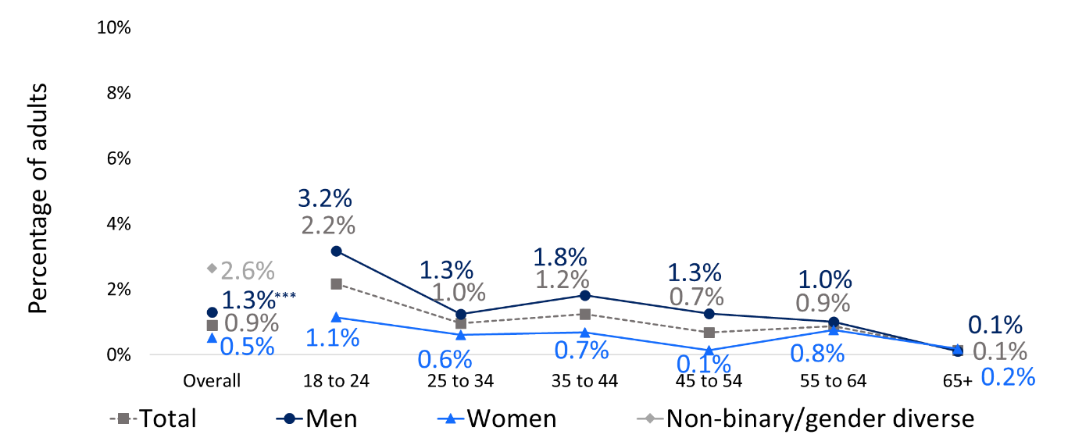

*“I’m going to read out a list of gambling activities. Could you please tell me which of these you have spent money on during the last 12 months?”. Base: All Respondents (n=10,000). Asterisks (if present) indicates a statistically significant difference: *p<.05, **p<.01, ***p<.001.*

OFFICIAL

**Figure 11 Participation in each form of gambling by age and gender, 2024 (continued)**

**Esports betting**

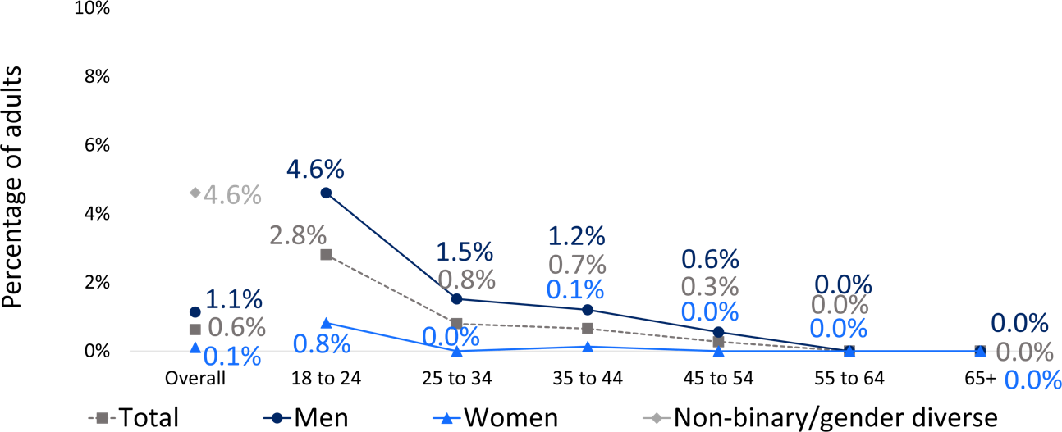

**Fantasy sports**

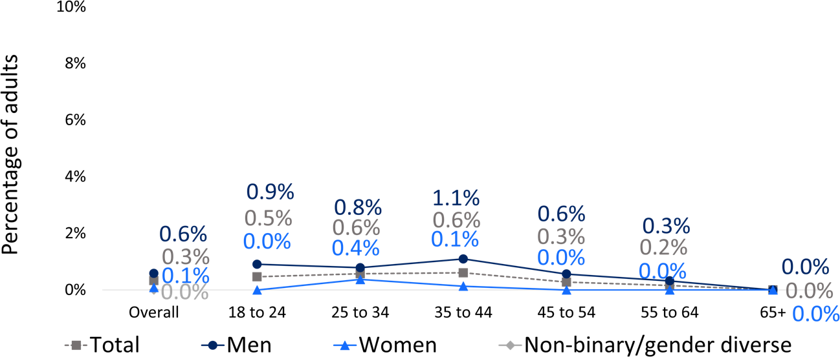

*“I’m going to read out a list of gambling activities. Could you please tell me which of these you have spent money on during the last 12 months?”. Base: All Respondents (n=10,000). Asterisks (if present) indicates a statistically significant difference: *p<.05, **p<.01, ***p<.001.*

OFFICIAL

**Figure 12 Participation in each form of gambling by age and gender, 2024 (continued)**

**Informal Private Betting**

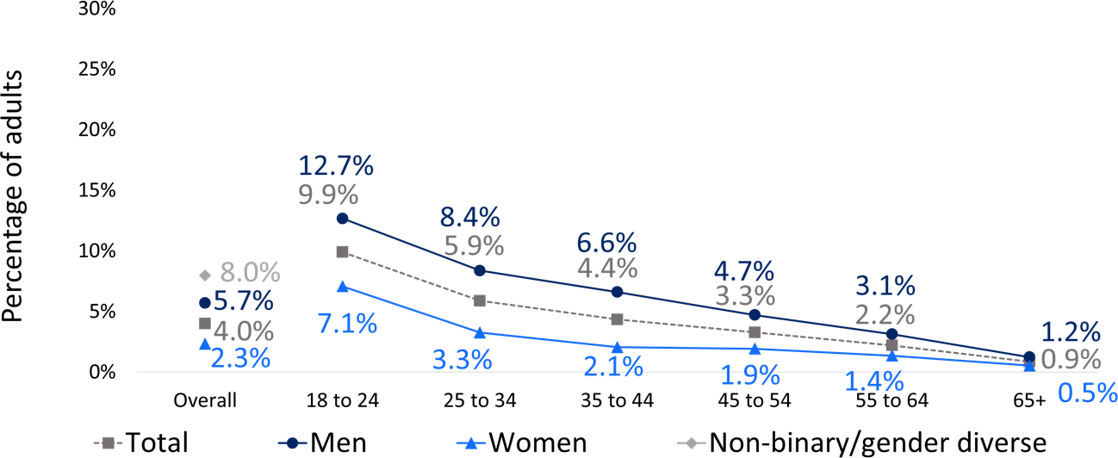

**Online Poker**

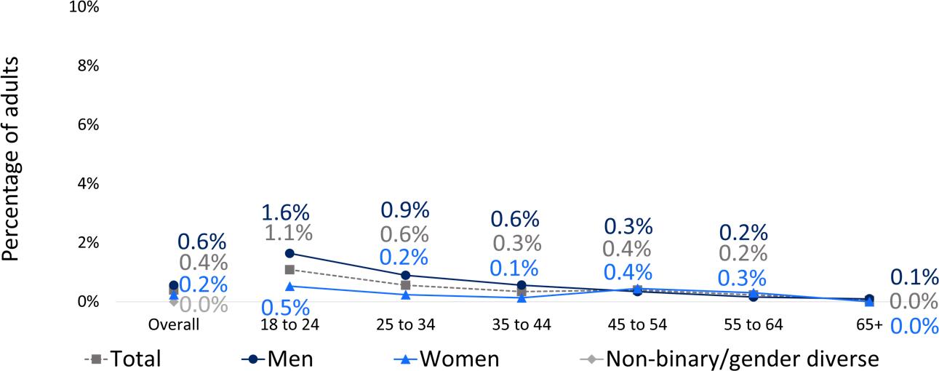

**Online Casino**

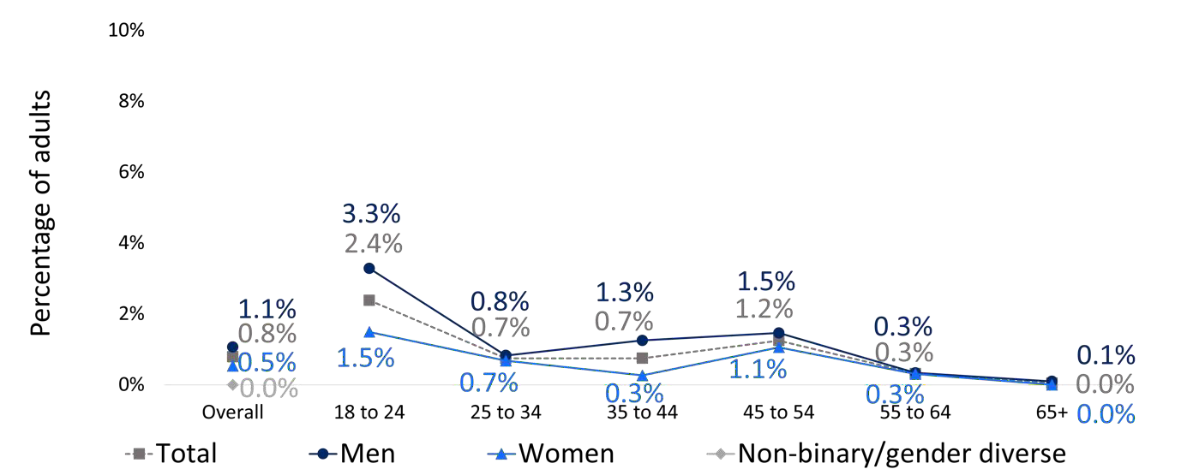

*“I’m going to read out a list of gambling activities. Could you please tell me which of these you have spent money on during the last 12 months?”. Base: All Respondents (n=10,000). Asterisks (if present) indicates a statistically significant difference: *p<.05, **p<.01, ***p<.001.*

OFFICIAL

**Figure 13 Participation in each form of gambling by age and gender, 2024 (continued)**

**Bingo**

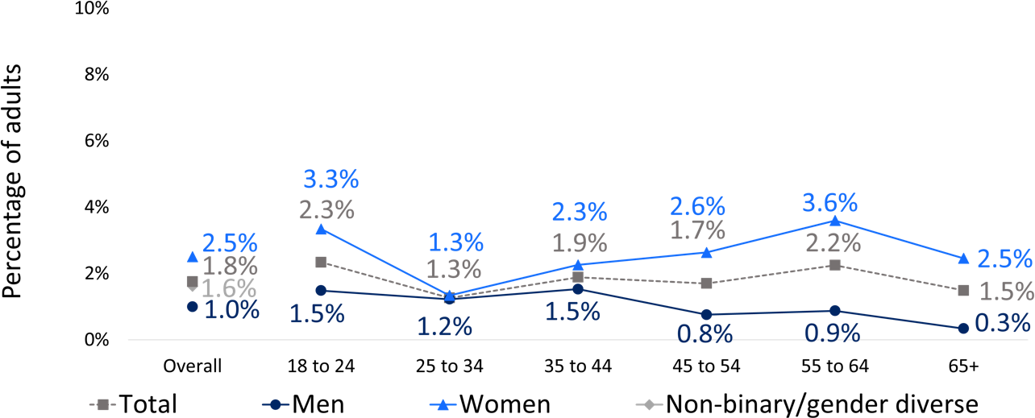

**Any other not mentioned**

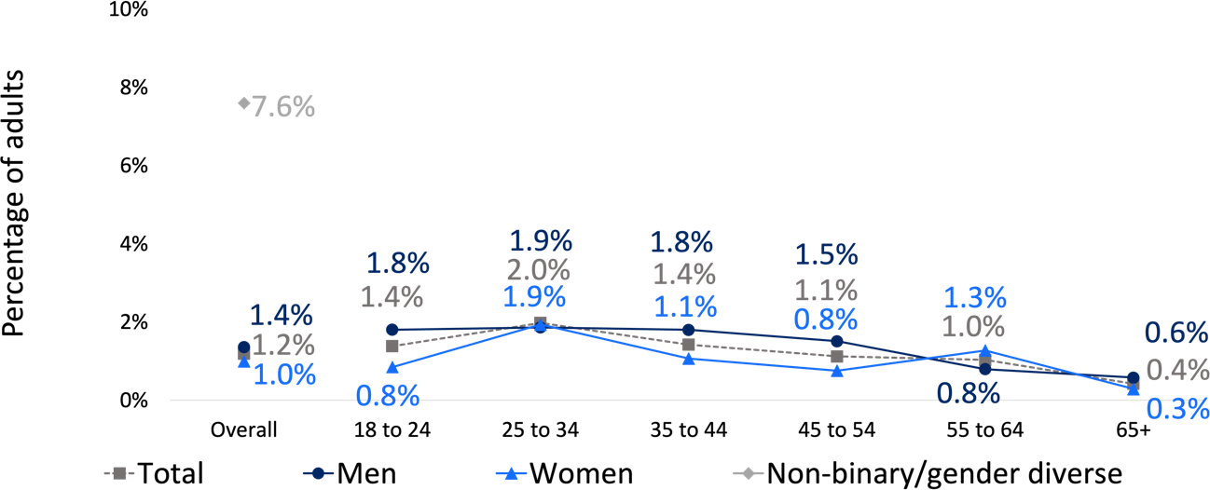

**Virtual currency**

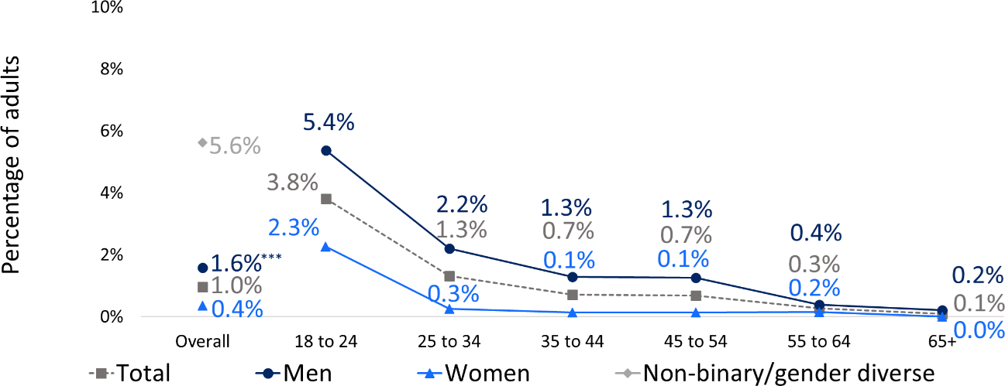

*“I’m going to read out a list of gambling activities. Could you please tell me which of these you have spent money on during the last 12 months?”. Base: All Respondents (n=10,000). Asterisks (if present) indicates a statistically significant difference: *p<.05, **p<.01, ***p<.001.*

Table 8 summarises participation in the key forms of interest by demographic variables other than age and gender. These forms were chosen based on policy interest, as well as prevalence. Lotteries were not included, for example, because they are not associated with much gambling harm, while less prevalent forms were excluded due to low cell counts.

EGMs, race betting and keno are markedly more prevalent in regional areas. People identifying as Aboriginal and/or Torres Strait Islander are also more likely to participate in these forms, as well as sports betting. These forms are also more prevalent amongst those who mainly speak English at home (rather than LOTE).

This difference is largest in the case of racing, with English speakers being over five- times more likely to participate than LOTE speakers. NSW residents who are working (in contrast to students, retired, etc) are generally more likely to participate in all forms of gambling, as are those without tertiary education. Those with children in the house were more likely to take part in sports betting, casino table games and keno, and those cohabiting with another adult were more likely to bet on races and sports and take part in casino table games. Being with a partner was associated with race betting, while not being currently with a partner was associated with engaging with EGMs.

##### Table 8 Participation in select forms in the last 12 months by demographics

|  |  |  |  |  |  |
| --- | --- | --- | --- | --- | --- |
|  | **EGMs** | **Racing** | **Sport** | **Casino table games** | **Keno** |
| **NSW adults** | 14.3% | 9.9% | 7.6% | 4.3% | 7.7% |
| **Location** | | | | | |
| Greater Sydney | 12.2% | 7.9% | 7.7% | 4.5% | 5.6% |
| Rest of NSW | **18.5%\*\*\*** | **13.6%\*\*\*** | 7.3% | 3.9% | **11.7%\*\*\*** |
| **Aboriginal and/or Torres Strait Islander** | | | | | |
| No | 13.8% | 9.7% | 7.4% | 4.2% | 7.3% |
| Yes | **31.6%\*\*\*** | **16.6%\*\*\*** | **13.1%\*\*\*** | 5.7% | **19.1%\*\*\*** |
| **Main language at home** | | | | | |
| English only | **15.8%\*\*\*** | **11.3%\*\*\*** | **8.0%\*\*\*** | 4.3% | **8.6%\*\*\*** |
| LOTE speaker | 5.6% | 1.8% | 5.2% | 4.4% | 2.3% |
| **Marital status** | | | | | |
| Not currently married (including divorced, separated, widowed and single) | **16.4%\*\*** | 8.8% | 8.1% | 4.9% | 7.3% |
| Married or living with a partner | 12.9% | **10.9%\*** | 7.8% | 3.8% | 8.3% |
| **Employment status** | | | | | |
| Not working (including student, retired, etc) | 11.6% | 7.2% | 3.7% | 1.8% | 7.2% |
| Working (full time, part-time, casual) | **16.0%\*\*\*** | **11.5%\*\*\*** | **10.3%\*\*\*** | **5.8%\*\*\*** | 8.2% |
| **Tertiary education** | | | | | |
| No | **20.7%\*\*\*** | **12.5%\*\*\*** | **9.0%\*\*** | 4.7% | **10.8%\*\*\*** |
| Yes | 8.3% | 7.5% | 6.9% | 4.0% | 5.0% |
| **Personal income, per year** | | | | | |
| Nil or negative income | 8.7% | 6.6% | 1.2% | 1.7% | 6.9% |
| $30,000 or less | 15.0% | 6.6% | 4.1% | 1.2% | 7.9% |
| $30,000 - $49,999 | 16.0% | 7.3% | 5.5% | 5.3% | 9.0% |
| $50,000 - $69,999 | 18.0% | 11.7% | 7.7% | 4.0% | 8.2% |
| $70,000 - $99,999 | 15.9% | 8.6% | 8.5% | 4.7% | 6.9% |
| $100,000 - $149,999 | 16.1% | 14.1% | 11.8% | 5.5% | 9.0% |
| $150,000 or more | 14.4% | 16.0% | 14.3% | 8.7% | 11.2% |
| **Children in the household** | | | | | |
| No | 14.5% | 9.4% | 7.0% | 3.9% | 7.2% |
| Yes | 14.1% | 11.1% | **10.0%\*\*\*** | **5.3%\*** | **9.2%\*** |
| **Cohabiting with another adult (group/couple)** | | | | | |
| No | 14.8% | 8.4% | 6.0% | 3.1% | 7.8% |
| Yes | 14.5% | **10.6%\*** | **8.6%\*\*** | **4.8%\*** | 8.0% |

*“I’m going to read out a list of gambling activities. Could you please tell me which of these you have spent money on during the last 12 months?”. Base: All Respondents (n=10,000) or subsampled respondents for certain demographics. Asterisks (if present) indicates a statistically significant difference: *p<.05, **p<.01, ***p<.001.*

### Frequency of gambling on each form (last 12 months) by age, gender, location and other demographics

Most NSW residents who participated in each gambling form over the last 12 months did so less than 6 times per year (Figure 14, Figure 15 and Figure 16). However, the participation profile differs by form. For example, those who engaged in sports betting or buying lottery tickets were more likely to gamble on that form more often. In contrast, those who gambled on casino table games, keno or instant scratchies were more likely to gamble on that form less than 6 times a year. While online poker and gambling with virtual currency both have very low prevalence (0.4% and 0.9% respectively), those who do engage in these forms are likely to do so quite regularly. However, caution must be exercised since these estimates of frequency are based on small subsamples (37 and 90 respondents, respectively).

At-least monthly EGM engagement, casino table games, race betting, sports betting and keno is more prevalent among men (Figure 17). While regular EGM gambling is more common among older women, rates among men are similar across age categories. Older men have the highest rates of casino table game gambling, race betting and keno gambling.

Table 9 shows at-least monthly participation in select forms by other demographics. These demographic trends largely mirror those shown in at-least yearly participation although not all effects are statistically significant. Residents who identify as Aboriginal and/or Torres Strait Islander, as well as those without tertiary education, are more likely to regularly gamble on EGMs, racing and sports.

##### Figure 14 Frequency profile of gambling on each form among those who participated on that form

|  |  |
| --- | --- |
| **EGMS (14.3%)**    *(n=1,425)*  **Lotteries (40.7%)**    *(n=4,068)*  **KENO (7.6%)**    *(n=761)* | **Casino table games (4.3%)**    *(n=425)*  **Overseas lotteries (1.3%)**    *(n=134)*  **Scratchies (10.9%)**    (n=1,086) |

*“Regarding the relevant form, how often did you take part in the last 12 months?”. Base: Respondents who had gambled on the relevant form in the last 12 months. Asterisks (if present) indicates a statistically significant difference: *p<.05, **p<.01, ***p<.001. Percentages in the figures are amongst those who took part in each form.*

##### Figure 15 Frequency profile of gambling on each form among those who participated on that form (continued)

|  |  |
| --- | --- |
| **Race betting (9.8%)** *(n=27)* | **Sports betting (7.5%)** *(n=60)* |

*“Regarding the relevant form, how often did you take part in the last 12 months?”. Base: Respondents who had gambled on the relevant form in the last 12 months. Asterisks (if present) indicates a statistically significant difference: *p<.05, **p<.01, ***p<.001. Percentages in the figures are amongst those who took part in each form.*

##### Figure 16 Frequency profile of gambling on each form among those who participated on that form (continued)

|  |  |
| --- | --- |
| **Informal private betting (3.8%)**    *(n=382)*  **Online casino (0.7%)**    *(n=74)*  **Any other not mentioned (1.2%)**    *(n=119)* | **BINGO (1.7%)**    *(n=175)*  **Online poker (0.4%)**    *(n=37)*  **Virtual currency (0.9%)**    *(n=90)* |

*“Regarding the relevant form, how often did you take part in the last 12 months?”. Base: Respondents who had gambled on the relevant form in the last 12 months. Asterisks (if present) indicates a statistically significant difference: *p<.05, **p<.01, ***p<.001. Percentages in the figures are amongst those who took part in each form.*

##### Figure 17 At-least monthly participation in select forms of gambling by age and gender

**EGMS**

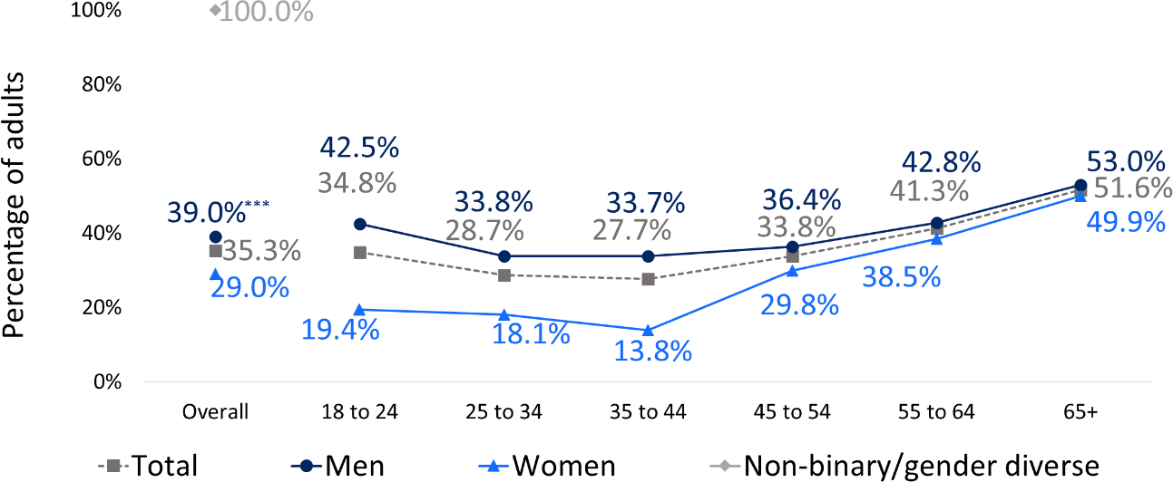

*(n=1,425)*

##### Casino table games

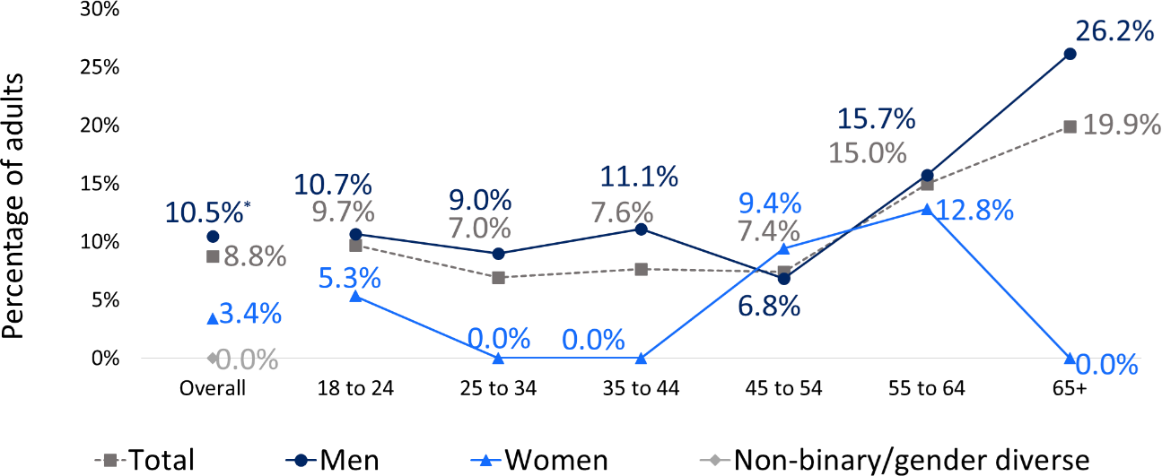

*(n=425)*

##### Race betting

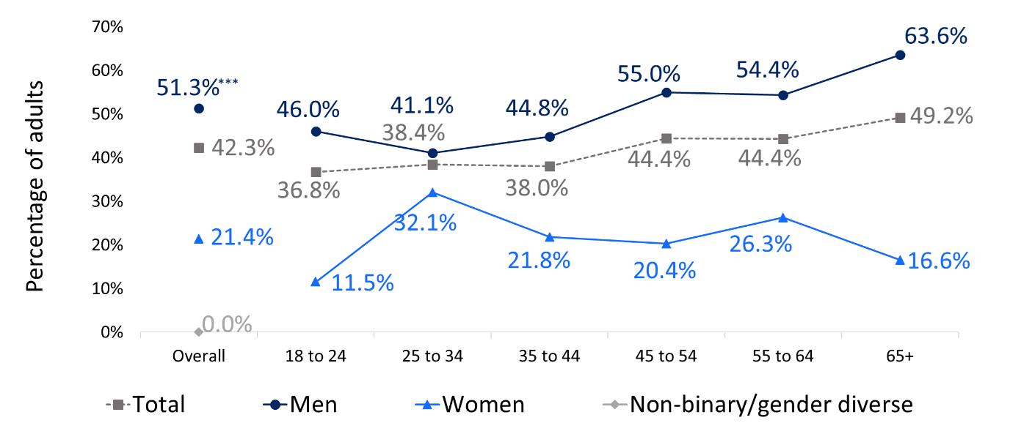

*(n=984)*

*“Regarding the relevant form, how often did you take part in the last 12 months?”. Base: Respondents who had gambled in the last 12 months at-least monthly per form. Asterisks (if present) indicates a statistically significant difference: *p<.05, **p<.01, ***p<.001. Percentages in the figures are amongst those who took part in each form.*

##### Figure 18 At-least monthly participation in select forms of gambling by age and gender

**Sports betting**

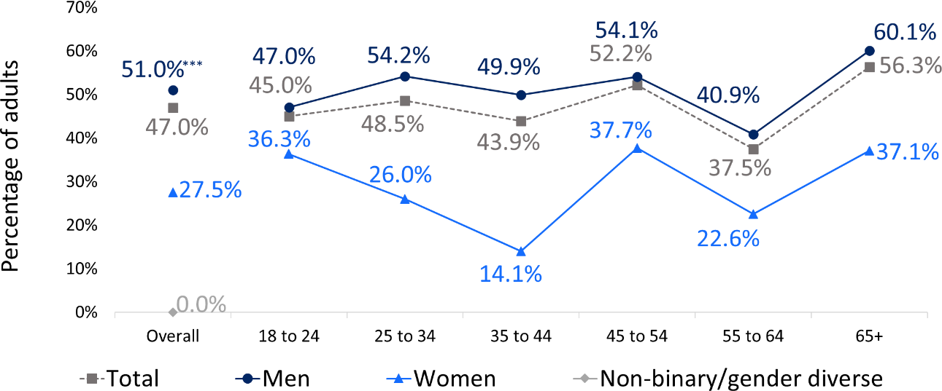

*(n=750)*

##### Keno

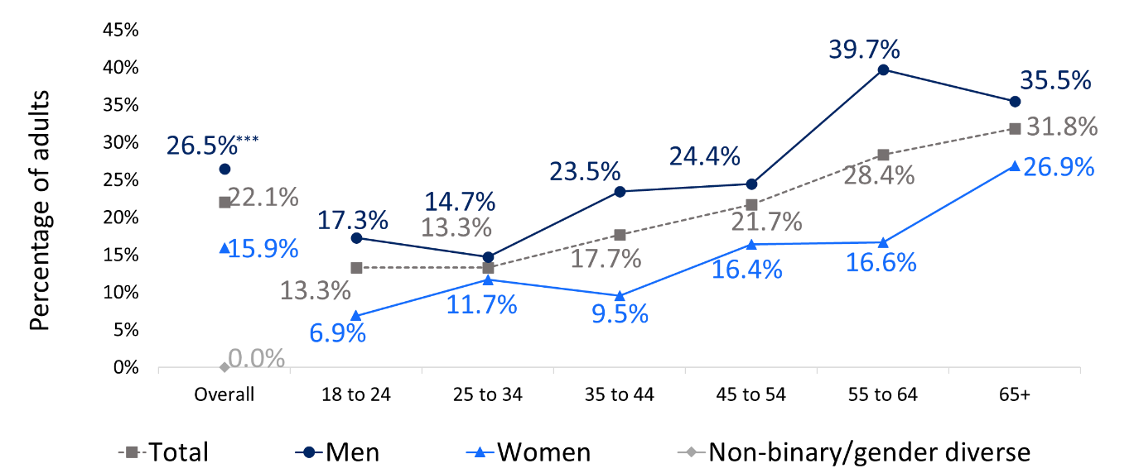

*(n=761)*

*“Regarding the relevant form, how often did you take part in the last 12 months?”. Base: Respondents who had gambled in the last 12 months at-least monthly per form. Asterisks (if present) indicates a statistically significant difference: *p<.05, **p<.01, ***p<.001. Percentages in the figures are amongst those who took part in each form.*

##### Table 9 Participation in select forms at-least monthly in the last 12 months by demographics

|  |  |  |  |  |  |
| --- | --- | --- | --- | --- | --- |
|  | **EGMs** | **Racing** | **Sport** | **Casino table games** | **Keno** |
| **NSW adults** | 35.4% | 42.3% | 47.0% | 8.9% | 22.1% |
| **Location** | | | | | |
| Greater Sydney | 35.8% | 39.1% | 45.3% | 10.1% | 21.7% |
| Rest of NSW | 34.8% | **46.0%\*** | 50.4% | 5.9% | 22.4% |
| **Aboriginal and/or Torres Strait Islander** | | | | | |
| No | 34.3% | 41.3% | 46.1% | 8.3% | 21.4% |
| Yes | **45.5%\*** | **65.0%\*\*\*** | **61.6%\*** | 13.7% | 30.4% |
| **Main language at home** | | | | | |
| English only | 34.8% | 42.4% | 47.5% | 7.5% | 22.3% |
| LOTE speaker | 41.3% | 45.6% | 41.4% | 14.4% | 18.3% |
| **Marital status** | | | | | |
| Not currently married (including divorced, separated, widowed and  single) | 39.5% | 41.5% | 45.9% | 9.4% | 24.9% |
| Married or living with a partner | 33.7% | 43.5% | 46.0% | 7.2% | 19.0% |
| **Employment status** | | | | | |
| Not working (including student,  retired, etc) | **44.1%\*** | 45.9% | 50.0% | 15.7% | 28.3% |
| Working (full time, part-time, casual) | 33.7% | 42.0% | 45.4% | 6.8% | 18.0% |
| **Tertiary education** | | | | | |
| No | **41.5%\*\*\*** | **50.1%\*\*\*** | **51.9%\*** | 10.3% | 23.8% |
| Yes | 25.1% | 31.1% | 38.9% | 5.6% | 16.5% |
| **Children in the household** | | | | | |
| No | 38.6% | 41.7% | 47.4% | 10.9% | 26.0% |
| Yes | 32.6% | 45.2% | 44.1% | 3.9% | 12.6% |
| **Cohabiting with another adult (group/couple)** | | | | | |
| No | 39.6% | 45.9% | 43.0% | 10.7% | 27.4% |
| Yes | 35.8% | 41.8% | 46.5% | 7.7% | 19.6% |

*“Regarding the relevant form, how often did you take part in the last 12 months?”. Base: Respondents who had gambled in the last 12 months at-least monthly per form. Asterisks (if present) indicates a statistically significant difference: *p<.05, **p<.01, ***p<.001. Percentages in the figures are amongst those who took part in each form.*

# Chapter 5: Gambling problems

* Less than one percent (0.9%) of the NSW adult population engaged in high- risk gambling (previously known as problem gambling), stable from the 2019 rate of 1.0%. A further 3.1% were classified as moderate-risk gambling, and 6.7% as low-risk gambling.
* About one in five gamblers and one in ten NSW residents were classified as experiencing low-, moderate- or high-risk gambling (i.e., PGSI score of 1 or higher).
* There has been a dramatic decrease in gambling participation, dropping from 69% in 2006 to 53.0% in 2019 and 53.5% in 2024. However, the rate of low-, moderate- and high-risk gambling has remained stable over this period.
* Men were over twice as likely to be engaged in moderate- to high-risk gambling than women (5.7% versus 2.3%). Risk was highest for men aged 18 to 24 (9.3%).
* Demographic groups at higher risk also include people:
  + identifying as Aboriginal and/or Torres Strait Islander
  + not currently married or living with a partner, and
  + who have not completed tertiary education.
* Of the mainstream (more prevalent) forms, casino table games (19.2%) and EGMs (18.5%) had the highest proportion of moderate- to high-risk gamblers.
* Gambling weekly or more was a significant risk factor: almost one in three NSW residents who gamble weekly or more (30.5%) were classified as moderate- to high-risk gambling. Risk was higher for weekly gambling on casino table games (50.1%) and EGMs (35.0%).
* Younger women and LOTE speakers were less likely to gamble weekly or more often, but those who do so were at substantially greater risk (47.8% for women, 61.1% for LOTE).
* People identifying as Aboriginal and/or Torres Strait Islander were more likely

to gamble at-least weekly (13.0% vs 5.0%) and were much more likely to experience moderate- to high-risk gambling if they do so (44.2% versus 29.6%).

* People who gambled online were almost five times more likely to experience

moderate- to high-risk gambling (9.2%) compared to those who do not (2.1%).

* 3.4% of NSW residents indicated that they had experienced gambling problems at some point in their lifetime.

### Individual items on the PGSI, and compared to 2019

Overall, one in five or 20.0% of gamblers (10.7% of NSW residents) scored 1+ on the Problem Gambling Severity Index (PGSI), which places them in either the low- risk, moderate-risk or high-risk gambling categories. This entails that they endorsed at least ‘sometimes’ on one of the 9 items of the PGSI. The percentage of gamblers endorsing each item is given in Table 10. Overall, responses to each PGSI item have remained relatively stable since 2019. Feeling guilty about their gambling remained the most endorsed indicator, endorsed by one in ten (11.6%) NSW gamblers in 2024.

Less commonly endorsed items include that gambling caused financial problems for them or their household (2.6%) and having borrowed money or sold something to obtain money for gambling (1.5%).

##### Table 10 Prevalence of NSW residents endorsing each question on the PGSI

|  |  |  |  |  |
| --- | --- | --- | --- | --- |
|  | **Never**  **(0)** | **Sometimes**  **(1)** | **Most of the time**  **(2)** | **Almost always**  **(3)** |
| Have you bet more than you could really afford to lose? | 94.1% | 4.6% | 0.5% | 0.7% |
| Have you needed to gamble with larger amounts of money to get the same feeling of excitement? | 94.0% | 5.0% | 0.5% | 0.5% |
| When you gambled, did you go back another day to try to win back the money you lost? | 93.4% | 5.5% | 0.6% | 0.6% |
| Have you borrowed money or sold anything to get money to gamble? | 98.5% | 1.3% | 0.1% | 0.1% |
| Have you felt that you might have a problem with gambling? | 94.8% | 4.0% | 0.5% | 0.7% |
| Has your gambling caused you any health problems, including stress or anxiety? | 95.9% | 3.1% | 0.4% | 0.5% |
| Have people criticised your betting or told you that you had a gambling problem, regardless of whether or not you thought it was true? | 95.4% | 3.6% | 0.5% | 0.4% |
| Has your gambling caused any financial problems for you or your household? | 97.4% | 2.0% | 0.2% | 0.3% |
| Have you felt guilty about the way you gamble, or what happens when you gamble? | 88.4% | 9.3% | 0.9% | 1.3% |

*“I am now going to read out some questions about what happens when people gamble. As I read out each statement please tell me whether it has applied to you personally in the last 12 months”. Base: All respondents who had gambled in the last 12 months (n=5,359), with people who had not gambled classified in a separate non-gambler category.*

### Problem Gambling Severity Index, groups overall, and over time

The proportions of the NSW adult population in each PGSI risk category from 2006 to 2024 are shown in Figure 19. The labels used for PGSI risk categories in this report are minimal-risk, low-risk, moderate-risk and high-risk. These correspond with the labels that are typically used for the PGSI: non-problem, low-risk, moderate-risk and problem gambling. Please see Chapter 2.

Less than one percent (0.9%) of the NSW adult population were classified in the high-risk gambling category (previously referred to as problem gambling), stable from the 2019 prevalence rate of 1.0%. The prevalence of moderate-risk gambling (3.1%) has also remained stable since 2019 (2.8%), along with the prevalence of low-risk gambling which was 6.6% in 2019 and 6.7% in 2024. None of these changes were statistically significant.

The most salient change since 2006 has been a dramatic decrease in gambling participation, dropping from 69% in 2006 to 53.0% in 2019, and remaining stable in 2024 (53.5%). Interestingly, the number of gamblers in any risk category has either remained stable (moderate-risk or low-risk) or increased (low-risk) over this period. Thus, the proportion of those in moderate- to high-risk categories *among gamblers* (but not NSW residents) has increased.

Amongst people who had gambled in the last 12 months, 80.0% were classified as minimal-risk (previously non-problem), 12.5% as low-risk, 5.8% as moderate-risk and 1.7% as high-risk (previously problem).

##### Figure 19 PGSI risk category prevalence among NSW residents, 2006-2024

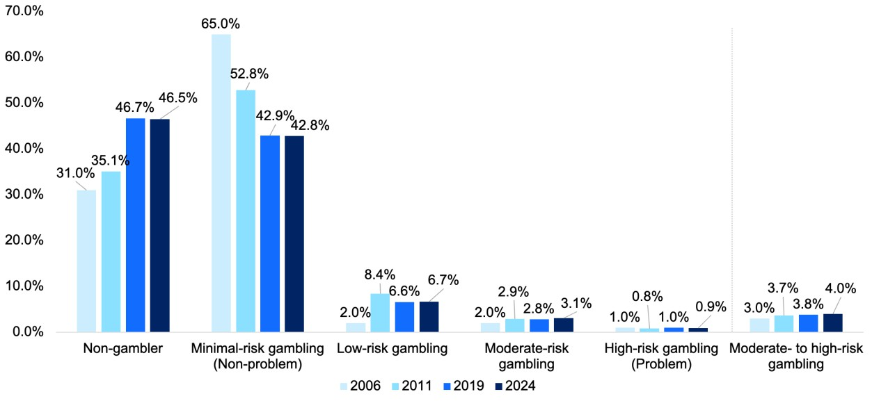

*Base: All respondents (2006 n=5,029, 2011 n=10,000, 2019 n=10,012, 2024 n = 10,000); Respondents who had gambled on any form in the last 12 months (2019 n=5,453, 2024 n=5,314). People who had not gambled in the last 12 months were classified in a separate non-gambler category. Asterisks (if present) indicate a statistically significant difference: *p<.05, **p<.01, ***p<.001.*

### Problem Gambling Severity Index moderate- to high-risk categories by age, gender, location and other demographics

Figure 20 shows the percentage of moderate- to high-risk gambling among all NSW residents by age and gender. Men have over twice the risk of women overall (5.7% versus 2.3%). Risk is highest for men aged 18 to 24 (9.4%) and declines with age. Risk is lowest for women aged 35 to 44 (1.2%), and then increases to 3.4% at ages 45 to 54, approaching that of women aged 18 to 24 (3.6%).

##### Figure 20 Prevalence of moderate- to high-risk gambling (previously moderate-

**TO PROBLEM GAMBLING), BY AGE AND GENDER, 2024**

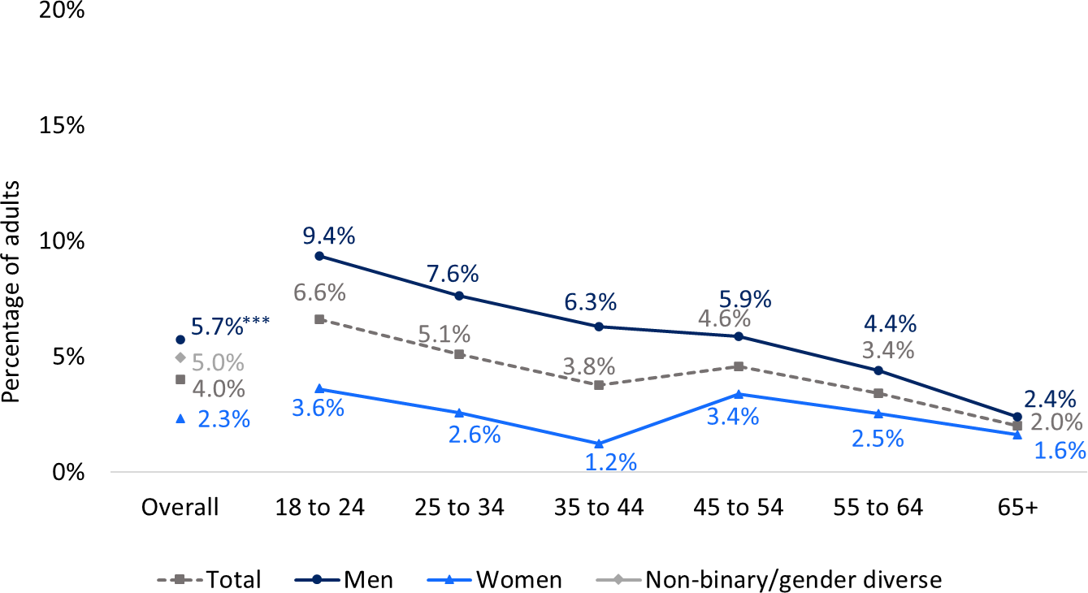

*“I am now going to read out some questions about what happens when people gamble. As I read out each statement please tell me whether it has applied to you personally in the last 12 months”. Base: All respondents who had gambled in the last 12 months (n=5,359), with people who had not gambled classified in a separate non-gambler category. Problem Gambling Severity Index, binarised to moderate-risk and high-risk (previously problem) compared to non-gamblers, minimal-risk (previously non-problem) and low-risk. Asterisks (if present) indicates a statistically significant difference: *p<.05, **p<.01, ***p<.001.*

Table 11 shows moderate- to high-risk gambling prevalence by demographics. Those identifying as Aboriginal and/or Torres Strait Islander are at much greater risk (10.4%) than other NSW residents (3.8%). There are no significant differences with respect to location, language spoken at home, employment status, income, or household structure. However, those without tertiary education have over double the risk (5.6%) of those with a tertiary degree (2.5%), and those not currently married (5.3%) had higher risk than those married or living with a partner (3.1%).

##### Table 11 Prevalence of moderate- to high-risk gambling by demographics

|  |  |
| --- | --- |
|  | **% moderate- to high-risk gambling** |
| **NSW adults** | 4.0% |
| **Location** | |
| Greater Sydney | 4.0% |
| Rest of NSW | 4.1% |
| **Aboriginal and/or Torres Strait Islander** | |
| No | 3.8% |
| Yes | **10.4%\*\*\*** |
| **Main language at home** | |
| English only | 3.9% |
| LOTE speaker | 4.4% |
| **Marital status** | |
| Not currently married (including divorced, separated, widowed and single) | **5.3%\*\*\*** |
| Married or living with a partner | 3.1% |
| **Employment status** | |
| Not working (including student, retired, etc) | 3.8% |
| Working (full time, part-time, casual) | 4.2% |
| **Tertiary education** | |
| No | **5.6%\*\*\*** |
| Yes | 2.5% |
| **Personal income, per year** | |
| Nil or negative income | 2.2% |
| $30,000 or less | 5.1% |
| $30,000 - $49,999 | 4.7% |
| $50,000 - $69,999 | 5.0% |
| $70,000 - $99,999 | 4.1% |
| $100,000 - $149,999 | 3.7% |
| $150,000 or more | 4.6% |
| **Children in the household** | |
| No | 4.1% |
| Yes | 3.8% |
| **Cohabiting with another adult (group/couple)** | |
| No | 4.7% |
| Yes | 3.9% |

*Problem Gambling Severity Index, binarised to moderate-risk and high-risk (previously problem) compared to non-gamblers, minimal-risk (previously non-problem) and low-risk. Base: All respondents who had gambled in the last 12 months (n=5,359), with people who had not gambled classified in a separate non-gambler category.*

*Asterisks (if present) indicates a statistically significant difference: *p<.05, **p<.01, ***p<.001.*

### Problem Gambling Severity Index by engagement with each form

The dark-blue bars in Figure 21 show the proportion of people who take part in each form who engage in moderate- to high-risk gambling. The light blue bars show the percentage of NSW residents who engaged in each form at least once in the last 12 months.

People who engage in moderate- to high-risk gambling tend to engage in multiple forms of gambling, and therefore caution should be taken in attributing problems to each form. For example, of the 6.5% of people at moderate- to high-risk who buy lottery tickets, the large majority also engage in other more risky forms. Readers are referred to Section 7.1 for an analysis that determines the proportion of problems and harm attributable to each form of gambling.

Figure 21 partly illustrates which forms are disproportionately used by those at moderate- to high-risk. As illustrated in the figure, this includes forms that cannot legally be provided to Australian residents, such as online poker and online casinos. Among the relatively small number of people who engage in these forms, the percentage of people engaged in moderate- to high-risk gambling is extremely high (59.0% and 41.8% respectively).

Other forms that are used by a high proportion of people engaged in moderate- to high-risk gambling include those that are newer (e.g., esports betting, virtual currency), or less prevalent (e.g. fantasy sports and non-sports betting). Of the more mainstream forms, the highest rates of moderate- to high-risk gambling are seen for casino table games, EGMs and sports betting. Almost one in five gamblers who engaged in these forms once a year or more are classified as engaging in moderate- to high-risk gambling.

##### Figure 21 Percentage of respondents who engaged in each form in the last 12

**MONTHS WHO WERE CLASSIFIED AS MODERATE- TO HIGH-RISK**

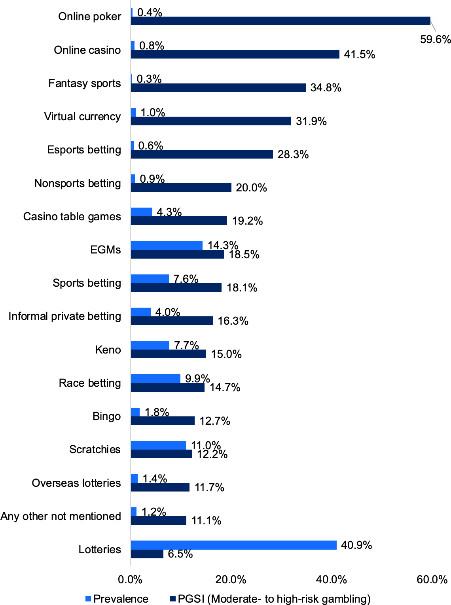

*Problem Gambling Severity Index, binarised to moderate-risk and high-risk (previously problem) compared to non-gamblers, minimal-risk (previously non-problem) and low-risk. Base: All respondents who had gambled in the last 12 months (n=5,359), with people who had not gambled classified in a separate non-gambler category.*

*Asterisks (if present) indicates a statistically significant difference: *p<.05, **p<.01, ***p<.001.*

### Problem Gambling Severity Index by weekly vs non-weekly gamblers

Moderate- to high-risk gambling is strongly associated with more regular gambling. When frequency was combined across all forms (excluding lotteries and scratchies), almost one in three (30.5%) respondents who gambled once a week or more engage in moderate- to high-risk for gambling, compared to 2.5% of those who gamble less often. This analysis was also conducted for individual forms, but for some forms, relatively few respondents gambled at-least weekly, so the analysis was conducted on an at-least monthly basis. These analyses were conducted only on some forms, excluding higher-prevalence but low-risk forms (e.g., lotteries), and low prevalence forms due to insufficient data. For all five forms analysed (EGMs, casino table games, race betting, sports betting and keno), people who gambled at-least monthly on that form were 3-4 times more likely to experience moderate- to high-risk gambling compared to those who gambled on the form less frequently. About one in three EGM gamblers and one in two casino table gamblers who engage in those forms at least once a month experience moderate- to high-risk gambling.

##### Table 12 Prevalence of moderate- to high-risk gambling by gambling frequency for specific forms

|  |  |
| --- | --- |
|  | **% moderate- to high-risk**  **gambling** |
| **NSW adults** | 4.0% |
| **Gambling frequency – all forms apart from lotteries, overseas lotteries and scratchies** | |
| Less than weekly | 2.5% |
| Weekly or more often | **30.5%\*\*\*** |
| **EGMs** | |
| Less than monthly | 9.4% |
| Monthly or more often | **35.0%\*\*\*** |
| **Casino table games** | |
| Less than monthly | 16.4% |
| Monthly or more often | **50.1%\*\*\*** |
| **Race betting** | |
| Less than monthly | 7.1% |
| Monthly or more often | **24.4%\*\*\*** |
| **Sports betting** | |
| Less than monthly | 10.4% |
| Monthly or more often | **26.5%\*\*\*** |
| **Keno** | |
| Less than monthly | 11.5% |
| Monthly or more often | **26.8%\*\*\*** |

*Problem Gambling Severity Index, binarised to moderate-risk and high-risk (previously problem) compared to non-gamblers, minimal-risk (previously non-problem) and low-risk. Base: All respondents who had gambled in the last 12 months (n=5,359), with people who had not gambled classified in a separate non-gambler category. (if present) indicates a statistically significant difference: *p<.05, **p<.01, ***p<.001.*

Table 13 presents the proportion of people who gamble at least weekly, and the prevalence of moderate- to high-risk gambling among these groups. As noted above, weekly gambling is a significant risk factor, with almost one in three individuals who do so being classified as moderate- to high-risk. While younger women (under the age of 40, 1.3%) and LOTE speakers (3.0%) are less likely than others to gamble at- least weekly, those who do are at much more likely to experience moderate- to high- risk gambling: 47.8% for women, 61.1% for LOTE speakers. People identifying as Aboriginal and/or Torres Strait Islander are both more likely to gamble at-least weekly (13.0% vs 5.0%) and are much more likely to experience moderate- to high- risk gambling if they do so (44.2% versus 29.6%). In addition, while more people in the rest of NSW gamble on at-least weekly, those in Greater Sydney who do so are at somewhat higher risk (34.1% vs 25.8%).

Overall, the groups at highest risk amongst at-least weekly gamblers were people who speak a language other than English (61.1% moderate- to high-risk amongst at- least weekly gamblers), women aged 18-39 (47.8%), Aboriginal or Torres Strait Islanders (44.2%), men aged 18-39 (37.6%) and people who do not currently have a partner (35.8%).

##### Table 13 Prevalence of moderate- to high-risk gambling by gambling frequency

|  |  |  |  |
| --- | --- | --- | --- |
|  | **Estimated**  **% of population** | **% who gamble at least weekly** | **% moderate- to**  **high-risk gambling amongst people who gamble at least weekly** |
| **NSW adults** | 100% | 5.2% | 30.5% |
| **Age by gender** | | | |
| Men 18-39 | 19.5% | **8.0%\*\*\*** | **37.6%\*\*\*** |
| Men 40+ | 29.6% | **8.3%\*\*\*** | 26.5% |
| Women 18-39 | 19.2% | 1.3% | **47.8%\*\*\*** |
| Women 40+ | 31.7% | 3.1% | 23.7% |
| **Location** | | | |
| Greater Sydney | 65.6% | 4.6% | **34.1%\*** |
| Rest of NSW | 34.4% | **6.6%\*\*\*** | 25.8% |
| **Aboriginal and/or Torres Strait Islander** | | | |
| No | 96.6% | 5.0% | 29.6% |
| Yes | 3.4% | **13.0%\*\*\*** | **44.2%\*** |
| **Main language at home** | | | |
| English only | 85.4% | **5.6%\*\*\*** | 27.9% |
| LOTE speaker | 14.6% | 3.0% | **61.1%\*\*\*** |
| **Marital status** | | | |
| Not currently married (including divorced, separated, widowed and single) | 42.2% | **5.8%\*** | **35.8%\*\*\*** |
| Married or living with a partner | 57.8% | 4.9% | 26.1% |
| **Employment status** | | | |
| Not working (including student, retired, etc) | 36.1% | 5.4% | 29.1% |
| Working (full time, part-time, casual) | 63.9% | 5.2% | 31.6% |
| **Tertiary education** | | | |
| No | 49.5% | **7.9%\*\*\*** | **31.7%\*\*\*** |
| Yes | 50.5% | 2.7% | 27.8% |
| **Children in the household** | | | |
| No | 71.1% | 5.3% | 30.2% |
| Yes | 28.9% | 5.1% | 31.4% |
| **Cohabiting with another adult (group/couple)** | | | |
| No | 25.5% | 5.6% | 31.7% |
| Yes | 74.5% | 5.2% | 30.7% |

*Problem Gambling Severity Index, binarised to moderate-risk and high-risk (previously problem) compared to non-gamblers, minimal-risk (previously non-problem) and low-risk. Base: All respondents who had gambled in the last 12 months (n=5,359), with people who had not gambled classified in a separate non-gambler category.*

*Asterisks (if present) indicates a statistically significant difference: *p<.05, **p<.01, ***p<.001. In comparing prevalence rates, multi-level rates (e.g. age by gender) are compared with the base rate (NSW adults). Binary categories (e.g. tertiary education) are compared with the alternative category.*

### Problem Gambling Severity Index by engagement with online gambling

Section 5.4 has shown the proportion of people engaged in moderate- to high-risk gambling for online-only forms (e.g., overseas lotteries, online poker, online casinos). Importantly, Section 5.4 compares those who engage in that form vs anyone who does not. However, the table below compares those who engage in that form online compared to those who engage in the form but not online.

As shown in Table 14, 9.2% of participants who gambled online were moderate- to high-risk gambling. This figure is significantly higher compared to those who did not gamble online (2.1%). People who engaged in keno online (versus offline) were significantly more likely to be at higher risk. Amongst other forms (sports, race, esports and lottery gambling), no significant differences were found amongst those who gamble online and those who do not.

##### Table 14 Prevalence of people engaged in moderate to high-risk gambling by online gambling status

|  |  |
| --- | --- |
|  | **% moderate- to high-**  **risk gambling** |
| **NSW adults** | 4.0% |
| **Online gambling, any form** | |
| Not online | 2.1% |
| Online | **9.2%\*\*\*** |
| **Online race betting (amongst those who bet on races, n=1,007)** | |
| No | 12.6% |
| Yes | 15.9% |
| **Online sports betting (amongst those who bet on sports, n=825)** | |
| No | 25.2% |
| Yes | 17.2% |
| **Online esports betting (amongst those who bet on esports, n=78)** | |
| No (note: 10 respondents) | 28.1% |
| Yes | 28.3% |
| **Online keno (amongst those who engage in keno, n=771)** | |
| No | 14.4% |
| Yes (note: 20 respondents) | **36.5%\*\*** |
| **Online lottery tickets (not overseas, amongst those who buy lottery tickets, n=4,024)** | |
| No | 6.2% |
| Yes | 6.8% |

*Problem Gambling Severity Index, binarised to moderate-risk and high-risk (previously problem) compared to non-gamblers, minimal-risk (previously non-problem) and low-risk. Base: All respondents who had gambled in the last 12 months (n=5,359), with people who had not gambled classified in a separate non-gambler category.*

*Asterisks (if present) indicates a statistically significant difference: *p<.05, **p<.01, ***p<.001.*

### Lifetime gambling problems

Lifetime gambling problems was assessed via a single question, “Now thinking about your life prior to the last 12 months, have you ever experienced problems with your gambling?”. The limitations to this probe are that it is not a validated screen, it depends on the person recognising and admitting they have experienced problems, and it is a retrospective report that can be affected by how recent the event was and the fallibility of memory.

With these caveats, 3.4% of NSW residents indicated that they had experienced gambling problems at some point in their lifetime. Demographic differences in positive responses are shown in Figure 22 and Table 15. Lifetime self-reported gambling problems were higher among men (4.8%) than women (2.2%). Positive responses tended to be higher among respondents aged 45-54 but was highest for men aged 25-34. In contrast, women were most likely to report lifetime gambling problems in the 55 to 64 age category. Lifetime problems were also slightly higher amongst those who had not completed a tertiary education, those who speak English at home (rather than LOTE), and people identifying as Aboriginal and/or Torres Strait Islander.

##### Figure 22 Lifetime gambling problems by age and gender

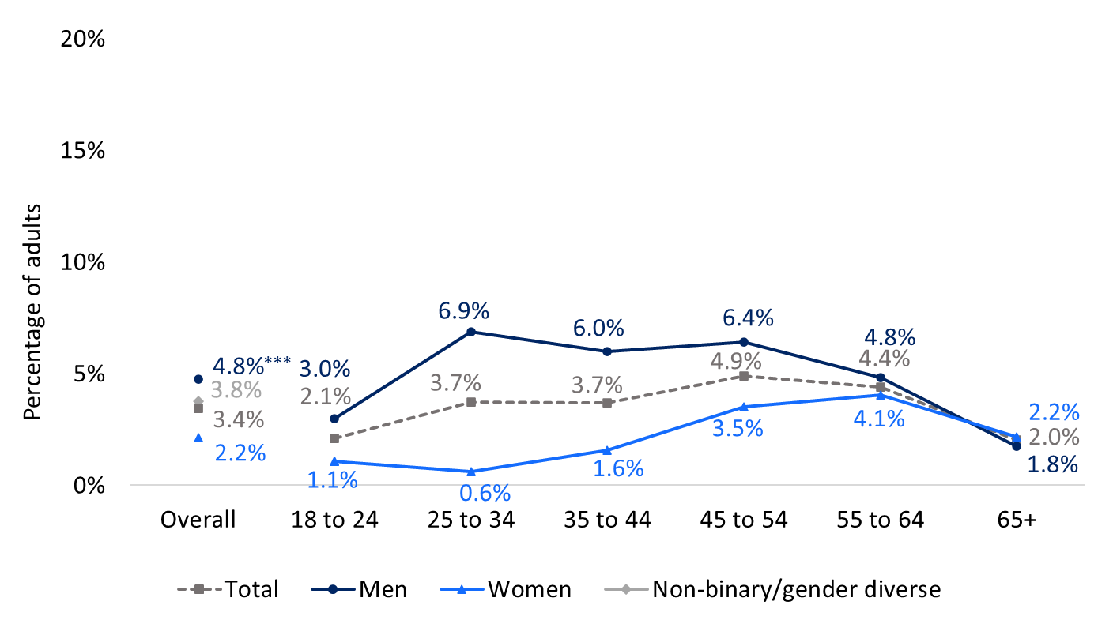

*“Now thinking about your life prior to the last 12 months, have you ever experienced problems with your gambling?”. Base: All respondents (N = 10,000). Asterisks (if present) indicate a statistically significant difference:*

*\*p<.05, **p<.01, ***p<.001.*

##### Table 15 Self-reported lifetime gambling problems by demographics

|  |  |
| --- | --- |
|  | **% Yes** |
| **NSW adults** | 3.4% |
| **Location** | |
| Greater Sydney | 3.1% |
| Rest of NSW | 4.1% |
| **Aboriginal and/or Torres Strait Islander** | |
| No | 3.3% |
| Yes | **8.2%\*\*** |
| **Main language at home** | |
| English only | **3.7%\*** |
| LOTE speaker | 2.0% |
| **Marital status** | |
| Not currently married (including divorced, separated, widowed and single) | 3.9% |
| Married or living with a partner | 3.1% |
| **Employment status** | |
| Not working (including student, retired, etc) | 2.9% |
| Working (full time, part-time, casual) | 3.7% |
| **Tertiary education** | |
| No | **4.7%\*\*\*** |
| Yes | 2.2% |
| **Personal income, per year** | |
| Nil or negative income | 1.7% |
| $30,000 or less | 2.4% |
| $30,000 - $49,999 | 5.0% |
| $50,000 - $69,999 | 3.2% |
| $70,000 - $99,999 | 3.4% |
| $100,000 - $149,999 | 4.0% |
| $150,000 or more | 4.3% |
| **Children in the household** | |
| No | 3.1% |
| Yes | 4.2% |
| **Cohabiting with another adult (group/couple)** | |
| No | 3.9% |
| Yes | 3.3% |

*“Now thinking about your life prior to the last 12 months, have you ever experienced problems with your gambling?”. Base: All respondents (N = 10,000). Asterisks (if present) indicate a statistically significant difference:*

*\*p<.05, **p<.01, ***p<.001.*

# Chapter 6: Gambling harm

This chapter measured three elements of gambling harm: harm to self from a person’s own gambling (GHS-10), harm experienced by people due to the gambling of others (GHS-10-AO), and legacy harm (single bespoke item).

##### Harm from own gambling

* 7.8% of NSW residents (14.5% of gamblers) reported at least one harm from gambling in the last 12 months.
* The most common harms included emotional impacts (feelings of regret, shame, distress) and financial impacts (reduction of savings, spending money and less spending on other recreational activities). Severe indicators of social dysfunction (e.g., violence, illegal activity) were relatively rare, reported by <1% of NSW residents.
* Total harm to NSW gamblers from their own gambling was measured in

terms of health utility and Years Lived with a Disability (YLD): totalling 105,515 YLD.

* Those who gambled regularly, or who gambled with higher amounts,

experienced disproportionately more harm. The 10% of gamblers who gambled more than once a week accounted for around 33% of harm. Similarly, 40% of gamblers spend more than $300 per annum, but accounted for 75% of total harm (in YLD).

* Younger men (<45 years) accounted for about half the total impact (50,548 YLD). Other population segments that incurred a disproportionate burden of harm include those identifying as Aboriginal and/or Torres Strait Islanders, LOTE speakers, those not in a relationship, those without tertiary education and those living alone.

##### Harm to affected others

* 12.7% reported at least one harm from another person’s gambling.
* A total of 158,877 YLD was incurred to affected others, which is about 1.5x the total for impacts to gamblers (105,515 YLD).
* Harm to affected others was more evenly spread across age and gender, although women generally tend to incur more harm than men.

##### Legacy harm

* 7.1% of NSW residents reported experiencing legacy impacts of gambling, with those identifying as Aboriginal and/or Torres Strait Islander being disproportionately affected.

##### Total harm

* Altogether, one in five NSW residents (21.0%) reported at least one harm from either their own gambling, another’s gambling, or legacy harm from gambling prior to the last 12 months.

The survey measured harm to gamblers using the 10-item Gambling Harms Scale (GHS-10), and harm to affected others using the companion scale, the 10-item Gambling Harms Scale for Affected Others (GHS-10-AO). These scales include specific *indicators or symptoms* of gambling harm, such as “having sold personal items” that the respondent asserts to have occurred as a result of their gambling. However, harm itself is conceptualised as an impact to an individual’s global health- related quality of life (HRQoL). In health economics and public health, this per- person impact or harm is measured on a zero to one scale, with zero reflecting no impact, and one reflecting an impact that makes life not worth living. Both the GHS- 10 and GHS-10-AO can be scored on this metric to yield a per-person measure of harm. Since the question frame is over the last 12 months, these individual HRQoL decrements can be summed over population segments, to yield a total impact borne by that group. These measures capture impacts from past-year gambling, rather than legacy impacts (assessed in a separate question). These values are described as Years Lived with Disability (YLD) due to gambling harm. Note that the term “disability” is standard in public health to describe morbidity impacts, in contrast to any increased risk of mortality caused by the condition.

The survey included a single item validation check of life satisfaction to confirm that non-zero harm scores were associated with lower quality of life in this sample. GHS- 10 raw scores of 1 (versus 0) were associated with a significantly lower life satisfaction score, *B* = -0.34, *p* < 0.001, as was 2 (versus 0) *B* = -64, *p* < 0.001, as well as 3+ scores *B* = -1.26, *p* < 0.001. These significant decrements for all non-zero scores on both measures supports the view that full spectrum of harm and problems should be taken into consideration when assessing the health impacts of gambling.

### Indicators of harm to gamblers

Among gamblers, 14.5% reported at least one indicator of harm on the GHS-10 (7.8% of all NSW residents). As well as the items comprising the GHS-10, the survey included the 19 specific harms included in the 2019 survey. To reduce the burden on participants, these questions were only asked of individuals who had answered positively to at least one item in the GHS-10. A small downward bias on estimated prevalence of these additional harms may be present because some participants were not asked these questions.

The prevalence of all specific harms to gamblers is given in Table 16. Financial and emotional harms are the most reported, followed by issues with relationships and fulfilling responsibilities, as well as physical health-related impacts. Work/study impacts and social dysfunction (e.g. violence, illegal activities) are reported much less often. Both within and across domains of harm, there is a prevalence/severity spectrum, with less severe impacts being reported more often, and more severe impacts reported less often.

##### Table 16 Prevalence of gambling harm indicators among gamblers

|  |  |
| --- | --- |
|  | **% Yes** |
| **Emotional** | |
| Had regrets that made me feel sorry about my gambling* | 6.5% |
| Felt ashamed of my gambling* | 3.4% |
| Felt distressed about my gambling* | 3.0% |
| Felt like a failure* | 2.7% |
| Feeling depressed | 1.8% |
| Feelings of hopelessness about gambling | 1.4% |
| **Financial** | |
| Reduction of my savings* | 7.1% |
| Reduction of my available spending money* | 6.7% |
| Less spending on recreational expenses such as eating out, going to movies or other entertainment* | 5.4% |
| Late payments on bills (for example electricity bills, rent) | 1.5% |
| Running out of money for food or other important items | 1.2% |
| Sold personal items* | 1.0% |
| Increased credit card debt* | 0.9% |
| Bankruptcy | 0.2% |
| Losing or selling your house, business or other significant assets | 0.2% |
| **Health** | |
| Loss of sleep | 1.6% |
| Serious thoughts about or attempted suicide. | 0.3% |
| Deliberately hurting yourself | 0.2% |
| **Relationships** | |
| Spent less time with people I care about* | 2.6% |
| Greater conflict in my relationships (for example arguing, fighting) | 1.5% |
| Neglect of my relationship responsibilities (for example spending less time with my family) | 1.5% |
| **Social** | |
| Feeling that I had shamed my family within my religious or cultural community | 0.8% |
| Experiencing violence from others, including family | 0.5% |
| Being violent toward others, including family | 0.3% |
| Leaving children unsupervised | 0.1% |
| Doing something illegal to fund gambling or pay debts | 0.1% |
| **Work/study** | |
| Using my work or study resources (for example time or money to gamble) | 0.7% |
| Missing work or study | 0.6% |
| Losing my job | 0.2% |

*\* Gambling Harms Scale – 10 items. Base: All subsampled respondents who had gambled in the last 12 months (n=3,300).*

The GHS-10 scores (0 to 10) were converted to health utility scores (HRQoL YLD2). Based on health utility scores, a total of 105,515 YLD were incurred to NSW gamblers due to their own gambling in the last 12 months. As shown in Table 17, about one in ten NSW residents who gamble does so weekly or more often. On an individual level, these individuals experience gambling harm at about four times the rate of those who gamble less than weekly. However, because they are much less prevalent that less-than-weekly gamblers, they account for about one-third of the total burden of harm (HRQoL YLD).

##### Table 17 Burden of gambling harm by gambling frequency

|  |  |  |  |  |
| --- | --- | --- | --- | --- |
|  | **NSW pop'n** | **HRQoL YLD** | **Pop'n %** | **HRQoL YLD %** |
| **Gambling frequency** | | | | |
| Less than weekly | 3,207,600 | 73,283 | 90.2% | 69.5% |
| Weekly or more# | 349,133 | 32,232 | 9.8% | **30.5%\*\*\*** |

*#Excluding lotteries, overseas lotteries and scratchies. These represent a test of proportions comparing population prevalence and the proportional YLD burden attributable to that segment. Base: All subsampled respondents who had gambled in the last 12 months (n=3,300). Asterisks (if present) indicate a statistically significant difference: *p<.05, **p<.01, ***p<.001.*

Table 18 breaks down the burden of gambling harm by self-reported gambling spend. Those spending over $300 per annum make up about 40% of the gambling population but account for about three-quarters (73.2%) of total impact on YLD.

##### Table 18 Burden of gambling harm by spend

|  |  |  |  |  |
| --- | --- | --- | --- | --- |
| **Spend (per annum)** | **Pop'n** | **HRQoL YLD** | **Pop'n %** | **HRQoL YLD %** |
| Not reported | 115,254 | 4,647 | 3.2% | 4.4% |
| $1-$100 | 1,290,926 | 10,834 | 36.3% | 10.3% |
| $101-$300 | 747,478 | 12,804 | 21.0% | 12.1% |
| $301-$1,200 | 862,887 | 28,297 | 24.3% | 26.8% |
| $1,201+ | 540,189 | 48,934 | 15.2% | 46.4% |

*Base: All subsampled respondents who had gambled in the last 12 months (n=3,300).*

Figure 23 shows the burden of harm to individuals from their own gambling by age and gender. Harm is disproportionately concentrated in men aged under 45, and the segment that bears the largest burden is men aged between 25 to 34 years old.

2 For a full description of how these values are calculated, please see section 2.4 of Browne et al. (2022). *The Gambling Harms Scales: Instruments to assess impacts to gamblers and affected others that are benchmarked to health utility.* Victorian Responsible Gambling Foundation.

##### Figure 23 Burden of gambling harm to gamblers by age and gender

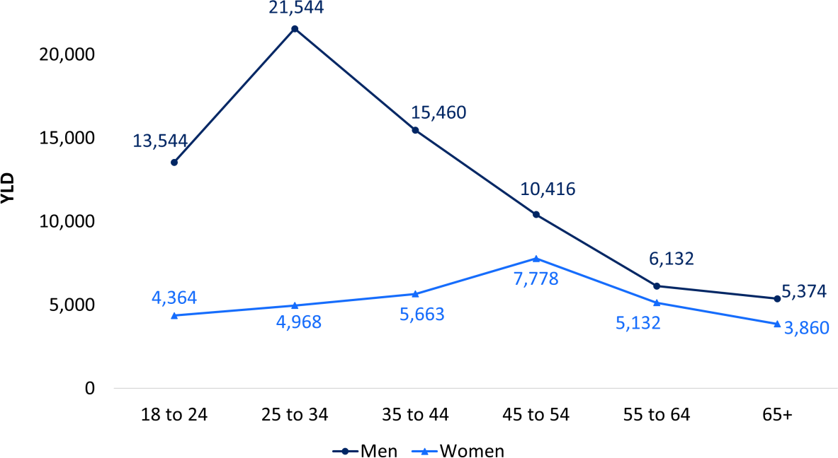

*Note: Total YLD illustrated (104,175 YLD) is slightly smaller than grand total (105,515 YLD) due to further 1,340 YLD attributable to gender-diverse individuals. * Gambling Harms Scale – 10 items. Base: All subsampled respondents who had gambled in the last 12 months (n=3,300).*

Table 19 below compares the prevalence of NSW demographic segments with the burden of gambling harm attributable to each segment. Impacts to residents of the Greater Sydney and the rest of NSW are proportional to their relative populations. There are also not large differences across income categories, or between households with and without children. Population segments that bear a disproportionate burden of harm include people who identify as Aboriginal and/ Torres Strait Islander, LOTE speakers, those not currently in a married or de facto relationship, those without tertiary education, and those living alone. Additionally, people who are employed bear a slightly higher burden than others (e.g. students, retirees).

##### Table 19 Burden of gambling harm to gamblers by demographics

|  |  |  |  |  |
| --- | --- | --- | --- | --- |
|  | **NSW pop'n** | **HRQoL YLD** | **Pop'n %** | **HRQoL YLD %** |
| **Location** | | | | |
| Greater Sydney | 4,360,700 | 69,246 | 65.6% | 65.6%* |
| Rest of NSW | 2,289,200 | 36,269 | 34.4% | 34.4%* |
| **Aboriginal and/or Torres Strait Islander** | | | | |
| No | 6,372,365 | 96,024 | 96.6% | 91.8% |
| Yes | 218,614 | 8,616 | 3.4% | **8.2%\*\*\*** |
| **Main language at home** | | | | |
| English only | 5,661,896 | 87,962 | 85.4% | 83.6% |
| LOTE speaker | 964,209 | 17,241 | 14.6% | **16.4%\*\*\*** |
| **Marital status** | | | | |
| Not currently married (including divorced, separated, widowed and single) | 2,753,281 | 57,343 | 42.2% | **55.2%\*\*\*** |
| Married or living with a partner | 3,776,825 | 46,608 | 57.8% | 44.8% |
| **Employment status** | | | | |
| Not working (including student, retired, etc) | 2,373,959 | 31,826 | 36.1% | 30.4% |
| Working (full time, part-time, casual) | 4,205,023 | 72,970 | 63.9% | **69.6%\*\*\*** |
| **Tertiary education** | | | | |
| No | 3,246,595 | 68,271 | 49.5% | **65.3%\*\*\*** |
| Yes | 3,307,406 | 36,200 | 50.5% | 34.7% |
| **Personal income, per year+** | | | | |
| Nil or negative income | 136,139 | 1,578 | 2.0% | 1.5% |
| $30,000 or less | 784,996 | 13,338 | 11.8% | 12.6% |
| $30,000 - $49,999 | 645,888 | 10,584 | 9.7% | 10.0% |
| $50,000 - $69,999 | 695,822 | 14,314 | 10.5% | 13.6% |
| $70,000 - $99,999 | 923,826 | 16,596 | 13.9% | 15.7% |
| $100,000 - $149,999 | 943,380 | 15,426 | 14.2% | 14.6% |
| $150,000 or more | 867,586 | 15,551 | 13.0% | 14.7% |
| **Children in the household** | | | | |
| No | 4,730,018 | 74,248 | 71.1% | 70.4% |
| Yes | 1,919,882 | 31,267 | 28.9% | 29.6% |
| **Cohabiting with another adult (group/couple)** | | | | |
| No | 1,639,346 | 29,497 | 25.5% | **28.6%\*\*\*** |
| Yes | 4,799,945 | 73,667 | 74.5% | 71.4% |

*Note: + Income breakdown excludes a substantial number of respondents who preferred not to disclose. YLD are rounded to integer values and each category breakdown excludes individuals who did not know or prefer not to say therefore totals will not add to exactly 100%. Asterisks (if present) indicate a statistically significant difference:*

*\*p<.05, **p<.01, ***p<.001. These represent a test of proportions comparing population prevalence and the proportional YLD burden attributable to that segment. Except for location, population prevalences are derived from the random sample rather than population weighting and may therefore not match census figures. Base: All subsampled respondents who had gambled in the last 12 months (n=3,300). It happens to be the case that the HRQoL proportion matches the Sydney / regional population proportions to 1 decimal place.*

### Harms to affected others overall, and by age, gender, location and other demographics

Among NSW residents, 12.7% reported at least one indicator of harm from another person’s gambling. The indicators used, along with their prevalence among NSW residents are presented in Table 20, and comprise the items from the GHS-10-AO measure of gambling harm to affected others. Those scoring 1-2 on the raw scale reported significantly lower life satisfaction than those scoring 0, *B* = -0.46, *p* <0.001, as did those scoring 3+, *B* = -0.87, *p* <0.001, supporting the HRQoL scoring of the instrument validated in prior research (Browne, Newall, et al., 2023).

The most prevalent impacts reported were getting less enjoyment from time spent with people they care about, anger about people not controlling their own gambling, and feelings of hopelessness. The least common and most severe impact was needing to take money or items from friends or family as a result of the other person’s gambling. Overall, harm to affected others follows the same pattern as with gamblers, with less severe impacts being more prevalent, and more severe impacts being less prevalent.

##### Table 20 Prevalence of gambling harm indicators due to another’s gambling

|  |  |
| --- | --- |
|  | **% Yes** |
| **Emotional** | |
| Felt angry about not controlling their gambling | 7.2% |
| Feelings of hopelessness about their gambling | 6.6% |
| **Financial** | |
| Late payments on bills | 4.0% |
| **Health** | |
| Loss of sleep due to stress or worry about their gambling or gambling-related problems | 5.3% |
| Increased experience of depression | 3.8% |
| Stress related health problems | 3.4% |
| **Relationships** | |
| Got less enjoyment from time spent with people I care about | 7.4% |
| Threat of separation or ending a relationship/s | 3.8% |
| **Social dysfunction** | |
| Took money or items from friends or family without asking first | 2.1% |
| **Work/Study** | |
| Reduced performance at work or study | 3.2% |

*\* Gambling Harms Scale – 10 – AO items. Base: All subsampled respondents (n=4,374).*

A total of 158,877 YLD were incurred by NSW residents due to impacts of gambling to affected others, which is about 1.5x the total for impacts to gamblers (105,515 YLD). Figure 24 shows the distribution of the burden of gambling harm to affected others, in terms of YLD impacts from gambling, broken down by age and gender. In contrast to impacts to individuals from their own gambling, it is more evenly distributed between genders and across age categories. Nevertheless, women tend to bear more of the burden than men for most age categories. Impacts are greatest for both men and women at ages 25 to 34.

##### Figure 24 Burden of gambling harm to affected others by age and gender

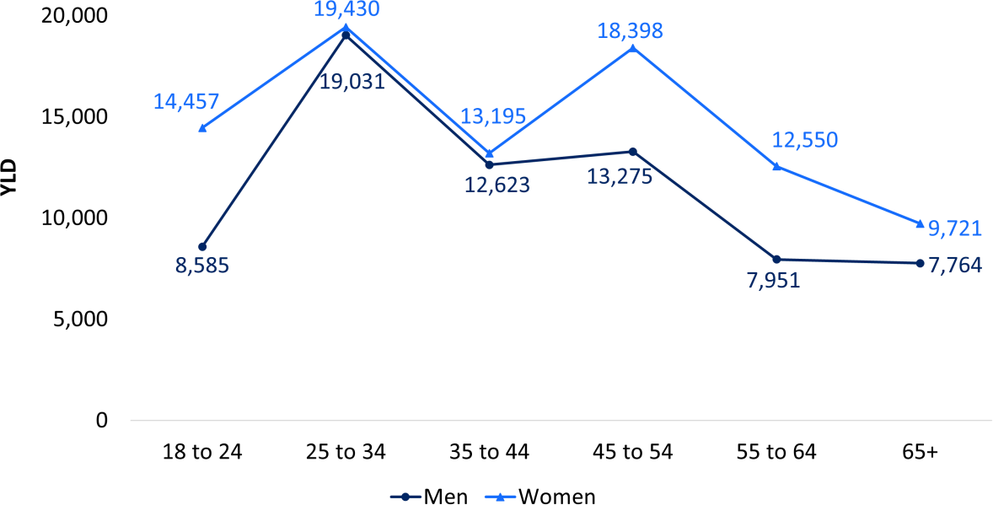

*“In the past 12 months have you had a close relationship with someone who has gambled?”. Base: All subsampled respondents (n=4,374).*

Table 21 shows the burden of harm to affected others for different demographic segments and compares the proportion of the NSW population to the proportion of the burden. A disproportionate burden is borne by NSW residents identifying as Aboriginal and/or Torres Strait Islander, English speakers, those not currently married or living with a partner, in employment, without a tertiary education, and with children in the household. Of these differential impacts, the largest in magnitude (in YLD terms compared to population prevalence) is between those with and without a tertiary education. Note that differences for employment status and children in the household may be surrogates for age (life-stage) effects.

##### Table 21 Burden of gambling harm for affected others by demographics

|  |  |  |  |  |
| --- | --- | --- | --- | --- |
|  | **NSW pop'n** | **HRQoL YLD** | **Pop'n %** | **HRQoL YLD %** |
| **Location** | | | | |
| Greater Sydney | 4,360,700 | 102,638 | 65.6% | 64.6% |
| Rest of NSW | 2,289,200 | 56,239 | 34.4% | 35.40 |
| **Aboriginal and/or Torres Strait Islander** | | | | |
| No | 6,372,365 | 143,341 | 96.6% | 91.4% |
| Yes | 218,614 | 13,435 | 3.4% | **8.6%\*\*\*** |
| **Main language at home** | | | | |
| English only | 5,661,896 | 140,033 | 85.4% | **88.2%\*\*\*** |
| LOTE speaker | 964,209 | 18,790 | 14.6% | 11.8% |
| **Marital status** | | | | |
| Not currently married (including divorced, separated, widowed and single) | 2,753,281 | 71,207 | 42.2% | **45.4%\*\*\*** |
| Married or living with a partner | 3,776,825 | 85,447 | 57.8% | 54.5% |
| **Employment status** | | | | |
| Not working (including student, retired, etc) | 2,373,959 | 39,441 | 36.1% | 24.8% |
| Working (full time, part-time, casual) | 4,205,023 | 119,337 | 63.9% | **75.2%\*\*\*** |
| **Tertiary education** | | | | |
| No | 3,307,406 | 92,852 | 49.5% | **58.5%\*\*\*** |
| Yes | 3,246,595 | 65,832 | 50.5% | 41.5% |
| **Personal income, per year+** | | | | |
| Nil or negative income | 136,139 | 1,440 | 2.0% | 0.9% |
| $30,000 or less | 784,996 | 18,936 | 11.8% | 11.9% |
| $30,000 - $49,999 | 645,888 | 22,087 | 9.7% | 13.9% |
| $50,000 - $69,999 | 695,822 | 17,839 | 10.5% | 11.2% |
| $70,000 - $99,999 | 923,826 | 28,496 | 13.9% | 17.9% |
| $100,000 - $149,999 | 943,380 | 24,393 | 14.2% | 15.4% |
| $150,000 or more | 867,586 | 16,954 | 13.0% | 10.7% |
| **Children in the household** | | | | |
| No | 4,730,018 | 105,870 | 71.1% | 66.6% |
| Yes | 1,919,882 | 53,007 | 28.9% | **33.4%\*\*\*** |
| **Cohabiting with another adult (group/couple)** | | | | |
| No | 1,639,346 | 38,113 | 25.5% | 24.9% |
| Yes | 4,799,945 | 114,786 | 74.5% | 75.1% |

*Note: + Income figures exclude a substantial number of respondents who preferred not to disclose. YLD are rounded to integer values and each category breakdown excludes individuals who did not know or prefer not to say therefore totals will not add to exactly 100%. Asterisks (if present) indicate a statistically significant difference:*

*\*p<.05, **p<.01, ***p<.001. These represent a test of proportions comparing population prevalence and the proportional YLD burden attributable to that segment. Except for location, population prevalences are derived from the random sample rather than population weighting and may therefore not match census figures. Base: All subsampled respondents (n = 4,374).*

### Legacy harm

Participants were asked if they were “currently feeling impacts from gambling that happened more than 12 months ago”. Overall, 7.1% of NSW residents currently experience legacy impacts of gambling. Figure 25 and Table 22 summarise demographic differences in the occurrence of legacy harms from gambling. Women were slightly more likely (7.8%) than men (6.3%) to report legacy harm. Positive responses were highest in the 35-44 age bracket, with similar patterns for men and women with respect to age, except for the youngest age bracket and those aged 45- 54, where women reported more legacy impact. NSW residents identifying as Aboriginal and/or Torres Strait Islander were significantly more likely (11.2%) to report legacy harm compared to others (6.9%). Those not living with other adults (8.6%) were also more likely to report legacy harm compared to those living with one or more adults (6.6%).

##### Figure 25 Legacy harm by age and gender

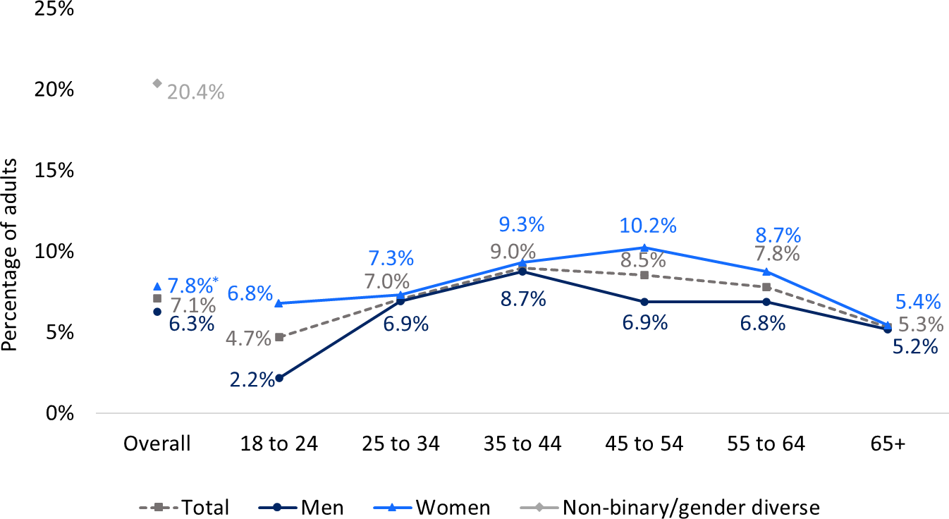

*“Are you currently feeling impacts from gambling that happened more than 12 months ago?”. Base: All subsampled respondents (n=4,374). Asterisks (if present) indicate a statistically significant difference: *p<.05,*

*\*\*p<.01, ***p<.001.*

##### Table 22 Legacy gambling harms by demographics

|  |  |
| --- | --- |
|  | **% Legacy harms** |
| **NSW adults** | 7.1% |
| **Location** | |
| Greater Sydney | 7.1% |
| Rest of NSW | 7.0% |
| **Aboriginal and/or Torres Strait Islander** | |
| No | 6.9% |
| Yes | **11.2%\*** |
| **Main language at home** | |
| English only | 7.2% |
| LOTE speaker | 6.6% |
| **Marital status** | |
| Not currently married (including divorced, separated, widowed and single) | 7.1% |
| Married or living with a partner | 7.1% |
| **Employment status** | |
| Not working (including student, retired, etc) | 6.8% |
| Working (full time, part-time, casual) | 7.2% |
| **Tertiary education** | |
| No | 7.2% |
| Yes | 6.9% |
| **Personal income, per year** | |
| Nil or negative income | 2.5% |
| $30,000 or less | 8.8% |
| $30,000 - $49,999 | 7.6% |
| $50,000 - $69,999 | 8.2% |
| $70,000 - $99,999 | 8.7% |
| $100,000 - $149,999 | 8.3% |
| $150,000 or more | 5.3% |
| **Children in the household** | |
| No | 7.0% |
| Yes | 7.2% |
| **Cohabiting with another adult** | |
| No | **8.6%\*** |
| Yes | 6.6% |

*Problem Gambling Severity Index, binarised to moderate-risk and high-risk (previously problem) compared to non-gamblers, minimal-risk (previously non-problem) and low-risk. Base: All subsampled respondents (n=4,374). Asterisks (if present) indicates a statistically significant difference: *p<.05, **p<.01, ***p<.001.*

### Harm from all sources

As outlined in the above sections, participants could report harm from gambling from a variety of sources: their own ongoing gambling (GHS-10), another’s gambling (GHS-10-A0), or legacy impacts from gambling (either their own or others) that occurred prior to the last 12 months (single item). Figure 26 shows the prevalence of any degree of reported harm from any of these sources. Individuals could report impact from multiple sources, so the combined prevalence is generally lower than the sum of the sources. Most respondents reporting legacy harm also report harm from ongoing gambling. Thus, 18.3% of NSW residents report one or more harms from either their own or someone else’s gambling and about one in five (21.0%) overall reported currently experiencing some form of negative impact, including from gambling that ceased more than 12 months ago.

At first glance, this may seem like a very high figure compared to previous gambling problem prevalence estimates, such as ~1.0% of the population engaging in high- risk gambling (previously problem gambling). However, in this survey, the PGSI categorised 10.7% of people as experiencing low-risk, moderate-risk or high-risk gambling, compared to 7.8% detected by the GHS-10. In this survey, both those classified as low-risk gambling and those scoring 1 on the GHS-10 report elevated spend and lower life-satisfaction compared to minimal-risk or unharmed gamblers. The additional harm captured below comes from the inclusion of affected others, which is not captured by the PGSI, as well as legacy harms from prior gambling, which is not captured by either the PGSI or the GHS-10 or GHS-10-AO. Therefore, this figure of 21.0% is a more comprehensive and complete measure of the proportion of NSW adults being impacted by gambling in the last 12 months than the prevalence rate of high-risk gambling (previously known as problem gambling).

##### Figure 26 Prevalence of harm from all sources: own gambling, others’ gambling and legacy harm

*The GHS-10 and GHS-10-AO measure harm from ongoing gambling (last 12 months) as a result of one’s own gambling or (GHS-10) or someone else’s gambling (GHS-10-A0). The percentages reported describe any positive response to each of the 10-item scales. Legacy harm was captured from responses to a single item: “Are you currently feeling impacts from gambling that happened more than 12 months ago?”. Base: All subsampled respondents (n=4,374).*

### Changes in harm between 2019 and 2024

Comparisons of specific gambling harms between 2019 and 2024 provide limited evidence of change. The two harm items asked consistently in both surveys showed no statistically significant change: "Distress about my gambling" slightly increased from 2.7% to 3.1%, while "Increased credit card debt" slightly decreased from 1.0% to 0.9%. These minimal changes align with the stability observed in PGSI rates. For a detailed comparison of all harm items asked in both surveys and important caveats regarding interpretation, readers are directed to Appendix A.4.

# Chapter 7: Which forms and demographic segments are associated with problems and harm

* + - EGMs were responsible for more than half of all harm to gamblers (57,832 YLD), followed by wagering products (including horse racing and sports betting) and casino games.
    - Lotteries, keno and bingo had no statistically detectable harm to gamblers.
    - There are intersecting effects of age, gender and education that result in an unequal distribution of harm in the community:
      * Younger men (<40) without a tertiary degree (N = 672,376) incurred the most harm from their own gambling (27,583 YLD).
      * Older women with a tertiary degree (N = 1,095,924) incurred the

least harm from their own gambling (6,920 YLD).

* + - * Younger women without a tertiary degree (N = 574,302) incurred the most harm from someone else’s gambling (26,706 YLD).
      * Older men with a tertiary degree (N = 872,060) incurred the least harm from someone else’s gambling (13,586 YLD).
    - Gambling harm and PGSI score are highly correlated (*r* = .73). Both

measures are correlated with lower life satisfaction (both *r* = -.24).

* + - About nine in ten people experiencing high-risk gambling (previously problem gambling) reported 1 or more harms, as compared to only 6.0% of those experiencing minimal-risk (previously non-problem) gambling.
    - People experiencing any degree of problems (PGSI 1+) or harm (GHS-10 1+) report lower levels of life satisfaction. These effects are independent and additive.
      * Those experiencing minimal-risk gambling (previously non-problem) with 1+ harms reported a significantly lower life satisfaction (7.8/10) than their unharmed counterparts (8.3).
      * The lowest life satisfaction was reported by those at high-risk who were also reporting harm (6.4).
    - Based on self-reports, those experiencing minimal-risk gambling spent an average of $309 per annum on gambling, as compared to $13,906 for those experiencing high-risk gambling.
      * Those at minimal-risk accounted for just 13.7% of gambling losses, with the balance (86.3%) derived from those at low-risk, moderate- risk and high-risk.
      * In contrast, harmed gamblers (GHS-10 1+) account for only 24.6% of gambling losses. This suggest that many people experiencing harm do not have the financial capacity to absorb unexpected expenses, and that the ‘excessive’ spending that is creating harm may be relatively small amounts in absolute monetary terms.

### Which gambling forms contribute the most to gambling problems and harm?

Both gambling problems and harm stem from excessive time and money spent on gambling. Since this gambling necessarily is done on some specific form, it is possible to use multiple regression and dominance analysis to attribute impact to specific forms. Although many gamblers participate in multiple forms, multivariate analysis allows us to parse out the influence of specific forms in causing problems and harm. The dominance analysis approach partials out the total variance in the weighted data, which means that it captures population-level impact that incorporates both severity and prevalence (Browne, Delfabbro, et al., 2023).

Figure 27 illustrates the proportion of total population impact associated with each form. In the case of the GHS-10 coded using HRQoL weights, this corresponds to the proportion of the total YLD attributable to that form. The results are very consistent for harms and problems in 2024, and broadly similar for problems between 2019 and 2024. Using PGSI score as an index, which was measured at both time points, the biggest change since 2014 was for casino table games. While 15.4% of variation in PGSI score could be attributed to this form in 2019, it accounted for only 6.6% in 2024.

EGMs are responsible for more than half of harm to gamblers (57,832 YLD), followed by wagering products (including horse racing and sports betting) and casino games. Although graphed for completeness, no statistically detectable impact was found for lotteries, keno and bingo.

##### Figure 27 Proportion of gambling harm and PGSI scores attributable to each form

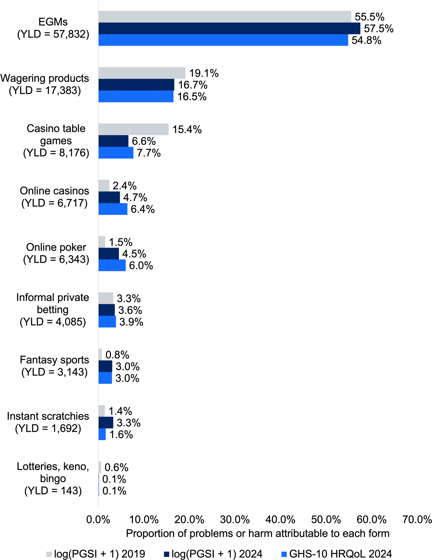

*Base: All respondents who had gambled in the last 12 months (n=5,370) for PGSI and all subsampled respondents who had gambled in the last 12 months (n=3,300) for GHS-10. Scores of 0 inferred for non- gamblers.*

### Which demographic segments experience the most gambling problems and harm

Figure 28 shows the relative importance of each demographic in accounting for gambling harm or PGSI score in a multiple regression model. As in the case of the analysis reported above, the measure of importance incorporates both prevalence of the segment, and the differential risk experienced by individuals in that segment.

Age and gender are the most important risk factors, with men and younger people more likely to be impacted. These are followed by marital status, with married people being less likely to experience impact than those who are widowed, single or separated/divorced. Those with tertiary education (bachelor’s degree or above) are much less likely to experience harm and tend to have lower PGSI scores. Although they gamble less than those employed, unemployed respondents reported more gambling harm and had higher PGSI scores than others, whilst pensioners, retirees and those working part time also reported higher rates of harm.

##### Figure 28 Proportion of gambling harm and PGSI scores attributable to each demographic variable

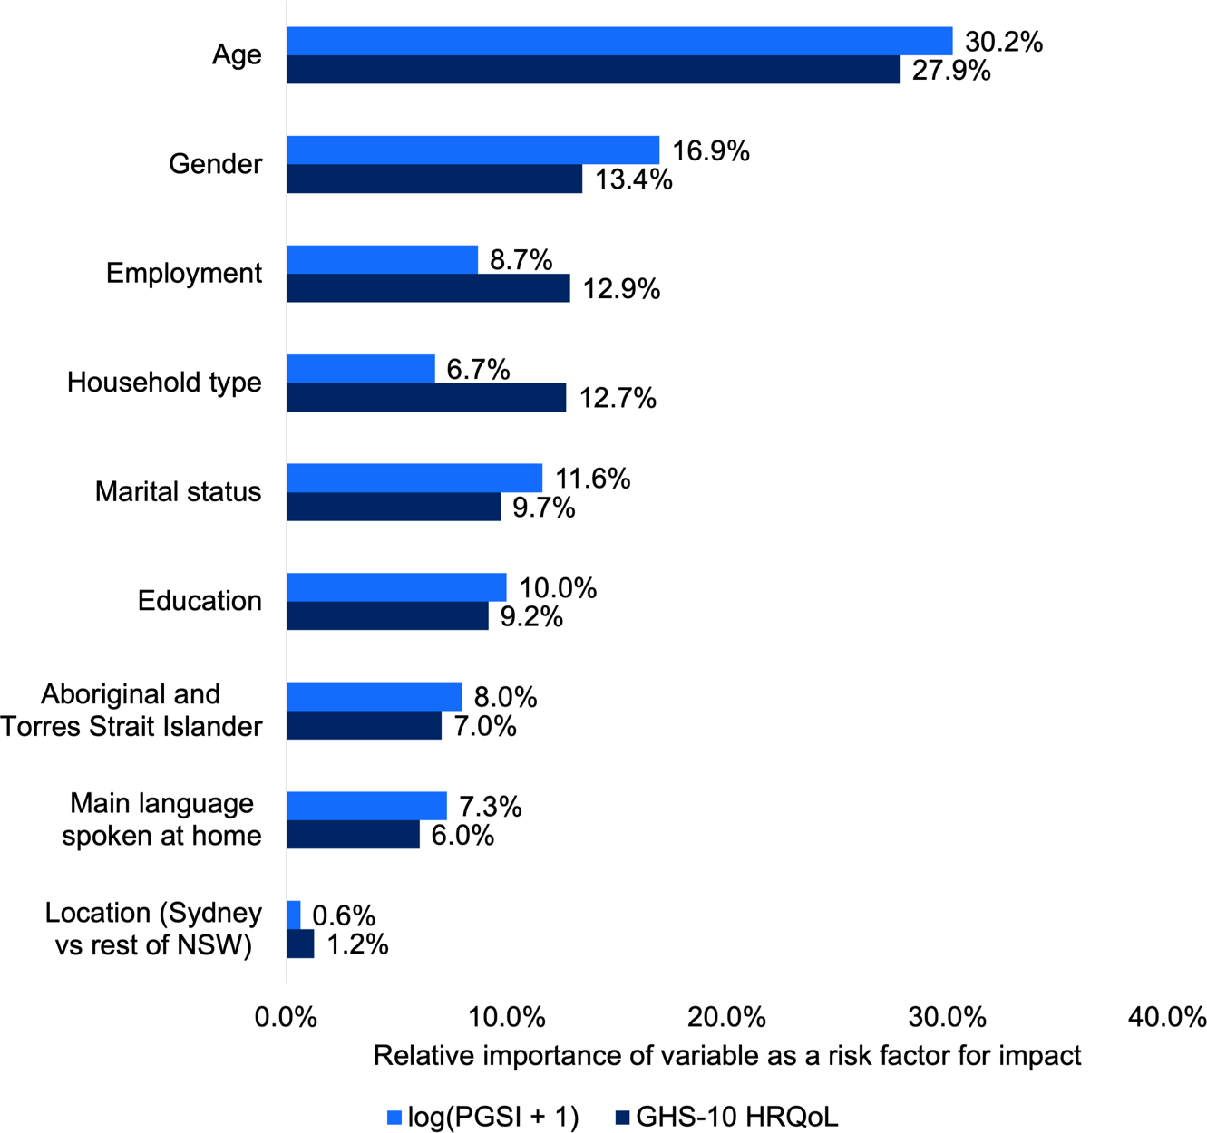

*Base: All respondents who had gambled in the last 12 months (n=5,370) for PGSI and all subsampled respondents who had gambled in the last 12 months (n=3,300) for GHS-10. Scores of 0 inferred for non- gamblers.*

Equally important on an individual level, but applying to a smaller proportion of the population, speaking a language other than English at home is associated with increased risk. Likewise, those identifying as Aboriginal and/or Torres Strait Islander, although representing a minority of the population, are at substantially greater risk. Those living in a group household were more likely to report harms, although there were not strong effects for household type on PGSI score.

Figure 29 presents a mosaic plot, in which the area of each rectangle is proportional to the Years of Life Lost (YLD) due to Health-Related Quality of Life (HRQoL) impacts from NSW residents’ own gambling. YLD is a population aggregated figure that combines both prevalence (i.e. number of people in each segment) and severity (i.e. the severity of harm experienced by individuals in the segment). Thus, Figure 29 divides the total harm incurred by the population into intersecting segments, divided by gender, age (40+) and education (bachelor’s degree or above). For each segment, the size of NSW population is given, and the rectangles are shaded proportional to the average degree of impact, with darker colours indicating more individual impact. For example, for women who do not have a bachelor's degree or higher, the colours of the cells for younger and older women are similar, indicating that on average per person, the HRQoL is similar. However, because there are more than 1 million women in NSW with tertiary degrees in the 40+ age bracket, compared to 573,283 in the <40 age bracket, the total HRQoL (YLD) is greater for the older group.

Based on scoring the GHS-10 measure, a total impact of 105,515 life-years occurred in the NSW population. As shown in Figure 29, men account for the bulk of harm from gambling, and more than a quarter of the total YLD in the population is borne by younger men without tertiary education (N = 672.4k, 27,583 YLD). Although there are

1.09 million women aged 40+ with a tertiary degree in NSW, they incur a much smaller quantity of impact (6,920 YLD).

For men, most harm is occurring in those aged under 40, but for women, risk is more homogenous with respect to age, leading to a greater burden in the more numerous 40+ segment. Education appears to be a protective factor for all groups.

##### Figure 29 Impact incurred by key population segments due to harm from one’s own gambling

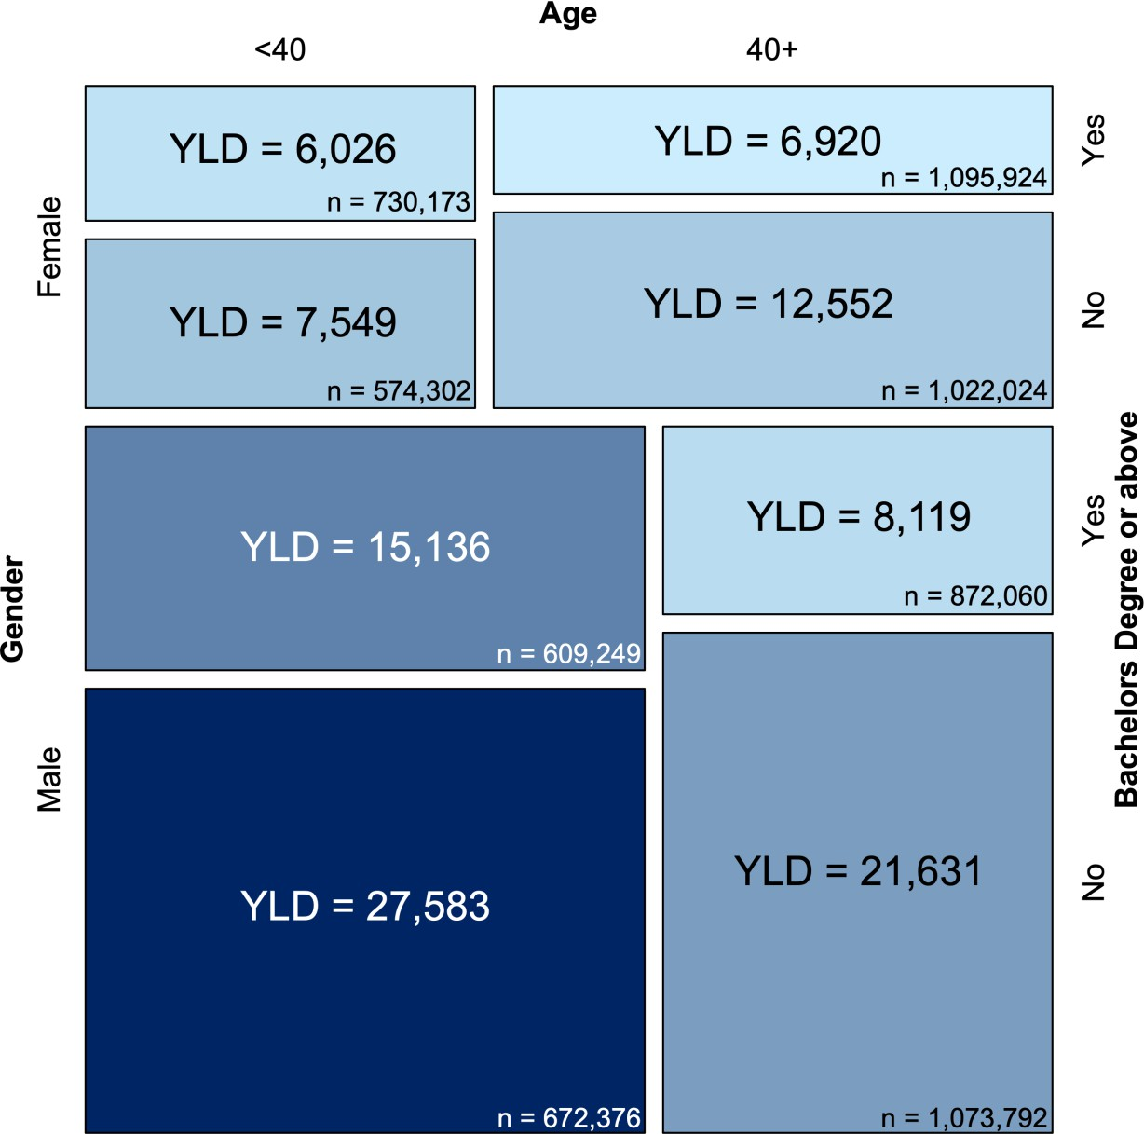

*Base: All subsampled respondents who had gambled in the last 12 months (n=3,300).*

### Which demographics are most strongly associated with harm to affected others?

As shown in Figure 30 the most important demographic risk factor predicting harms for affected others was gender, with women being more affected than men. This was followed by household type, with those in group households or other living arrangements being more affected. Unemployed persons are more likely to be affected by another's gambling, as are those who identify as Aboriginal and/or Torres Strait Islanders. Age had a non-significant association with risk to experiencing harm from another's gambling, and its’ relative importance was low, in contrast to being the most important risk factor for gamblers. Location (Sydney versus other) also was not a significant risk factor. Those without a tertiary degree and unmarried persons were more likely to report harm. Although the relative importance of main language spoken at home was also low, those who spoke a language other than English were nevertheless slightly more likely to report harm from another’s gambling.

##### Figure 30 Relative importance of demographic factors in determining harm to affected others

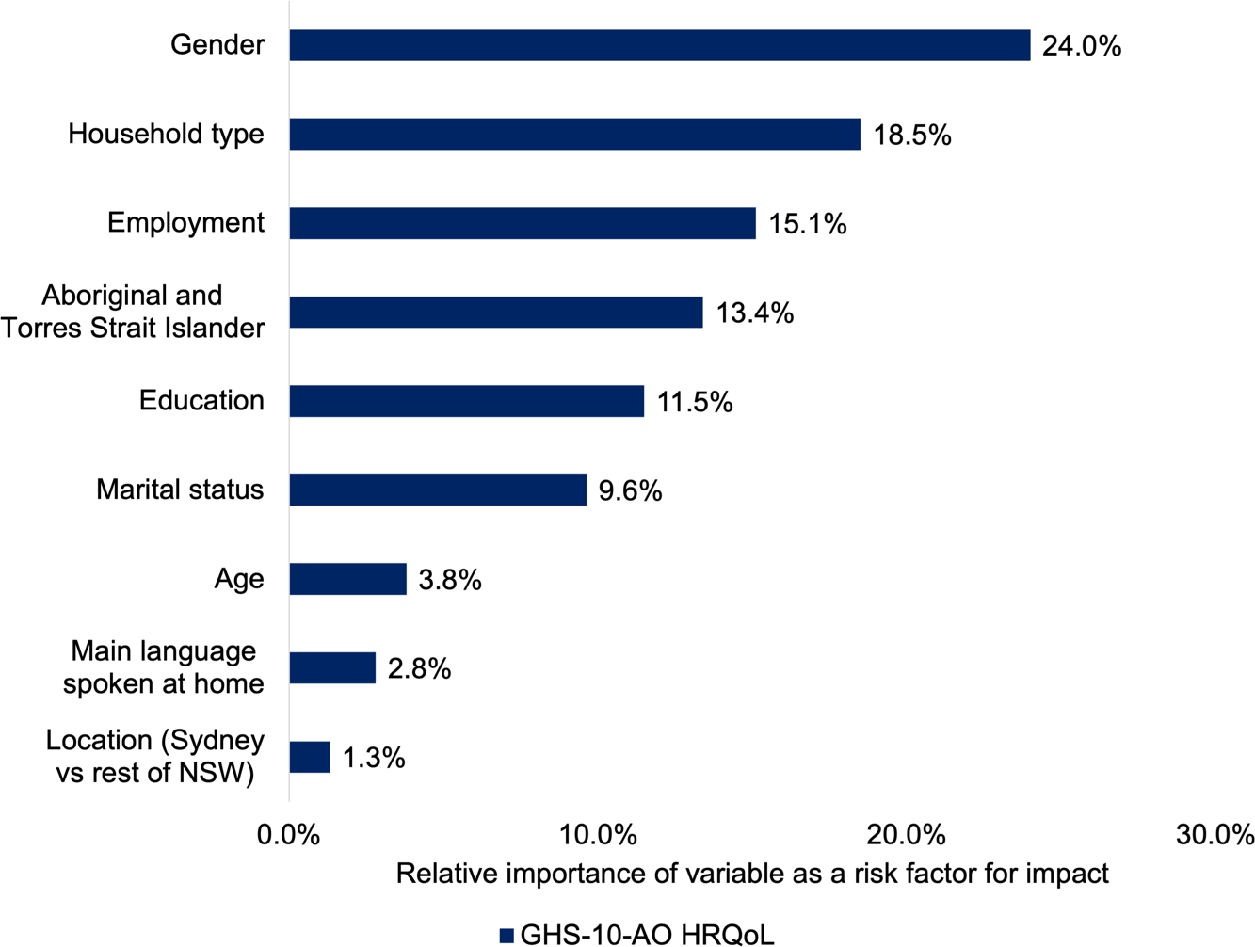

*Base: All subsampled respondents (n=4,374).*

Figure 31 provides a mosaic plot (described above) for gambling harm to affected others. In parallel with the previously described harm to gamblers, those most affected are younger women without a bachelor’s degree. While this segment of women is at most risk individually, the larger number of women aged 40+ means that they bear a slightly higher burden overall. Likewise, although younger men are at greater risk, this is counterbalanced by the larger number of older men, to entail the burden across these groups is approximately equal. Women in general tend to bear more harm from another’s gambling than men. The total amount of harm reported by affected others was 158,877 YLD, about 50% more than attributable to gamblers themselves. In comparing these statistics, it should be borne in mind that each gambler experiencing problems is likely to affect more than one person.

##### Figure 31 Impact incurred to key population segments from gambling harm to affected others

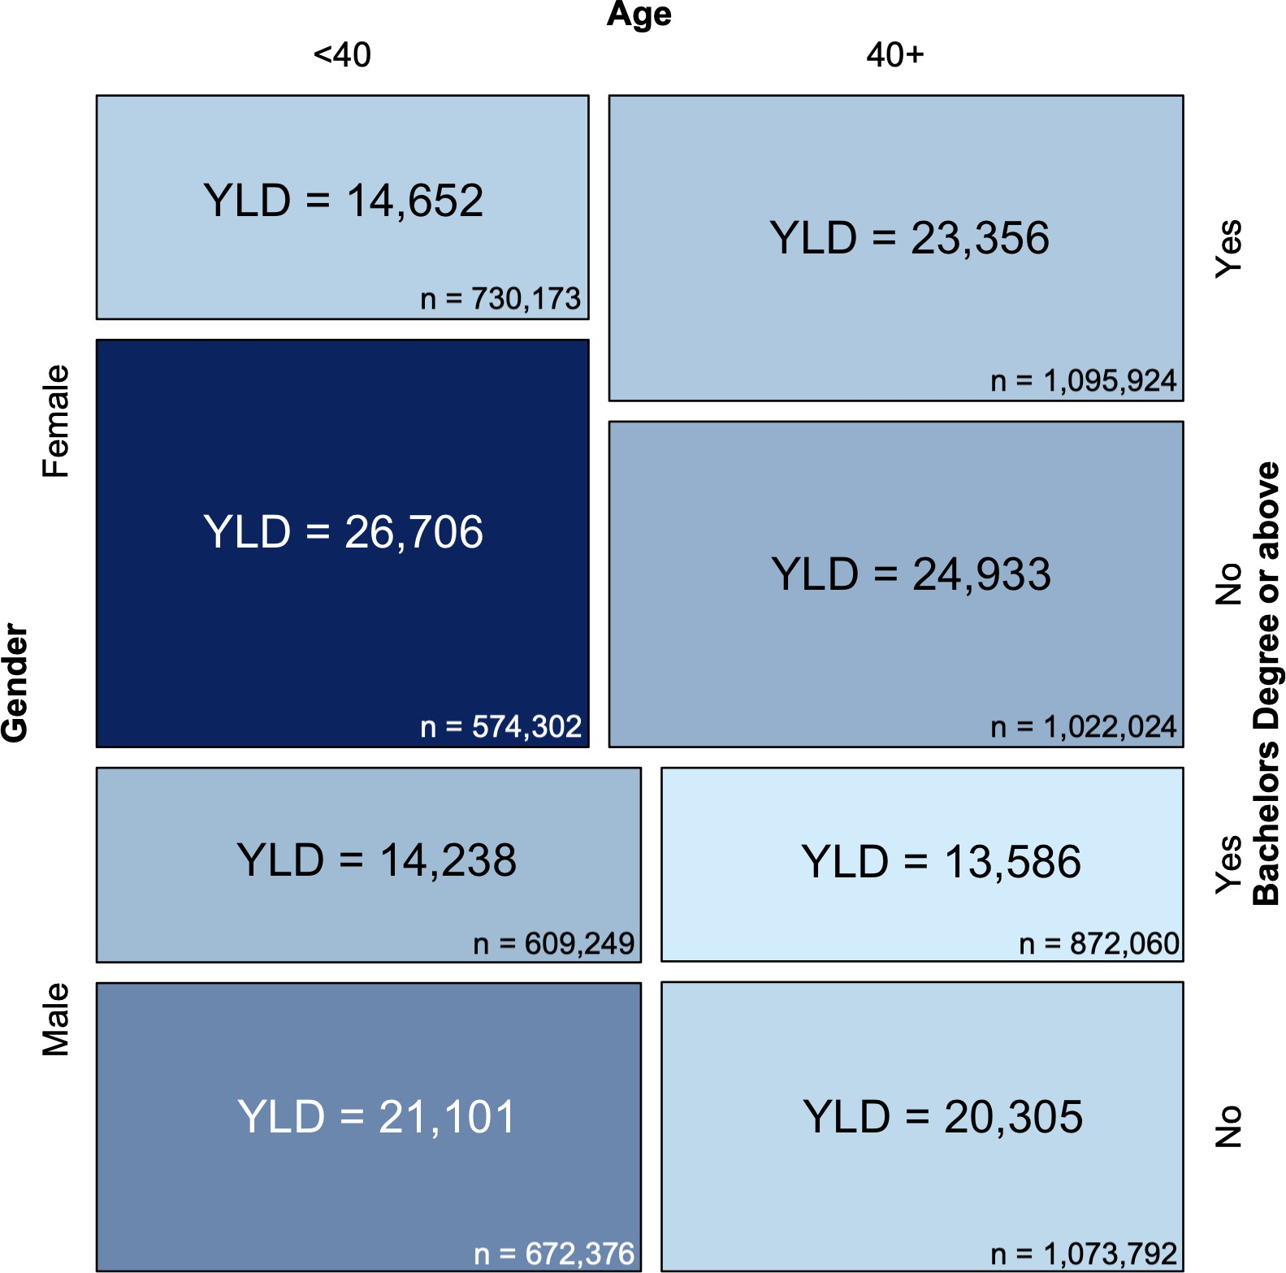

*Base: All subsampled respondents (n=4,374).*

### Harm, gambling problems and wellbeing

Gambling harm and gambling problems are highly related, but distinct concepts. Furthermore, no population screen measures the target concept with perfect reliability. Nevertheless, the PGSI and GHS-10 are highly and significantly correlated at *r* = .73, which speaks to their mutual validity. Both measures have been extensively validated in the literature. Using data from the present survey, both PGSI category and harms, if valid, ought to have an impact on general life satisfaction, which was measured via a single item, “*How satisfied are you with your life as a whole, on a scale from zero to 10?*". Both the PGSI and GHS-10 are correlated with this item to the same degree: *r* = -.24, *p* <.001, supporting the validity of both measures. All PGSI risk categories, including low-risk gambling, reported significantly lower life satisfaction than those at minimal risk (previously non- problem) (all *p* < 0.001). All degrees of gambling harm, including those reporting only 1 only 2 harms also reported lower life satisfaction (all *p* < 0.001).

Figure 32 illustrates a cross-tabulation of the GHS-10 and PGSI and Figure 33 shows the converse cross-tabulation. About nine out of ten of those in the high-risk gambling category report one or more harms, as compared to only 6.0% of those at minimal-risk. While one in five (20.0%) gamblers fall into some risk category (low-, moderate- or high-risk), only 14.5% of gamblers report one or more harms. Whilst 88.1% of unharmed gamblers are in the minimal-risk category, this figure drops sharply among groups reporting one or more harms. Taken together, this comparison illustrates that gambling harm is not a “lower bar” for gambling problems, but rather that harm and problems are different constructs that align strongly, but imperfectly with one another. Nevertheless, because those who experience high-risk gambling form a very small minority of gamblers, most gambling harms and HRQoL impact is incurred outside this group.

##### Figure 32 Cross-tabulation of GHS-10 with the PGSI

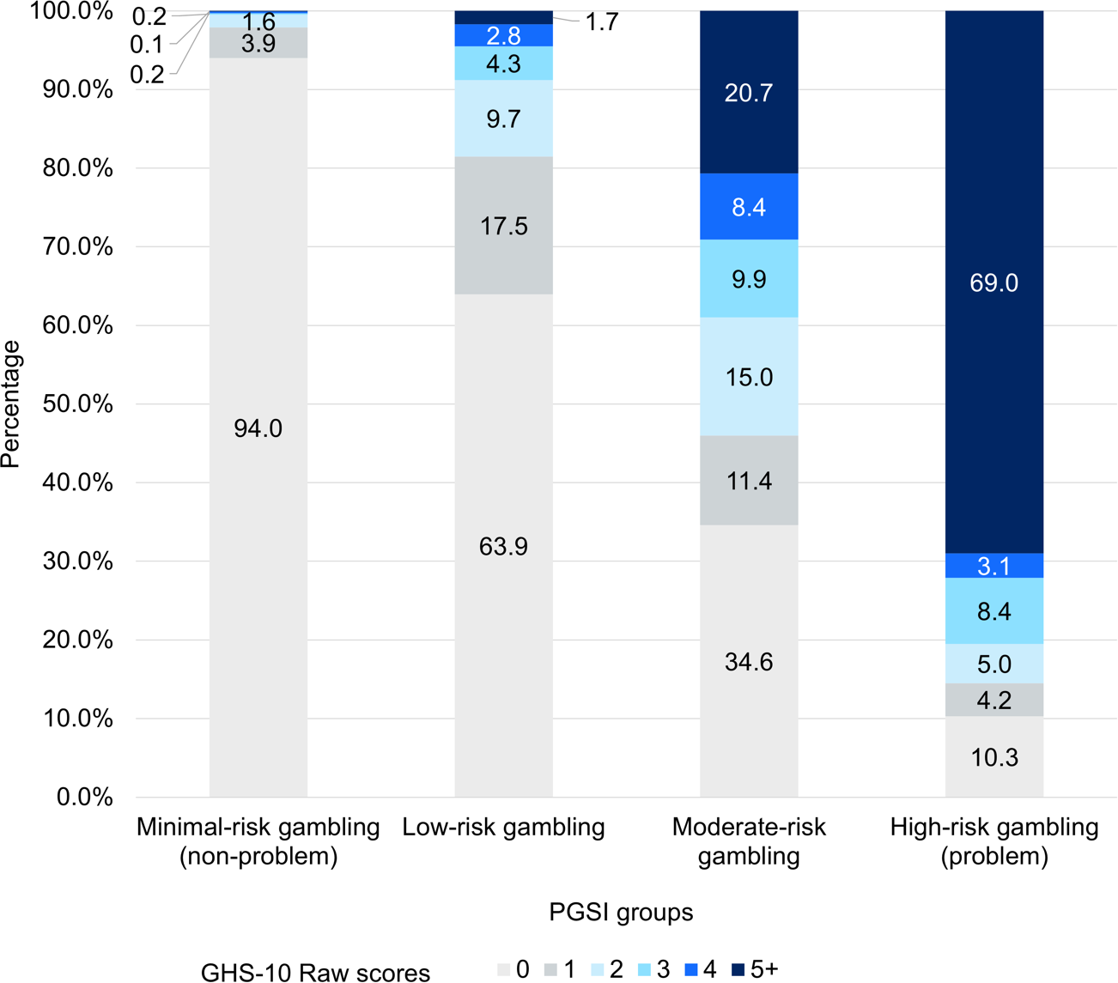

*Base: All subsampled respondents who had gambled in the last 12 months (n=3,300).*

##### Figure 33 Cross-tabulation of PGSI with the GHS-10

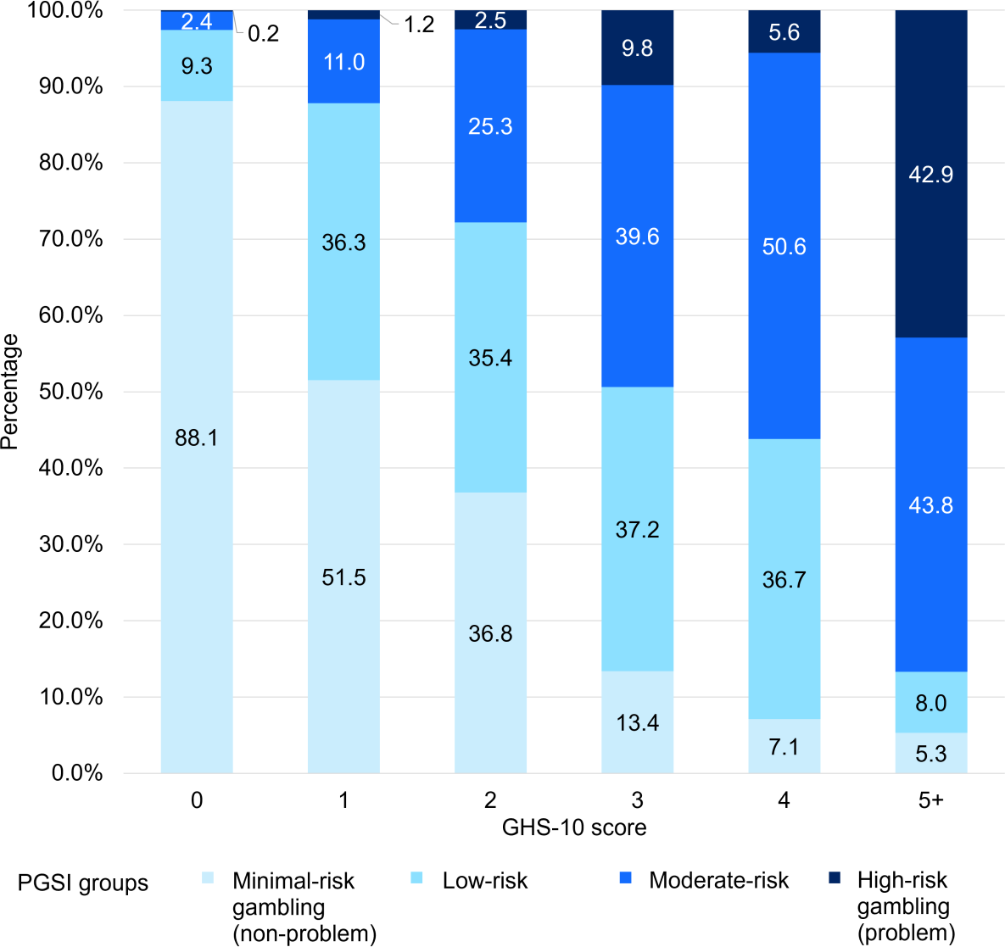

*Base: All subsampled respondents who had gambled in the last 12 months (n=3,300).*

Figure 34 illustrates the combined effect of gambling harm (GHS-10 1+) and gambling problems on self-reported wellbeing. Both PGSI category and gambling harm have statistically significant and independent effects on life satisfaction, as measured by the single item measure. Particularly notable is the fact that among both minimal-risk gamblers and high-risk gamblers, those indicating one or more harms report a significantly lower life satisfaction (both *p* < 0.001). Thus, despite being highly correlated, both gambling harms and PGSI category have meaningful and independent implications for quality of life.

##### Figure 34 Combined effect of PGSI category and harm on life satisfaction

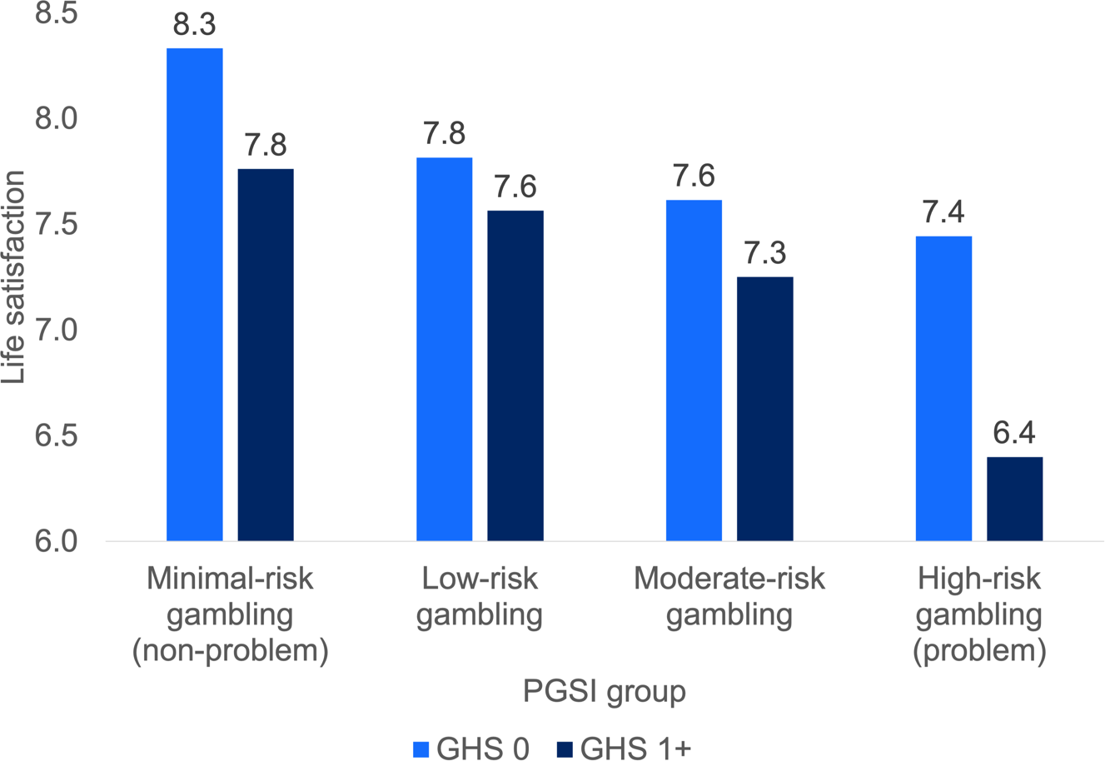

*Base: All subsampled respondents who had gambled in the last 12 months (n=3,300).*

### Total gambling losses incurred by PGSI category and harms

Figure 35 and Figure 36 provide robust means of self-reported spend by GHS-10 and PGSI categories. We describe our methods for calculating robust means in the technical appendices below. These figures are then scaled by the population percentage to yield implied aggregate losses for each gambling segment.

Although minimal-risk gamblers comprise 80.0% of the gambling population, they spend on average only $309 per person, which makes up only 13.7% of total industry loss revenue.

##### Figure 35 Total gambling losses by PGSI category

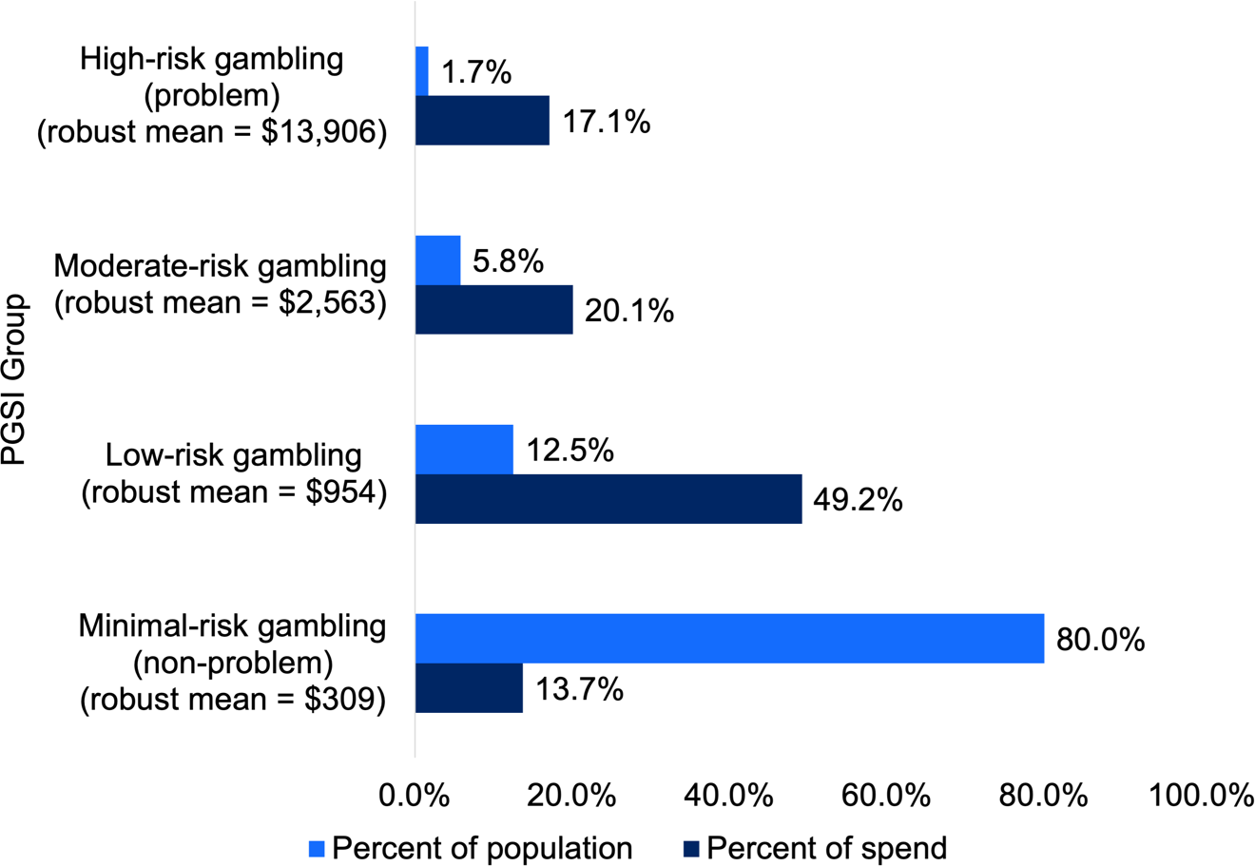

*Base: All subsampled respondents who had gambled in the last 12 months (n=3,300).*

In contrast, unharmed gamblers make up 85.4% of the gambling population, but account for a lower, but somewhat commensurate 75.6% of gambling revenue. Whilst an average person experiencing high-risk gambling spends $13,906 per annum, an average gambler experiencing significant harm (arbitrarily 3+ on the

GHS-10 for illustration purposes) spends only $3,456. This counter-intuitive finding is because most people who experience harm are likely to have little disposable income or capacity to absorb unexpected expenses, in part because discretionary income is very unequally distributed in the population. Thus, while harmed gamblers spend on average many times more than unharmed gamblers, their excessive spending is relative to their capacity to spend, which is in many cases quite limited.

##### Figure 36 Aggregate gambling losses by GHS-10 harm bands

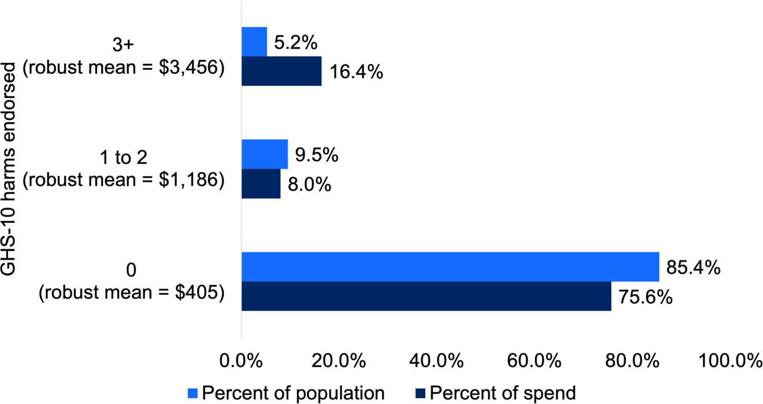

*Base: All subsampled respondents who had gambled in the last 12 months (n=3,300).*

# Chapter 8: Attitudes, awareness and use of support services

##### Exposure to GambleAware and responsible gambling advertising

* A substantial proportion of NSW residents reported seeing responsible gambling messages:
  + during or at the end of betting advertisements (65.2%)
  + as GambleAware advertising (54.8%)
  + as GambleAware signage in venues (38.1%)

##### Help-seeking

* Amongst 1,381 regular (i.e., weekly) gamblers and those at any risk on the PGSI, 72 (4.9%) reported seeking help in the last 12 months. For those experiencing moderate- to high-risk gambling, 59 (13.5%) reported seeking help.
* Most sought personal help (e.g., speaking to family, friends or colleagues;

71.4%), followed by professional help (41.5%), self-help (16.5%) or spiritual or cultural help (7.0%).

* Most who did not seek help reported that they did not feel that they had a

problem (87.5%), or that their problems were serious enough to see a counsellor (7.6%).

##### Self-exclusion

* Very few (1.4%) gamblers had attempted to self-exclude from a venue.
* Very few (1.2%) gamblers had attempted to self-exclude from online providers via BetStop (0.8%) or other means, such as directly from a wagering operator (0.4%) or state-based self-exclusion scheme (0.1%).

##### Attitudes towards gambling

* About four in five NSW residents believed that gambling has done more harm than good.
* Attitudes towards gambling were more negative in Greater Sydney, among English speakers, those with tertiary education, and non-gamblers. Aboriginal and/Torres Strait Islander respondents had more positive attitudes.
* About four in five NSW residents believed that it is the individual’s responsibility to control their gambling, with men being more likely to endorse this opinion, as well as those living outside Sydney, those without a tertiary education, and gamblers themselves. This was also more likely to be endorsed by those living with another adult, those experiencing lower levels of harm, and those not affected by another person’s gambling.

### Awareness of GambleAware and support services

Almost two-thirds of subsampled participants reported awareness of gambling help messages during or at the end of betting advertisements (Table 23). Slightly more than half reported being aware of GambleAware advertising on the internet, television or radio, more than a third reported seeing GambleAware signage in gambling venues and around one-sixth reported being aware of GambleAware pamphlets or cards, as well as the GambleAware website. The least commonly seen elements were the Reclaim the Game advertising (12.7%) and GambleAware Week (digital radio; 9.0%).

Common “other” responses included the GambleAware helpline, “gamble responsibly” messaging or the newer gambling messaging such as “bet within your limits” and “you win some you lose more”. Some participants also identified GambleAware signage in other locations (e.g., cinemas, transport, billboards) and on social media.

##### Table 23 Percentage of respondents who reported seeing responsible gambling messaging or GambleAware material

|  |  |
| --- | --- |
|  | **% Yes** |
| Gambling help messages during or at the end of betting advertisements | 65.2% |
| GambleAware advertising (via the internet, television or radio) | 54.8% |
| GambleAware signage in gambling venues | 38.1% |
| GambleAware pamphlet or cards | 17.5% |
| The GambleAware website | 15.6% |
| Reclaim the Game advertising | 12.7% |
| GambleAware Week (digital radio) | 9.0% |
| Other | 2.1% |
| None of these | 16.4% |

*“Before today, have you seen any of the following?”. Base: All subsampled participants (n = 4,374).*

### Help-seeking

##### How many sought help

All regular gamblers (i.e., at-least weekly across forms) and any respondents with a PGSI score of 1 or more were asked whether they had tried to seek help in the last 12 months. Out of 1,381 respondents, 72 (4.9% weighted) reported seeking help.

Amongst those experiencing moderate- to high-risk gambling, 59 respondents (13.5% weighted) sought help.

##### What kind of help

Those who sought help tended to prefer personal help (e.g., talking to family, friends, work colleagues), followed by seeking professional help, with around one in six opting for self-help (Table 24).

##### Table 24 Type of help sought amongst help-seekers

|  |  |  |
| --- | --- | --- |
|  | **% Yes** | **%**  **moderate- to high-**  **risk gambling** |
| Personal (such as speaking with family/friends/work colleagues) | 71.4% | 67.4% |
| Professional (including counselling service, GP or social worker) | 41.5% | 47.5% |
| Self- help (such as online tools, manuals) | 16.5% | 16.8% |
| Spiritual or cultural help (e.g., religious leader, community elder) | 7.0% | 8.3% |

*“What kind of help did you seek?”. Base: All participants who sought help (unweighted n = 72, weighted n = 28).*

##### Where help-seekers heard about professional help

Amongst the 26 people (unweighted) who sought professional help, six reported finding out about the professional service from a family member, friend or colleague or other personal relation, four reported a referral from other professional services (e.g., a GP), three reported advertising material or sign in a pub, hotel, club or casino, and two reported the GambleAware phoneline. One each reported the NSW GambleAware website, directly contacting an independent counsellor, through an online wagering provider’s website and a staff member at a pub, hotel, club or casino. In addition, two participants reported that they were already seeing a psychologist and two reported being referred through their work, e.g., through an Employee Assistance Program.

##### Why respondents did not seek help

Most participants indicated that they did not seek help because they did not feel that they had a problem, 87.5% amongst regular gamblers or people who had a PGSI of 1 or more (Table 25). For those experiencing moderate- to high-risk gambling, almost three quarters indicated that they did not seek help because they felt they did not have a problem.

The next most common response was feeling that their problems were not serious enough to see a counsellor (7.6% of all asked, and 12.5% of those experiencing moderate- to high-risk gambling), followed by thinking that they could beat the problem on their own (1.9% of all asked, 5.3% of those experiencing moderate- to high-risk gambling). Relatively few reported barriers, such as not knowing where to go or preferring anonymous counselling, and no respondents reported that the kind of help they wanted was not available locally.

Other reported verbatim responses included that they currently do not gamble very much, or that they could afford their gambling.

##### Table 25 Why respondents did not seek help

|  |  |  |
| --- | --- | --- |
|  | **% Yes** | **% moderate- to high-risk gambling** |
| Did not feel that they had a problem | 87.5% | 75.9% |
| Did not think their problems were serious enough to see a counsellor | 7.6% | 12.5% |
| Thought they could beat the problem on their own | 1.9% | 5.3% |
| Too embarrassed to see a counsellor | 1.0% | 3.1% |
| Did not know where to go | 0.5% | 0.6% |
| Prefer anonymous counselling | 0.1% | 0.0% |
| The kind of help they wanted is not available locally | 0.0% | 0.0% |

*“May I ask why you didn’t seek help for problems relating to gambling?”. Base: All participants who had gambled at least weekly or who had a PGSI of 1 or more but who had not sought help (n = 1,381).*

### Self-exclusion from venues

Of the 3,300 gamblers in the sample, 64 (1.4%) reported trying to self-exclude from a gambling venue, such as a hotel, pub, club or casino through a formal self-exclusion process within the venue. Most of these respondents reported doing so from one venue (40.5%) or two venues (24.1%).

Of the 64 who self-excluded, 18 attempted re-entry, and 12 were successful in gaining re-entry despite being self-excluded (Figure 37). Further, 14 of those who self-excluded from venues reported going to gamble at other venues instead of the ones from which they were excluded. It should be noted that the weighted percentages in the figure are based on low numbers of respondents and should be treated with caution.

**Figure 37 Self-exclusion and re-entry (venues)**

## 67.1%

Self-

e d

xclude

* 1.4%

Attempted re-entry

* 27.0%

Successfully

re-entered

*Base: All subsampled respondents who had gambled in the last 12 months (n=3,300).*

### Self-exclusion from online operators

Of the 3,300 gamblers in the subsample, 38 (0.8%) reported trying to self-exclude from online gambling providers using BetStop. In addition, some respondents reported excluding from online gambling providers in other ways, such as self- exclusion directly with the operator (n = 20, 0.4%), a state-based self-exclusion scheme (n = 3, 0.1%) or that they had self-excluded but were not sure who they had self-excluded with (n = 7, 0.2%). Together, 47 people (1.2% of gamblers) reported self-excluding from online gambling providers, with most reporting self-excluding through one provider, principally BetStop.

Of the 47 who had self-excluded, 8 reported attempting to bet via a wagering operator’s website or mobile app during the self-exclusion period, and 4 of those reported being successful (Figure 38). It should be noted that the weighted percentages in the figure below for attempted re-entry and successfully re-entered are based on low numbers of respondents and should be treated with caution.

**Figure 38 Self-exclusion and re-entry (online)**

## 52.1%

Self-

e d

xclude

* 1.2%

Attempted

re-entry

* 15.9%

Successfully re-entered

*Base: All subsampled respondents who had gambled in the last 12 months (n=3,300).*

### Attitudes towards gambling overall, and by age, gender, location, gambler status, and PGSI groups

All subsampled respondents were asked their opinions about the relative good versus harm for the community from gambling. Half the participants were asked to rate how strongly they agree or disagree with the statement that “Gambling has done more good for the community than harm”, while for the other half the statement was framed the other way, that “Gambling has done more harm for the community than good”. For reporting purposes, the “more good vs harm” version was reverse coded so that responses could be combined. This counter-balanced question format ensured that the question format would not bias the summarised statistics.

Four in five respondents agreed or strongly agreed that gambling has done more harm than good (79.7%), which is very similar to the finding from 2019 (78%) (Figure 39). This was significantly higher for women (81.5%) than men (77.6%), while younger people were more likely to report less perceived harm to the community (75.9% vs approximately 80% for other ages) (Figure 40). Other groups who were more likely to report less perceived harm to the community were those living outside of Sydney, people identifying as Aboriginal or Torres Strait Islander, people who speak a language other than English, and people who without a tertiary education (Table 26).

##### Figure 39 Agreement or disagreement that gambling has done more harm to the community than good

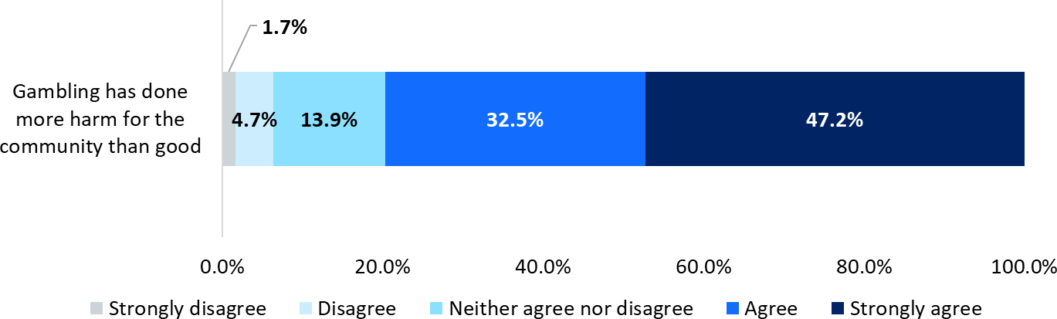

*Agreement or disagreement with the statement that “Gambling has done more harm for the community than good”. The question was asked this way for half of the participants and asked as “Gambling has done more good for the community than harm” for the other half, with the latter half being reverse-coded for these results. All subsampled participants (n = 4,374).*

##### Figure 40 Percentage of respondents who agree or strongly agree that gambling does more harm than good in the community by age and gender

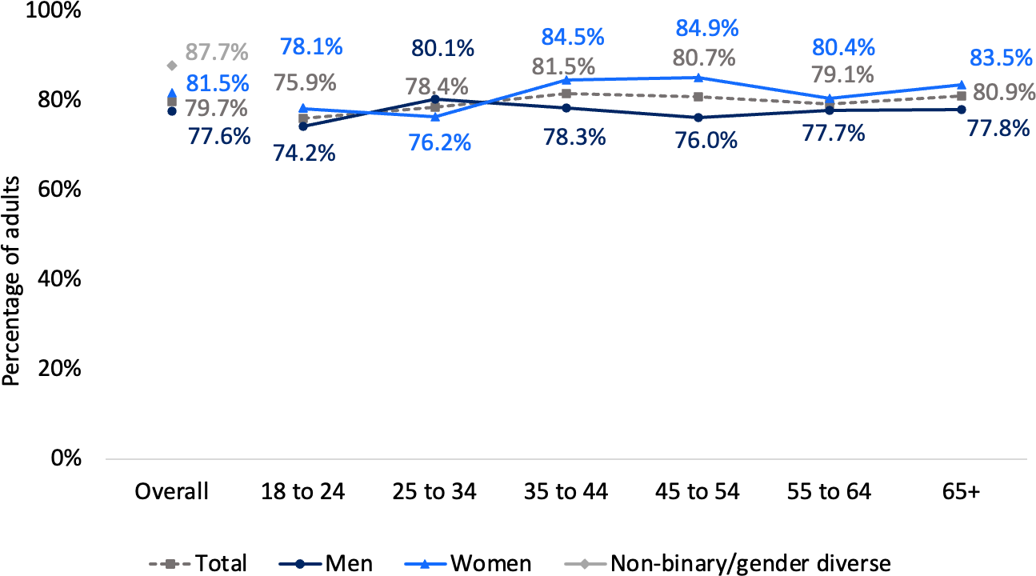

*Agreement or disagreement with the statement that “Gambling has done more harm for the community than good”. Base: All subsampled respondents (n=4,374). Asterisks (if present) indicate a statistically significant difference: *p<.05, **p<.01, ***p<.001.*

Those who had not gambled in the last 12 months were somewhat more likely to believe that gambling does more harm than good (Table 27). This effect was pronounced in the case of at-least weekly gamblers, who had the most positive attitudes about the effect of gambling on the community. There was an inconsistent pattern of effects for both the PGSI and the GHS-10. However, those who reported any degree of harm on the GHS-10-AO were significantly more likely to believe that gambling does more harm than good in the community.

##### Table 26 Percentage of respondents who agree or strongly agree that gambling does more harm than good in the community by demographics

|  |  |
| --- | --- |
|  | **% Agree or strongly agree** |
| **NSW adults** | 79.7% |
| **Location** | |
| Greater Sydney | **81.0%\*\*** |
| Rest of NSW | 77.2% |
| **Aboriginal and/or Torres Strait Islander** | |
| No | **80.1%\*\*** |
| Yes | 71.3% |
| **Main language at home** | |
| English only | **80.4%\*\*** |
| LOTE speaker | 75.3% |
| **Marital status** | |
| Not currently married (including divorced, separated, widowed and single) | 79.4% |
| Married or living with a partner | 79.8% |
| **Employment status** | |
| Not working (including student, retired, etc) | 79.0% |
| Working (full time, part-time, casual) | 80.0% |
| **Tertiary education** | |
| No | 77.8% |
| Yes | **81.8%\*\*** |
| **Personal income, per year** | |
| Nil or negative income | 73.9% |
| $30,000 or less | 78.0% |
| $30,000 - $49,999 | 81.4% |
| $50,000 - $69,999 | 80.6% |
| $70,000 - $99,999 | 82.6% |
| $100,000 - $149,999 | 80.6% |
| $150,000 or more | 81.4% |
| **Children in the household** | |
| No | 79.5% |
| Yes | 80.1% |
| **Cohabiting with another adult (group/couple)** | |
| No | 79.5% |
| Yes | 79.9% |

*Agreement or disagreement with the statement that “Gambling has done more harm for the community than good”. Base: All subsampled respondents (n = 4,374). Asterisks (if present) indicate a statistically significant difference: *p<.05, **p<.01, ***p<.001.*

##### Table 27 Percentage of people who agree or strongly agree that gambling does more harm than good in the community by gambling behaviour and risk

|  |  |
| --- | --- |
|  | **% Agree or strongly agree** |
| **Gambled in the last 12 months on any form** | |
| No | **83.0%\*\*\*** |
| Yes | 76.7% |
| **Gambled at-least weekly in the last 12 months (across forms apart from lotteries, overseas lotteries and scratchies)** | |
| No | **80.5%\*\*\*** |
| Yes | 65.0% |
| **PGSI** | |
| Minimal-risk gambling (previously non-problem) | 77.3% |
| Low-risk gambling | 75.2% |
| Moderate-risk gambling | 72.6% |
| High-risk gambling (previously problem) | 76.3% |
| **GHS-10** |  |
| 0 | 76.9% |
| 1 | 72.7% |
| 2 | 76.9% |
| 3+ | 77.7% |
| **GHS-10-AO** |  |
| 0 | 76.1% |
| 1 | **83.6%\*\*\*** |
| 2 | **88.0%\*\*\*** |
| 3+ | **87.2%\*\*\*** |

*Agreement or disagreement with the statement that “Gambling has done more harm for the community than good”. Base: All subsampled respondents (n = 4,374). Asterisks (if present) indicate a statistically significant difference: *p<.05, **p<.01, ***p<.001. Where multiple categories are marked in bold, they represent a combined comparison with the un-bolded group.*

### Perceptions of responsibility

All subsampled respondents were asked their agreement or disagreement with the statement “It is the individual’s responsibility to manage their own gambling by knowing what he or she can afford”. Respondents who endorse this do not necessarily think that it is not also the responsibility of other parties, such as gambling operators or governments to play a role in minimising harm. Instead, this question may indicate a degree of stigma towards people who experience problems due to their gambling.

Around four in five (78.1%) agreed or strongly agreed that it is the individual’s responsibility to manage their own gambling, which was very similar to 2019 (80%) (Figure 41). This agreement was significantly higher amongst men (80.3%) vs

women (76.2%), especially for younger people (Figure 42). Other groups who were more likely to agree or strongly agree with this statement were people outside of Sydney, without a tertiary education, those who live with another adult, those who had gambled in the last 12 months, and particularly those who gamble more often than weekly, and those in lower risk groups (Tables 28 and 29).

##### Figure 41 Agreement or disagreement that it is the individual’s responsibility to manage their own gambling

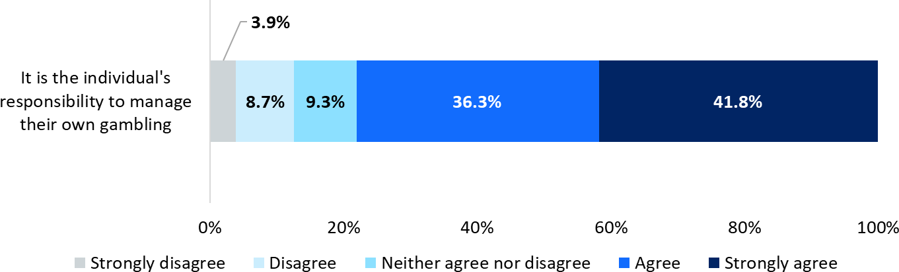

*Agreement or disagreement with the statement that “it is the individual’s responsibility to manage their own gambling by knowing what he or she can afford”. All subsampled participants (n = 4,374).*

##### Figure 42 Percentage of respondents who agree or strongly agree that it is the individual’s responsibility to manage their own gambling by age and gender

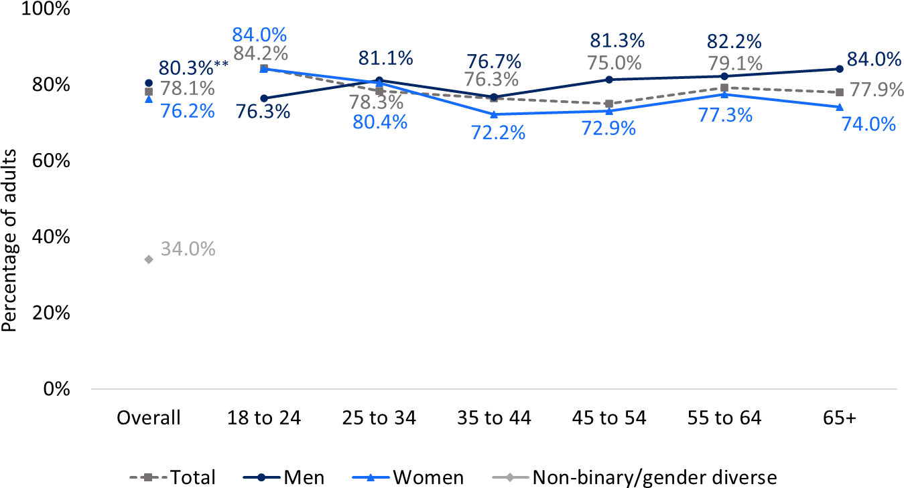

*Agreement or disagreement with the statement that “it is the individual’s responsibility to manage their own gambling by knowing what he or she can afford”. Base: All subsampled respondents (n=4,322). Asterisks (if present) indicate a statistically significant difference: *p<.05, **p<.01, ***p<.001.*

##### Table 28 Percentage of respondents who agree or strongly agree that it is the individual’s responsibility to manage their own gambling

|  |  |
| --- | --- |
|  | **% Agree or strongly agree** |
| **NSW adults** | 78.1% |
| **Location** | |
| Greater Sydney | 76.6% |
| Rest of NSW | **81.0%\*\*\*** |
| **Aboriginal and/or Torres Strait Islander** | |
| No | 78.1% |
| Yes | 78.9% |
| **Main language at home** | |
| English only | 77.9% |
| LOTE speaker | 79.1% |
| **Marital status** | |
| Not currently married (including divorced, separated, widowed and single) | 77.9% |
| Married or living with a partner | 78.3% |
| **Employment status** | |
| Not working (including student, retired, etc) | 78.1% |
| Working (full time, part-time, casual) | 78.0% |
| **Tertiary education** | |
| No | **82.8%\*\*\*** |
| Yes | 73.5% |
| **Personal income, per year** | |
| Nil or negative income | 78.4% |
| $30,000 or less | 78.8% |
| $30,000 - $49,999 | 75.9% |
| $50,000 - $69,999 | 81.5% |
| $70,000 - $99,999 | 79.8% |
| $100,000 - $149,999 | 75.4% |
| $150,000 or more | 75.3% |
| **Children in the household** | |
| No | 78.2% |
| Yes | 78.0% |
| **Cohabiting with another adult (group/couple)** | |
| No | 75.8% |
| Yes | **79.0%\*** |

*Agreement or disagreement with the statement that “it is the individual’s responsibility to manage their own gambling by knowing what he or she can afford”. Base: All subsampled respondents (n = 4,374). Asterisks (if present) indicate a statistically significant difference: *p<.05, **p<.01, ***p<.001.*

People experiencing high-risk gambling were significantly less likely to endorse the statement about individual responsibility, as were those reporting high levels of harm (scoring 3+ on the GHS-10), and affected others who reported any harms (scoring 1+ on the GHS-10-AO).

##### Table 29 Percentage of respondents who agree or strongly agree that it is the individual’s responsibility to manage their own gambling

|  |  |
| --- | --- |
|  | **% Agree or strongly agree** |
| **NSW adults** | 78.1% |
| **Gambled in the last 12 months on any form** | |
| No | 74.4% |
| Yes | **81.3%\*\*\*** |
| **Gambled at-least weekly in the last 12 months (across forms apart from lotteries, overseas lotteries and scratchies)** | |
| No | 77.7% |
| Yes | **85.9%\*\*\*** |
| **PGSI** | |
| Minimal-risk gambling (previously non-problem) | **81.3%\*\*\*** |
| Low-risk gambling | **82.6%\*\*\*** |
| Moderate-risk gambling | **81.9%\*\*\*** |
| High-risk gambling (previously problem) | 71.5% |
| **GHS-10** |  |
| 0 | **81.3%\*\*\*** |
| 1 | **83.0%\*\*\*** |
| 2 | **84.3%\*\*\*** |
| 3+ | 77.0% |
| **GHS-10-AO** |  |
| 0 | **81.5%\*\*\*** |
| 1 | 74.5% |
| 2 | 78.0% |
| 3+ | 68.9% |

*Agreement or disagreement with the statement that “it is the individual’s responsibility to manage their own gambling by knowing what he or she can afford”. Base: All subsampled respondents (n = 4,374). Asterisks (if present) indicate a statistically significant difference: *p<.05, **p<.01, ***p<.001. Where multiple categories are marked in bold, they represent a combined comparison with the un-bolded group.*

# Chapter 9: Detailed gambling behaviour

* NSW gamblers spent an average of $608 on gambling per annum.
* Men spent over three times ($956) as much as women ($291).
* Spend was highly concentrated in the gambling population:
  + At-least weekly gamblers spend over 10 times ($3,631) that of others ($374)
* Spend increases sharply with respect to gambling risk category, from

$309 for those experiencing minimal-risk (previously non-problem) gambling to $13,906 for those experiencing high-risk gambling (previously problem gambling)

* Session duration varies by form:
  + Most (57.6%) keno sessions were less than 30 minutes.
  + Most EGM sessions (62.2%) were more than 30 minutes.
  + Typical casino table game sessions (33.6%) were 1-2 hours.
* People engaging in moderate- to high-risk gambling were more likely to gamble at night.
* EGM gamblers preferred to gamble at clubs or hotels and keno also usually

took place in these venues. About half buying lottery tickets did so online, and sports, esports and race bettors prefer gambling online using apps.

* 14.4% of EGM gamblers and 12.1% of casino table game gamblers were

members of loyalty schemes, with 19.9% of those who gambled on EGMs and casino games having loyalty memberships for both. These figures were higher amongst those in higher-risk PGSI groups.

* About four in ten gamblers drank alcohol at least sometimes when gambling,

and this was more common among regular gamblers and those engaging in moderate- to high-risk gambling.

* Amongst race and sports bettors, 3.5% reported being restricted from betting with a betting service provider, with most believing it was because they were winning too much.

### Expenditure

In this analysis, we used a method called robust regression to calculate the average expenditure. This approach is designed to give a more reliable estimate by reducing the impact of unusually high values (outliers), ensuring the average better represents the overall spending patterns in the population.

NSW gamblers reported spending an average of $608 on gambling per annum. It is known from prior research that all gamblers tend to underestimate their losses. On- average this underestimation occurs at a proportionately similar rate, including across PGSI categories (Braverman, 2014). Thus, relative comparisons on average spend can be made across groups. It should also be noted that the spend distribution is highly positively skewed, with a relatively small number of consumers reporting very high spends. As a result, robust means are essential and used for all statistics reported in this section.

Men tended to spend more than women across all age categories (Figure 43). Table 30 compares robust mean spend across other demographic categories. Although NSW residents who identify as Aboriginal and/or Torres Strait Islanders reported almost three times the spend of other residents, the highly skewed data and the relatively small sample size meant that this difference was not statistically significant. Respondents who gambled weekly or more often spent almost 10 times that of other gamblers (Table 30 and Table 31). People experiencing high-risk gambling spent about 45 times that of those at minimal-risk. Similarly, compared to those reporting zero harms, those reporting one harm spend approximately double, and those reporting three or more harms spend about six times as much.

##### Figure 43 Robust mean expenditure by age and gender, 2024

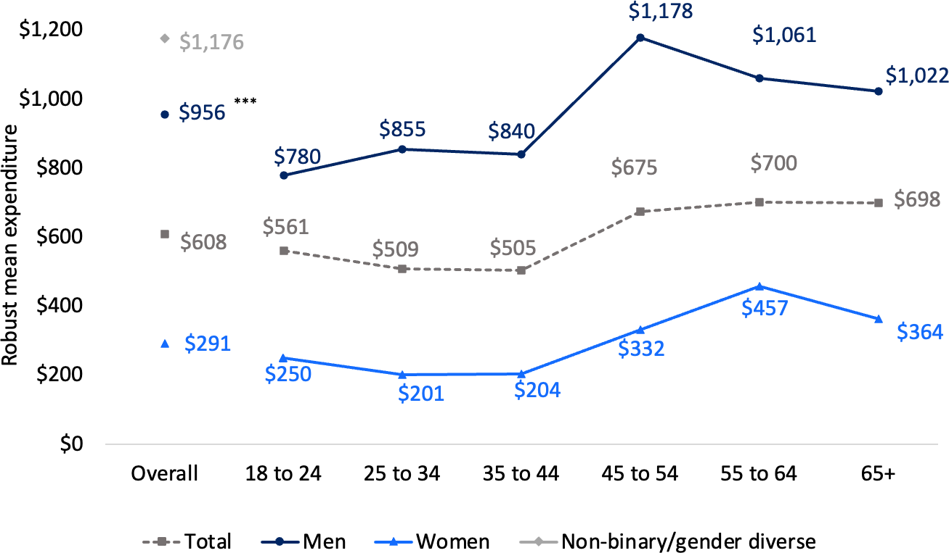

*“How much money do you usually spend on gambling?”. Base: All subsampled respondents who gambled in the last 12 months (n=3,300). Asterisks (if present) indicate a statistically significant difference: *p<.05, **p<.01,*

*\*\*\*p<.001.*

##### Table 30 Robust mean expenditure by demographics

|  |  |
| --- | --- |
|  | **Robust mean** |
| **NSW adults** | $608 |
| **Location** | |
| Greater Sydney | $571 |
| Rest of NSW | $656 |
| **Aboriginal and/or Torres Strait Islander** | |
| No | $580 |
| Yes | $1,542 |
| **Main language at home** | |
| English only | $602 |
| LOTE speaker | $511 |
| **Marital status** | |
| Not currently married (including divorced, separated, widowed and single) | $647 |
| Married or living with a partner | $560 |
| **Employment status** | |
| Not working (including student, retired, etc) | $635 |
| Working (full time, part-time, casual) | $572 |
| **Tertiary education** | |
| No | $823 |
| Yes | $413 |
| **Personal income, per year** | |
| Nil or negative income | $692 |
| $30,000 or less | $559 |
| $30,000 - $49,999 | $549 |
| $50,000 - $69,999 | $639 |
| $70,000 - $99,999 | $640 |
| $100,000 - $149,999 | $619 |
| $150,000 or more | $753 |
| **Children in the household** | |
| No | $639 |
| Yes | $520 |
| **Cohabiting with another adult (group/couple)** | |
| No | $668 |
| Yes | $581 |

*“How much money do you usually spend on gambling?”. Base: All subsampled respondents who gambled in the last 12 months (n=3,300). Asterisks (if present) indicate a statistically significant difference: *p<.05, **p<.01,*

*\*\*\*p<.001. Note that tests were conducted using robust statistics due to the distribution of spend data. Therefore, an apparently large mean difference may not meet the threshold for statistical significance.*

##### Table 31 Robust mean expenditure by gambling behaviour and risk

|  |  |
| --- | --- |
|  | **Robust mean** |
| **NSW adults** | $608 |
| **Gambling frequency – all forms apart from lotteries, overseas lotteries and scratchies** | |
| Less than weekly | $374 |
| Weekly or more often | **$3,631\*\*\*** |
| **PGSI** | |
| Minimal-risk gambling (previously non-problem) | $309 |
| Low-risk gambling | **$954\*** |
| Moderate-risk gambling | **$2,563\*\*\*** |
| High-risk gambling (previously problem) | **$13,906\*\*\*** |
| **GHS-10** |  |
| 0 | $420 |
| 1 | **$790\*\*\*** |
| 2 | **$901\*\*\*** |
| 3+ | **$2,536\*\*\*** |

*“How much money do you usually spend on gambling?”. Base: All subsampled respondents who gambled in the last 12 months (n=3,300). Asterisks (if present) indicate a statistically significant difference: *p<.05, **p<.01,*

*\*\*\*p<.001. Note that tests were conducted using robust statistics due to the distribution of spend data. Where multiple categories are marked in bold, they represent a combined comparison with the un-bolded group.*

### Time spent per session

Average session length varied by form (Figure 44). Sessions tended to be shorter for keno, with more than half of keno gamblers doing so for less than 30 minutes. For EGMs, 37.8% of people who use EGMs do so for less than 30 minutes, and around one in three (34.9%) gambles for more than an hour per session on average. In contrast, 68.5% of people who engage in casino table games do so for more than an hour.

For online casino and online poker, the figures are based on relatively small numbers of respondents and should be interpreted with caution. Patterns were similar for both, with around one-fifth to one-quarter gambling for less than half an hour on average, and around half gambling for up to an hour on average.

The following figures (45, 46 and 47) show the proportion of gamblers on specific forms in each PGSI category by session length. The proportion of gamblers with a PGSI score of 1 or more rises steadily as session length increases for EGMs. For casino table games and keno, the higher proportion of those in moderate- and high- risk groups was most evident at approximately the three-hour mark.

Please note that average session length was collected for select forms, because the concept of a session may not apply for forms such as wagering, e.g., in the instance of placing a single bet.

##### Figure 44 Time spent per session by gambling form

|  |  |
| --- | --- |
| **EGMs**    *(n=612)*  **Casino table games**    *(n=184)*  **Online poker**    *The sample size (n=13) for this figure is small, which may impact the reliability and generalisability of the results.* | **Keno**    *(n=326)*  **Online casino**    *The sample size (n=31) for this figure is small, which may impact the reliability and generalisability of the results.* |

*“When you visit a… how much time do you usually spend playing…?”. Base: Respondents who gambled on the relevant form in the last 12 months. Note: Very low numbers of respondents for online casinos and online poker.*

##### Figure 45 Usual session length amongst EGM gamblers by PGSI category

*“When you visit a… how much time do you usually spend playing…?”. Base: Subsampled respondents who gambled on EGMs in the last 12 months (n = 1,072).*

##### Figure 46 Usual session length amongst casino table game gamblers by PGSI

**CATEGORY**

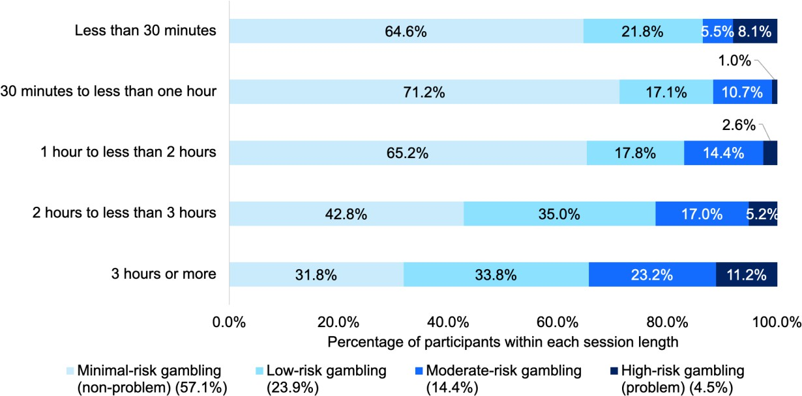

*“When you visit a… how much time do you usually spend playing…?”. Base: Subsampled respondents who gambled on casino table games in the last 12 months (n = 350).*

##### Figure 47 Usual session length amongst keno gamblers by PGSI category

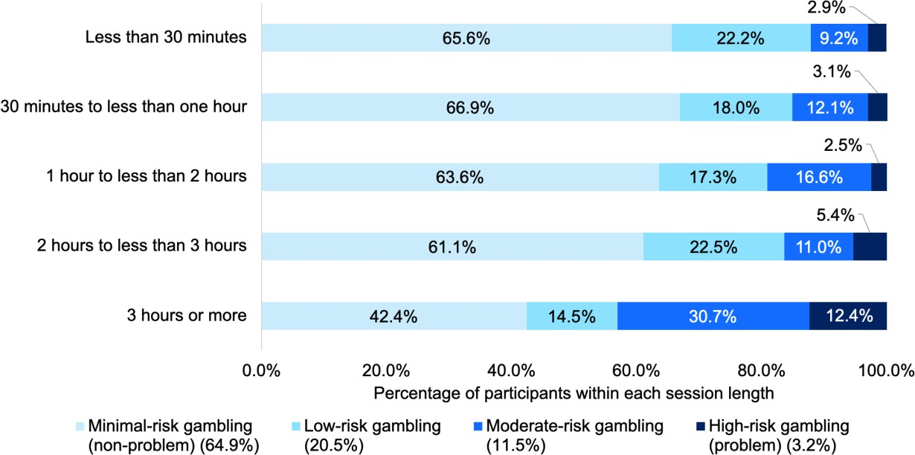

*“When you visit a… how much time do you usually spend playing…?”. Base: Subsampled respondents who gambled on keno in the last 12 months (n = 551).*

### Where respondents gamble (near home or work)

More than half of all subsampled gamblers indicated that they tended to gamble near home (58.2%), 5.8% said they gambled near work and 6.5% said they gambled near both. Approximately one in three (29.4%) reported that they gambled away from work and home. Figures were largely similar for different PGSI groups (Table 32).

##### Table 32 Where respondents gamble by PGSI category

|  |  |  |  |  |  |
| --- | --- | --- | --- | --- | --- |
|  | **All gamblers** | **Minimal-**  **risk gambling** | **Low-risk gambling** | **Moderate-**  **risk gambling** | **High-risk gambling** |
| Nearer to home | 58.2% | 57.3% | **59.9%\*\*\*** | **67.2%\*\*\*** | **59.9%\*\*\*** |
| Nearer to work | 5.8% | 5.7% | 6.7% | 4.0% | 6.9% |
| Both | 6.5% | 5.6% | **9.8%\*\*\*** | **10.1%\*\*\*** | **13.3%\*\*\*** |
| Neither | 29.4% | **31.4%\*\*\*** | 23.5% | 18.7% | 19.9% |

*“Do you normally gamble nearer your home or work?”. Base: All subsampled respondents who gambled in the last 12 months (n = 3,300). Significant effects are noted with asterisks. If present, they indicate a statistically significant difference: *p<.05, **p<.01, ***p<.001. Where multiple categories are marked in bold, they represent a combined comparison with the un-bolded group.*

### Time of day overall, and by PGSI status

When asked at which time of day they gambled, 50.1% reported during the day (between 5am and 5pm), 44.5% reported during the evening (between 5pm and midnight) and 5.4% during the night (between midnight and 5am). People in higher- risk groups were more likely to gamble during the evening and the night (Table 33).

##### Table 33 Time of day by PGSI category

|  |  |  |  |  |  |
| --- | --- | --- | --- | --- | --- |
|  | **All gamblers** | **Minimal-**  **risk gambling** | **Low-risk gambling** | **Moderate-**  **risk gambling** | **High-risk gambling** |
| During the day (between 5am and 5pm) | 50.1% | 54.8% | **33.5%\*\*\*** | **31.0%\*\*\*** | **25.8%\*\*\*** |
| During the evening (between 5pm and midnight) | 44.5% | 40.8% | **57.3%\*\*\*** | **61.3%\*\*\*** | **62.3%\*\*\*** |
| During the night (between midnight and 5am) | 5.4% | 4.4% | **9.2%\*\*\*** | **7.7%\*\*\*** | **11.9%\*\*\*** |

*“What time of day do you normally gamble?”. Base: All subsampled respondents who gambled in the last 12 months (n = 3,300). Significant effects are noted with asterisks. If present, they indicate a statistically significant difference: *p<.05, **p<.01, ***p<.001. Where multiple categories are marked in bold, they represent a combined comparison with the un-bolded group.*

Figure 48 shows the proportion of gamblers in different PGSI categories by the time of day they normally gamble. Having a PGSI score of 1 or more was more prevalent among those who gambled during the evening (compared to the day) and most prevalent late at night (between midnight and 5am).

##### Figure 48 Proportion of gamblers in each PGSI category by time of day

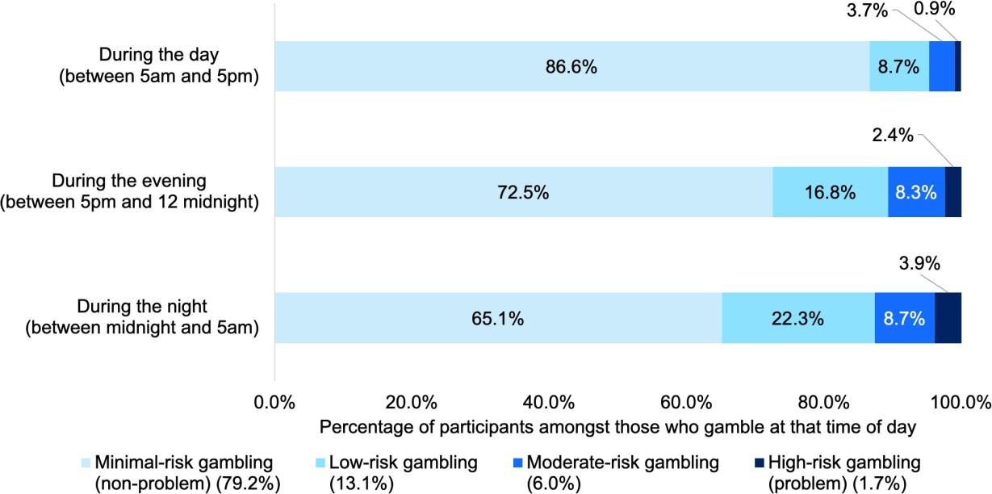

*“What time of day do you normally gamble?”. Base: All subsampled respondents who gambled in the last 12 months (n = 3,300).*

### Venues used for EGMs, keno, racing, sports, esports, lottery

The use of different modes or venues for relevant forms is outlined in Figure 49. Percentages can sum to more than 100% as participants could report multiple venues or modes of access (e.g., online, telephone call) for all forms apart from EGMs, where participants reported their preferred venue. Online gambling was not assessed for all forms. For example, online EGMs are typically available in online casinos, which were assessed as a separate category.

For EGMs, clubs and pubs/hotels were evenly split, with 47.4% preferring clubs, 48.7% preferring pubs/hotels and 3.9% preferring the casino. For keno, only 2.4% gambled online, with most (97.7%) taking part in venues. For lotteries, almost half (49.8%) bought their tickets online, with almost two-thirds (63.9%) going to venues, with most going to the newsagent.

Figure 50 shows the proportion of EGM gamblers in each PGSI category by preferred venue. Having a PGSI score of 1 or more was slightly more prevalent among those who gambled on EGMs in pubs or hotels. Keno gamblers who preferred to gamble online were more likely to have a PGSI score of 1 or more (Figure **51**). However, only 20 respondents reported doing so, so this effect should be treated with caution.

Sports and esports bettors far preferred to place bets online Figure 49, with almost nine in ten gambling online including using apps for sports and esports betting. A lower proportion of race bettors bet online (65.2%), with about a third gambling at venues such as at a racetrack (31.2%) or at a TAB kiosk or terminal in a hotel (31.4%), and 8.3% at a stand-alone TAB shop. Relatively few placed bets via phone calls (1.4% for esports, 3.4% for sports and 4.0% for racing).

##### Figure 49 Venue by gambling form, 2024

|  |  |
| --- | --- |
| **EGMS**    *(N=624)*  **Race betting**    *(n=990)*  **Esports**    *(n=62)* | **Keno**    *(N=769)*  **Sports betting**    *(n=759)*  **Lotteries**    *(n=4,093).* |

*“Over the last 12 months, did you play/place your ….? [Race betting, sporting events, esports, lotteries, keno];” and, for EGMs, “Do you most often play the pokies at a club, a pub or hotel, or a casino?”. Base: Respondents who gambled on the relevant form in the last 12 months.*

##### Figure 50 Preferred venue for EGM gambling by PGSI categories

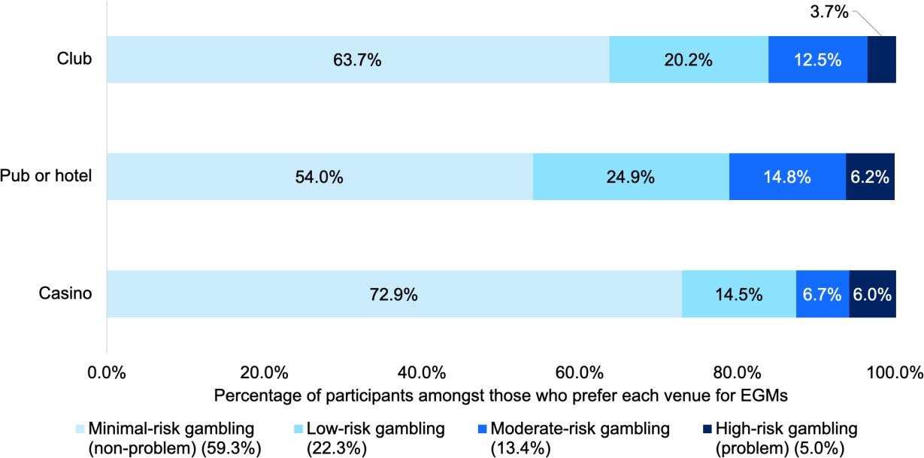

*“Do you most often play the pokies at a club, a pub or hotel, or a casino?”. Base: Subsampled respondents who gambled on EGMs in the last 12 months (n = 1,093).*

##### Figure 51 Preferred venue for keno gambling by PGSI categories

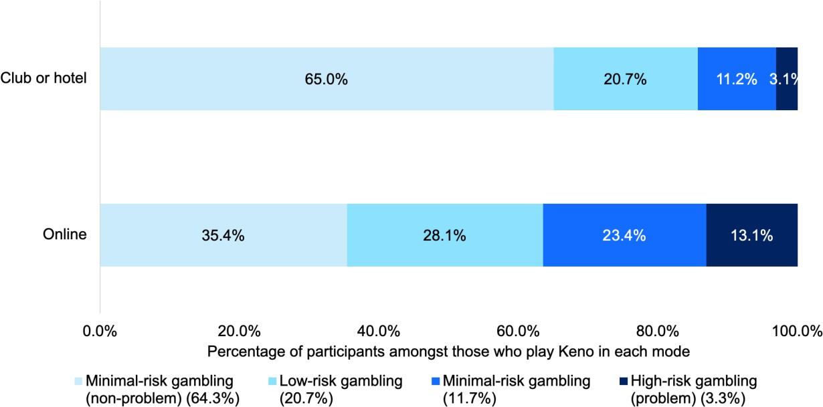

*“Over the last 12 months, did you play/place your keno;” Base: Respondents who gambled on keno in the last 12 months (n = 771).*

### Loyalty scheme membership (EGMs, casino table games)

Amongst EGM gamblers, 14.4% were members of a loyalty scheme where they were rewarded for gambling on EGMs. For casino table game gamblers, this figure was 12.1%. Amongst those who gambled on both EGMs and casino table games, 19.9% reported having a loyalty membership for one or both, with 7.2% having a loyalty membership only for EGMs, 5.3% having a loyalty membership only for casino table games, and 7.4% having a loyalty membership for both (Table 34).

Gamblers in low-, moderate- and high-risk PGSI categories were more likely to have loyalty scheme membership for EGMs and for casino table games (Figure 52).

##### Table 34 Loyalty membership by PGSI category

|  |  |  |  |  |  |
| --- | --- | --- | --- | --- | --- |
|  | **All gamblers** | **Minimal-**  **risk gambling** | **Low-risk gambling** | **Moderate-**  **risk gambling** | **High-risk gambling** |
| EGM loyalty membership | 14.4% | 10.7% | **16.2%\*\*\*** | **23.5%\*\*\*** | **26.5%\*\*\*** |
| Casino table games loyalty membership | 12.1% | 8.4% | **13.7%\*\*\*** | **21.3%\*\*\*** | **18.5%\*\*\*** |
| One or both amongst gamblers who do both forms | 19.9% | 14.7% | **20.0%\*\*\*** | **32.7%\*\*\*** | **22.7%\*\*\*** |

*“Are you a member of a loyalty scheme where you get rewarded for playing the pokies” and “are you a member of a gaming player reward or loyalty scheme?”. Base: All subsampled respondents who gambled on EGMs (n=1,105) and/or casino table games (n=359). Asterisks (if present) indicate a statistically significant difference:*

*\*p<.05, **p<.01, ***p<.001. Where multiple categories are marked in bold, they represent a combined comparison with the un-bolded group.*

##### Figure 52 Loyalty card membership for EGMs and casino table games by PGSI

**CATEGORY**

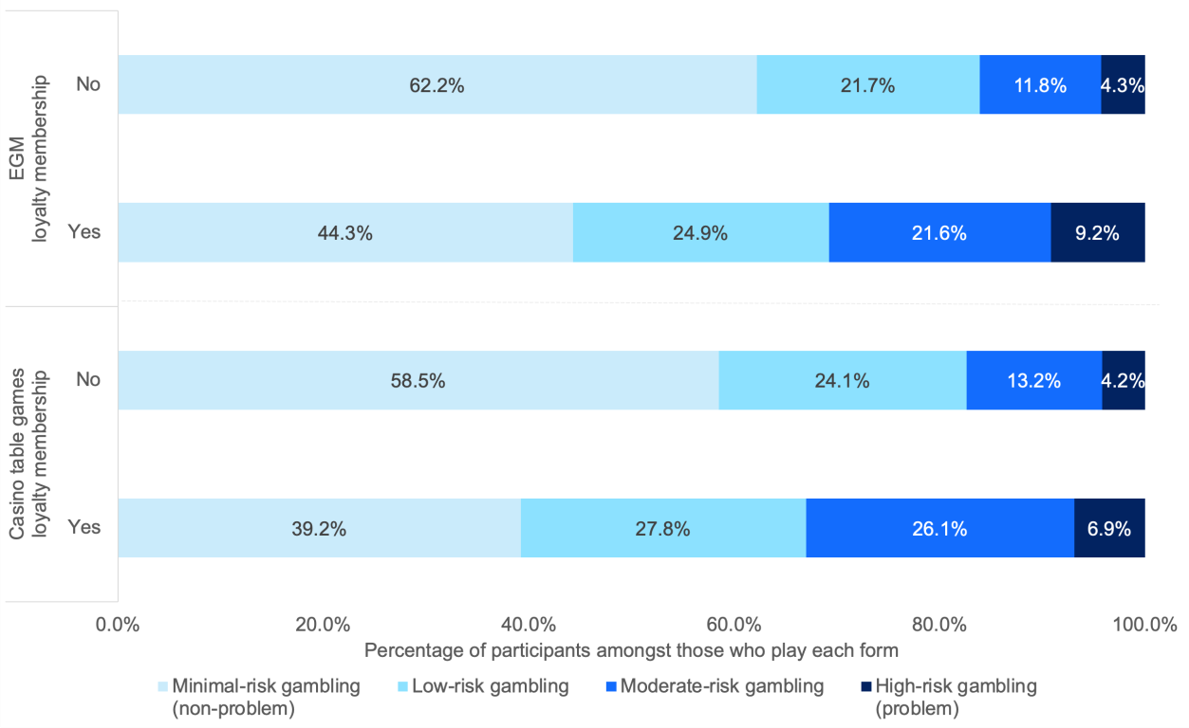

*“Are you a member of a loyalty scheme where you get rewarded for playing the pokies” and “are you a member of a gaming player reward or loyalty scheme?”. Base: All subsampled respondents who gambled on EGMs (n=1,105) and/or casino table games (n=359).*

### Favourite EGM features

EGM gamblers were asked which features of the pokies (EGMs) drew them in when deciding which one to play. Free games or spins (50.9%) and the design and artwork on the machine (49.2%) had the greatest reported influence over their decision (see Table 35).

##### Table 35 Features of EGMs that participants are drawn to

|  |  |
| --- | --- |
|  | **% yes amongst EGM gamblers** |
| Free games or spins | 50.9% |
| Design and artwork of machine | 49.2% |
| Games with large payouts | 39.1% |
| Linked jackpots | 34.2% |
| Games with frequent wins | 32.4% |
| Lighting displays | 25.0% |
| Sounds of machine | 19.0% |
| Number of lines available | 18.9% |
| “Gamble” and “Double Up” features | 15.6% |

*What features of the pokies are you drawn to when deciding which one to play? Base: Respondents who have gambled on pokies/ EGMs (n=1,105).*

### Consuming alcohol while gambling

Of the 3,300 gamblers in the subsample, more than half (57.9%) indicated that they never drank alcohol while gambling in the last 12 months. A further 12.0% said rarely and 11.1% said sometimes, while 7.4% said often and 11.7% said always.

People who gambled weekly or more often on non-lottery forms were significantly more likely to report drinking alcohol while gambling often or always (39.7%) vs those who gambled less often (16.7%, *p* < .001), as were those experiencing moderate- to high-risk gambling (36.6%) compared to those experiencing minimal- to low-risk gambling (17.6%, *p* < .001).

### Restrictions on race and sports betting

Amongst race and sports bettors, 3.5% reported being restricted from betting with a betting service provider. The following figures are based on unweighted data due to the low numbers of participants.

Amongst the 44 people who reported being restricted by a wagering operator, 21 believed that it was for winning too much, 8 due to a breach of terms and conditions, 4 due to experiencing gambling harm and 3 due to misuse of terms and conditions, with multiple responses possible.

In addition, 14 indicated that they had been restricted for another reason, such as:

* + - self-exclusion,
    - being intoxicated,
    - hitting a machine,
    - not proving their identity,
    - betting too much,
    - using someone else’s account,
    - getting angry at a provider when their winnings were reduced, or
    - the operator stated that someone tried to get into their account.

### Fantasy sports

As noted in the previous chapter, less than one percent (0.3%) of NSW adults had bet on fantasy sports games for money such as through Draftstars or Moneyball in the last 12 months. The 28 fantasy sports bettors in the subsample were asked further details about their fantasy sports betting.

Twenty-two respondents (of 28) usually engaged in season-long fantasy sports, a small number (4 of 28) usually engaged in daily fantasy sports, and two respondents refused to answer the question.

Approximately one in five of the sub-sampled respondents said they “always” (2 of 28) or “mostly” (4 of 28) engage in fantasy sports for money, whereas just over a third said they “rarely” (11 of 28) or “never” (1 of 28) do so for money.

# Chapter 10: Discussion

### Summary of key findings

The NSW Gambling Survey 2024 provides a comprehensive snapshot of gambling behaviour, problems and harm in NSW. Overall gambling participation (53.5%) has remained relatively stable since 2019 (53.0%), yet significant shifts have occurred in the prevalence and impact of specific gambling forms.

A notable trend is the continued decline in participation for several traditional gambling activities, including EGMs, race betting, instant scratchies, and keno. This decline has been counterbalanced by increases in buying lottery tickets and sports betting, particularly through online channels. The growth of online gambling is a key development, with 26.6% of NSW adults reporting some form of online gambling in the past year, predominantly for lottery tickets (20.4%), sports betting (6.7%) and race betting (6.5%).

Despite these changes in gambling patterns, the prevalence of high-risk (previously problem) gambling has remained stable at 0.9% of the adult population, consistent with the 2019 figure of 1.0%. Figures for moderate-risk and low-risk gambling were also stable from 2019, at 3.1% and 6.7% respectively, for a total of 10.7% of NSW adults experiencing low-risk, moderate-risk or high-risk gambling, or approximately one in five people who gamble. However, the survey reveals that gambling harm extends beyond those classified as experiencing high-risk gambling. Approximately 7.8% of NSW residents reported experiencing at least one harm from their own gambling, while 12.7% reported harm from someone else's gambling. These findings underscore the broader impact of gambling on individuals, families, and communities, highlighting the need for a comprehensive approach to harm minimisation that goes beyond focusing solely on the behaviour of, and impact to, those experiencing high-risk gambling.

The survey also provides insights into the demographic distribution of gambling problems and harm. Men, younger adults, and specific demographic groups such as those identifying as Aboriginal and/or Torres Strait Islanders were found to be at higher risk. Furthermore, the study identified EGMs as the primary source of gambling harm, accounting for more than half of all harm to gamblers. These findings have significant implications for targeted interventions and policy development in NSW's approach to gambling regulation and harm reduction.

### Trends in gambling participation

The survey reveals stability in overall participation but significant shifts in the prevalence of specific gambling forms. The overall gambling participation rate of 53.5% represents a continuation of the level observed in 2019 (53.0%), suggesting that the proportion of NSW adults engaging in gambling activities has plateaued after the substantial decline from 69% in 2006.

While overall participation remains stable, there have been notable changes in the types of gambling activities NSW residents engage in. Traditional forms of gambling have seen continued decline since 2019. Participation in EGMs dropped from 15.7% to 14.3%, instant scratchies from 13.0% to 11.0%, race betting from 12.9% to 9.9%, and keno from 9.5% to 7.7%. This downward trend in land-based gambling activities may reflect changing consumer preferences.

Contrasting with these declines, the survey indicates growth in certain gambling forms. Notably, buying lottery tickets increased from 37.0% in 2019 to 40.9% in 2024, and it remains the most prevalent form of gambling in NSW. Sports betting also saw an increase from 6.1% to 7.6%. This trend may reflect an increased normalisation of sport betting.

Perhaps the most significant trend identified is the growth in online gambling. The survey found that 26.6% of NSW adults engaged in some form of online gambling in the past year, with buying online lottery tickets (20.4%), online sports betting (6.7%) and online race betting (6.5%) being the most prevalent. This shift towards digital platforms represents a fundamental change in how people access and engage with gambling, presenting both new challenges for regulators and opportunities for implementing digital harm minimisation strategies. The growth in online gambling, particularly in sports betting, may be attributed to increased accessibility, aggressive marketing strategies, and the convenience offered by mobile betting applications.

### Gambling problems and risk

The survey reveals that the prevalence of problem gambling in the state has remained relatively stable, with 0.9% of the adult population experiencing high-risk gambling (previously problem gambling) according to the PGSI. This figure is consistent with the 2019 survey, which reported a high-risk gambling rate of 1.0%. The figures for moderate-risk (3.1%) and low-risk (6.7%) are also similar to the 2019 survey (2.8% and 6.6% respectively). This stability is noteworthy in the context of the changes observed in gambling participation patterns and the growth of online gambling. This pattern, whereby rates of low-, moderate- and high-risk gambling are stable or increase, in the context of markedly decreasing participation rates, means

that the proportion of gamblers experiencing low-, moderate- or high-risk gambling is increasing. This has been observed in other jurisdictions.

The survey highlights concentrations of risk among specific populations. Men, particularly those aged 18-24, are more than twice as likely to be experiencing moderate- to high-risk gambling compared to women. Other groups more likely to experience high-risk gambling include people who identify as Aboriginal and/or Torres Strait Islander, those not currently in partnerships, and individuals without tertiary education. These findings point to the intersection of social vulnerability and gambling risk, underscoring the need for targeted interventions. Notably, while younger women and LOTE speakers are less likely to gamble regularly, those who do gamble weekly face substantially higher risks, with 47.8% and 61.1% respectively classified as engaging in moderate- to high-risk gambling.

Emerging forms of gambling, particularly online platforms, present new challenges. Gamblers engaging in less common and internet-based forms such as online poker and fantasy sports show high rates of moderate- to high-risk gambling (59.6% and 41.5% respectively). Moreover, online gamblers overall are nearly five times more likely to experience moderate- to high-risk gambling compared to those who do not gamble online (9.2% vs 2.1%). Among mainstream forms, casino table games and EGMs continue to be associated with the highest proportion of those engaging in moderate- to high-risk gambling.

Frequency of gambling emerges as a critical risk factor, with almost one in three weekly gamblers (30.5%) classified as experiencing moderate- to high-risk gambling. This risk is even higher for those who gamble on casino table games (50.1%) or EGMs (35.0%) on a weekly basis. The elevated risk associated with regular gambling, particularly on these forms, suggests a need for strategies that address both the accessibility and the potentially addictive features of these games and interventions targeted towards regular gamblers.

### Gambling harm

The NSW Gambling Survey 2024 provides crucial insights into gambling harm, and a more complete picture of impact than what is captured by PGSI categories alone. A significant proportion of the population - 14.5% of gamblers and 7.8% of all NSW residents - reported experiencing at least one harm from their own gambling in the past year. These harms predominantly manifest as emotional and financial impacts, with common experiences including feelings of regret, shame and distress, as well as reduction in savings and decreased spending on other recreational activities.

While severe indicators of social dysfunction, such as violence or illegal activities, are relatively rare (reported by less than 1% of NSW residents), the cumulative impact of gambling harm on the population is substantial.

Quantifying this impact in terms of health utility, the survey estimates a total of 105,515 Years Lived with Disability (YLD) due to gambling harm among NSW gamblers. This burden is not evenly distributed across the gambling population. Despite comprising only about 10% of gamblers, those who gamble more than once a week account for approximately one-third of the total harm. Similarly, individuals spending over $300 per annum on gambling make up about 40% of the gambling population but are responsible for about 75% of the total impact. These findings highlight the disproportionate harm associated with more regular and higher-spend gambling behaviours. They are also suggestive of the most appropriate targeting of interventions towards high-spending and regular gamblers.

The survey also reveals significant demographic disparities in gambling harm. Younger men under 45 years of age bear about half of the total impact (50,548 YLD). Other population segments experiencing a disproportionate burden of harm include Aboriginal and/or Torres Strait Islanders, LOTE speakers, those not in a relationship, those without tertiary education, and those living alone. These findings underscore the importance of considering social, cultural and demographic factors in developing harm minimisation strategies.

Importantly, the impact of gambling extends beyond the gamblers themselves. The survey found that 12.7% of NSW residents reported experiencing at least one harm from someone else's gambling, with the total impact on affected others estimated at 158,877 YLD - approximately 1.5 times the impact on gamblers themselves. This harm to affected others is more evenly distributed across age and gender, although women generally tend to incur more harm than men, almost certainly due to the gambling problems of their partners and other family members. Those experiencing the least harm from the gambling of others were older men with tertiary degrees.

Additionally, 7.1% of NSW residents reported currently experiencing legacy impacts from gambling they engaged in more than 12 months ago, with those who identify as Aboriginal and/or Torres Strait Islander being disproportionately affected. In total, one in five NSW residents (21.0%) reported experiencing at least one harm from either their own gambling, another's gambling, or legacy gambling harm.

### Converging evidence on sources and segments of impact

The approach taken in this prevalence survey combined measures of gambling frequencies on various forms, problems, harm, life satisfaction and self-reported expenditure. Taken together, these measures provide a clear picture of the sources of gambling impact, and the segments of the population that incur these impacts.

The survey reveals that EGMs are responsible for more than half of all harm to gamblers (57,832 Years Lived with Disability or YLD), followed by wagering products

and casino games. This is consistent with prior analyses of Australian population gambling data (Browne et al, 2023). This finding underscores the disproportionate impact of certain gambling forms, even as others like lotteries, keno, and bingo show no statistically detectable harm despite their wide uptake in the population.

Importantly, the study highlights the intersecting effects of age, gender and education on the distribution of gambling harm. Younger men (under 40) without a tertiary degree are the group that experience the most harm from their own gambling (27,583 YLD), while older women with degrees experience the least harm (6,920 YLD). This pattern shifts when considering harm from others' gambling, with younger women without tertiary degrees experiencing the most harm (26,706 YLD).

The strong correlation between gambling harm (GHS-10) and gambling problems (PGSI) (r = .73) supports the validity of both measures, while their equal correlation with lower life satisfaction (r = -.24) is a source of external validity. Crucially, the study shows that harm extends beyond those experiencing high-risk gambling (previously problem gambling). While nine in ten of those experiencing high-risk gambling report one or more harms, 6.0% of those experiencing minimal-risk gambling (previously non-problem gambling) also report experiencing harm.

The additive and independent effects of problems and harm on life satisfaction provide further evidence for considering the full spectrum of gambling impact. Those experiencing minimal-risk gambling reporting at least one harm show significantly lower life satisfaction (7.8/10) compared to their unharmed counterparts (8.3/10), with those at high-risk who also report harm showing the lowest life satisfaction (6.4/10). This finding supports the large body of psychometric studies supporting the validity of the GHS-10 as an index of impact to quality of life. Consistent with prior research, even those experiencing low-risk gambling and those scoring 1-2 on the GHS-10 report lower life satisfaction that those scoring zero on either instrument.

Self-reported expenditure data further supports this comprehensive view of gambling impact. Individual spend on gambling is highly variable due not only to behavioural addiction, but primarily due to the amount of discretionary income available. Those experiencing minimal-risk gambling spend an average of $309 annually on gambling (compared to $13,906 for those at high-risk) and account for only 13.7% of total gambling losses. Most losses (86.3%) come from those experiencing low-risk, moderate-risk, and high-risk gambling combined. Even within PGSI categories, extraordinary spends are concentrated within a minority of individuals. Many persons experiencing harm or problems from gambling have very little capacity to bear unexpected expenses, and intermittent losses of a few hundred dollars can causes financial problems.

These converging lines of evidence – from health utility measures, problem gambling screens, life satisfaction indices, and expenditure data – collectively build a

compelling case for considering gambling impact across the entire spectrum of people experiencing problems and/or harm. While severe cases of high-risk gambling with concomitant harm undoubtedly require focused attention, this study demonstrates that a significant portion of gambling harm occurs among those not classified as experiencing high-risk gambling.

### Contribution of different forms to population impact

Although many individuals gamble on multiple forms, this covariation is relatively low in statistical terms. Accordingly, this methodology allows us to tease out the contributions of specific forms in driving gambling problems and harm.

Electronic Gaming Machines (EGMs) emerge as the primary source of gambling harm, accounting for more than half of all harm to gamblers (57,832 YLD). This disproportionate impact can be attributed to a combination of (a) widespread availability and relatively high participation rate, and (b) several structural characteristics of EGMs that make them particularly hazardous. These include high event frequency, near-miss features, losses disguised as wins, and variable ratio reinforcement schedules. Such features can promote continuous gambling and loss- chasing behaviours, potentially leading to more rapid development of problematic gambling patterns. The ubiquity of EGMs in regional and metropolitan NSW, their accessibility in community venues, and their capacity to deliver high-intensity gambling experiences further contribute to their outsized role in gambling harm.

Wagering products, including horse racing and sports betting, follow EGMs as significant contributors to gambling harm. The increasing contribution of sports betting, particularly in its online form, is a notable trend. This rise can be linked to the growing accessibility of online betting platforms, aggressive marketing strategies, and the integration of betting into sports media and culture. The 24/7 availability of online betting, combined with features like receiving frequent inducements to bet, can foster impulsive gambling behaviours and make it challenging for moderate- to high-risk individuals to disengage from gambling activities.

Interestingly, the dominance analysis reveals that lotteries, keno and bingo have no statistically detectable connection to gambling harm or problems when accounting for participation in other forms of gambling. This finding is particularly striking given the widespread buying of lottery products. The relatively benign nature of these activities may be attributed to their structural characteristics - typically involving low- frequency draws, small stake sizes, and an absence of features that encourage continuous gambling.

The importance analysis conducted in this study is a significant strength, allowing for a precise attribution of harm to specific gambling forms. This approach accounts for

the fact that many gamblers engage in multiple forms of gambling at differing frequencies, providing a clearer picture of which activities are most problematic. The contrast between the harm attributed to EGMs and sports betting versus lotteries and keno provides evidence for the relative impact of different gambling forms on harm experienced by individuals and communities in NSW.

### Demographic segments of specific concern

Based on the findings from the 2024 survey, gambling-related risk and harm are not evenly distributed across the population. The survey reveals complex and sometimes counterintuitive patterns of vulnerability among different demographic groups.

Young men aged 18-24 show the highest risk of experiencing moderate- or high-risk gambling (9.4%). However, for women risk increases again in the 45-54 age group. Similar effects have been observed in other Australian jurisdictions (Rockloff et al., 2020), suggesting that gendered life-course effects play a role in gambling risk. The picture for women is particularly complex. On one hand, younger women who gamble weekly are at very high risk, with 47.8% classified as participating in moderate- to high-risk gambling. However, women aged 18-39 are much less likely to gamble weekly compared to men. Only 1.3% of women in this age group gamble weekly or more often, compared to 8.0% of men in the same age range. In contrast, men aged 18-39 not only gamble more regularly but also show a high risk when they do so, with 37.6% of weekly gamblers in this group classified as engaging in moderate- to high-risk gambling Given the higher prevalence of regular gambling among young men (8.0% gambling weekly or more), this translates to a larger absolute number of individuals who are moderate- to high-risk gambling in this demographic. The pattern for young women parallels that of some other groups, such as LOTE speakers (see below), in that it is less common for them to gamble regularly but those who do are at greater risk.

One of the most striking findings relates to people who speak a language other than English (LOTE) at home. While this group shows much lower overall gambling participation (37.3% compared to 56.3% for English speakers), those who do gamble regularly face substantially higher risk. Among weekly gamblers, 61.1% of LOTE speakers are classified in the moderate- to high-risk gambling groups, compared to 27.9% of English speakers. This discrepancy is further reflected in the distribution of harm, with LOTE speakers accounting for 16.4% of gambling harm (measured in YLD) despite comprising only 14.6% of the population.

Similarly complex patterns emerge for Aboriginal and/or Torres Strait Islander people. This group shows higher overall gambling participation (60.9% compared to 53.3% for non-Indigenous people) and are more likely to gamble weekly (13.0% vs

5.0%). Moreover, when they do gamble weekly, they are much more likely to experience moderate- to high-risk gambling (44.2% vs 29.6% for non-Indigenous weekly gamblers). The cumulative effect of these factors is stark: while making up 3.4% of the population, Aboriginal and Torres Strait Islander people account for 8.2% of gambling harm and 8.6% of harm to affected others.

Education level also emerges as a significant factor. Those without tertiary education are not only more likely to gamble (60.7% vs 46.7% for those with tertiary education) but are also at higher risk of being classified as experiencing moderate- or high-risk gambling (5.6% vs 2.5%). This translates to a disproportionate burden of harm, with this group accounting for 65.3% of gambling harm despite comprising only 49.5% of the population.

Comparing the effects of education and indigeneity illustrates the importance of considering both prevalence and severity of risk factors. Although Aboriginal or Torres Strait Islander identification is a larger risk factor at the individual level than non-tertiary education, 3.4% of the population identify as Aboriginal or Torres Strait Islander, as opposed to 49.5% of the population in the case of non-tertiary education. This demographic distribution affects the overall impact of these risk factors at the population level.

Marital status presents another area of vulnerability. Individuals who are not currently married or living with a partner are at higher risk of experiencing moderate- or high- risk gambling (5.3% vs 3.1% for those in relationships). They account for 55.2% of gambling harm while making up 42.2% of the population, suggesting that social and interpersonal factors play a role in gambling behaviour and outcomes.

The survey highlights elevated risks associated with online gambling, with online gamblers being at almost five times the risk of experiencing moderate- to high-risk gambling (9.2%) compared to those who do not gamble online (2.1%). However, this effect is not uniform across all forms of gambling. For instance, in sports betting, there's no significant difference in risk between online and offline gambling.

Geographical location plays a complex role in gambling behaviour and risk. Those outside of Sydney show higher overall gambling participation (59.7% vs 50.2% for Greater Sydney), with notable differences in preferred gambling forms. EGMs, race betting and keno are significantly more prevalent in regional areas. Despite lower overall participation, among weekly gamblers, those in Greater Sydney are at somewhat higher risk (34.1% vs 25.8%). This suggests that while regional areas have higher participation rates, regular gambling in urban areas may be associated with greater risk, possibly due to factors such as greater accessibility to diverse gambling options. Alternatively, greater normalisation of gambling, or lack of alternative entertainment in regional areas, may both contribute to a broader section of society gambling regularly, but not necessarily experiencing higher risk of

problems. These geographic variations highlight the diverse patterns of gambling behaviour and associated risks across different areas of NSW.

These findings paint a picture of intersecting vulnerabilities and risk factors in gambling behaviour and harm. These findings underscore the importance of considering factors beyond overall participation rates when examining gambling behaviour and its impacts. The data reveals varying patterns of risk and vulnerability across different population segments. This provides valuable context for understanding the diverse experiences of gambling within NSW communities. The intersecting nature of these risk factors and vulnerabilities highlights the complexity of gambling behaviour and its potential consequences across different demographic groups.

### A focus on affected others

The survey marks an advancement in our understanding of gambling harm by incorporating not only the Gambling Harms Scale (GHS-10) but also its companion scale for affected others (GHS-10-AO). As done recently in other jurisdictions, this inclusion represents a crucial step forward in gambling prevalence research, addressing a historical neglect of the impacts on individuals affected by someone else's gambling. By quantifying harm in terms of YLD due to reduced Health-Related Quality of Life, this study provides a more comprehensive picture of gambling's societal impact.

The findings reveal that the harm experienced by affected others is approximately

1.5 times greater than that experienced by gamblers themselves, with 158,877 YLD incurred compared to 105,515 YLD for gamblers. This difference underscores the consequences of gambling beyond the individual gambler. Importantly, the current findings do not include estimates of harm amongst children, as the survey only included those aged 18 or older. Therefore, this estimate of harm to others, including legacy harms, is likely to be a considerable underestimate of the amount of harm in the population.

The prevalence of harm to affected others is considerable, with over one in ten NSW residents (12.7%) reporting at least one harm from another person's gambling. It should be emphasised that even respondents reporting only one harm reported significantly lower life satisfaction in the present survey (*B* = -.34, *p* = .011), supporting prior evidence for the validity of the measure, and further undermining the idea that lower levels of reported harm should be discounted.

This figure emphasises the widespread nature of gambling's negative impacts throughout the community. The most frequent harms reported include reduced enjoyment of time spent with loved ones (7.4%), feelings of anger about the other person's gambling (7.2%), and feelings of hopelessness (6.6%). These findings

highlight the fact that, although the immediate impact of excessive gambling is financial, there are subsequent emotional and relational impacts on families and social networks.

Importantly, the distribution of harm among affected others shows different patterns compared to harm experienced by gamblers. While gambling harm is heavily skewed towards younger men, harm to affected others is more evenly spread across age and gender, though women generally tend to incur more harm than men. This gender disparity likely reflects broader societal patterns of heterosexual relationships, caregiving responsibilities and financial interdependence in relationships.

The study also reveals complex intersections of age, gender, and education in the distribution of harm to affected others. Younger women without a tertiary degree were found to incur the most harm (26,706 YLD), while older men with a tertiary degree experienced the least (13,586 YLD). This discrepancy almost certainly stems from the simple fact that a younger woman without a tertiary degree is more likely to be in a close, financially interdependent relationship with a person engaging in moderate- to high-risk gambling than the converse demographic. Again, this pattern suggests that socioeconomic factors play a significant role in vulnerability to gambling harm.

Certain demographic groups emerge as particularly vulnerable to experiencing harm as affected others. These include individuals living in group households or other non- traditional living arrangements, unemployed persons, those who identify as Aboriginal and Torres Strait Islander, and to a lesser extent, those who speak a language other than English at home. These findings point to the compounding effects of social vulnerability on gambling harm. Moreover, 7.1% of NSW residents reported current experience of legacy impacts from gambling that they did more than 12 months ago, either from one own’s or others’ gambling. This effect appears to be particularly pronounced among Aboriginal and Torres Strait Islander people.

### Limitations

This report is subject to limitations, many of them applicable to all CATI surveys of this kind.

**Representativeness:** Sampling of the IPND dataset was effective, leading to higher response rates than obtained in comparable RDD CATI surveys in recent years, and yielding a sample that matched the NSW population very closely on key demographic characteristics. Nevertheless, the completion rate is low in absolute terms (7.9%). The completion rate is principally determined by ability to contact potential participants on mobile phone numbers, and willingness of the respondent to

participate voluntarily. Although there is no evidence that this contributed to non- representativeness, we cannot discount the possibility. For example, it could be the case that more agreeable and sociable residents are more willing to participate, and that these individuals are less likely to experience gambling harm. If so, this would bias our estimates lower.

**Censored data:** It is a practical necessity to implement question skip logic so as to only ask questions where they are likely to be relevant, in order to reduce total interview time. This is unlikely to cause issues in most cases, for instance only asking questions about current gambling harm of those who currently gamble.

However, in some scenarios this might result in missing information. For example, gambling may have ceased before the last 12 months, but an individual may still be experiencing harms (e.g. struggling to pay off a credit card debt) from that prior gambling. Also, to reduce burden on participants, less prevalent harms were only asked of those who answered positively to at least one item on the GHS-10. Prior statistical evidence suggests that very few individuals who score zero of the GHS-10 would answer positively to any other harm. However, estimates of the prevalence of these items may be subject to small downward bias.

**Gambling spend:** The present survey only asked about gambling spend overall, rather than with respect to each from on which participants gambled. While doing so is time-consuming, more reliable and nuanced information about gambling spend can be obtained by asking about spend on each form.

**Self-report data**: Self-report data may be biased by memory and self-report biases. In addition, some questions may be open to a degree of interpretation. For example, frequency questions asked “how often” people engaged in a form, rather than “how many days”. This measure is difficult to standardise across forms when some forms may lend themselves to playing for a continuous period (e.g., EGMs), while others are more likely to involve discrete bets/purchases (e.g., sports betting, lotteries).

### Conclusion

The NSW Gambling Survey 2024 aimed to provide a comprehensive and up-to-date picture of gambling behaviour and associated harms in the state. The survey's findings offer an evidence base for policy decisions, highlighting several key areas of interest:

**Gambling participation:** Overall gambling participation has remained stable at 53.5% since 2019, but there have been significant shifts in preferred gambling forms. Traditional activities like EGMs and race betting have declined, while buying lottery tickets and sports betting have increased. The growth of online gambling, particularly

for lottery tickets (20.4%), sports betting (6.7%) and race betting (6.5%), represents a notable trend.

**Prevalence of high-risk gambling:** The rate of high-risk gambling (previously problem gambling) has remained stable at 0.9% of the adult population. However, the survey reveals that 21.0% of NSW residents report being currently impacted by gambling in some way, either through their own gambling, someone else's, or as a legacy of past gambling.

**Gambling harm:** The survey quantified gambling harm using health and quality of life measures, estimating 105,515 YLD due to gamblers' own gambling, and 158,877 YLD due to the impacts on affected others. This approach provides a tangible metric that incorporates both prevalence and severity. It allows for the comparison of gambling's impact to other public health issues as well as differential impact to various population segments.

**High-risk groups and activities:** The survey identified several demographic groups at higher risk of experiencing high-risk gambling or gambling harm, including young men, people identifying as Aboriginal and/or Torres Strait Islander, and those without tertiary education. EGMs were identified as the primary source of gambling harm, accounting for more than half of all harm to gamblers.

**Gambling expenditure:** The survey used robust statistical methods to analyse self- reported gambling expenditure, revealing important relationships between spending, PGSI category, and harm. While those experiencing minimal-risk (previously non- problem) gambling comprise 80.0% of the gambling population, they account for only 13.7% of total gambling losses. Although all self-reported spends tend to be underestimates, those experiencing high-risk gambling (previously problem gambling) reported spending an average of $13,906 per annum, about 45 times that of those at minimal-risk ($309). Interestingly, gamblers reporting any level of harm account for only 24.6% of gambling losses, suggesting that harm can occur at relatively low levels of expenditure for individuals with limited financial capacity.

**Online gambling:** The survey highlighted the growing prominence of online gambling, with 26.6% of NSW adults reporting some form of online gambling in the past year. Online gamblers were found to be at almost five times the risk of experiencing moderate- to high-risk gambling compared to those who do not gamble online.

**Help-seeking behaviours:** Only 13.5% of those experiencing moderate- to high-risk gambling reported seeking help for gambling-related issues. Among those who did seek help, personal support (such as talking to family or friends) was the most common form (71.4%), followed by professional help (41.5%).

**Attitudes towards gambling:** A substantial majority of NSW residents (79.7%) believe that gambling has done more harm than good for the community, consistent with the 2019 findings. However, about four in five respondents (78.1%) agreed that it is the individual's responsibility to manage their own gambling.

These findings, along with other data presented in the survey, provide valuable insights into the current gambling landscape in NSW. By presenting this comprehensive data, the survey fulfills its purpose of informing stakeholders about the nature and extent of gambling and gambling-related harm in NSW. This information will provide a solid foundation for future policy responses.

# References

AC Nielsen. (2007). *Prevalence of gambling and problem gambling in NSW - A community survey 2006*. NSW Office of Liquor, Gaming and Racing.

Ashing-Giwa, K. T. (2005). The contextual model of HRQoL: a paradigm for expanding the HRQoL framework. *Quality of Life Research, 14*, 297-307.

Australian Gambling Research Centre (AGRC) (2023). Gambling in Australia.

*Australian Institute of Health and Welfare*.

Braverman, J., Tom, M. A., & Shaffer, H. J. (2014). Accuracy of self-reported versus actual online gambling wins and losses. *Psychological Assessment, 26*(3), 865–877. https://doi.org/10.1037/a0036428

Browne, M., Delfabbro, P., Thorne, H. B., Tulloch, C., Rockloff, M. J., Hing, N., Dowling, N. A., & Stevens, M. (2023). Unambiguous evidence that over half of gambling problems in Australia are caused by electronic gambling machines: Results from a large-scale composite population study. *J Behav Addict*, *12*(1), 182–193. https://doi.org/10.1556/2006.2022.00083

Browne, M., Goodwin, B. C., & Rockloff, M. J. (2017). Validation of the Short Gambling Harm Screen (SGHS): A Tool for Assessment of Harms from Gambling. *J. Gambl. Stud.* https://doi.org/10.1007/s10899-017-9698-y

Browne, M., Newall, P., Rawat, V., Tulloch, C., Rockoff, M., Li, E., Hing, N., Russell,

* + 1. M. T., & Begg, S. (2023). *The Gambling Harms Scales: Instruments to assess impact to gamblers and affected others that are benchmarked to health utility*. Victorian Responsible Gambling Foundation. https://responsiblegambling.vic.gov.au/resources/publications/the-gambling- harms-scales-instruments-to-assess-impact-to-gamblers-and-affected-others- that-are-benchmarked-to-health-utility-1206/

Browne, M., Rockloff, M., Hing, N., Russell, A., Murray Boyle, C., Rawat, V., Tran, K., Brook, K., & Sproston, K. (2019). *NSW Gambling Survey 2019*. NSW Responsible Gambling Fund.

Ferris, J. A., & Wynne, H. J. (2001). The Canadian problem gambling index (pp. 1- 59). Ottawa, ON: Canadian Centre on substance abuse.

Genizi, A. (1993). Decomposition of R^2 in Multiple Regression with Correlated Regressors. *Statistica Sinica*, *3*(2), 407–420.

Groemping, U. (2007). Relative Importance for Linear Regression in R: The Package relaimpo. *Journal of Statistical Software*, *17*, 1–27. https://doi.org/10.18637/jss.v017.i01

Hampel, F. R., Ronchetti, E. M., Rousseeuw, P. J., & Stahel, W. A. (2005). Linear Models: Robust Estimation. In *Robust Statistics* (pp. 307–341). John Wiley & Sons, Ltd. https://doi.org/10.1002/9781118186435.ch6

Hing, N., Russell, A.M.T., Rockloff, M., Browne, M., Rawat, V., Bryden, G., Greer, N., Thorne, H., Newall, P., Dowling, N., & Merkouris, S. (2024). *Catalyst or circuit- breaker? A prospective study to assess COVID-19’s effects on relationships between gambling availability, gambling and harmful gambling, and social, psychological and financial wellbeing.* Victorian Responsible Gambling Foundation.

Queensland Government Statistician’s Office. (2024). *Australian gambling statistics*. https:/[/www.qgso.qld.gov.au/statistics/theme/society/gambling/australian-](http://www.qgso.qld.gov.au/statistics/theme/society/gambling/australian-) gambling-statistics

Rockloff, M., Browne, M., Hing, N., Thorne, H., Russell, A., Greer, N., Tran, K., Brook, K., & Sproston, K. *Victorian population gambling and health study 2018-2019*. Victorian Responsible Gambling Foundation.

Sproston, K., Hing, N., & Palankay, C. (2012). *Prevalence of Gambling and Problem Gambling in New South Wales*. NSW Office of Liquor, Gaming and Racing. https:/[/www.responsiblegambling.nsw.gov.au/](http://www.responsiblegambling.nsw.gov.au/) data/assets/pdf_file/0018/138

123/Prevalence-of-gambling-and-problem-gambling-in-NSW.pdf

Venables, W. N., & Ripley, B. D. (2002). *Modern Applied Statistics with S*. Springer. https://doi.org/10.1007/978-0-387-21706-2

# Appendices

### Subsampling and weighting

This section provides further detail around the weighting procedure used, allowing the methods section in Chapter 2 to remain approachable to most audiences, while providing further information for interested readers. Full details of the weighting are provided in the Technical Report.

##### Weighting data

While the sampling method (randomly calling telephone numbers from the IPND) was expected to provide a sample that had similar age, gender and location characteristics to the NSW adult population, it is standard practice with population studies to apply weighting to ensure that the sample more closely aligns to the population. Population data are required for weighting variables (age, gender and location) to conduct this weighting.

The population data were the June Quarter 2024 data from the Centre for Population 2023, Population Statement: Capital City and Rest-of-State Population Projections, 2022-23 to 2033-34, published by the Australian Government, Canberra. These data include population projections for males and females in Sydney and the Rest of NSW, for each age from 0 to 84, and then a bracket for 85+. These data were used to apply corrective weights for age and location (Sydney vs rest of NSW), as reported by the participants. There were no missing data for these questions, as participants were required to answer them to confirm eligibility to continue with the survey.

At the time of writing, the Australian Bureau of Statistics collects data for sex, while the survey captured gender. The population data includes categories for males and female, while the gender question includes male/man, female/woman, other (with responses captured verbatim), as well as refused and don’t know. Participants who reported a gender of male/man were weighted using the male population data, while participants identifying as female/woman were weighted using the female population data. We note that for some participants, there may be a disparity between their reported gender and their biological sex. No weighting data are available for people who identify as a gender other than men or women, or who refuse to report their gender or who do not know their gender. A total of 88 participants did not identify as either a man or woman, with 38 identifying as a gender other than man or woman, 39 refused to answer and 11 stated they did not know. Some of the verbatim responses for people who identified as a gender other than man or woman were non-binary, no gender, other, them/them, trans, trans man, transexual, transexual

woman, trans nonbinary agender and unspecified. As there are no normative data for people who identify as another gender, or refuse or don’t know, it is impossible to weight them, which would mean that these participants could not be included in any weighted analyses, i.e., the entire report. Therefore, purely for weighting purposes, a

“hot deck” approach was used, where these 88 people were assigned to be male or female purely for the purpose of weighting. This approach allowed weights to be calculated on their other demographic features and so that participants could be included in analyses. Importantly, this assignment was only used for the purpose of weighting. For any gender analyses, participants who reported another gender were treated as a combined non-binary/gender diverse category, while those who refused or did not know were excluded from gender analyses but included in any other analyses. This statistical procedure should not be construed as ignoring or downplaying important issues around gender diversity. However, we acknowledge the limitations of the approach in terms of assuming alignment between gender (survey) and sex (population), as well as the lack of population data for gender in general, including people who identify as genders other than men or women.

##### Weighting calculations

Weights were calculated for combinations of gender (2 levels), location (2 levels, Sydney vs rest of NSW) and age brackets (18-24, 25-29, 30-34 etc to 70 and over). These age groupings contained sufficient data for weighting, with a minimum cell size of 634 cases. Weightings were calculated by comparing the proportion of the sample in each cell to the proportion of the population in each cell (with proportions based on adult participants only, 18+), and calculating a calibration factor, which is different for each combination of conditions (i.e., 18-24 female from Sydney has a different calibration to 18-24 female from the rest of NSW), but the same for all people within a combination of conditions. Cells that are underrepresented in the sample compared to the population are weighted “up” (i.e., have a normalised weight greater than 1), while those in overrepresented cells are weighted “down” (i.e., have a normalised weight of less than 1).

In addition, participants were asked to report how many mobile phones they have access to, both personal and for business purposes. Participants who had access to more than one mobile phone had an increased chance of being selected in the sample and appropriate weighting was also included to account for this by down- weighting these responses. The full details, including calculations, are shown in the Technical Report.

The above weights were used for all questions that were asked of the main sample of 10,000 people. In addition, some questions were only asked of a subsample of participants. For these questions participants were categorised into one of three groups, either:

1. People who had not gambled in the last 12 months
2. People who had gambled in the last 12 months, but did so less than weekly and had a PGSI score of 0, and
3. People who had gambled in the last 12 months at least weekly, and/or had a PGSI score of 1 or higher.

To calculate at-least weekly gambling, participants who endorsed any gambling forms were asked how often they had engaged in that form in the last 12 months. Responses were summed across forms to calculate a total number of times per year, excluding lotteries, overseas lotteries and scratchies, on the basis that these are lower-risk forms. Participants who reported refused or don’t know for the frequency for any form were treated as 0 times per year on that form for this calculation only.

Subsampling was used to allow more questions to be asked, as only some participants were asked each question. This allowed for the inclusion of more questions while retaining a reasonable average survey length to minimise participant attrition. All participants in subsample 3 were included, half of participants in subsample 2 were included, and one-quarter of the participants in subsample 1 were included. To correct for this subsampling, within each of the subsamples, the subsample was weighted against the population by age, gender and location, using similar calculations to above, while also weighting for differential selection due to the subsampling procedure. Therefore, any questions asked of the subsample, when weighted should reflect the population, even though fewer non-gamblers and non- regular gamblers were subsampled.

For each weight (the full sample and the subsamples), two versions are present in the data. For each, one version weights the sample up to the population, so that the total weighted N equals the number of adults in the NSW population based on the population data. These weights were used for statistics pertaining to the population of NSW, with normalised weights factored up by the target population divided by the size of the sample; i.e. 6,649,900 / 10,000. The second version weights the sample to the number of people who were asked the question. Thus, the weights for the full sample have either an N of 6,649,900 (the number of adults in the NSW population from the prevalence data) or N of 10,000 (the number of participants who are in the full sample).

When weights are applied, each person does not necessarily count for an n of 1 in an analysis. This can lead to confusing finding where, for example, an unweighted n of 40 out of 100 participants answered a question a particular way, but the weighted n is not 40%. This is especially true for questions asked of the subsample. For this reason, we have opted not to report unweighted or weighted ns in the body of the report, and instead report weighted percentages. The unweighted and weighted ns for key variables are reported in an appendix.

Table 36 and Table 37 compares unweighted and weighted sample sizes for the full sample and the subsample, respectively.

##### Table 36 Unweighted and weighted N for select variables in the full sample

|  |  |  |  |  |  |  |
| --- | --- | --- | --- | --- | --- | --- |
|  | **Unweighted**  **n** | **Weighted**  **n** |  |  | **Unweighted**  **n** | **Weighted**  **n** |
| **Gender** | | |  | **Location** | | |
| Men | 5,223 | 4,867 |  | Greater Sydney | 6,591 | 6,558 |
| Women | 4,689 | 5,050 |  | Rest of NSW | 3,409 | 3,442 |
| Other | 38 | 34 |  | **Main language at home** | | |
| Refused | 39 | 37 |  | English only | 8,409 | 8,510 |
| Don’t know | 11 | 11 |  | LOTE speaker | 1,560 | 1,461 |
| **Age groups** | | |  | Refused | 28 | 26 |
| 18-24 | 1,442 | 1,134 |  | Don’t know | 3 | 3 |
| 25-34 | 1,910 | 1,840 |  | **Gambled in the last 12 months** | | |
| 35-44 | 1,667 | 1,776 |  | No | 4,630 | 4,653 |
| 45-54 | 1,531 | 1,549 |  | Yes | 5,370 | 5,347 |
| 55-64 | 1,347 | 1,443 |  | **Online gambler in the last 12 months** | | |
| 65+ | 2,103 | 2,257 |  | No | 7,289 | 7,342 |
| **Aboriginal and/or Torres Strait Islander** | | |  | Yes | 2,711 | 2,658 |
| No | 9,557 | 9,571 |  | **PGSI group** | | |
| Yes | 351 | 341 |  | Non-gambler | 4,630 | 4,653 |
| Refused | 63 | 62 |  | Minimal-risk | 4,231 | 4,279 |
| Don’t know | 29 | 25 |  | Low-risk | 704 | 667 |
|  |  |  |  | Moderate-risk | 338 | 310 |
|  |  |  |  | High-risk | 97 | 91 |

*Note: Please see Chapter 2 for a discussion around PGSI terminology.*

##### Table 37 Unweighted and weighted N for select variables in the subsample

|  |  |  |  |  |  |  |
| --- | --- | --- | --- | --- | --- | --- |
|  | **Unweighted**  **n** | **Weighted**  **n** |  |  | **Unweighted**  **n** | **Weighted**  **n** |
| **Gender** | | |  | **Location** | | |
| Men | 2,473 | 2,123 |  | Greater Sydney | 2,849 | 2,868 |
| Women | 1,863 | 2,214 |  | Rest of NSW | 1,525 | 1,506 |
| Other | 12 | 12 |  | **Main language at home** | | |
| Refused | 22 | 22 |  | English only | 3,748 | 3,724 |
| Don’t know | 4 | 3 |  | LOTE speaker | 609 | 634 |
| **Age groups** | | |  | Refused | 16 | 15 |
| 18-24 | 652 | 496 |  | Don’t know | 1 | 1 |
| 25-34 | 822 | 805 |  | **Gambled in the last 12 months** | | |
| 35-44 | 713 | 777 |  | No | 1,062 | 2,035 |
| 45-54 | 707 | 677 |  | Yes | 3,312 | 2,339 |
| 55-64 | 606 | 631 |  | **Gambled online in the last 12 months** | | |
| 65+ | 874 | 987 |  | No | 2,617 | 3,216 |
| **Aboriginal and/or Torres Strait Islander** | | |  | Yes | 1,757 | 1,158 |
| No | 4,163 | 4,191 |  | **PGSI group** | | |
| Yes | 174 | 144 |  | Non-gambler | 1,062 | 2,035 |
| Refused | 29 | 28 |  | Minimal-risk | 2,173 | 1,872 |
| Don’t know | 8 | 11 |  | Low-risk | 704 | 292 |
| **Marital Status** | | |  | Moderate-risk | 338 | 136 |
| Not currently married | 1,928 | 1,811 |  | High-risk | 97 | 40 |
| Married or living with a partner | 2,371 | 2,484 |  | **Cohabitating with another adult** | | |
| Refused | 44 | 50 |  | No | 1,084 | 1,078 |
| Don’t know | 31 | 28 |  | Yes | 3,152 | 3,157 |
| **Children in the household** | | |  | Refused | 48 | 53 |
| No | 3,131 | 3,111 |  | Don’t know | 21 | 21 |
| Yes | 1,243 | 1,263 |  |  |  |  |

*Note: Continued over the page. Please see Chapter 2 for a discussion around PGSI terminology.*

##### Table 37 Unweighted and weighted N for select variables in the subsample

**(CONT.)**

|  |  |  |  |  |  |  |
| --- | --- | --- | --- | --- | --- | --- |
|  | **Unweighted**  **n** | **Weighted**  **n** |  |  | **Unweighted**  **n** | **Weighted**  **n** |
| **Employment status** | | |  | **Personal income, per year** | | |
| Not working (including student, retired, etc) | 1,467 | 1,561 |  | Nil or negative income | 88 | 90 |
| Working (full time, part-time, casual) | 2,862 | 2,766 |  | $30,000 or less | 516 | 516 |
| Refused | 36 | 40 |  | $30,000 - $49,999 | 434 | 425 |
| Don’t know | 9 | 7 |  | $50,000 - $69,999 | 482 | 458 |
| **Tertiary education** | | |  | $70,000 - $99,999 | 625 | 608 |
| No | 2,359 | 2,135 |  | $100,000 - $149,999 | 644 | 621 |
| Yes | 1,955 | 2,175 |  | $150,000 or more | 610 | 571 |
| Refused | 37 | 41 |  | Refused | 626 | 706 |
| Don’t know | 23 | 22 |  | Don’t know | 349 | 381 |

### Technical notes on analysis methods

Tests of proportions reported throughout were conducted using weighted chi-square tests.

To determine the relative importance of variables (e.g. forms, demographics) in explaining gambling problems and harm, multiple regression was first applied, followed by checks for multicollinearity. These models were then analysed using dominance analysis (Genizi, 1993).

Dominance analysis is an established approach used to determine the relative importance of predictors in a regression model (Groemping, 2007). It is particularly useful when dealing with correlated predictors, as it provides a more complete understanding of each variable's contribution than traditional methods like standardised regression coefficients.

The *relaimpo* package in R was used to implement dominance analysis for the linear and regression models employed. It calculates several metrics of relative importance, including general dominance weights. The default metric is the *lmg* metric, which has been previously applied to gambling data and was also used here (Browne, Delfabbro, et al., 2023). These weights represent the average additional contribution of each predictor across all possible subset models.

The *rlm* (Robust Linear Model) function, part of the MASS package in R, was employed to calculate robust means for expenditure data. This method is particularly useful when dealing with datasets that may contain outliers or exhibit non-normal distributions, which are common in expenditure data (Hampel et al., 2005; Venables & Ripley, 2002).

The *rlm* function fits a linear model using an iterative reweighted least squares algorithm. It offers several options for the weight function, with the default being Huber weights, which was used here. This approach gives less weight to outlying observations, resulting in estimates that are more resistant to extreme values compared to ordinary least squares regression. By using *rlm* rather than ordinary means, we obtain robust estimates of central tendency that are less influenced by outliers, providing a more stable and representative measure of average expenditure across the population segment of interest.

### Survey instrument

##### NSW 2023 Gambling Prevalence Questionnaire CQU/ NSW

If necessary texts

Programmer note: display at top of CATI screen BUTTON 1: Attrition risk

I know this intrudes on your time, but this is important for understanding an important social issue and the New South Wales Government needs the community’s views. We’d really appreciate you taking part. Would you help me out?

*Doesn’t gamble*

We’re just as interested in people who don’t gamble, as this study is also exploring why some people prefer not to gamble.

BUTTON 2: What is the study about?

This is a major study on gambling participation and gambling related harm in New South Wales. The study will look at both people who don’t gamble as well as those who do to see how gambling affects well-being. This is an anonymous study, the data collected will only be presented in aggregated form so no one will be able to tell what your individual answers were.

BUTTON 3: Which Government department?

NSW Department of Enterprise, Investment and Trade BUTTON 4: How did you obtain my number?

Your telephone number has been chosen at random from all possible telephone numbers. This is the best way we can get a representative sample of people across the state.

BUTTON 5: Do not call list

We’d really appreciate you taking part but if you wish to be removed, we can add you to our do not call register. This means you won’t receive calls from our company but this doesn’t stop other market research companies from contacting you.

BUTTON 6: Gambler’s Help

Details for free confidential services through the GambleAware Helpline – 1800 858 858 or [www.gambleaware.nsw.gov.au](http://www.gambleaware.nsw.gov.au/)

Lifeline – 13 11 14

NSW’s Domestic Violence Line – 1800 65 64 63

1800RESPECT – 1800 737 732

##### Introduction

**\*(MOBILE SAMPLE – i.e., everyone)**

“Good Morning/Afternoon/Evening. My name is [interviewer name] from Ipsos Public Affairs an independent research company. We are conducting an important social research study for the New South Wales Government with residents aged 18 years and over. Would that be you?”

“Taking part in the survey is voluntary and confidential. The survey will take around 10 minutes to complete on average.”

X3. Firstly, may I just check are you able to take this call at the moment? You’re not driving are you?

|  |  |
| --- | --- |
| Yes, able to take call | 1 |
| No, not able to take call – but OK to call back | 2 |
| Refused | 3 |

#### ASK IF CODES 2-3 AT X3

X4. And, are you a permanent resident of New South Wales and aged 18 years or over?

|  |  |
| --- | --- |
| Yes [Continue, make appointment or thank & close as appropriate] | 1 |
| No [Terminate & Thank] | 2 |
| Refused [Terminate & Thank] | 3 |

**[TERMINATE & THANK] -** Thank you for your time, however for this survey we wish to talk to people aged 18 years and over who are living in New South Wales**.**

#### ASK IF X3 =1

X5. Can I please continue?

“Let me know if you need to go somewhere private to talk”

|  |  |  |
| --- | --- | --- |
| Yes | 1 | Continue |
| No | 2 | Make appointment or Thank & close |

##### Monitor ASK ALL

X6. This interview is being recorded for quality control and training purposes. Please let me know if you do not wish for this to occur.

|  |  |
| --- | --- |
| Recording allowed | 1 |
| Recording not permitted | 2 |

TS1 TIMESTAMP1

##### Screener

There are a few quick questions to start with, to see if you qualify for the survey, and your answers will be strictly confidential.

#### ASK ALL

S1. What is your age please? SR/NUM

RECORD AGE IN YEARS

|  |  |  |
| --- | --- | --- |
| Age given _ _ _  (RANGE 18 TO 120) | 1 | Continue |
| RESPONDENTS IS 17 OR YOUNGER | 2 | Thank & Close |
| Refused | 3 | Go to S2 |

Thank and close - Thank you for your time, but for this survey we only wish to speak to people 18 and over.

##### ASK IF S1 = Refused (3), OTHERS GO TO S3

S2. What is your broad age-group please? SR

PROBE TO CLARIFY

|  |  |  |
| --- | --- | --- |
| 18 to 24 | 1 | Continue |
| 25 to 29 | 2 | Continue |
| 30 to 34 | 3 | Continue |
| 35 to 39 | 4 | Continue |
| 40 to 44 | 5 | Continue |
| 45 to 49 | 6 | Continue |
| 50 to 54 | 7 | Continue |
| 55 to 59 | 8 | Continue |
| 60 to 64 | 9 | Continue |
| 65 to 69 | 10 | Continue |
| 70 and over | 11 | Continue |
| Refused | 98 | Thank & Close |

Thank and close - “Sorry this study is only for people who can answer this question about their age. Thanks for your time.”

#### ASK ALL

S3. What is your gender? SR

DO NOT READ OUT

|  |  |  |
| --- | --- | --- |
| Male or man | 1 | Continue |
| Female or woman | 2 | Continue |
| Other (DO NOT PROMPT) | 96 | Continue |
| Refused | 98 | Continue |
| Don’t know | 99 | Continue |

S4. What is your postcode at home? SR/NUM

|  |  |
| --- | --- |
| _ _ _ _ | 1 |
| INVALID | 2 |
| Refused DO NOT READ OUT | 98 |
| Don’t know DO NOT READ OUT | 99 |

PN: LOOKUP POSTCODE AGAINST LIST:

|  |  |  |  |
| --- | --- | --- | --- |
| ‘Need to ask  suburb based on postcode | NSW (Yes/No) | MetroRegional | GO TO |
| ‘Ask’ OR ‘Yes’ |  |  | S4a |
| ‘No’ | Yes | SYD/REST_NSW | Q6 |
| ‘No’ | Yes | Check | S4b |
| ‘No’ | ‘No’ |  | Thank and  close |

S4a. Which suburb do you live in?

|  |  |  |
| --- | --- | --- |
| PN: Display list of suburbs associated with postcode | 1 |  |
| Refused DO NOT READ OUT | 98 | Thank & Close |
| Don’t know DO NOT READ OUT | 99 | Thank & Close |

PN: LOOKUP POSTCODE & SUBURB AGAINST LIST:

|  |  |  |
| --- | --- | --- |
| NSW (Yes/No) | MetroRegional | GO TO |
| Yes | SYD/REST_NSW | Q6 |
| Yes | Check | S4b |
| ‘No’ |  | Thank and close |
| Check |  | S4b |

S4b. Just to confirm, are you a permanent resident of NSW?

|  |  |
| --- | --- |
| Yes [PN: GO TO S6] | 1 |
| No [Terminate & Thank] | 2 |
| Refused [Terminate & Thank] | 3 |

##### ASK IF S4 = Invalid (2), Refused (98) or Don’t know (99), OTHERS GO TO Q6

AUTOCODE S5 WITH S4a RESPONSE IF ASKED

S5. What is the suburb? SR/TEXT

|  |  |  |
| --- | --- | --- |
| Record suburb | 1 | Continue |
| Refused | 98 | Continue |
| Don’t know | 99 | Continue |

S6. In which of the following areas do you live? SR

READ OUT

|  |  |  |
| --- | --- | --- |
| Sydney | 1 | Continue |
| New South Wales not Sydney | 2 | Continue |
| Refused (DO NOT READ OUT) | 98 | Thank & Close |
| Don’t know (DO NOT READ OUT) | 99 | Thank & Close |

Thank and close - “Sorry this study is only for people who can answer this question about where they live. Thanks anyway for your time.”

TS2 TIMESTAMP2

**Section A**

#### GAMBLING PARTICIPATION – GAMBLING PRODUCT/S ASK ALL

Now to begin with, we’d like to get an idea of your participation in gambling activities over the last 12 months.

Q6. I’m going to read out a list of gambling activities. Could you please tell me which of these you have spent money on during the **last 12 months?**

IF NECESSARY: Non-gambler

I realise you’ve said that you don’t gamble, however, in order for us to ensure our data are complete, I need to ask you the following questions. If you would please give me a yes or no for each of the following…

READ OUT MR

PROGRAMMER: RANDOMISE CODES 1-15

|  |  |
| --- | --- |
| CODES | Activity |
| 1 | Played Pokies or poker machines, not including similar games played online |
| 2 | Bet on Horse or greyhound races including virtual races such as ‘‘Trackside’’, NOT including sweeps such as Melbourne Cup |
| 3 | Bought lottery tickets either online or in person, including Lotto or any other lottery game like Powerball, Lucky Lotteries or Set for Life - do not include scratchies |
| 4 | Bought overseas lottery tickets via online services |
| 5 | Bought instant scratchies for your own use |
| 6 | Played Keno at a club, hotel or casino or online |
| 7 | Played Bingo or Housie for money |
| 8 | Played table games at a casino such as Blackjack or Roulette, NOT including casino games played online |
| 9 | Bet on sporting events like football, cricket or tennis but NOT including sweeps, fantasy sports, and eSports |
| 10 | Bet on eSports event like CS:GO, League of Legends or DOTA2  IF NECESSARY: eSports means betting on professional video game tournaments. |
| 11 | Bet on Fantasy sports games for money such as Draftstars, Moneyball  IF NECESSARY: Fantasy sports is a type of online game, where participants assemble virtual teams of real sports players. Betting on fantasy sports involves spending money. |

|  |  |
| --- | --- |
| 12 | Bet on a non-sporting event, such as who will win an Academy Award, a political event, or a reality TV show |
| 13 | Played casino games, such as Blackjack, Roulette, or poker machine games,  **online** (including via a mobile phone), FOR MONEY rather than points |
| 14 | Played poker games online FOR MONEY rather than points |
| 15 | Informal private betting FOR MONEY like playing cards, Mahjong or betting on sports with family, friends or colleagues |
| 94 | Played any other gambling activity I haven’t mentioned NOT including raffles or sweeps - First Other Mention **(SPECIFY)** |
| 95 | All Other Mentions. Second mention **(SPECIFY)** |
| 96 | All Other Mentions. Third mention **(SPECIFY)** |
| 99 | None of the above/ no gambling in last 12 months DO NOT READ OUT |

TS3 TIMESTAMP3

##### ASK IF Q6 All other mentions = Codes 94, 95, 96. IF Q6=99 GO TO Q9 GAMBLING PARTICIPATION – FREQUENCY OF OTHER ACTIVITY

Q8. Regarding <INSERT ‘OTHER’ ANSWER GIVEN AT Q6>, how often did you take part in the last 12 months?

Interviewer Note: Enter week/month/year then record frequency. If can't say, encourage best guess. For example, number of times you played per week, per month, per year

SR/NUM

PROGRAMMER NOTE: VALIDATED TO MINIMUM OF 1

|  |  |
| --- | --- |
| _ per week | 1 |
| _ _ per month | 2 |
| _ _ per year | 3 |
| Refused DO NOT READ OUT | 98 |
| Don’t know DO NOT READ OUT | 99 |

#### ASK ALL

**GAMBLING PARTICIPATION – VIRTUAL CREDITS**

Q9. In the last 12 months, have you gambled using something other than money, such as cryptocurrency, video game items (such as skins) or virtual credits?

DO NOT READ OUT SR

|  |  |
| --- | --- |
| Yes | 1 |
| No | 2 |
| Refused | 98 |
| Don’t know | 99 |

TS4 TIMESTAMP4

**ASK IF Q6 Pokies (1) = Yes (1), OTHERS GO TO Q11**

#### GAMBLING PARTICIPATION – FREQUENCY PLAYED GAMING MACHINES

Q10. In the past 12 months, how often did you play the pokies or poker machines NOT including similar games played online?

SR/NUM

Interviewer Note: Enter week/month/year then record frequency. If can't say, encourage best guess. For example, number of times you played per week, per month, per year

(INTERVIEWER NOTE: this refers to number of sessions of playing poker machines NOT number of individual machines played)

PROGRAMMER NOTE: VALIDATED TO MINIMUM OF 1

|  |  |
| --- | --- |
| _ per week | 1 |
| _ _ per month | 2 |
| _ _ per year | 3 |
| Refused DO NOT READ OUT | 98 |
| Don’t know DO NOT READ OUT | 99 |

##### ASK IF Q6 Horses or greyhound (2) = Yes (1), OTHERS GO TO Q14 GAMBLING PARTICIPATION – FREQUENCY BET ON HORSES OR GREYHOUNDS

Q11. In the last 12 months, how often have you bet on horse or greyhound races including virtual races such as “Trackside”, NOT including sweeps such as Melbourne Cup?

Interviewer Note: Enter week/month/year then record frequency. If can't say, encourage best guess. For example, number of times you played per week, per month, per year

SR/NUM

PROGRAMMER NOTE: VALIDATED TO MINIMUM OF 1

|  |  |
| --- | --- |
| _ per week | 1 |
| _ _ per month | 2 |
| _ _ per year | 3 |
| Refused DO NOT READ OUT | 98 |
| Don’t know DO NOT READ OUT | 99 |

#### GAMBLING PARTICIPATION – VENUE FOR BETTING ON HORSE OR GREYHOUND RACES

Q12. Over the last 12 months, did you place your racing bet… MR

READ OUT

|  |  |
| --- | --- |
| With a bookmaker or TAB outlet or kiosk AT A RACE TRACK | 1 |
| At a TAB kiosk or terminal at a club or hotel | 2 |
| At a stand-alone TAB shop (not in a club or hotel) | 3 |
| Online (including apps) | 4 |
| By phone call | 6 |
| Other **(SPECIFY)** | 96 |
| Refused DO NOT READ OUT | 98 |
| Don’t know DO NOT READ OUT | 99 |

#### ASK IF Q12= CODE ~~4~~, OTHERS GO TO Q14

**GAMBLING PARTICIPATION – FREQUENCY BET ON HORSE OR GREYHOUND VIA ONLINE**

Q13. Over the last 12 months, how often have you placed bets on horse or greyhound races ONLINE?

Interviewer Note: Enter week/month/year then record frequency. If can't say, encourage best guess. For example, number of times you played per week, per month, per year

SR/NUM

PROGRAMMER NOTE: VALIDATED TO MINIMUM OF 1

|  |  |
| --- | --- |
| _ per week | 1 |
| _ _ per month | 2 |
| _ _ per year | 3 |
| Refused DO NOT READ OUT | 98 |
| Don’t know DO NOT READ OUT | 99 |

##### ASK IF Q6 Lotto or lottery tickets (3) = Yes (1), OTHERS GO TO Q15 GAMBLING PARTICIPATION – FREQUENCY BOUGHT LOTTO/LOTTERY TICKETS

Q14. In the last 12 months, how often did you buy tickets for Lotto or any other lottery game like Powerball, Lucky Lotteries or Set for Life?

Interviewer Note: Enter week/month/year then record frequency. If can't say, encourage best guess. For example, number of times you played per week, per month, per year

SR/NUM

PROGRAMMER NOTE: VALIDATED TO MINIMUM OF 1

|  |  |
| --- | --- |
| _ per week | 1 |
| _ _ per month | 2 |
| _ _ per year | 3 |
| Refused DO NOT READ OUT | 98 |
| Don’t know DO NOT READ OUT | 99 |

Q14a. Over the last 12 months, did you buy your lottery tickets… MR

READ OUT

|  |  |
| --- | --- |
| At a newsagent | 1 |
| At another venue other than a newsagent | 2 |
| Online (including apps) | 3 |
| Other (**SPECIFY**) | 96 |
| Refused DO NOT READ OUT | 98 |
| Don’t know DO NOT READ OUT | 99 |

##### ASK IF Q6 Overseas lotteries (4) = Yes (1), OTHERS GO TO Q16 GAMBLING PARTICIPATION – FREQUENCY BET ON LOTTERIES OR KENO

Q15. In the last 12 months, how often did you buy OVERSEAS lottery tickets online?

Interviewer Note: Enter week/month/year then record frequency. If can't say, encourage best guess. For example, number of times you played per week, per month, per year

SR/NUM

PROGRAMMER NOTE: VALIDATED TO MINIMUM OF 1

|  |  |
| --- | --- |
| _ per week | 1 |
| _ _ per month | 2 |
| _ _ per year | 3 |
| Refused DO NOT READ OUT | 98 |
| Don’t know DO NOT READ OUT | 99 |

##### ASK IF Q6 Scratchies tickets (5) = Yes (1), OTHERS GO TO Q17 GAMBLING PARTICIPATION – FREQUENCY BET ON SCRATCHIES

Q16. In the last 12 months, how often did you buy INSTANT scratchies for your own use?

Interviewer Note: Enter week/month/year then record frequency. If can't say, encourage best guess. For example, number of times you played per week, per month, per year

SR/NUM

PROGRAMMER NOTE: VALIDATED TO MINIMUM OF 1

|  |  |
| --- | --- |
| _ per week | 1 |
| _ _ per month | 2 |
| _ _ per year | 3 |
| Refused DO NOT READ OUT | 98 |
| Don’t know DO NOT READ OUT | 99 |

##### ASK IF Q6 Played Keno (6) = Yes (1), OTHERS GO TO Q18 GAMBLING PARTICIPATION – FREQUENCY BET ON KENO

Q17. In the last 12 months, how often did you play Keno at a club, hotel or casino or online?

Interviewer Note: Enter week/month/year then record frequency. If can't say, encourage best guess. For example, number of times you played per week, per month, per year

SR/NUM

PROGRAMMER NOTE: VALIDATED TO MINIMUM OF 1

|  |  |
| --- | --- |
| _ per week | 1 |
| _ _ per month | 2 |
| _ _ per year | 3 |
| Refused DO NOT READ OUT | 98 |
| Don’t know DO NOT READ OUT | 99 |

Q17a. Over the last 12 months, did you play Keno… MR

READ OUT

|  |  |
| --- | --- |
| In a venue such as a club or hotel or casino | 1 |
| Online | 2 |
| Refused | 98 |
| Don’t know | 99 |

**ASK IF Q6= Played Bingo or Housie for money (7) = YES (1), OTHERS GO TO Q19**

#### GAMBLING PARTICIPATION – FREQUENCY PLAYED BINGO/HOUSIE FOR MONEY

Q18. In the last 12 months, how often did you play Bingo or Housie for money? Interviewer Note: Enter week/month/year then record frequency. If can't say, encourage best guess. For example, number of times you played per week, per month, per year

SR/NUM

PROGRAMMER NOTE: VALIDATED TO MINIMUM OF 1

|  |  |
| --- | --- |
| _ per week | 1 |
| _ _ per month | 2 |
| _ _ per year | 3 |
| Refused DO NOT READ OUT | 98 |
| Don’t know DO NOT READ OUT | 99 |

##### ASK IF Q6 Played Casino tables games (8) = Yes (1), OTHERS GO TO Q20 GAMBLING PARTICIPATION – FREQUENCY PLAYED CASINO TABLES GAMES

Q19. In the last 12 months, how often did you play table games at a casino such as Blackjack or Roulette, NOT including casino games played **online**?

Interviewer Note: Enter week/month/year then record frequency. If can't say, encourage best guess. For example, number of times you played per week, per month, per year

SR/NUM

PROGRAMMER NOTE: VALIDATED TO MINIMUM OF 1

|  |  |
| --- | --- |
| _ per week | 1 |
| _ _ per month | 2 |
| _ _ per year | 3 |
| Refused DO NOT READ OUT | 98 |
| Don’t know DO NOT READ OUT | 99 |

##### ASK IF Q6 Bet on sporting events (9) = Yes (1), OTHERS GO TO Q23 GAMBLING PARTICIPATION – FREQUENCY BET ON SPORTING EVENT

Q20. In the last 12 months, how often did you bet on a sporting event like football, cricket or tennis? This does NOT include sweeps, fantasy sports, and eSports.

Interviewer Note: Enter week/month/year then record frequency. If can't say, encourage best guess. For example, number of times you played per week, per month, per year

SR/NUM

PROGRAMMER NOTE: VALIDATED TO MINIMUM OF 1

|  |  |
| --- | --- |
| _ per week | 1 |
| _ _ per month | 2 |
| _ _ per year | 3 |
| Refused DO NOT READ OUT | 98 |
| Don’t know DO NOT READ OUT | 99 |

#### GAMBLING PARTICIPATION – MODE USED TO BET ON SPORTING EVENT

Q21. Over the last 12 months, did you place bets on a sporting event… This does NOT include sweeps, fantasy sports, and eSports.

MR

READ OUT

|  |  |
| --- | --- |
| With a bookmaker or TAB outlet or kiosk AT A SPORTING STADIUM | 1 |
| At a TAB kiosk or terminal at a club or hotel | 2 |
| At a stand-alone TAB shop (not in a club or hotel) | 3 |
| Online (including apps) | 4 |
| By phone call | 6 |
| Other **(SPECIFY)** | 96 |
| Refused DO NOT READ OUT | 98 |
| Don’t know DO NOT READ OUT | 99 |

#### ASK IF Q21= CODE 4, OTHERS GO TO Q23

**GAMBLING PARTICIPATION – FREQUENCY BETTING ON SPORTING EVENT ONLINE**

Q22. Over the last 12 months, how often did you place bets on sporting events ONLINE?

Interviewer Note: Enter week/month/year then record frequency. If can't say, encourage best guess. For example, number of times you played per week, per month, per year

SR/NUM

PROGRAMMER NOTE: VALIDATED TO MINIMUM OF 1

|  |  |
| --- | --- |
| _ per week | 1 |
| _ _ per month | 2 |
| _ _ per year | 3 |
| Refused DO NOT READ OUT | 98 |
| Don’t know DO NOT READ OUT | 99 |

##### ASK IF Q6 eSports (10) = Yes (1), OTHERS GO TO Q25 GAMBLING PARTICIPATION – FREQUENCY BET ON ESPORTS

Q23. In the last 12 months, how often did you bet on eSports like CS:GO, League of Legends or DOTA2?

Interviewer Note: Enter week/month/year then record frequency. If can't say, encourage best guess. For example, number of times you played per week, per month, per year

SR/NUM

PROGRAMMER NOTE: VALIDATED TO MINIMUM OF 1

|  |  |
| --- | --- |
| _ per week | 1 |
| _ _ per month | 2 |
| _ _ per year | 3 |
| Refused DO NOT READ OUT | 98 |
| Don’t know DO NOT READ OUT | 99 |

#### GAMBLING PARTICIPATION – MODE OF BETTING ON ESPORTS

Q24. Over the last 12 months, did you place bets on eSports events… MR

READ OUT

|  |  |
| --- | --- |
| With a bookmaker or TAB outlet or kiosk AT A SPORTING STADIUM | 1 |
| At a TAB kiosk or terminal at a club or hotel | 2 |
| At a stand-alone TAB shop (not in a club or hotel) | 3 |
| Online (including apps) | 4 |
| By phone call | 6 |
| Other **(SPECIFY)** | 96 |
| Refused DO NOT READ OUT | 98 |
| Don’t know DO NOT READ OUT | 99 |

**ASK IF Q6 Played Fantasy Sports for money (11) = Yes (1), OTHERS GO TO Q26**

#### GAMBLING PARTICIPATION – FREQUENCY PLAYED FANTASY SPORTS

Q25. In the last 12 months, how often did you bet on fantasy sports for money? Interviewer Note: Enter week/month/year then record frequency. If can't say, encourage best guess. For example, number of times you played per week, per month, per year

SR/NUM

PROGRAMMER NOTE: VALIDATED TO MINIMUM OF 1

|  |  |
| --- | --- |
| _ per week | 1 |
| _ _ per month | 2 |
| _ _ per year | 3 |
| Refused DO NOT READ OUT | 98 |
| Don’t know DO NOT READ OUT | 99 |

##### ASK IF Q6 Bet on Non-Sporting event (12) = Yes (1), OTHERS GO TO Q27 GAMBLING PARTICIPATION – FREQUENCY BET ON NON-SPORTING EVENT

Q26. In the last 12 months, how often did you bet on a non-sporting event like who will win an Academy Award, a political event, or a reality tv show?

Interviewer Note: Enter week/month/year then record frequency. If can't say, encourage best guess. For example, number of times you played per week, per month, per year

SR/NUM

PROGRAMMER NOTE: VALIDATED TO MINIMUM OF 1

|  |  |
| --- | --- |
| _ per week | 1 |
| _ _ per month | 2 |
| _ _ per year | 3 |
| Refused DO NOT READ OUT | 98 |
| Don’t know DO NOT READ OUT | 99 |

**ASK IF Q6 Played online casino or poker machine games (13) = Yes (1), OTHERS GO TO Q28**

#### GAMBLING PARTICIPATION – FREQUENCY PLAYED ONLINE CASINO OR POKER MACHINE GAMES

Q27. In the last 12 months, how often did you play casino games, such as Blackjack, Roulette and poker machine games, online, FOR MONEY rather than points?

Interviewer Note: Enter week/month/year then record frequency. If can't say, encourage best guess. For example, number of times you played per week, per month, per year

SR/NUM

PROGRAMMER NOTE: VALIDATED TO MINIMUM OF 1

|  |  |
| --- | --- |
| _ per week | 1 |
| _ _ per month | 2 |
| _ _ per year | 3 |
| Refused DO NOT READ OUT | 98 |
| Don’t know DO NOT READ OUT | 99 |

##### ASK IF Q6 Played poker online (14) = Yes (1), OTHERS GO TO Q29 GAMBLING PARTICIPATION – FREQUENCY PLAYED POKER ONLINE

Q28. In the last 12 months, how often did you play poker games online, FOR MONEY rather than points?

Interviewer Note: Enter week/month/year then record frequency. If can't say, encourage best guess. For example, number of times you played per week, per month, per year

SR/NUM

PROGRAMMER NOTE: VALIDATED TO MINIMUM OF 1

|  |  |
| --- | --- |
| _ per week | 1 |
| _ _ per month | 2 |
| _ _ per year | 3 |
| Refused DO NOT READ OUT | 98 |
| Don’t know DO NOT READ OUT | 99 |

##### ASK IF Q6 Played private games (15) = Yes (1), OTHERS GO TO Q30 GAMBLING PARTICIPATION – FREQUENCY PLAYED PRIVATE GAMES

Q29. In the last 12 months, how often did you bet informally for money at home, on games like cards or Mahjong?

Interviewer Note: Enter week/month/year then record frequency. If can't say, encourage best guess. For example, number of times you played per week, per month, per year

SR/NUM

PROGRAMMER NOTE: VALIDATED TO MINIMUM OF 1

|  |  |
| --- | --- |
| _ per week | 1 |
| _ _ per month | 2 |
| _ _ per year | 3 |
| Refused DO NOT READ OUT | 98 |
| Don’t know DO NOT READ OUT | 99 |

**ASK IF Q9= Yes (1), OTHERS GO TO Q30a**

#### GAMBLING PARTICIPATION – NON-MONETARY GAMBLING

Q30. In the last 12 months, how often have you played gambling style activities for something other than money? For instance, using virtual credits purchased with real money, video game items or cryptocurrencies?

Interviewer Note: Enter week/month/year then record frequency. If can't say, encourage best guess. For example, number of times you played per week, per month, per year

SR/NUM

PROGRAMMER NOTE: VALIDATED TO MINIMUM OF 1

|  |  |
| --- | --- |
| _ per week | 1 |
| _ _ per month | 2 |
| _ _ per year | 3 |
| Refused DO NOT READ OUT | 98 |
| Don’t know DO NOT READ OUT | 99 |

TS5 TIMESTAMP5

#### EVER GAMBLED AND AGE FIRST GAMBLED

**ONLY ASK PEOPLE WHO ARE NON-GAMBLERS IN THE LAST 12 MONTHS, I.E., HAVEN’T GAMBLED ON ANY OF THE ABOVE IN THE LAST 12 MONTHS.**

Code people who have gambled in the last 12 months on any of the above forms as “yes (0 or 1)” to this question depending whether they said yes for Q6 and/or Q9.

Q30a. Have you ever gambled in your lifetime? (Multiple response for 0 and 1)

|  |  |
| --- | --- |
| Yes, for money | 0 |
| Yes, for something other than money, such as cryptocurrency, video game items (such as skins) or virtual credits. | 1 |
| No | 2 |
| Refused (DO NOT READ OUT) | 98 |
| Don’t know (DO NOT READ OUT) | 99 |

##### ASK IF = yes (0 or 1) in Q30a, including gamblers in the last 12 months who weren’t asked Q30a.

Q30b. How old were you when you first gambled? Please remember that this survey is anonymous.

Interviewer note, this can be for either money or something other than money, such as cryptocurrency, video game items (such as skins) or virtual credits. If they report

both, take the earliest age.

|  |  |
| --- | --- |
| (Please enter age as reported) |  |
| Refused (DO NOT READ OUT) | 98 |
| Don’t know (DO NOT READ OUT) | 99 |

**Section B PGSI**

#### ASK IF Q6 ≠99 (NO GAMBLING IN THE LAST 12 MONTHS) OR IF Q9= 1 (YES TO NON-MONETARY GAMBLING)

I am now going to read out some questions about what happens when people

gamble. As I read out each statement please tell me whether it has applied to you personally in the last 12 months. Remember that all the information you provide is anonymous and confidential, so please give honest answers.

**IF NECESSARY:** The next questions measure the risk of problematic gambling. I understand that the following questions may not apply to you but we have to ask everyone. The answers you provide are still important information for us to capture. Q31. Thinking about the last 12 months . . . have you bet more than you could really afford to lose?

WOULD YOU SAY… (REPEAT ONLY IF NEEDED FOR SUBSEQUENT ITEMS) READ OUT

SR

|  |  |
| --- | --- |
| Never | 0 |
| Sometimes | 1 |
| Most of the time | 2 |
| Almost always | 3 |
| Refused (DO NOT READ OUT) | 98 |
| Don’t know (DO NOT READ OUT) | 99 |

Still thinking about the last 12 months…

Q32. Have you needed to gamble with larger amounts of money to get the same feeling of excitement?

READ OUT SR

|  |  |
| --- | --- |
| Never | 0 |
| Sometimes | 1 |
| Most of the time | 2 |
| Almost always | 3 |
| Refused (DO NOT READ OUT) | 98 |
| Don’t know (DO NOT READ OUT) | 99 |

Q33. When you gambled, did you go back another day to try to win back the money you lost?

READ OUT SR

|  |  |
| --- | --- |
| Never | 0 |
| Sometimes | 1 |
| Most of the time | 2 |
| Almost always | 3 |
| Refused (DO NOT READ OUT) | 98 |
| Don’t know (DO NOT READ OUT) | 99 |

Q34. Have you borrowed money or sold anything to get money to gamble? READ OUT

SR

|  |  |
| --- | --- |
| Never | 0 |
| Sometimes | 1 |
| Most of the time | 2 |
| Almost always | 3 |
| Refused (DO NOT READ OUT) | 98 |
| Don’t know (DO NOT READ OUT) | 99 |

Q35. Have you felt that you might have a problem with gambling? READ OUT

SR

|  |  |
| --- | --- |
| Never | 0 |
| Sometimes | 1 |
| Most of the time | 2 |
| Almost always | 3 |
| Refused (DO NOT READ OUT) | 98 |
| Don’t know (DO NOT READ OUT) | 99 |

Q36. Has gambling caused you any health problems, including stress or anxiety? READ OUT

SR

|  |  |
| --- | --- |
| Never | 0 |
| Sometimes | 1 |
| Most of the time | 2 |
| Almost always | 3 |
| Refused (DO NOT READ OUT) | 98 |
| Don’t know (DO NOT READ OUT) | 99 |

Q37. Have people criticised your betting or told you that you had a gambling problem, regardless of whether or not you thought it was true?

READ OUT SR

|  |  |
| --- | --- |
| Never | 0 |
| Sometimes | 1 |
| Most of the time | 2 |
| Almost always | 3 |
| Refused (DO NOT READ OUT) | 98 |
| Don’t know (DO NOT READ OUT) | 99 |

Q38. Has your gambling caused any financial problems for you or your household? READ OUT

SR

|  |  |
| --- | --- |
| Never | 0 |
| Sometimes | 1 |
| Most of the time | 2 |
| Almost always | 3 |
| Refused (DO NOT READ OUT) | 98 |
| Don’t know (DO NOT READ OUT) | 99 |

Q39. Have you felt guilty about the way you gamble or what happens when you gamble?

READ OUT SR

|  |  |
| --- | --- |
| Never | 0 |
| Sometimes | 1 |
| Most of the time | 2 |
| Almost always | 3 |
| Refused (DO NOT READ OUT) | 98 |
| Don’t know (DO NOT READ OUT) | 99 |

TS6 TIMESTAMP6

##### Subsampling

PGSI VARIABLE TO BE DEFINED

* IF GAMBLER_STATUS = “Non-gambler” THEN PGSI = NG (Non-gambler)
* IF GAMBLER_STATUS = “Gambler” Then sum the responses to the 9 questions Q31-Q39, excluding 98 or 99 values, and use this sum to create the PGSI as follows:
* If SUM = 0, PGSI = NPG (NON-PROBLEM GAMBLER)
* If SUM = 1-2, PGSI = LRG (LOW RISK GAMBLER)
* If SUM = 3-7, PGSI = MRG (MODERATE RISK GAMBLER)
* If SUM = 8-27, PGSI = PG (PROBLEM GAMBLER)

#### PROGRAMMER: IF SOMEONE RESPONDS TO ALL OF Q31-Q39 WITH EITHER 98 OR 99 THEN THE PGSI VALUE SHOULD BE 99 (REFUSED/DON’T KNOW). HOWEVER, IF SOMEONE PROVIDES AT LEAST ONE VALUE FOR Q31-Q39 THEN ALL THE 98 OR 99 VALUES SHOULD BE TREATED AS ZERO WHEN CALCULATING THE PGSI

**FREQUENCY TO BE DEFINED**

**PROGRAMMER: CONVERT TO ANNUAL AMOUNT BY MULTIPLYING WEEKLY AMOUNT BY 52 and MONTLY AMOUNT BY 12**

1. **CALCULATE “TOTAL_FREQ” BY ADDING ALL ANNUAL AMOUNTS OF ALL FORMS OF GAMBLING (FROM QUESTIONS Q8, Q10, Q11, Q14, Q15, Q16, Q17, Q18, Q19, Q20, Q23, Q25, Q26, Q27, Q28, Q29, Q30)**
2. **CALCULATE “TOTAL_FREQ_EXC_LOTT” BY ADDING ALL FREQUENCIES OF ALL FORMS (FROM QUESTIONS Q8, Q10, Q11, Q17, Q18, Q19, Q20, Q23, Q25, Q26, Q27, Q28, Q29, Q30) EXCLUDING LOTTERIES AND SCRATCHIES (Q14, Q15, Q16)**
3. **CALCULATE “GAMBLER_STATUS” AS FOLLOWS**
   * **IF TOTAL_FREQ_EXC_LOTT AND SCRAT >= 52 THEN**

**GAMBLER_STATUS = “Regular gambler”**

* + **ELSE IF TOTAL_FREQ > 0 THEN GAMBLER_STATUS = “Non-**

**regular gambler”**

* + **ELSE (NO ACTIVITES) GAMBLER_STATUS = “Non-gambler”**

#### CREATE “RAND” A RANDOM NUMBER BETWEEN 0 AND 1 FOR EACH

**RECORD WITH GAMBLER_STATUS = “Non-gambler” OR “Non-regular gambler”**

#### SECTION F IS TO BE COMPLETED BY 25% OF NON-GAMBLERS, SECTION C IS TO BE COMPLETED BY 50% OF NON-REGULAR GAMBLERS WHO HAVE PGSI SCORE 0, AND 100% OF THOSE WHO ARE REGULAR GAMBLERS OR ARE NON-REGULAR GAMBLERS WHO HAVE PGSI SCORE > 0. THIS WILL BE IMPLEMENTED THROUGH THE CREATION OF A “SUB-SAMPLE” VARIABLE AS FOLLOWS.

1. **CREATE “SUB-SAMPLE” WITH VALUES “Sub-sampled” OR “Not sub- sampled” USING THE FOLLOWING RULES BASED ON GAMBLER_STATUS AND RAND. NOTE THAT FOR RECORDS WITH**

**GAMBLER_STATUS = “Regular gambler” SUB_SAMPLE ALWAYS TAKES THE VALUE “Sub-sampled” AND NO RAND VALUE IS REQUIRED.**

#### SUB_SAMPLE RULES

|  |  |  |
| --- | --- | --- |
| **GAMBLER_STATUS** | **RAND** | **SUB_SAMPLE** |
| **Non-gambler** | **<=0.25** | **Sub-sampled** |
| **Non-gambler** | **>0.25** | **Not sub-sampled** |
| **Non-regular gambler**  **AND PGSI =0** | **<=0.5** | **Sub-sampled** |
| **Non-regular gambler** | **>0.5** | **Not sub-sampled** |
| **Regular gambler OR PGSI SCORE >0** | **N/A** | **Sub-sampled** |

**IF GAMBLING_STATUS = NOT SUB-SAMPLED, GO TO SECTION G D0, OTHERS GO TO SECTION C**

##### Section C

IF PGSI = 8 OR HIGHER

“In the previous questions, your answers indicated that you might be experiencing some issues due to gambling. If you like, I can provide you with help details?”

(If yes, BUTTON 6.)

(If no, “No problem! On to our next question.”)

IF GAMBLER_STATUS = REGULAR GAMBLER OR PGSI SCORE >0, NON- REGULAR GAMBLER AND PGSI SCORE = 0 AND SUB-SAMPLED = “SUB- SAMPLED”

**ASK IF Q6 = PLAYED POKIES OR POKER MACHINES (1) = Yes (1), OTHERS GO TO Q46**

#### POKIES – FEATURES

Now thinking about pokies…

Q40. What features of the pokies are you drawn to when deciding which one to play?

READ OUT MR

PROGRAMMER: RANDOMISE CODES 1-9

|  |  |
| --- | --- |
| Free games or spins | 1 |
| Games with frequent wins | 2 |
| Games with large payouts | 3 |
| Design and artwork of machine (e.g., brand, such as Queen of the Nile) | 4 |
| Sounds of machine | 5 |
| Lighting displays | 6 |
| “Gamble” and “Double Up” features | 7 |
| Linked jackpots | 8 |
| Number of lines available | 9 |
| Refused DO NOT READ OUT | 98 |
| Can't say/ don't know DO NOT READ OUT | 99 |

#### POKIES - VENUE

Q41. Do you most often play the pokies at a club, a pub or hotel, or a casino? READ OUT

SR

|  |  |
| --- | --- |
| Club | 1 |
| Pub or hotel | 2 |
| Casino | 3 |
| Refused DO NOT READ OUT | 98 |
| Don’t know DO NOT READ OUT | 99 |

#### ASK IF Q41 = CODES 1-3, OTHERS GO TO Q43 POKIES - TIME SPENT PLAYING

Q42. When you visit a <INSERT ANSWER FROM Q41>, how much time do you usually spend playing the pokies?

SR/NUM

|  |  |
| --- | --- |
| _ _ hours | 1 |
| _ _ minutes | 2 |
| Refused DO NOT READ OUT | 98 |
| Don’t know DO NOT READ OUT | 99 |

#### POKIES – LOYALTY

Q43. Are you a member of a loyalty scheme where you get rewarded for playing the pokies?

DO NOT READ OUT SR

|  |  |
| --- | --- |
| Yes | 1 |
| No | 2 |
| Refused | 98 |
| Don’t know | 99 |

##### ASK IF Q6 Bet on Races (2) = Yes (1), OTHERS GO TO Q49 RACING - RESTRICTIONS

Q46. Have you ever been restricted from betting with a betting service provider? DO NOT READ OUT

SR

|  |  |
| --- | --- |
| Yes | 1 |
| No | 2 |
| Refused | 98 |
| Don’t know | 99 |

##### ASK IF Q46 = Yes (1)

Q47. Why? READ OUT MR

|  |  |
| --- | --- |
| Due to winnings | 1 |
| Gambling related harm | 2 |
| Breach of terms and conditions or account rules | 3 |
| Misuse of promotions | 4 |
| Other (**SPECIFY**) | 96 |
| Refused | 98 |
| Don’t know | 99 |

##### ASK IF Q46 = Yes (1)

Q47a. How were you restricted? READ OUT

MR

|  |  |
| --- | --- |
| Account closed | 1 |
| Restricted from accessing promotions | 2 |
| Bets rejected | 3 |
| Betting limits imposed | 4 |
| Other (**SPECIFY**) | 96 |
| Refused | 98 |
| Don’t know | 99 |

**ASK IF Q6 KENO AT A CLUB, HOTEL OR CASINO (6) = Yes (1), OTHERS GO TO Q50**

#### KENO - TIME SPENT PLAYING

Q49. How much time do you usually spend playing Keno during each visit to the venue or online?

SR/NUM

|  |  |
| --- | --- |
| _ _ hours | 1 |
| _ _ minutes | 2 |
| Refused | 98 |
| Don’t know | 99 |

**ASK IF Q6 PLAYED TABLE GAMES AT A CASINO (8) = Yes (1), OTHERS GO TO Q52**

#### CASINO GAMES - TIME SPENT PLAYING

Now thinking about table games at a casino such as Blackjack or Roulette…

Q50. How much time do you usually spend playing table games at a casino such as Blackjack or Roulette?

SR/NUM

|  |  |
| --- | --- |
| _ _ hours | 1 |
| _ _ minutes | 2 |
| Refused | 98 |
| Don’t know | 99 |

#### CASINO GAMES – LOYALTY

Q51. Are you a member of a gaming player reward or loyalty scheme? DO NOT READ OUT

SR

|  |  |
| --- | --- |
| Yes | 1 |
| No | 2 |
| Refused | 98 |
| Don’t know | 99 |

##### ASK IF Q6 BET ON SPORTS EVENTS (9) = Yes (1), OTHERS GO TO Q58 SPORTS EVENTS – RESTRICTIONS

Now thinking about sporting events like football, cricket or tennis…

Q52. Have you ever been restricted from betting with a betting service provider? DO NOT READ OUT

SR

|  |  |
| --- | --- |
| Yes | 1 |
| No | 2 |
| Refused | 98 |
| Don’t know | 99 |

##### ASK IF Q52 = Yes (1) and as long as they have not already answered Q47.

Q53. Why? READ OUT MR

|  |  |
| --- | --- |
| Due to winnings | 1 |
| Gambling related harm | 2 |
| Breach of terms and conditions or account rules | 3 |
| Misuse of promotions | 4 |
| Other (**SPECIFY**) | 96 |
| Refused | 98 |
| Don’t know | 99 |

##### ASK IF Q52 = Yes (1) and as long as they have not already answered Q47a,

Q53a. How were you restricted? READ OUT

MR

|  |  |
| --- | --- |
| Account closed | 1 |
| Restricted from accessing promotions | 2 |
| Bets rejected | 3 |
| Betting limits imposed | 4 |
| Other (**SPECIFY**) | 96 |
| Refused | 98 |
| Don’t know | 99 |

##### ASK IF Q6 PLAY FANTASY SPORTS (11) = Yes (1), OTHERS GO TO Q62 FANTASY SPORTS - TIMING

Q58. Do you usually play daily or season long fantasy sports? SR

|  |  |
| --- | --- |
| Daily | 1 |
| Season long | 2 |
| Refused DO NOT READ OUT | 98 |
| Don’t know DO NOT READ OUT | 99 |

#### FANTASY SPORTS – FOR MONEY

Q59. How often do you usually play fantasy sports for money? Would you say… READ OUT

SR

|  |  |
| --- | --- |
| Always | 1 |
| Mostly | 2 |
| Sometimes | 3 |
| Rarely | 4 |
| Never | 5 |
| Refused DO NOT READ OUT | 98 |
| Don’t know DO NOT READ OUT | 99 |

##### ASK IF Q6 ONLINE CASINO OR POKIES (13) = Yes (1), OTHERS GO TO Q63 ONLINE CASINO OR POKIES – TIME SPENT PLAYING

Q62. How much time do you usually spend playing casino or pokie games for money online on each occasion?

SR/NUM

|  |  |
| --- | --- |
| _ _ hours | 1 |
| _ _ minutes | 2 |
| Refused | 98 |
| Don’t know | 99 |

**ASK IF Q6 ONLINE POKER (14) = Yes (1), OTHERS GO TO THE START OF SECTION D TO SEE IF THEY ARE ELIGIBLE FOR THOSE QUESTIONS, OTHERWISE THE NEXT QUESTION THEY ARE ELIGIBLE FOR.**

#### ONLINE POKER – TIME SPENT PLAYING

Q63. How much time do you usually spend playing poker for money online on each occasion?

SR/NUM

|  |  |
| --- | --- |
| _ _ hours | 1 |
| _ _ minutes | 2 |
| Refused | 98 |
| Don’t know | 99 |

TS7 TIMESTAMP7

##### Section D

IF GAMBLER_STATUS = REGULAR GAMBLER OR PGSI SCORE >0, NON- REGULAR GAMBLER AND PGSI SCORE = 0 AND SUB-SAMPLED = “SUB- SAMPLED”

#### GAMBLING ACTIVITY – SPENT MOST MONEY

Q68. Over the last 12 months, on which single gambling activity did you spend the most money?

PROGRAMMER: ONLY DISPLAY ACTIVITIES CODED YES FROM Q6 OR Q9 IF ONLY ONE ACTIVITY, AUTOFILL

SR

READ OUT ONLY ACTIVITIES INDICATED IN Q6 IF NECESSARY Q6 ACTIVITIES

|  |  |
| --- | --- |
| CODES | Activity |
| 1 | Played Pokies or poker machines, not including similar games played online |
| 2 | Bet on Horse or greyhound races including virtual races such as ‘‘Trackside’’, NOT including sweeps such as Melbourne Cup |
| 3 | Bought lottery tickets either online or in person, including Lotto or any other lottery game like Powerball, Lucky Lotteries or Set for Life - do not include scratchies |
| 4 | Bought overseas lottery tickets via online services |
| 5 | Bought instant scratchies for your own use |
| 6 | Played Keno at a club, hotel or casino or online |
| 7 | Played Bingo or Housie for money |
| 8 | Played table games at a casino such as Blackjack or Roulette, NOT including casino games played online |
| 9 | Bet on sporting events like football, cricket or tennis but NOT including sweeps, fantasy sports, and eSports |
| 10 | Bet on eSports event like CS:GO, League of Legends or DOTA2  IF NECESSARY: eSports means betting on professional video game tournaments. |
| 11 | Bet on Fantasy sports games for money such as Draftstars, Moneyball |

|  |  |
| --- | --- |
|  | IF NECESSARY: Fantasy sports is a type of online game, where participants assemble virtual teams of real sports players. Betting on fantasy sports involves spending money. |
| 12 | Bet on a non-sporting event, such as who will win an Academy Award, a political event, or a reality TV show |
| 13 | Played casino games, such as Blackjack, Roulette, or poker machine games,  **online** (including via a mobile phone), FOR MONEY rather than points |
| 14 | Played poker games online FOR MONEY rather than points |
| 15 | Informal private betting FOR MONEY like playing cards, Mahjong or betting on sports with family, friends or colleagues |
| 94 | Played any other gambling activity I haven’t mentioned NOT including raffles or sweeps - First Other Mention - Single Code **(SPECIFY)** |
| 95 | All Other Mentions. Second mention **(SPECIFY)** |
| 96 | All Other Mentions. Third mention **(SPECIFY)** |
| 99 | None of the above/ no gambling in last 12 months DO NOT READ OUT |

Q9 ACTIVITIES

|  |  |
| --- | --- |
| 97 | Virtual credits purchased with real money, video game items (such as skins), or cryptocurrencies |

|  |  |
| --- | --- |
| 98 | Refused |
| 99 | Don’t know |

#### GAMBLING BEHAVIOUR – MONEY SPENT IN LAST MONTH

Q70. How much money do you usually spend on gambling? DO NOT READ OUT

SR/NUM

PROGRAMMER NOTE: VALIDATED TO MINIMUM OF $1

|  |  |
| --- | --- |
| _ per week | 1 |
| _ _ per month | 2 |
| _ _ per year | 3 |
| Refused | 98 |
| Don’t know | 99 |

TS8 TIMESTAMP8

#### GAMBLING BEHAVIOUR – GAMBLE NEAR HOME OR WORK

Q71. Do you normally gamble nearer to your home or your work? READ OUT

SR

|  |  |
| --- | --- |
| Home | 1 |
| Work | 2 |
| Both | 3 |
| Neither | 4 |
| Refused DO NOT READ OUT | 98 |
| Don’t know DO NOT READ OUT | 99 |

#### GAMBLING BEHAVIOUR – TIME OF DAY

Q72. What time of the day do you normally gamble? INTERVIEWER NOTE – ONLY READ THE TIMES IF NECESSARY SR

|  |  |
| --- | --- |
| During the day (between 5am and 5pm) | 1 |
| During the evening (between 5pm and 12 midnight) | 2 |
| During the night (between midnight and 5am) | 3 |
| Refused DO NOT READ OUT | 98 |
| Don’t know DO NOT READ OUT | 99 |

#### GAMBLING BEHAVIOUR – CONSUME ALCOHOL WHILE GAMBLING

Q77. During the last 12 months, how often did you drink alcohol while gambling? Would you say…

READ OUT SR

|  |  |
| --- | --- |
| Never | 1 |
| Rarely | 2 |
| Sometimes | 3 |
| Often | 4 |
| Always | 5 |
| Refused DO NOT READ OUT | 98 |
| Don’t know DO NOT READ OUT | 99 |

##### Section E

IF GAMBLER_STATUS = REGULAR GAMBLER OR PGSI SCORE >0, NON- REGULAR GAMBLER AND PGSI SCORE = 0 AND SUB-SAMPLED = “SUB- SAMPLED”

TS11 TIMESTAMP11

#### GAMBLING REGULATION – FORMAL SELF-EXCLUSION

Q80. In the last 12 months have you ever tried to exclude yourself from a gambling venue such as a hotel, pub, club or casino through a formal self-exclusion process within the venue?

DO NOT READ OUT SR

|  |  |
| --- | --- |
| Yes | 1 |
| No | 2 |
| Refused | 98 |
| Don’t know | 99 |

##### GAMBLING REGULATION – FORMAL SELF-EXCLUSION VENUE (COUNT) ASK IF Q80= Yes (1), OTHERS GO TO Q85

Q81. How many venues did you self-exclude from? SR/NUM

INTERVIEWER NOTE: If respondent says >10, enter 10

|  |  |
| --- | --- |
| _ _ [ALLOWABLE RANGE 1-10] | 1 |
| Refused | 98 |
| Don’t know | 99 |

#### GAMBLING REGULATION – FORMAL SELF-EXCLUSION VENUE (ATTEMPT TO RE-ENTER)

Q82. Did you ever attempt to re-enter that / those venue(s) during the self-exclusion period?

DO NOT READ OUT SR

|  |  |
| --- | --- |
| Yes | 1 |
| No | 2 |
| Refused | 98 |
| Don’t know | 99 |

#### GAMBLING REGULATION – FORMAL SELF-EXCLUSION VENUE (RE-ENTER SUCCESS)

##### ASK IF Q82= Yes (1), OTHERS GO TO Q84

Q83. Did you succeed in re-entering that / those venue(s)? DO NOT READ OUT

SR

|  |  |
| --- | --- |
| Yes | 1 |
| No | 2 |
| Refused | 98 |
| Don’t know | 99 |

#### GAMBLING REGULATION – FORMAL SELF-EXCLUSION VENUE (OTHER VENUES)

##### ASK IF Q80= Yes (1), OTHERS GO TO Q85

Q84. Did you go to gamble at other venues instead of venues from which you were excluded?

DO NOT READ OUT SR

|  |  |
| --- | --- |
| Yes | 1 |
| No | 2 |
| Refused | 98 |
| Don’t know | 99 |

#### GAMBLING REGULATION – FORMAL SELF-EXCLUSION ONLINE PROVIDER

Q85. In the last 12 months have you ever tried to formally exclude yourself from online gambling providers, using BetStop?

INTERVIEWER NOTE: BetStop is the national online wagering self-exclusion register, where you can self-exclude from all Australian licensed online wagering operators. It was launched in August 2023.

DO NOT READ OUT SR

|  |  |
| --- | --- |
| Yes | 1 |
| No | 2 |
| Refused | 98 |
| Don’t know | 99 |

Q85a. Did you try to self-exclude with any other providers?

MR (allow any combination of 1, 2 and 3, but “No” (4) cannot be selected with other options.)

|  |  |
| --- | --- |
| Yes, a state-based self-exclusion scheme | 1 |
| Yes, self-excluded directly via one or more online wagering operators | 2 |
| Yes, but not sure who the provider is DO NOT READ OUT | 3 |
| No | 4 |
| Refused DO NOT READ OUT | 98 |
| Don’t know DO NOT READ OUT | 99 |

#### GAMBLING REGULATION – FORMAL SELF-EXCLUSION ONLINE PROVIDER (COUNT)

##### ASK IF Q85a = Yes (1, 2, or 3)

(If participants say no to Q85a, but yes to Q85, please record answer as 1.) Q86. How many online providers did you self-exclude from, including BetStop? SR/NUM

INTERVIEWER NOTE: If respondent says >10, enter 10

|  |  |
| --- | --- |
| _ _ [ALLOWABLE RANGE 1-10] | 1 |
| Refused | 98 |
| Don’t know | 99 |

#### GAMBLING REGULATION – FORMAL SELF-EXCLUSION ONLINE PROVIDER (ATTEMPT TO RE-ACCESS)

##### ASK IF Q85= Yes (1), OTHERS GO TO Q90

Q87. Did you attempt to bet via a wagering operator’s website or mobile app during the self-exclusion?

DO NOT READ OUT SR

|  |  |
| --- | --- |
| Yes | 1 |
| No | 2 |
| Refused | 98 |
| Don’t know | 99 |

#### GAMBLING REGULATION – FORMAL SELF-EXCLUSION ONLINE PROVIDER (RE-ACCESS SUCCESS)

##### ASK IF Q87= Yes (1), OTHERS GO TO Q90

Q88. Did you succeed in betting via a wagering operator’s website or mobile app during the self-exclusion?

DO NOT READ OUT SR

|  |  |
| --- | --- |
| Yes | 1 |
| No | 2 |
| Refused | 98 |
| Don’t know | 99 |

TS12 TIMESTAMP12

#### GAMBLING HELP SEEKING BEHAVIOUR – SOUGHT HELP

IF GAMBLER_STATUS = REGULAR GAMBLER OR PGSI SCORE >0 AND SUB- SAMPLED = “SUB-SAMPLED”

Q90. In the last 12 months, have you tried to get any sort of help for problems

relating to your gambling, such as professional or personal help like talking to family or friends?

DO NOT READ OUT SR

|  |  |
| --- | --- |
| Yes | 1 |
| No | 2 |
| Refused | 98 |
| Don’t know | 99 |

#### GAMBLING HELP SEEKING BEHAVIOUR – TYPE OF HELP

##### ASK IF Q90 = Yes (1), OTHERS GO TO Q96 (IF Q90= No (2)) OR Q100 (IF Q90=

**Refused (98) OR Don’t know (99))** Q91. What kind of help did you seek? READ OUT

MR

|  |  |
| --- | --- |
| Professional (Including counselling service, GP or social worker) | 1 |
| Personal (Such as speaking with family/friends/work colleague) | 2 |
| Self-help (such as online tools, manuals) | 3 |
| Spiritual/cultural help (e.g., religious leader, community elder) | 4 |
| Refused DO NOT READ OUT | 98 |
| Don’t know DO NOT READ OUT | 99 |

#### GAMBLING HELP SEEKING BEHAVIOUR – PROFESSIONAL HELP AWARENESS

##### ASK IF Q91 = Professional (Including counselling service or social worker) (1)

Q94. How did you find out about the professional service? DO NOT READ OUT

SR

INTERVIEWER NOTE: If respondent says website, probe “What website?”

|  |  |
| --- | --- |
| Referral from other professional service (e.g., GP) | 1 |
| NSW GambleAware Website | 2 |
| NSW GambleAware phoneline | 3 |
| National Gambling Help Online website | 4 |
| NSW GambleAware Social Media Channel | 5 |
| Directly contacting an independent counsellor | 6 |
| Advertising material or sign in a pub, hotel, club or casino | 7 |
| Through an online wagering provider’s website | 8 |
| Staff member at a pub, hotel, club or casino | 9 |
| Television/Radio advertisement from a wagering operator | 10 |
| Television/radio/online advertisement from GambleAware | 11 |
| From a family member, friend, colleague or other personal relation | 12 |
| Other (**SPECIFY**) DO NOT READ OUT | 96 |
| Refused DO NOT READ OUT | 98 |
| Don’t know DO NOT READ OUT | 99 |

##### GAMBLING HELP SEEKING BEHAVIOUR – WHY DIDN’T SEEK HELP ASK IF Q90 = No (2)

Q96. May I ask why didn’t you seek help for problems relating to gambling? DO NOT READ OUT

MR

PROBE: What else?

|  |  |
| --- | --- |
| Didn't know where to go | 1 |
| Too embarrassed to see a counsellor | 2 |
| The kind of help I wanted wasn't available locally | 3 |
| Thought I could beat the problem on my own | 4 |
| I don’t think my problems are serious enough to see a counsellor | 5 |
| I would prefer counselling to be anonymous | 6 |
| I don't have a problem | 7 |
| Other (**SPECIFY**) | 96 |
| Refused | 98 |
| Don’t know | 99 |

TS13 TIMESTAMP13

##### Section F

ASKED IF SUB-SAMPLED = “SUB-SAMPLED”

#### ATTITUDE – INDIVIDUAL RESPONSIBILITY

I now have some statements to read out. How much do you agree with…

Q100. It is the individual’s responsibility to manage their own gambling, by knowing what he or she can afford. Would you say you…

READ OUT SR

|  |  |
| --- | --- |
| Strongly agree | 1 |
| Agree | 2 |
| Neither agree nor disagree | 3 |
| Disagree | 4 |
| Strongly disagree | 5 |
| Refused DO NOT READ OUT | 98 |
| Don’t know DO NOT READ OUT | 99 |

#### ATTITUDE – GAMBLING RELATED POSITIVE COMMUNITY IMPACT CREATE “RAND2” A RANDOM NUMBER BETWEEN 0 AND 1 FOR EACH RECORD. IF RAND2 <=0.5 ASK Q101, OTHERWISE ASK Q102

Q101. Gambling has done more good for the community than harm. Would you say you …

READ OUT SR

|  |  |
| --- | --- |
| Strongly agree | 1 |
| Agree | 2 |
| Neither agree nor disagree | 3 |
| Disagree | 4 |
| Strongly disagree | 5 |
| Refused DO NOT READ OUT | 98 |
| Don’t know DO NOT READ OUT | 99 |

Q102. Gambling has done more harm for the community than good. Would you say you…

READ OUT SR

|  |  |
| --- | --- |
| Strongly agree | 1 |
| Agree | 2 |
| Neither agree nor disagree | 3 |
| Disagree | 4 |
| Strongly disagree | 5 |
| Refused DO NOT READ OUT | 98 |
| Don’t know DO NOT READ OUT | 99 |

#### ASKED IF SUB-SAMPLED = “SUB-SAMPLED”

**GAMBLING PROBLEMS (PERSONAL OR FINANCIAL) – KNOW OF SOMEONE**

Q105. In the past 12 months have you had a close relationship with someone who has gambled?*

(READ IF REQUIRED) * ‘Close relationship’ is often a family member, is one in which you know each other well, you care about each other, and you depend on each other.

DO NOT READ OUT SR

|  |  |
| --- | --- |
| Yes | 1 |
| No | 2 |
| Refused | 98 |
| Don’t know | 99 |

#### ASK IF Q105 = YES

Q105a. During the last 12 months, did any of these issues occur to you **as a result of their gambling**?

If there is more than one person, think about the person who’s gambling negatively affected you the most.

READ OUT

|  |  |  |  |  |
| --- | --- | --- | --- | --- |
|  | Yes | No | Refused | Don’t  know |
| Late payments on bills (e.g. utilities, rates) | 1 | 2 | 98 | 99 |
| Reduced performance at work or study (i.e. due to tiredness or distraction) | 1 | 2 | 98 | 99 |
| Loss of sleep due to stress or worry about their gambling or gambling-related problems | 1 | 2 | 98 | 99 |
| Stress related health problems (e.g. high blood pressure, headaches) | 1 | 2 | 98 | 99 |
| Increased experience of depression | 1 | 2 | 98 | 99 |
| Feelings of hopelessness about their gambling | 1 | 2 | 98 | 99 |
| Felt angry about not controlling their gambling | 1 | 2 | 98 | 99 |
| Got less enjoyment from time spent with people I care about | 1 | 2 | 98 | 99 |
| Threat of separation or ending a relationship/s | 1 | 2 | 98 | 99 |
| Took money or items from friends or family without  asking first | 1 | 2 | 98 | 99 |

#### GAMBLING PROBLEMS – SELF

ASKED IF SUB-SAMPLED = “SUB-SAMPLED”

Q110. Now thinking about your life prior to the last 12 months, have you EVER experienced problems with your gambling?

DO NOT READ OUT SR

|  |  |
| --- | --- |
| Yes | 1 |
| No | 2 |
| Never gambled in my life | 3 |
| Refused | 98 |
| Don’t know | 99 |

TS17 TIMESTAMP17

#### GAMBLING HARMS – REGULAR AND NON-REGULAR GAMBLERS

IF GAMBLER_STATUS = REGULAR GAMBLER OR PGSI SCORE >0, NON- REGULAR GAMBLER AND PGSI SCORE = 0 AND SUB-SAMPLED = “SUB- SAMPLED”

Q117a. During the last 12 months, did any of these issues occur as a result of **your**

**gambling**? READ OUT

|  |  |  |  |  |
| --- | --- | --- | --- | --- |
|  | Yes | No | Refused | Don’t know |
| Reduction of my available spending money | 1 | 2 | 98 | 99 |
| Less spending on recreational expenses such as eating out, going to movies or other entertainment | 1 | 2 | 98 | 99 |
| Reduction of my savings | 1 | 2 | 98 | 99 |
| Sold personal items | 1 | 2 | 98 | 99 |
| Increased credit card debt | 1 | 2 | 98 | 99 |
| Had regrets that made me feel sorry about my gambling | 1 | 2 | 98 | 99 |
| Felt like a failure | 1 | 2 | 98 | 99 |
| Felt ashamed of my gambling | 1 | 2 | 98 | 99 |
| Felt distressed about my gambling | 1 | 2 | 98 | 99 |
| Spent less time with people I care about | 1 | 2 | 98 | 99 |

IF GAMBLER_STATUS = REGULAR GAMBLER OR PGSI SCORE >0, NON- REGULAR GAMBLER AND PGSI SCORE = 0 AND SUB-SAMPLED = “SUB- SAMPLED”

##### ONLY ASKED IF Q117a = YES FOR ONE OR MORE RESPONSES.

Q117. Given that you’ve experienced some harms from your gambling, we’d like to ask about some more harms that people may experience. In the last 12 months, has your gambling ever led to any of the following?

Remember, this survey is anonymous and confidential. READ OUT

SR for each of the 19 items

|  |  |  |  |  |
| --- | --- | --- | --- | --- |
|  | Yes | No | Refused | Don’t Know |
| 1. Bankruptcy | 1 | 2 | 98 | 99 |
| 2. Losing or selling your house, business or  other significant assets | 1 | 2 | 98 | 99 |
| 3. Running out of money for food or other  important items | 1 | 2 | 98 | 99 |
| 4. Late payments on bills ( for example  electricity bills, rent) | 1 | 2 | 98 | 99 |
| 5. Serious thoughts about or attempted suicide. | 1 | 2 | 98 | 99 |
| 6. Deliberately hurting yourself | 1 | 2 | 98 | 99 |
| 7. Feeling depressed | 1 | 2 | 98 | 99 |
| 8. Loss of sleep | 1 | 2 | 98 | 99 |
| 9. Greater conflict in my relationships (for  example arguing, fighting) | 1 | 2 | 98 | 99 |
| 10. Neglect of my relationship responsibilities (for  example spending less time with my family) | 1 | 2 | 98 | 99 |
| 11. Losing my job | 1 | 2 | 98 | 99 |
| 12. Using my work or study resources (for  example time or money to gamble) | 1 | 2 | 98 | 99 |
| 13. Missing work or study | 1 | 2 | 98 | 99 |
| 14. Feelings of hopelessness about gambling | 1 | 2 | 98 | 99 |
| 15. Leaving children unsupervised | 1 | 2 | 98 | 99 |
| 16. Experiencing violence from others, including  family | 1 | 2 | 98 | 99 |
| 17. Being violent toward others, including family | 1 | 2 | 98 | 99 |
| 18. Doing something illegal to fund gambling or  pay debts | 1 | 2 | 98 | 99 |
| 19. Feeling that I had shamed my family within  my religious or cultural community | 1 | 2 | 98 | 99 |

#### ASK ALL SUBSAMPLES

Q117b. Often the negative effects of gambling continue after someone stops. Are you currently feeling impacts from gambling that happened more than 12 months ago?

READ OUT SR

|  |  |
| --- | --- |
| Yes, from my gambling | 1 |
| Yes, from someone else’s gambling | 2 |
| Yes, from my gambling and someone else’s gambling | 3 |
| No | 4 |
| Refused DO NOT READ OUT | 98 |
| Don’t know DO NOT READ OUT | 99 |

TS18 TIMESTAMP18

#### GAMBLING HELP AWARENESS

Q118. Before today, have you seen any of the following? READ OUT

MR

|  |  |
| --- | --- |
| The GambleAware website | 1 |
| GambleAware advertising (via online, television or radio) | 2 |
| GambleAware pamphlet or cards | 3 |
| GambleAware signage in gambling venues | 4 |
| GambleAware Week (digital radio) | 5 |
| Reclaim The Game Advertising | 6 |
| Gambling help messages during or at the end of betting advertisements | 7 |
| Other **(SPECIFY)** | 96 |
| Don’t know DO NOT READ OUT | 99 |
| None of these DO NOT READ OUT | 97 |

TS19 TIMESTAMP19

##### Section G

OK, we’re nearly done! Just a few general questions about you to finish up.

#### WELLBEING ASK ALL

D0. Thinking about your own life and personal circumstances, how satisfied are you with your life as a whole, on a scale from zero to 10?

“**Zero** means you feel no satisfaction at all. **10** means you feel completely satisfied.” (Record number from 0 to 10).

|  |  |
| --- | --- |
| (Record number from 0 to 10) |  |
| Refused DO NOT READ OUT | 98 |
| Don’t know DO NOT READ OUT | 99 |

#### DEMOGRAPHICS – ATSI

ASK ALL

D1. Are you of Aboriginal or Torres Strait Islander origin? SR

|  |  |
| --- | --- |
| Yes | 1 |
| No | 2 |
| Refused DO NOT READ OUT | 98 |
| Don’t know DO NOT READ OUT | 99 |

##### ASK IF D1= Yes (1), OTHERS GO TO D3

D2. Are you of Aboriginal origin, Torres Strait Islander origin, or both? SR

|  |  |
| --- | --- |
| Aboriginal | 1 |
| Torres Strait Islander | 2 |
| Both Aboriginal and Torres Strait Islander | 3 |
| Refused DO NOT READ OUT | 98 |
| Don’t know DO NOT READ OUT | 99 |

#### DEMOGRAPHICS – LOTE

ASK ALL

D3. Is English the main language spoken in your household? SR

|  |  |
| --- | --- |
| Yes | 1 |
| No | 2 |
| Refused DO NOT READ OUT | 98 |
| Don’t know DO NOT READ OUT | 99 |

#### DEMOGRAPHICS – LOTE TYPE

##### ASK IF D3= No (2), OTHERS GO TO D5

D4. What is the main language spoken in your household? DO NOT READ OUT

SR

|  |  |
| --- | --- |
| Arabic | 1 |
| Cantonese Chinese | 2 |
| Chinese | 3 |
| Croatian | 4 |
| Dutch | 5 |
| French | 6 |
| German | 7 |
| Greek | 8 |
| Hindi | 9 |
| Indonesian | 10 |
| Italian | 11 |
| Korean | 12 |
| Macedonian | 13 |
| Mandarin Chinese | 14 |
| Polish | 15 |
| Portuguese | 16 |
| Russian | 17 |
| Serbian | 18 |
| Spanish | 19 |
| Tagalog (Filipino) | 20 |
| Turkish | 21 |
| Vietnamese | 22 |

|  |  |
| --- | --- |
| Other **(SPECIFY)** COLLECT VERBATIM | 23 |
| Refused | 98 |
| Don’t know | 99 |

#### DEMOGRAPHICS – MARITAL STATUS

ASKED IF SUB-SAMPLED = “SUB-SAMPLED”

D5. What is your current marital status? DO NOT READ OUT

SR

|  |  |
| --- | --- |
| Married or living with a partner | 1 |
| Separated or divorced | 2 |
| Widowed | 3 |
| Single | 4 |
| Refused | 98 |
| Don’t know | 99 |

#### ASKED IF SUB-SAMPLED = “SUB-SAMPLED”

D6. First, could you please tell me how many people aged 18 or over usually live in your household? (Don’t forget to count yourself and any children aged 18 and over)

SR/NUM

|  |  |
| --- | --- |
| _ _ | 1 |
| Refused (DO NOT READ OUT) | 98 |
| Don’t know (DO NOT READ OUT) | 99 |

#### DEMOGRAPHICS – HOUSEHOLD

ASKED IF SUB-SAMPLED = “SUB-SAMPLED”

D7. Which of the following best describes your household? READ OUT

SR

|  |  |
| --- | --- |
| Single person | 1 |
| One parent family with children | 2 |
| Couple with children | 3 |
| Couple with no children | 4 |
| Group household | 5 |
| Other **(SPECIFY)** | 96 |
| Refused DO NOT READ OUT | 98 |
| Don’t know DO NOT READ OUT | 99 |

#### DEMOGRAPHICS – NUMBER OF CHILDREN ASK IF D7 = CODES 2 OR 3 OR 96

D8. How many children under 18 years of age usually live in your household? SR/NUM

PROGRAMMER NOTE: VALIDATED TO MINIMUM OF 0

|  |  |
| --- | --- |
| _ _ _ Children | 96 |
| Refused DO NOT READ OUT | 98 |
| Don’t know DO NOT READ OUT | 99 |

#### DEMOGRAPHICS – WORK STATUS

ASKED IF SUB-SAMPLED = “SUB-SAMPLED”

D9. Which of the following best describes your current work status? READ OUT

SR

|  |  |
| --- | --- |
| Working full-time | 1 |
| Working part-time | 2 |
| Home duties | 3 |
| Full-time student | 4 |
| Retired (self-supporting, in receipt of superannuation) | 5 |
| Pensioner | 6 |
| Unemployed (or looking for work) | 7 |
| Other DO NOT READ OUT **(SPECIFY)** | 96 |
| Refused DO NOT READ OUT | 98 |
| Don’t know DO NOT READ OUT | 99 |

#### DEMOGRAPHICS – WORK INDUSTRY

ASKED IF SUB-SAMPLED = “SUB-SAMPLED” and D9 = 1 or 2

D11. Which industry do you work in? DO NOT READ OUT

PROBE FOR CORRECT CODE SR

|  |  |
| --- | --- |
| [Agriculture](http://en.wikipedia.org/wiki/Agriculture), [forestry](http://en.wikipedia.org/wiki/Forestry), [fishing](http://en.wikipedia.org/wiki/Fishing) and [hunting](http://en.wikipedia.org/wiki/Hunting) | 1 |
| [Mining](http://en.wikipedia.org/wiki/Mining) | 2 |
| [Manufacturing](http://en.wikipedia.org/wiki/Manufacturing) | 3 |
| [Electricity](http://en.wikipedia.org/wiki/Electricity), [gas](http://en.wikipedia.org/wiki/Gas) and [water](http://en.wikipedia.org/wiki/Water) supply | 4 |
| [Construction](http://en.wikipedia.org/wiki/Construction) | 5 |
| [Wholesale](http://en.wikipedia.org/wiki/Wholesale) trade | 6 |
| [Retail trade](http://en.wikipedia.org/wiki/Retail_trade) | 7 |
| [Accommodation](http://en.wikipedia.org/wiki/Lodging), [cafes](http://en.wikipedia.org/wiki/Cafe) and [restaurants](http://en.wikipedia.org/wiki/Restaurant) | 8 |
| [Transport](http://en.wikipedia.org/wiki/Transport) and [storage](http://en.wikipedia.org/wiki/Warehouse) | 9 |
| [Communication](http://en.wikipedia.org/wiki/Communication) services | 10 |
| [Finance and insurance](http://en.wikipedia.org/wiki/Finance_and_insurance) | 11 |
| [Property](http://en.wikipedia.org/wiki/Property) and business services | 12 |
| Government administration and [defence](http://en.wikipedia.org/wiki/Defense_industry) | 13 |
| [Education](http://en.wikipedia.org/wiki/Education) | 14 |
| [Health](http://en.wikipedia.org/wiki/Health) and community services | 15 |
| [Cultural](http://en.wikipedia.org/wiki/Culture) and [recreational](http://en.wikipedia.org/wiki/Recreation) services | 16 |
| Personal and other services (including hair dressing) | 17 |
| Other (**SPECIFY**) | 96 |
| Refused | 98 |
| Don’t know | 99 |

#### DEMOGRAPHICS – EDUCATION

ASKED IF SUB-SAMPLED = “SUB-SAMPLED”

D13. What is the highest education qualification you have received? DO NOT READ OUT, PROBE FOR CORRECT CODE

SR

|  |  |
| --- | --- |
| Post graduate qualifications | 1 |
| A university or college degree | 2 |
| A trade, technical certificate or diploma | 3 |
| Completed senior high school (Year 12) | 4 |
| Completed junior high school (Year 10) | 5 |
| Completed primary school | 6 |
| Did not complete primary school | 7 |
| No schooling | 8 |
| Other (**SPECIFY**) | 96 |
| Refused DO NOT READ OUT | 98 |
| Don’t know DO NOT READ OUT | 99 |

#### DEMOGRAPHICS – INCOME

**ASKED IF SUB-SAMPLED = “SUB-SAMPLED”**

D14. Could you please tell me your personal annual income from all sources before tax – including any government payments?

SR/NUM

RECORD VALUE TO WHOLE NUMBERS

|  |  |
| --- | --- |
| Nil or negative income | 0 |
| $ PER WEEK | 1 |
| $ PER FORTNIGHT | 2 |
| $ PER YEAR | 3 |
| Refused (DO NOT READ OUT) | 98 |
| Don’t know (DO NOT READ OUT) | 99 |

##### ASK IF D14 = Refused (98) or Don’t know (99), OTHERS GO TO D18

D15. Could you please tell me your personal annual income from all sources before tax – including any government payments?

Interviewer notes: Please note that these income categories are reported in thousands of dollars, to save time reading them out. If a person says, e.g., $29,500 (which falls between categories 2 and 3), please use the $10,000 to $29,000 category.

READ OUT CATEGORIES SR

|  |  |
| --- | --- |
| Less than $10,000 | 1 |
| $10,000 - $29,000 | 2 |
| $30,000 - $49,000 | 3 |
| $50,000 - $69,000 | 4 |
| $70,000 - $79,000 | 5 |
| $80,000- $89,000 | 6 |
| $90,000-$99,000 | 7 |
| $100,000-$109,000 | 8 |
| $110,000-$119,000 | 9 |
| $120,000-$129,000 | 10 |
| $130,000-$139,000 | 11 |
| $140,000-$149,000 | 12 |
| $150,000 or more | 13 |
| Refused DO NOT READ OUT | 98 |
| Don’t know DO NOT READ OUT | 99 |

#### ASK ALL (FOR WEIGHTING PURPOSES)

**ASKED IF SUB-SAMPLED = “SUB-SAMPLED” OR “NOT-SUB-SAMPLED”**

D18. Including this one, how many active mobile numbers do you have? SR/NUM

|  |  |
| --- | --- |
| _ _ [ALLOWABLE RANGE 1-10] | 1 |
| Refused DO NOT READ OUT | 98 |
| Don’t know DO NOT READ OUT | 99 |

##### ASK IF IPND SAMPLE AND MULTIPLE MOBILE PHONES at D18

D18a. How many of the other mobile phones are business mobile phones?

|  |  |
| --- | --- |
| _ _ [ALLOWABLE RANGE 1-10] | 1 |
| Refused DO NOT READ OUT | 98 |
| Don’t know DO NOT READ OUT | 99 |

TS21 TIMESTAMP21

##### IF FOLLOW_UP = “Yes” ASK D19, OTHERWISE GO TO D21

D19. There is a possibility that the New South Wales Government might want to conduct further research and invite you to participate. Would you agree to being contacted in future?

DO NOT READ OUT SR

|  |  |
| --- | --- |
| Yes - If yes, record contact details | 1 |
| No | 2 |
| Refused | 98 |

##### Record if D19 = Yes (1)

D20.

1. Name: [enter text]
2. Phone number:

#### QUALITY ASSURANCE

**ASKED IF SUB-SAMPLED = “SUB-SAMPLED” OR “NOT SUB-SAMPLED”**

D21. Thank you very much for taking the time to answer the questions. In case my supervisor needs to call back to check my work, would you mind giving me your first name?

1. Name: [enter text]
2. And may I confirm that I’ve called you on is: [pre-load phone number from sample]

TS22 TIMESTAMP22

#### IF NECESSARY:

Would you like details for free confidential services through GambleAware? GambleAware HELPLINE – 1800 858 858 or <https://www.gamblinghelponline.org.au/>

##### Thank and close

“Thank you for participating in this survey. This research is being conducted in keeping with the Australian Privacy Principles and the industry Privacy Code.

“Our privacy policy is available on our website (ipsos.com.au)

“Thank you, and just in case you missed it, I’m <INTERVIEWER NAME> calling from IPSOS Public Affairs on behalf of the New South Wales Government.”

“Thanks again.”

#### RESPONDENT LEVEL OF COOPERATION

D22. TO BE COMPLETED BY THE INTERVIEWER

PLEASE RATE THE LEVEL OF THE RESPONDENT’S CO-OPERATION WITH THE SURVEY. HOW WILLING WAS THE RESPONDENT TO BE INTERVIEWED? SR

|  |  |
| --- | --- |
| High | 1 |
| Medium | 2 |
| Low | 3 |

TS23 TIMESTAMP23

### Comparison of individual harm items between 2019 and 2024

Table 38 below summarises prevalence rates for individual harm items between the 2019 and 2024 surveys. However, when comparing gambling harm prevalence between the 2019 and 2024 surveys, readers should exercise caution in interpreting apparent changes. Several factors complicate direct comparisons:

* + - * + Methodological differences: The 2024 survey introduced the Gambling Harms Scale (GHS-10), which includes milder harms not captured in 2019. More severe harms were only asked of respondents scoring 1+ on the GHS-10, potentially affecting prevalence estimates.
        + Inconsistent changes: The two harm items asked consistently across both surveys ("Distress about my gambling" and "Increased credit card debt") showed no statistically significant or consistent pattern of change. This lack of change aligns with the stability observed in PGSI rates.
        + Low base rates: Many individual harm items have very low prevalence, making them susceptible to random sampling fluctuations rather than real changes over time.
        + Multiple comparisons: While some items show apparent decreases, few are statistically significant, especially when accounting for multiple comparisons.
        + Potential filtering bias: The method of asking more severe harms only to those

reporting milder harms in 2024 may have introduced a bias in prevalence estimates.

Given these considerations, we cannot confidently conclude that there have been meaningful changes in gambling harm prevalence between 2019 and 2024. The apparent decreases in some items should be interpreted with extreme caution.

Future surveys using consistent methodology and validated scales like the GHS-10 will provide more reliable comparisons over time.

##### Table 38 Comparison of prevalence of specific harms with prior survey

|  |  |  |
| --- | --- | --- |
| **Specific harm item (category)** | **2019** | **2024** |
| Emotional/Psychological harm | | |
| Feeling depressed | 2.93% | 1.84% |
| **Distress about my gambling** | **2.70%** | **3.06%** |
| Feelings of hopelessness about gambling | 1.87% | 1.43% |
| Feeling that I had shamed by family within my religious or cultural community | 0.93% | 0.79% |
| Harms to Health | | |
| Loss of sleep | 2.21% | 1.59% |
| Serious thoughts about or attempted suicide | 0.53% | 0.35% |
| Deliberately hurting yourself | 0.38% | 0.17% |
| Relationship Harms | | |
| Greater conflict in my relationships | 1.75% | 1.50% |
| Neglect of my relationship responsibilities (for example spending less time with my family) | 1.63% | 1.50% |
| Work Study Harms | | |
| Using my work or study resources (for example time or money to gamble) | 1.34% | 0.72% |
| Missing work or study | 1.01% | 0.59% |
| Losing my job | 0.41% | 0.24% |
| Social devaluation | | |
| Experiencing violence from others, including family | 0.60% | 0.46% |
| Being violent toward others, including family | 0.40% | 0.25% |
| Doing something illegal to fund gambling or pay debts | 0.31% | 0.14% |
| Leaving children unsupervised | 0.30% | 0.12% |
| Financial Harms | | |
| Late payments on bills (for example electricity bills, rent) | 1.34% | 1.47% |
| Running out of money for food or other important items | 1.28% | 1.16% |
| **Increased credit card debt** | **1.03%** | **0.93%** |
| Bankruptcy | 0.26% | 0.18% |
| Losing or selling your house, business or other significant assets | 0.09% | 0.23% |

*Note: Bolded items indicate harms included in the GHS-10 and were asked of all gamblers in both surveys. In 2024, other harms were only asked of respondents who indicated at least one harm on the GHS-10, while in 2019, they were asked of all subsampled gamblers.*

### Gambling prevalence and PGSI groups by Local Health District

##### Table 39 Gambling prevalence and PGSI groups by Local Health District

|  |  |  |  |  |  |  |  |  |  |  |  |  |  |  |  |  |  |
| --- | --- | --- | --- | --- | --- | --- | --- | --- | --- | --- | --- | --- | --- | --- | --- | --- | --- |
|  | Total | Albury (in- reach) | Central Coast | Far West NSW | Hunter New England | Illawarra Shoalha ven | Mid North Coast | Murrum bidgee | Nepean Blue Mtns | Northern NSW | Northern Sydney | South East Sydney | South West Sydney | Souther n NSW | Sydney | Western NSW | Western Sydney |
| Unweighted n | 10,000 | 63 | 492 | 27 | 1218 | 673 | 99 | 359 | 623 | 309 | 1271 | 1269 | 1015 | 120 | 982 | 213 | 900 |
| Gambled | 53.5% | 67.3% | 62.4% | 73.5% | 61.8% | 53.4% | 51.7% | 66.3% | 52.4% | 56.7% | 48.0% | 52.4% | 52.3% | 67.4% | 48.7% | 64.1% | 47.6% |
| Lotteries | 40.9% | 49.7% | 47.6% | 69.5% | 47.2% | 39.2% | 39.5% | 52.1% | 40.4% | 41.4% | 35.2% | 39.4% | 41.7% | 53.1% | 38.1% | 50.0% | 38.1% |
| EGMs | 14.3% | 19.3% | 18.1% | 25.8% | 18.7% | 16.6% | 15.2% | 23.3% | 16.4% | 18.2% | 9.0% | 11.6% | 17.1% | 15.2% | 9.7% | 17.9% | 10.9% |
| Scratchies | 11.0% | 13.9% | 14.9% | 15.6% | 15.4% | 10.0% | 10.9% | 14.2% | 12.2% | 13.3% | 8.1% | 9.9% | 9.2% | 17.6% | 8.9% | 9.9% | 10.2% |
| Race betting | 9.9% | 17.8% | 11.3% | 6.8% | 14.5% | 12.2% | 10.9% | 17.9% | 10.1% | 11.7% | 7.6% | 9.2% | 7.4% | 10.4% | 5.9% | 20.9% | 6.9% |
| Keno | 7.7% | 10.7% | 11.7% | 6.8% | 13.8% | 8.5% | 8.7% | 10.6% | 10.0% | 11.9% | 2.9% | 4.7% | 7.8% | 11.1% | 3.6% | 13.5% | 6.6% |
| Sports betting | 7.6% | 10.1% | 8.2% | 15.0% | 7.6% | 6.4% | 6.8% | 8.1% | 7.8% | 6.9% | 6.6% | 9.2% | 9.2% | 6.3% | 7.1% | 9.0% | 6.2% |
| Casino table games | 4.3% | 1.4% | 3.4% | 6.4% | 3.8% | 3.4% | 3.2% | 3.2% | 3.3% | 4.9% | 5.0% | 5.4% | 5.4% | 3.3% | 4.5% | 3.5% | 3.7% |
| Informal private betting | 4.0% | 1.8% | 3.8% | 3.6% | 3.4% | 2.9% | 0.0% | 3.7% | 3.1% | 3.8% | 5.5% | 4.8% | 2.8% | 3.2% | 5.9% | 2.9% | 4.0% |
| Bingo | 1.8% | 3.1% | 3.6% | 0.0% | 2.0% | 2.0% | 1.1% | 0.5% | 3.1% | 0.7% | 1.0% | 1.3% | 2.7% | 5.1% | 0.7% | 2.2% | 1.5% |
| Overseas lotteries | 1.4% | 3.3% | 1.1% | 3.2% | 1.5% | 1.0% | 1.5% | 1.2% | 0.9% | 3.2% | 1.1% | 1.3% | 2.5% | 3.5% | 1.0% | 1.4% | 1.6% |
| Non-sports betting | 0.9% | 1.4% | 0.8% | 0.0% | 1.2% | 0.3% | 0.0% | 0.5% | 1.7% | 1.1% | 0.7% | 1.5% | 0.8% | 1.0% | 0.5% | 1.5% | 0.9% |
| Online casino | 0.8% | 1.4% | 0.3% | 0.0% | 1.0% | 0.5% | 1.1% | 0.5% | 1.2% | 1.2% | 0.6% | 0.6% | 1.0% | 0.7% | 0.5% | 1.0% | 1.1% |
| Esports betting | 0.6% | 0.0% | 0.5% | 0.0% | 0.6% | 0.3% | 1.2% | 0.2% | 0.1% | 0.6% | 0.3% | 0.6% | 1.5% | 0.7% | 0.7% | 0.0% | 1.1% |
| Online poker | 0.4% | 0.0% | 0.2% | 0.0% | 0.6% | 0.3% | 0.0% | 0.5% | 0.3% | 1.2% | 0.1% | 0.3% | 0.4% | 2.4% | 0.2% | 0.5% | 0.5% |
| Fantasy sports | 0.3% | 0.0% | 0.3% | 0.0% | 0.3% | 0.3% | 0.0% | 0.0% | 0.2% | 0.4% | 0.1% | 0.5% | 0.3% | 0.8% | 0.6% | 0.9% | 0.3% |
| Any other | 1.2% | 1.5% | 1.9% | 0.0% | 1.9% | 1.5% | 3.2% | 0.9% | 1.4% | 1.7% | 1.1% | 1.0% | 0.8% | 0.8% | 1.6% | 0.5% | 0.2% |
| Minimal-risk gambling | 42.8% | 54.5% | 50.3% | 63.5% | 50.6% | 43.9% | 42.5% | 55.7% | 41.6% | 42.7% | 40.2% | 43.1% | 38.9% | 55.2% | 37.2% | 49.8% | 36.3% |
| Low-risk gambling | 6.7% | 6.4% | 7.7% | 6.9% | 7.2% | 6.1% | 2.8% | 8.3% | 7.2% | 8.3% | 5.3% | 5.7% | 7.4% | 5.9% | 7.2% | 8.3% | 6.9% |
| Moderate-risk gambling | 3.1% | 1.9% | 3.2% | 3.2% | 2.8% | 2.6% | 4.2% | 1.6% | 2.4% | 4.8% | 2.1% | 3.2% | 4.6% | 4.6% | 3.7% | 4.6% | 3.2% |
| High-risk gambling | 0.9% | 4.6% | 1.2% | 0.0% | 1.1% | 0.8% | 2.2% | 0.8% | 1.1% | 1.0% | 0.4% | 0.4% | 1.3% | 1.6% | 0.6% | 1.4% | 1.1% |

*Note: Percentages are weighted. Regions with small numbers of participations are shown in lighter grey, to indicate that these estimates may be less reliable and trends in these regions should be interpreted with caution, particularly when compared to regions with higher numbers of participants.*