Unit 5, 13 – 15 Stokes St
Lane Cove North NSW 2066
18 –April 2024
0434 715.861
scribepj@bigpond.com
22 April 2024

Dr Kate da Costa
Campaign Lead, Communications & Advocacy
Wesley Mission
220 Pitt Street, Sydney NSW 2000

Dear Ms da Costa

Chronicled hereunder is a campaign to bring NSW Pokie numbers in sync with the average pro-rata numbers across Australia’s other five States and two territories within 10 years - 67% of below calc'd reduction to be attained within 5 years
References:
- Kate da Costa’s email to Philip Johnston sent 14 March 2024 titled “your assistance with some economic modelling?” and another email sent 20 March 2024.
- Phil Johnston’s response emails sent to Kate da Costa on 15 Mar ‘24, 18 Mar ‘24,
20 Mar ’24 and 25 Mar ‘24.
Below is a snapshot of a campaign (directed to the NSW State Premier, Chris Minns) that I have developed – explained hereunder:
Within 10 years, for the NSW Premier to bring NSW Pokie numbers in sync with the average (per capita) across Australia’s other five States and two Territories.
Achieving two thirds of that reduction in numbers of poker machines in NSW
within five years. (All requisite calculations are set out in one worksheet in 2nd Attachment.)

Wesley Mission could energise such a campaign to require our NSW Govt. to bring the damage caused by Pokies down to the level existent per capita across Australia’s other five states and two territories.

The Guardian article Western_Australia_shows_the_harm_poker_machines.htm (10 Jan ‘23) graphically evidences that NSW is materially more exposed to and addicted to losing money on poker machines than any other Australian state or territory.

“There were just over 2,400 machines in Western Australia in 2018-19 – the last non-pandemic year for which comprehensive data is available – which works out at less than one per 1,000 residents. In the same year there were more than 91,000 machines in NSW, more than 10 times as many per capita.
Total gambling expenditure per capita in Western Australia is less than what is $lost per capita on poker machines alone in NSW, and has been for more than a decade.”
SMH article ‘Gambling capital of Australia’: Six charts that show the scale of poker machine use in NSW - Nov 2022 includes:

“Across NSW each poker machine generated $44,265 in profit on average in the first half of this year (2022). If the state’s machines make the same average profit in the second half of the year, it will equate to an average of around $88,000 per machine. That would put an average machine’s yearly profits in line with the typical yearly salary of a radiographer, public relations manager or nursing supervisor or manager.
The top three local government areas for poker machine losses in the first half of this year were all in south-western Sydney: Canterbury-Bankstown ($325 million) Fairfield ($313 million) and Cumberland ($217 million).
According to Liquor & Gaming NSW, there are 4741 poker machines at clubs and pubs in the Canterbury-Bankstown council area, 3831 in Fairfield and 2647 in Cumberland.”

Below is an extract from an email from Bill Browne from Queensland Govt. Statisticians Office to this writer sent Wed 3/04/2024 10:58 AM. Bill Browne co-wrote Pokies pub test.
“I think you’ll find the information you’re after in the Australian Gambling Statistics: https://www.qgso.qld.gov.au/statistics/theme/society/gambling/australian-gambling-statistics
Tab #31 for each state (NSW 31, Vic 31, etc.) should have the number of gambling machines operating in that state, with data going back a couple of decades. Not every gaming machine in the world is a poker machine, but as far as I know all gaming machines in Australia are poker machines.”
This writer extracted 1st attached Excel worksheet (2nd Attachment) from the final worksheet within 2nd attached Excel file (3rd Attachment) that contains 139 worksheets recommended above. The final of the 139 worksheets is titled ‘Total 16’. The afore-mentioned, Bill Browne, Queensland Govt. Statisticians Office directed me to the final worksheet titled ‘Total 16’. It contains 20 years of poker machines quantities (across 6 states and 2 territories) up to 30 June 2021.
- Cell E27 of 2nd Attachment notes 88,609 Pokies in NSW at 30 June 21.
- Cell Z27 of 2nd Attachment aggregates total Pokies across Australia to be 185,256 at
30 June 2021
- Cell AC33 calcs that there were 10.56 Pokies per 1,000 residents in NSW at 30 June 2021.
- Cell AC34 calcs there were 5.25 Pokies per 1,000 residents across the other five states and two territories as at 30 June 2021.
- Cell AD33 calcs that 44,041 Pokies would need to be removed/shut down within ten years in order to bring NSW’s 1,000 head ratio of Pokies very close to the other states/territories 5.25 Pokies per 1,000 residents.
This paper does not address the specific strategies to so reduce Pokies numbers in NSW, but it does quantify what should be a politically appealing strategy to demonstrably reduce as described in The social cost of gambling to Victoria, The economic and social cost of harms associated with gambling in England et al. Hopefully, others are familiar with legal and regulatory strategies that extend beyond the NSW Govt. merely giving cash payments to buy back Pokies, where invariably only the least profitable Pokies are surrendered.
Changes to gambling on Pokies to facilitate the afore-mentioned campaign to bring NSW Pokie numbers per capita in accord with the rest of Australia.
- The Federal Govt., pursuant to the Australian Constitution, should create a national independent regulator that the six states would be accountable to.
“In Great Britain, the Federal Dept. of 'Office for Health Improvement and Disparities' governs gambling regulation across England, Ireland, Scotland and Wales.”

The Alliance For Gambling Reform (2023) recommends the establishment of a Federal Govt. (national) independent regulator (similar to Great Britain above) which would oversee the licenses of all online wagering bookmakers at arm’s length, rather than the current state based regulation. A Federal regulator would materially reduce the leverage for the gambling industry in NSW to buy off state politicians - chronicled in Big Gambling is playing with our democracy. It would also considerably facilitate the afore-mentioned recommended campaign to bring NSW Pokie numbers in sync with the average pro-rata numbers across Australia’s other five States and two territories. As mathematically calc’d below, presently NSW has double the number of poker machines per 1,000 residents, than the average across the remainder of Australia’s population.

- A national independent regulator would predominantly adopt the Wesley Mission Gambling reform goals

1. Implement universal cashless gambling with built-in harm reduction measures. Poker machines in NSW be modified to only accept a card or a digital wallet as the payment linked to bank account or debit card - to a proven identity. A gambling card or digital wallet set sensible loss limits – the default being the Tasmanian model of $100 a day, $500 a week, $5,000 a year. Players choose to set their limit at $0 if they want. Players can also set their time limits so that machines will stop working after a set time, and the person cannot just move to the next machine. If they are still within their limit but need to top up funds, the card/wallet cannot be used for 30 minutes to encourage people to take a break. Improved activity statements can be generated, and winnings quarantined. If someone has self-excluded, their card or wallet would not be accepted.

2. All poker machines in pubs and clubs to be turned off between midnight and 10 am.

3. Establish an independent State-wide self-exclusion register within NSW.

4. Local Councils are well-placed to act on behalf of their communities. They hold planning, economic, and social data that creates a more complete picture of community composition and should be considered in the determination of poker machine applications. Local Councils to have a statutory right to be able to make submissions on every poker machine application in their community, regardless of Local Impact Assessment (LIA) status, and appeal any decision made by the Independent Liquor & Gaming Authority.

5. Greater transparency in NSW – Clubs and pubs to publish venue data
“... every six months, each gambling venue published weekly data on the number of EGMs, gross profit, and average expenditure per customer.”
Tasmanian recommendations
Universal, pre-commitment card and the introduction of safer machine design features, such as $1 bet limits and slower wheel spin speeds. Namely, a binding pre-commitment with default loss limits to all people using poker machines; single system across all venues; and single card per person.
- Ban political donations from registered clubs and pubs that have poker machines
The current NSW Labor government wants the Electoral Funding Act 2018 amended to outlaw political donations from registered clubs that have poker machines or are involved in any other wagering, betting or other gambling activities.

- Prohibit the use of credit cards and any other form of borrowing in order to gamble
The UK ‘White Paper’ - April 2023 recommends -
1. ban the use of credit cards in gambling,
2. introduce tighter age verification checks for betting online; and
3. cutting the maximum stake on fixed-odds betting terminals to £2 per spin.

Alliance for Gambling Reform Policy Paper, Wesley Mission Gambling reform goals ‘inter alia’ support the prohibition of gambling with -
1. credit that includes not using a credit card,
2. ‘buy now, pay later’ systems,
3. digital or e-wallets; and
4. third-party payment mechanisms.
- Poker machines are addictive to approx. 10% of Australian adults and should be banned because the costs far exceed any benefits. It took over 50 years of negative health evidence for Commonwealth and State governments to ban cigarette advertising.
Report of the Royal Commission into Gambling 1974, p. 72 notes:
“...poker machine playing is a mindless, repetitive and insidious form of gambling which has many undesirable features. It requires no thought, no skill or social contact. The odds are never about winning. Watching people playing the machines over long periods of time, the impressionistic evidence at least is that they are addictive to many people. Historically poker machines have been banned from Western Australia and we consider that, in the public interest, they should stay banned.”
Sky News article ‘Not just harmless fun’: MP explains why ‘addictive’ poker machines should be banned includes “Poker machines are not just harmless fun they are addictive and we know that,” MP Ms Helen Dalton said.
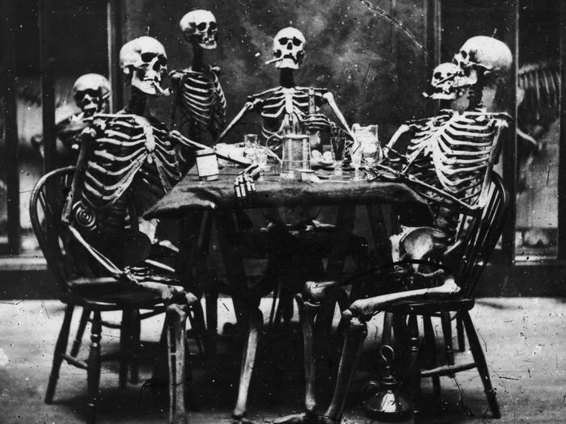
Six skeletons smoking around the dinner table, in an image taken around 1865.
London Stereoscopic Company/Hulton Archive/Getty Images

Notwithstanding that there had been mounting evidence of serious health issues, notably including lung cancer and coronary thrombosis up to 100 years beforehand, cigarette advertising in Australia was not banned on radio and television until 1976, such had been the power of lobby groups amongst Rothmans, WD & HO Wills etc. The ban was implemented by the Whitlam government and took effect on September 1, 1976. It wasn’t until 1992 that the Tobacco Advertising Prohibition Act was passed that prohibited cigarette companies from advertising in sport. Governments are invariably slow to move.

Yours sincerely
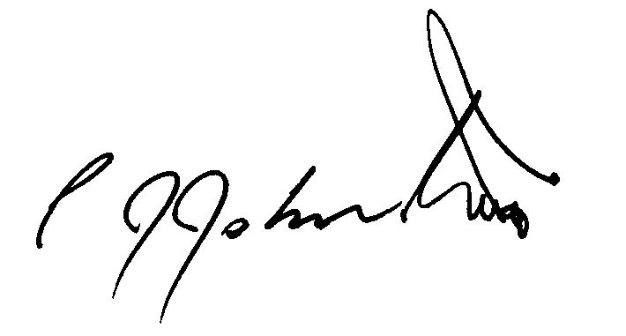
Philip James Johnston

