Liquor & Gaming NSW
Review of the ClubGRANTS Scheme
Discussion Paper
December 2023 www.liquorandgaming.nsw.gov.au

Contents
- Introduction 2
About this Review 2
Terms of Reference 2
How to make a submission 3
Definitions 4
- Background 5
Registered clubs in NSW 5
Gaming machines in registered clubs 5
What is ClubGRANTS? 6
Previous reviews of the ClubGRANTS Scheme 10
- Costs and benefits of the Scheme 11
How many clubs participate in the ClubGRANTS Scheme? 11
How do clubs claim the ClubGRANTS tax concession? 11
Expenditure and grants under ClubGRANTS in 2022-23 12
Types of activities and services funded under ClubGRANTS 12
- Appropriateness of the Regulatory framework 16
Regulatory framework 16
Gaming Machines Tax Act 2001 17
Other relevant legislation 18
ClubGRANTS Guidelines 18
Category 3 Infrastructure Grants Program Guide 18
Known constraints and issues with the regulatory framework 19
- Effective administration 20
Roles and responsibilities of stakeholders 21
Role of local committees 22
Administration of the Scheme 22
Grant administration standards and best practice 23
Additional Feedback 25
Appendix A: Target questions 26
Appendix B: ClubGRANTS categories 28
Appendix C: Comparison of similar initiatives 29

Introduction

About this Review
The ClubGRANTS Scheme (Scheme) enables eligible registered clubs to contribute a portion of gaming machine profits to local community services, projects and infrastructure through grants, and receive a tax concession in return.
The Review of the Scheme was announced by the Premier, the Hon Chris Minns MP, in July 2023 and the Terms of Reference were published in October 2023.
The NSW Government is committed to restoring integrity and public trust in government grants.
Under the NSW Treasury Evaluation Policy and Guidelines (TPG22-22) initiatives must be evaluated and reviewed regularly to ensure they are meeting intended outcomes and providing a social benefit to the people of NSW.
This discussion paper has been prepared to help stakeholders, including members of the public, to participate in the Review. Your feedback about the Scheme will inform the Review.

Terms of Reference
The Review will include examination of:
- The costs and benefits of arranging the Scheme as a tax concession:
  - whether the Scheme provides benefit to the people of NSW (as per TPG22-22)
  - whether the tax concession given to clubs under the Scheme provides value for money
  - whether the tax concession is effective in the context of other forms of concessions provided to clubs
  - whether there are alternatives for funding community programs that are more cost effective or provide greater benefits to the people of NSW.
- The appropriateness of the Regulatory framework:
  - whether the intent of Part 4 of the Gaming Machine Tax Act 2001 (Act) remains valid
  - whether the Scheme’s objectives listed in the ClubGRANTS Guidelines, align to, and achieve the intent of the Act
  - whether the regulatory framework is effective in achieving the Scheme’s objectives.
- The effective administration of the Scheme:
  - whether the Scheme’s current administration arrangements achieve the objectives listed in the ClubGRANTS Guidelines
  - whether the Scheme’s current administration complies with modern standards for grants programs, including the NSW Grants Administration Guide, relevant standards, codes, and best practice grants administration, including the principles of transparency, accountability and probity.

Review of the ClubGRANTS Scheme | Discussion Paper 2

The Review is being undertaken concurrently with, but separately to, the work of the Independent Panel on Gaming Reform. Feedback from relevant members of the Panel would be sought to inform the Review.
Review of the ClubGRANTS Scheme | Discussion Paper
3

How to make a submission
Liquor & Gaming NSW is seeking feedback until 18 March 2024.
This discussion paper provides background to the Scheme and targeted questions to help guide submissions. Appendix A contains a list of all the questions. You are not required to address these questions in your submission.

Written submissions
- You can provide your submission via email to gaming.policy@liquorandgaming.nsw.gov.au
- You can visit the Liquor & Gaming NSW website to complete a survey:
- You can visit the NSW Government’s Have Your Say website www.haveyoursay.nsw.gov.au for links to the survey and discussion paper.
Feedback must be provided by 18 March 2024.

Privacy
Your written submission may be made publicly available. If you do not want your personal details or any part of your submission published, please indicate this clearly. Submissions may be referred to in a report on the outcome of the consultation, however anonymous submissions will be referred to as such.
Survey responses will be de-identified and aggregated.
There may be times where the Government is required to release the information in your submission, such as under the Government Information (Public Access) Act 2009.

Interviews
Liquor & Gaming NSW will conduct interviews with key NSW Government, industry and community stakeholders and will contact these representatives directly.

Definitions
- ClubsNSW: a peak body for NSW registered clubs that advocates on matters related to state and national policy direction, including the development of industry-specific legislation relating to alcohol, gambling, taxation and industrial relations.
- Eligible club: a club earning over $1 million in annual profits from gaming machines.
- Gaming machine: a device approved as a gaming machine under the Gaming Machines Act 2001.
- Gaming machine tax rate: the rate of tax a registered club must pay on gaming machine profits to the NSW Government under the Gaming Machine Tax Act 2001.
- Gaming machine tax year: the period of 12 months between 1 September and 31 August.
- Gaming Machine Tax Act 2001: The legislation that prescribes tax rates and regulates the ClubGRANTS Scheme.
- Gaming Machines Act 2001: The legislation that governs the approval, licensing and use of gaming machines in NSW.
- NSW Council of Social Service (NCOSS): a peak body for the social services sector in NSW that advocates to alleviate poverty and disadvantage in NSW.
- Prescribed profits: the profits from gaming machines kept on the premises of a registered club during a tax year over $1 million.
- Probity: Probity relates to ethical behaviour. Grants administration must be conducted honestly, impartially and with integrity and accountability.
- Registered club: a club that meets criteria in section 10(1) of the Registered Clubs Act 1976 and holds a club licence granted under the Liquor Act 2007.

Background

Registered clubs in NSW
Registered clubs in NSW (clubs) are governed under the Registered Clubs Act 1976 (Clubs Act). A registered club must hold a club licence under the Liquor Act 2007. Requirements that must be met by clubs are listed under Section 10 of the Clubs Act.
Under the Clubs Act, a club is established for social, literary, political, sporting or athletic purposes or for any other lawful purposes, and for the purpose of providing accommodation for its members and their guests. A club must either be a company under the Corporations Act 2001 (Cth) or (if registered before the commencement of Part 10 of the Clubs Act) a co-operative under the
Co-operatives Act 1992 or a corporation constituted by another act.
A member of a club is not entitled to derive any profit, benefit or advantage from the club that is not offered equally to every full member of the club. A club and its members can only derive profit, benefit or advantage from the ownership or occupation of the premises of the club in the form of interest or rent or occupation fees.
Historically clubs receive concessions and benefits from the NSW Government in recognition of the social benefits they provide to communities. Clubs are a point of connection for members, offering a place to meet, socialise and connect. During emergencies and natural disasters they are often used as evacuation centres and play a pivotal role in communities at these times.
Clubs are a significant contributor to the NSW economy, providing employment for more than 40,000 people, including about 23,000 people in regional communities. Clubs also contribute to the local economy through their support of local businesses and services.

Gaming machines in registered clubs
As of 31 August 2023, there were 72,694 gaming machine entitlements and 64,916 gaming machines held in 1,016 club premises in NSW.
The total net profit of these gaming machines in the gaming machine tax year between 1 September 2022 to 31 August 2023 was $4.6 billion.
Under the Gaming Machines Tax Act 2001 (Act), clubs must pay taxes on gaming machine revenue when gaming machine profits exceed $1 million in a tax year. The gaming machine tax year for clubs is 1 September to 31 August. Gaming machine tax is calculated using a progressive tax scale, like Australian income tax. This means clubs with larger gaming operations contribute more tax revenue. Further details can be found on the Revenue NSW website.

What is ClubGRANTS?
The ClubGRANTS Scheme was established in 1998. It was originally established under the Clubs Act and was then called the Community Development and Support Expenditure (CDSE) Scheme. Prior to 1998, clubs provided support to communities under a welfare expenditure scheme.
The objective of the CDSE Scheme was to encourage larger registered clubs with profits over
$1 million to contribute financially and in-kind to locally based community programs and services. In return, clubs received a tax rebate equivalent to the amount spent on community development and support.
In 2011, the Scheme was transferred to Part 4 of the Gaming Machines Tax Act 2001 and Category 3 was introduced. At this time, the CDSE Scheme was renamed the ClubGRANTS Scheme. In addition to the overall object of the Scheme, Category 3 grants are to support and develop large scale projects and services associated with sport, health or community infrastructure.
In 2022/23 more than 9,000 grants totalling over $120 million were provided by clubs under the Scheme for Categories 1 and 2 and 98 grants totalling $12.2 million were provided under Category 3.

Categories of ClubGRANTS
Under the Guidelines, there are three categories of ClubGRANTS, which vary in their purpose, application and administration. Further details are provided at Appendix B.

Category 1
- Projects and services that contribute to the welfare and broader social fabric of the local community and are aimed at improving the living standards of low income and disadvantaged people. Recipients must apply for Category 1 grants. Recipients are determined by individual clubs in accordance with the Guidelines and funding is provided by individual clubs directly to successful applicants.

Category 2
- Community development and support activities and projects not listed under Category 1 and expenditure allocated to a club’s core activities (such as sport, returned servicemen’s league/veteran welfare, golf course and bowling green maintenance, including for wages paid to staff to carry out the maintenance). Funding is allocated by individual clubs in accordance with the Guidelines and there are no application requirements.

Category 3
- Large scale community infrastructure projects or services for sport and recreation facilities, arts and cultural infrastructure, as well as projects that assist communities with essential infrastructure and disaster readiness. Grants are allocated from the Fund through competitive, publicly advertised grant rounds administered by the Office of Responsible Gambling (ORG). Grant applications are assessed by ORG and recommendations on recipients are made to the Minister for Gaming and Racing. Grants are approved by the Minister in accordance with Section 17A of the Act.

ClubGRANTS Guidelines
The Act allows the Minister, in consultation with Clubs NSW, to publish ClubGRANTS Guidelines (Guidelines) for all three categories of ClubGRANTS. The Guidelines determine what constitutes application of profits to community development and support and must include details on:
- the minimum proportion of profits to be expended on Category 1 projects and services
- community priorities identified by ClubGRANTS Local Committees
- advertising the availability of ClubGRANTS
- accountability of expenditure on ClubGRANTS.
The definitions of “Category 1 projects and services” and “Category 2 projects and services” must be settled in consultation with ClubsNSW and the NSW Council of Social Services (NCOSS) and the definition of “Category 3 projects and services” must be settled in consultation with ClubsNSW.

How does the ClubGRANTS tax concession work?
Clubs that earn over $1 million on annual gaming machine profits are eligible to participate in the ClubGRANTS Scheme. These clubs are referred to as “eligible clubs”. Eligible clubs can get a tax rebate of up to 2.25% on gaming machine profits over $1 million (prescribed profits) in exchange for financial contributions under the Scheme.
Total available ClubGRANTS rebate of 2.25% on prescribed profits

Category 2 maximum expenditure is 1.1% as a condition of eligibility for rebate
Category 1 minimum expenditure is 0.75% as a condition of eligibility for rebate
Category 3 Mandatory payment of
0.4% given back to clubs as a rebate
Categories 1 & 2
Optional rebate of 1.85% for eligible community expenditure

Figure 1: ClubGRANTS tax concession allocations

Tax rebates for categories 1 and 2
Participation in categories 1 and 2 is not compulsory. Eligible clubs can seek a reduction on the tax they pay on prescribed profits if they provide eligible Category 1 and 2 ClubGRANTS. The tax payable by a club can be reduced by an amount equal to the amount provided by a club for community development and support. To qualify for the rebate, at least 0.75% must be spent on Category 1 grants. The amount that the tax is reduced by cannot be more than 1.85% of the prescribed profits. If eligible clubs choose not to participate in this part of the Scheme, they are taxed at the applicable tax rate without this tax reduction (see Revenue NSW website).

Tax rebate for category 3
Eligible clubs must allocate 0.4% of their gaming machine profits over $1 million into a Special Deposits Account called the ClubGRANTS Fund. Participation in Category 3 of the Scheme is mandatory for eligible clubs.

Comparable schemes in other jurisdictions
Licensed or registered clubs in many states and territories provide financial and in-kind assistance to their communities. Funding these initiatives can include using a portion of the taxes paid from net gaming machine revenue, directly channelling gaming machine revenue towards funding accounts, or direct contributions from clubs’ gaming machine profits.
Victoria has a community grants scheme that is comparable to ClubGRANTS where funding is directly distributed by clubs in exchange for a lower tax rate. Other jurisdictions where clubs directly distribute funds include Northern Territory and Queensland, however, no tax incentive is granted. Though no explicit incentives are provided for these jurisdictions, evidence of contributions are mandated to ensure a reasonable portion of gaming machine revenue is redirected to community benefits.
Several jurisdictions impose community grant initiatives or levies on gaming machine profits on clubs, which is used to fund government managed community benefit funds. Victoria, for instance, allocates a portion of the community benefit contributions towards gambling harm prevention and treatment services, housing assistance, and community infrastructure.
Similarly, South Australia uses redirected gaming machine tax revenue towards sports and recreation, a fund to support gambling harm-minimisation programs, and various community health and wellbeing programs.
Tasmania includes a discretionary fund that broadly contributes a large portion of the community support levy towards capacity building and community development aimed at gambling harm- minimisation or prevention and other services or programs related to gambling harm.
For a summary of comparable schemes in other jurisdictions, see Appendix C.

Previous reviews of the ClubGRANTS Scheme
The table below outlines key publicly available reviews of the Scheme and their findings.

Review | Description and findings
A review of the Community Development and Support Expenditure Scheme by Robert Scullion and Associates Pty Ltd. (2005)1 | In 2005, a review of the CDSE scheme was conducted by an independent consultant which found the scheme was not meeting its objectives.
Review of the NSW Registered Clubs Industry by the Independent Pricing and Regulatory Tribunal NSW (IPART) (2008)2 | IPART reviewed the Scheme in its former iteration, the CDSE, as part of a broader review of clubs’ contribution to social infrastructure in NSW.  IPART found that the CDSE was an effective means to support NSW communities and stakeholder feedback indicated its widespread support. However, IPART also recommended governance be strengthened.
Audit Office of NSW Performance Audit of the Management of the ClubGRANTS scheme (2013)3 | This audit examined whether the Guidelines were consistent with the objectives of the Act, and whether the then Office of Liquor, Gaming and Racing was effectively administrating the Scheme in accordance with the applicable policies and guidelines. The audit made 14 recommendations to strengthen the ClubGRANTS Guidelines to ensure compliance, improve review processes and improve reporting and transparency of the ClubGRANTS Scheme.
Review of the NSW Council of Social Service (NCOSS) Role on ClubGRANTS Local Committees (2021)4 | In 2019, NCOSS reviewed its role in the Scheme to establish processes that would support its role and determine whether it would be able to resource this role into the future. NCOSS conducted a desktop review and consulted its members and found that NCOSS had not been effectively resourced to perform its role in the Scheme and that governance of the scheme was not in keeping with community expectations for the management of public money.  The NSW Government made changes to the ClubGRANTS Guidelines in 2023 to address some of the issues raised by NCOSS as an interim measure until a full review of the Scheme was completed.

Table 2: Previous reviews of the ClubGRANTS Scheme

¹ Scullion, R. (2005). A review of the Community Development and Support Scheme. Prepared for the Gaming and Racing Minster of the Central Coast.
² IPART (2008). Review of the registered clubs industry in NSW: Other industries - final report. Independent Pricing and Regulatory Tribunal of NSW.
³ Achterstraat, P. (2013). Management of the ClubGRANTS scheme: Performance audit. New South Wales Auditor-General.
⁴ NCOSS (2021). Review of the NCOSS role on ClubGRANTS Local Committees: Full report. Prepared for the Office of Responsible Gambling.

Costs and benefits of the Scheme

How many clubs participate in the ClubGRANTS Scheme?
In the 2022-23 gaming machine tax year:
  - 502 clubs were eligible to participate in the Scheme. Of these clubs, 451 participated in Categories 1, 2 and 3, and 51 clubs participated in Category 3 only.
  - Clubs claimed a total of $120.7M as Category 1 and 2 expenditure, including:
    - $37.1M as Category 1 expenditure ($33.2M in cash and $3.9M in-kind) and claimed
    - $83.6M as Category 2 expenditure ($72.9M in cash and $10.7M in-kind)
  - The total of Category 1 and 2 tax concessions provided to clubs was $71.9M.

How do clubs claim the ClubGRANTS tax concession?

Categories 1 and 2
  - Eligible clubs claim a rebate for Category 1 and 2 expenditure by submitting a ClubGRANTS annual return to Liquor & Gaming NSW at the end of every gaming machine tax year. Liquor & Gaming NSW assesses these returns on behalf of the Independent Liquor and Gaming Authority (Authority).
  - In practice, clubs often claim a rebate on an amount of Category 1 and 2 expenditure which exceeds the maximum available rebate under the Scheme of 1.85% of prescribed profits. In other words, some clubs spend more on grants than they get back.
  - When Liquor & Gaming NSW receives a club’s annual return, it assesses the eligibility of expenditure on individual grants claimed by the club until the maximum rebate amount the club can receive has been reached. Liquor & Gaming NSW then stops its assessment, and the remainder of the club’s annual return is not assessed. If a grant remains unassessed, this does not mean that the grant is ineligible. In practice, Liquor & Gaming NSW prioritises the assessment of larger grants to reduce administrative burden of assessing a higher quantity of smaller grants.

Category 3
  - Clubs must provide 0.4% of prescribed profits to the ClubGRANTS Fund and funding is administered by the Office of Responsible Gambling. There is no annual returns process, and 100% of the funds dedicated to Category 3 grants are provided back to clubs as a rebate.

Expenditure and grants under ClubGRANTS in 2022-23
  - Table 4 lists the grants and expenditure claimed by eligible clubs in the 2022-23 gaming machine tax year, and the rebate received on claimed expenditure. The number of grants includes all expenditure claimed through 2022-23 club annual returns. This includes unassessed grants funded by clubs that may be eligible under the Scheme where a club’s expenditure for the gaming machine tax year exceeded the available rebate. It also includes funded projects and services ineligible for funding under the Scheme.
  - Rebate figures reflect the amount that clubs had their tax reduced by. The rebate as a percentage of expenditure demonstrates the percentage of expenditure clubs got back through the tax reduction.

Table 4: ClubGRANTS data from the 2022-23 gaming machine tax year

Category 1 grants  4,940 | Category 2 grants  8,338 | Category 3 grants  98
Category 1 expenditure  $37.1m | Category 2 expenditure  $83.6m | Category 3 expenditure  $12.2m
Category 1 rebate  $28.6m | Category 2 rebate  $43.7m | Category 3 rebate  $12.2m

Types of activities and services funded under ClubGRANTS

Categories 1 and 2
Category 1 expenditure is for grants under four broad categories:
  - Community welfare and social services
  - Community development
  - Community health services
  - Employment assistance activities
Category 2 allows for expenditure on “other community development and support services”. This may include expenditure allocated to a club’s core activities such as sport, veteran welfare and golf course and bowling green maintenance. Expenditure can be allocated for professional sport purposes including National Rugby League but not to payments to professional or semi-professional sports people, coaches or managers.

The number of grants listed in Figure 2 reflect total number of projects and services listed in club annual returns for the 2022-23 gaming machine tax year, rather than total projects assessed as eligible by the Authority. Category 1 and 2 grant categories data is sourced from MAXsys. Individual grant information can be found on the ClubGRANTS website⁵.

Figure 2: Breakdown of the number of Category 1 and 2 projects funded in the 2022-23 gaming machine tax year by type.

93  Home & community  care | 506  Health promotion | 3811  Sport | 766  Education
903  Aged, disability &  youth services | 205  Veteran welfare | 470  Family support | 101  Childcare/child  protection
137  Counselling services | 166  Victims of natural  disasters | 313  Volunteer emergency  services | 121  Neighbourhood centres
82  Community transport | 717  Community education | 8  Tenant services | 30  State-wide/regional  services

⁵ https://www.clubgrants.com.au/2023-clubgrants-recipients

374
Health
139
Cultural activities
422
Community enterprises
318
Child health

1747
Community activities

3
Gambling harm
168
Community nursing
29
Employment services

690
Club facilities
125
Drug & alcohol
12
Group training

77
Medical research

376
Local communities
317
Other

Note these categories are selected by clubs when they submit their returns and may not reflect breadth of categories a project may cover.

Category 3
Category 3 provides grants to support and develop projects or services associated with sport, health or community infrastructure. Funding can be provided for designing, building, upgrading, renewing, funding or acquiring land or property for projects and services.
The number and types of grants Category 3 infrastructure projects provided in the 2022-23 gaming machine tax year are listed in Figure 3. A list of funded Category 3 projects can be found on the NSW Government Grants and Funding Finder website⁶.

⁶ https://www.nsw.gov.au/grants-and-funding/clubgrants-category-3-fund

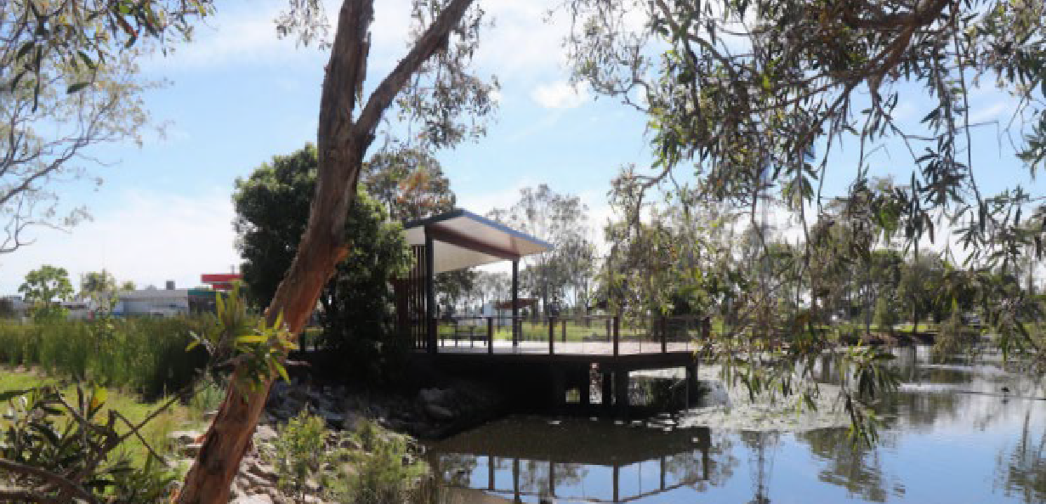
Figure 3: Breakdown of the number of Category 3 projects funded in the 2022-23 gaming machine tax year by type.
Review of the ClubGRANTS Scheme | Discussion Paper
15

54  Sport and recreation  infrastructure | 32  Community  infrastructure | 7  Arts and culture  infrastructure | 5  Disaster readiness  infrastructure

Target questions - The costs and benefits of arranging the Scheme as a tax concession
- To what extent has the ClubGRANTS Scheme helped to improve the lives of disadvantaged communities in NSW? What type of benefits do these groups experience from the Scheme?
- To what extent do the benefits that communities experience, if any, differ between categories 1, 2, and 3 funding? Why?
- What factors associated with the ClubGRANTS Scheme do you think could either
strengthen or reduce any benefits that it delivers to NSW communities?
- Are you aware of any unintended effects, positive or negative, of the ClubGRANTS Scheme? If so, what are they?
- Do the benefits of the ClubGRANTS Scheme outweigh the costs (in terms of tax revenue forgone)? Why or why not? What changes would you make to the ClubGRANTS Scheme, if any, to improve public ‘value for money’ or benefits to local communities?
- How appropriate is the tax concession that clubs receive under the ClubGRANTS Scheme? How likely do you think it is that clubs would continue to fund local community services if the tax concession did not exist?
- What other funding options are available to support local community programs and services in addition to, or instead of, the ClubGRANTS Scheme?

Appropriateness of the Regulatory framework

Regulatory framework
The overarching framework for the ClubGRANTS Scheme is the Gaming Machines Tax Act 2001 (the Act), specifically Part 4 and Schedule 1 of the Act. The ClubGRANTS Scheme is authorised by the Act and governed by the ClubGRANTS Guidelines and Category 3 Infrastructure Grants Program Guide. Figure 4 provides an overview of the role, intent, and objectives across each of these mechanisms which are discussed in further detail below.
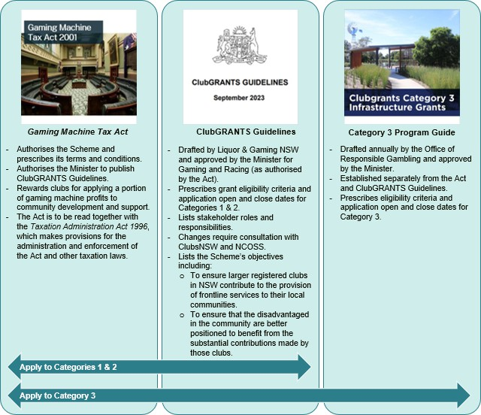

Figure 4: Role, intent and objectives of ClubGRANTS regulatory mechanisms

Gaming Machines Tax Act 2001
Part 4 and Schedule 1 of the Act form part of a broader group of gaming and liquor legislation listed in section 4 of the Gaming and Liquor Administration Act 2007.
The Act provides overarching requirements tax payable on gaming machine profits. It imposes a tax on profits from gaming machines in both registered clubs and hotels, makes provision for the lodgement of returns and prescribes the rate of payable tax.
The Act establishes the Scheme as tax rebate, whereby NSW Government funds are allocated to clubs that provide grants to community development and support projects and services.
The Act is to be read together with the Taxation Administration Act 1996, which makes provision for the administration and enforcement of this Act and other taxation laws.
When the Scheme was established under the Act, the Minister at the time stated that clubs are best placed to determine how the money derived from club revenue should be spent in local communities, to accurately reflect the origins of contributions made under the Scheme and this would help club members and the community understand the origin of the funds.

What are the requirements of the Act?
Part 4 authorises the Scheme and prescribes its high-level requirements and establishes the ClubGRANTS Guidelines.
Under section 16, the Minister administering the Registered Clubs Act 1976 is authorised to publish ClubGRANTS Guidelines that determine what constitutes 'the application of profits to community development and support’ for the purposes of the Scheme. The Act also authorises the Minister to publish these Guidelines “from time to time”. In other words, the Minister can publish a revised or new version of the Guidelines as the Minister sees fit.
Part 4 of the Act requires the Minister to consult with ClubsNSW and NCOSS on specific aspects of the Guidelines.

Powers of the Authority
Part 4 authorises the Authority to apply a club’s tax reduction if a proportion of a club’s prescribed profits has been applied to community development and support or to refuse a club’s tax reduction if a club claiming a reduction has not complied with the Guidelines.

Terms and conditions under the Guidelines
Part 4 of the Act prescribes terms and conditions that must be contained in the Guidelines including:
- at least 0.75% of the club’s prescribed profits must be for Category 1 projects and services
- local committees must identify the community social expenditure priorities
- advertising requirements
- acquittal requirements
- Requirement for the Guidelines to be tabled in both houses of Parliament.

Establishment and conditions of the ClubGRANTS Fund
The Act requires the establishment of the ClubGRANTS Fund within the Special Deposits Account, and specifies obligations regarding the Fund including payments into the Fund and payments from the Fund in the form of grants for Category 3 large scale projects or services associated with sport, health or community infrastructure.

Other relevant legislation
Because the Scheme is established under NSW legislation, the framework encompasses NSW Government requirements for grants administration and use of Governments funds. While clubs give grants directly to organisations for community development and support, the grant money is refunded to clubs via a tax reduction.
For these reasons ClubGRANTS is also bound by the Government Sector Finance Act 2018, the Government Sector Finance Amendment (Grants) Act 2023 and the Grants Administration Guide and any rules issued by the NSW Government in relation to Government programs and initiatives, including the NSW Treasury Evaluation Policy and Guidelines.

ClubGRANTS Guidelines
The ClubGRANTS Guidelines provide further details that govern the administration of the Scheme, including the details of what expenditure can be allocated under each category, the expenditure that is not eligible under the Scheme, application and funding process, accountability and reporting, and the local committee membership and requirements.
The Guidelines provide a flexible mechanism for the Minister to review and update the requirements as new challenges or issues emerge.

Category 3 Infrastructure Grants Program Guide
As Category 3 grants are approved by the Minister, they are administered on a state-wide basis by the Office of Responsible Gambling (ORG), in line with the requirements of the Act and Guidelines. ORG develops and publishes a Category 3 Infrastructure Grants Program Guide (Program Guide) each year to provide details of application dates, details about funding available for each category, assessment criteria and eligibility requirements.
The Program Guide outlines the process of how to apply, how applications are assessed, and provides guidance about how applications are assessed and how funding is decided. Funding obligations and reporting requirements are also provided.
The Program Guide operates and includes information similar to that of other grant guidelines approved by NSW Government ministers and administered by NSW Government agencies, and was updated in 2023 to meet the requirements of the NSW Government Grants Administration Guide.

Known constraints and issues with the regulatory framework
There are some known limitations to the use and operation of the regulatory framework.
Stakeholder roles and responsibilities are listed in different parts of the regulatory framework including the Act, ClubGRANTS Guidelines and Program Guide. Previous reviews of the Scheme, and informal feedback, indicate there is a lack of clarity about stakeholder obligations which have caused confusion and non-compliance with the Scheme. The Guidelines are broad and unclear in some areas, leading to misunderstandings and misinterpretations of the requirements.
The different roles for different Government bodies can make the framework confusing for stakeholders. The Authority has legislative responsibility for assessing compliance with certain aspects of the Scheme related to the tax rebate, the Office of Responsible Gambling administers Category 3 grants, Liquor & Gaming NSW assesses tax eligibility for category 1 and 2 grants and undertakes audits, Revenue NSW collects revenue and assesses tax returns, and the Minister approves the Guidelines and Category 3 grants.
Whilst Guidelines offer a flexible mechanism for regulating the Scheme, their enforcement creates a large administrative burden. This is exacerbated by the short time between clubs lodging their tax reduction claim (from 1 September to 7 September each gaming machine tax year) and needing to be assessed and finalised by Liquor & Gaming NSW (under delegation from the Authority) by 13 September.
Under the Grants Administration Guide, officials must prepare clear, consistent grant guidelines that contain information about a grant opportunity. However, it is unusual for a grant program to be governed by two sets of grant guidelines as is the case with Category 3 funding. This contributes to the complexity of the regulatory framework.

Target questions – Appropriateness of the regulatory framework
- To what extent do registered clubs in NSW have a responsibility to support frontline community programs and services in their local areas?
- The intent of Part 4 of the Act is not explicitly stated in any regulatory documents. For this review, intent has been defined as “rewarding clubs for applying a portion of gaming machine profits to community development and support.”
Does this definition align to your understanding of the intent? Why or why not? How well do you think the specific terms of Part 4 of the Act both reflect and support its intent?
How could the terms of the Act be improved?
- How well do the ClubGRANTS Guidelines align to and support Part 4 of the Act? How could the Guidelines be improved?
- How well do the Act and the ClubGRANTS guidelines combine to support the fulfilment of the Scheme’s objectives? What features of these regulatory documents are least and most effective in supporting a successful grants scheme?
- Based on your understanding of the types of programs and services funded under each ClubGRANTS category, how closely would you say these align to the objectives of the Scheme?

OFFICIAL

Effective administration
Figure 5 below outlines the current processes under each category of ClubGRANTS.
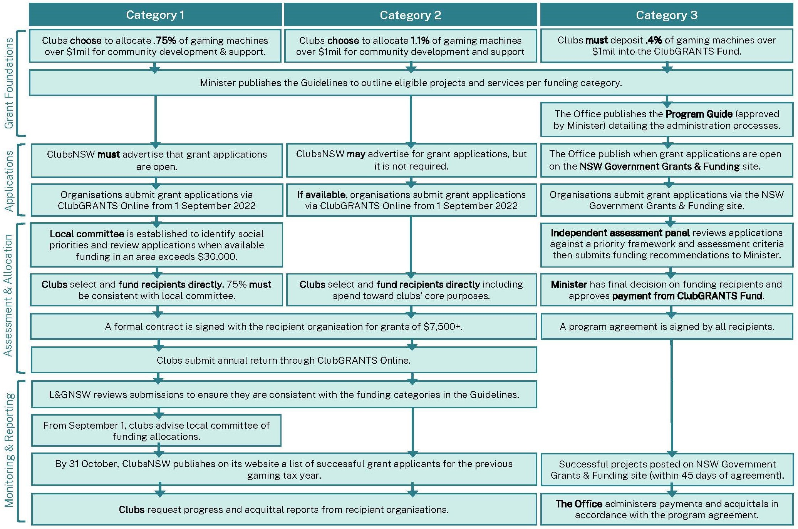
Figure 5: ClubGRANTS administration process

OFFICIAL

Roles and responsibilities of stakeholders
Below is an overview of the diverse stakeholders involved in the ClubGRANTS scheme, and their roles and responsibilities under Categories 1, 2 and 3.

Minister for Gaming and Racing
Categories 1, 2 & 3: Publishes ClubGRANTS Guidelines.
Category 3: Approves Category 3 Infrastructure Grants Program Guide and determines recipients.
Clubs
Categories 1 & 2: Manage grants, must satisfy the Authority that obligations have been met for the tax reduction, participate in local committees where required.
ClubsNSW
Categories 1 & 2: Administer ClubGRANTS Online, are consulted on ClubGRANTS Guidelines, publish successful grant recipient information, advertise Category 1 grant opportunity.
Liquor & Gaming NSW (under delegation of the Authority)
Categories 1 & 2: Determine if a club’s tax reduction is appropriate, may take action for non-compliance, reviews requests for exemptions. Manages the Centralised Monitoring System (CMS) licence with Maxgaming.
Maxgaming (MAX)
Holds a 15-year licence to operate the CMS, a regulatory tool that connects all gaming machines in NSW registered clubs and hotels to calculate a venue’s gaming machine tax.
Local committees (Category 1 only)
Identify local community service priorities, review applications and make funding recommendations to clubs, advise ORG of changes to membership, must adopt a local committee charter, must meet core membership requirements.
Revenue NSW
Categories 1 & 2: Collects gaming machine tax, issues gaming machine tax reassessment invoices and approves gaming machine tax payment arrangements via the CMS.
The Office of Responsible Gambling (ORG)
Category 1: Develops a list of social expenditure priorities for LGAs with no local committee, endorses community organisation representatives on local committees. Category 3: Develops Category 3 Program Guide, administers applications, coordinates independent assessment panel, provides the assessment report and funding recommendations to the Minister, publishes the funding recipients. Administers the funding agreements, payments, reporting and acquittals for all recipients.
Independent Assessment Panels (Category 3 only)
Assesses applications against the publishes assessment criteria. The assessment report is provided to the Minister by ORG
NSW Council of Social Service
Categories 1 & 2: Consulted on the provisions in the ClubGRANTS guidelines that define the terms Category 1 projects and services and Category 2 projects and services.

Role of local committees
The Guidelines set out obligations for local committees including membership requirements.
A local committee must be established in a Local Government Area (LGA) where over $30,000 of Category 1 funding is available from clubs within the LGA for that gaming machine tax year.
Local committees identify local community service priorities and make funding recommendations to clubs in the LGA. They also report a club’s failure to comply with the Guidelines to the Authority.
Under the 2023 Guidelines, 75% of Category 1 grants must be allocated according to Local Committee recommendations. If a club does not meet this requirement, they must report to L&GNSW to explain why those recommendations were not accepted. Despite this, Local Committees do not have veto power and responsibility for the allocation of funding rests with each club.
If ClubGRANTS funding in an LGA is less than $30,000, a local committee does not have to be established. In these LGAs, ORG and the Department of Communities and Justice (DCJ) must develop a list of social expenditure priorities for the LGA and make this available to all participating clubs of that LGA. This role was previously fulfilled by the NSW Council of Social Services (NCOSS) and DCJ.

Administration of the Scheme
There are some known issues with some of the current administration arrangements of the Scheme.
For example, around 60% of grants given by clubs in categories 1 and 2 are granted tax concessions each year. Whilst clubs are encouraged to give back to their communities, this means approximately 40% of grants are advertised as “ClubGRANTS funds” even though they were not accepted as part of the Scheme.
This is due to a variety of factors including clubs spending more money on grants than the tax concession they are eligible for, or clubs giving grants that are ineligible under the Guidelines.
Liquor & Gaming NSW undertakes a preliminary assessment of the eligibility of each club’s grants within 2 weeks of the end of the gaming machine tax year so that tax returns can be finalised.
L&GNSW then undertakes proactive audits to investigate grants in more detail throughout the year. If grants are subsequently determined to not be eligible, L&GNSW must require the club to repay the equivalent tax concession. This is an administratively complex, and costly process.
There is no requirement for clubs or recipients of funds from Categories 1 and 2 to demonstrate that funds were effective or put to the purpose for which they applied. This means that funds could continually be given to organisations even though they demonstrate limited or poor outcomes from the funding.
There is no requirement for clubs to administer funds to organisations or programs recommended by Local Committees. Clubs can ignore Local Committee recommendations and give Category 1 grants to any organisation or program.
The Minister has sole decision-making authority in relation to Category 3 grants and has discretion to fund projects within limited Guidelines for eligibility.
Given the Government uses foregone taxes to fund the Scheme, it is a NSW Government program, however, because the grants are given by clubs, they are not currently bound by best practice grants administration and NSW Government grants requirements (such as the Government Grants Administration Guide).

Grant administration standards and best practice
The NSW Government has committed to restoring integrity and public trust in government grants.
New legal protections were introduced in July 2023 to strengthen the regulation of grants administration in NSW and to ensure government grants are administered fairly and achieve value for money. In approving or declining a grant, decision-markers must have regard to the principles for administering grants set out in the Grants Administration Guide (Guide).
The Guide also requires grants must be demonstrated as providing value for money, meet their objectives, and adopt key principles of transparency, accountability and probity. It provides mandatory requirements and recommends best practice principles to be adopted by NSW Government agencies with responsibilities related to grants.
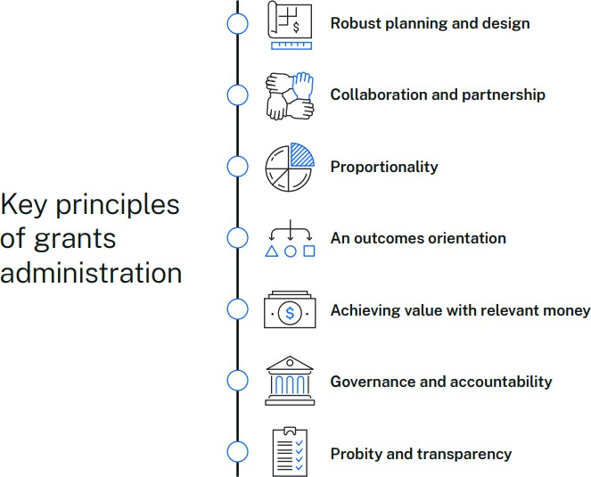

Target questions – Effective administration of the scheme
- Do you think the governance arrangements help to ensure that ClubGRANTS are awarded in accordance with the Scheme's objectives? Why/why not?
- Would the Scheme operate more effectively if it was structured differently? For example, via a levy and administered by an independent body. Why/why not?
- Is it appropriate that the Minister is the final decision-maker for the allocation of Category 3 funding? Why/why not?
- Is it appropriate that registered clubs are the final decision-makers for the allocation of Category 1 and 2 funding? Why/why not?
- Do local committees (where established) have enough influence in deciding how Category 1 funding is allocated? Why/why not?
- Should clubs be permitted to provide ClubGRANTS funding to organisations not recommended by the local committees? Why/why not?
- Do the other key stakeholders listed above fulfil their roles and responsibilities under the ClubGRANTS Scheme? Why/why not?
- Is it appropriate that clubs are required to advertise publicly to invite and accept applications for Category 1 funding? Should the same requirement apply to Category 2 funding? Why/why not?
- Do the ClubGRANTS assessment and selection processes help to ensure that only the most suitable community programs and services receive funding? What differences exist between Categories 1, 2, and 3, if any?
- Is the requirement for Category 3 benefitting organisations to submit six-monthly progress reports and a final acquittal report adequate to monitor the delivery of funded programs and services? Why/why not?
- What measures could be put in place to ensure the ClubGRANTS Scheme meets Government grants administration requirements? Specifically, what changes could be made to enhance:
  - Transparency?
  - Accountability?
  - Probity?
- What other changes should be made, if any, to ensure the ClubGRANTS Scheme is consistent with best practice grants administration?

Additional Feedback
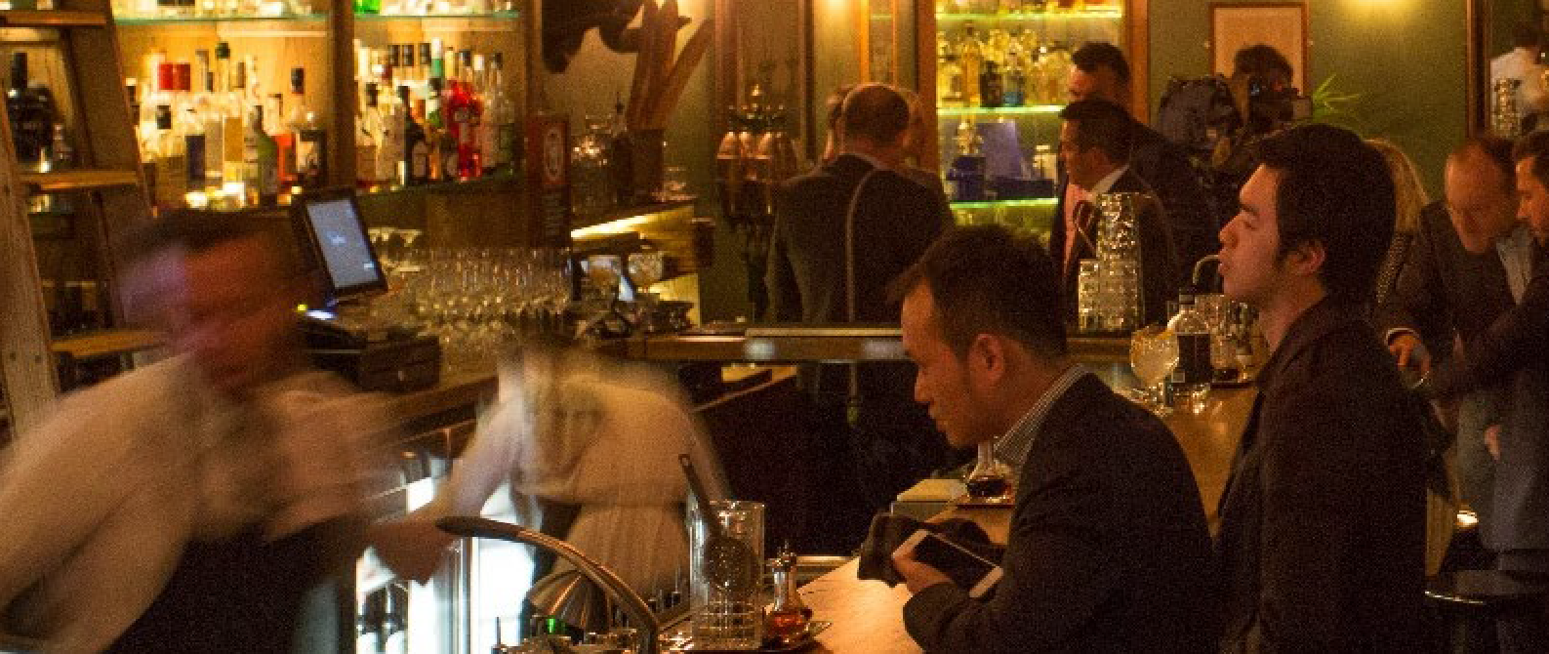
The issues identified in this consultation paper are not exhaustive. You are not limited to the questions listed in this paper. You do not need to address all questions noted in this paper, they are designed to start discussion and feedback. You may also include any other relevant comments that you would like to make as part of your submission.

Appendix A: Target questions

Target questions: the costs and benefits of arranging the Scheme as a tax concession:
(1.1) To what extent has the ClubGRANTS Scheme helped to improve the lives of disadvantaged in NSW communities? What type of benefits do these groups experience from the Scheme?
(1.2) To what extent do the benefits that communities experience, if any, differ between categories 1, 2, and 3 funding? Why?
(1.3) What factors associated with the ClubGRANTS Scheme do you think could either strengthen or
reduce any benefits that it delivers to NSW communities?
(1.4) Are you aware of any unintended effects, positive or negative, of the ClubGRANTS Scheme? If so, what are they?
(1.5) Do the benefits of the ClubGRANTS Scheme outweigh the costs (in terms of forgone tax revenue)? Why or why not? What changes would you make to the ClubGRANTS Scheme, if any, to improve public ‘value for money’ or benefits to local communities?
(1.6) How appropriate is the tax concession that clubs receive under the ClubGRANTS Scheme? How likely do you think it is that clubs would continue to fund local community services if the tax concession did not exist?
(1.7) What other funding options are available to support local community programs and services in addition to, or instead of, the ClubGRANTS Scheme?

Target questions: the appropriateness of the Regulatory framework
(2.1) To what extent do registered clubs in NSW have a responsibility to support frontline community programs and services in their local areas?
(2.2) The intent of Part 4 of the Act is not explicitly stated in any regulatory documents. For this review, intent has been defined as “rewarding clubs for applying a portion of gaming machine profits to community development and support.”
Does this definition align to your understanding of the intent? Why or why not? How well do you think the specific terms of Part 4 of the Act both reflect and support its intent? How could the terms of the Act be improved?
(2.3) How well do the ClubGRANTS Guidelines align to and support Part 4 of the Act? How could the Guidelines be improved?
(2.4) How well do the Act and the ClubGRANTS Guidelines combine to support the fulfilment of the Scheme’s objectives? What features of these regulatory documents are least and most effective in supporting a successful grants scheme?
(2.5) Based on your understanding of the types of programs and services funded under each ClubGRANTS category, how closely would you say these align to the objectives of the Scheme?

Target questions: the effective administration of the Scheme:
(3.1) Do you think the governance arrangements help to ensure that ClubGRANTS are awarded in accordance with the Scheme's objectives? Why/why not?
(3.2) Would the Scheme operate more effectively if it was structured differently? For example, via a levy and administered by an independent body. Why/why not?
(3.3) Is it appropriate that the Minister is the final decision-maker for the allocation of Category 3 funding? Why/why not?
(3.4) Is it appropriate that registered clubs are the final decision-makers for the allocation of Category 1 and 2 funding? Why/why not?
(3.5) Do local committees (where established) have enough influence in deciding how Category 1 funding is allocated? Why/why not?
(3.6) Should clubs be permitted to provide ClubGRANTS funding to organisations not recommended by the local committees? Why/why not?
(3.7) Do the other key stakeholders listed above fulfil their roles and responsibilities under the ClubGRANTS Scheme? Why/why not?
(3.8) Is it appropriate that clubs are required to advertise publicly to invite and accept applications for Category 1 funding? Should the same requirement apply to Category 2 funding? Why/why not?
(3.9) Do the ClubGRANTS assessment and selection processes help to ensure that only the most suitable community programs and services receive funding? What differences exist between Categories 1, 2, and 3, if any?
(3.10) Is the requirement for benefitting organisations to submit six-monthly progress reports and a final acquittal report adequate to monitor the delivery of funded programs and services? Why/why not?
(3.11) What measures could be put in place to ensure the ClubGRANTS Scheme meets Government grants administration requirements? Specifically, what changes could be made to enhance:
- Transparency?
- Accountability?
- Probity?
(3.12) What other changes should be made, if any, to ensure the ClubGRANTS Scheme is consistent with best practice grants administration?

OFFICIAL

Appendix B: ClubGRANTS categories

Category | Purpose | Administration | Tax rebate | Total funding to community
1 | Funds community welfare and social services, community development, community health services and employment assistance activities. | Administered by clubs, with grants provided by individual clubs directly to the successful applicant. Specific requirements are outlined in the ClubGRANTS Guidelines | Approximately $28.6 million in 2022/23.  Approximately $25.9 million in 2021/22.  Minimum allocation per venue to qualify for the full 1.85% tax rebate is 0.75% of gaming machine profits over  $1 million. | Approximately $36.5 million in 2022/23.  Approximately $33.5 million in 2021/22.
2 | Funds other community development and support services not listed in Category 1, including expenditure on a club’s core activities, such as sport, returned servicemen’s league/veteran welfare and golf course and bowling green maintenance. | Administered by clubs, with expenditure allocated by individual clubs to their core activities or directly to recipients. Specific requirements are outlined in the ClubGRANTS Guidelines | Approximately $43.7million in 2022/23.  Approximately $38 million in 2021/22.  Maximum allocation per venue to qualify for the full 1.85% tax rebate is 1.1% of gaming machine profits over $1 million. | Approximately $83 million in 2022/23.  Approximately $70 million in 2021/22.
3 | Infrastructure grants for arts and culture, community facilities, disaster readiness and sport and recreation. | Administered by the Office of Responsible Gambling and funded through a Special Deposit Account called the ClubGRANTS Fund established by section 17A of the Act. | 0.4% of profits over $1 million of each venue to be paid into a Special Deposits Account called the ClubGRANTS Fund. | $12.5 million allocated for 2023/24.  98 grants totalling $12.2 million in 2022/23.  Approximately $12.5 million in 2021/22.

OFFICIAL

Appendix C: Comparison of similar initiatives

Cross-jurisdictional analysis of comparable initiatives

State or  territory | Fund or initiative | What it funds | How initiative is funded | Mandated minimum | Acts and relevant  documents | Administrator | Tax rebate
South Australia | Sport and Recreation Fund | Provides financial assistance for sporting and recreation organisations. | Taxes from NGR* paid to the treasurer. | $3.5m allocated to fund every FY | Gaming machine act | Department of Treasury and Finance | None
 |  |  |  |  | 1992 (72a)
 | Charitable and Social Welfare | Provides financial assistance for charitable or social welfare organisations. | Taxes from NGR* paid to the treasurer. | $4m allocated to fund every FY | Gaming machine act | Department of Treasury and Finance | None
 |  |  |  |  | 1992 (72a)
 | Gamblers Rehabilitation Fund | Funds projects to minimise problem gambling and offers services to those affected by gambling harm.  A joint initiative with Australian Hotels Association South Australia, Clubs SA, Adelaide Casino, and Government of South Australia. | Taxes from NGR* and contributions from Fund stakeholders in gambling industry paid to the treasurer. | $4.845m allocated to fund every FY plus any voluntary stakeholder contribution | Gaming machine act | Office for Problem Gambling, within Department of Human Services | None
 |  |  |  |  | 1992 (72a)
 | Community Development Fund | Provides financial assistance for community  development, the provision of government health, and welfare and education services. | Taxes from NGR* paid to the treasurer. | $20m allocated to fund every FY | Gaming machine act | Department of  Treasury and Finance | None
 |  |  |  |  | 1992 (72a)
 | Clubs for Communities | Funds projects up to $10k to assist disadvantaged communities or benefits to SA charity, community organisation, sporting or community club.  It is joint initiate with Clubs SA and the Independent Gaming Corporation (IGC is a non-profit company owned by AHA SA and Clubs SA) | A portion of gaming machine monitoring fees that were paid to Independent Gaming Corporation are used to fund program. Program is initiated by clubs. | Unspecified | Clubs for Communities criteria | Clubs SA manages the fund in conjunction with IGC | None

Tasmania | Community Support Levy | Funds are allocated as:  - 25% Sport and Recreation  - Discretionary distribution  - Harm minimisation or prevention programs; direct support for harm minimisation, prevention, or both; research; capacity building and community development in harm minimisation prevention. | Gross profits from gaming machines that is paid into the community support fund. | 4% of monthly gross profits | Gaming Control Act 1993 (151)  Gaming Control (Community Support | Department of Sports and Recreation  Department of Treasury and Finance | None
 |  |  |  |  | Fund) Regulations 2023
Queensland | Gambling Community Benefit Fund | Funds are allocated to not-for-profits that provide services or activities that benefit the community. Community purposes are broad.  Gambling Community Benefit Committee is formed by the Minister to recommend grant distributions. | Taxes from gambling operators including gaming machine operators is paid into the Gabling Community Benefit Fund. | Unspecified - Sourced from a percentage of tax imposed on gaming machine operators | Gaming machine act | Queensland Liquor, Gaming and Fair Trading.  Department of Justice and Attorney-General helps to manage. | None
1991 (315, 316)

Gambling Community Benefit Fund Guidelines
 | Community Benefit Statement | Clubs with 51+ gaming machines must report their financial community contributions. Statement must detail contributions and support given to charitable, sporting, recreational, and other community associations or initiatives. Not subject to audit. | Funded directly by clubs. | Unspecified minimum or maximum. | Gaming machine act | Office of Liquor and Gaming Regulation | None
 |  |  |  |  | 1991 (305)
Northern Territory | Community Benefit Statement | Clubs must report on their financial community contributions every 6 months. Statement can include contributions to charitable organisations, welfare, safety and social service, sport and recreation activities, other non-profit, and community infrastructure and associated services.  The Minister is responsible for the administration and is monitored by Community Benefit Committee. | Funded directly by clubs | Unspecified minimum or maximum. | Gaming machine act | Department of Industry, Tourism, and Trade | None
1995 (36) –
community contributions and Minster guidelines
Gaming control act 1993 (68A)
Club Community Contributions Guidelines
ACT | Chief Minister’s Charitable Fund - Community Contribution Scheme | The Fund supports local charities and community organisations to meet the social, economic, cultural, educational, environmental and other charitable needs  of the community. | Licensee’s net gaming machine revenue for an individual venue is paid to the Chief Minister’s  Charitable Fund | 0.4% per tax period | Gaming Machine Act | Chief Minster, Treasury and Economic Development  Directorate | None
 |  |  |  |  | 2004 (167)

 |  |  |  |  |  | Voluntary Board of Directors for Hands Across Canberra
 | Gambling Harm Prevention and Mitigation fund** - Community Contribution Scheme | Funding supports gambling harm prevention and mitigation initiatives. | Licensee’s net gaming machine revenue for an individual venue is paid to the Gambling Harm Prevention and Mitigation  Fund | 0.4% per tax period | Gaming Machine Act | Gambling and racing commission | None
 |  |  |  |  | 2004 (167)
 | Community purpose contribution – Community Contribution Scheme | Contributions including funding initiatives such as supporting charitable causes, improving social inclusion, equality or cultural diversity, preventing drug and alcohol misuse, increasing participation in community sport and particularly women’s sport, and natural disaster relief. | Licensee’ net gaming machine revenue is directly contributed by clubs towards community purposes. This can be across multiple venues owned by licensee. | 8.0% per tax period  (Clubs not meeting minimum contribution must pay shortfall tax at the rate of 150% of that amount in tax as of reporting FY 2022 which is transferred to the gambling harm prevention and  mitigation fund.) | Gaming Machine Act | ACT Clubs | Unsure
2004 (167)

Community Contribution Scheme Guidelines
Victoria | Community Benefit Statement | Contributions must be allocated into three classes:  - Direct community benefits: donations, gifts, and sponsorships  - Indirect community benefits: capital expenditures, utilities and operational costs  - Miscellaneous: administration costs and certain responsible gambling measures. | Net Gaming Machine Revenue is directly paid by clubs and contributed towards program or initiative. | 8.33% per financial year | Gambling Regulation Act 2003  Ministerial Order 2012 | Department of Treasury and Finance  Victoria Gambling and Casino Control Commission | Between 4.33% and  8.33%  (Lower rate is given to clubs with higher average monthly gaming  machine profit per machine.)
NSW | Community benefit payment scheme | Funding supports not-for-profits and registered charities that support social wellbeing of local community. Funds are allocated based on the recommendations of local Community Contribution Panels convened to advise on the distribution of the payments. | Payments made by clubs for increased allocation of gaming machine licenses that are approved by the Authority are paid into the Responsible Gambling Fund for distribution in the local area of the contributing club or  hotel.. | NA | Casino Control Act 1992  Gaming Machine Act | Office of Responsible Gambling | NA
 |  |  |  |  | 2001

 | Community Development Fund | Funding supports community benefits. There are no specified limits on the focus of community benefit funding. | Unclaimed gaming machine jackpot prizes and unclaimed gaming machine tickets are paid into the Community Development Fund. | NA | Casino Control Act 1992  Gaming Machine Act | Office of Responsible Gambling | NA
 |  |  |  |  | 2001
 | Category 1 – ClubGRANTS Scheme | Funding supports community welfare and social services, community development, community health services, and employment assistance activities. | Gaming machine profits are directly paid by clubs and contributed towards program or initiative. | .75% per tax year if gaming machine profits exceed $1m | Gaming Machine Tax Act 2001  ClubGRANTS Guidelines | NSW Clubs advised by Local Committees. 75% of allocation must be in line with Local Committee  recommendations. | .75%  (categories 1  and 2 must meet threshold to receive  rebate)
 | Category 2 – ClubGRANTS Scheme | Funding supports community development and support activities not captured in Category 1 and includes some parameters for Club improvements not related to gaming activities. | Gaming machine profits are directly paid by clubs and contributed towards program or initiative. | 1.1% per tax year if gaming machine profits exceed $1m | Gaming Machine Tax Act 2001  ClubGRANTS Guidelines | NSW Clubs | 1.1%  (categories 1  and 2 must meet threshold to receive  rebate)
 | Category 3 – Infrastructure Grants ClubGRANTS Scheme | Funding supports programs in the following categories: arts and culture, community infrastructure, disaster readiness, sport and recreation. | Gaming machine profits deposited into the ClubGRANTS Fund. | .4% per tax year | Gaming Machine Tax Act 2001  ClubGRANTS Guidelines  Infrastructure Grants Program Guide | Office of Responsible Gambling | .4%

OFFICIAL

Review of the ClubGRANTS Scheme

Discussion Paper

2-2 Rawson Place  Haymarket NSW 2000  GPO Box 7060  Sydney NSW 2001 | Office hours:  Monday to Friday 9.00am — 4.00pm  T: 1300 024 720  E: gaming.policy@liquorandgaming.nsw.gov.au  W: www.liquorandgaming.nsw.gov.au

