1305, 12 Glen St
Milsons Point NSW 2061
0434 715.861
scribepj@bigpond.com
14 February 2018
Reserve Bank of Australia rbainfo@rba.gov.au
GPO Box 3947
Sydney NSW 2001
Attention: Chairman of the Board
Mr Philip Lowe
Dear Mr Lowe
A question relating to the Royal Commission into misconduct in the Banking, Superannuation and Financial Services Industry
This letter relies on the below clauses (g), (h) and (i) of the Terms of Reference
dated 14 December 2017 to the afore-mentioned Royal Commission:
(g) the effectiveness and ability of regulators of a financial services entity to identify and address misconduct by those entities;
(h) whether any further changes to the following are necessary to minimise the likelihood of misconduct by financial services entities in future (taking into account any law reforms announced by the Government):
(i) the legal framework;
(ii) practices within financial services entities; and
(iii) the financial regulators,
(j) any matter reasonably incidental to a matter mentioned in paragraphs (a) to (i).
Is there any prohibition on members of the Board of Directors of the Reserve Bank of Australia owning ordinary shares in financial institutions that the RBA does or may regulate? If there are any such restrictions, could you set out what limits they are?
The writer has asked the same question of APRA, the ACCC and ASIC.

Yours sincerely
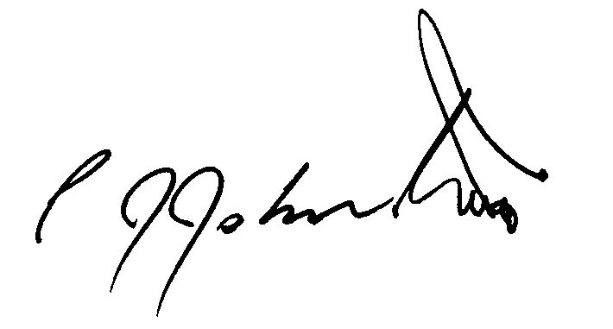
Philip Johnston
1305, 12 Glen St
Milsons Point NSW 2061
0434 715.861
scribepj@bigpond.com
26 February 2018
Reserve Bank of Australia rbainfo@rba.gov.au
GPO Box 3947
Sydney NSW 2001
Attention: Chair of the Payment Systems Board, Mr Philip Lowe
Dear Mr Lowe
A question relating to the Royal Commission into misconduct in the Banking, Superannuation and Financial Services Industry
Enclosed references:
- Philip Johnston’s letter to the Chair of the Board of the Reserve Bank dated 14 Feb 2018 [1 pg].
- Reserve Bank response letter to Philip Johnston dated 19 Feb 2018 [1 pg].
This letter relies on the below clauses (g), (h) and (i) of the Terms of Reference
dated 14 December 2017 to the afore-mentioned Royal Commission:
(g) the effectiveness and ability of regulators of a financial services entity to identify and address misconduct by those entities;
(h) whether any further changes to the following are necessary to minimise the likelihood of misconduct by financial services entities in future (taking into account any law reforms announced by the Government):
(i) the legal framework;
(ii) practices within financial services entities; and
(iii) the financial regulators,
(j) any matter reasonably incidental to a matter mentioned in paragraphs (a) to (i).
Is there any prohibition on members of the Payments System’s Board of Directors owning ordinary shares in financial institutions that the Payments System Board does or may regulate? If there are any such restrictions, could you set out what limits they are?
Yours sincerely
Philip Johnston

