Interchange Fee means The Personal Credit Card Market in Australia: Pricing over the Past Decade (by Iris Chan, Sophia Chong and Stephen Mitchell from RBA's Payments Policy Department) notes an Interchange Fee is a ‘transfer’ fee set by the Credit Card Payment Schemes and is paid by the Merchant's financial institution (known as the Card Acquirer) to the Cardholder’s Credit Card Issuer each time a Credit Card transaction is made.
Interchange Fee is -
(i) a transaction fee that the Merchant's bank, known as the Acquirer Bank, pays whenever a customer uses a credit/debit card to make a Purchase; and
(ii) paid to the Card Issuer to cover -
* funding cost up to 55 days,
* electronic hardware and software handling costs,
* fraud and bad debt costs; and
* the risk involved in approving the payment.
Since November 2006, there has been a common cost-based benchmark for average interchange fees of 50 basis points for both MasterCard and Visa.
Interchange Fees are levied on the Wholesale Supply Side that are set by Credit Card Schemes such as MasterCard, Visa and eftpos that require payments from the Merchant's bank, known as the Card Acquirer, to the Credit Card Issuer on every transaction - see Why does the RBA regulate interchange fees? which includes:
"Interchange fees are wholesale fees set by card schemes such as MasterCard, Visa and eftpos that require payments from the merchant's bank to the cardholder's bank on every transaction."

"The tendency for interchange rates to rise to high levels is most apparent in unregulated jurisdictions like the United States where credit card interchange rates in the MasterCard system are as high as 3.25 per cent plus 10 cents, implying that – after scheme fees and acquirer margin – some merchants may pay over 3½ per cent in merchant service fees for high rewards cards."

"What are the RBA's new interchange standards?
The weighted-average benchmarks will remain the primary element of interchange regulation. The weighted-average benchmark for credit cards will remains at 0.50 per cent. The weighted-average benchmark for debit cards will be lowered from 12 cents to 8 cents, effective 1 July 2017,consistent with the fall in average transaction values since the debit benchmark was introduced.
The weighted-average benchmarks will be supplemented by caps on any individual interchange fee within a scheme's schedule. No credit card interchange fee will be permitted to exceed 0.80 per cent and no debit interchange fee will be able to exceed 15 cents if levied as a fixed amount or 0.20 per cent if levied as a percentage amount."

.....“interchange rates on premium and other higher-cost cards have risen as interchange fee schedules have become increasingly complicated” over the past decade or so. New card schemes have been introduced into the credit card market since around 2010. As a result, there has been significant growth in credit card usage in the premium segment.
If a Credit Cardholder makes a $100 Purchase with its Credit Card, the Merchant would receive approximately $97.23 'same day'.
The remaining $2.77, known as the Merchant Service Fee, gets divided up:
* $0.50 to Card Acquirer
* $2.00 approx. Interchange Fee would go to the Credit Card Issuer - a flat fee plus a percentage of the purchase price (including taxes)
* $0.20 approx. On Charged Scheme Fee would go to Visa or MasterCard
* $0.07 (remaining) fee [referred to as a discount rate, an add-on rate, or passthru] would go to the Merchant's bank known as the Card Acquirer.

Interchange fees vary depending on:
• The brand of the card, e.g. MasterCard ®
• Where the card was issued, e.g. Australia or overseas
• How the transaction was processed, e.g. card present or card not present
• Card product type, e.g. premium card, business card
• Merchant industry type, e.g. Merchant Category Code
In more recent years, however, the structure of credit card pricing and product offerings have changed. Credit Card Payment Schemes have found ways, within the bounds of the Reserve Bank’s regulation, to charge a Merchant Service Fee. Hence, a credit card system with high Interchange Fees may result in Merchants effectively subsidising Cardholders who use that system, unless Merchants are able to pass these costs on to Cardholders.
Australian Retailers Association - Submission to RBA - Credit Card Schemes in Australia sourced on the RBA website using Google (overtly marked Confidential) is highly critical of the RBA's inept and complicit role in Credit Card Issuers imposing an Interchange Fee upon Merchants when the contract is between the Card Issuer and the Cardholder.
"1.1 Confidentiality
The contents of this report are confidential. Data relating to the business of the Australian Retailers Association (ARA) or its members and contained within this submission is confidential and is not to be released into the public domain."
Below are pertinent extracts:
Argument 1 - The risk of extending credit to cardholders:
"The magnitude of credit card annual percentage rates (APR) is well above other unsecured lending rates."
Argument 2 - The cost of the Issuer processing the transaction
"It is therefore reasonable for the Issuer to seek cost recovery and a competitive margin for this service – from the cardholder with whom a relationship exists and for whom a service is being performed. Such a fee for service should reflect the exact nature of the services offered by the Issuer to the cardholder.
The fee should be ‘internal’ to that relationship.
We would therefore argue that the cost of the Issuer processing a credit card transaction does not warrant an Interchange Fee being levied to the Card Acquirer and ultimately passed on to the Merchant via Merchant Service Fee. We would cite a number of reasons in support of this:
The Issuer is acting on behalf of their Cardholder in processing a credit card transaction. The Cardholder is instructing the Issuer to perform the transaction;
It is the Cardholder who is seeking to effect payment to the Merchant via a credit card. It is at the Cardholder's discretion to select a payment method. The Cardholder initiates the entire credit card processing cycle and should bear the costs of the party (the Issuer) acting directly on their behalf;"
Argument 3 - Costs associated with the interest free period attached to credit cards
"We agree that the interest free period encourages potential Cardholders to take up card products and existing cardholders to utilise their cards. It is very useful and beneficial for consumers to delay payment for goods and services for some 55 days. We would point out that certain credit cards have zero interest free days, yet still attract identical interchange and Merchant Service Fee levels.
The interest free period is again, a Card Issuer / card holder relationship cost.
The introduction and length of interest free periods was determined by credit Card Issuers to facilitate credit card take up and usage – both revenue generating activities for themselves. We find it implausible that Issuers sought to introduce interest free periods for any reason other than to increase their own income levels."
Argument 4 - The cost associated with providing a payment guarantee to merchants
"We would expressly reject that any credit losses resulting to the Issuer from this process (card holders lodging bogus charge backs and then not paying when proof of purchase is provided), should be passed back to the Merchant via Merchant Service Fee that has interchange as a major cost component. This is an Issuer / Cardholder credit matter."
The above submission contends that 'ad valorem' Merchant Service Fees "should be completely abolished and replaced with market negotiated activity based fees", seemingly based on the User Pays Principle for all enjoying such a Credit Card Line Of Credit.
Given that Credit Card Issuers under the Four-Party Scheme receive an Interchange Fee from which they may fund rewards programs, they have an incentive to issue and promote cards that attract a higher Interchange Fee for each transaction. In line with this, the Four-Party Schemes have an incentive to put in place an Interchange Fee pricing structure that encourages financial institutions to issue and promote their Credit Cards; while the card scheme does not directly generate revenue from Interchange Fees, it charges fees to Card Issuers and Acquirer Banks based on the volume of credit card transactions.
In contrast to Four-Party Schemes, there are no Interchange Fees in Three-Party Schemes because the card scheme itself is the sole acquirer for transactions on its cards, and typically also the sole issuer. Instead, rewards programs in this model are funded directly through fees paid by the Merchant.
Hence, the higher the average Merchant Service Fee for a Three-Party Scheme, the more generous the rewards that scheme is able to offer. At the same time, a high Merchant Service Fee tends to discourage Merchants from accepting Credit Cards for payments. To some extent this acts as a competitive discipline on Merchant Service Fees, although some Merchants may feel that declining to accept a particular card is not a realistic option.
Regardless of the model, the costs of funding rewards for Cardholders has been borne by Merchants in the first instance through higher Merchant Service Fees – either through the pass-through of higher Interchange Fees (for four-party schemes) or directly (for three-party schemes). Moreover, card schemes in many credit card markets have rules in place that prevent Merchants from passing their card acceptance costs directly through to cardholders in increase incentives for Card Issuers to promote particular products within their suite of offerings; Card Issuers have responded, particularly through new strategies focusing on the premium segment of the market. Some of these new pricing strategies have focused on upgrading existing cardholders – offering platinum cards with additional benefits or more generous rewards for no additional annual fee – which has the effect of generating increased interchange revenue for the issuer every time a customer uses their card. There have also been a number of merchant-branded platinum cards that have entered the market in recent years. Separately, American Express has modified its product offerings, entering into arrangements with major banks to issue ‘companion’ American Express cards with MasterCard or Visa products.
Some of these recent developments have changed the effective price to some Cardholders of a credit card transaction, and correspondingly added to costs on the acquiring side of the market. Merchant Service Fees have remained relatively stable in the past few years, though these recent developments could put upward pressure on some fees if they continue.

Interchange Fees
Interchange Fees are often a feature of Four-Party Schemes (Figure 2.1), which include the debit and credit schemes operated by eftpos, MasterCard and Visa. Card Acquirers, the Merchants’ providers of payment acceptance facilities, pay Interchange Fees to Card Issuers, the Cardholders’ payment card providers. The fees enable issuers to recover the cost of processing transactions. Payment schemes can also set Interchange Fees to incentivise financial institutions to issue their payment cards. Issuers can incentivise Cardholders to use their cards by passing on a proportion of Interchange Fees as reward points, interest-free periods or other benefits.
Figure 2.1: Simplified example of a Four-Party Scheme
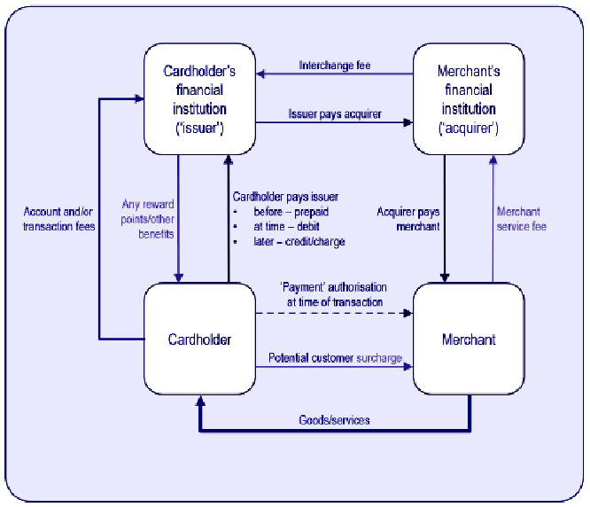
Payment schemes designated by the RBA (eftpos, MasterCard and Visa) ensure that the weighted-average value of their Interchange Fees complies with caps established by the RBA. The caps are 0.5 per cent of the value of transactions for credit card schemes and 12 cents per transaction for Debit Card schemes. The RBA established these caps following a cost-based benchmarking exercise.
The RBA caps Interchange Fees for a number of reasons:
- Price signals are not efficient in four-party payment schemes, which can result in competition and paradoxically lead to higher prices. Merchants generally exhibit low price sensitivity to Merchant Service Fees for widely used payment schemes, such as those operated by eftpos, Visa and MasterCard. If merchants do not accept these cards, they may lose sales to the majority of merchants that do. In comparison, cardholders are often more price sensitive. They have access to a range of payment schemes, and will respond to incentives like reward points when determining which scheme to use. Payment schemes therefore have an incentive to set high Interchange Fees, which issuers can use to offer reward points for cardholders.
- Interchange fees act like price floors for Merchant Service Fees. To break even, at a minimum, acquirers set Merchant Service Fees at the cost of Interchange Fees, plus the cost of processing transactions.
- Cross-subsidisation will occur if merchants do not recover Merchant Service Fees through customer surcharges. The cost of absorbing Merchant Service Fees would be reflected in higher prices for goods and services. This would result in cross subsidisation from customers using low-cost payment mechanisms, such as eftpos and cash, to those using high-cost payment schemes – an inefficient outcome.
Amex and Diners Club operate three-party payment schemes. In three-party schemes, the scheme takes the role of issuer and acquirer. As no Interchange Fees are involved, these schemes are not covered by Interchange Fee regulation. Issues with the regulation of a variation of three-party schemes, known as companion cards, are discussed below.
Interchange fee is a term used in the payment card industry to describe a fee paid between banks for the acceptance of card based transactions. Usually it is a fee that a merchant's bank (the "acquiring bank") pays a customer's bank (the "issuing bank") however there are instances where the Interchange Fee is paid from the issuer to acquirer, often called reverse interchange.
In a credit card or Debit Card transaction, the card-issuing bank in a payment transaction deducts the Interchange Fee from the amount it pays the acquiring bank that handles a credit or Debit Card transaction for a merchant. The acquiring bank then pays the merchant the amount of the transaction minus both the Interchange Fee and an additional, usually smaller, fee for the acquiring bank or ISO, which is often referred to as a discount rate, an add-on rate, or passthru. For cash withdrawal transactions at ATMs, however, the fees are paid by the card-issuing bank to the acquiring bank (for the maintenance of the machine).
These fees are set by the credit card networks,^{[1]} and are the largest component of the various fees that most merchants pay for the privilege of accepting credit cards, representing 70% to 90% of these fees by some estimates, although larger merchants typically pay less as a percentage. Interchange fees have a complex pricing structure, which is based on the card brand, regions or jurisdictions, the type of credit or Debit Card, the type and size of the accepting merchant, and the type of transaction (e.g. online, in-store, phone order, whether the card is present for the transaction, etc.). Further complicating the rate schedules, Interchange Fees are typically a flat fee plus a percentage of the total purchase price (including taxes). In the United States, the fee averages approximately 2% of transaction value.^{[2]}
In recent years, Interchange Fees have become a controversial issue, the subject of regulatory and antitrust investigations. Many large merchants such as Wal-Mart have the ability to negotiate fee prices,^{[3]} and while some merchants prefer cash or PIN-based Debit Cards, most believe they cannot realistically refuse to accept the major card network-branded cards. This holds true even when their interchange-driven fees exceed their profit margins.^{[4]} Some countries, such as Australia, have established significantly lower Interchange Fees, although according to a U.S. Government Accountability study, the savings enjoyed by merchants were not passed along to consumers.^{[5]} The fees are also the subject of several ongoing lawsuits in the United States.
"The interchange fee payable on a four-party card transaction depends on the category of that transaction within a schedule of interchange rates set by the scheme. The average level of interchange rates is subject to a Reserve Bank standard that requires that the weighted average of the schedule of rates does not exceed 50 basis points, with compliance required once every three years (or at the time of any reset of the schedule). The specific rate applying to a transaction will depend on the type of merchant (‘strategic’, service station, etc), the type of card (various types of premium cards, corporate, etc) and the nature of the authentication (contactless, SecureCode, etc) or the value of the transaction. There is a hierarchy of categories, which determines how the merchant, card and transaction categories interact. Typically, the relatively low ‘strategic’ interchange rates for large merchants have precedence over the interchange category for the type of card, so that the same relatively low rate for strategic merchants applies for all their transactions, including for those transactions using premium cards with high interchange rates. However, merchants that do not have access to strategic or merchant-specific rates will face different rates based on the type of card presented.
In recent years, there has been significant growth in the premium segment of the credit card market, with the emergence of ‘super-premium’ and, more recently ‘elite’/‘high net worth’ credit cards in addition to ‘gold’ and ‘platinum’ cards. Issuing banks can earn higher interchange fee revenue on these products than from standard credit cards, and may use this revenue to fund more generous rewards programs in terms of frequent flyer points, spending vouchers at retailers, travel insurance, etc. One objective measure of the generosity of rewards to consumers is in terms of the card spending required to generate a $100 voucher, which can be translated into an effective cash-back percentage. Data on the interchange rates and rewards on offer in a sample of around 80 cards monitored by the Bank, show a positive correlation between the interchange rate on cards and the generosity of rewards by issuers (Graph 9)."
The Financial System Inquiry recommended in 2014 that the RBA look into the card payment regulatory framework again, with particular focus on the interchange fee and surcharging. Subsequently, the RBA implemented major changes to how credit card payments are processed and the extent of surcharges that businesses can charge to customers to use credit cards in Australia. The new rules are effective in stages from Sept 2016, with full implementation from Sept 2017.
Below is Graph 8.5 from Submission to the Financial System Inquiry - RBA - March 2014 which notes that the (RBA's) "interchange fee reforms have brought down the average interchange fees paid in the international systems and have reduced the gap between interchange fees in the credit card, scheme debit card and eftpos systems (Graph 8.5). The broader effects of the interchange reforms are discussed below."
Post-reform benchmarks, the Cardholder Bank now receives only about a $0.50c Interchange Fee on a $100 Merchant sale instead of about $0.98c. The Merchant's bank, known as the Card Acquirer, now receives nothing on a eftpos transaction where previously it received $0.20c.
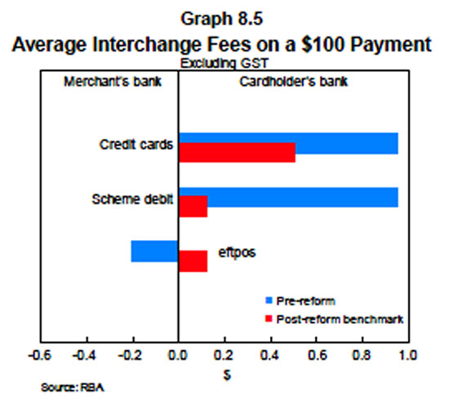

Point Hacks' website dated March 15, 2016 notes two current interchange rates:
- Standard cards (e.g. Silver and Gold cards) have a rate of about 0.27% – 0.32%
- Premium cards (e.g. Platinum and Black cards) have a much higher rate of about 0.70% – 0.92%
However, the Review identified an opportunity to step back from direct regulation of interchange fees, predicated on there being a sufficiently strong competitive environment to prevent interchange fees rising over time from their regulated levels. Two approaches to addressing this risk were identified:
- Industry could strengthen competition through measures which included: enhancement of the eftpos system to allow it to compete more effectively with the international card schemes and the development of an alternative system for online payments; further modifications to the honour-all-cards rules to allow merchants to make separate acceptance decisions for any card for which there was a separate interchange fee; and more transparent scheme fees.
- Four-party schemes could directly address the Board's concerns that interchange fees might rise by providing voluntary undertakings that the weighted average of credit card interchange fees would not rise above 0.5 per cent.
The Board indicated that, if industry was not able to make sufficient progress on these, interchange regulation would be retained and the benchmark for credit card interchange fees could be reduced to 0.3 per cent.

Interchange Fee is charged by the Card Issuer to the Merchant for putting the Merchant in funds 'same day' of Purchase.
Interchange Fee is -
(i) a transaction fee that the Merchant's bank, known as the Acquirer Bank, pays whenever a customer uses a credit/debit card to make a Purchase; and
(ii) paid to the Card Issuer to cover -
a) funding cost up to 55 days,
b) electronic hardware and software handling costs,
c) fraud and bad debt costs; and
d) the risk involved in approving the payment.
Rewards Programmes are incentive programs operated by Credit Card Issuers where a percentage of the amount spent by a Credit Cardholder is paid back to the Cardholder by means of points earned. Many Credit Card Issuers run programs to encourage use of their Credit Card where the Cardholder earns loyalty points, often referred to as Reward Points, frequent flyer miles or a monetary amount.
The former is a fee for performing a) to d) above. The latter is a lure to entice Credit Cardholders to make purchases with their Credit Card/s.
RBA's The Personal Credit Card Market in Australia: Pricing over the Past Decade - March 2012 noted:
"In four-party card schemes (such as MasterCard and Visa), rewards programs are, for the most part, funded by interchange fees."
The following statement is from the Reserve Bank's Submission to the Senate Inquiry into Matters Relating to Credit Card Interest Rates - August 2015
"The rewards programs offered by credit card issuers are due in large part to the existence of interchange fees."

Issues Paper "dated March 2015 "Review of Card Payments Regulation 3. Developments in the Card Payments Market" evidences that the RBA enjoys virtually unlimited access to data from the primary players amongst the Credit Card Payment Schemes.
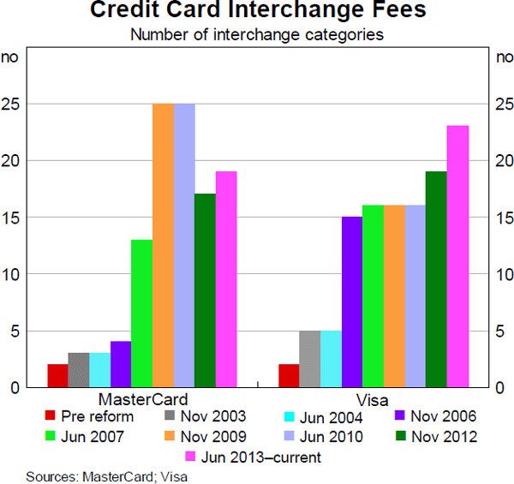
Te above RBA graph as at March 2015 evidences the range of interchange fees
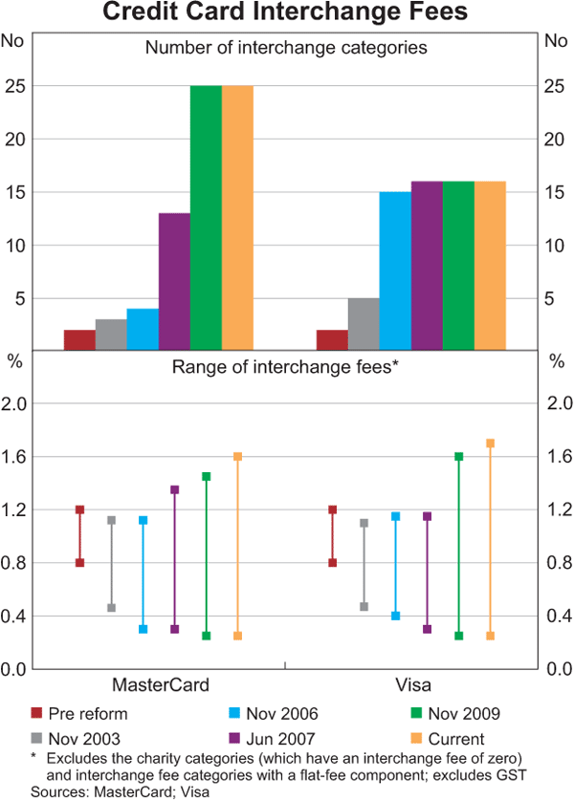
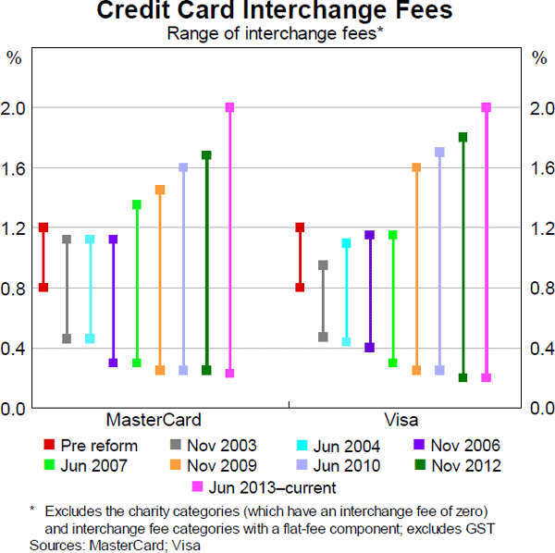

See Fees Levied On The Wholesale Supply Side.

