**Contentious Thought Provokers** means a **Senex Programme** analysing contentious topical issues [clause (d) of the **Five Categories Of DGOPI**amongst **Debatable Government Opportunities, Issues or Problems**].

Below are a few Contentious Thought Provoker which would create substantive controversy and discussion as the opening **Approved Selected Submissions**presented on the initial handful of **Senex Programmes****:**

**1.The rich continue to get even richer at the expense of the poor**

'Home ownership' is a diminishing prospect for more and more Australians, primarily due to a 30 year reign of Negative Gearing.  When investment interest rates are at record low levels, and the All Ords Index is still below pre-GFC levels of 6,800, real estate price appreciation (particularly in Sydney and Melbourne) is racing ahead with no prospect of steadying.  Mortgage brokers evidence individuals owning five or more home units investment properties, in addition to also owning a 'Principal Place of Residence'.  Due to record low mortgage rates, the scope to '*negatively gear*' is reduced because the primary cost of owning an investment property, namely, mortgage costs is reduced.  However, the scope to buy more and more investment properties, compared to Australians that are not property owners, is infinitely greater.  Because '*negative gearers*' can use the equity in their existing investments as collateral security to purchase more properties in a buoyant property market.

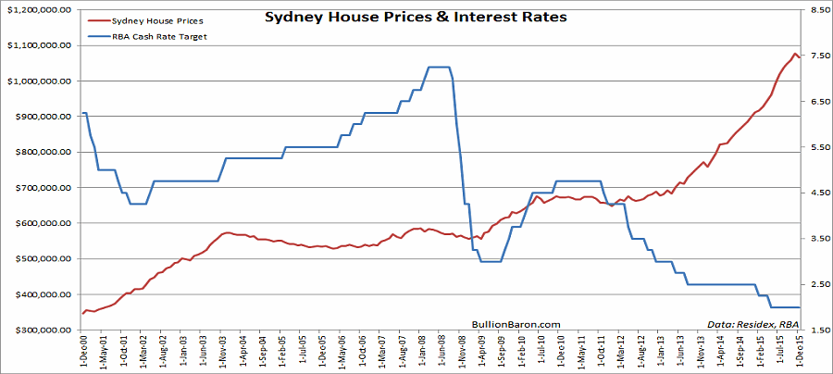

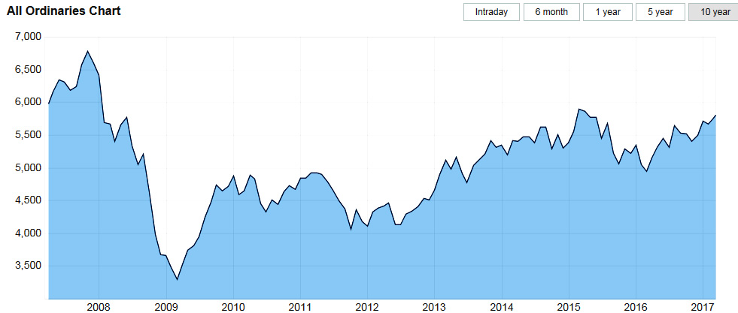

Was individual income tax payers purchasing multiple properties, which is the primary reasons for Sydney and Melbourne real estate appreciating by 10% p.a*. circa* for the last 5 years, and doubling in value since 2009, contemplated when -

(A)       Negative Gearing was introduced in 1985 by the Hawke/Keating Govt where investment property expenses were allowed to offset personal income, reducing personal income tax; and

(B)       the then Treasurer, Peter Costello, reduced to 50% the tax impost on capital gains on an investment property/ies in September 1999?

Despite the clamors from the Labor Opposition and *The Greens*, the ruling Liberal/Coalition is unwilling to alter the existing tax deduction benefits of Negative Gearing.

Arresting rampant real estate appreciation in Sydney and Melbourne that is predominately due to a 30 years reign of Negative Gearing first introduced by a Labor Govt. is not restricted to abolishing *'in toto'* the current allowance to offset net investment property costs against personal income.

It would be a simple task to reduce the income tax deductions on investment properties incrementally by say 5% per investment property owned.

**Policy Presenter's****Policy Proposal**

That the tax deduction rules for Negative Gearing investment properties be as follows to apply from 1 July 2017 for all Australian tax payers:

1. **100% income tax deduction of net losses on the First Designated Investment Property**
2. **95% income tax deduction of net losses on the Seconded Designated Investment Property**
3. **90% income tax deduction of net losses on the Third Designated Investment Property**
4. **85% income tax deduction of net losses on the Fourth Designated Investment Property**
5. **80% income tax deduction of net losses on the Fifth Designated Investment Property**
6. **75% income tax deduction of net losses on the Sixth Designated Investment Property and any additional Designated Investment Property/ies.**

The above six incremental reductions in 'net costs allowances' could easily be altered 'bigger' or 'smaller' according to future property inflation.

**2.        Capital and Corporal punishments deter others from similarly crimes.  Long term incarceration as a form of punishment is dehumanising and highly cost-ineffective expenditure of the public purse.  Economic necessity dictates that we have to learn from history as to what are effective deterrents and what are not!**

**A.    Reason**

Burgeoning Federal and state govt. health care costs is a difficult problem to solve because humans are living longer due to, but not restricted to education re the dangers of smoking, better understanding of excessive alcohol and eating (obesity/diabetes), as well as the benefits of statins, anti-coagulants, blood pressure drugs and medical interventions.  Those extra 'living years' are usually post-working life, so health care '***costs***' increase, but income tax receipts don't '***benefit***'.  Economic necessity dictates that our governments must reduce fiscal expenditure somewhere to fund health care.

**B.    History of punishment for major crimes against humanity did not incarcerate.  It brandished a cruel and painful execution to '*send out a fearful message*' to dissuade similar transgressions**

*Homo sapiens* (approx 108 billion of them) have occupied '*terra firma*' for approx 125,000 years.  *Homo sapiens* moved beyond East Africa appro. 75,000 years ago.  Incarceration as a punishment for taking the lives of others is a very recent phenomena in a few Western countries -  stretching back barely 100 years.  It is highly cost-ineffective expenditure of the public purse.  Incarceration does not effectively deter, in part because the punishment is no longer inflicted in the 'public eye'.

Jesus of Nazareth was executed in a vicious way to send out a patent message not to similarly challenge the ruling authority. Joan of Arc was also burnt at the stake in 1431. *Decimation* originally referred to the execution of every tenth mutineer, a punishment used in the Roman army for 're-educating' mutinous legions.  One in ten soldiers, who had run from battle, was flogged by a metal ball attached to a rope until dead in full view of the other nine in ten mutineers.  Care was made not to strike the 'decimated' above the shoulders, so as to prolong the execution.  Through the Middle Ages the greatest and most grievous punishment used in England was being hanged until he/she be half dead, and then taken down, and quartered alive; after that, their members and bowels were cut from their bodies, and thrown into a fire.  If the crime was deemed less heinous, the accused was hanged until dead.  These punishments were carried out in the public square as a deterrent for others similarly offending.

Keelhauling was a form of severe punishment first credited to the Dutch Navy in the 1500s.  The victim was suspended by a rope from one fore yardarm which was attached to his back. Another rope was fastened to him, which lead under the ship's bottom, and through a block at its opposite yard-arm. The 'punishment detail' then hauled briskly on the rope on the opposite side of the ship, drawing the victim along the hull on one side, then over the ship's keel.  From there the rope dragged the victim over the opposite side of the hull until the victim was hoisted up on the other yardarm.  Some victims survived*.* The entire ship's crew witnessed the punishment.  Swift and cruel punishment was deemed necessary to warn others of the likely consequences of similarly transgressions.

Many Islam countries still carry out stonings in the public square on a Friday.

Until the last 100 years of the 125,000 years history of *Homo sapiens*, the concept of incarcerating a person as punishment for a crime was not evident because there was no ‘fiscal pot’ to pay the high cost of imprisonment (presently exceeds $100,000 pa for maximum security in Australian prisons).  In the history of *Homo sapiens*, if there was any 'public purse', it would be assigned a higher importance eg, civil protection, health, education, food supply.

Most prisons were used as holding areas until trial and subsequent sentencing. Trials were often skewed in favour of the prosecution.  Justice was usually swift and often brutal.  Our predecessors implemented swift and painful punishment as a deterrent for similar transgressions.

**C.    Current punishment practices**

If in many Asian countries, a cost-effective sentence for the person that killed Daniel Christie at Kings Cross in 2013 with one 'coward punch' would be to flog the assailant to within an inch of his death once a week for a few weeks, then the weapon that killed Daniel Christie namely the assailant's punching arm surgically removed.  The assailant’s assets would be sold and paid to the health care system towards the significant cost of treating Daniel Christie whilst in an induced coma.  The cost of punishment would receive a small offset by selling the assailant's assets.  On 27 Aug 2015, Shaun McNeil, 27, was found guilty of manslaughter of Daniel Christie and sentenced to a maximum of 10 years in jail - eligible for parole in 2021:

* Will a 10 year jail sentence deter others from throwing a vicious punch, usually without any warning when the offenders punishment is not in the public eye?
* Will the NPV of over $1,000,000 from the fiscal purse for the cost of the trial and a 10 years incarceration be cost-effective fiscal expenditure when governments are generally running deficits already?

Ivan Milat murdered at least seven back-packers in the Belanglo State Forest in the 1990's.  Ivan Milat is serving seven consecutive life sentences, plus 18 years without parole.  Ivan Milat is never to be released.  Ivan Milat is to spend the remainder of his life in a cage of steel bars.

In 2012, Ivan Milat's great-nephew Matthew Milat and his friend Cohen Klein (both aged 19 at the time of their sentencing) were sentenced to 43 years and 32 years in prison respectively, for murdering David Auchterlonie on his 17th birthday with an axe at the Belanglo State Forest in 2010.  Matthew Milat struck with the double-headed axe as Klein recorded the attack with a mobile phone. This was the same forest where Ivan Milat had killed and buried his victims.

Patently, the sentence that Ivan Milat received at a net-present-value fiscal cost approaching $3 million dollars from the public purse did not act as a deterrent to great-nephew, Matthew Milat, and his friend, Cohen Klein.

Australia in the 21st Century would benefit from learning from the overwhelming history of human behaviour that is still practiced in much of Asia, Africa, Russia and other countries, namely applying 'capital' and 'corporal' punishments on the basis of *"an eye for an eye"*.  Many of our major global competitors in particular China, India and Indonesia will not expend a material portion of their ‘fiscal pot’ on long term incarceration.  Rather they will expend their tax revenues on education and health care for current and future tax payers to improve their country's competitive advantages.

Similarly, in Australia the material cost of imprisonment for citizens who commit heinous crimes (multiple murders) against innocent victims would be better invested on health care and education of future and current Australian tax payers in order to better compete with our trading partners.  Because the alternative of incarceration until death is not fussing up to the problem - merely shifting it off to someone else.

Sentencing a vicious and dangerous murderer that is judged to never be released, to a life in a steel cage is without sense when the fiscal cost could be expended on health and education for future and present tax-payers, as many of our trading partners do.

Presently the tax payer incurs the punishment of a sentence of long-term incarceration, not the accused.  This is inequitable and cost-inefficient.  Some will contend that the cost of executions in the highly litigious USA is greater than long term incarceration, but not in China, India and Indonesia.  In China, punishment is swift and the family is charged for the bullet.

**D.    Corporal punishment for some crimes**

Only a very small proportion of prisoners are sentenced to 'life'; never to be released.  There is a welter of evidence that many prisons are a training ground for further crime, because like-minded transgressors are in close proximity and with a lot of time on their hands.

Corporal punishment is a [punishment](https://en.wikipedia.org/wiki/Punishment) intended to cause physical [pain](https://en.wikipedia.org/wiki/Pain) on a person.   It is commonly practiced on minors, especially in home and school settings, usually employing more modest forms. Common methods in this regard often include spanking or paddling.  The writer and his fellow-class mates received the 'strap' up until about 15 years of age from their teachers.  The writer received the feather duster from his late father for some offences. In the calls room, there was a sense of 'pride' in having stood firm when 'strapped' which was usually applied to the open palm, but not always.

Corporal punishment is used on adult prisoners in some countries.  In history, most cultures have practiced corporal punishment on adults in settings of imprisonment or slavery. Frequently employed methods are flagellation (beating the human body with special implements such as whips, [lashes](https://en.wiktionary.org/wiki/lash), the cat o' nine tails) and caning.

Official punishment for [crime](https://en.wikipedia.org/wiki/Crime) by inflicting pain or injury, including flogging, branding and even mutilation, was practised in most [civilizations](https://en.wikipedia.org/wiki/Civilization) since [ancient](https://en.wikipedia.org/wiki/Ancient_history) times. However, with the growth of 'Humanitarianism' since the 18th Century, such punishments were increasingly viewed as inhumane.  By the late 20th Century, corporal punishment had been eliminated from the [legal systems](https://en.wikipedia.org/wiki/Legal_system) of many [developed countries](https://en.wikipedia.org/wiki/Developed_countries).

[Judicial corporal punishment](https://en.wikipedia.org/wiki/Judicial_corporal_punishment), as part of a [criminal sentence](https://en.wikipedia.org/wiki/Sentence_(law)) ordered by a [court of law](https://en.wikipedia.org/wiki/Court_of_law), remains lawful in parts of [Africa](https://en.wikipedia.org/wiki/Africa), [Asia](https://en.wikipedia.org/wiki/Asia) and [Latin America](https://en.wikipedia.org/wiki/Latin_America). Corporal punishment is also allowed in some [military](https://en.wikipedia.org/wiki/Military) settings in a few jurisdictions

Advocates of 'Humanitarianism' that will not countenance the use of capital and corporal punishment for some crimes against society are unable to cost-justify the high cost of incarceration against applying its fiscal cost on the burgeoning health care budget, education and accommodation for the homeless.

**Policy Presenter's****Policy Proposal**

Supreme Court judges and Territory Court judges in the Australian legal system be granted authority to sentence 're-offenders' and 'multiple offenders' capital and corporal punishment due to the more effective deterrent value because incarceration is not cost effective expenditure of the 'public purse'

Such capital and corporal punishment be carried out in public view to Australians without a criminal record.  That no cameras or recording devices be allowed in the public viewing area.

**4.        Compulsory Voting vis-à-vis Optional Voting and KPIs**

Democracy is not possible without the participation of citizens in politics.  In order to make democracy work, citizens have the right to choose their representatives in free regularly held elections.  The majority of Western countries have 'optional voting' arguing that democracy is about choice, including the choice not to vote.  The majority of Australians approve of 'compulsory voting' and have done so for decades.

The following 24 countries have 'compulsory voting':

Argentina, Australia, Belgium, Bolivia, Brazil, Democratic Republic of Congo, Costa Rica, Cyprus, Dominican Republic, Ecuador, Egypt, France (Senate elections only), Liechtenstein, Luxembourg, Mexico, Nauru, Panama, Paraguay, Peru, Singapore, Switzerland (one canton only), Thailand, Turkey and Uruguay.

Prior to the introduction of 'compulsory voting' in Australia at the federal level in 1924, turnout was hovering in the 50–60% range (of registered voters).  Since then, voter turnout has remained steady for many decades at around 93%.

'Compulsory voting' offers an easy escape to get away with cheap one-liner rhetoric, repeated again and again, intent upon sinking the message into voters who have no interest in what politicians are doing, theoretically "to identify and implement good policies."  John Howard and Tony Abbott have been adroitly adept at *'parroting out'* one-liners repeatedly, ostensibly to gain the attention of blue collar workers/*Tradies* and other voters more intent on feeding their families than monitoring the performance ofpoliticians. 'Compulsory voting' also encourages blame games and mudslinging.

'Optional voting', conversely compels politicians to attempt to capture the support of people who want to vote, and to vote for them or their party, by articulating to those voters exactly what policies they have assisted to implement, or attempted to implement, and what they want to implement and why.  Rather than repeating one-liners and slogans.

Politicians are unique amongst highly paid employees as they do not have to provide evidence of what work they have completed over what period.  There are no 'key performance indicators' that they release to voters on a periodic basis, say annually, as to what they have achieved for the electorate.

**Policy Presenter's****Policy Proposal**

That Australia follow the lead of the vast majority of Western countries and make voting, at state and federal elections in both houses of parliament, 'optional voting' so that our politicians will be more accountable for performance and desist iterating one-liners, criticizing the other party/ies and mudslinging.

That all state and federal politicians, from both the lower and upper houses, provide to their respective '[**Department of the Senate**](http://www.aph.gov.au/About_Parliament/Parliamentary_Departments/Department_of_the_Senate)' or '[**Department of the House of Representatives**](http://www.aph.gov.au/About_Parliament/Parliamentary_Departments/Department_of_the_House_of_Representatives)' a two page KPI (in 10 font Arial at 1.5 spacing with 20mm text boundaries) that set out what policies they have pursued and the policies they have assisted to be implemented, for publication on their respective Parliamentary websites, so that interested voters have a better understanding of what each has pursued/achieved over the previous 12 months.  Travel and accommodation costs incurred would be recorded on an Annexure to each annual KPI.

**5.        Reporting remuneration movements in annual reports to shareholders**

The *Four Pillars* enjoy unique Oligopoly advantages/benefits not evident in any other Western banking economy.  The *Four Pillars* enjoyed a smaller market share and experienced greater competition than immediately prior to the 2008 GFC.  Since 2008, Westpac purchased St.George Bank which owned Bank SA. CBA purchased Bankwest after Bankwest became illiquid.  Several foreign banks closed their Australian operations.

In a normal mature market, businesses are '*price takers*'. They have little power over what they charge, and rely on product differentiation and superior customer service. The only businesses that can fix prices are monopolies or oligopolies, where a few very large suppliers act in unison.  The *Four Pillars* which control 80% *circa* of deposits and lending in Australia display the behaviour of Oligopolies, particularly with regard to passing on reductions in the Overnight Cash Rate:

*           Oligopolists tend to adopt a similar price, for similar products,

*           If price is to be raised, the firms find it best to do so in close sequence.

*           Oligopolists avoid price wars – the spread between the Overnight Cash Rate and Credit Cards has never been wider.

*           Sales competition, not price competition is their area.

“**The Payment Systems (Regulation) Act 1998 gives the Reserve Bank of Australia 'extensive powers' to gather information from a payment system or from individual participants****."  "**[**The Payments System Board was established by the Commonwealth Govt. in 1998 so as to best contribute to: .......... and promoting competition in the market for payment services.**](http://www.rba.gov.au/payments-system/reforms/debit-card-systems/rev-inter-stand-eftpos/rev-inter-stand-eftpos-112009.pdf)**"**

Section 10(2) of the **Payment Systems (Regulation) Act 1998** says:

**‘It is the duty of the Reserve Bank Board, within the limits of its powers, to ensure that the monetary and banking policy of the Bank** **is directed to the greatest advantage of the people of Australia and that the powers of the Bank ... are exercised in such a manner as, in the opinion of the Reserve Bank Board, will best contribute to** ...........**the economic prosperity and welfare of the people of Australia****.**

[**Payments System Board Annual Report – 1999 'Overview**](http://www.rba.gov.au/publications/annual-reports/psb/1999/overview.html)**':**

"The Payments System Board of the Reserve Bank was established on   
1 July 1998, with a mandate to promote the safety and efficiency of the payments system in Australia. This marked a watershed in governance of the payments system. The new regulatory regime, introduced in response to the Financial System Inquiry (the Wallis Committee), was an acknowledgment of the importance of the payments system to financial stability and of the scope to reap significant gains in efficiency.

**The Board has been given the backing of strong regulatory powers, unique among central banks**. At the same time, the Government has indicated its preference for a co-regulatory approach and it has balanced the Board's powers with safeguards for private-sector operators.

To date, the Board's strategy has been to treat its powers as ‘reserve powers’ to be exercised if other methods of persuasion and implementation prove to be ineffective. Its main priority over its first year has been to undertake a detailed stock take of the safety and efficiency of the Australian payments system, as the basis for determining an initial work program."

**Policy Presenter's****Policy Proposal**

That the Federal Treasurer seek the Governor of the Reserve Bank to exercise its "...*extensive powers* ...." under the ***Payment Systems (Regulation) Act 1998*** to request the CEO’s at each of the *Four Pillars* to:

1.         Report in their respective 2017 Annual Report to Shareholders in a -

(A)      single table (with five columns) which lists for the previous   
20 financial years (since the financial year ending 30 June 1998) the -

(i)        CEO's total annual remuneration for the previous   
20 financial years

(ii)       Chairman of the Board's total annual remuneration for the previous 20 financial years

(iii)      average of the remaining Board Member total annual remuneration for the previous 20 financial years

(iv)      median employee total remuneration for the previous   
20 financial years

(B)        single graph that displays the annual financial comparative costs listed in (A) above, together with the movement in the CPI where the CPI for the start date of 30 June 1998 is 1 which represents the CEO’s total remuneration for that financial year.  In each subsequent year, 1 increases according to any increase in total remuneration of the CEO.

2.       Explain to their Shareholders in each future Annual Report to Shareholders the reason/s for any material variance/s in the relative share of remunerations in the above four categories (i.e. Are the CEO's more skilled than their predecessors?    
Do they work longer hours?  Do Board Members work harder than previous Boards?  Are they subject to increased risk of personal litigation?  Or are they fully insured against personal losses?  Has the contribution and skill level or effort of the median salary employee altered/diminished/increased over the last twenty years?

3.       Provide annually to the Governor of the Reserve Bank all the numerical calculations (relied upon to provide 1. above) that are certified as 'true and correct' by the Chairman of the Board and the CEO.