1305, 12 Glen Street 'The Pavilion'
Milsons Point NSW 2061
scribepj@bigpond.com
0434 715.861

17 August 2017

Insert one of the two enclosed DVDs in a Windows PC which will auto-open at this IntroLetterToNickXenophon_17-Aug-17.htm
If using a MAC or the enclosed USB stick drive, open this letter at CreditCards\NickXenophon\IntroLetterToNick Xenophon_17-Aug-17.htm

Senator Nick Xenophon
PO Box 6100
Senate, Parliament House
Canberra ACT 2600
Dear Senator Xenophon - (click on any of the embedded URLs in this Intro Letter)
THIS INTRO LETTER IS CONFIDENTIAL TO THE NICK XENOPHON TEAM – FOR THE TIME BEING
A Royal Commission with only Two Terms Of Reference into the 'standout' Unconscionable Product in Australia's Financial Services Industry, namely Credit Cards, in order to reduce the Extreme Financial And Emotional Distress suffered by almost one million Credit Cardholders, identified by the Reserve Bank as Persistent Revolvers, many of whom are Financially Uneducated And Vulnerable Australians
Australian Governments allocate $43.38 million annually to 44 circa charities to provide financial counselling to predominantly Persistent Revolvers.
Will a member of the Nick Xenophon Team, that possesses financial acumen and legal skills, read the Writer's Submission Letter to Nick Xenophon dated 17 Aug 17 in my enclosed two DVDs and USB Drive stick?
The Writer -
(i) is aware that you "voted very strongly for a Royal Commission into banking";
(ii) has expended six years researching Credit Card Products and has created a catalogue of over 500 Defined Terms and Documents - the major source has been the myriad of reports and statistics on the RBA website
(iii) has R&D'd a comprehensive Grounds/Reasons why the Shadow Minister for Revenue and Financial Services should submit Thirteen Written Questions (re credit card products) to the Minister for Revenue and Financial Services during Question Time in the Lower House of Federal Parliament ***;
(iv) has prepared Thirteen Written Questions (re Credit Cards) for a member of the Opposition Party in the 'lower house' to ask the Minister for Revenue and Financial Services during Question Time ***;

- 2 –

- (v) posted submissions on CDs to:
A. Reserve Bank dated 8 December 2011
B. Submission Letter to Slater & Gordon dated 17 July 2015 (Slater & Gordon response letter dated 21 Sept 2015)
C. Submission Letter to Maurice Blackburn dated 8 May 2017 ***
D. Second Letter to Maurice Blackburn dated 25 June 2017 (Maurice Blackburn response letter dated 14 July 2017 ***)
*** The most pertinent are (iii), (iv) and (v) C. and D. above.
A Royal Commission into many facets of the Financial Services Industry as proposed by the Federal Labor Party, would take at least four years to table to Federal Parliament and cost several multiples of the forecast $53 million dollars, as the Commissioners investigated 300 circa Products and Services delivered by 130 approx. large companies that employ 500,000 staff circa in the Financial Services Industry, many of which, particularly within Credit Card Products, are highly differentiated. There would be very little of 'comparing apples with apples' to determine what is "...illegal and unethical behaviour and how the financial services industry institutions understood and gave effect to their duty of care to consumers."
Merely considering the banks, there are 37 Australian-owned banks, nine foreign-owned subsidiary banks and another 35 circa branches of foreign banks that collectively provide 200 circa banking Products and Services in Australia. Looking in isolation at only one of the Four Pillars, ANZ Bank with 50,152 employees (in 2015), under 7 Divisions, delivers approx. 200 Products and Services.
Australia has had 133 Royal Commissions since 1902, but none previously with the broad terms of reference and density of matters to examine than that announced by the Federal Labor Party in April 2016. Previous Royal Commissions have been granted both time and budget extensions. The more complexity in the warranted terms of reference, the less likely that the Royal Commission will -
(i) be cost-effective; and
(ii) achieve material improvement in 'banking behaviour' in the 'shorter term'.
I. By supporting a Royal Commission with only Two Terms Of Reference, investigating only one 'Product', albeit the most differentiated bank 'Product' that uniquely does not follow the ubiquitous User Pays Principle -
* provided by five large banks in Australia and any banks that they own that provide Credit Card Products; and
* supervised by Two Financial Services Regulators,
Labor can establish, within two years, a robust 'launching pad' for further Royal Commissions into Unconscionable Conduct within specific 'Products' and 'Services' in Australia's Financial Services Industry where time extensions and budget 'blowouts' would not occur

- 3 –

The Labor Party supporting a Royal Commission into the 'standout'' Unconscionable Conduct in Australia's Financial Services Industry, namely Credit Card Products limited to "the Four Pillar Banks now account for around 80 per cent of the credit card market" and Citibank Australia (and any banks that they own that provide Credit Cards) that collectively control well over 80% of Credit Cards issued in Australia, would -
(A) 'fast track' fees redistribution where the almost ubiquitous User Pays Principle would then also apply to Credit Cards, which the Writer implored the Reserve Bank to implement in A. above back in 2011;
(B) reduce Predatory Advertising and Numeracy And Literacy Targeting presently evidencing many Financially Uneducated And Vulnerable Australians paying Usurious Interest Rates with no Interest Free Period and usually incurring Late Payment Fees (some also incurring OverLimit Fees), whilst 67% circa of Credit Cardholders, referred to by the Reserve Bank as Transactors, pay nothing or very little for enjoying a Line/s of Credit for up to 55 days with many receiving Rewards Points; and
(C) establish a robust 'launching pad' for further Royal Commissions into Unconscionable Conduct within Specific Products and Services in Australia's Financial Services Industry where time extensions and budget 'blowouts' would not occur.
II. Conclusion
The Writer beseeches you to enthuse the Labor Party to support meaningful assistance to almost 1,000,000 Credit Cardholders, that the Reserve Bank has identified as Persistent Revolvers, by supporting this request for a Royal Commission with only Two Terms Of Reference. The evidence of Unconscionable Conduct and inept, painfully slow to regulate, and conflicted regulation [in (v) C and (v) D above] that the Writer recently provided to Maurice Blackburn is substantial and material.
NB: The Writer has not sent this submission to the Federal Labour Party or anyone else. He believes that he may achieve the above explained outcome by approaching a Senator from SA that "voted very strongly for a Royal Commission into banking".

Yours sincerely
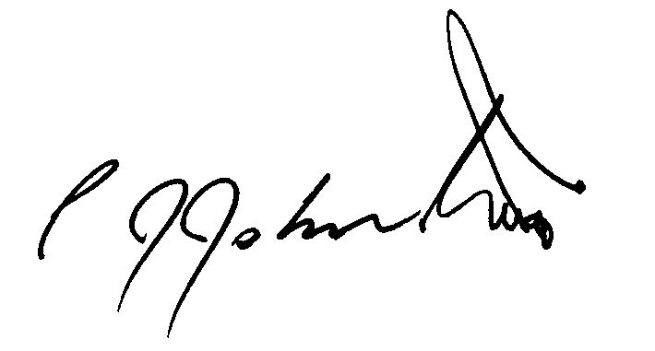
Phil Johnston aka Bank Teller

