Duty of care
Maurice Blackburn Page 2
Additionally, on the issue of negligence, it would be difficult to establish that the Australian Securities and Investments Commission (ASIC) owed a legal duty of care to individual consumers of credit card products. Although the ASIC Act provides that one of its objects is to promote the confident and informed participation of investors and consumers in the financial system, based on our consideration of legal principles of the law of negligence, in our view it is unlikely that a Court would hold ASIC liable for debts and interest charges incurred by individual consumers through their use of credit cards.
We have similar concerns in relation to a potential claim against the Reserve Bank of Australia, which has a broad duty to exercise powers in a manner that, in the opinion of the board, best contribute to the economic prosperity and welfare of the people of Australia.³ However, duties framed in the broad public interest are unlikely to extend to the individual circumstances of consumers such as those outlined in your letter.
Conclusion
In our view there would be legal risks associated with a claim in relation to the circumstances outlined in your letter and for this reason the proposed claim does not meet our criteria for the pursuit of a class action.
Although it may be the case that financially vulnerable consumers are at risk when it comes to credit card products, we think that the concerns outlined in your letter would be best addressed by legislative or regulatory change that is designed to protect the interests of these consumers. In this regard, we suggest that you contact your local Member of Parliament to continue your advocacy on behalf of vulnerable consumers.
Julian Schimmel MAURICE BLACKBURN

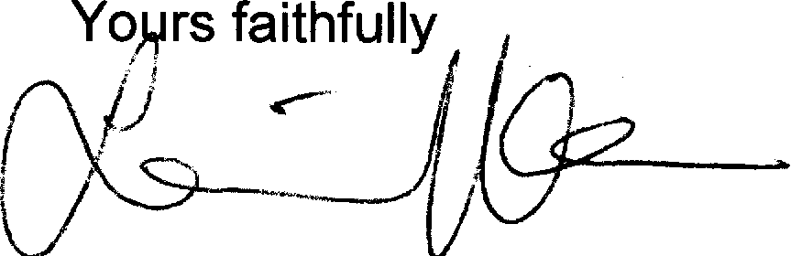
Yomrs faithfully
/^{I)}

3 Reserve Bank Act 1959 (Cth), s 10(2). 400305288_1

