1305, 12 Glen St,
Milsons Point NSW 2061
scribepj@bigpond.com
0434 715.861

Insert enclosed CD in a Windows PC - will auto-open at this ThirdLetterToMauriceBlackburn_9-Aug-17.htm
If using a MAC, open CreditCards\MauriceBlackburn\ThirddLetterToMauriceBlackburn_9-Aug-17.htm

9 August 2017
Mr. Julian Schimmel
Principal, Class Actions
Maurice Blackburn
Level 10, 456 Lonsdale Street
Melbourne VIC 3000
Dear Julian
The Writer is taking his concerns re -
- Predatory Advertising of some Credit Cards by the Four Pillars (and the banks that they own or are merged with) and Citibank that collectively issue Credit Cards to over 80% of Australian Credit Cardholders;
- Numeracy And Literacy Targeting; and
- Two Financial Services Regulators inept regulation,
to Senator Nick Xenophon
Someone from the Nick Xenophon Team might contact you - refer the Final Paragraph of Intro Letter to Nick Xenophon dated 17 Aug 2017.

The Writer refers to -
(i) his Intro Letter to Maurice Blackburn dated 8 May 2017;
(ii) his Submission Letter dated 8 May 2017;
(iii) his Second Letter to Maurice Blackburn dated 25 June 2017; and
(iv) Maurice Blackburn response letter dated 14 July 2017.
The Writer proposes to post 2 CDs (and one USB Stick Drive) to Senator Nick Xenophon which open at Intro Letter to Nick Xenophon dated 17 Aug 2017.

Yours sincerely
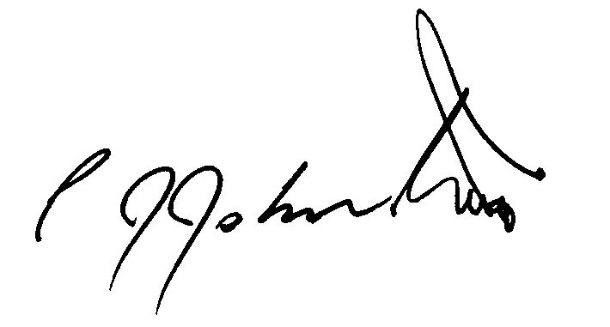
Phil Johnston aka Bank Teller

