1305, 12 Glen St - The Pavilion on the Harbour'
Milsons Point NSW 2061
scribepj@bigpond.com 0434 715.861
Insert one of enclosed DVDs in a Windows PC to auto-open this Letter_to_Andy_Kollmorgen_10-Feb-19.htm
If using a MAC or the enclosed USB Stick Flash Drive, or the enclosed DVDs do not auto-open, open this letter at CreditCards/Choice/Letter_to_Andy_Kollmorgen_10-Feb-19.htm
10 February 2019
Andy Kollmorgen
Investigations Editor
CHOICE, 57 Carrington Road
Marrickville NSW 2204
Dear Andy
1. Discussion Paper primarily addressing breaches of Statutory Duty by the RBA as Principal Regulator of the Payments System through its Payments Systems Board

2. Thirty Two Written Questions (and Supporting Documented Evidence) to facilitate the next Federal Govt. extending the Royal Commission to address inter alia Predatory Marketing of Credit Card Products to Financially Uneducated And Vulnerable Australians - many have suffered Extreme Financial And Emotional Distress
The Writer wishes to publish his Discussion Paper and his Thirty Two Written Questions (and the Supporting Documented Evidence) on a website after his Discussion Paper and each of his Thirty Two Written Questions has been peer reviewed. He would then email Financial Services Reformists and other Interested Entities seeking them to review both documents in the hope that the next Federal Govt. would extend the Royal Commission to address Unconscionable Conduct and Unconscionable Credit Card Interest Rates/Usurious Interest Rates and Numeracy And Literacy Targeting 'et al' by some Credit Card Issuers and the failure of Australia's Principal Regulator of the Payments System to -
A.) regulate the User Pays Principle which accords with The Public Interest Test that the RBA recommended in the below extract from pg 115 in 5.2 'Scheme regulations and competition benchmarks' of its paper "Reform of Credit Card Schemes in Aust: "A Consultation Document" published Dec 2001:

"Reform of credit card schemes will also have a direct impact on credit cardholders and is likely to result in some re-pricing of credit card payment services. However, this is the means by which the price mechanism is to be given greater rein in the credit card market. A movement towards a “user pays” approach to credit card payment services would be consistent with the approach adopted by Australian financial institutions in pricing other payment instruments under their control. As the ABA itself has confirmed: “Pricing services efficiently provides

- 2 –
consumers with choice to use lower cost distribution channels and, therefore, facilitates a more efficient financial system. It is also fairer and efficient, because consumers only pay for what they use.”198
The principles that consumers should face prices that take into account the relative costs of producing goods and services, as well as demand conditions, and that resources should be free to enter a market in response to above-normal profit opportunities, have been the guiding principles for tariff reform and market deregulation in Australia. Such market reforms may impact unevenly on different groups – some gaining, some losing – but they are now the well-established route to more efficient use of resources in the Australian economy."

Alas, the above aspirations by the RBA back in 2001 for a "... movement towards a “user pays” approach to credit card payment services ..." never materialised, because of the horrendous interest/fees burden still born by Persistent Revolvers.
B.) re-regulate*** a maximum interest rate for Credit Card Purchases and a maximum interest rate for Credit Card Cash Advances after Three Pivotal 'Landmark' RBA Published Papers in the last 26 years that recognised the increasing spread between the overnight cost of funds and Highest Credit Card Interest Rates because of the financial burden falling upon Persistent Revolvers that invariably possess low Financial Literacy Capacity and are perpetually paying Usurious Interest Rates. An Unconscionable 80% circa of all Interest And Penalty Fees Revenue levied by Credit Card Issuers annually is paid by Persistent Revolvers.
*** Below is an extract from the bottom of page 7 of University of Wollongong 'Economics Working Paper Series 2012':
"Prior to 1985 the maximum rate that could be charged on credit cards had been set at 18 per cent per annum by the Reserve Bank of Australia. In April 1985, this rate was deregulated." (In April 1985 the Overnight Cash Rate was 17.2% circa.)
Could you provide to the Writer contact details of one or two economic/legislative academics, or others, that are fervent that the Royal Commission ensures that Two Of Australia's Three Financial Services Regulators rely upon their existing regulatory powers to regulate that Credit Card Issuers desist inter alia Predatory Marketing by Numeracy And Literacy Targeting of Financially Uneducated And Vulnerable Australians? Alternatively, ask anyone that is dissatisfied with the regulatory performance of the Principal Regulator of the Payments System to review 1. and 2. above.

- 3 –

Should you provide contact details of one or two academic economists/legislators that peer reviewed the Writer's Discussion Paper and/or his Thirty Two Written Questions and responded with comments, the Writer would provide a written commitment to you to have first rights to write an article/s, on the Discussion Paper and/or his Thirty Two Written Questions that you, or your associate, wanted to. He would also provide a written undertaking to acknowledge the input of any economic/legislative academic/s who reviewed his Discussion Paper and/or Thirty Two Written Questions. Such acknowledgement of any peer reviewers would appear immediately under the final cut of his Discussion Paper and Thirty Two Written Questions on his website.

NB: If the Writer does not hear from you, or your associate, within nine days from the date of this letter, he will similarly write to other journalists, one at a time.
Yours sincerely
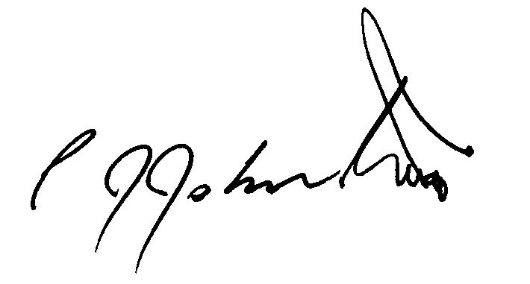
Phil Johnston aka Bank Teller

