Six Reasons Credit Card Interest Rates Are So High
By Justine Davies August 11, 2016
Australia’s official cash rate is at an historic low of just 1.50% – but credit card interest rates haven’t budged.
It’s a sad fact that while Australia’s official cash rate has been constantly declining over the past few years, the credit card interest rates being charged in Australia have barely moved at all. In fact average credit card interest rates have actually increased since the pre-GFC days, while the official cash rate is at a record low. Consider this:
In November 2007 the official cash rate was 6.50% and the average credit card interest rate was 14.51%.
In August 2016 the official cash rate was 1.50% and the average credit card interest rate was 17.00%
Based on credit cards listed on Canstar database in 11/07 and 8/16
This lack of credit card interest rate decrease is occasionally noted by the media and the public and is usually roundly criticised when noticed. It was also the subject of a 2015 Treasury Ministerial Brief, which noted that headline interest rates on credit cards and unsecured loans have been unresponsive to falling bank funding costs in recent years.
What are the reasons for stubbornly high credit card interest rates though? Here are at least six reasons to think about.
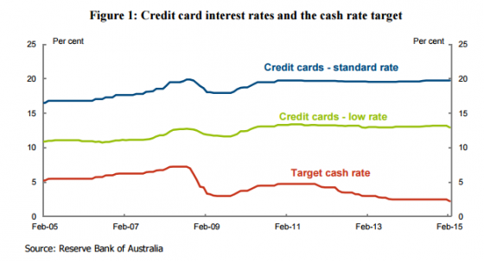

1. Some credit card users pay off their debt each month
The fact is that if you pay your credit card in full each month then you don’t need to worry about what interest rate is being charged – because you’re not paying it.
Another fact though is that if you’re not paying interest, then the bank is losing money by giving you credit to use each month. As banks don’t like to make a loss, someone else needs to pay extra.
According to the Reserve Bank, approximately 30% – 40% of Australians with a credit card pay interest. That means that they interest they pay needs to compensate for the 60% – 70% of credit card users who don’t pay interest. They compensate by paying a high interest rate.
Or let’s put it another way:
According to the Reserve Bank, Australians owe around $52 billion on their credit cards each month, with approximately $33 billion of that amount accruing interest.
Amount | Average interest rate
$33 billion | 17%
$19 billion | 0%
$52 billion | 10.7%
So if you’re a credit card user who isn’t paying interest, remember to say thanks to a couple of your friends who do pay interest . After all, they’re paying for you as well.
Compare Credit Card Interest Rates

2. Many banks offer zero percent balance transfer deals
As well as Aussies who pay off their credit card spending each month, many Aussies take advantage of 0% balance transfer deals that many banks offer and the number of 0% balance transfer deals available has exploded in recent years.
Currently on CANSTAR’s database, there are 106 cards that offer a balance transfer deal of zero percent interest for a certain length of time. 58 of those cards offer a 0% balance transfer for more than 12 months.
That is a lot of credit card balance transfer deals that help people avoid paying credit card interest! There are; however, pitfalls with a balance transfer that could see you entering back into a spiral of debt, especially after the promotional period has ended:
- Minimum repayments: There is a good reason your credit card statement comes printed with an “Australian Government Minimum Repayment Warning”. In most cases, making the minimum repayments each month will not see anywhere near enough paid off for a debt to be repaid before the balance transfer offer expires. Balance transfers can revert to very high interest rates – up to 23.50% p.a. This could be even higher than the interest rate being paid before the balance was transferred in the first place!
- Balance Transfers Fees: A balance transfer fee is sometimes charged up front which means that the interest-free period still has a cost associated with it. These fees currently range from 1-2.5% but are sometimes worth paying to get access to longer balance transfer periods – up to 24 months.
- Card Purchases: When you owe money on a credit card on a month-to-month basis (including balance transfers), the benefit of the cards “interest free days” is usually lost. This means that purchases made on the card will be incurring interest charges straight away – often at interest rates over 20% p.a.
Irrespective of the pros and cons, many Aussies take advantage of balance transfer offers. So, in the words of the Treasury report: “Because of the prevalence of interest-free periods and users who pay no interest, credit card issuers have chosen to make most of their return from the subset of users who carry positive balances from month to month.”

Compare balance transfer offers

3. It’s unsecured lending
This one is short and sweet: credit cards are a form of unsecured lending, hence much riskier than a home loan or secured personal loan.
With a home loan, the bank holds the property you are buying as security against the debt. If you default on your loan, the bank can take the house. Similarly with a car loan, the debt is secured against the car that you buy. Car loan interest rates are higher than home loan interest rates because cars, after all, lose value rather than gain it over time.
As the Treasury report noted, there was a general repricing of credit risk on unsecured lending during the GFC, not just in Australia but across the world. With a credit card, the interest rate reflects the risk of that unsecured debt.

4. Competition might not be very effective
On the face of it the Australian credit card market should be highly competitive with around 100 credit card brands offering over 250 credit card products.
Nevertheless, according to the Treasury report, the major banks – as in the mortgage lending market – control around 80% of the credit card market.
“There is a high degree of concentration among issuers, with the four major domestic banks accounting for around 80 per cent of total credit card balances outstanding. This reflects the concentration of the Australian banking system more generally rather than being a unique feature of the credit card market.”
If 80% of the credit card market is with just 4% of providers, this really indicates that competition is not effective and therefore pressure to compete on price is not that great.

5. We’re paying for rewards and other services
Rewards credit cards are extremely popular – we all love to be rewarded for good (or even bad) behaviour. Whether it’s flight rewards, cashback rewards or general rewards, there are a multitude of credit cards on the market to offer just that (approximately 169 rewards credit cards on Canstar’s database).
When it comes to what we’re looking for in a credit card, it’s primarily about rewards. As an example, this is the credit card search behaviour of Canstar’s visitors in June and July this year, with searches for a frequent flyer card, premium card or a rewards card accounting for more than 60% of the search volume.
If you want rewards though, someone has to pay for them. Higher interest rates (along with annual card fees) help to cover the cost of those glittery rewards we demand.
Or to quote from the Treasury paper:
“Credit cards are multifaceted products: competition is on the entire value proposition offered by a card and not just the headline interest rate on the product. This value proposition includes balance transfer offers, rewards programs, insurance, concierge services and other benefits as well as fee structures and interest-free periods.”

6. We’re maybe a bit lazy
When was the last time you compared credit cards with a view to changing your card? A recent Canstar Blue survey of more than 1,700 Australian adults found that the majority are more likely to take out financial products (e.g. credit cards, savings accounts, personal loans) with the financial institution they bank with than to shop around. This would explain the market domination of the Big 4.
Across the generations, the results were as follows:
I am more likely to take out financial products (e.g. credit cards, savings accounts, personal loans) with the financial institution I bank with than to shop around…
 | 18 – 29 years | 61%
 | 30 – 39 years | 59%
 | 40 – 49 years | 59%
 | 50 – 59 years | 55%
 | 60 – 69 years | 60%
 | 70 0r more years | 69%
Source: Canstar Blue survey.

What is the effective credit card interest rate?
So given all of the above, what is the interest that banks are really earning on credit cards, if the interest they earned is spread across all credit card debt?
According to the Treasury report, an estimate of the ‘effective’ interest rate on all credit card balances can be calculated by multiplying the headline interest rate by the proportion of credit card balances accruing interest. And when they did that, it turns out that the effective rate is approximately 8.70%.
None of this is to suggest that you personally should be paying credit card interest though! If you do carry an ongoing debt, there are plenty of low rate credit cards you can compare.
If you’re currently comparing credit cards, the comparison table below displays some of the low interest credit cards currently available on Canstar’s database for Australians looking to spend around $2,000 per month. Please note that this table features links direct to the provider’s website, and is sorted by Star Rating (highest to lowest), followed by provider name (alphabetical). Use Canstar’s credit card comparison selector to view a wider range of credit cards.
Company | Star Rating | Purchase Rate | Balance Transfer | Annual Fee
 | ANZ | Low Rate |  | 12.49% | 0%for22 mths  then 20.24%  Upfront fee 1.5% applies | $58  $0 in first year | Go to site  on ANZ's website
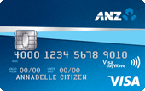 | ANZ | First |  | 20.24% | 0%for18 mths  then 20.24%  Upfront fee 2% applies | $30 | Go to site  on ANZ's website
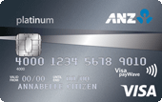 | ANZ | Platinum |  | 20.24% | 0%for18 mths  then 20.24%  Upfront fee 2% applies | $0  $87 waived due to spend | Go to site  on ANZ's website
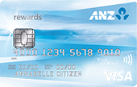 | ANZ | Rewards |  | 20.24% | 20.24% | $80 | Go to site  on ANZ's website
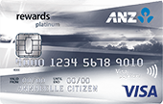 | ANZ | Rewards Platinum |  | 20.24% | 20.24% | $95 | Go to site  on ANZ's website
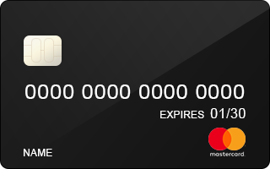 | Bankwest | More Mastercard |  | 19.99% | 0%for6 mths  then 19.99%  Upfront fee 1% applies | $100 | Go to site  on Bankwest's website
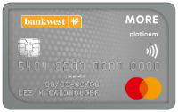 | Bankwest | More Platinum Mastercard |  | 19.99% | 0%for6 mths  then 19.99%  Upfront fee 1% applies | $160 | Go to site  on Bankwest's website
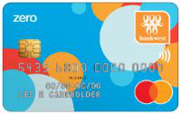 | Bankwest | Zero Mastercard |  | 17.99% | 2.99%for9 mths  then 17.99% | $0 | Go to site  on Bankwest's website
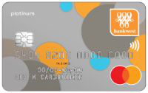 | Bankwest | Zero Platinum Mastercard |  | 17.99% | 2.99%for9 mths  then 17.99% | $0 | Go to site  on Bankwest's website
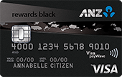 | ANZ | Rewards Black | Not rated | 20.24% | 20.24% | $375 | Go to site  on ANZ's website
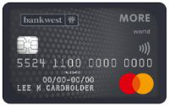 | Bankwest | More World Mastercard | Not rated | 19.99% | 0%for6 mths  then 19.99%  Upfront fee 1% applies | $270 | Go to site  on Bankwest's website
View all Canstar rated Credit Cards products
View disclosures
Compare credit cards

Learn more about Credit Cards
- What are credit card minimum repayments?
- How can I increase my credit limit?
- What are credit card late payment fees?

PREVIOUS
How Do Interest-Free Days Work On Credit Cards?
NEXT
What is a credit card minimum repayment
Similar Topics:
- cash rate
- Credit card interest rate
- credit cards

Share this article

Compare Credit Cards
Low Rate Cards

Low Fee Cards

Premium Cards

Rewards Cards

Frequent Flyer Cards

Balance Transfer

Related

6 questions to ask when planning for retirement

Investing and the Seven Deadly Sins – what not to do!

Is now a good time to consolidate your super or should you wait until markets stabilise?

Find a Credit Card that gives you the most value for your spend.
Compare now
Important Information

- Canstar is an information provider and in giving you product information Canstar is not making any suggestion or recommendation about a particular credit product or loan. If you decide to apply for a credit product or loan, you will deal directly with a credit provider, and not with Canstar. Rates and product information should be confirmed with the relevant credit provider. For more information, read the credit provider’s key facts sheet and other applicable loan documentation for that product. Read the Comparison Rate Warning.
- Canstar may earn a fee for referrals from its website tables, and from sponsorship of certain products. Fees payable by product providers for referrals and sponsorship may vary between providers, website position, and revenue model. Sponsorship fees may be higher than referral fees. Sponsored products are clearly disclosed as such on website pages. They may appear in a number of areas of the website such as in comparison tables, on hub pages and in articles. Sponsored products may be displayed in a fixed position in a table, regardless of the product's rating, price or other attributes. The table position of a Sponsored product does not indicate any ranking or rating by Canstar. For more information please see How We Get Paid.
- The Star Ratings in this table were awarded in April, 2020. The search results do not include all providers and may not compare all features relevant to you. View the Canstar Credit Cards Star Ratings Methodology and Report. The Star Rating shown is only one factor to take into account when considering products.
- Canstar is an information provider and in giving you product information Canstar is not making any suggestion or recommendation about a particular credit card product. If you decide to apply for a credit card, you will deal directly with a financial institution, and not with Canstar. Rates and product information should be confirmed with the relevant financial institution. For more information, read Canstar’s Financial Services and Credit Guide (FSCG), detailed disclosure, important notes and liability disclaimer. Products displayed above that are not “Sponsored” are sorted as referenced in the introductory text and then alphabetically by company. Canstar may receive a fee for referral of leads from these products. See How We Get Paid for further information.

