3 HOURS AGO

Skin in the game for Latitude CEOs
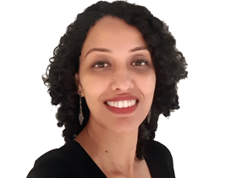
VALERINA CHANGARATHIL
Latitude chief executive and managing director Ahmed Fahour's shadow will continue to loom large at the ASX-listed lender after he steps down on March 31, its annual report shows.
While the near five-year reign ends then, he will retire in August after offering transition support to incoming boss Bob Belan.
But Mr Fahour, who took home $2.6m in FY22 remuneration, will hold sway over the 2.9 million shares held directly and through his super fund, 1.4 million in performance rights and short-term incentive shares – alongside 16.5 million options that have an exercise date of between September 1 and September 27 next year.
The call option arrangement between Mr Fahour and Latitude's 64 per cent shareholder, KVD Singapore, was entered into prior to Latitude's listing on the ASX in April 2021 and extended last year.
Mr Belan, who joined Latitude in 2021 when it bought his co-founded business Symple, also begins his CEO tenure next month with strong skin in the game.
Mr Belan, who will start the gig on a $1.3m base pay contract, has a 11.4 million shares in Latitude and another 11.7 million held under an escrowed arrangement until October 26 this year. For FY23, he will also be invited to participate in the Latitude Options Plan for 9 million options, subject to shareholder approval and vesting hurdles.
He must maintain a minimum shareholding of 7 million Latitude Financial shares for five years from commencement date, but is allowed to sell up to 1.5 million shares per annum to maintain his tax obligations.
Shares in the group, which is trying to contain a major cyber hack since last week, are at $1.20 at 2pm AEDT.

