2 + 2 + 10 = 14 pages

67 Coronga Crescent
Killara NSW 2071
0434 715.861
scribepj@bigpond.com

7 April 2012

Mr Scott Henricks
General Manager, Retail Customer Service
GPO Box 2719,
Sydney NSW 1155

Dear Mr Henricks

Diamonds Award MasterCard
- Will some merchants pay a higher merchant service fee to their respective card acquirers (merchants’ financial institution); or
- Will some card acquirers (merchant’s financial institution) pay a higher interchange fee to the cardholder’s financial institution (the card issuer) which in my case would be Commonwealth Bank?

I have written this letter directly to you, because I have been unable to source anyone in ‘credit card enquiries’ 13 2221 who can provide to me an email address where I could email this enquiry to obtain an answer by email.

I have rec'd –
- your letter dated 20 March 12 which attached a new Diamonds Award MasterCard;
- the attached two emails; and
- an SMS to my mobile.

All of the above written advices have beseeched me to 'Activate' the new Diamonds Award MasterCard which is attached to 1 above. None provide any email address to send enquiries about the effect of using the new card. I opened CBA’s ‘Contact Us’ webpage and clicked on ‘View full email list’.

I then clicked on ‘General Banking’ but it did not provide an email address for General Banking enquiries re credit cards. Rather it directed me to ‘Welcome to Online Support’ which should have provided an email address for credit card enquiries within ‘General Banking’ enquiries.

I note from a journal article 'The Personal Credit Card Market in Australia: Pricing over the Past Decade' recently written by Iris Chan, Sophia Chong and Stephen Mitchell from RBA’s Payments Policy Department that in -
* 2003 the average spend required to earn a $100 shopping voucher was $12,400;
* 2004 this had risen to $14,400; and
* 2011 to $18,400 - shown in (Table 1) of the attached RBA journal report.

This letter seeks to learn if merchants and/or merchants’ financial institutions are contributing to meeting the higher rewards points offered with the new Diamonds Award MasterCard, albeit the value of points has diminished as set out above and the increase in points with the new Diamonds Award MasterCard seems to be 25%. Personally, I wish the ATO would deem loyalty rewards programmes as income to put an end to them.

2

The Diamonds Award MasterCard seems to be a 'four-party scheme' because four parties are typically involved in the payment process:
1. Cardholder (me)
2. Card Issuer (usually the Cardholder’s bank)
3. Card Acquirer (merchant’s financial institution)
4. Merchant (Coles, BP, newsagent, doctor etc).

I understand that –
- ‘interchange fees’ are ‘transfer’ fees set by the card schemes and are paid by the merchant’s financial institution (Card Acquirer) to the cardholder’s financial institution (Card Issuer) each time a credit card transaction is made; and
- ‘merchant service fees’ are fees paid by a merchant to its card acquirer (merchant’s financial institution).

Prima facie, it appears to me that CBA's 'driver' to issue me a new Diamonds Award MasterCard is to pass on higher merchant service fees – either through the pass-through of higher interchange fees under a four-party scheme.

I telephoned 13 2221 (listed in CBA’s attached emails) and asked Krish S/N 255221 who said he would have to ask his supervisor. A few minutes later Krish told me that his supervisor had told him that no merchants would pay any more in merchant service fees if I presented the Diamonds Award MasterCard.

Would CBA please respond in writing, either email or letter, that if I ‘activate’ and present the new Diamonds Award MasterCard –
- will some/all merchants pay a higher merchant service fee to their Card Acquirers (merchant’s financial institution); or
- will some/all Card Acquirers (merchant’s financial institution) pay a higher interchange fee to the Cardholder’s financial institution (Card Issuer) which in this case would be Commonwealth Bank?

Yours sincerely
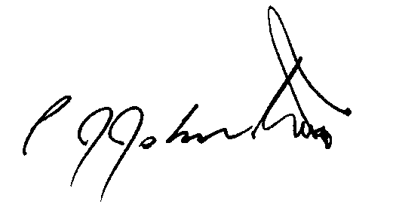
Phil Johnston

