1305, 12 Glen St - The Pavilion on the Harbour'
Milsons Point NSW 2061
scribepj@bigpond.com 0434 715.861
Insert one of enclosed two DVDs in a Windows PC to auto-open Letter_to_Peter_Brandson_16-Mar-19.htm
If using a MAC or the enclosed USB Stick Flash Drive, or the enclosed DVDs do not auto-open, open this letter at CreditCards/BankReformNow/Letter_to_Peter_Brandson_16-Mar-19.htm
To navigate my submission, click on the countless black underlined or blue embedded threads therein
To leave a page and return to the previous page, click on the arrow at top left of screen
16 March 2019
Dr. Peter Brandson
CEO, Bank Reform Now
PO Box 497
Batemans Bay NSW 2536
Dear Peter

1. Second Wave of Royal Commission into Financial Services:
Duration: Two weeks
One week of Hearings from -
(1) Financially Uneducated And Vulnerable Australians identified by the RBA as
Persistent Revolvers - sourced by Financial Counsellors; and
(2) 'Credit Card Distress' Authorities in particular Financial Counsellors drawing
upon a Welter of Evidence
Then one week of Cross Examination of -
A) Governor of the RBA (re 'Sixteen Questions" in 2. below); and
B) Chairman of APRA, ASIC, ACCC & CEO of ABA (re another 6 Questions in 2. below)
Singular Term of Reference: Breach of Statutory Duty by the RBA as Principal Regulator of the Payments System through its Payments Systems Board that countenanced Predatory Marketing of Credit Card Products to Financially Uneducated And Vulnerable Australians - many have paid Usurious Unsecured Interest Rates and suffered Extreme Financial And Emotional Distress contrary to the RBA's parliamentary decreed role to ensure ".the economic prosperity and welfare of (all) the people of Aust"

2. Sixteen of the Thirty Two Written Questions (to extend the Royal Commission to address inter alia 1. above) are directed at the Governor of the Reserve Bank of Australia - some will be difficult to answer. A further six Questions are directed to other financial services regulators
The Writer wishes to publish 'the final cut' of his Discussion Paper and his Thirty Two Written Questions (and the Supporting Documented Evidence) on a website after his Discussion Paper and each of his Thirty Two Written Questions has been peer reviewed. He would then email Financial Services Reformists and other Interested Entities seeking them to review both documents in the hope that the next Federal Govt. would extend the Royal Commission to address Unconscionable Conduct, Unconscionable Credit Card Interest Rates/Usurious Interest Rates and Numeracy And Literacy Targeting 'et al' by some Credit Card Issuers particularly in the 20 years circa prior to mid-2018 and the abject failure of Australia's Principal Regulator of the Payments System to -
A.) regulate the User Pays Principle which accords with The Public Interest Test that the RBA recommended from pg 115 in 5.2 'Scheme regulations and competition benchmarks' of its paper "Reform of Credit Card Schemes in Aust: "A Consultation Document" -Dec 2001:
– 2 –

"Reform of credit card schemes will also have a direct impact on credit cardholders and is likely to result in some re-pricing of credit card payment services. However,
this is the means by which the price mechanism is to be given greater rein in the credit card market. A movement towards a “user pays” approach to credit card
payment services would be consistent with the approach adopted by Australian financial institutions in pricing other payment instruments under their control. As
the ABA itself has confirmed: “Pricing services efficiently provides consumers with choice to use lower cost distribution channels and, therefore, facilitates a more efficient financial
system. It is also fairer and efficient, because consumers only pay for what they use.”198
The principles that consumers should face prices that take into account the relative costs of producing goods and services, as well as demand conditions, and that
resources should be free to enter a market in response to above-normal profit opportunities, have been the guiding principles for tariff reform and market
deregulation in Australia. Such market reforms may impact unevenly on different groups – some gaining, some losing – but they are now the well-established route
to more efficient use of resources in the Australian economy."
Alas, the above aspirations by the RBA back in 2001 for a "... movement towards a “user pays” approach to credit card payment services ..." never materialised, because of the horrendous interest/fees burden still born by Persistent Revolvers that pay for the Retail Supply Side costs of the Lines of Credit used by Transactors.
B.) re-regulate*** a maximum interest rate for Credit Card Purchases and a maximum interest rate for Credit Card Cash Advances after Three Landmark RBA Published Papers in the last 26 years that recognised the increasing spread between the overnight cost of funds and Highest Credit Card Interest Rates because of the financial burden falling upon Persistent Revolvers that invariably possess low Financial Literacy Capacity and are perpetually paying Usurious Interest Rates. An Unconscionable 80% circa of all Interest And Penalty Fees Revenue levied by Credit Card Issuers annually is paid by Persistent Revolvers.
*** Below is an extract from the bottom of page 7 of University of Wollongong 'Economics Working Paper Series 2012':
"Prior to 1985 the maximum rate that could be charged on credit cards had been set at 18 per cent per annum by the Reserve Bank of Australia. In April 1985, this rate was deregulated."
(In April 1985 the Overnight Cash Rate was 17.2% circa.)
Could you provide to the Writer contact details of one or two economic/legislative academics, or others, that are fervent that a second phase of the Royal Commission ensures that inter alia -

1. the RBA is held to account for not actioning A.) and B.) above in view of revelations in
Four Pivotal RBA Publications (explained in Section 6 of Discussion Paper) by actioning
Two Effortless Legislative Changes; and

2. Two Of Australia's Three Financial Services Regulators rely upon their existing regulatory powers to regulate that Credit Card Issuers desist inter alia Predatory Marketing by Numeracy And Literacy Targeting of Financially Uneducated And Vulnerable Australians?
– 3 –

Alternatively, please provide contact details of anyone that is dissatisfied with the regulatory performance of the Principal Regulator of the Payments System to review 1. and 2. above that possesses the capacity to "read, comprehend and respond".
Should you provide contact details of one or two academic economists/legislators that peer review the Writer's Discussion Paper and/or his Thirty Two Written Questions and respond with their comments, the Writer will provide a written undertaking to Bank Reform Now to acknowledge the input of any economic/legislative academic/s et al who reviewed his Discussion Paper and/or Thirty Two Written Questions. Such acknowledgement of any peer reviewers would appear immediately under the final cut of his Discussion Paper and Thirty Two Written Questions on his website.
NB: If you have any doubts as to whether the Writer has undertaken requisite due diligence for his Discussion Paper, and his Thirty Two Written Questions to Financial Services Regulators, click on:

* Grounds/Reasons for Written Questions and scroll down about 40 mouse scrolls through the 21 Chapters; and
* some of the 600+ Defined Terms and Documents.

Yours sincerely
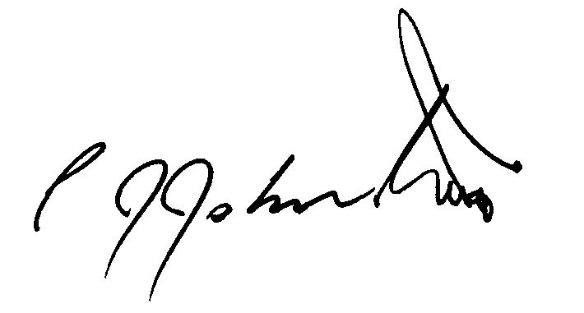
Philip J. Johnston

