Insert one of enclosed two DVDs in Windows PC to auto-open this 3rd_Letter_to_Peter_Brandson_2-Aug-19.htm
If using a MAC or the enclosed USB Stick Flash Drive, or the enclosed DVDs do not auto-open, open this letter at CreditCards/BankReformNow/3rd_Letter_to_Peter_Brandson_2-Aug-19.htm
To navigate my submission, click on the countless black underlined or blue embedded threads therein
To leave a page and return to the previous page, click on the arrow at top left of screen

2 Aug 2019

Dr. Peter Brandson
CEO, Bank Reform Now
PO Box 497
Batemans Bay NSW 2536
Dear Peter

1. Why did the Royal Commission ignore the most Unconscionable Conduct across the entire Financial Services sector that has materially exploited 400,000 circa Credit Cardholders with poor Financial Literacy Capacity over the 5 years (to mid-2017) - and many more Financially Uneducated Australians this century?

2. Why has the Australian Labor Party ignored the Disgraceful Financial Plight Of 400,000 circa Vulnerable Australians that have suffered Extreme Financial And Emotional Distress due to Unconscionable Credit Card Interest Charging, Predatory Marketing Practices and Numeracy And Literacy Targeting?
Until April 1985, no Credit Card Issuer could charge more than 18% interest. Chapter 5 chronicles that when that 18% interest rate cap was removed in 1985 by the RBA (at the recommendation of the Campbell Report), the Overnight Money Market Interest Rate was less than 1% lower - at a whisker over 17%. The highest Cash Advance interest rate is now 29.49% for a 'Go Mastercard' Credit Card from Latitude Financial. That is 28.50% higher than the current Overnight Money Market Interest Rate of 1%.
Why hasn't the Labor Party prosecuted that the RBA, as Australia's Principal Regulator of the Payments System, should draw upon its 'extensive powers' to recommend to the Federal Govt. (as required under Section 11(1) of the Reserve Bank Act 1059) to set new Standards "...in the public interest....", pursuant to Division 4, Section 18, to -

A.) force Credit Card Issuers to apply the User Pays Principle to user costs/fees because Credit Cardholders with poor Financial Literacy Capacity pay the Line/s of Credit Costs of Credit Cardholders with high Financial Literacy Capacity identified by the RBA as Transactors; and
B.) re-regulate a maximum interest rate for Purchases and re-regulate a maximum interest rate for Cash Advances,
under Section 50 of the Banking Act 1959 as amended for "Control of interest rates", with the approval of the Federal Treasurer, as requested by the Writer in Section 8 A) to H) of his CD Submission to the RBA dated 8 Dec 2011 after the Writer had earlier shared emails with Ms. Sharon van Etten, Public Relations Officer, Media & Public Relations Office, RESERVE BANK, re the RBA's powers over Credit Card Issuers.

3. Does the Labor Party have access to a lawyer, versed in “statutory interpretation”, to appraise the above referenced sections of legislation that govern the RBA's obligations to ensure "...the economic prosperity and welfare of (all) the people of Australia"?
- 2 -

4. Second Wave of Royal Commission into Financial Services:

Duration: Two weeks (one week of hearings followed by one week of questioning/cross examination of financial regulators in particular the Principal Regulator of the Payments System)
One Week Of Hearings - Six Hours a Day For Five Days from:
(1) Financially Uneducated And Vulnerable Australians identified by the RBA as Persistent Revolvers - sourced by Financial Counsellors; and
(2) Quantitative, Qualitative, Credit Card Distress Authorities, Numeracy And Literacy Authorities, And Newspaper Article Evidence Of Unfair Credit Card Practices Which Prey Upon Financially Uneducated And Vulnerable Australians By Numeracy And Literacy Discrimination, in particular Credit Card Distress Authorities and Numeracy And Literacy Authorities
Then One Week of Cross Examination/Questioning of -
(A) Governor of the RBA (re 'Sixteen Questions" in 2. of Version2 of Letter to Dr. Peter Brandson dated 16 March 2019); and
(B) Chairman of APRA, ASIC, ACCC and CEO of ABA (re another 6 Questions in 2. of Version2 of Letter to Dr. Peter Brandson dated 16 March 2019)
Singular Term of Reference: Breach of Statutory Duty by the RBA as Principal Regulator of the Payments System through its Payments Systems Board that countenanced Predatory Marketing of Credit Card Products to Financially Uneducated And Vulnerable Australian Credit Cardholders - many have paid Usurious Unsecured Interest Rates and suffered Extreme Financial And Emotional Distress contrary to the RBA's parliamentary decreed role to ensure "...the economic prosperity and welfare of (all) the people of Australia"

5. Sixteen of the Thirty Two Written Questions (to extend the Royal Commission to address inter alia 2. above) are directed at the Governor of the Reserve Bank of Australia - some will be difficult to answer, notably 2nd Question. A further six Questions are directed to other financial services regulators
The Writer refers to his 2nd Letter to Dr. Peter Brandson dated 9 April 2019 that he provided in A4 hardcopy, USB Flash Drive and 2 DVDs which explained his Discussion Paper and his Thirty Two Written Questions (and the Supporting Documented Evidence).
The Writer's 2nd Letter to Dr. Peter Brandson dated 9 April 2019 provided Version 2 of Letter to Dr. Peter Brandson dated 16 March 2019 which included the below timetable/breakdown of the '1st week of hearings' in One Week Of Hearings - Six Hours a Day For Five Days:

(a) Three days interviewing 66 Financially Uneducated And Vulnerable Australian Credit Cardholders (sourced by Financial Counsellors) that have suffered Extreme Financial And Emotional Distress (identified in RBA Submission to the Senate Inquiry into Matters Relating to Credit Card Interest Rates - Aug 2015 - as Persistent Revolvers) that are asked by a Financial Counsellor (that assisted him/her/them manage their financial indebtedness) if s/he/they would like to be interviewed by the Royal Commission, and so agreed.

- 3 –

(b) One day interviewing the authors of comprehensive published reports listed in Numeracy And Literacy Authorities and financial journalists that have written articles about the havoc upon Financially Uneducated And Vulnerable Australians that were issued too many Credit Cards.
(c) One day interviewing Credit Card Distress Authorities, in particular Financial Counsellors that have assisted a welter of Financially Uneducated And Vulnerable Australians manage their financial indebtedness due to Credit Cards.
The Writer welcomes discussing with you his above work, after you have sought a lawyer, versed in “statutory interpretation”, to appraise the above referenced sections of legislation that govern the RBA's statutory obligations. The Writer worked for one of the Four Pillars for 37 years. His efforts to rectify Credit Card rorting officially started when he sent his substantive submission to the RBA dated 8 Dec 2011, after he had earlier shared emails with Ms. Sharon van Etten, Public Relations Officer, Media & Public Relations Office, RESERVE BANK, re the RBA's powers over Credit Card Issuers. Section 8 A) to H) of his CD Submission to the RBA dated 8 Dec 2011 contains the changes that he sought 7 years ago to fees and interest on Credit Card transactions which accord with the RBA's Four Pivotal RBA Publications, in particular Reform of Credit Card Schemes in Aust: "A Consultation Document" – Dec 2001 (refer page 117 re the RBA wanting the Credit Card Issuers to adopt the User Pays Principle).
Hence, during the last nine months of recriminations and promises to do better, it disappoints that Australia's Principal Regulator of the Payments System has laid-low, and not had the courage of its 2001 written beliefs/convictions to address its statutory failings upon Financially Uneducated And Vulnerable Australians that were preyed upon by some unscrupulous Credit Card Issuers, whilst our Principal Regulator remained asleep at the wheel, conflicted by being way too close to the commercial banks that Federal Parliament had legislated it to control for fairness.
If you do not respond to this third letter to the CEO, Bank Reform Now within four weeks, the Writer will take his concerns to SMH tyro, Adele Ferguson, because someone should protect Financially Uneducated And Vulnerable Credit Cardholders.
Yours sincerely
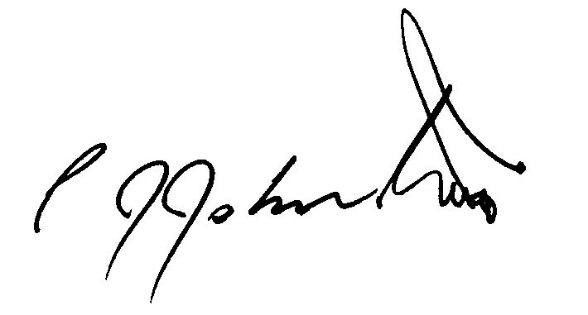
Phil Johnston aka Bank Teller

