1305, 12 Glen St - The Pavilion on the Harbour'
Milsons Point NSW 2061
scribepj@bigpond.com 0434 715.861
Insert one of enclosed two DVDs in Windows PC to auto-open 2nd_Letter_to_Peter_Brandson_9-Apr-19.htm
If using a MAC or the enclosed USB Stick Flash Drive, or the enclosed DVDs do not auto-open, open this letter at CreditCards/BankReformNow/2nd_Letter_to_Peter_Brandson_9-Apr-19.htm
To navigate my submission, click on the countless black underlined or blue embedded threads therein
To leave a page and return to the previous page, click on the arrow at top left of screen
9 April 2019
Dr. Peter Brandson
CEO, Bank Reform Now
PO Box 497
Batemans Bay NSW 2536
Dear Peter

1. Second Wave of Royal Commission into Financial Services:
Duration: Two weeks (one week of hearings followed by one week of questioning/cross examination of financial regulators in particular the Principal Regulator of the Payments System)

One Week Of Hearings - Six Hours a Day For Five Days from -
(1) Financially Uneducated And Vulnerable Australians identified by the RBA
as Persistent Revolvers - sourced by Financial Counsellors; and
(2) Quantitative, Qualitative, Credit Card Distress Authorities, Numeracy And Literacy Authorities, And Newspaper Article Evidence Of Unfair Credit Card Practices Which Prey Upon Financially Uneducated And Vulnerable Australians By Numeracy And Literacy Discrimination, in particular Credit Card Distress Authorities and Numeracy And Literacy Authorities
Then one week of cross examination/questioning of -
(A) Governor of the RBA (re 'Sixteen Questions" in 2. of
Version2 of Letter to Dr. Peter Brandson dated 16 March 2019); and
(B) Chairman of APRA, ASIC, ACCC and CEO of ABA (re another 6 Questions in 2. of
Version2 of Letter to Dr. Peter Brandson dated 16 March 2019)
Singular Term of Reference: Breach of Statutory Duty by the RBA as Principal Regulator of the Payments System through its Payments Systems Board that countenanced Predatory Marketing of Credit Card Products to Financially Uneducated And Vulnerable Australian Credit Cardholders - many have paid Usurious Unsecured Interest Rates and suffered Extreme Financial And Emotional Distress contrary to the RBA's parliamentary decreed role to ensure "...the economic prosperity and welfare of (all) the people of Australia"

2. Sixteen of the Thirty Two Written Questions (to extend the Royal Commission to address inter alia 1. above) are directed at the Governor of the Reserve Bank of Australia - some will be difficult to answer. A further six Questions are directed to other financial services regulators

2
The Writer refers to his Letter to Dr. Peter Brandson dated 16 March 2019 that he provided in
A4 hardcopy, USB Flash Drive and 2 DVDs.
The Writer's 2nd Letter to Dr. Peter Brandson dated 9 April 2019 provides
Version 2 of Letter to Dr. Peter Brandson dated 16 March 2019 which now also includes a timetable/breakdown of the '1st week of hearings' in One Week Of Hearings - Six Hours a Day For Five Days:

(a) Three days interviewing 66 Financially Uneducated And Vulnerable Australian Credit Cardholders that have suffered Extreme Financial And Emotional Distress (identified in RBA Submission to the Senate Inquiry into Matters Relating to Credit Card Interest Rates - Aug 2015 - as Persistent Revolvers) that are asked by a Financial Counsellor (that assisted him/her/them manage their financial indebtedness), if s/he/they would like to be interviewed by the Royal Commission, and so agreed.
(b) One day interviewing the authors of comprehensive published reports listed in
Numeracy And Literacy Authorities and financial journalists that have written articles about the havoc upon Financially Uneducated And Vulnerable Australians that were issued too many Credit Cards.
(c) One day interviewing Credit Card Distress Authorities, in particular Financial Counsellors that have assisted a welter of Financially Uneducated And Vulnerable Australians manage their financial indebtedness.

Yours sincerely
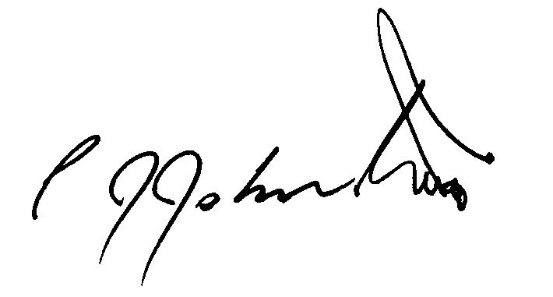
Phil Johnston aka Bank Teller

