1305, 12 Glen St
Milsons Point NSW 2061
0434 715.861
scribepj@bigpond.com
Australian Prudential Regulatory Authority
GPO Box 9836
Sydney NSW 2001
Attention: Mr. Wayne Byres
The Chairman of the Board

Dear Mr Byres
A question relating to the Royal Commission into misconduct in the Banking, Superannuation and Financial Services Industry
This letter relies on the below clauses (g), (h) and (i) of the Terms of Reference dated 14 December 2017 to the afore-mentioned Royal Commission:
(g) the effectiveness and ability of regulators of a financial services entity to identify and address misconduct by those entities;
(h) whether any further changes to the following are necessary to minimise the likelihood of misconduct by financial services entities in future (taking into account any law reforms announced by the Government):
(i) the legal framework;
(ii) practices within financial services entities; and
(iii) the financial regulators,
(j) any matter reasonably incidental to a matter mentioned in paragraphs (a) to (i).
Is there any prohibition on members of the Board of Directors of APRA owning ordinary shares in financial institutions that APRA does or may regulate? If there are any such restrictions, could you set out what limits they are?
The writer has asked the same question of the RBA, the ACCC and ASIC.

Yours sincerely
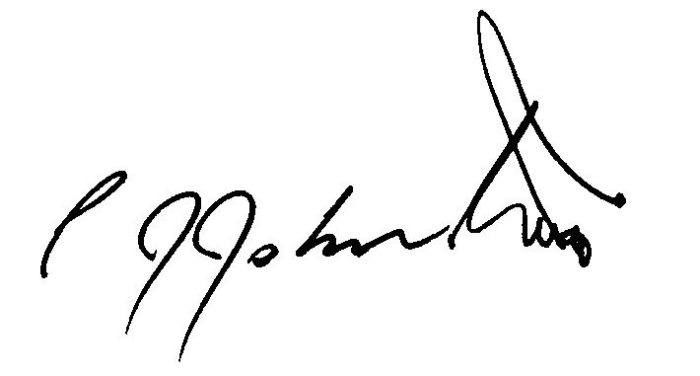
Philip Johnston

