1305, 12 Glen St
Milsons Point NSW 2061
0434 715.861
scribepj@bigpond.com
Insert one of the enclosed three CDs into a Windows PC to auto-open this Letter_to_Senator_Patrick_Dodson_1-Jan-20.htm
About 15 seconds after inserting the CD, click on the Windows prompt on lower RHS of your monitor after inserting a CD, then click on Letter_to_Senator_Patrick_Dodson_1-Jan-20.htm at upper RHS to open this letter.
If using a MAC, or the enclosed USB stick drive, or the enclosed two CDs do not auto-open this letter, then navigate to ATLSEIP/NT/Letter_to_Senator_Patrick_Dodson_1-Jan-20.htm
Click on it and then the embedded URLs in Black (underlined), Blue Text or Red Text to open associated files.
To leave a page and return to the previous page, click on the arrow at top left of your screen/monitor.
If this page accidentally closes when you leave another page, right click on your CD/DVD Drive icon and
left click on 'Open Auto play'.
Alternatively save the file ATLSEIP in a folder on your hard drive, then navigate to ATLSEIP/NT/Letter_to_Senator_Patrick_Dodson_1-Jan-20.htm.

1 January 2020
Senator Patrick Dodson
PO Box 3490
Broome, WA, 6725
Dear Senator Dodson
Recommendation 236 of the Royal Commission Into Aboriginal Deaths in Custody: "That in the process of negotiating with Aboriginal communities and organisations in the devising of Aboriginal youth programs (that) governments should recognise that local community based and devised strategies have the greatest prospect of success and this recognition should be reflected in funding."
Pursuant to Chapter 7 'Community engagement' of the Royal Commission into the Protection and Detention of Children in the Northern Territory - Findings and Recommendations (tabled in Parliament on 17 Nov 2017), the Northern Territory Government and the Commonwealth Government are requested to "reach agreement with Aboriginal community representatives on the strategies, policies and programs needed to provide sustained positive outcomes for children and young people".
The Writer's Aboriginal Teenager Life Skills' RTV Social Inclusion Early Intervention Programme -
* accords with afore-mentioned Recommendation 236, Chapter 7 and the Prime Minister’s Community Business Partnership where "Levels of philanthropy have tapered off in recent years, with Australia now lagging behind other countries";
* Closes the Gap on Indigenous Disadvantage;
* is Administered and fully Funded by Ten Corporate Sponsors for the Thirteen Deliverables from the 'Aboriginal Teenager Life Skills' Programme involving 140 Accepted Year 9 Aboriginal Students drawn from the Selected Six Townships In the Northern Territory With A Population >2000; and
* is fully Funded by Ten Corporate Sponsors for the
Three Benefits To Ten Corporate Sponsors

References:
- Amnesty International Australia's comprehensive, 871-page report that opines on governments’ lack of progress in implementing many of the 339 Recommendations from the Royal Commission into Aboriginal Deaths In Custody, in particular "Breaking the cycle: programs for Aboriginal youth (recommendations 234-245)"
- Professor Patrick Dodson's call for accountability from legislators almost 25 years later (at the National Press Club Address on Wed, 13 April 2016) re a lack of attention to most of the 339 Recommendations
- ABC The Drum programme on Monday, 16 Dec 2019 where Arthur Moses (President of Law Council of Australia) was critical of Governments ineptitude, particularly in not raising the age of criminal responsibility to 14 years old
- ABC Youth Detention articles
- Royal Commission and Board of Inquiry into the Protection and Detention of Children in the Northern Territory - Recommendations
- "The Northern Territory Government would save hundreds of millions of dollars by implementing the recommendations of the Royal Commission into Youth Detention and Child Protection"
The Executive Summary of CLOSING THE GAP - PRIME MINISTER’S REPORT 2018 lists (on page 9) four 'Closing the gap' targets that are not on track to be achieved. There are 650,000 circa indigenous Australians which represent approx. 2.56% of the Australian population of 25.4 million people circa.
Below is an on-line 'Response Comment' to the recent newspaper article "The cost of programs that helped meet the government’s Closing the Gap targets to improve indigenous Australians’ lives over the eight years to 2016 exceeded $130.2 billion, according to analysis of government spending data by The Australian.":

".... Only an idiot keeps doing the same thing and expects a different result...." albeit referring to the previous practice of funding exceedingly small isolated Indigenous populations at materially higher delivery costs.
You may wish to ask Working Dog Productions (or Cordell Jigsaw) or Sarah Davies, CEO of Philanthropy Australia to -
(i) review my Aboriginal Teenager Life Skills' RTV Social Inclusion Early Intervention Programme;
and
(ii) rate it between 0 and 10 under each of Ten Business Case Parameters for its cost-effective utility to address the four 'Closing the gap' targets that are not on track to be achieved - Executive Summary - page 9;
(iii) provide those ratings to your office.
Inter alia, ATLSEIP:
(A) Would be Administered and fully Funded by the Life Skills Philanthropic Service Movement for the Three Benefits To Ten Corporate Sponsors to provide Thirteen Deliverables which include Overriding Purpose Of 'Aboriginal Teenager Life Skills' Programme.
(B) Entails Three Philanthropic Elder Colleagues From Each Of Ten Corporate Sponsors Providing Different Project Development Expertise.
(C) Draws on the potent Motivational Incentive Of RTV and taps into the burgeoning number of Baby-Boomers that possess Three WOO Qualities under the Private Sector Philanthropic Administrator Model.
(D) Enables New Role Models In Ten Isolated Country Towns By Building Upon Valuable Survival
Skills - Enhance Pride In These Towns.
(E) Mitigates Risks.
(F) Will cost a television production company, the ABC, SBS or the Life Skills Philanthropic Service Movement a Peppercorn Fee of $1 to purchase from the 'Life Skills' Programme Developer (Writer) the I.P. associated with the 9 months (ave. 35 hours a month) R&D to prepare 'Aboriginal Teenager Life Skills' RTV Early Intervention Programme.
The Writer's final position at Commonwealth Bank prior to retirement after a 37 years' career was in Social & Corporate Infrastructure after previously acting as the Agent bank for 18 years to syndicates of first ranking banks that funded a welter of very large social, corporate and transport infrastructure projects such as the privatisation of Sydney Airport and Brisbane Airports, construction of Sydney Harbour Tunnel. In acting as a fiduciary for large syndicates of 1st and/or 2nd ranking debt providers, the Writer dealt with very talented lawyers, civil and structural engineers, accountants, CFOs and bankers. These were senior execs well used to completing complex projects. Hence, sourcing Three Philanthropic Elder Colleagues that possess Three WOO Qualities from each of Ten Corporate Sponsors is a walk in the park due to the Three Benefits To Ten Corporate Sponsors.
Aforementioned Recommendation 236, Chapter 7 and the Prime Minister’s Community Business Partnership behoove the Commonwealth Govt. and Northern Territory Govt. to appraise inter alia the Thirteen Deliverables for 'Aboriginal Teenager Life Skills' Social Inclusion Early Intervention Program.
Hence, will the Australian Labor Party ask the Commonwealth Govt. to support ATLSEIP on a bipartisan basis?
The Writer will answer in writing any written questions put to him by anyone that reviews ATLSEIP.
NB: Re Reference 3 above, the Writer has posted a copy of this letter on CD to Arthur Moses, President of Law Council of Australia. because of the concern that he expressed in the recent The Drum programme re Govt. ineptitude regarding mass jailings of aboriginal youth, particularly in the Northern Territory.
Yours sincerely
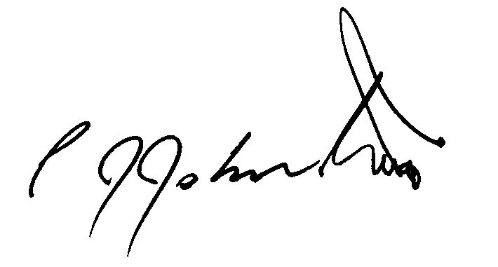
Philip Johnston

