1305, 12 Glen St
Milsons Point NSW 2061
0434 715.861
scribepj@bigpond.com
Insert one of the enclosed two CDs into a Windows PC to auto-open this Letter_to_Arthur_Moses_LCA_1-Jan-20.htm
About 15 seconds after inserting the CD, click on the Windows prompt on lower RHS of your monitor after inserting a CD, then click on Letter_to_Arthur_Moses_LCA_1-Jan-20.htm at upper RHS to open this letter.
If using a MAC, or the enclosed USB stick drive, or the enclosed two CDs do not auto-open this letter, then navigate to ATLSEIP/NT/Letter_to_Arthur_Moses_LCA_1-Jan-20.htm
Click on it and then the welter of embedded URLs in Black (underlined), Blue Text or Red Text to open associated files.
To leave a page and return to the previous page, click on the arrow at top left of your screen/monitor.
If this page accidentally closes when you leave another page, right click on your CD/DVD Drive icon and left click on 'Open Auto play'.
Alternatively save the file ATLSEIP in a folder on your hard drive, then navigate to ATLSEIP/NT/Letter_to_Arthur_Moses_LCA_1-Jan-20.htm.

1 January 2020
Mr. Arthur Moses
President, Law Council of Australia
Levels 33 & 34,
126 Phillip Street
Sydney NSW 2000
Dear Mr. Moses
Recommendation 236 of the Royal Commission into Aboriginal Deaths in Custody is "That in the process of negotiating with Aboriginal communities and organisations in the devising of Aboriginal youth programs (that) governments should recognise that local community based and devised strategies have the greatest prospect of success and this recognition should be reflected in funding."

Pursuant to Chapter 7 'Community engagement' of the Royal Commission into the Protection and Detention of Children in the Northern Territory - Findings and Recommendations (tabled in Parliament on 17 Nov 2017) the Northern Territory Government and the Commonwealth Government are requested to "reach agreement with Aboriginal community representatives on the strategies, policies and programs needed to provide sustained positive outcomes for children and young people" in the Northern Territory.

The Writer's Aboriginal Teenager Life Skills' RTV Social Inclusion Early Intervention Programme -
* accords with afore-mentioned Recommendation 236, Chapter 7 and the Prime Minister’s Community Business Partnership where "Levels of philanthropy have tapered off in recent years, with Australia now lagging behind other countries";
* is Administered by Ten Corporate Sponsors for the Thirteen Deliverables from the 'Aboriginal Teenager Life Skills' Programme involving 140 Accepted Year 9 Aboriginal Students drawn from the Selected Six Townships In the Northern Territory With A Population >2000; and
* is fully Funded by Ten Corporate Sponsors for the
Three Benefits To Ten Corporate Sponsors.
On Monday 16 Dec 2019, the Writer watched ABC The Drum programme where you were critical of Governments ineptitude regarding many of the 339 Recommendations from the Royal Commission Into Aboriginal Deaths in Custody, particularly in not raising the age of criminal responsibility to 14 years old.
Hence, the Writer hereby provides his Letter to Senator Patrick Dodson dated 1 January 2020 which asks the Labour Party to recommend
'Aboriginal Teenager Life Skills' Social Inclusion Early Intervention Program to the Commonwealth Govt.

Yours sincerely
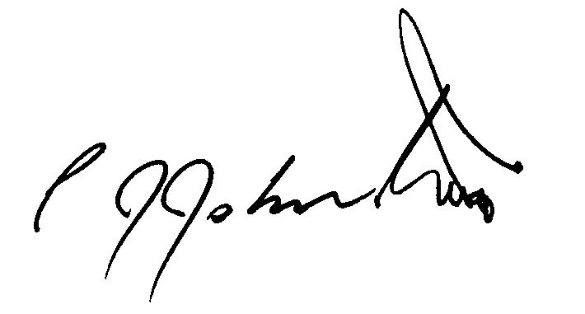
Philip Johnston

