1305, 12 Glen St
Milsons Point NSW 2061
0434 715.861
scribepj@bigpond.com

Insert one of the enclosed three CDs into a Windows PC to auto-open this 2nd_Letter_to_Senator_Patrick_Dodson_27-Feb-20.htm
About 15 seconds after inserting a CD, left mouse click on the Windows prompt on lower RHS of your monitor after inserting a CD, then mouse click on 2nd_Letter_to_Senator_Patrick_Dodson_27-Feb-20.htm at upper RHS to open this letter.
If using a MAC, or the enclosed USB stick drive, or the enclosed three CDs do not auto-open this letter, then navigate to ATLSEIP/NT/2nd_Letter_to_Senator_Patrick_Dodson_27-Feb-20.htm
Left mouse click on it and then click on the welter of embedded URLs in Black (underlined), Blue Text or Red Text to open associated files.
To leave a page and return to the previous page, click on the arrow at top left of your screen/monitor.
If this page accidentally closes when you leave another page, right click on your CD/DVD Drive icon and left click on 'Open Auto play'. Alternatively save the file ATLSEIP in a folder on your hard drive, then navigate to ATLSEIP/NT/2nd_Letter_to_Senator_Patrick_Dodson_27-Feb_20.htm.

27 February 2020
Senator Patrick Dodson senator.dodson@aph.gov.au
PO Box 3490
Broome, WA, 6725
Dear Senator Dodson
Aboriginal Teenager Life Skills' RTV Social Inclusion Early Intervention Programme ticks ALL the current bureaucratic boxes as chronicled herein
Ipso facto, will the Australian Labor Party ask the Commonwealth Govt. to support ATLSEIP on a bipartisan basis?

The Writer refers to -

A) his initial Letter to Senator Patrick Dodson dated 1 January 2020 (provided in 2 x CDs, one x USB Stick and 3 x A4 hardcopy) that asked the Australian Labor Party to request the Commonwealth Govt. to support the Writer's Aboriginal Teenager Life Skills' RTV Social Inclusion Early Intervention Programme which -
* accords with -
(i) Recommendation 236 of the Royal Commission Into Aboriginal Deaths in Custody;
(ii) Chapter 7 'Community engagement' of the Royal Commission into the Protection and Detention of Children in the Northern Territory - Findings and Recommendations;
(iii) Prime Minister’s Community Business Partnership, in particular "shared accountability and shared responsibility – governments, Indigenous Australians and their communities and organisations" under the P.M.'s recently announced/acknowledged involvement with the Coalition of Peaks;
(iv) Closing the Gap Partnership Agreement dated 22 March 2019 "recognises that shared decision making with Aboriginal and Torres Strait Islander peoples, through their representative organisations, in the design, implementation, monitoring and evaluation of the Closing the Gap framework is essential to closing the gap in life outcomes between Indigenous and non-Indigenous Australians."
* Closes the Gap on Indigenous Disadvantage under a highly cost-effective RTV Platform;
* is managed by the Coalition of Peaks that selects/appoints Three Local Connectors in each of the Selected Six Townships In The Northern Territory With A Population >2000;
* is Administered by Ten Corporate Sponsors -
(a) for the Thirteen Deliverables from the 'Aboriginal Teenager Life Skills' Programme involving 140 Accepted Year 9 Aboriginal Students drawn from the Selected Six Townships In the Northern Territory With A Population >2000;
* (b) under the Life Skills Philanthropic Service Movement, comprising Thirty Philanthropic Elder Colleagues - where at least one third of the Thirty Philanthropic Elder Colleagues will be Indigenous Australians;
* at least one of the Three Philanthropic Elder Colleagues, from each of each of the Ten Corporate Sponsors, from each of Ten Different Market Sectors, will be an Indigenous Australian; and
* is fully Funded by Ten Corporate Sponsors for the Three Benefits To Ten Corporate Sponsors; and
B) his follow-up email to Senator Dodson sent 11 February 2020 that provided six attached files referred to therein and offered to respond to any questions re. his ATLSEIP; and

C) email receipt acknowledgement from Senator Dodson's office sent 11 Feb 20 that included inter alia "I will consider the matters you raise as soon as possible."
The Writer –

(a) will answer in writing any written questions put to him by anyone that reviews ATLSEIP, in particular from members of the Coalition of Peaks that hail from the Northern Territory (Aboriginal Medical Services Alliance N.T., Central Land Council and Northern Land Council); and
(b) is available to meet with you or your representative/s at any time, at any venue, to discuss ATLSEIP.
Aboriginal Teenager Life Skills' RTV Social Inclusion Early Intervention Programme complies with all the current bureaucratic sensitivities/focuses, as evidenced above. Hence, will the Australian Labor Party ask the Commonwealth Govt. to support ATLSEIP on a bipartisan basis?
Yours sincerely
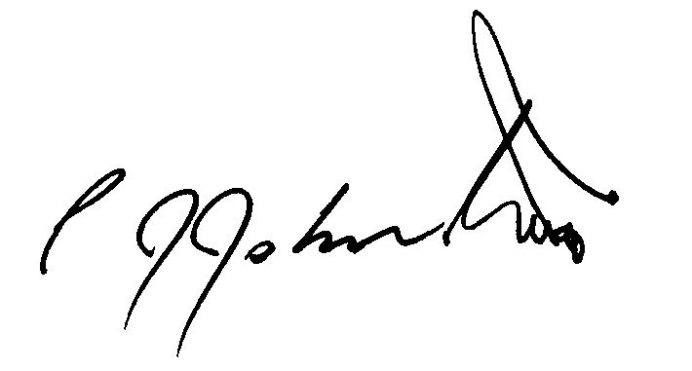
Philip Johnston

